2026 Annual General Meeting | 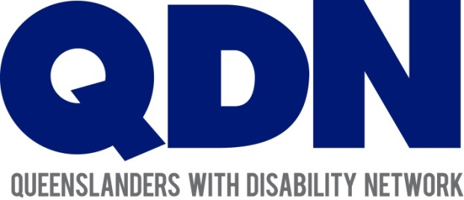

Ballot for the Election of Directors:

Meet the Candidates
Page 2

Marie Bledsoe 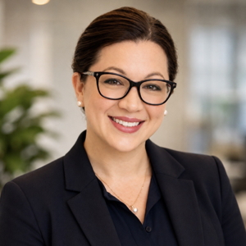
Like many of us, my disability journey has shaped who I am. As a woman living with multiple disabilities, an NDIS participant, and the step-parent of a young person navigating disability supports, I understand both personally and professionally the importance of being heard, respected and included in decisions that affect our lives.
Throughout my career, I have been passionate about removing barriers and creating opportunities for people to participate, contribute and thrive. I have led accessibility and inclusion initiatives across government and industry, chaired the Queensland Fire Department’s Community of Inclusion for People with Disability, and contributed as a lived experience consultant to Queenslanders with Disability Network, the Queensland Mental Health Commission and Women with Disabilities Australia.
I believe leadership begins with listening. If elected, I will bring curiosity, integrity and collaboration to the Board, ensuring members’ voices remain at the centre of QDN’s work. I am committed to strengthening peer leadership, supporting good governance and helping QDN continue to influence meaningful systems change across Queensland.
I don’t have all the answers, but I do believe in bringing people together, asking thoughtful questions and working alongside others to create positive change. It would be a genuine privilege to serve QDN’s members and contribute to an organisation that continues to champion the rights, leadership and inclusion of people with disability.
Page 3

Sharon Boyce 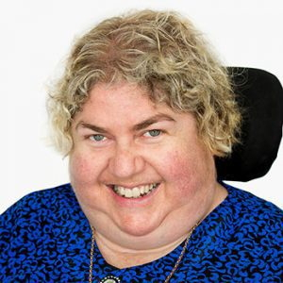
I am seeking re-election to the QDN Board because I believe strongly in the power of our collective voice and in QDN’s capacity to create meaningful change for Queenslanders with disability.
I bring extensive lived experience of disability, together with more than 30 years’ professional experience in disability advocacy, research, education, community engagement and inclusion. My lived experience informs how I listen, advocate and approach leadership. I understand the realities of navigating systems, but I also understand the strength, knowledge, resilience and solutions that people with disability bring to the table.
I have previously served QDN as both Chair and Deputy Chair, giving me a deep understanding of QDN’s history, governance, members and role within the Queensland disability sector. I want to build on that experience and contribute to strengthening QDN’s leadership and influence across Queensland.
I am also a Graduate of the Australian Institute of Company Directors, bringing formal governance knowledge and board-level skills that I can apply to QDN’s leadership, strategic direction, accountability and good governance.
I also bring strong Queensland and national networks. As Co-Chair of the Queensland Disability Advisory Council, I contribute to conversations with government and the Minister and help bring the experiences and priorities of Queenslanders with disability into those discussions. I am also a member of the Independent Advisory Council to the NDIA, providing an important connection to national conversations at a time of significant change within the NDIS.
In addition, as Co-Chair of the evaluation committee for the Australian Disability Strategy, I contribute to work examining Australia’s national framework for disability inclusion and its impact. These roles provide opportunities to connect QDN members’ experiences and priorities with broader policy and systemic discussions.
My approach is solution-focused and member-centred. I value the passion and knowledge members bring to QDN discussions—their stories, their struggles, their ideas and, importantly, the solutions they have developed themselves.
Page 4
I believe leadership is about listening, connecting and turning collective knowledge into action. My research and community engagement experience enables me to bring together evidence, lived experience and community knowledge, and to share that knowledge back through QDN and the broader disability community.
If re-elected, I will bring lived experience, leadership, governance, research, advocacy, strong networks and a genuine commitment to listening to members.
I would be proud to continue contributing to QDN and to help ensure that the voices, stories and ideas of Queenslanders with disability are heard, valued and translated into meaningful change.
Page 5

Jake Bryar 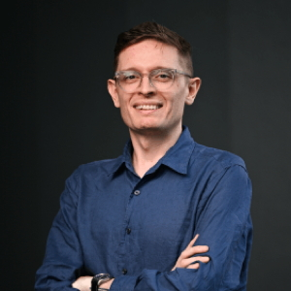
QDN’s strength is that it is led by its members: people with disability shaping the policy, services and systems that affect their own lives. I am drawn to nominate by a simple conviction: that authority on disability belongs to the people who live it. I am applying to help protect and grow that member-led model from the board table, bringing the compliance, risk, and fiduciary discipline that keeps an organisation accountable, resilient, and trusted.
My commitment is not abstract. I developed Guillain-Barré Syndrome, an autoimmune condition that attacks the peripheral nerves. It changed my life overnight, moving me from someone who took physical capability for granted to someone navigating recovery, rehabilitation, and a hugely complex health and disability system. I went from one side of the barrier to the other. That experience reshaped how I understand leadership, access, and what it means to enable and include people. It is the perspective I would bring to every decision around the board table.
Professionally, I am a compliance and risk specialist with more than a decade of experience across retail, logistics, international trade, and government regulation. I lead compliance and risk strategy across an ASX-listed retail organisation with nearly a thousand sites, advising executives on regulatory and governance obligations. I understand fiduciary duty, risk appetite, conflict management, and the discipline of asking the questions that protect an organisation and the people it serves.
I have deliberately built my governance readiness through a board observership program, and I am a participant in QDN’s Emerging Leaders Program. I have also done meaningful community work to strengthen my understanding of disability from the ground up, including direct support work, volunteering with young adults with autism, and contributing to disability access and inclusion planning at local government and corporate levels.
I am committed to preparation, fiduciary discipline, transparent declaration of conflicts, and conduct consistent with QDN’s Governance Charter.
Above all, I am committed to the principle at QDN’s heart: nothing about us without us.
Page 6

Aaron Cotton 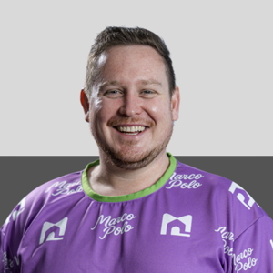
I am a neurodivergent person living with ADHD and dyslexia. That lived experience shapes how I think, communicate and solve problems, and it gives me a personal understanding of what it means to navigate systems that were not always designed with us in mind.
I bring three things to the board.
First, deep NDIS knowledge. I sit on the advisory council of the NDIS Quality and Safeguards Commission, where I contribute to the national conversation on how quality and safeguarding should work in practice. I understand the scheme from the inside, including the real pressures facing participants and providers.
Second, business experience. I have founded two NDIS businesses, one of which has been profitable for more than six years. Building and running a company teaches strategy, finance, risk management and accountability. These are the same disciplines a good director brings to the table.
Third, advocacy. I built a platform called Marco Polo with advocacy at its heart, and through it I have designed and facilitated co-design sessions that put people with disability in the lead. This reflects the principle QDN lives by. Nothing about us without us.
The strength I am most proud of is the way I communicate. I stay calm and effective under pressure, and I can hear perspectives different from my own without judgement and without creating conflict.
I would be honoured to serve QDN, its members, and the community it represents. Thank you for considering me.
Page 7

Kate Dufty 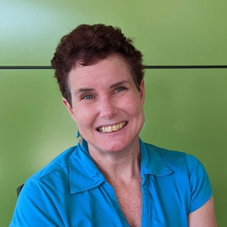
My name is Kate and I live in Gladstone, Central Queensland. I have lived experience of physical disability since my teenage years.
My involvement in systemic advocacy began before moving to Queensland and has grown significantly since joining QDN in 2019. I was proud to be one of QDN’s first Emerging Leaders in 2021, and today I continue to contribute as Co-convenor of the Gladstone and Statewide Online Peer Support Groups, a member of the Disability Reforms Co-design Team, and through QDeNgage consultations.
Beyond QDN, I am passionate about strengthening disability advocacy in my local community. In 2022, I helped establish the Gladstone Disability Community Network and continue to serve on its Leadership Team. Earlier this year, I was honoured to receive the Gladstone Region Australia Day Community Volunteer Award in recognition of my advocacy. I am committed to ensuring regional voices are heard and to building strong relationships between people with disability, community organisations and decision-makers.
My fifteen years of university study in the humanities have equipped me with strong communication, analytical and critical thinking skills that would support the work of the Board. My advocacy has always reflected, and will always reflect, QDN’s commitment to representing all people with disability, regardless of their circumstances.
As QDN celebrates its 25th year, I believe it is more important than ever to have a Board with a diverse mix of skills, experiences and perspectives to guide the organisation into its next chapter. If elected, I will always put QDN’s mission, values and long-term success at the centre of every decision. I would be proud to contribute to strong governance, support our dedicated staff and members, and help ensure QDN continues to be a trusted and influential voice for people with disability across Queensland for many years to come.
Page 8

Lesh Prasad 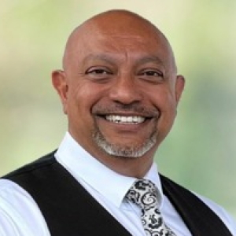
I am seeking to join the QDN Board because disability-led advocacy is the piece of the system I believe in most, and the piece I am best placed to serve rather than lead. My career has been built almost entirely within the disability and inclusive sector, and that experience has taught me where systems genuinely work for people with disability, and where they still fail us.
Over more than two decades I have held senior operating roles across NDIS, SDA, SIL and disability employment services. In numerous executive roles, I have achieved and sustained strong job placement outcomes for our community. I have also managed large-scale SDA and SIL operations, which gave me a firsthand understanding of how critical housing and health supports are to our community, and how much risk disconnected living conditions pose to people’s most basic needs. I recently served six years as Chair of the board of Nature Freedom, expanding outdoor access for people with disability, and have also served on the boards of ABLE Digital Wellness (digital wellbeing for people with disability) and Disability Advocacy Australia.
What I would bring to QDN is lived experience of disability, both personally and as a carer for a child with disability. I have served this sector loyally, and will continue to do so, working toward better employment, housing and government systems that shape economic participation for Queenslanders with disability. I bring strong, established relationships with national employers, peak bodies, and state and federal government — relationships that can open doors for QDN’s advocacy, particularly as Queensland moves toward Brisbane 2032 and its commitments to an inclusive legacy.
I want to put that network and operating experience directly in service of a genuinely disability-led organisation, and I would welcome the opportunity to contribute.
Page 9

Natalie Terry-Bedwell 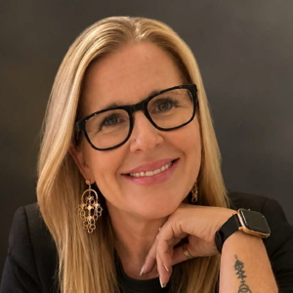
My passion for disability advocacy is both personal and practical. As an autistic woman with ADHD, I understand the experience of navigating systems and communities that are not always designed with inclusion in mind. It has shaped my belief that people with disability should not simply be included, we should have the opportunity to shape the systems, services and communities that affect our lives.
I am the Founder and Director of Honoured Social Enterprise Gym and Infinitely Valued Ltd, a registered charity. Through these organisations, I work alongside people with disability to create opportunities in health, employment, education, leadership and community participation.
My experience as a counsellor, advocate, educator and social entrepreneur has taught me that true inclusion is about more than access. It is about belonging, purpose, valued roles, meaningful employment, leadership and having a genuine voice.
I also bring governance and strategic leadership experience, including serving as Secretary of the QCIE Governance Committee and establishing and leading both a social enterprise and registered charity.
If elected as a QDN Director, I would bring lived experience, frontline knowledge, governance capability and an entrepreneurial mindset, while ensuring the voices and experiences of people with disability remain central to decision-making.
As Queensland looks towards Brisbane 2032 and beyond, we have an extraordinary opportunity to create a lasting legacy of inclusion. I want to see people with disability recognised not simply as participants, but as leaders, employees, entrepreneurs, athletes, advocates and decision-makers.
I would be honoured to contribute to QDN’s leadership and help build a Queensland where people with disability are not only heard and included, but valued, empowered and leading change.
Page 10

John Tomlinson 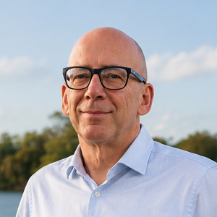
As a person with lived experience of disability, I understand both the opportunities and the barriers that people with disability face every day. My own journey has reinforced the importance of strong advocacy organisations that ensure people with disability have a genuine voice in the decisions that affect their lives. That is why I am seeking election to the Board of QDN.
I am a qualified accountant holding CPA and CIMA qualifications, with 35 years’ experience in finance, governance, strategic planning and business improvement. Throughout my career, I have worked with organisations to strengthen financial sustainability, improve governance and support informed decision-making. I also serve on Finance and Infrastructure Committees at Hope Island Resort, contributing to budget oversight, infrastructure planning, risk assessment and governance.
In recent years, I have focused my work on the disability sector through Disability Financial Clarity, supporting disability providers, self-managed NDIS participants and people navigating disability, injury and major life transitions. My work includes Supported Independent Living (SIL) sustainability reviews, financial reporting and analysis, cash-flow forecasting, operational reviews and financial literacy education. This has given me practical insight into the opportunities and challenges facing participants, providers and the broader disability community.
I would bring to the Board a combination of lived experience, financial expertise and strategic thinking. As the disability sector continues to evolve, organisations need directors who can help ensure long-term sustainability while remaining firmly focused on their purpose and the needs of members. I am experienced in analysing complex issues, identifying strategic risks and opportunities, and supporting evidence-based decisions that deliver positive outcomes.
Page 11
I am also passionate about ensuring Queensland maximises the opportunities presented by the Brisbane 2032 Olympic and Paralympic Games. These Games provide a once-in-a-generation opportunity to create a lasting disability legacy through improved accessibility, greater employment opportunities, more inclusive communities and increased economic participation for people with disability. I offer a combination of lived experience together with financial, governance and strategic expertise that will help QDN remain a strong, sustainable and influential voice for Queenslanders with disability.
If elected, I will bring a collaborative and respectful approach to governance, a commitment to listening to members, and a strong belief that people with disability should lead the conversations that shape their future. I would be honoured to contribute my lived experience, financial expertise and strategic perspective to help QDN continue to strengthen its impact for Queenslanders with disability.
Thank you for considering my nomination.
Page 12

Mark Warren 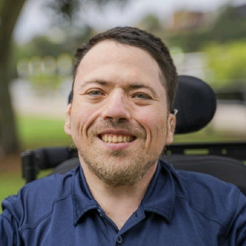
My name is Mark Warren, I am a mid 40 year old single white man who was born with Dwarfism and hearing loss. QDN has been a part of my life for the last 10 years and helped me become a better voice for myself and those around me.
Living independently with a disability has shaped the way I see the world and has given me a genuine passion for improving the lives of other people with disability. I’ve experienced many of the challenges that come with navigating services, accessibility, and inclusion, but I’ve also seen what is possible when people with disability are given a voice and the opportunity to lead. That lived experience drives everything I do, both personally and professionally.
For nine years, I’ve worked in the disability sector, where I’ve grown from creating social media content into leading the marketing function for my organisation. My role now involves co-developing marketing strategies, managing communications, producing newsletters, attending expos and networking events, and building relationships with participants, providers, and community organisations. It’s taught me the importance of listening, communicating clearly, thinking strategically, and finding practical ways to connect people with the information and support they need.
Outside of work, disability sport has been a huge part of my life. Through my involvement with the Queensland Powerchair Football Association, I’ve had the opportunity to help build and grow the sport beyond what happens on the court. I’ve been involved in sponsorship, marketing, governance, strategic planning, player development, and creating opportunities for people with disability to participate in sport. Those experiences have reinforced how important strong leadership and good governance are in building organisations that make a lasting difference.
I believe I can bring a practical, real-world perspective to QDN’s Board. I understand the disability sector not only through my lived experience, but also through my professional work and community involvement. I’m someone who enjoys tackling problems, thinking about the bigger picture, and finding ways to improve systems while making sure people remain at the centre of every decision.
Page 13
Most importantly, I want to help ensure that people with disability continue to have a genuine voice in shaping the services, policies, and communities that affect their lives. I believe my combination of lived experience, marketing and communication expertise, leadership skills, and commitment to inclusion would allow me to make a positive contribution to QDN’s Board and support the organisation in continuing its important work across Queensland.
v1 – 29/09/2026

