Stakeholder Pack
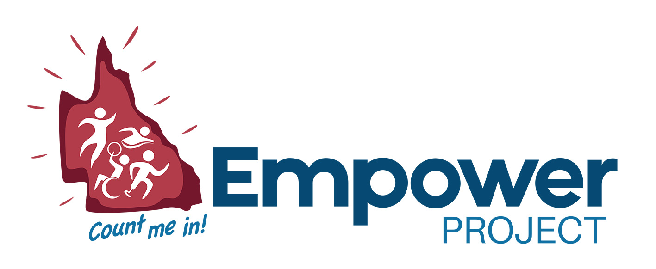

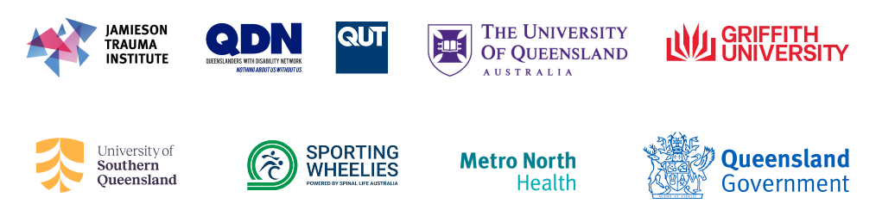
Contents
Stakeholder Campaign Pack 1
Introduction 4
Key Messages 5
Campaign Assets 6
Tile 1 6
Tile 2 7
Tile 3 8
Tile 4 9
Tile 5 10
Tile 6 11
Tile 7 12
Tile 8 13
Tile 9 14
Tile 10 15
Tile 11 16
Tile 12 17
Tile 13 18
Tile 14 19
Tile 15 20
Tile 16 21
Tile 17 22
Tile 18 23
Proposed email copy 24
Video 26
Website/newsletter 26

Introduction
Thank you for supporting the Empower Legacy Project and Count Me In survey and helping to shape a more inclusive future for Queenslanders with disability.
The Empower Legacy Project is building a stronger evidence base to understand what supports people with disability to take part in sport and physical activity, what gets in the way, and what needs to change.
The Count Me In survey gives people with disability across Queensland an opportunity to share their experiences of sport and physical activity.
We need your help. As a stakeholder with important connections across Queensland, you can help us reach people with disability, including people who currently take part in sport and physical activity and those who don’t. We also encourage you to share the survey with families, support workers, coaches and others in your networks.
This pack includes everything you need to help promote the survey, including proposed social media posts and tiles, email templates and links to video files.
You can support the campaign by sharing the social media tiles through your platforms, adding a link to your website, including the provided copy in your newsletters, and completing the survey yourself.
This campaign was developed by people with disability and key stakeholders across the Empower project.
Thank you for helping us reach people across Queensland and supporting this important campaign.

Key Messages
- Empower is the first Queensland government funded 2032 Olympic and Paralympic Games Legacy Project. By sharing your story, you can help create a lasting legacy of more inclusive sport and physical activity for future generations.
- Your experience matters. Whether you participate in sport and physical activity, volunteer, support someone who does, or have never participated, your voice can help shape a more inclusive future.
- We want to hear from people with disability, families and carers.
- Share what's getting in the way. Understanding barriers such as access, cost, transport, confidence or information is the first step to creating better opportunities for everyone.
- Better data creates better opportunities. Your experiences will help improve planning, funding, programs and access to sport and physical activity across Queensland.
- Inclusive sport and physical activity strengthen clubs, communities and participation pathways, from grassroots through to elite sport. Everyone deserves the opportunity to participate in ways that are meaningful to them.
- Real stories create real change. Empower is co-designed with people with disability, ensuring lived experience helps shape future programs, policies and opportunities across Queensland.
- Empower is building a statewide picture to improve sport and physical activity opportunities for people with disability.

Campaign Assets

Tile 1
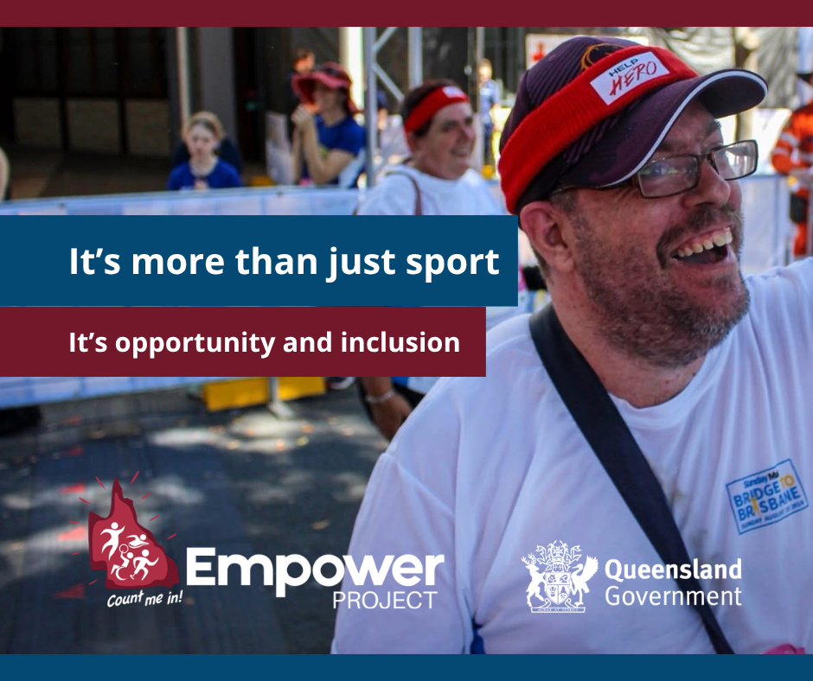  Alt text:  A smiling man with glasses, maroon cap, red headband and bridge to Brisbane shirt. Empower Project logo and text that says "It's more than just sport – It's opportunity and inclusion". Queensland government logo is at the bottom right corner. | Help us understand what supports people with disability to get involved in sport and physical activity- and what gets in the way.  Maybe you play sport every week. Maybe you used to. Maybe you've never had the opportunity.  Wherever you are on your journey, your experience matters.  The Empower survey takes just a few minutes to complete.  Together, we can create more inclusive opportunities across Queensland.  👉 Complete the survey today and help shape the future of inclusive sport: https://bit.ly/EmpowerSurvey2026  The Empower Legacy Project is proudly supported by the Queensland Government.  #EmpowerCountMeIn #DisabilityQld #InclusiveSport #Brisbane2032 #2032Legacy #2032Games

Tile 2
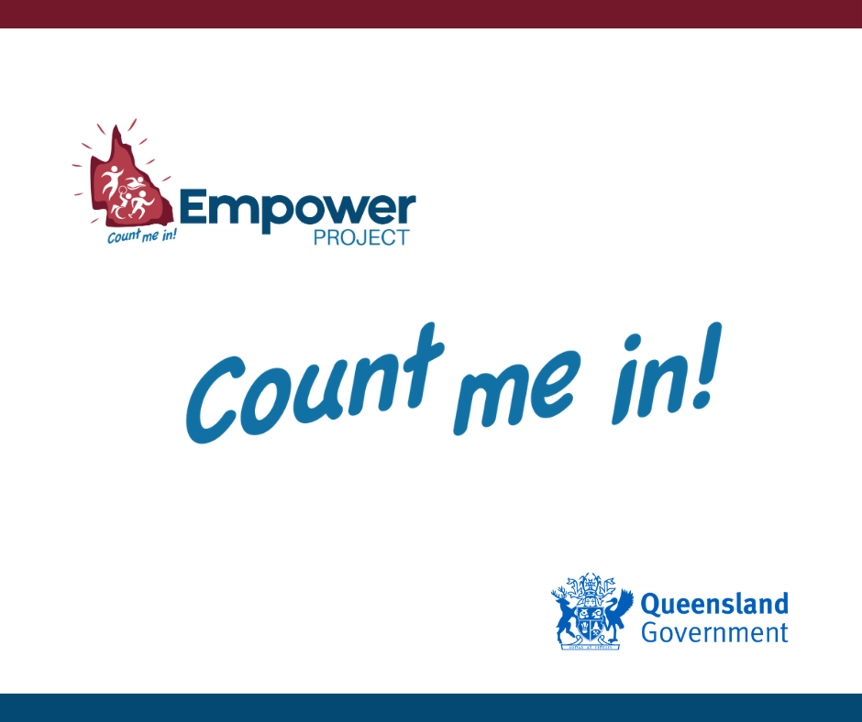  Alt Text:  Empower Project logo featuring a maroon Queensland with white silhouettes of active people and the text Count me in. Also has the words Count me in! Below the Empower logo. Queensland government logo is at the bottom right corner. | Count me in. Three words that can change what sport looks like in Queensland.  Whether you're currently active in sport, used to be, or haven't yet found the right opportunity – we want to hear from you.  Your experience helps us understand what supports people with disability to get involved in sport and physical activity, and what gets in the way.  Together, we can create more inclusive opportunities across Queensland.  👉 Complete the survey today and help shape the future of inclusive sport: https://bit.ly/EmpowerSurvey2026  The Empower Legacy Project is proudly supported by the Queensland Government.  #EmpowerCountMeIn #DisabilityQld #InclusiveSport #Brisbane2032 #2032Legacy #2032Games

Tile 3
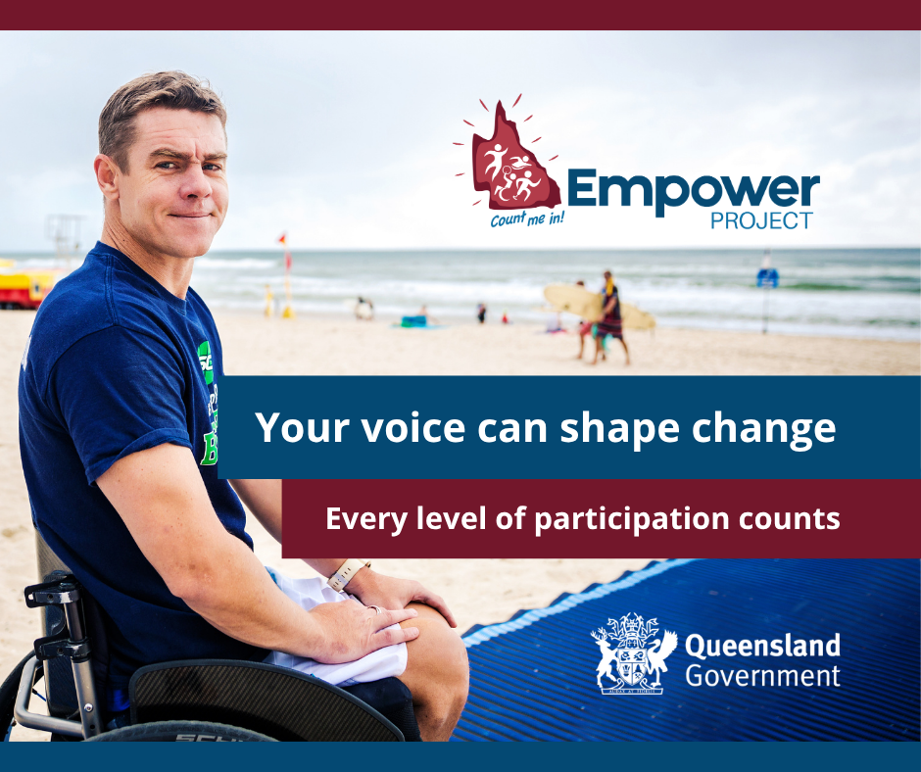  Alt text:  A man with brown short hair and blue shirt in a manual wheelchair on a wheelchair ramp at the beach. Empower Project logo and text that says "Your voice can shape change – Every level of participation counts". Queensland government logo is at the bottom right corner. | What is the biggest barrier you have faced when it comes to participating in sport or physical activity?  🚗 Transport?  💰 Cost?  ♿ Accessibility?  🤝 Feeling welcome?  📍 Not knowing what is available?  Or is it something else?  There is no right or wrong answer. We simply want to understand real experiences.  The more we know, the better we can work towards removing barriers for the future.  👉 Share your experience by completing the survey today: https://bit.ly/EmpowerSurvey2026  The Empower Legacy Project is proudly supported by the Queensland Government.  #EmpowerCountMeIn #DisabilityQld #InclusiveSport #Brisbane2032 #2032Legacy #2032Games

Tile 4
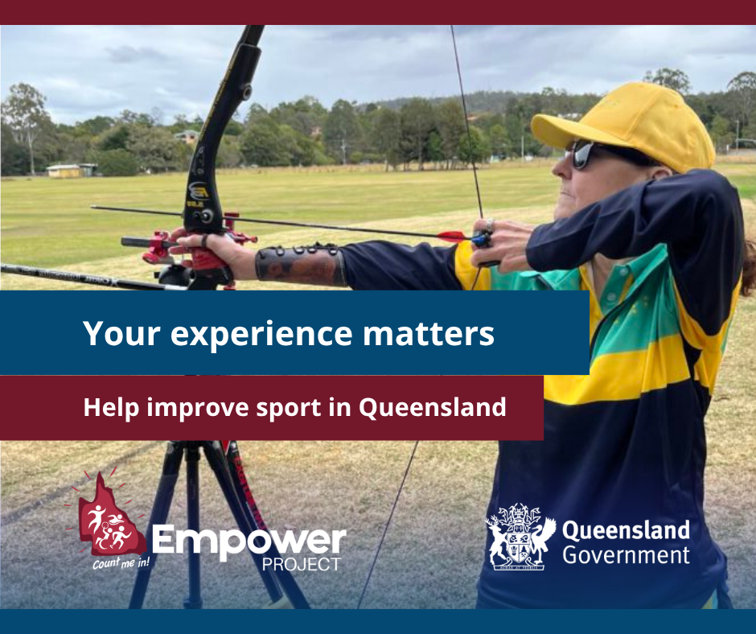  Alt text:  A woman in dark glasses and yellow and gold colours is drawing an arrow back on a black and red bow. Empower Project logo and text that says "Your experience matters – help improve sport in Queensland". Queensland government logo is at the bottom right corner. | If you're a person with disability, or you support someone who is, we want to hear about your experience with sport and physical activity in Queensland.  The more we hear, the better equipped we are to help clubs and organisations create environments where everyone feels welcome.  👉 Take part today - your voice shapes what's possible: https://bit.ly/EmpowerSurvey2026  The Empower Legacy Project is proudly supported by the Queensland Government.  #EmpowerCountMeIn #DisabilityQld #InclusiveSport #Brisbane2032 #2032Legacy #2032Games

Tile 5
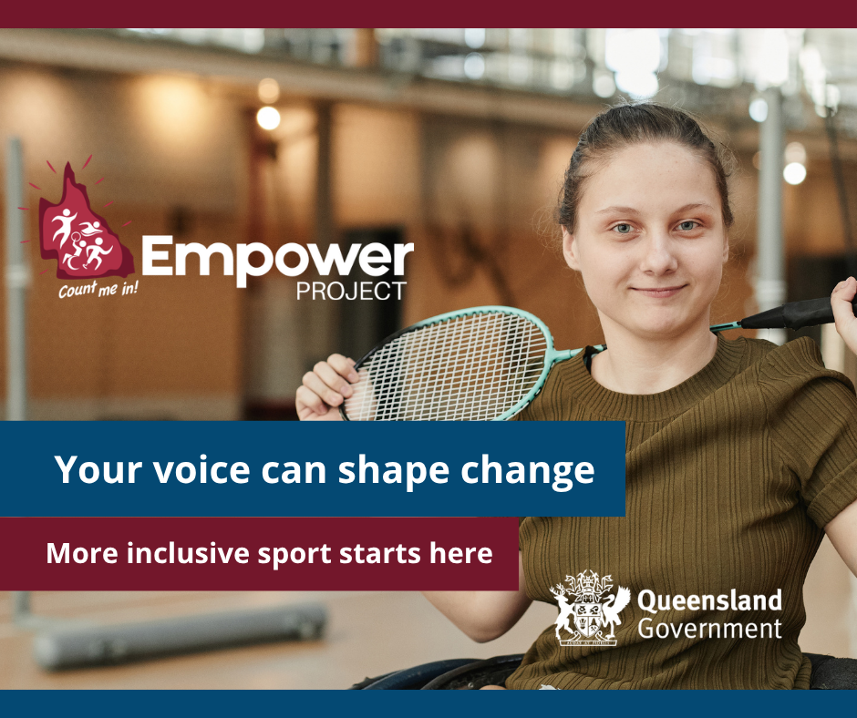  Alt text:  A young woman with green shirt in a wheelchair and on an indoor hardcourt, holding a badminton racquet. Empower Project logo and text that says "Your voice can shape change – More inclusive sport starts here". Queensland government logo is at the bottom right corner. | What gets counted gets supported  Right now, we don’t have a clear picture of sports participation for people with disability.  Empower is gathering insights from people with disability - whether currently active in sport, previously involved, or yet to find the right opportunity - to identify barriers and enablers to participation.  Your input will help build the evidence needed for improved sport and recreation opportunities.  👉 Be counted. Take the survey: https://bit.ly/EmpowerSurvey2026  The Empower Legacy Project is proudly supported by the Queensland Government.  #EmpowerCountMeIn #DisabilityQld #InclusiveSport #Brisbane2032 #2032Legacy #2032Games

Tile 6
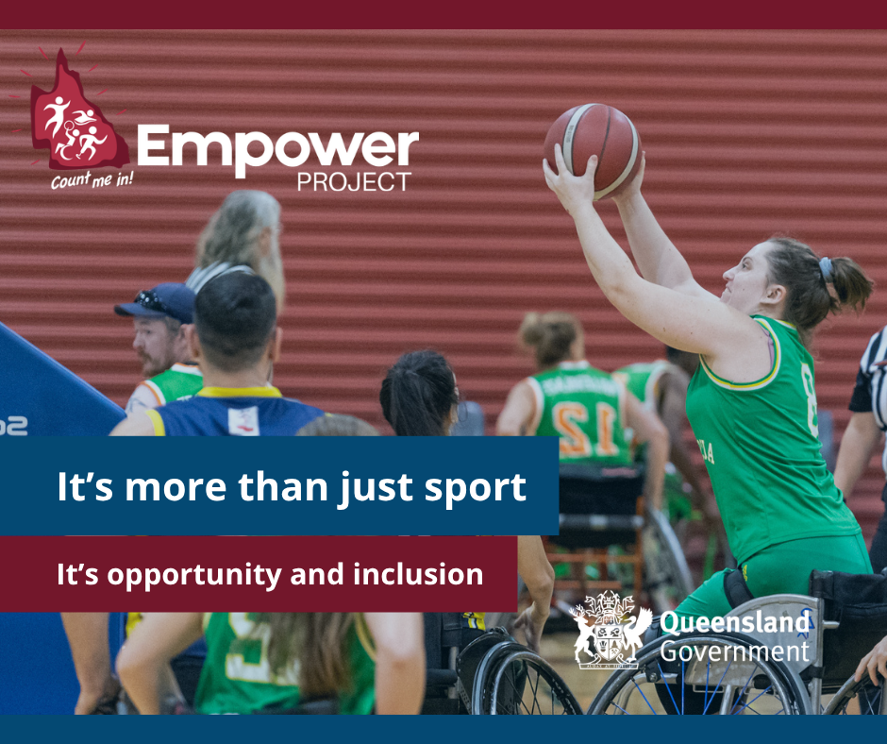  Alt text:  A team of people in wheelchairs playing basketball. Woman with green jersey in a wheelchair is making a shot with the basketball about to leave her hands. Empower Project logo and text that says "It's more than just sport – It's opportunity and inclusion". Queensland government logo is at the bottom right corner. | Empower isn’t just collecting data – it’s co-designed with people with disability, so what we build actually reflects real experiences.  From co-design workshops to survey design, lived experience shapes every step.  Now it’s your turn to help shape it – your voice adds to a survey built by and for people with disability.  Because nothing about us, without us.  👉 Be counted. Complete the survey today: https://bit.ly/EmpowerSurvey2026  Photo credit: @SportingWheelies  The Empower Legacy Project is proudly supported by the Queensland Government.  #EmpowerCountMeIn #DisabilityQld #InclusiveSport #Brisbane2032 #2032Legacy #2032Games

Tile 7
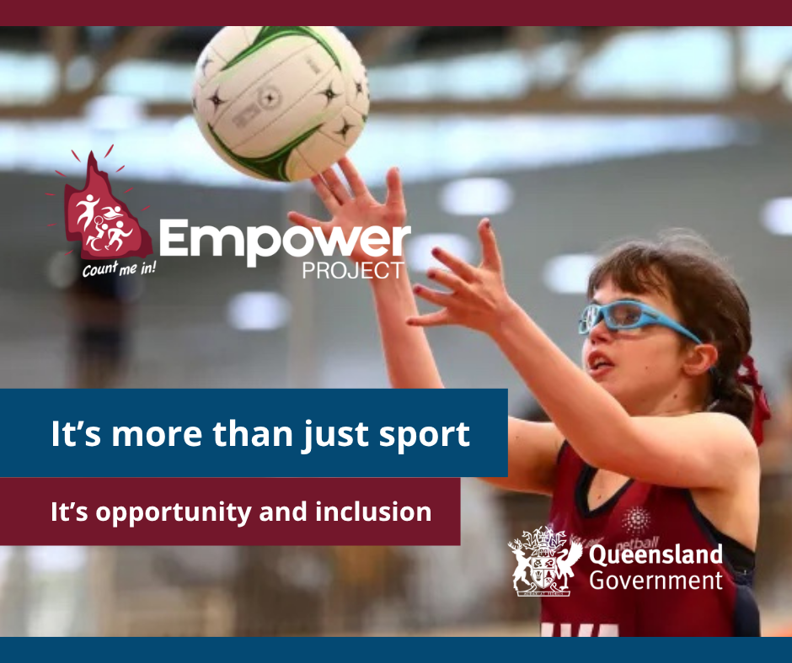  Alt Text:  Young girl with bright blue glasses and maroon jersey is about to catch a netball. Empower Project logo and text that says "It's more than just sport – It's opportunity and inclusion". Queensland government logo is at the bottom right corner. | As a parent or carer of a person with disability, you see firsthand what helps the person you support get involved in sport and physical activity, and what gets in the way.  Empower is building a statewide picture to improve sport and physical activity opportunities for people with disability.  Your voice can help create more welcoming and inclusive spaces.  👉 Share your experience today: https://bit.ly/EmpowerSurvey2026  Photo credit: @Sport4All  The Empower Legacy Project is proudly supported by the Queensland Government.  #EmpowerCountMeIn #DisabilityQld #InclusiveSport #Brisbane2032 #2032Legacy #2032Games

Tile 8
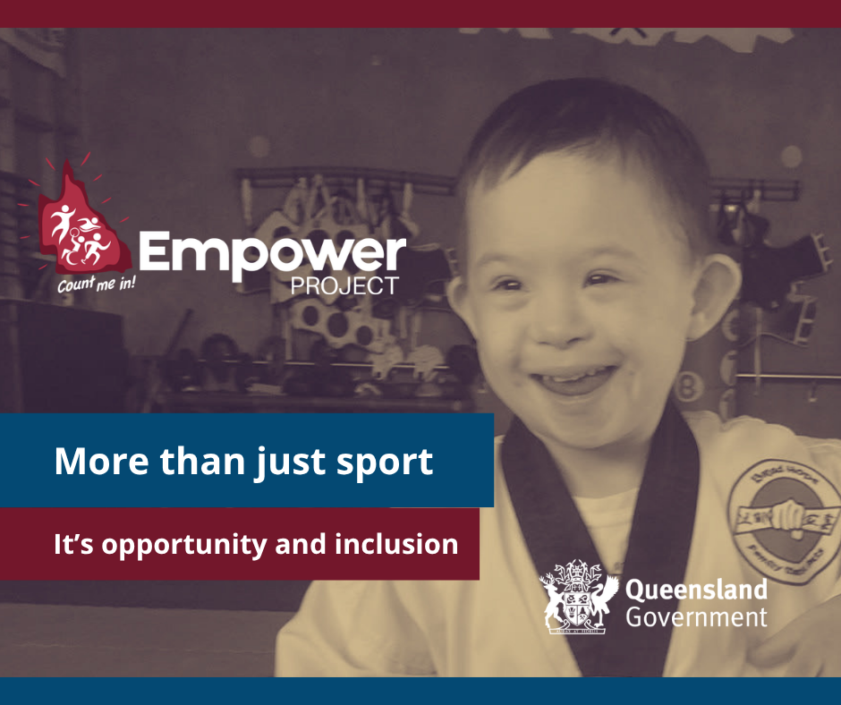  Alt Text:  A smiling young boy in a martial arts outfit. Empower Project logo and text that says "More than just sport – It's opportunity and inclusion". Queensland government logo is at the bottom right corner. | As a parent or carer of a person with disability, you see firsthand what helps the person you support get involved in sport and physical activity, and what gets in the way.  Empower is building a statewide picture to improve sport and physical activity opportunities for people with disability.  Your voice can help create more welcoming and inclusive spaces.  👉 Share your experience today: https://bit.ly/EmpowerSurvey2026  The Empower Legacy Project is proudly supported by the Queensland Government.  #EmpowerCountMeIn #DisabilityQld #InclusiveSport #Brisbane2032 #2032Legacy #2032Games

Tile 9
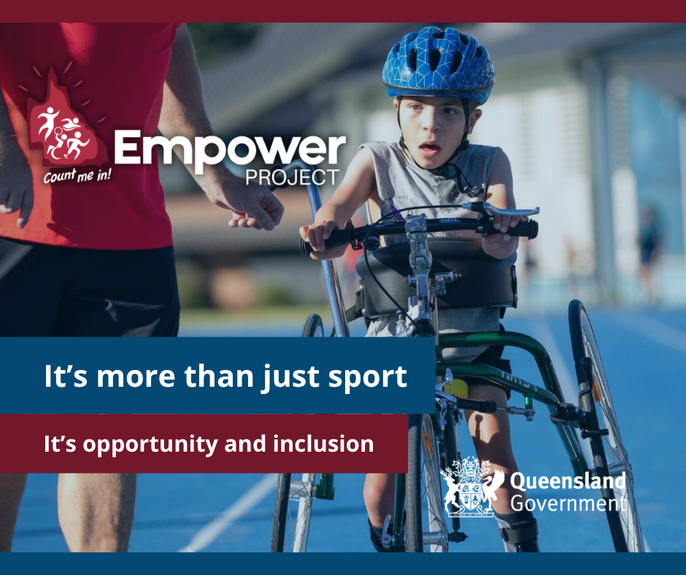  Alt text:  Young boy in a race runner and blue helmet on an athletic track with a supporter in orange shirt standing next to them. Empower Project logo and text that says "It's more than just sport – It's opportunity and inclusion". Queensland government logo is at the bottom right corner. | As a parent or carer of a person with disability, you see firsthand what helps the person you support get involved in sport and physical activity, and what gets in the way.  Empower is building a statewide picture to improve sport and physical activity opportunities for people with disability.  Your voice can help create more welcoming and inclusive spaces by finding the barriers that stand in the way.  👉 Share your experience today: https://bit.ly/EmpowerSurvey2026  The Empower Legacy Project is proudly supported by the Queensland Government.  #EmpowerCountMeIn #DisabilityQld #InclusiveSport #Brisbane2032 #2032Legacy #2032Games

Tile 10
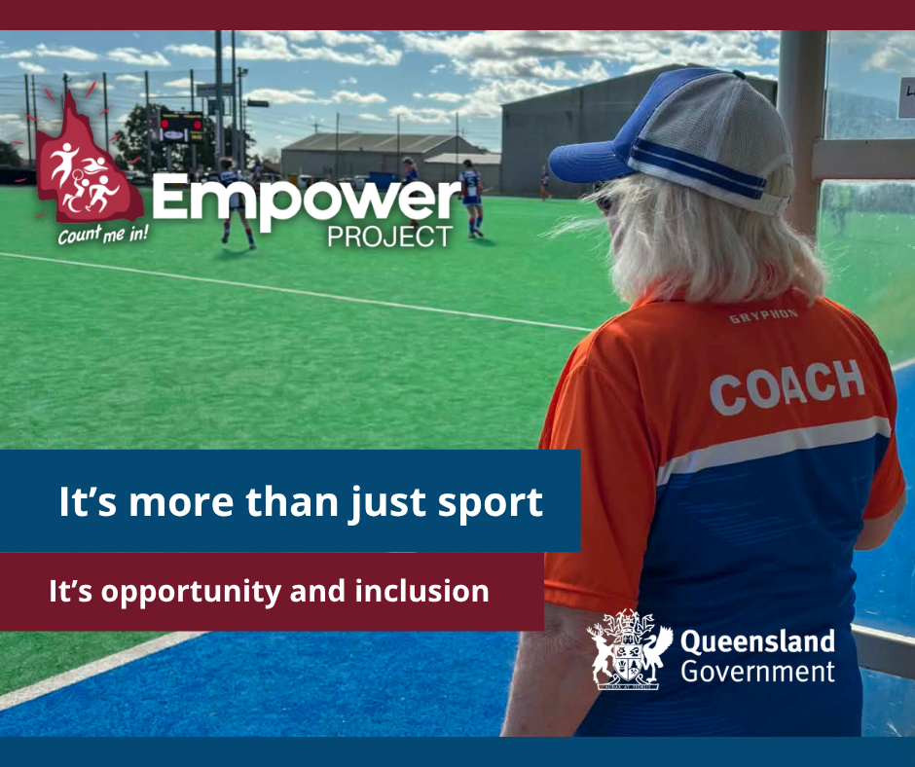  Alt Text: A woman in a blue and white cap and blue and orange shirt that reads coach looking out over a green and blue astro-turf field. Empower Project logo and text that says "It's more than just sport, it's opportunity and inclusion." Queensland government logo is at the bottom right corner. | Not everyone dreams of becoming a Paralympian.  Some people want to play social sport with friends.  Some want to volunteer.  Some want to coach.  Some want to compete at the highest level.  Every pathway is valuable and everyone deserves the opportunity to choose their own.  👉 Share your experience and help create more inclusive pathways for all Queenslanders with disability: https://bit.ly/EmpowerSurvey2026  The Empower Legacy Project is proudly supported by the Queensland Government.  #EmpowerCountMeIn #DisabilityQld #InclusiveSport #Brisbane2032 #2032Legacy #2032Games

Tile 11
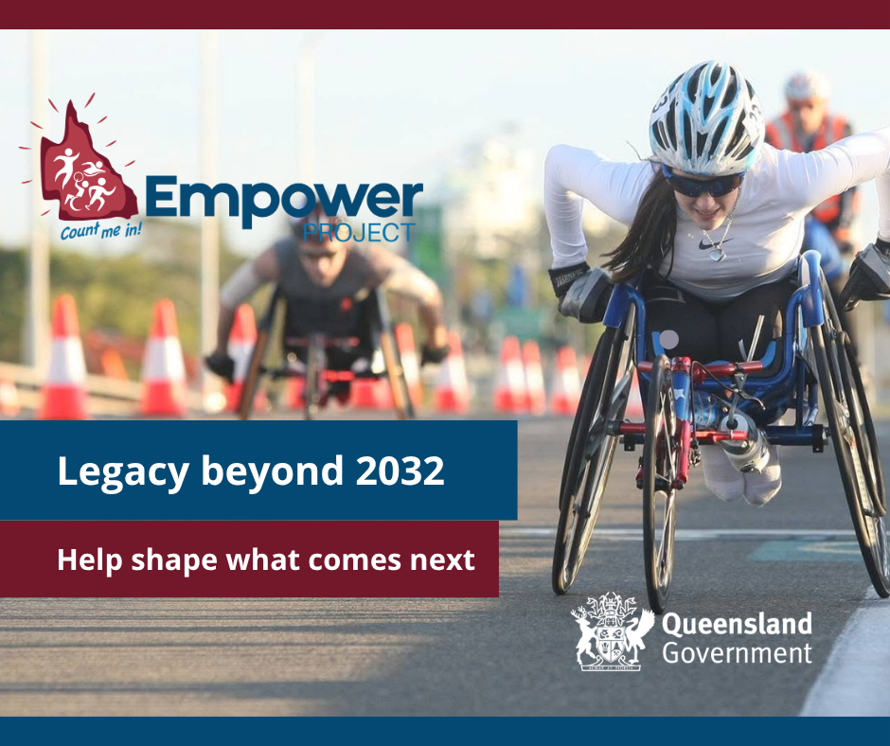  Alt Text:  A woman in sporting glasses, white shirt and helmet in a racing wheelchair. In the background are orange and white traffic cones, a man in a racing wheelchair and another man on a bike in a bright orange vest. Empower Project logo and text that says "Legacy beyond 2032 – Help shape what comes next". Queensland government logo is at the bottom right corner. | 2032 Olympic and Paralympic Games legacy opportunities include growing sport and physical activity participation for people with disability.  Empower is Queensland’s first step towards that commitment – and every response makes it real.  This is a legacy for future generations, not just the Games.  👉 Complete the survey today and help create lasting change: https://bit.ly/EmpowerSurvey2026  The Empower Legacy Project is proudly supported by the Queensland Government.  #EmpowerCountMeIn #DisabilityQld #InclusiveSport #Brisbane2032 #2032Legacy #2032Games

Tile 12
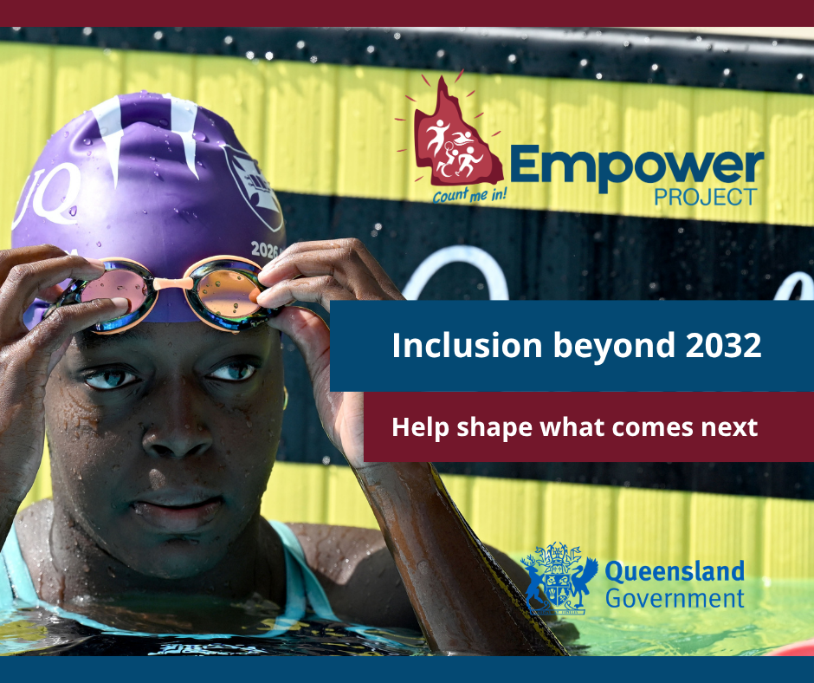  Alt Text:  A woman with a purple swimming cap and gold goggles in a swimming pool touching her swimming goggles. Empower Project logo and text that says "Inclusion beyond 2032 – Help shape what comes next". Queensland government logo is at the bottom right corner. | The 2032 Olympic and Paralympic Games are a once-in-a-generation opportunity.  Alongside the medals, there's a legacy we can build together - one where more people with disability can have the opportunity to play, coach, volunteer and participate in sport and physical activity for years to come.  That legacy starts now.  👉 Complete the survey and help build a more inclusive future: https://bit.ly/EmpowerSurvey2026  Photo credit: @swimaus  The Empower Legacy Project is proudly supported by the Queensland Government.  #EmpowerCountMeIn #DisabilityQld #InclusiveSport #Brisbane2032 #2032Legacy #2032Games

Tile 13
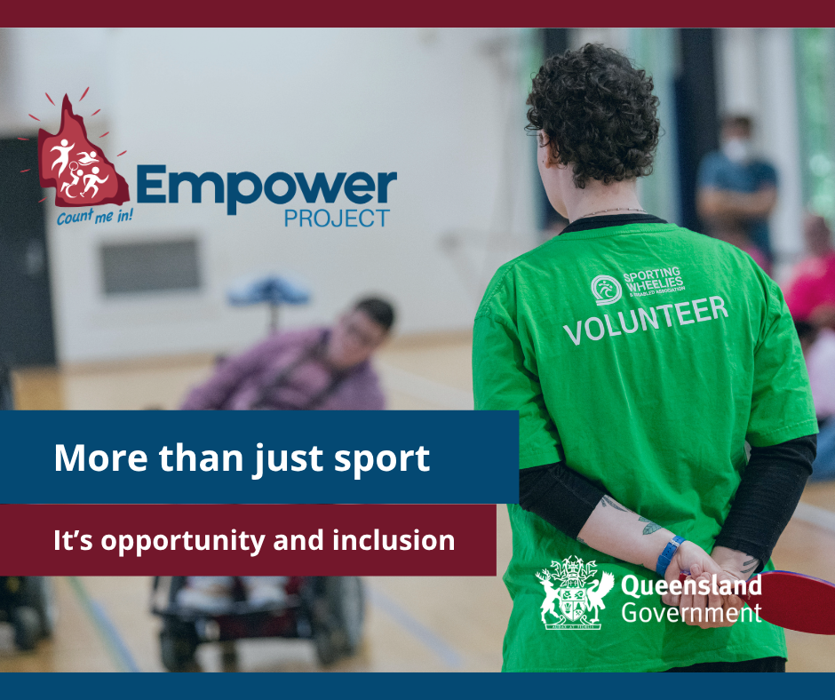  Alt Text:  A person wearing a green shirt that says volunteer, looking towards a person in a wheelchair. They are holding a red badminton racquet behind their back with both hands. Empower Project logo and text that says "More than just sport – It's opportunity and inclusion". Queensland government logo is at the bottom right corner. | You might know someone whose experience could help create change for people with disability.  A family member.  A friend.  A teammate.  A volunteer.  A coach.  Please share this survey with them.  The more voices we hear, the stronger the picture we can build and the better the outcomes for everyone.  👉 Complete the survey and share it with your community: https://bit.ly/EmpowerSurvey2026  Photo credit: @SportingWheelies  The Empower Legacy Project is proudly supported by the Queensland Government.  #EmpowerCountMeIn #DisabilityQld #InclusiveSport #Brisbane2032 #2032Legacy #2032Games

Tile 14
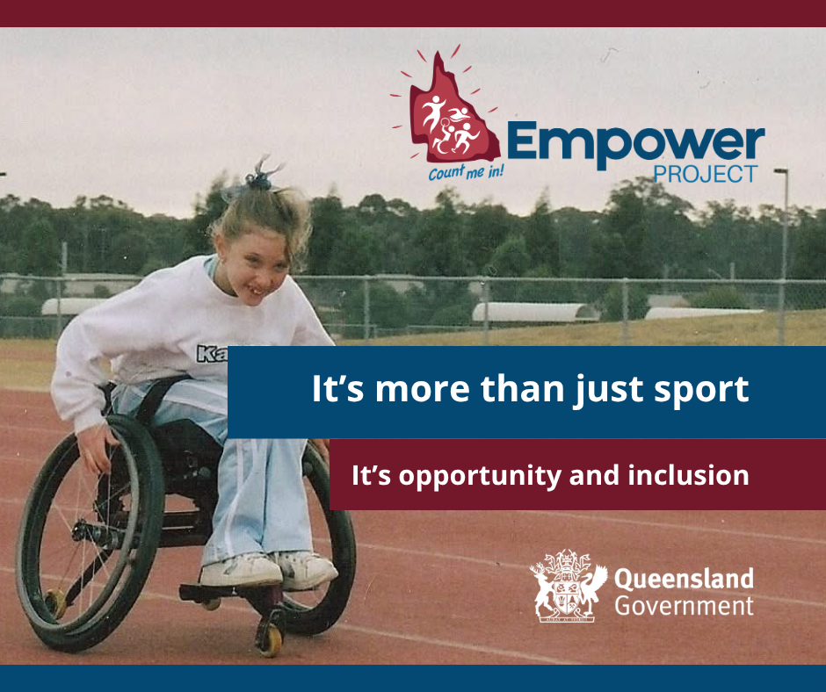  Alt Text:  A young girl in a white shirt and light blue pants in a manual wheelchair on a clay athletic track. Empower Project logo and text that says "Your voice can shape change – Every level of participation counts". Queensland government logo is at the bottom right corner. | You might know someone whose experience could help create change for people with disability.  A family member.  A friend.  A teammate.  A volunteer.  A coach.  Please share this survey with them.  The more voices we hear, the stronger the picture we can build and the better the outcomes for everyone.  👉 Complete the survey and share it with your community: https://bit.ly/EmpowerSurvey2026  The Empower Legacy Project is proudly supported by the Queensland Government.  #EmpowerCountMeIn #DisabilityQld #InclusiveSport #Brisbane2032 #2032Legacy #2032Games

Tile 15
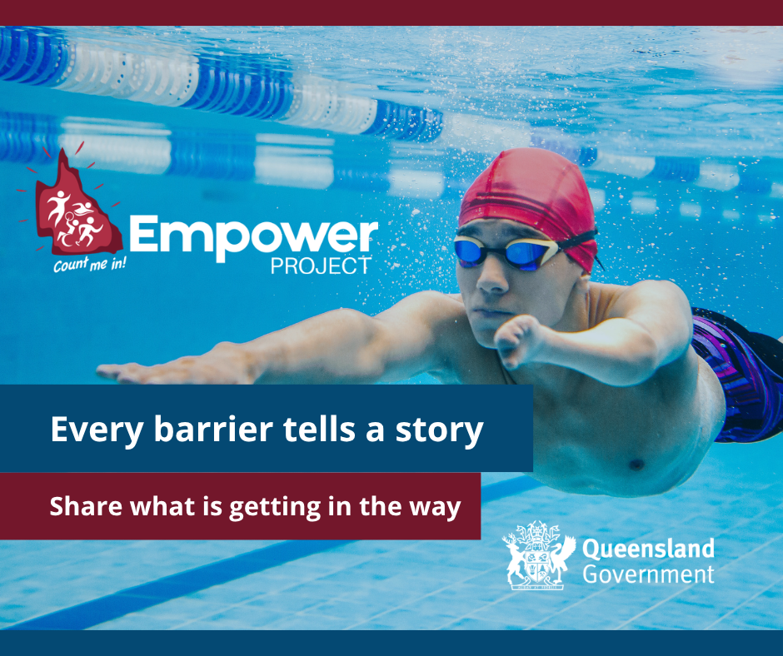  Alt Text:  A man in a red cap and goggles and a shorter arm swimming underwater. Empower Project logo and text that says "Every barrier tells a story – Share what is getting in the way". Queensland government logo is at the bottom right corner. | Better data means better opportunities for people with disability.  When you share your experience, it helps us see what's working, what's not, and what needs to change.  Empower is building a statewide picture to improve sport and physical activity opportunities for people with disability.  👉 Complete the survey and help guide what's next: https://bit.ly/EmpowerSurvey2026  The Empower Legacy Project is proudly supported by the Queensland Government.  #EmpowerCountMeIn #DisabilityQld #InclusiveSport #Brisbane2032 #2032Legacy #2032Games
‘

Tile 16
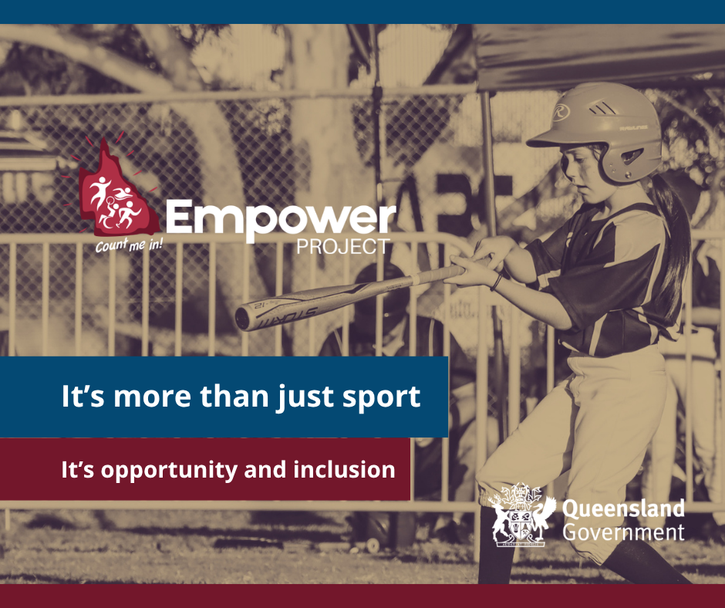  Alt Text:  A young girl in a helmet and wielding a baseball bat. Empower Project logo and text that says "It’s more than just sport – It's opportunity and inclusion". Queensland government logo is at the bottom right corner. | Inclusion in sport and physical activity strengthens clubs, communities and participation pathways - from grassroots through to elite sport.  Everyone deserves the opportunity to participate in ways that are meaningful to them.  Empower is building a statewide picture to improve sport and physical activity opportunities for people with disability.  👉Share your story: https://bit.ly/EmpowerSurvey2026  The Empower Legacy Project is proudly supported by the Queensland Government.  #EmpowerCountMeIn #DisabilityQld #InclusiveSport #Brisbane2032 #2032Legacy #2032Games

Tile 17
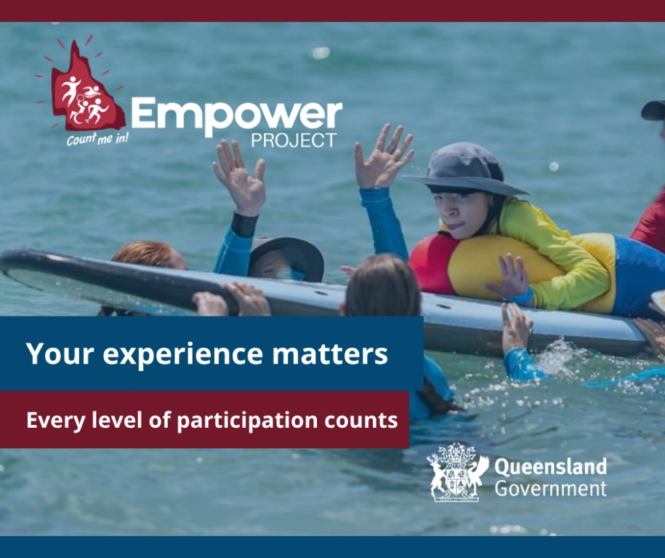  Alt Text:  A young boy with a hat and yellow shirt on a surfboard being supported by other young people in blue shirts all around the surfboard out in the ocean. Empower Project logo and text that says "Your experience matters – Every level of participation counts". Queensland government logo is at the bottom right corner. | Data tells us what is happening.  Your story helps us understand why.  Every response represents a real person, real experiences and real opportunities to improve inclusion.  Your voice can help shape future programs, policies and community sport across Queensland.  Your experience matters.  👉 Complete the survey and help turn lived experience into lasting change for people with disability: https://bit.ly/EmpowerSurvey2026  The Empower Legacy Project is proudly supported by the Queensland Government.  #EmpowerCountMeIn #DisabilityQld #InclusiveSport #Brisbane2032 #2032Legacy #2032Games

Tile 18
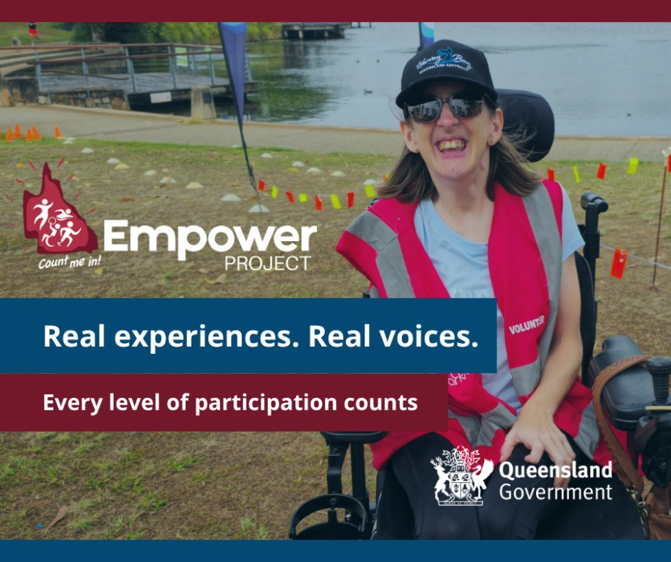  Alt Text:  A woman wearing sunglasses and a cap with shoulder length brown hair in a pink vest that says volunteer in a power wheelchair. Empower Project logo and text that says "Real experiences. Real voices. Every level of participation counts". Queensland government logo is at the bottom right corner. | Community sport is stronger when everyone feels welcome.  If you're a person with disability who plays, coaches, volunteers, or is part of a local club or group, we want to hear from you.  Your experiences - good, bad, or somewhere in between - will help shape more inclusive sport and physical activity across Queensland.  Clubs, coaches and families: please share this with your members too, so we can hear from as many people as possible.  👉 Take part today: https://bit.ly/EmpowerSurvey2026  The Empower Legacy Project is proudly supported by the Queensland Government.  #EmpowerCountMeIn #DisabilityQld #InclusiveSport #Brisbane2032 #2032Legacy #2032Games

Proposed email copy
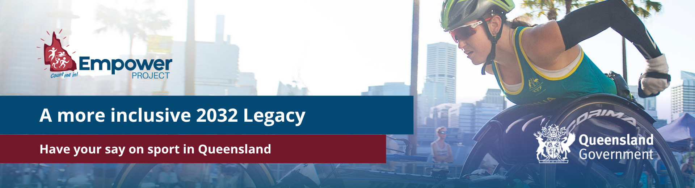
Alt Text: A woman wearing racing sunglasses, a helmet and arm warmers is pushing a racing wheelchair on with buildings in the background. The Empower Project logo and text that reads “A more inclusive 2032 Legacy, Have your say on sport in Queensland. Queensland government logo is at the bottom right corner.

Dear <INSERT NAME>
Empower Legacy Project – ‘Count Me In’ Survey
We imagine a Queensland where every person with disability can take part in sport and physical activity in ways that matter to them.
This survey is an opportunity to help shape a lasting legacy for the 2032 Olympic and Paralympic Games.
We want to hear from you.
Tell us about your experiences with sport and being active:
- What sports or physical activity do you enjoy?
- What makes it harder to take part?
- What helps you join in?
- What would make things better?
Your voice and experiences matter.
What you share will help build the evidence needed to create real change in sport and physical activity across Queensland - so more people with disability can say “Count Me In”.
The survey takes about 15 minutes to complete, and you can do it in your own time. You can skip any questions you do not want to answer, and you can stop at any time.
Survey link: https://bit.ly/EmpowerSurvey2026
Survey closes: 4th of December 2026
If you would like support to complete the survey, you can the Empower team on 1300 363 783 or email qdn@qdn.org.au.
The Empower Legacy Project is proudly supported by the Queensland Government.
Thank you for sharing your experiences with us.

Video
Hear from the Empower team about the vision for more inclusive sport and physical activity in Queensland and why we want people to say Count Me In.
Video link: https://vimeo.com/1218755174

Website/newsletter
Short version
Heading: Help shape inclusive sport in Queensland
The Empower project is the first Queensland Government funded 2032 Games Legacy Project, co-designed with people with disability. We’re building a long-term picture of how Queenslanders with disability take part in sport and physical activity – and what gets in the way.
Your experience will help shape funding, policy and program design across the state.
Complete the survey.
The Empower Legacy Project is proudly supported by the Queensland Government.

Long version
Heading: Be part of the Empower Legacy Project
How inclusive is sport in your community – and what needs to change?
The Empower project is the first Queensland Government funded 2032 Olympic and Paralympic Games Legacy Project. Co-designed with people with disability, Empower is building a long-term data collection framework to understand how, where and why Queenslanders with disability do or don’t take part in sport and physical activity.
Your experience will help:
- Identify barriers such as access, cost, transport, confidence or information
- Inform funding, policy and program design
- Strengthen inclusive sport pathways, from grassroots to elite sport
- Contribute to a lasting legacy for the 2032 Games and beyond.
Take part in the survey https://bit.ly/EmpowerSurvey2026
The Empower Legacy Project is proudly supported by the Queensland Government.

