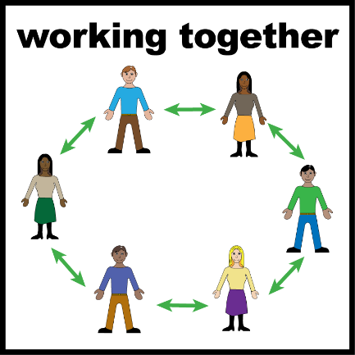
Autism In-Justice

Help us improve youth justice for Autistic young people
Reframing Autism is creating new training for youth justice staff across Australia.
We want the training to include the experiences of Autistic young people.
The project is funded by the Australian Government through the National Autism Strategy.
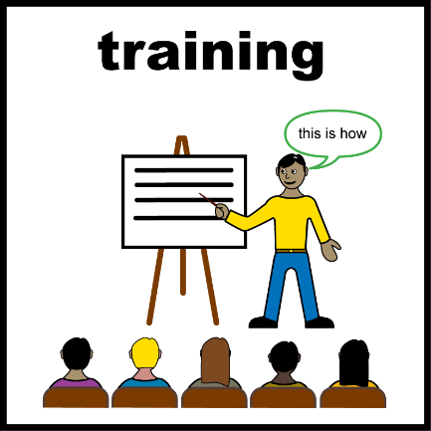

Why are we doing this project?
We want youth justice staff to:
- understand autism
- communicate well
- provide better support
- create safer experiences for Autistic young people.
Your experiences can help improve the youth justice system for other young people.


Who can take part?
You can take part if you are:
- Autistic (diagnosed or self-identified)
- between 14 and 25 years old
- have current or past experience with the youth justice system.
If you are 14 to 17 years old, your parent or guardian also needs to agree.


What is youth justice?
Youth justice may include:
- courts
- family group conferencing
- youth detention
- community supervision
- bail or parole
- rehabilitation programs.


Do I have to take part?
No.
Taking part is your choice.
You can:
- say yes
- say no
- change your mind later.
You do not have to tell us why.
What you tell us will not be shared with people making decisions about you.

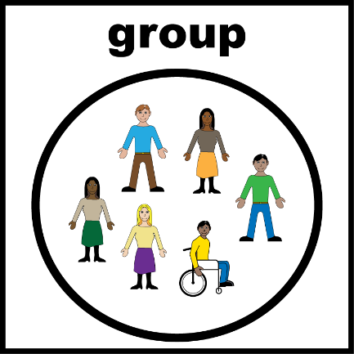
What will I do?
You can choose how you would like to take part.
You can:
Join a small online group discussion.
Have a one-to-one interview.
Complete an online survey.
Send us a video, voice recording, drawing or written response.
You can tell us the way that works best for you.
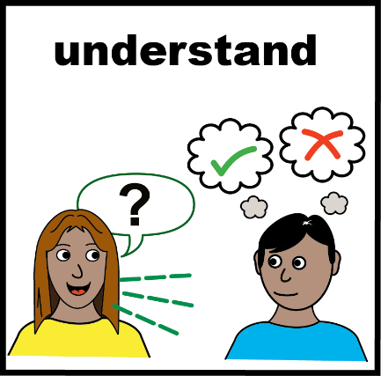

What will we talk about?
We want to learn about your experiences.
We will not ask about your offence, court case or criminal record.
We want to know:
- what helped
- what made things harder
- what youth justice staff understood
- what you wish staff knew about autism
- how the system could be better.

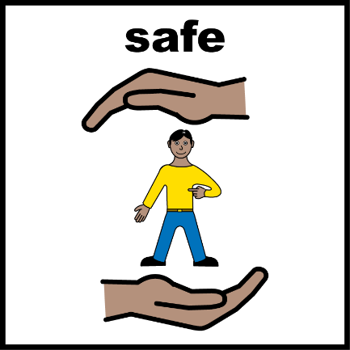
How will you support me?
We want you to feel safe and comfortable.
We can make changes to support your
- sensory needs
- communication needs
- access needs
- disability support needs.
You can:
- speak
- write
- type
- use Alternative Augmented Communication (AAC)
- communicate in another way that works for you.

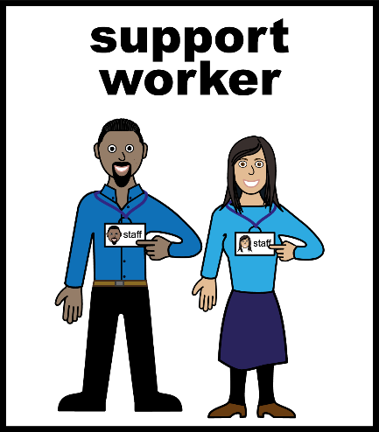
Can I bring a support person?
Yes.
You can bring someone you trust.
They can:
- help you communicate
- help you understand information
- provide emotional support
- attend activities with you.
You can decide how you would like your support person to be involved.


Will I be paid?
Yes.
To thank you for your time, you will receive an online $100 Prezzee voucher.

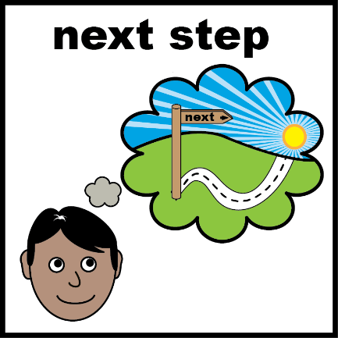
What happens next?
If you are interested:
- Complete the Expression of Interest form.
- We will contact you.
- We will send you more information.
- You can ask questions.
- If you decide to take part we will ask you to complete a consent form.


How do I complete the Expression of Interest form?
You can:
Type on the online form using this link:
Autism In-Justice - Expression of Interest Form
Write on the paper form and email it to us.
You can ask someone you trust to help you with the Expression of Interest form.
You can contact us if you would like help with the Expression of Interest form.
Email:
Autism.In-Justice@reframingautism.org.au

