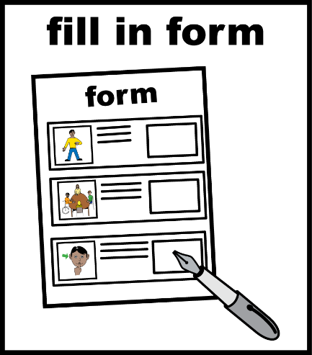
Autism In-Justice

Expression of Interest Form

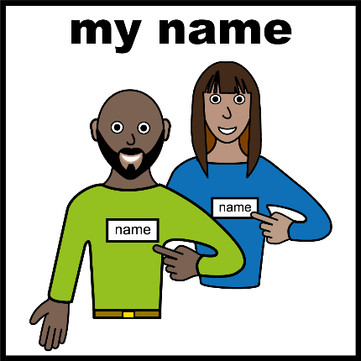

About You:
Name:
Preferred name:
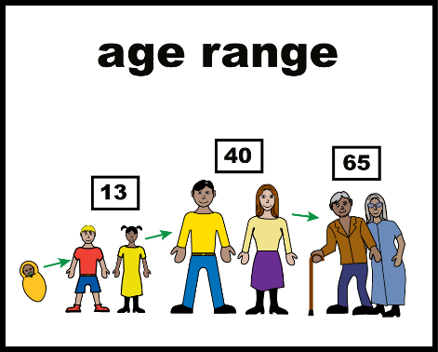

Your Age:
☐ 14 -17 years old
☐ 18 - 25 years old
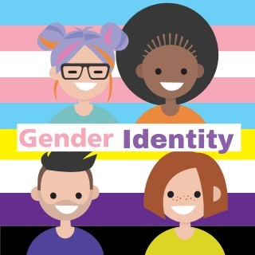
Your Gender:
☐ Male / Boy
☐ Female / Girl
☐ Non-binary
☐ Another Gender:

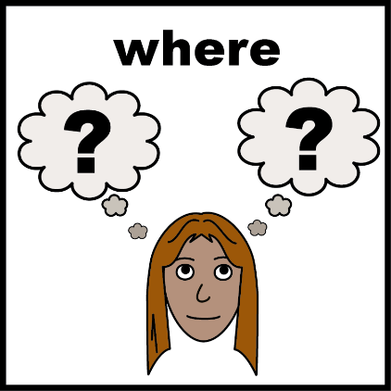
What state do you live in?
☐ Western Australia
☐ Northern Territory
☐ South Australia
☐ Queensland
☐ New South Wales
☐ Victoria
☐ Tasmania
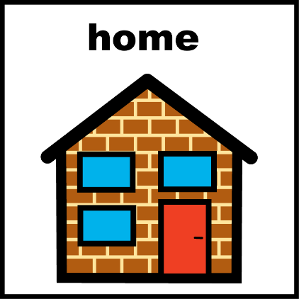
What type of area do you live in?
☐ City or large town
☐ Country town
☐ Far away from towns and services
☐ I don’t know
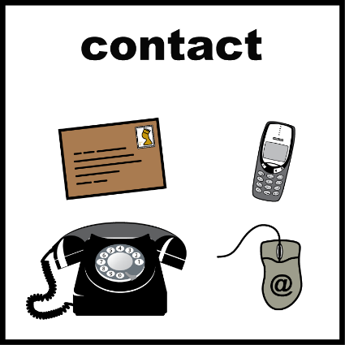
How can we contact you?
You can give us one or both.

Email:
Phone:

How would you like us to contact you?
Tick any boxes that are right for you.
☐ Phone call
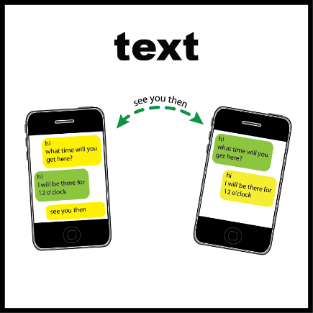

☐ Text message (SMS)


☐ Email

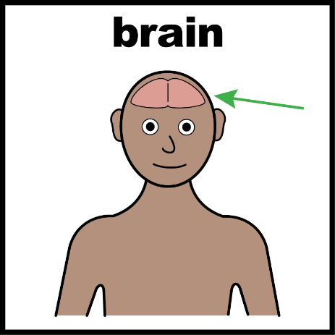
About How Your Brain Works
You can choose more than one answer.
☐ I am autistic.
☐ I have been diagnosed as autistic.
☐ My brain works differently in another way (for example, ADHD).


Do Any of These Describe You?
You can choose more than one answer.
☐ Aboriginal or Torres Strait Islander
☐ I come from a different cultural or language background (CALD)
☐ LGBTQIA+
☐ I have complex or high support needs
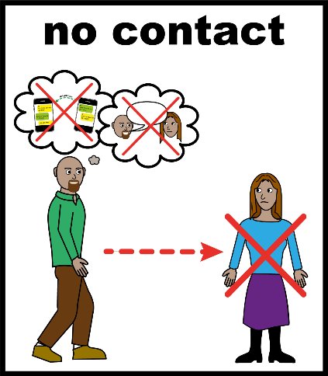
☐ I do not use speech (non-speaker)

Who we can not talk to
We cannot talk with young people who are currently in youth detention or currently under Youth Justice supervision in the community.
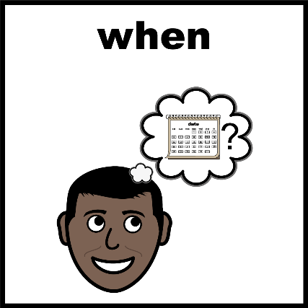
When Was Your Last Youth Justice Experience?
Tick one box.
☐ In the last 6 months
☐ In the last 12 months
☐ 1 to 2 years ago
☐ 2 to 4 years ago
☐ More than 5 years ago
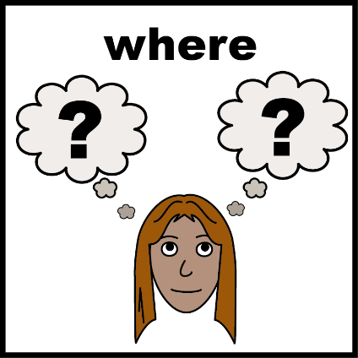
Which of these have you experienced?
You can choose more than one answer.
☐ Courts
☐ Youth detention
☐ Community supervision
☐ Something else:
_____________________________

How Would You Like to Take Part?
Tick any boxes that are right for you.
☐ Group activity (video call)


☐ One-on-one interview (video call)

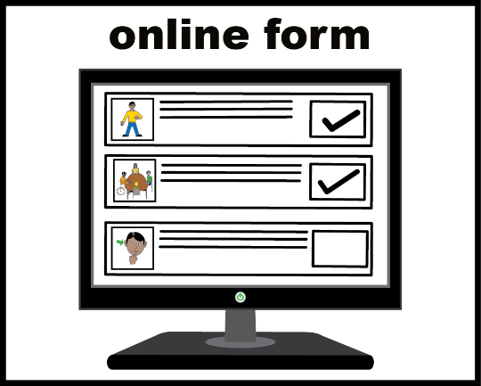
☐ Survey

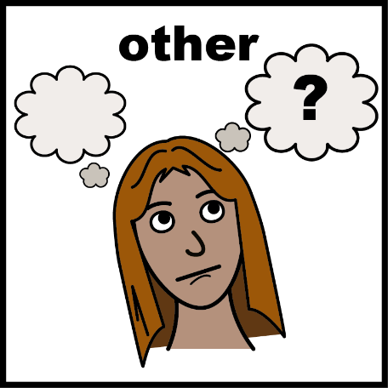
☐ Other:
_____________________________

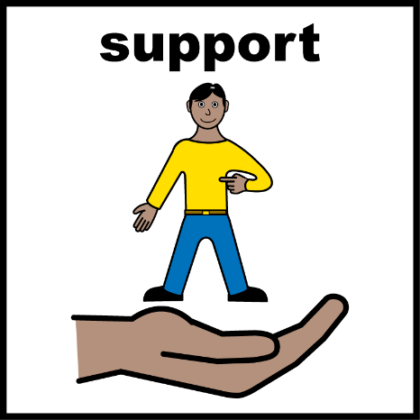
Would You Like to Bring a Support Person?
☐ Yes
☐ No
If YES, please tell us about them.
Name

Email
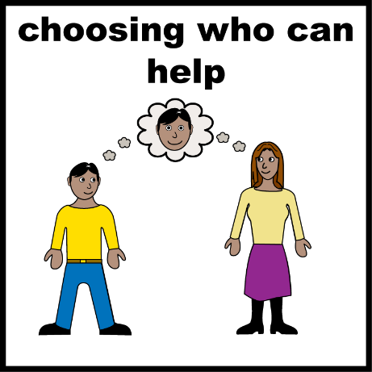
How do they know you?
(for example: parent, sibling, friend, support worker)

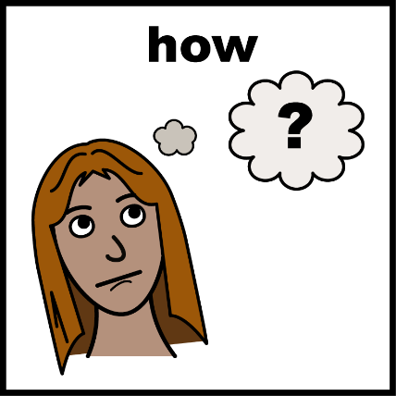
How Would You Like Your Support Person Involved?
Tick one or more boxes.
☐ Include my support person in all emails and communication.
☐ Include my support person only for information and invitations about the activity.
☐ My support person will attend with me.
☐ I will organise my own support.
☐ I would like to talk with Reframing Autism about getting a support person.
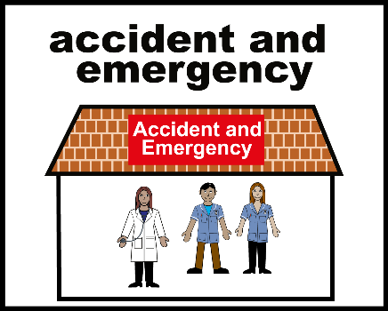
Emergency Contact
We will only contact this person if we are very worried that you or someone else is not safe.

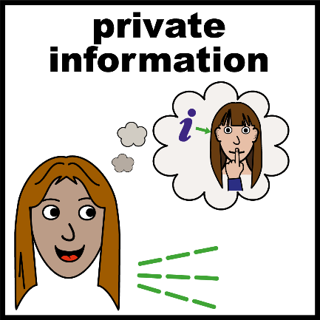
We will keep what you tell us private, unless we need to share information to help keep someone safe.

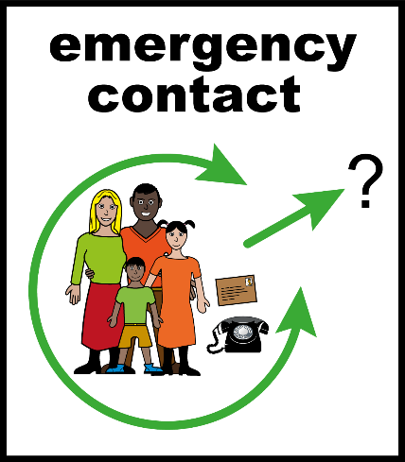
Emergency Contact Details
Name

Phone number

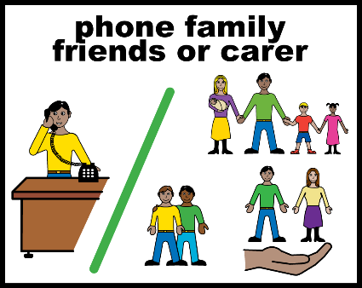
How do they know you?
(for example: family, friend, support worker)

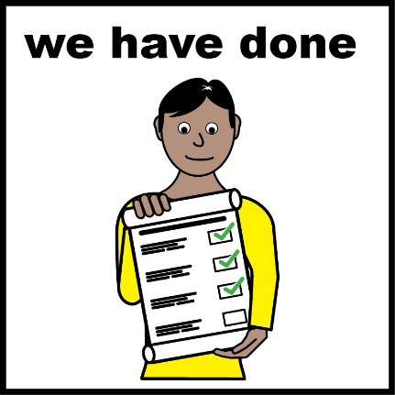

This is the end of the form.



Please send this form to:
Autism.In-Justice@reframingautism.org.au

All Images/Resources copyright © LYPFT

