
The Voice of Queenslanders with Disability: Report 2024
Authors: Kelsey Chapman, Alicia Yon and Elizabeth Kendall July 2024



Suggested Citation
Chapman, K., Yon, A., Kendall, E. (2024). The Voice of Queenslanders with Disability. Griffith University.

Published by
Inclusive Futures: Reimagining Disability, Griffith University 1 University Drive, Southport, QLD 4215
www.griffith.edu.au/research/inclusive-futures-reimagining-disability

© Griffith University 2024

A Note on Terminology
Everyday language plays an influential part in forming people’s perceptions and identities. In this report, we have used person-first language, focusing on the individual first and then, if at all, disability or impairment. We recognise and uphold every individual’s right to self-identify the terms, pronouns, and language that is best for them, and we respect individual use of language and terminology. Where a person does not state their preferred language, person-first language is used. We have also used the terms ‘First Nations’ and CALD (Culturally and Linguistically Diverse) throughout this report to represent Queenslanders with disability who identify as Aboriginal or Torres Strait Islander or culturally diverse. We acknowledge that these may not be preferred terminology for everyone and respect the right for people to choose their own terminology. We also acknowledge the emergence of new terminologies and preferences which may render our terminology choices inappropriate. Disability, in the context of this report, is grounded in the United Nations Convention on the Rights of Persons with Disabilities (CRPD) and is conceptualised as resulting “from the interaction between persons with impairments and attitudinal and environmental barriers that hinders full and effective participation in society on an equal basis with others”.1

Acknowledgements
We gratefully acknowledge the many people with disability, families and carers, and organisation representatives who contributed to this research. We would like to acknowledge the six citizen scientists with lived experience of disability who worked with us on this research – Karin Swift, Lisa Bagnall, Erica Golding, Natacha Kamp, Kate Dufty, and Maria O’Hara. Thank you for sharing honestly and authentically about your experiences and for encouraging others in the community to do the same. Thank you to our partners and funders, QDN and the Department of Child Safety, Seniors and Disability Services, for engaging us in this research and supporting and guiding us through the process. A specific thank you to Michelle Moss, Stephen Coulter, Karen Maciolek and Carla Mendoza for their contribution to the success of this initiative.

All graphic design were created by Joe-Anne Kek-Pamenter.


Acknowledgement
We acknowledge the Traditional Owners of the lands throughout Queensland. We pay our respects to Elders – past, present, and emerging – and acknowledge the important role Aboriginal and Torres Strait Islander people continue to play within the community. We also acknowledge people with disability who have come before us and died in institutional settings, as well as those who are still trapped in institutions or silenced by institutional practices. Queenslanders with Disability Network takes on the responsibilities of being clear about the rights of all people with disability and, where necessary, they speak in an informed and considered manner for those who cannot speak for themselves.

Table of Contents

Suggested Citation 2
Published by 2
A Note on Terminology 2
Acknowledgements 3
Acknowledgement 4
Table of Contents 5
List of Figures 8
List of Abbreviations 9
- Introduction 10
- Executive summary 12
- Context 20
  - National Context 20
  - Queensland Context 20
- Approach 22
  - Terms of Reference 22
  - Survey sample 24
- Results 29
  - Employment and financial security 33
    - Employment and financial security achievements 33
    - Employment and financial security challenges 35
    - Family and carer perspectives on employment and financial security 39
  - Inclusive homes and communities 41
    - Inclusive homes and community achievements 42
    - Inclusive homes and community challenges 44
    - Family and carer perspectives on inclusive homes and community 48
  - Safety, rights and justice 50
    - Safety, rights, and justice achievements 51
    - Safety, rights, and justice challenges 52
    - Family and carer perspectives on safety, rights, and justice 54
  - Personal and community support 56
    - Personal and community support achievements 57
    - Personal and community support challenges 58
    - Family and carer perspectives on personal and community supports 60
  - Education and learning 62
    - Education and learning achievements 63
    - Education and learning challenges 64
    - Family and carer perspectives on education and learning 66
  - Health and wellbeing 69
    - Health and wellbeing achievements 70
    - Health and wellbeing challenges 71
    - Family and carer perspectives on health and wellbeing 75
  - Community attitudes 76
    - Community attitudes achievements 77
    - Community attitudes challenges 78
    - Family and carer perspectives on community attitudes 80
- Strategic areas for action 81
- Strengthen economic security and increase financial supports 81
- Develop comprehensive approaches to standard of living and inclusion 82
  - Increase access to accessible and affordable housing 82
  - Improve the accessibility and reliability of transportation 83
  - Enhance inclusive employment practices and opportunities 84
  - Enhance professional training and quality support services 85
- Enhance dignity and equity 85
  - Continue to raise awareness and foster inclusion 86
  - Address the urban and regional/rural/remote divide in equity and access 87
  - Promote inclusive education and learning 87
  - Improve healthcare access, support, and equity 88
  - Advocate for policy reform 89
- Improve and increase support for family and carers 89
6.5 Summary of strategic areas for action 91
References 101
Appendix 1: Executive Summary Dashboard 103
Appendix 2: Trends highlights from 2023 to 2024 107
Appendix 3: Survey Participant Demographics 109
Appendix 4: Disability Identity 110
Appendix 5: State Disability Plan Outcome Areas and Policy Priorities 111
Appendix 6: Services and support utilised by participants with disability 114
Appendix 7: Experiences and outcomes with services and supports 115
Appendix 8: Some key recommendations from the 2023 NDIS Review 116
Appendix 9: Some key recommendations from the 2023 Disability Royal Commission
. 119
Appendix 10: Griffith Inclusive Futures 121

List of Figures
Figure 1: Executive Summary Dashboard 15
Figure 2: 2023 and 2024 Trends over Time 17
Figure 3: Queensland Context 21
Figure 4: Demographic Details of Participants 26
Figure 5: Disability Identity (self-reported) 27
Figure 6: Location of Survey Participants with Disability 28
Figure 7: Rating of Trends in Quality of Life by Survey Participants with Disability 30
Figure 8: Services and supports Utilised by Participants with Disability 31
Figure 9: Experiences and Outcomes with Services and Supports Rated by Participants with Disability 32
Figure 10: Employment and Financial Security for Participants with Disability 33
Figure 11: Inclusive Homes and Communities Results from Participants with Disability
. 42
Figure 12: Safety, Rights, and Justice Results from Participants with Disability 51
Figure 13: Personal and Community Support Results from Participants with Disability
. 57
Figure 14: Education and Learning Results from Participants with Disability 63
Figure 15: Health and Wellbeing Results from Participants with Disability 70
Figure 16: Community Attitudes Results from Survey Participants with Disability 77

List of Abbreviations

ABA | Applied Behavioural Analysis Therapy
ADHD | Attention-deficit/hyperactivity disorder
ADS | Australia’s Disability Strategy 2021-2031
CALD | Culturally and Linguistically Diverse
CRPD | United Nations Convention on the Rights of Persons with  Disabilities
DCSSDS | Department of Child Safety, Seniors and Disability Services
DDA | Disability Discrimination Act 1992
DSE | Disability Standards for Education 2005
DSP | Disability Support Pension
FC | Families/carers of people with disability (participant code for  quotes)
GP | General Practitioners
LGBTIQA+ | Lesbian, gay, bisexual, transgender, intersex, queer, asexual, and  other sexually or gender diverse
ME/CFS | Myalgic Encephalomyelitis/Chronic Fatigue Syndrome
NDIA | National Disability Insurance Agency
NDIS | National Disability Insurance Scheme
ORG | Organisational participants (participant code for quotes)
PBS | Pharmaceutical Benefits Scheme
PWD | People with disability (participant code for quotes)
QDN | Queenslanders with Disability Network
SDA | Specialist Disability Accommodation
SIL | Supported Independent Living
TMR | Department of Transport and Main Roads

Introduction
The Voice of Queenslanders with Disability report shares high-level insights gathered from a sample of 427 Queenslanders with disability (136 more than in 2023), 188 family/carers (71 more than in 2023), and 25 organisational representatives (9 less than in 2023), who engaged with the survey over a six-week period in 2024. Different versions of the survey were developed for each group: one for people with disability, one for family/carers, and one for disability organisations. Queenslanders shared the achievements and challenges they were experiencing, often sharing personal stories with candour.

This report builds on the 2023 baseline insights across all seven outcome areas of Queensland’s Disability Plan 2022-2027: Together, a Better Queensland and Australia’s Disability Strategy 2021-2031 (ADS).2,3 Comparing the 2023 and 2024 cohorts, there was similar representation from First Nations people with disability (4%) but slightly stronger representation from people living in regional, rural and remote areas (39.3%), an increase of 7.8% from 2023. This year, there was also improved representation from people living in “Tier 3” supported accommodation under the National Regulatory System for Community Housing. These increases reflected our deliberate attempts to amplify the voices of those that were not included in 2023.

Although many people completed the survey and shared their stories, we note that there was no single ‘voice of disability’ in Queensland. Many participants shared diverse and often divergent experiences, even in the same circumstances. It is important to recognise that the report does not represent all disability experiences or even a typical experience. However, it does present some key findings about what life is like for people with disability, their families and carers in Queensland. With repeated annual data collections, we will be able to paint a picture of the trends and shifts over time.

In the 2023 report, 29.4% participants shared that their life was getting better. However, this year, only 24.7% of people with disability felt that way. Most participants felt that their lives were staying the same (43.5%) or getting worse (31.9%) despite

ongoing commitments and progress towards change. Although some participants had stable income, employment, secure housing, good health and wellbeing, and good supports, just as many participants shared the opposite. This finding confirms the diverse experiences of people with disability and the inability to generalise when discussing disability.

Some people with disability and family/carers reported doing reasonably well despite a few challenges. However, participants were generally concerned about what the future might hold, particularly in relation to the ongoing cost of living crisis impacting the entire country. The overall findings of this report support the statement made in the 2023 report that “Queenslanders are experiencing a range of achievements and challenges, and it is important to consider multiple viewpoints when designing policies, support services, and implementing change”.4

We asked participants with disability and family/carers to share their individual experiences, and the ways in which the lives of all Queenslanders with disability could be improved through strategic actions across all levels of government, organisations, community and industry groups, and mainstream systems and services. Participants told us that action should be considered across a range of areas:

Some key recommendations identified by participants:
- Economic security to be strengthened and financial supports to be increased.
- A comprehensive approach to improving standards of living and inclusion initiatives in housing, transport, employment, and support services.
- Enhance dignity and equity for people with disability, including raising awareness and fostering inclusion, being treated with respect, addressing geographical disparities, improving inclusive education and learning, improving healthcare access and equity, and advocating for policy reform.
- Safety in relation to housing, educational facilities, transport, and the wider community.
- Improve and increase support for family and carers.

Executive summary
Hundreds of Queenslanders (640 participants) shared their experiences by participating in the “Voice of Queenslanders with Disability” survey: 427 people with disability, 188 family/carers, and 25 organisational representatives. There were 200 more participants than the 2023 report, representing a strong increase in engagement. The experiences were diverse and complex, reflecting a spectrum of lived experiences. Although the report may not be representative of all Queenslanders with disability, family/carers, and organisations across the State, there were some achievements, challenges, and strategic actions that were mentioned by the majority of participants. These common findings are important for developing key insights, even though we acknowledge the diversity of the experience of disability.

The importance of the Voice of Queenslanders with Disability survey was highlighted by participants. As in 2023, participants were enthused by the opportunity to share their stories, with one participant saying:

I think this survey and project are a really good start - and gives me hope! Investing in understanding the communities you aim to serve is an important part of making inclusive and accessible outcomes (PWD27).

The findings from this 2024 Voice of Queenslanders with Disability report are compared where possible to the 2023 baseline report. A repeated cross-sectional design was adopted due to the challenges of tracking individuals over time and the risk of identification of participants, particularly those living in small regional, rural or remote areas. Although participants were not tracked over time, this cohort comparison allowed us to identify how the lives of Queenslanders with disability might have changed over the past year.4 Over time, more definite trends and patterns will emerge while retaining the anonymity of those who participate. This report will help to identify achievements, challenges, and trends to inform planning and decision-making processes that could improve the lives of Queenslanders with disability.

Participants who engaged in the survey shared clear achievements. The majority of participants told us they were employed in good jobs (43.8%), lived in housing that met their needs (69%), felt safe (77.5%), and were happy (66.3%). People (62.6%) felt welcome and included in their communities and could pursue courses and training if they wanted to (60.6%). Participants with disability and family/carers who said that life had improved also reported having good financial security (46.5% had enough money to live on) and support (32.5% had paid support and 47.2% had unpaid support), including National Disability Insurance Scheme (NDIS) (51.5%) and other funding support (38% could get extra support when needed).

Participants told us they were experiencing challenges. More participants felt that life was getting worse this year (31.9%) compared to 24% in 2023. Even though the majority of participants had good jobs and felt welcome in their communities, over half of participants said that they did not have enough money to live well (53.1%), could not go anywhere they wanted to (56%), and did not have enough paid support (56.1%, which was an increase from 49% in 2023). Participants with disability and family/carers were negatively impacted by the ongoing cost of living crisis, which was exacerbating and creating many additional challenges from 2023. Participants’ views on education declined, with the number of people able to access courses dropping from 56% in 2023 to 30% in 2024. The reason for this drop was not clear. However, previously positive ratings of education also dropped from 77% in 2023 to only 30.9% in 2024. Participants who identified as having multiple types of disability, people living in regional, rural, and remote locations and First Nations people with disability were more likely to experience greater challenges than other participants.

Despite the challenges, participants were hopeful for the future and felt that Queensland was well placed to address their needs, through strategic actions that would improve the current circumstances for Queenslanders with disability. Participants recommended a range of strategic actions through collaboration across all levels of government, business, and community; underpinned by evidence and engagement with people with disability. These strategic actions were derived from participant insights in line with Queensland’s Disability Plan 2022-2027: Together, a Better Queensland and Australia’s Disability Strategy 2021-2031, and are consistent

with the findings from the 2023 NDIS Review, the 2023 Disability Royal Commission, and the philosophy set out in the CRPD.1,2,3,5,6

Several specific areas were identified by participants for future improvement. These strategic actions are clustered into four key themes: (1) strengthen economic security and increase financial supports; (2) develop comprehensive approaches to standard of living and inclusion; (3) enhance dignity and equity; and (4) improve and increase support for family and carers. Figure 1 on the next two pages provides a high-level overview of the responses to the quantitative survey questions by participants with disability. Figure 2, which is three pages, demonstrates the main trends from the 2023 report.

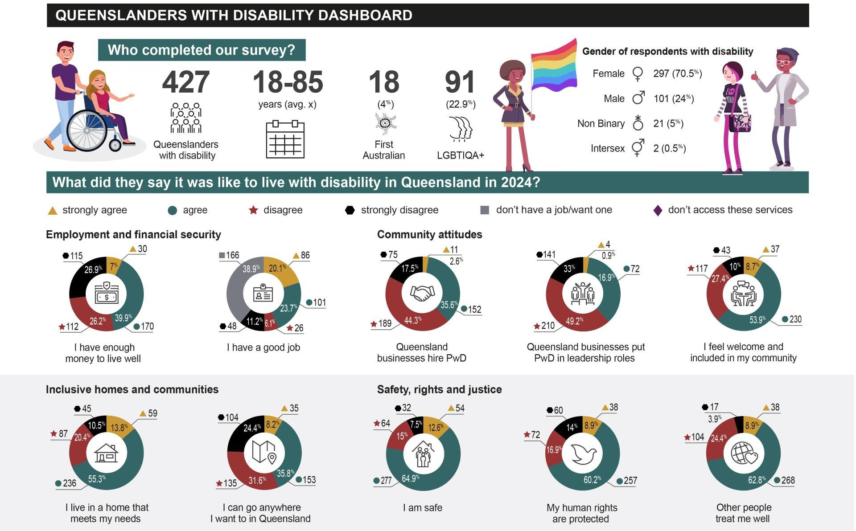
Figure 1: Executive Summary Dashboard

A strongly agree • agree
Personal and community supports
- disagree

  - strongly disagree

- don't have a job/want one

Education & learning

- don't access these services

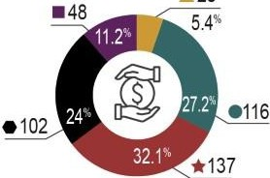
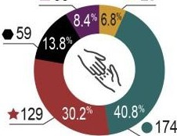
  - 23
  - 36

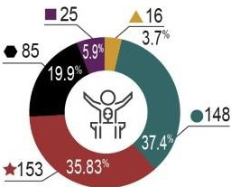
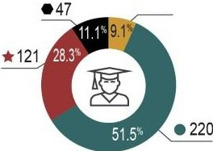

- 29
- 39

I have all the paid support I need

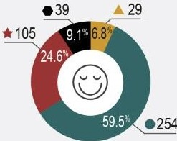
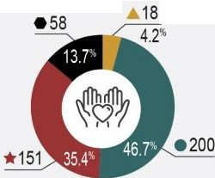
Health and wellbeing
I have all the unpaid support I need

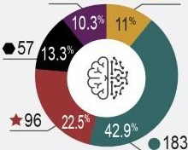
  - 44 •47
I can get extra support if I need it
I can do courses and training if I want to

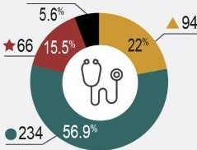
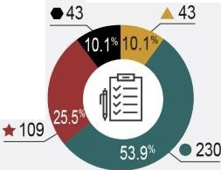
- 24

I am happy
I can access mental health services when I need them
I am healthy
I have access to a good primary care
doctor I GP
I have a plan to stay safe during disasters

How did their lives compare to early 2023?
* 100 (24.7%) | - 177 (43.5%) | .A. 130 (31.9°10}
*28 |  | .A. 154 (37.1%)

How does your life compare to this time last year?

How do the lives of all Queenslanders with disability compare to this time last year?

10 20 30 40 50 60 70 80 90 100

* It is better

- It is the same
.A. It is worse

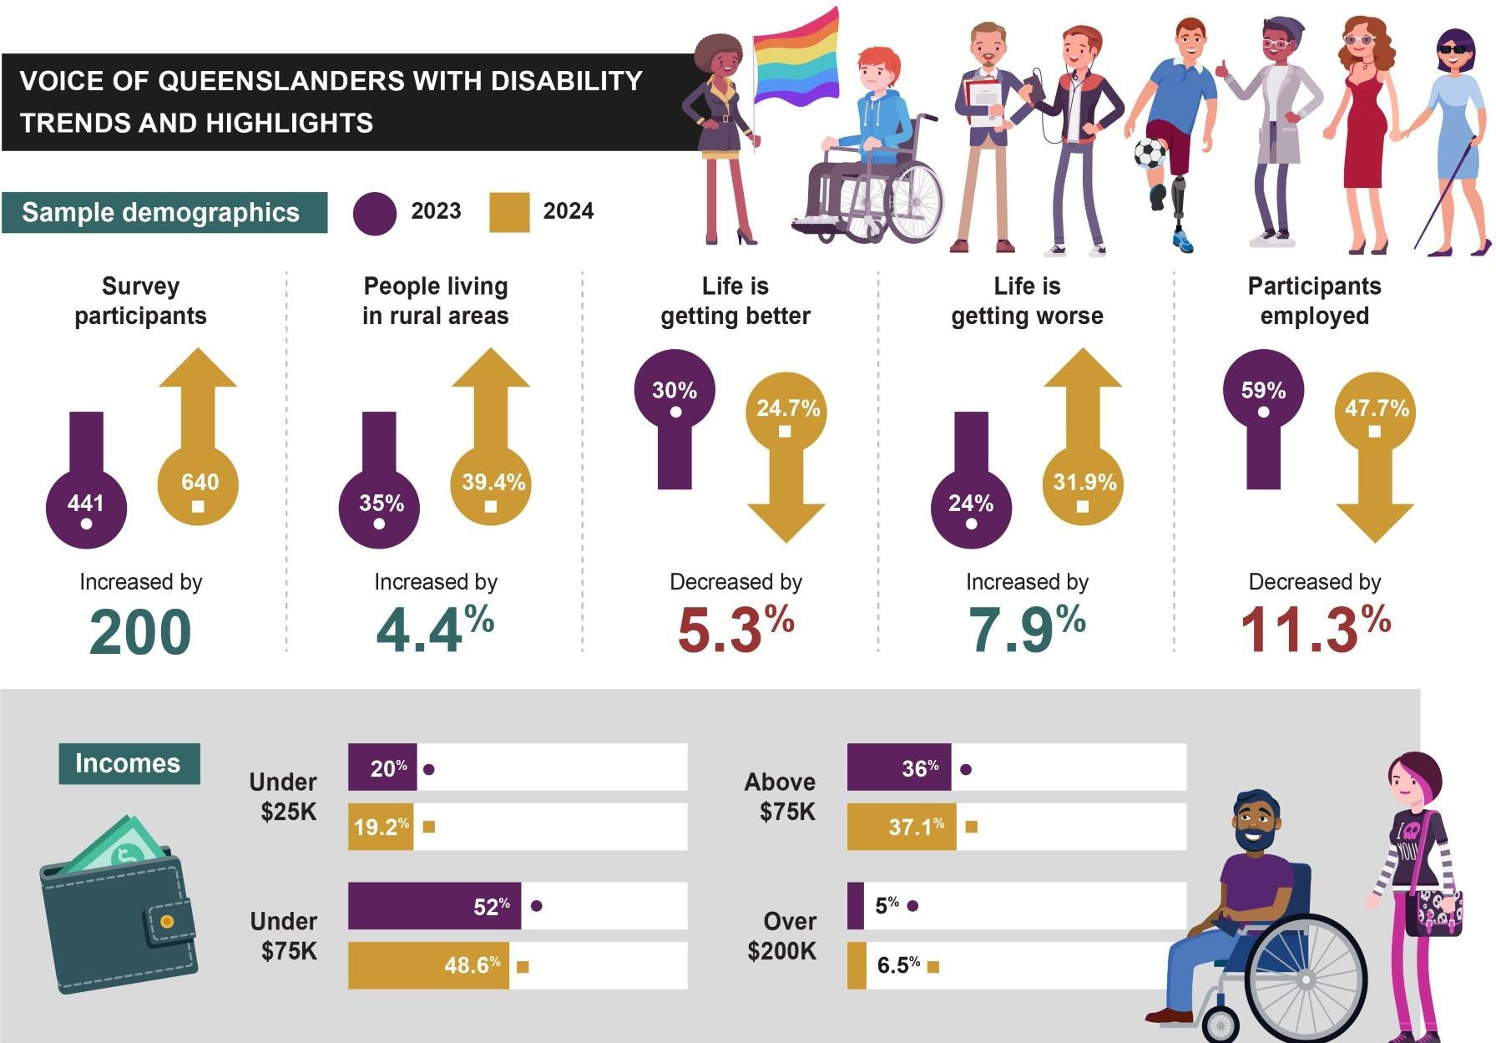
Figure 2: 2023 and 2024 Trends over Time


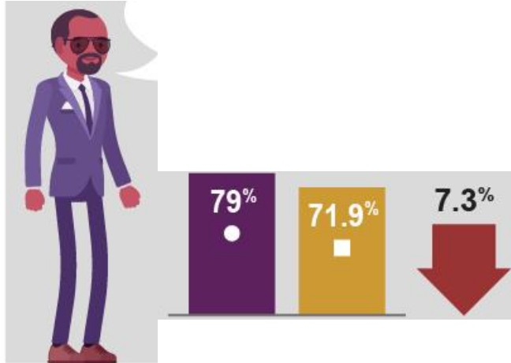
Jobs and money - 2023 ■2024
Safety and rights
I am safe
�
•2.5°10
My human rights
Other people treat me well


I have enough -0-
money to live well jm

I have a goodjob

Queensland businesses hire people with disability
Queensland businesses
put people with disability � in leadership roles

Qfj:@
NIAi
  - 46.9"!. ..
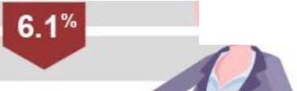


• 53°1•
•

43.8°1•
    - 56°10
•
•


- 38.2°10
- 33°10

0
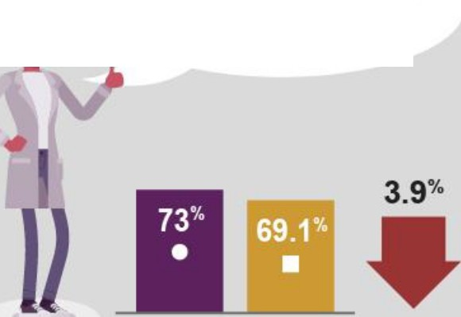
20 40 60 80 100
are protected

Inclusive
homes and communities
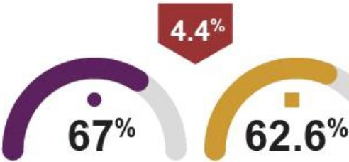
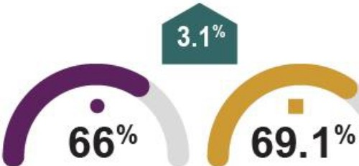
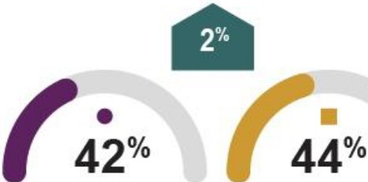

I feel welcome and included in my community


Decreased by
6.7010

Able to access public transport most of the time
I live in a home that meets my needs


Increased by

3.40/o
Having good public transport experiences
I can go anywhere

I want to in Queensland

Increased by

6.90/o
Experiencing difficulty accessing public facilities

Personal aind community supports
- 20!23 2!024

I have,all thie paid support I need
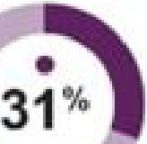
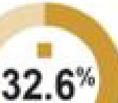
1.16'11-
t
I have all the unpaid support Eneed
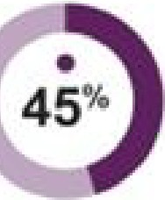
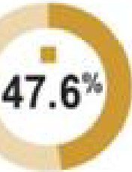
2.6 ·
t
I can get extira support if I need H

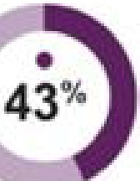
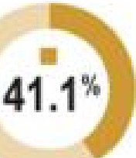



HeaHh and wellbeing I
Education and training
- 20:23
I c:,an do courses and training [1f I want to
Participants able to actess courses and education

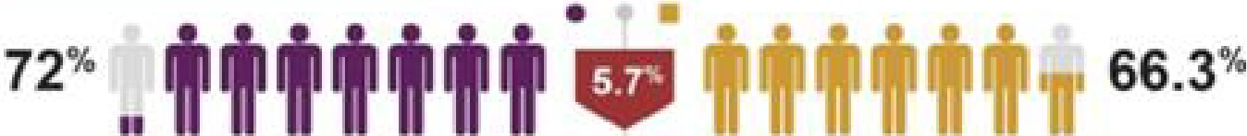
I am happy
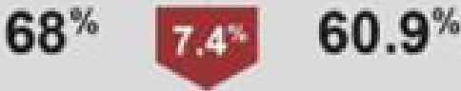




I can access mental health services whell'II I need them

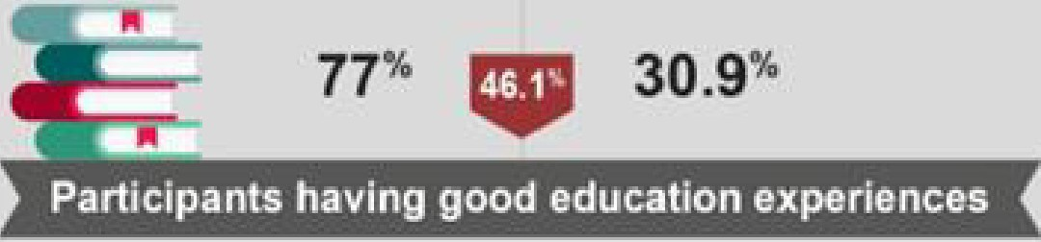
 50.9%

I have acce,ss to a good! primary care d'octor I GP

Context

National Context

Around 4.4 million Australians (18%) are estimated to have disability.7 Australia’s Disability Strategy 2021-2031 aims to help them fulfil their potential as equal members of an inclusive society.3 This strategy outlines improvements across seven outcome areas:
- employment and financial security
- inclusive homes and communities
- safety, rights, and justice
- personal and community support
- education and learning
- health and wellbeing
- community attitudes.3

The first report measuring outcomes of the ADS was released in February 2023, providing baseline information for each outcome area across Australia.8 In the past 12 months, Australia has undergone two major national pieces of reform, the Disability Royal Commission (DRC) into the Violence, Abuse, Neglect and Exploitation of People with Disability and the NDIS Review. The reports, released in September 2023 and December 2023 respectively, included a large range of recommendations (see Appendix 8 for NDIS Review and Appendix 9 for DRC Recommendations) to reform and transform mainstream systems and services and the lives of Australians with disability. Recommendations are now being considered by various levels of government.

Queensland Context

Over 935,000 Queenslanders (19%) have disability: 488,100 males (52%) and
449,500 females (48%).9 Less than 121,000 (40%) of these people receive support from the NDIS.10 Around 191,000 Queenslanders (4%) support people with disability as their primary carer: 137,200 females (72%) and 54,500 males (28%).11 Primary

carers tend to be partners (40%), parents (25%) or children (24%) of people with disability.9

Queensland’s Disability Plan 2022-2027: Together, a better Queensland, affirms our state’s commitment to becoming more welcoming, accessible and inclusive for people with disability.2 It aligns with Australia’s Disability Strategy 2021-2031, the 2023 NDIS Review, and the CRPD.1,3,5 Appendix 5 describes Queensland’s policy priorities for each outcome area.
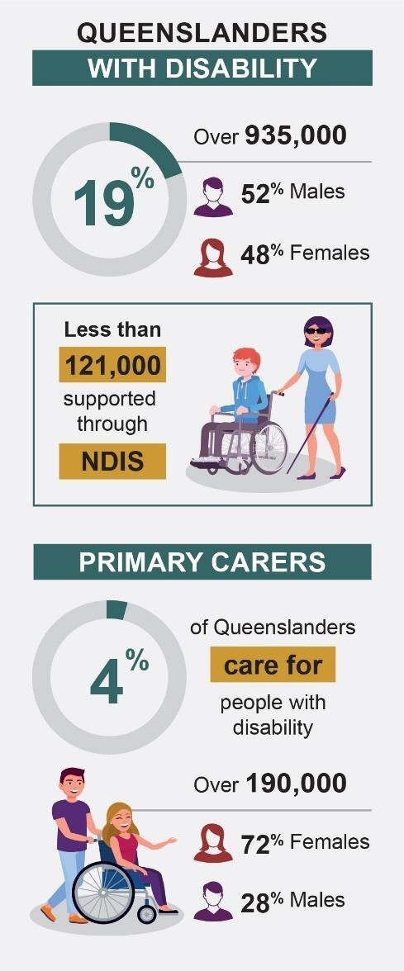
Figure 3: Queensland Context

Approach
In late 2022, Queenslanders with Disability Network (QDN) partnered with Griffith University’s Inclusive Futures: Reimagining Disability team (see Appendix 10) to produce a report representing “The Voice of Queenslanders with Disability”; funded by the Queensland Government’s Department of Child Safety, Seniors and Disability Services (DCSSDS). The report needed to provide information across the seven outcome areas in Queensland’s Disability Plan 2022-2027: Together, a Better Queensland, including an in-depth understanding of inclusion and service experiences, achievements, challenges, and strategic areas for action.2

The 2024 report builds on the report released in 2023. A repeated cross-sectional design was adopted due to the challenges of tracking individuals over time and the risk of identification of participants, particularly those living in small regional, rural or remote areas. In this approach, the same outcome areas are assessed to enable trends to emerge over time. Data is collected from different samples of people at multiple points in time. It is acknowledged that many participants will participate in multiple cohorts, but they are treated as independent samples. Analysis focuses on trends over time and no attempt is made to analyse this as longitudinal data.

Consistent survey questions and recruitment procedures are used to ensure that changes in responses reflect actual trends rather than differences in data collection methods. However, attempts were made to increase the size of the sample and to ensure representation of groups that may be easily overlooked. For instance, in 2024, effort was made to increase rural/remote and regional representation and also those living in more complex circumstances. In 2024, the sample size increased by 200 (described below). One consequence of this change in the sample is that it increases the risk that some increases or decreases in the findings may reflect changes in the sample constitution. This possibility must be kept in mind.

Terms of Reference

Griffith University, QDN, and DCSSDS created a reference group in 2023 to guide the development of the Voice of Queenslanders with Disability report, including people

with disability and family/carers from each organisation. This group informed survey development for three groups:
- Queenslanders with disability
- family, carer, and support networks of Queenslanders with disability
- disability support organisations.

Each survey included questions on demographics, achievements and challenges across each outcome area in Queensland’s Disability Plan 2022-2027: Together, a Better Queensland.2 In addition to quantitative questions, participants could opt to share qualitative experiences about each specific outcome area.

Griffith University and QDN partnered to identify, train, and support seven paid citizen scientists with disability in January 2024 who had recently completed the “Citizen Research Essentials” micro-credential training at Griffith University. Building on the citizen science approach developed by Griffith University’s “Dignity Project” team, the approach includes a bottom-up style of working with broad networks of people to bring real-world perspectives and experiences to the research process.12

The survey was open from 24 January 2024 and closed on 22 March 2024. The citizen scientists promoted the survey that underpinned this report to their networks and supported people to complete the survey as required (online, in-person, or over the phone). The survey was promoted through Griffith University, QDN, and DCSSDS networks, including newsletters, mainstream and social media, text messages, and cross-organisational signature blocks.

Following the survey closure, the Griffith University research team analysed the data from the survey to inform this report. Most of the quantitative (numerical) data was automatically tallied into response totals (counts and percentages) through EngagementHQ survey software.13 Extra descriptive insights were provided as appropriate (e.g., age range and average). Comparisons between the 2023 and 2024 results occurred. The qualitative data (e.g., descriptions of what was going well, what was not going well, and what could be improved) were thematically analysed by two

research fellows using NVivo, a data management tool. This information was incorporated into the results section of this report.

Survey sample

Many participants responded in both the 2023 and 2024 surveys. In 2024, there were 640 participants across the three groups, an increase of 200 participants from the 2023 survey. Participants included 427 people with disability (an increase of 136 from 2023), 188 family/carers (an increase of 71 from 2023), and 25 organisational representatives (a decrease of 9 from 2023). While this sample size is not necessarily reflective of Queenslanders with disability, all family/carers, and organisations, it does provide a useful baseline of what life is like for the survey participants and how it has changed, if at all, since the previous report. A breakdown of the demographics of the participants with disability and family/carers is included in Figure 4 and described below.

The participants with disability and family/carers came from diverse age groups, with an average age of 49 years for people with disability and 52.6 years for family/carers. The average ages were similar to the 2023 report, but the family/carer average age decreased by 5.4 years due to an increase in younger family/carer participants in 2024. Similarly to the 2023 report, participants were predominantly female (70.5% people with disability and 90.4% family/carers).

Intersectional groups were reasonably well represented within the survey sample, including 4% First Nations across both people with disability and family/carers, and 22.9% of people with disability identifying as lesbian, gay, bisexual, transgender, intersex, queer, asexual, and other sexually or gender diverse (LGBTIQA+). Although the majority of participants spoke English at home (98.6% of people with disability and 99.5% of family/carers), there was a slight increase in participants born in a country other than Australia where English was not the primary language (6.3%).

Participants lived primarily in urban locations (60.7% of people with disability and 65.4% of family/carers), but there was an increase in participation of people with

disability living in rural (7.3%) and remote areas (1.2%) in comparison to the 2023 report. Please see Figure 6 for the breakdown of geographic locations of people with disability who completed the survey.

People with disability and family/carers represented diverse types of disability, as shown in Figure 5. Among participants with disability, 20% reported having chronic illness/pain and another 20% reported having physical disability. However, only one-third (33%) of participants with disability reported having only one disability, reflecting the complexity of the population. Two-thirds (66%) of people with disability had two or more types of disability, the most frequent being chronic illness/pain which tended to co-occur with neurodivergence, neurological, physical, or psychosocial disabilities. Family/carers reported that they supported people who are neurodivergent (18.8%), who have sensory disability (15.1%), physical disability (13.2%), and intellectual disability (13%).

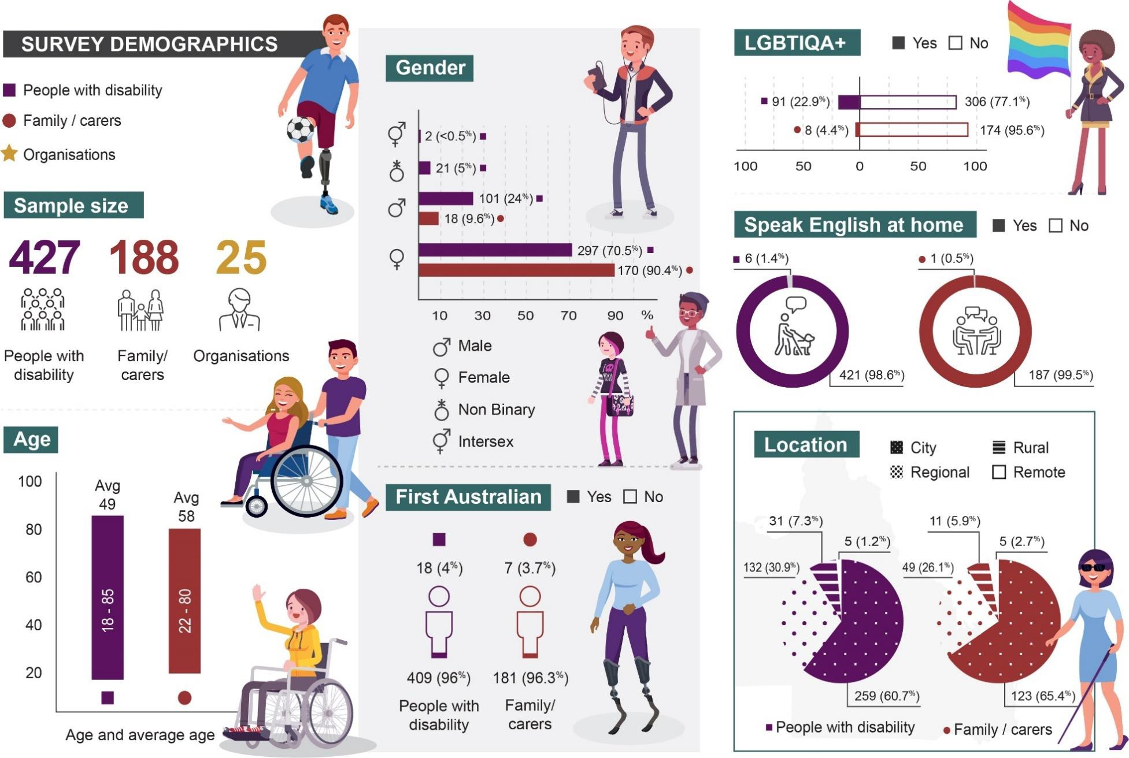
Figure 4: Demographic Details of Participants

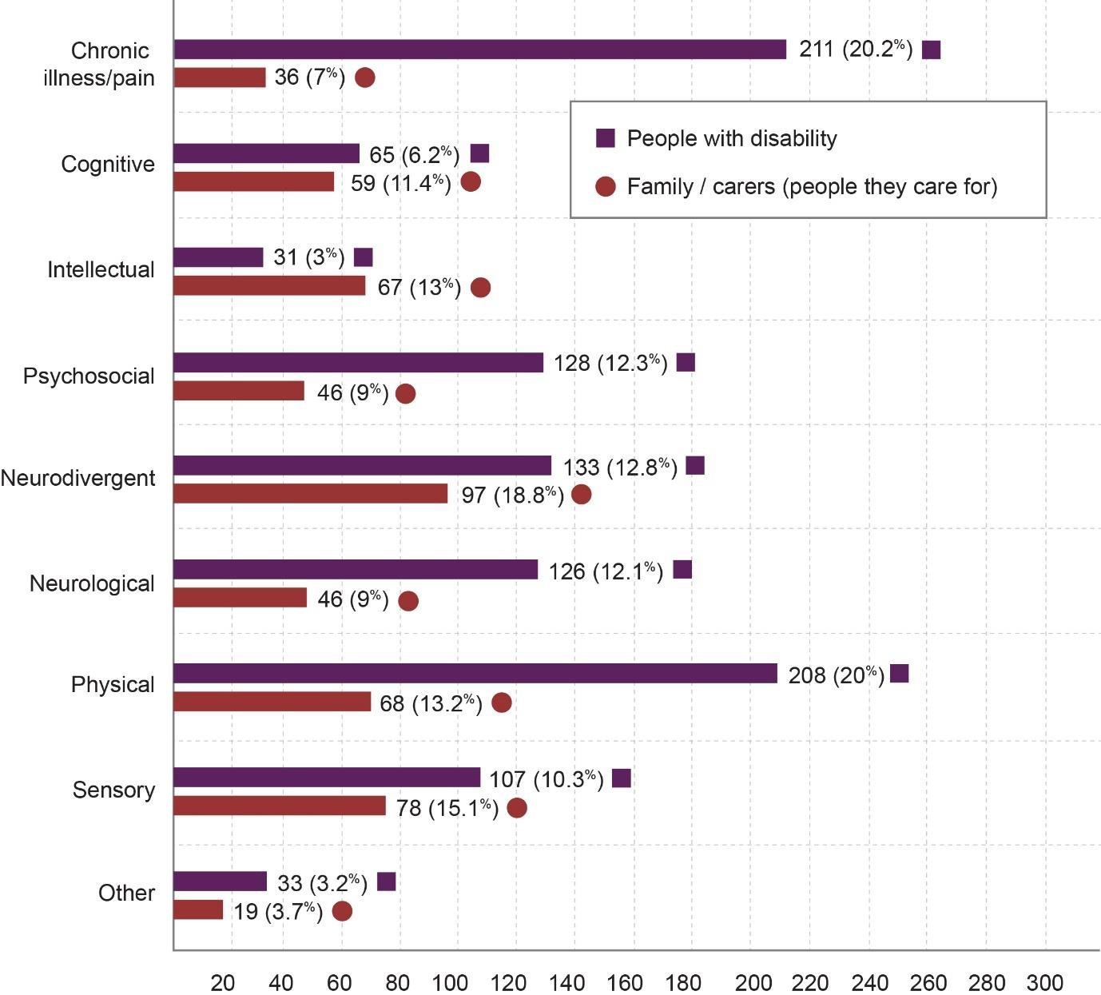
Figure 5: Disability Identity (self-reported)

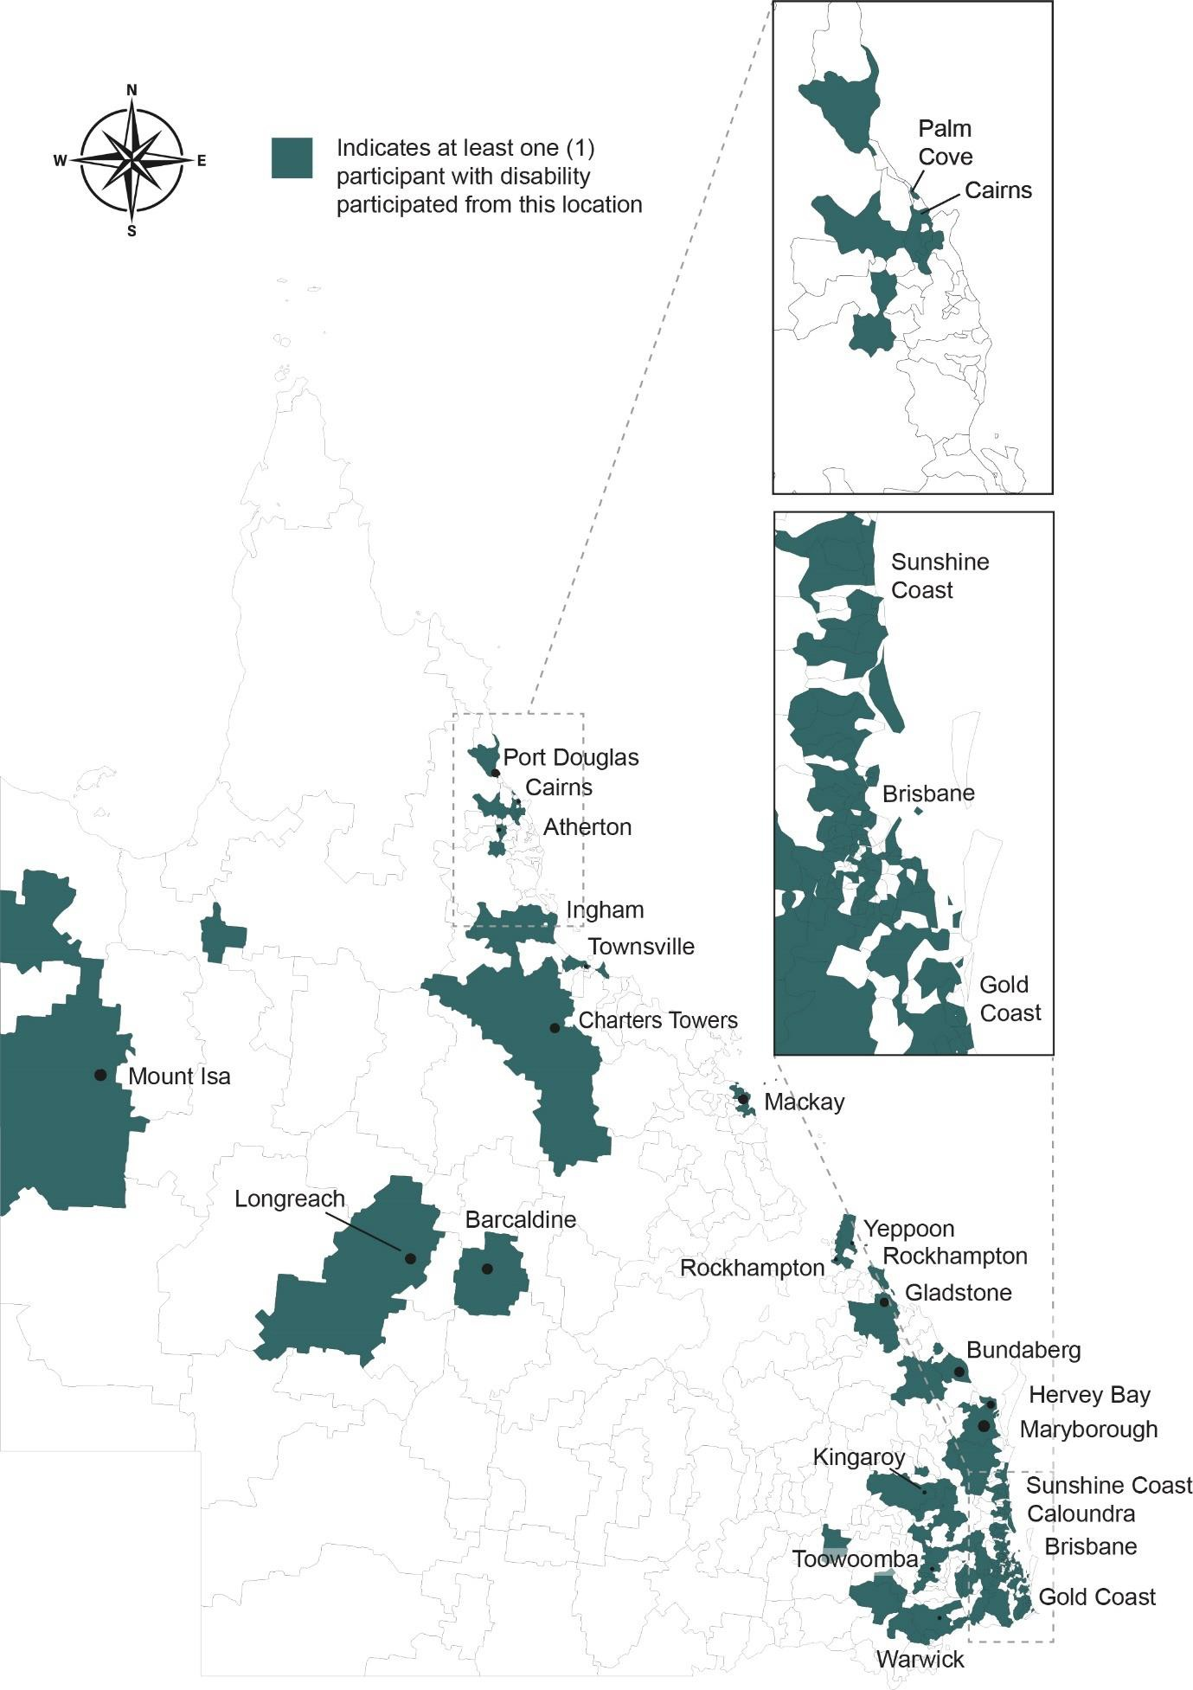
Figure 6: Location of Survey Participants with Disability

Results
This section of the report describes the Voice of Queenslanders with Disability survey results in a way that highlights the complex, subjective, and sometimes divergent voices of participants with disability, family/carers, and organisational representatives. Although the perspectives of people with disability are prioritised within the results section, the perspectives of family/carers and organisational representatives are included and highlighted.

Like the Voice of Queenslanders with Disability report from 2023, some people who participated in this study thought life was better than last year (24.7%). They reported having good jobs (43.8%), good housing (69%), and being safe (77.5%) and happy (66.3%). Around half (43.5%) of the people who participated in this survey told us that life was the same as last year, and this was true for many of the outcome areas. For some of these participants, life was stable but for others, this finding meant no improvement in some of the challenges they faced. The cost-of-living crisis, for example, continued to be concerning for most participants and weighed on their physical and mental health.

However, nearly one third (31.9%) of people who participated told us that life was worse than last year, an increase of 7.9% from the previous year. For those participants who said life was getting worse, poor physical and mental health, financial security and concerns about the future were frequent responses. These were universal challenges. For instance, the majority of all participants did not have enough money (53.1%) or paid support (56.1%) and could not move freely throughout the State (56%). To see how people reported that life had changed from last year, see Figure 7. To understand how participants rated their ability to access various mainstream systems and services and the quality of those experiences, see Figures 8 and 9.

As in the 2023 report, participants with disability with intersectional identities (e.g. sexuality, geographic location, cultural background, multiple disability identities) experienced challenges in accessing funding, services, and support. Non-urban

participants found it particularly difficult to access mainstream supports and services and commented that the disparities between urban and regional residents with disability seemed to be widening. Family/carer participants continued to experience a great deal of stress associated with the overwhelming administrative nature of the NDIS, challenges accessing mainstream services and supports, and a lack of support and recognition for the value of their caring role.

The remainder of the results section is presented according to the seven outcome areas in Queensland’s Disability Plan 2022-2027: Together, a Better Queensland and the ADS: (1) employment and financial security, (2) inclusive homes and communities,
(3) safety, rights, and justice, (4) personal and community support, (5) education and learning, (6) health and wellbeing, and (7) community attitudes.2,3

Each of the seven results sections includes the policy priorities for that outcome area, participant demographics related to the outcome area, and achievements and challenges identified by participants. Quotes from participants are included throughout in order to highlight experiences in peoples’ own words. Graphics depicting some results shared by people with disability are included within each outcome area (Figures 10-16).

As with the 2023 report, each outcome area is connected to, and impacts on, the other outcome areas. Achievements in one area likely contribute to achievements in others and vice versa, which demonstrates the complexity of the disability experience and the responses required to influence the future. Finally, following the results section, we have included a series of strategic actions derived from participants comments.
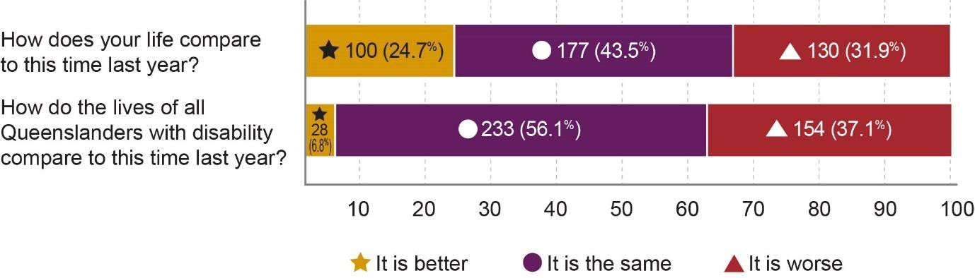
Figure 7: Rating of Trends in Quality of Life by Survey Participants with Disability

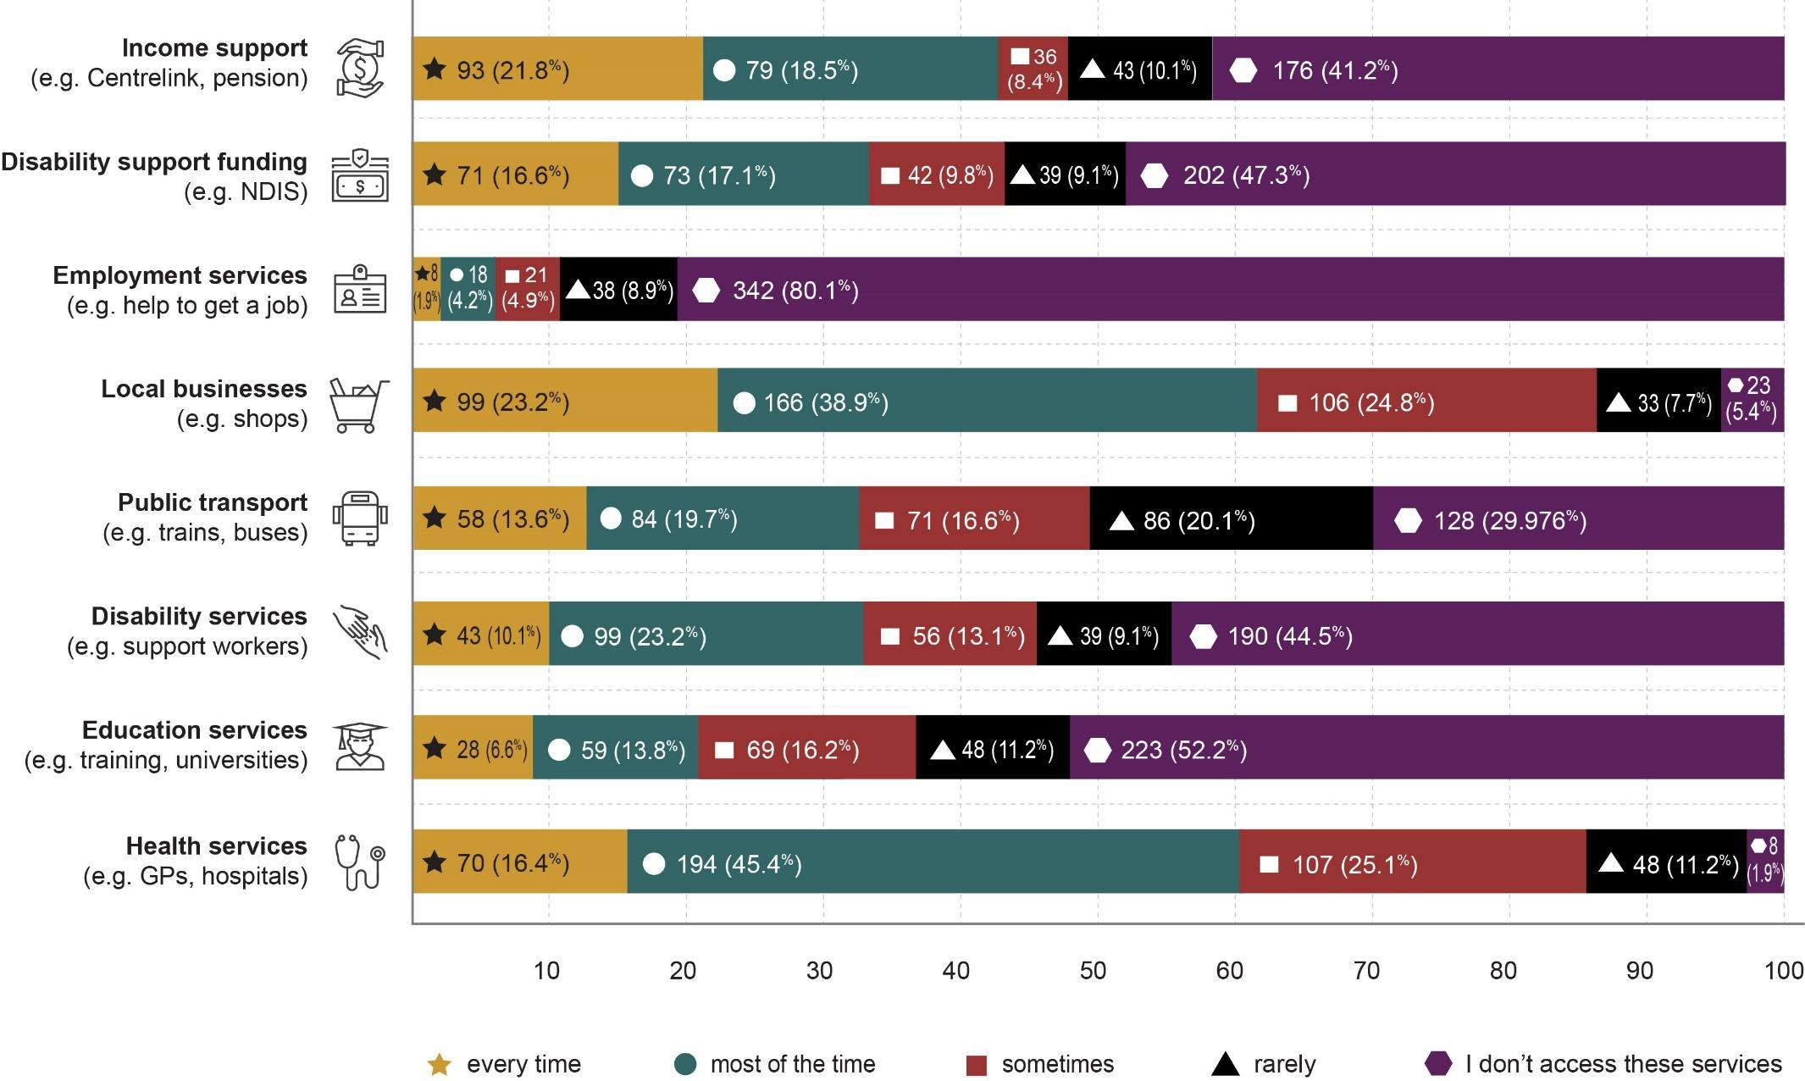
Figure 8: Services and supports Utilised by Participants with Disability

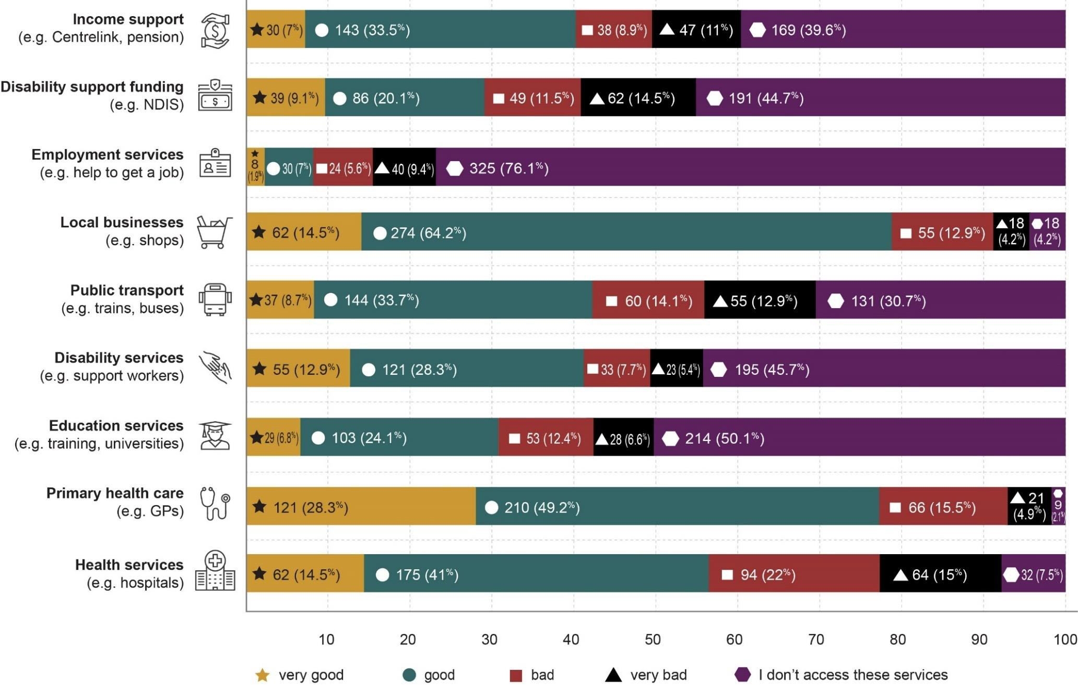
Figure 9: Experiences and Outcomes with Services and Supports Rated by Participants with Disability

Employment and financial security

Goal^{2,3} | People with disability have economic security, enabling them to plan for the  future and exercise choice and control over their lives.
Policy priorities^{2,3} | - Strengthen the financial independence of people with disability.  - Increase employment of people with disability.  - Improve the transition of young people with disability from education to employment.

Employment and financial security are important determinants of health and wellbeing, enabling people to experience a sense of meaning, connection and belonging, and obtain essential goods and services such as food, housing, and healthcare. The ‘employment and financial security’ outcome area in Queensland’s Disability Plan 2022-2027: Together, a Better Queensland2 aspires towards economic security, so all Queenslanders with disability can “plan for the future and exercise choice and control over their lives”.2 Its three policy priorities aim to strengthen the financial independence of people with disability, increase their employment, and improve the transition of young people with disability from education to employment. Twenty six percent (26%) of participants with disability provided additional qualitative information about their financial security and employment.

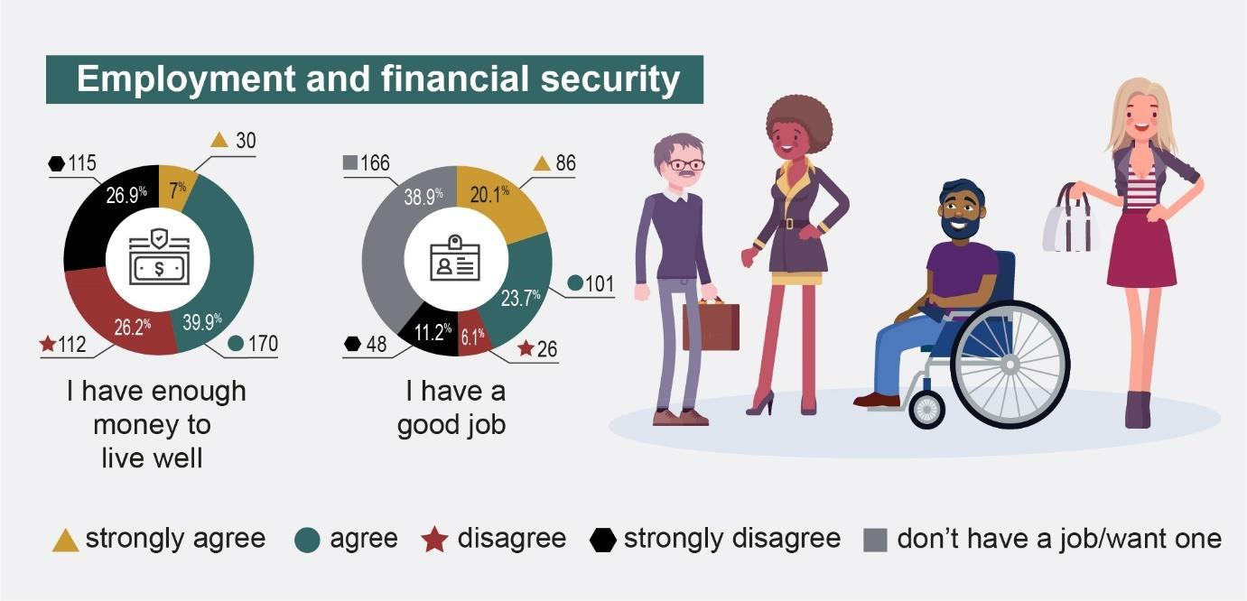
Figure 10: Employment and Financial Security for Participants with Disability

Employment and financial security achievements

Employment and financial security were closely linked to many other areas of participants’ lives. For example, secure housing and adequate formal and informal supports were critical for enabling some participants with disability to get jobs, earn money, and enjoy a better quality of life. Nearly half (47.7%) of participants with disability had employment (policy priority 1.2) in full-time (49.5%) and part-time (24.5%) roles in professional occupations (39.9%) and management and administration (34.5%). Just under half (43.8%) of participants with disability agreed or strongly agreed that they had a good job, with people who identified as neurodivergent only or as having a physical disability only more likely to have a good job. Having a ‘good job’ was enabled by a number of factors, including alignment with individual needs; providing a sense of meaning and purpose in the role; financial incentive; support from managers and colleagues; and an alignment of skills and opportunity. Participants highlighted this positive alignment saying, “I currently have a good job that helps support my needs and lifestyle” (PWD120) and “I work for the government and I have been able to tick the box [disclosing disability] and have not been disadvantaged by it as previously. I can be slightly more unmasked than in [other] workplace[s] and management seem supportive” (PWD 172).

Like the 2023 report, flexibility was a key enabler for obtaining a good job. Flexibility in hours, hybrid working arrangements including work from home, and support from colleagues were critical, as highlighted by PWD2 who said, “I have a fantastic employer that has been compassionate and kind as I recommence cancer treatment. I am unable to work full time due to a brain injury. Short shifts are provided (I only work a few days of the week for 2-3 hours)”. The importance of flexibility was best described by PWD115 who said, “Having an understanding and flexible approach [includes] being able to work hours that suit my body and care schedule. Hybrid working for days that I can’t stand for long. Understanding that my light will burn very bright and at other times it will be dim”. Flexibility in employment was also reflected by a small number of participants who were self-employed (8.8%). PWD93 said:

Since [COVID-19] I’ve been able to set up my own small business with an ABN. About 90 percent of my meetings are online. This has opened up a whole new world for me in terms of flexible work conditions. I can work when I want on

projects that I want. I am not tied to the inflexibility that employment brings (inflexible hours, needing to be based in the office, etc.) (PWD93).

Positive achievements in employment were reflected somewhat in income levels (policy priority 1.1). Similar to the 2023 report, 37.1% of people with disability had annual individual incomes above $75,000 (compared to 36% in 2023), with 6.5% earning over $200,000 (compared to 5% in 2023). The remaining 48.6% earned less than $75,000 per year. Adequate financial security and income enabled participants to obtain a higher quality of life and access the services, goods, and supports that they needed and wanted (e.g. medicines, allied health support, nutrition) rather than having to choose between competing priorities. Adequate financial security also decreased stress and feelings of being overwhelmed.

Employment and financial security challenges
The lack of change in income between 2023 and 2024 was problematic and was likely reflected in the concerns expressed about cost of living, particularly given how many people were not working (56.1%). Over half (53.1%) of participants with disability said that they did not have enough money to live well (an increase of more than 6% from 2023) (policy priority 1.1). Nearly half (48.6%) of participants with disability earned under $75,000 (compared to 52% in 2023), including 19.2% under $25,000 (compared to 20% in 2023). Not surprisingly, financial security was reported as a challenge for most participants. People with multiple disabilities, particularly those with chronic illness/pain and physical and/or psychosocial disabilities, were most likely to report not having enough money to live well. People with disability living in rural areas were also more likely to report that they did not have enough money to live well.

The rising cost of living for all Australians was a major contributing factor impacting financial security (policy priority 1.1). Participants reported needing to choose between paying for rent, medical bills, food, and personal care support as a direct impact of lower incomes and lack of secure or flexible jobs. PWD141 underscored the impact of poverty on people with disability, stating “The cost of living and also paying for medical care is killing me. I can’t [sic] barely feed my child. I am often at the food bank or borrowing money. The stress is awful”. Many participants echoed these sentiments. Participants with disability as well as family/carer participants noted that the increasing

“cost of living negatively impacts people with disability at an accelerated rate” (PWD202).

Multiple other factors, like the housing crisis, and the “[...] insufficiency of the DSP to meet the basic cost of living” (FC63) contributed to longer term poverty, increased anxiety and stress, and poorer health and wellbeing (policy priority 1.1). Although 40.9% of participants with disability received the Disability Support Pension (DSP) and 35% of participants with disability received NDIS funding, these funding schemes were not enough to cover rising costs, particularly given ongoing impacts of NDIS funding cuts. PWD71 described this, saying:

The cost of living and housing post-pandemic is very much a pressure; we know we won’t be able to buy our own place, likely ever, and find the unstable nature of renting (let alone the way renters are treated and extorted) to have huge impacts on our mental and physical health as two neurodivergent people (PWD71).

Ongoing financial insecurity was compounded by the fact that while “[...] housing costs have doubled, we only had small increases federally from Centrelink […] there is no money left over after housing and bills and doctors to do anything” (PWD23).

Participants recommended some solutions to strengthen financial support and economic security (see Section 6: strategic area for action 1). Participants emphasised the need for increasing the rate of welfare and pensions (strategic area for action 1.1) as well as expanding the eligibility criteria and financial support for people who may be falling through the cracks of existing support systems (strategic area for action 1.2). Financial security and economic stability impacted on all other outcome areas and participants wanted more collaboration to improve supports and subsidies for healthcare, transportation, housing, education, and employment (strategic area for action 1.3). The need for additional crisis support services was identified as being critical for supporting people with disability, particularly those with intersectional identities (strategic area for action 1.4).

Employment presented major challenges for participants with disability (policy priority 1.2). More than half (52.3%) of participants with disability were not employed, compared with 41% of participants with disability not employed in 2023, an increase of 11.3%. Although it is not possible to determine the cause of this shift in employment rate, employment remains a topic of strategic importance. Of the participants with disability who were not employed, 12.5% were actively looking for work and 22.8% were engaging in volunteer activity. Although 17.3% of participants with disability who had a job disagreed or strongly disagreed that it was a ‘good job’, the same participants reported a number of barriers to finding good employment. Barriers included the lack of (1) job security, (2) flexibility, (3) meaningful career progression, (4) awareness and adjustments to support inclusion, and (5) supports and services, including accessible public transport.

Inclusion within the workplace requires awareness among hiring managers and managers in general and support for reasonable accommodations. However, in the absence of these inclusive practices, participants with disability found employment environments to be exclusionary and sometimes even hostile (policy priority 1.2). PWD88 stated that “My role does not consider my invisible disability – a car park at work would help and there are no adjustments to the workload or access to [to funding for employment]”. Exclusionary attitudes and practices resulted in many participants experiencing negative assumptions about their capacity and capability within the workplace and impacts on their career progression, including being “[...] moved sideways and backwards in the organisation and my hours were cut in half in part due to my disability” (PWD1). Similarly, PWD94 said that “the attitudes of people who think I am unable to do what I do due to being disabled” had an impact on their ability to be respected and included within workplaces. The lack of inclusion within workplaces, experienced during recruitment, onboarding, throughout the course of employment, and in retention practices, contributed to increased feelings of anxiety, and chronically poor physical and mental health.

Lack of flexibility was a critical barrier for people with disability to getting any job, let alone a good job (policy priority 1.2). PWD53 was previously employed in an “[...] extraordinarily inflexible and disability unfriendly workplace”, which resulted in them deciding to leave that role even though it meant seeking work in a difficult job market.

Some participants with disability who wanted to work found that the lack of flexible approaches to work ruled them out of employment entirely, as illustrated by PWD90 who said, “I am often ruled out of contention for government jobs despite being qualified as I cannot manage ‘full-time’”. Along with flexibility, participants with disability mentioned concerns about the current lack of supportive and reasonable workplace adjustments related to flexibility, including modified work processes, practices and procedures that would better support inclusive employment.

Lack of services and supports to assist participants with disability in obtaining and maintaining employment also contributed to ongoing challenges within the employment sector (policy priority 1.2). Specifically, there was a general lack of jobs in non-metropolitan and regional areas, with increasing difficulties in getting to and from work when living in locations outside of main public transportation corridors. “Lack of personal transport or reliable public transport in my areas” meant that participants with disability, like PWD139, felt that they “[...] have no way to hold down a job”. For participants with disability who could not access funding support schemes like the DSP or NDIS, there was increasing pressure to maintain employment, but often at the cost of health and wellbeing. PWD63 illustrated this challenging dynamic, saying:

The dynamic nature of my disability makes me unreliable and therefore unemployable. I am completely reliant on my partner for all financial support [as they are unable to access the DSP and NDIS]. This creates stress in my relationship, which is one of the few positive parts of my life. It’s so difficult and has a deleterious effect on my mental health (PWD63).

Participants identified a number of recommendations that could improve inclusive employment practices and opportunities (strategic area for action 2.3). There was a particular emphasis on developing flexible and inclusive workplace policies and practices (strategic areas for action 2.3.3 and 2.3.4) and advocating for policies and practices that would improve equitable opportunities and access for people with disability (strategic areas for action 2.3.1 and 2.3.2).

    - Family and carer perspectives on employment and financial security Family/carer participants highlighted a complex landscape where aspirations for independence and stability for themselves and the people with disability they supported were often hindered by systemic barriers. Access to inclusive and supportive employment is essential for people with disability, yet family/carer participants noted many of the same barriers articulated by participants with disability. Despite some family/carer participants mentioning positive examples of flexible and supportive employers, the majority identified the scarcity of flexible work options as a significant concern.

Family/carer participants emphasised the need for more part-time and flexible employment opportunities for themselves and the people with disability they supported. As FC66 noted:

As a carer I am financially vulnerable – limited super, nearly no income, children to support, forced homeschooling, renting because I have no reliable income to buy. And my children also miss out now and in the future as my family doesn’t have the assets of one where both parents can work and have reliable income (FC66).

Although family/carer participants were generally older than those who participated in the 2023 survey, there was a notable presence of younger caregivers in this survey, whose caring roles seemed to impede their ability to engage in paid employment.

Financial hardship (policy priority 1.1) directly impacted the level of care that family/carer participants felt they could provide, reflecting a cycle of economic strain exacerbated by housing affordability issues, ongoing funding cuts to NDIS plans, and means-tested allowances that further diminish financial stability. FC75 said, “Ensure sufficient funding is provided to single parents to enable their children to participate like other kids are able to”. Many family/carer participants expressed concerns about their own financial and job security, having either left well-paid positions due to caregiving duties or struggling to find suitable employment that accommodated their responsibilities: “I can’t work due to my full-time caregiver responsibilities” (FC5). Other participants described the challenges of balancing caregiving with work: “2 x children

with disability are too young for jobs. It is hard finding a job with a decent income whilst having to care for children with disability” (FC33).

Cost of living weighed heavily on family/carer participants as well as on participants with disability. FC146 noted that the cost-of-living crisis was exacerbating financial strain and limiting opportunities for both family/carers and people with disability.

Family/carer participants supporting children with disability were concerned about their children’s future employment prospects and financial security (policy priority 1.1), underscoring the broader societal implications of inadequate support systems and inaccessible job opportunities. Aspirations for inclusive workplaces and meaningful employment opportunities for people with disability were emphasised as a critical step towards independence, as noted by FC87 who said, “Create spaces for people with disability to do work and create an income. This is satisfaction for the person and reduces the cost to our systems”. The implications of ongoing cost of living crisis created major concerns for family/carer participants, who held anxiety about what the future of care may look like for the people whom they support. Specifically, FC68 described their fear of what the future may hold, “[...] especially in accessing treatments and support continues to get more expensive what happens when we can no longer afford it?”.

Finally, the financial hardship on family/carer participants seemed to negatively impact on their physical and mental well-being, with burnout becoming more of a reality. FC66 illustrated the impact of financial hardship saying,

I am burnt out from years of caring for two children with disability and advocating for them in the health and education sectors. I need to work for financial reasons and keep my brain alive but can’t find part-time work for an experienced professional woman (FC66).

These and similar stories underscore the need for comprehensive support mechanisms and policy interventions to address the multifaceted challenges faced by family/carer participants striving for economic security and meaningful employment.

Inclusive homes and communities

Goal^{2,3} | People with disability live in inclusive, accessible and well-designed homes  and communities.
Policy priorities^{2,3} | - Increase the availability of affordable housing.  - Housing is accessible and people with disability have choice and control about where they live, who they live with, and who comes into their home.  - People with disability are able to fully participate in social, recreational, sporting, religious and cultural life.  - The built and natural environment is accessible.  - Transport systems are accessible for the whole community.  - Information/communication systems are accessible, reliable and responsive.

Inclusive homes and communities help people with disability live, work, play, and socialise.3 Queensland’s ‘inclusive homes and communities’ outcome area aims to ensure that “people with disability live in inclusive, accessible, and well-designed homes and communities”.2 Two policy priorities focus on housing affordability, choice, and control; the others concentrate on accessible built and natural environments (including public transport), quality information and communication systems, and participation in recreational, social, sporting, cultural, and religious life. Twenty-nine percent (29%) of participants opted to share additional qualitative information about inclusive homes and community. Participants with disability were primarily living in cities or urban areas (60.7% of participants) with 30% living in regional areas, and 8.4% living in rural and remote areas. One-third of participants with disability were living with 1 other person, 27.6% of participants with disability were living alone, and 28.1% were living with 2 or more other people in their household.

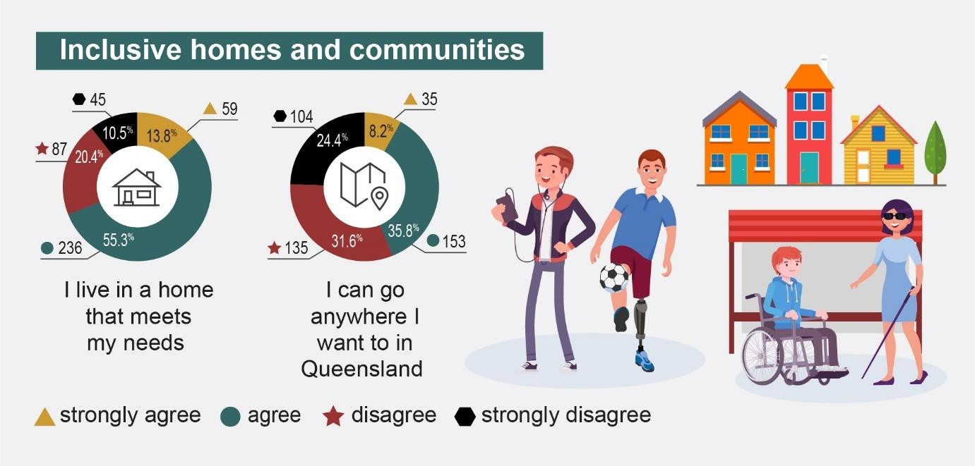
Figure 11: Inclusive Homes and Communities Results from Participants with Disability

Inclusive homes and community achievements

Accessibility and inclusion in the community are continuing to improve. Accessibility and inclusion were discussed across three distinct categories: (1) housing, (2) community inclusion and access, and (3) travel and transport.

More than two-thirds (69%) of participants with disability said that their housing needs were met in their current living situation (policy priority 2.2). Participants revealed that supportive home environments provided independence, stability, accessibility, safety and comfort, even for the 50.7% of participants who required support with getting around in their home. For some participants with disability, flexible employment arrangements were enabled by adequate housing, as exemplified by PWD145: “I am able to work remotely 2 days a week from home so I don't need to travel and can take naps when I need to and I earn a good income”.

Participants with disability and family/carer participants shared divergent experiences in regard to affordability (policy priority 2.1), the positive nature of supported independent living, and new construction (policy priority 2.2). Although some participants, like FC68, described how “funding is adequate so he [person with disability] can stay in his own home”, other participants did not have that security. Supported accommodation was “[...] safe and suitable [...]” (FC99) for some

participants, but not for others. PWD138 said that “universal design and/or inclusive design is being considered more in new [housing] developments”, but not all participants agreed with that observation.

Under half of the participants with disability (44%) noted that they could go anywhere they wanted to in Queensland similar to 2023 (policy priority 2.5). PWD101 said:

I find most places are now inclusive and there is less stigma […] People have a broader education about the needs of people with disabilities. People are now aware that there are many ‘hidden’ disabilities and we can’t judge a ‘book by [its] cover’ (PWD101).

The vast majority of participants with disability (86.9%) said they could access local shops and businesses (policy priority 2.4) and reported high levels of satisfaction, with 78.7% rating the quality of their experiences with local shops as good or very good. These findings were supported by observations such as, “It’s great that large supermarkets are providing quiet hour shopping times” (PWD20), and “Shopping centres are a lot easier to access” (PWD101), and “Most businesses are good about my service dog” (PWD33).

Travel and transport experiences for some participants with disability were positive (policy priority 2.5), with one-third (33.3%) of participants being able to access public transport every time they needed or most of the time (although this was a drop from 40% in the 2023 report). The satisfaction rating of experiences with travel and transport were high, with 42.4% rating them good or very good (a 3.4% increase from the 2023 report). Participants noted a range of positive changes, including “excellent Queensland rail, guards on all trains and staffed train stations mean safety for me and my guide dog” (PWD162) and “Wayfinding signage is improving” (PWD121). The efforts for improvement were noted by one participant, who stated: “I’ve seen great codesign through TMR [Department of Transport and Main Roads] and consultation through Brisbane Metro Accessibility Working Group” towards the development of “[...] genuine commitment to inclusive spaces” (PWD276).

Some participants with disability noted the positive impacts of planning for the 2032 Olympic and Paralympic Games, with “[...] stations on our line are being made accessible [...]” (PWD71) (policy priority 2.4) and “Co-design and consultation [around accessibility and inclusion] seems to be happening so I’m satisfied with how the planning is going” (PWD55).

Inclusive homes and community challenges

Although improvements were made across various aspects of homes and community, some participants with disability still experienced challenges in accessing suitable housing (policy priority 2.2), with about one-third of participants (30.9%) reporting that their homes did not meet their needs. First Nations participants with disability were less likely than those who were not First Nations to live in a home that met their needs.

Accessible, safe and affordable housing (policy priority 2.1 and 2.2) was a challenge for participants with disability, even those who identified that their home met their current needs. The ongoing housing crisis and rising cost of living contributed to anxiety and fear for participants who had adequate housing, with one participant saying, “I am literally terrified and shaking everyday as I am so fearful of becoming homeless” (PWD391). These anxieties were echoed by PWD2, who felt that they could “[...] be homeless and unable to easily get a new rental” at any moment. Participants with disability and family/carers were concerned about the “[...] lack of long-term housing security for people needing SDA/SIL [specialist disability accommodation/supported independent living]” (FC63) because “the market is competitive, however housing options are restricted” (FC98). PWD23 mentioned that “There is not enough housing not only for the disabled but the [non-disabled]. My concern is that we shall have housing built for the [2032 Olympic and Paralympic Games] but have the disabled with [nowhere] to live”.

Participants with disability were concerned not just about the cost of adequate housing, but also about accessibility and safety (policy priority 2.2). Some participants were specifically concerned about the type and location of their housing, like PWD380, who shared that they “[...] live in government housing that don’t [sic] have correct [disability] access this means I’m prone to injury and excluded from the community”. Another

participant noted that their home was not wheelchair accessible “[...] even if it says so on paper, it’s not for me” and felt “[...] in danger every time I stand up in my home” which they had to regularly do from lack of accessibility (PWD106). Similar safety concerns were articulated by participants like PWD248, who noted how their “[...] ongoing battle to gain access to wheelchair accessible housing is hugely frustrating and stressful”. Lack of accessible housing had a detrimental impact on participants’ wellbeing and their ability to live a dignified, equitable life, as confirmed by PWD121, who said that the “[...] impact [of] living in this house is failing my health even more”.

To address access to accessible, safe, and affordable housing (strategic area for action 2.1), participants suggested conducting further investigations into the housing situation of First Nations people with disability. Participants called for improved advocacy, development, and enforcement of policies and subsidies to improve housing costs (strategic areas for action 2.1.1 and 2.1.2). Improving the overall accessibility standards for new housing and increasing support for home modifications were critical for participants (strategic area for action 2.1.3) as were improved collaboration with key stakeholders to develop new and innovative solutions to the housing crisis (strategic area for action 2.1.4).

Community access and inclusion (policy priority 2.3) continued to present a challenge for participants with disability. More than half (56%) of participants could not go anywhere they wanted to in Queensland (compared with 58% in the 2023 report). Participants with physical disability and more than two disabilities were more likely to experience negative community access and travel challenges. Participants living in regional, rural, and remote areas (38.4%) were also more likely to disagree or strongly disagree that they could go anywhere they wanted to. Many of these participants commented on geographical disparities and disadvantages (policy priority 2.4), emphasising differences in proximate access and availability of services and community facilities. Participants with disability in cities and even in some regional areas tended to have better access and more quality interactions with community and transport infrastructure than those in regional, rural, and remote areas.

Access to local shops and businesses (policy priority 2.4) was mostly positive, however, 37.9% of participants with disability could only sometimes, rarely, or never

access public facilities in those locations, including public toilets, libraries, and community venues (this was an increase of 6.9% from the 2023 report). Similar to 2023, the quality of outcomes and experiences with public facilities were positive, with only 17% of participants rating them bad or very bad. Physical accessibility and design of local shops/businesses and the integration with public infrastructure (e.g. parking, toilets, public spaces, public transport) presented challenges for many participants. PWD54 noted that “So many shops and restaurants have steps” and PWD449 said that “Toilets are a nightmare. Toilet doors are worse – hardly any are automatic”. PWD449 also mentioned difficulty with building standards not accounting for different body sizes, making it harder for users of large wheelchairs to get around and access essential services, including essential public services such as a police station.

Accessibility and inclusive design (policy priority 2.4) beyond just physical accessibility were critical but somewhat lacking. PWD276 called for “Greater understanding of the sensory impact on navigation and wayfinding when buildings and infrastructure are designed/upgraded” and PWD257 said that “[...] not all disabilities fit into neat little boxes”. PWD252 echoed these sentiments saying, “Everyone seems to think that wheelchair provision equals disability access for all – it does not!” Tactile markings for navigation and interaction, quiet sensory spaces, closed captions, and audio descriptions were all mentioned as ways to improve accessibility, inclusive design, and community access and interaction.

Public infrastructure, including sidewalks and roads, presented challenges to accessibility, personal mobility, and the inclusive nature of communities (policy priority 2.4). PWD50 said, “Mobility access in Brisbane is adversely impacted by poor street planning and maintenance and management”. Similarly, PWD99 noted that the footpath quality and design across Queensland presented challenges to “Access not just for wheelchairs but walking aids” and said it was “[...] absolutely disgraceful”. Many participants with disability agreed with concerns about the accessibility of public infrastructure, including lack of “[...] maintained footpaths, vegetation obstruction [sic] footpaths” (PWD165) and lack of “[...] ease of access and lighting is disgusting” (PWD131). Infrastructure design challenges were noted similarly in urban and regional settings. Participants emphasised the importance of regular maintenance checks,

cleaning, and repairs that were critical for ensuring that community infrastructure serves their purpose and enables freedom of movement and accessibility for the whole community.

Although organisational representatives who participated in the survey largely reflected the views of participants with disability and family/carers, they specifically highlighted the financial impacts associated with retrofitting to improve accessibility because “older areas have lots of barriers and are costly to modify” (ORG4) and that “transport infrastructure is significantly underfunded” (ORG8).

Transport and travel challenges (policy priority 2.5) were closely linked with community access and inclusion challenges. Nearly one-third (30%) of participants with disability were not able to access public transport services and 27% rated the quality and outcomes of their experiences with public transport as bad or very bad. Participants identified challenges related to accessibility, cost, availability, stigma, and safety. Availability and access were critical challenges for many participants, particularly those living in regional, rural and remote areas. PWD99 noted that someone visiting:

[...] the Brisbane CBD on a Saturday night with a mobility chair or scooter [you] cannot get past Caboolture after the 8.30 [pm] train. In fact regular services off peak are disgraceful given these are the areas [people] with disabilities live, the social isolation brought about by inaccessibility is disgraceful (PWD99).

Service availability and access to transport were not limited to public transport, although this was the most frequent type of transport mentioned. Taxi and ride-share services, ferries, and airports/airplanes all presented different access and availability challenges for different participants, often depending on their disability identification. Taxis and ride-shares were particularly challenging, as illustrated by PWD157 who said, “Stigma and discrimination still are rampant – taxi drivers refusing to take me because I am in a wheelchair”. Airports were mentioned by a number of participants as were “airline refusals” (PWD384), a challenge that is often highlighted in the media.

Participants outlined several potential action areas to improve the accessibility and reliability of transportation and public infrastructure, including public transportation and other modes (strategic areas for action 2.2 and 2.2.1). Strategic actions included improving public transportation infrastructure and services (strategic area for action 2.2.2.) and better collaboration with transportation authorities to co-design solutions that address the mobility priorities of people with disability (strategic area for action 2.2.3).

Family and carer perspectives on inclusive homes and community
Most family/carer participants confirmed the achievements and challenges shared by participants with disability. Family/carer participants emphasised the lack of accessibility for the people that they supported and the detrimental effects that exclusion had on both physical and mental health.

Shortage of accessible, safe and affordable housing (policy priority 2.1 and 2.2) was noted and echoed by family/carer participants. Participants who identified as parents and were supporting children with disability noted the need to weigh up the cost of housing with the proximity to services. For example, FC126 said, “Living rurally [where rent is cheaper] to afford to live, sacrificing access to services” was required for their family at this point in time. FC138 shared a similar experience and said that they were “[...] dealing with housing issues e.g. needing affordable housing and one that supports physical disability issues while staying in the area where medical team has been established finally after 8 years”. The impact of the balancing act of affordability versus location was reported by many family/carer participants as taking a toll on entire households.

Inclusive public spaces (policy priority 2.3 and 2.4) were noted as improving by some family/carer participants who said “[...] that there are more places that are being inclusive” (FC141) and that there was an “amazing local library” (FC14), “accommodating hairdresser” (FC29), “inclusive sport” (FC5), and places that allowed “assistance dogs to come [along]” (FC85). Other family/carer participants felt positive about the availability of a “legal aid youth hotline” (FC130) and “accessible housing suitable for a wheelchair” (FC67). However, inclusive access was also noted by other participants as a “working process [work in progress]” (FC47). Family/carer

participants wanted to see “More facilities that are disability friendly” (FC33) and “Better town planning or at least local councils enforcing the rules for disability toilets and access” (FC67). Suggestions included “Better toileting facilities for example change tables for older children and adults. Better infrastructure (paths, accessibility in general, parking, etc.)” (FC33). Some family/carer participants noted additional challenges including environments that do not meet the access requirements of people with hearing impairments and neurodiverse people, as well as ongoing negative attitudes which continued to limit access for the people in their lives with disability.

Safety, rights and justice

Goal^{2,3} | The rights of people with disability are promoted, upheld and protected, and  people with disability feel safe and enjoy equality before the law.
Policy priorities^{2,3} | - People with disability are safe and feel safe from violence, abuse, neglect and exploitation.  - Policies, processes and programs provide better responses to people with disability who have experienced trauma.  - Policies, processes and programs for people with disability promote gender equality and prevent violence against groups at heightened risk, including women and their children.  - The rights of people with disability are promoted, upheld and protected.  - People with disability have equal access to justice.  - The criminal justice system responds effectively to the complex needs and vulnerabilities of people with disability.

Safety, rights, and justice are protected by the CRPD, including rights to safety, justice, accessibility, inclusion, an adequate standard of living and the highest attainable standard of health.1 The ‘safety, rights, and justice’ outcome area in Queensland’s Disability Plan 2022-2027: Together, a Better Queensland focuses on upholding these rights.2 Its policy priorities aim to ensure that people with disability have their rights promoted and protected; are safe and free of harm; are supported by trauma-informed policies, programs and processes that prioritise vulnerable groups; and have equal access to a responsive criminal justice system that understands complex needs. Almost one-third of participants (29%) shared additional qualitative information about their safety, rights and justice experiences.

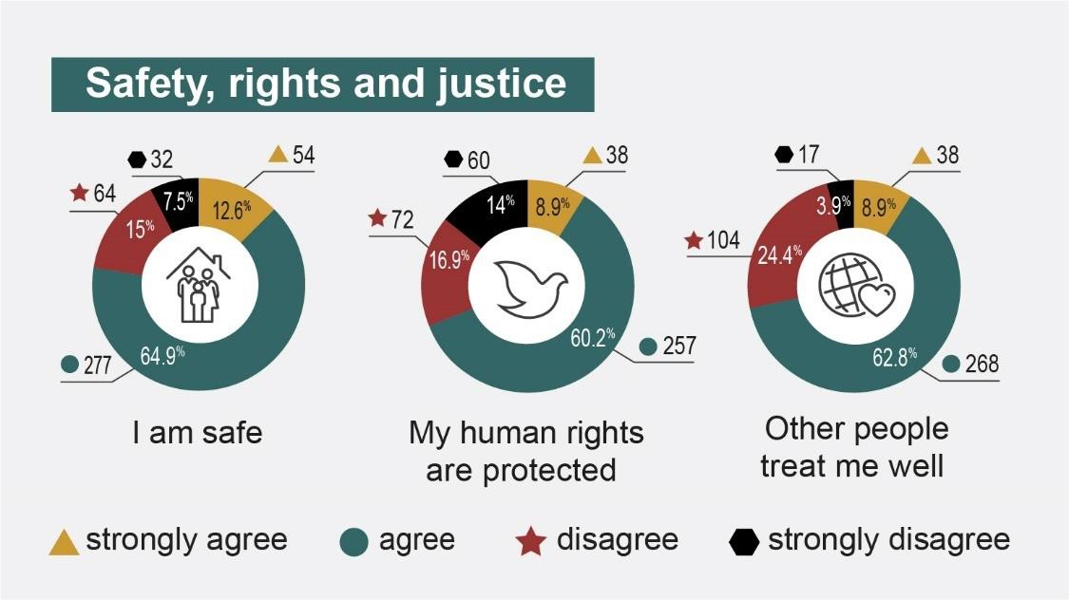
Figure 12: Safety, Rights, and Justice Results from Participants with Disability

Safety, rights, and justice achievements
Positive safety experiences were reported by nearly three-quarters of participants with disability, with 77.5% saying that they felt safe and 71.7% saying that they were treated well by other people (compared to 80.5% and 79% from the 2023 report respectively) (policy priority 3.1). Participants with disability felt safer when they were able to access community facilities and public transport, when their assistance animals were recognised and permitted in spaces, and when their rights were protected through strong legislation and the observance of relevant laws. PWD130 highlighted the improvements made in the context of safety when they said, “there is more awareness around issues of safety and protection for vulnerable people, with laws evolving accordingly”. Some participants related safety and justice to the opportunity to share their stories and perspectives, including PWD171 who said, “This questionnaire is in the right direction and I’m thankful for being able to use my voice”.

Most participants with disability (69%) still believed that their human rights were protected (compared to 73% in the 2023 report) (policy priority 3.4). More participants had knowledge and awareness of their rights and knew where to go for help when recognising their rights had been denied. PWD143 said that “Knowing how the DDA [Disability Discrimination Act] law works and having the knowledge to be able to educate shop owners when it comes to access” helped participants to feel that their human rights were protected.

There were few achievements related to justice (policy priority 3.5) with one participant noting some positive shifts:

Some improvements [-] good social justice advocacy and changes in [behaviours], initiatives to create opportunities for acceptance of diversity, accessible and inclusive changes and [...] inclusive co-design [...] (PWD203).

Safety, rights, and justice challenges
Despite the overall positive sense of safety expressed by participants with disability, qualitative data revealed some key challenges and gaps. One-fifth or more of participants with disability felt unsafe (22.5%), reported that other people did not treat them well (28.3%) and felt their rights were not protected (30.9%). These figures had all increased slightly when compared to the 2023 report. Participants, who reported challenges in this outcome area, did so across a variety of barriers, including attitudes, system policies, and equitable access to justice processes. Although the majority of participants did not report these challenges, such significant issues should be minimal.

Attitudes and discrimination affected participants’ experiences of safety and rights (policy priorities 3.1 and 3.4). PWD328 reported that “Disability discrimination is rife and limits so much of my life, e.g. work opportunities, dating, housing, transport” and PWD52 further explained that “Some people are just not educated or listen to people with lived experiences”. Stigma associated with certain disability identifications was particularly evident across the participant cohort. Participants, who used assistance animals shared numerous experiences and encounters where they were treated negatively, and their rights were violated through the denial of access for their assistance animals. PWD137 described the emotional toll this denial of rights and safety took, saying “Every social engagement in community or access to a new place is prefaced with anxiety and mental conversation about how to negotiate or advocate a potential refusal with my assistance dog”. Discriminatory attitudes also impacted on health and wellbeing, with some participants being hesitant to “[...] go to the hospital due to the way I’m treated” (PWD281). Paternalism was also evident to many participants with disability. For example, one participant said that “Service providers will make judgements on [what’s] right for me and my life [and what type] of supports are good for me” (PWD134).

Negative attitudes and unsafe situations (policy priority 3.1) were evident at home for some participants who experienced “[...] bullying or saying offensive things” (PWD139) and sometimes violence including threats “[...] in my own home” (PWD74) from neighbours or community members. Some participants felt that people with disability were targeted by crime and that some housing providers failed in their obligation to create safe living spaces (e.g. faulty air conditioning, lack of door locks and security doors, and no way to escape during a crime or disaster).

Systemic policies and challenges resulted from policy, procedures, and practices that hindered positive safety and rights outcomes (policy priorities 3.1, 3.2 and 3.4). The NDIS was frequently spoken about in regard to rights by participants with disability, many of whom felt that accessing the scheme was “[...] impossible with no justice and no rights” (PWD198) and was “[...] over complicated unnecessarily” (FC60). FC7 specifically shared how:

Restrictive practices legislation [that] was put in place by the NDIA [National Disability Insurance Agency] is a violation of human rights of people with disability. This legislation allows the [safety] and health of people [with disability] to be put at risk, going against the advice of medical professionals and common sense. (FC7).

The Disability Royal Commission recommendations called for a review and elimination of restrictive practices. Other participants noted refusal of reasonable adjustments in workplace and education systems, stating that people experienced unfair treatment due to a “one-size-fits-all” (FC114) approach and policies that did not adequately respond to the rights of diverse people with disability (policy priority 3.4). One participant noted that systemic policies caused them to lose many of their rights and said they:

[...] slipped through every possible crack in the system. I’m not eligible for assistance, I’m not treated as a human being worthy of support. I don’t have access to adequate healthcare, I don’t have employment support, I can’t access tertiary education that suits my disabilities (PWD112).

Some participants noted a lack of just processes and equitable access to justice (policy priority 3.5). PWD80 mentioned “[...] being pushed out of [the workforce] early due to injustice” while PWD234 said that “policing and justice is a joke”. Importantly, PWD252 clarified that “access to justice is a major issue” for people with disability and First Nations people with disability”. PWD87 expressed “[...] grave concerns about the criminal justice system and the numbers of people who have unrecognised disability being criminalised”.

Participants identified a number of potential strategic actions to improve rights, safety, and justice for Queenslanders with disability. Advocating for legislative improvements and protections towards maintaining safety standards and equitable access for people with disability in mainstream services (including housing, health, education, and transport) and community facilities and amenities were identified as critical actions (strategic area for action 3.5). Developing anti-discrimination and disability rights legislation, in alignment with the DRC recommendations, was important to enhance dignity and equity (strategic area for action 3.5.1).

Family and carer perspectives on safety, rights, and justice
While some family/carer participants supported the positive sentiments towards safety, rights, and justice by participants with disability, many more expressed concerns over the safety and rights (policy priorities 3.1 and 3.4) of the people that they looked after. Key concerns were related to physical safety, with some articulating incidences of violence and abuse by services and systems (e.g. education and employment).

Safety and rights in schools were particularly strong themes, with many family/carer participants sharing experiences of bullying of their child at school. FC154 shared that the “[...] State school system [cannot] assist with the lunch time bullying” and that they “[...] now pay enormous fees for a private school so that [our child] is not bullied”. Several family/carer participants shared that State schools were denying their child’s right to an education by blocking enrolment when options for inclusive education were already limited. This forced some parents into homeschool and distance education situations.

Lack of access/resources for justice (policy priority 3.5) was also mentioned by many family/carer participants. Participants mentioned feeling dismissed, ignored, and even mistreated when reporting violence or violation of rights, even by the police, sometimes leading to “retraumatisation” (FC130). Many family/carer participants were concerned that the people they supported or cared for might be more vulnerable to abuse, neglect, and/or discrimination. These concerns were highlighted by FC37 who said, “Safety is a concern and therefore my [child] is NEVER out in the community on her own”. The unethical behaviour of support workers, particularly related to neglect, was also a common concern, especially for participants from CALD backgrounds with children with disability who needed “[...] much more support, especially in advocacy and working within the various bureaucracies” (FC21).

Advocacy was critical but also a challenge (policy priority 3.4). FC58 described the ongoing struggle of “[...] advocating for [safety and rights] is extremely challenging and stressful”. FC33 echoed that “Everything is a fight. You have to fight for inclusion in sport. You have to fight for inclusion in schools, you have to fight for accessibility. You have to fight for everything”. Sustained advocacy roles from family/carer participants to ensure rights and justice for the people with disability that they supported was required and often overwhelming. There was some support for advocacy efforts to promote and protect safety and rights, however FC98 noted geographical differences, stating “The disability advocacy sector in the regional areas is currently and historically chronically underfunded”.

Personal and community support

Goal^{2,3} | People with disability have access to a range of supports to assist them to  live independently and engage in their local communities.
Policy priorities^{2,3} | - People with disability are able to access supports that meet their needs.  - The NDIS provides eligible people with permanent and significant disability with access to reasonable and necessary disability supports.  - The role of informal support is acknowledged and supported.  - People with disability are supported to access assistive technology.

Personal and community supports enable people with disability to live more interdependently and actively engage in their communities. These services and resources include the quality and availability of formal and informal care, NDIS funding, and assistive technology. Many participants accessed several types of support. Participants with disability received support for:
- Getting around your home or community (50.8%)
- Talking and communicating with others (26.5%)
- Relationships with friends and family and people you don’t know (28.3%)
- Learning new things (27%)
- Looking after yourself and personal care (40%)
- Doing things day to day, and making own decisions and choices (33.3%)
- Accessing healthcare or talking to health professionals (42%).

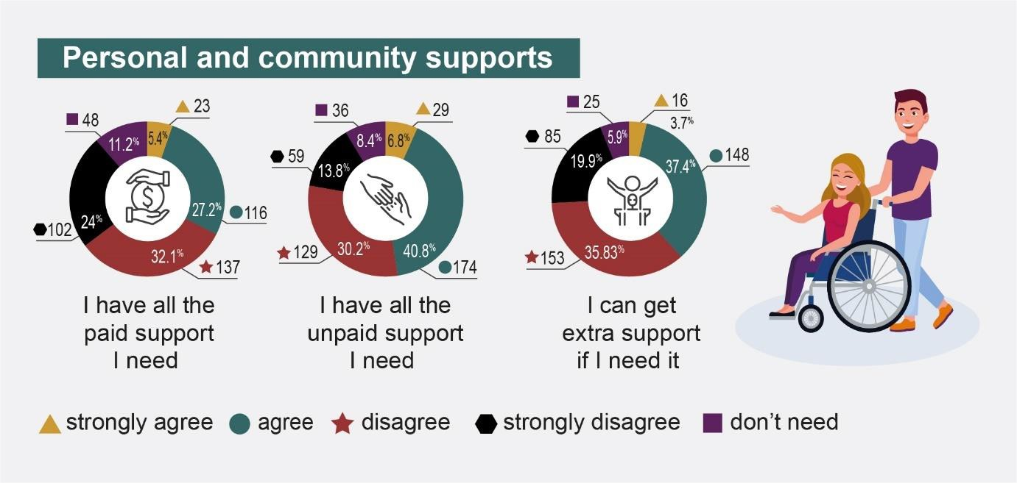
Figure 13: Personal and Community Support Results from Participants with Disability

Personal and community support achievements
Nearly half (46.4%) of all participants with disability accessed some type of disability services for personal and community supports (policy priority 4.1), including formal paid support through NDIS or other funding schemes. Nearly three-quarters (73.4%) of all participants with disability received some type of funding or other support from a variety of support schemes, including DSP (30.4%), NDIS (26%), Job Access (2%), Services Australia (11%), and other sources (4.5%).

Quality supports and services (policy priority 4.1) were considered to be those that were available, flexible, affordable, consistent, and delivered by well-qualified providers who were knowledgeable about disability. Participants with disability with employment and/or NDIS funding had access to better supports and services than those without employment and funding. Nearly one-third (32.6%) of participants with disability agreed that they had all the paid support that they needed (much lower than the 49% in the 2023 report). Participants, who were positive about their experiences and outcomes of interactions with disability services (41.2%) and disability funding (29.2%), said that their supports were “brilliant”, “useful”, “good”, “helpful”, “fabulous”, and “wonderful”. Some participants, who did not have access to funding for paid support, “[...] arranged and funded supports [themselves] which was working well” (PWD86).

Informal support was an important part of participants’ perceptions of good personal and community support (policy priority 4.3). Almost half (47.6%) of participants with disability said that they had access to all the unpaid support they required and 38.4% of participants said that they could access extra support if they needed it. Like the year before, informal supports continued to be important for participants with disability. Family/carer participants took great pride in providing informal support, as FC179 said: “I am a strong advocate for them and make sure they get the support they need”.

Personal and community support challenges
Access to quality formal supports (policy priorities 4.1 and 4.2) was significantly impacted by a number of factors. More than half (56.1%) of participants with disability said they did not have all the paid support they required and 55.7% could not access extra support if needed, which represented increases from the 2023 report (49% and 52% respectively). Lack of availability of formal support and reliability (often related to high staff turnover and staff shortages) was a critical challenge shared by many participants with disability. In regional, rural, and remote locations, participants with disability said they had “no alternatives” and were “begging for subpar support” (FC126). Indeed, participants living outside of cities were more likely to strongly disagree/disagree that they could get extra support if they needed it. Lack of quality care was also cited by many participants with disability and family/carer participants. Some participants mentioned abuse and poor treatment by support workers, who were “often abusive” (FC168) and sometimes “manipulative” (FC110). Generally, participants with disability felt that support workers treated people with disability with “[...] disrespect, negligence [and] exploitation” (PWD209). Lack of staff awareness and skills was often identified as a major challenge for overall quality formal supports, as demonstrated by PWD275 who said it was:

[...] very hard to keep the retention of support workers due to the inconsistencies with skill sets of workers. There [were] a lot of new workers entering the industry with limited skills and charging top high rates as independent workers. They [were] not qualified or [had] the correct skill set to the job for high complex support (PWD275).

Quality of NDIS support coordinators were also inconsistent and some participants with disability reporting that NDIS and NDIA staff were “generally ill-informed” about disability (PWD161), which impacted on quality service outcomes. The NDIS was viewed as a complex system to navigate due to “[...] the amount of paperwork” (PWD161) and the pressure from providers to “[...] fit into their box rather than offering individualised” services (FC152). This topic has been covered in detail in other reports and reviews, but continues to be a topic of great concern to participants.

The cost and financial challenges of formal and informal supports (policy priorities 4.1, 4.2 and 4.3) were also having an impact on participants with disability. Some participants, particularly those who were self-funded, were in challenging circumstances, as illustrated by PWD130 who said: “I am totally [self-funded] with very little savings left. I will soon need to choose between supports or food. Centrelink have been sitting on my application for [the] disability [pension] for 4 months and I have been battling with NDIS for 9 months”.

Other participants shared that the “[...] cost of living is too high with not enough support for the extra activities required for a person with disability” (FC19) which put pressure on the ability to access quality support. Some participants were very concerned with overcharging and rorting of the formal support system, with one participant saying, “[...] because we access NDIS we seem to pay more for therapies than private clients” (FC148). Similarly, PWD164 said that companies were “[...] ripping off NDIS clients” charging “[...] triple the costs compared with non-NDIS clients”. Some participants were also concerned about the ongoing increase in service pricing out of alignment with increase in NDIS budgets. The uncertainty of funding with ongoing “[...] NDIS funding cuts [affecting] quality of care [and participants’] quality of life” was worrisome for many participants (FC74). Finally, some participants expressed the need for improved flexibility and eligibility for accessing NDIS and other funding schemes, specifically for people with psychosocial disability, people with terminal degenerative neurological conditions, and people over the age of 65.

Organisational representatives who participated in the survey also emphasised the geographical disparities in service provision and the ongoing challenges they experienced in finding and staffing experienced, trained support workers outside of

urban areas. Administrative challenges were also mentioned by most organisational representatives who were “[...] very disillusioned by [the] NDIS” (ORG21) and had “[...] revoked our NDIS registration” (ORG24).

Participants recommended some key strategic actions to improve access to and the quality of services and supports, including enhanced professional training and development of quality support services (strategic area for action 2.4). Providing increased safety measures and mandatory enforcement of minimum skills requirements were identified as potential methods for improving quality and safety of formal supports (strategic area for action 2.4.2). Ongoing training and professional development were also important (strategic area for action 2.4.1). Recognising the critical role that family and carers play in supporting people with disability and improving supports for family and carers were identified as key strategic actions for both participants with disability and family/carer participants (strategic area for action 4).

    - Family and carer perspectives on personal and community supports Family/carer participants underscored the pivotal role that personal and community supports play in the lives of people with disability (policy priority 4.3). The positive impact of adequate and high-quality support was acknowledged by many family/carer participants, noting significant improvements in in-home and social/community engagement and participation. FC50 said: “Having good support workers and an understanding community makes a difference” and especially when the “[...] health system is supportive” (FC30).

Despite noting positive improvements, family/carer participants also identified some service-related barriers that impacted on quality of life for the people with disability that they support. Long wait times and prohibitive costs (policy priority 4.1) associated with accessing quality services and supports were noted as chief among the service-related barriers. The frustration stemming from navigating available services was noticeable, with family/carer participants feeling the constant need to advocate in order to secure essential support for people with disabilities, the aged and their families “[...] having to fight all the time to be provided with services” (FC1).

Geographic location presented additional challenges, with rural and regional areas facing significant underservicing, characterised by waiting lists and limited access to quality providers (policy priority 4.1). FC33 said that there were “[...] long wait lists for therapists and overall lack of opportunities compared to people with disability in a big city […] good surgeons and specialists are [many hours’] drive away without traffic, add traffic and it can [take longer]”. A lack of experienced professionals exacerbates the situation, with some rural areas experiencing a lack of skilled service providers: “Rurally since NDIS came in, there seems to be a bunch of unskilled 19 year olds charging 90 an hour to play playdough or if you can find a decent service provider, the agency they work for is ripping them off and they don’t stick around for too long” (FC126). Family/carer participants expressed concerns about quality services and support, with some participants going so far as to highlight “predatory” practices and that they are “[...] only interested in the money not quality of service. One even abandoned my son without notice” (FC41).

The reliability and consistency of support workers (policy priorities 4.1 and 4.2) was a recurring concern, with high turnover rates and inadequate training impacting the quality of care provided. Many parent/carer participants, in the face of unreliable support workers, stated that they often felt overwhelmed and exhausted by the increased caring responsibilities, calling for “Respite, we need someone skilled in home from time to time to help us all manage his condition, without having to sell the house to be able to afford it” (FC170).

Although informal support from family and friends (policy priority 4.3) was noted as being critical for spreading out the caring duties, not all family/carer participants had access to such networks. Single parent family/carer participants noted the increased challenges they were facing with “[...] no help from family” (FC121). Overall, family/carer participants underscored the crucial role of personal and community support in enhancing the lives of people with disability. However, systemic barriers and service-related challenges continued to present barriers to accessing essential supports.

Education and learning

Goal^{2,3} | People with disability achieve their full potential through education and  learning.
Policy priorities^{2,3} | - Children with disability can access and participate in high-quality early childhood education and care.  - Build capability in the delivery of inclusive education to improve educational outcomes for school students with disability.  - Improve pathways and accessibility to further education and training for people with disability.  - People with disability have increased opportunities to participate in  accessible and inclusive lifelong learning.

Inclusive and accessible educational environments are crucial for the development and success of all Queenslanders. Inclusive education fosters opportunities and pathways for people with disability to improve many aspects of their lives. Education and learning, in turn, are affected by many other outcome areas. For example, community attitudes influence the perspectives of education staff and the policies that inform how the education system is run. Funding and service availability, cost and quality also impact on accessibility and quality of education and learning. Eighteen percent (18.9%) of participants with disability chose to share additional qualitative information about education and learning.

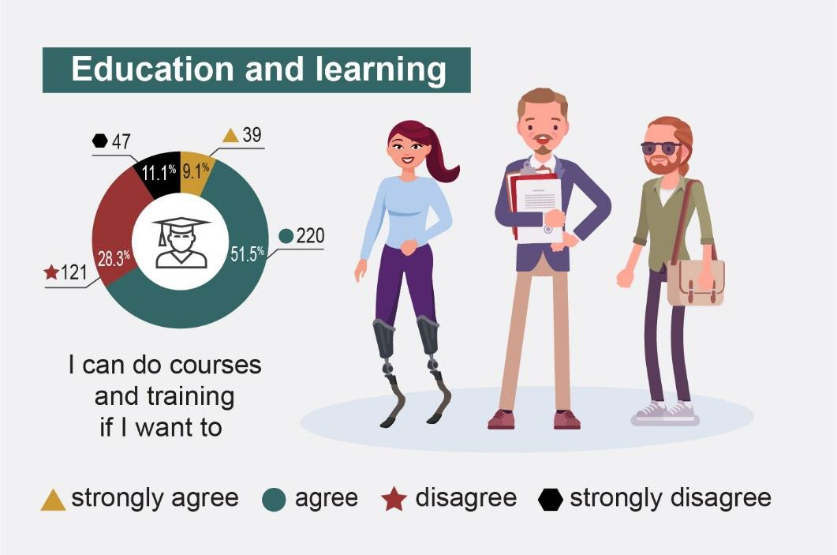
Figure 14: Education and Learning Results from Participants with Disability

Education and learning achievements
Improving access and support systems has led to significant improvements in education and learning, as reported by participants with disability (policy priorities 5.1 and 5.2). A majority of participants (60.6%) expressed the ability to pursue courses and training. However, only one-fifth (20.4%) reported having consistent access to education services and 50% reported that they did not use education services at all. Nearly one-third (30.9%) of the participants with disability who used educational services (i.e., 20.4% of the sample) rated their experiences with education services positively, indicating progress in enhancing accessibility and supports. Schools were reported, by some participants with disability, to be improving and prioritising inclusive practices, as highlighted by PWD86 who commended their school’s efforts: “my school is doing its very best to support students with a disability including those with no diagnosis or funding. We run an amazing inclusion program in a large mainstream High School!”. Participants with disability noted that access to education was improved by technological advancements, with hybrid learning options and online learning playing a critical role in enabling independent study (policy priorities 5.3 and 5.4).

Although perceptions and stories shared of higher education improved in comparison to the 2023 report, with accommodations and supports being provided by universities

to some participants (policy priority 5.3), there were still many barriers to education. Regardless, some participants reported positive experiences such as PWD165, “[...] doing very well in my university studies and my university is very accommodating of my disability”. VET programs were mentioned with increased positivity, particularly programs that were subsidised, as described by PWD138, “I’ve been able to begin to study toward a new qualification under the subsidised VET program, which has been excellent”.

Attitudes towards neurodivergence in education were reported by some participants with disability as gradually shifting in a positive direction, including greater acceptance and support in educational settings (policy priority 5.2). As one participant noted, there was a marked shift from viewing neurodivergent people as “[...] naughty boys on [R]italin” (PWD86) with a focus on behaviour management towards improved reasonable accommodation and support.

Education and learning challenges
Despite ongoing efforts to improve access and support in education around Queensland, participants with disability continued to face significant challenges that hindered their lifelong learning experiences. The percentage of participants with disability who were able to access courses decreased significantly from 56% in 2023 to 30% in 2024. Similarly, the positive rating of experiences with education services dropped from 77% in 2023 to 30.9% in 2024, underscoring the need for comprehensive reforms to address the significant challenges participants with disability are experiencing when interacting with education systems (policy priorities 5.1, 5.2, 5.3 and 5.4).

Negative attitudes towards disability persisted within education settings, contributing to a lack of understanding and appropriate support (policy priorities 5.2 and 5.3). For instance, parents (with and without disability) of children with autism expressed frustration over the limited knowledge about autism among educators and how to manage behaviour. For example, one participant noted: “There is a lack of neuroaffirming options. The default is to use [outdated and potentially restrictive strategies] without our consent or input which requires significant advocacy to avoid” (PWD87). Participants clearly felt that formal responses to their behaviour lacked any

sense of control or dignity for themselves. Organisational representatives agreed that additional professional development and support is required for educators in order to improve inclusive education and attitudes.

Negative attitudes, combined with a lack of reasonable supports and adjustments (policy priorities 5.2 and 5.3) for both students and staff with disability contributed to the increasing negative perception of education environments and experiences. Some school staff with disability mentioned a hesitancy to disclose their disability due to “[...] reports of unfair treatment/observation of my peers in this situation” (PWD86). Clear guidelines for reasonable adjustments for staff and students were lacking and this extended to tertiary education as well. One participant discussed their experience with education and transition to employment, highlighting both negative attitudes and lack of support, saying:

I have had to fight to even be allowed to enrol and study my allied health degree that I have since completed; secure employment in a field that’s largely dismissive of healthcare professionals living with disabilities; and gain support for starting a business. Throughout all of these [endeavours], I have rarely found protections for people living with disabilities or substantive support services. Instead, I have found the disabled community itself, and peer networks therein, to provide much more support (PWD160).

Financial constraints were also challenges to education and learning (policy priority 5.1), with participants with disability citing affordability as a critical barrier to pursuing courses, especially those that were not specifically ‘disability focused’. Additionally, a number of participants reported that higher education institutions failed to provide adequate accommodations and support, resulting in barriers to access and success. One participant, who worked in higher education for more than 20 years, highlighted systemic issues including underfunding of disability services and lack of flexibility in support systems: “[...] universities and TAFEs do not do enough to fulfil their requirements under Disability Discrimination Act and DSE [Disability Standards for Education 2005] [and] neither the State or federal governments adequately addressing this” (PWD44).

Limited course options and lack of flexibility in delivery methods and curricula were noted as additional challenges by some participants with disability (policy priority 5.2). Geographic disparities, particularly for students in regional, rural and remote areas, exacerbated educational challenges, with some courses and supports only available in specific locations, necessitating costly and difficult travel arrangements (policy priorities 5.1, 5.2 and 5.3).

Participants with disability and family/carer participants made a number of recommendations to promote inclusive education and learning (strategic area for action 3.3). Co-designing education programs, workshops and training for education and other professionals working with people with disability was identified as needed to improve both community attitudes and equitable and dignified education experiences (strategic area for action 3.3.1). Improving the use of inclusive practices in education and building educator capacity were also critical next steps (strategic area for action 3.3.2). Investing in lifelong learning and other opportunities to improve transition from school to employment was a key action for improving equitable pathways and engagement in employment post-schooling years (strategic area for action 3.3.3). Finally, participants wanted to see more flexible education pathways developed while working to reduce segregation and improve inclusivity (strategic area for action 3.3.4).

Family and carer perspectives on education and learning
Family/carer participant perspectives on education and learning revealed a diverse range of experiences and opinions, particularly within state school education settings. Although some viewed schools as valuable sources of social interaction and enablement, others expressed dissatisfaction, labelling the experience as either “glorified babysitting” or discriminatory (FC167). Like the year before, the spectrum of viewpoints was encapsulated in contrasting statements, with some commending schools for their efforts in accommodating people with disability, while others criticised schools for lack of support. One family/carer participant said:

The teachers are becoming more knowledgeable and at adjusting assessment methods for my son to demonstrate his abilities and at the level of his actual grade. They are better at engaging with him, and I know the school has been focused on developing this capability among the staff (FC14).

Another participant said, “Schools and teachers are not equipped to adequately support or understand a child with disability” (FC121).

The contrasting viewpoints and experiences among family/carer participants highlighted the ongoing systemic challenges within the education sector around the issue of segregated schooling for students with disability. The closure of special education units in high schools, inadequate provision of supports and services in mainstream schools, and difficulties in finding and accessing inclusive schooling options were identified by numerous family/carer participants as challenges to appropriate education for their children (policy priority 5.1 and 5.2). Closure of segregated education naturally raised concerns for a number of family members, particularly if they had experienced non-inclusive mainstream schooling. Participants shared their fears and frustrations, saying “I am very worried about trying to find a good inclusive high school for my child next year as the Queensland Education Department has closed the special education units in high schools” (FC5) and “It is difficult to find a suitable school. A lot of time was spent researching and talking to schools in the area. We have had to move to find a school for my son” (FC17). The need for improved mainstream schooling options was highlighted by family/carers. FC33 said, “Mainstream schooling options are reduced due to lack of support at State schools and lack of acceptance from private schools”. Other family/carer participants noted that, in the face of barriers, they were forced to pursue “[...] distance education due to schools not wanting to allow her access” (FC166) and “[...] me having to supervise child’s distance education whilst trying to work” (FC29).

Inaccessibility due to inadequate facilities were reported with one participant sharing about their struggles for a child “[...] who attends school in a wheelchair (policy priority 5.1). After 3 years the little school has still not received funding or had the necessary changes made so that this child can access the school facilities available to her age. No disability parking for our vehicle and no wheelchair access into the school grounds. No ramp to the upstairs classroom” (FC27).

Other challenges noted by family/carer participants included lack of funding, absence of inclusive pedagogy, and insufficient transparency and coordination (policy priorities 5.1, 5.2 and 5.3). FC89 said that “children are sent home because [the

schools] simply aren’t able to care for them if there are any behavioural needs” and FC75 agreed that the “[...] public school system is not sufficiently funded to support him to do well academically or socially”.

Negative attitudes were an ongoing concern for many family/carer participants. While some recognised the need for educators with lived experience of disability to improve understanding and support, others noted that stigma, inaccessibility, and ongoing hardships continued for students with disability (policy priorities 5.1, 5.2 and 5.3). One family/carer participant said that there needed to be “[...] more training for teachers to understand certain disabilities. I myself work in education and it astounds me how little teachers are aware of various disability profiles. Inclusive education will never work if the staff are unaware of how to teach their students” (FC196). Safety concerns were also frequently raised by family/carer participants, who identified reports of abuse, bullying, and inadequate accessibility further compromising the educational experience for the people with disability that they support (policy priorities 5.1 and 5.2). Some of these examples were shared in Section 5.3, Safety, Rights, and Justice.

Health and wellbeing

Goal^{2,3} | People with disability attain the highest possible health and wellbeing  outcomes throughout their lives.
Policy priorities^{2,3} | - All health service providers have the capabilities to meet the needs of people with disability.  - Prevention and early intervention health services are timely, comprehensive, appropriate, and effective to support better overall health and wellbeing.  - Mental health supports and services are appropriate, effective, and accessible for people with disability.  - Disaster preparedness, risk management plans and public emergency responses are inclusive of people with disability, and support their  physical and mental health, and wellbeing.

Health and wellbeing help to determine peoples’ quality of life. They are influenced by a wide range of physical, mental, social, cultural, and economic determinants, including the design and implementation of health services and support systems, and efforts to address and mitigate health disparities. Queensland’s Disability Plan 2022-2027: Together, a Better Queensland aims to help people with disability attain the best possible health and wellbeing outcomes throughout their lives.2 A comprehensive and inclusive health and wellbeing approach is crucial to ensure that prevention and early intervention services, mental health supports, and emergency response plans are tailored to the specific needs of people with disability. One-third (34%) of participants with disability opted to share additional qualitative information about health and wellbeing.

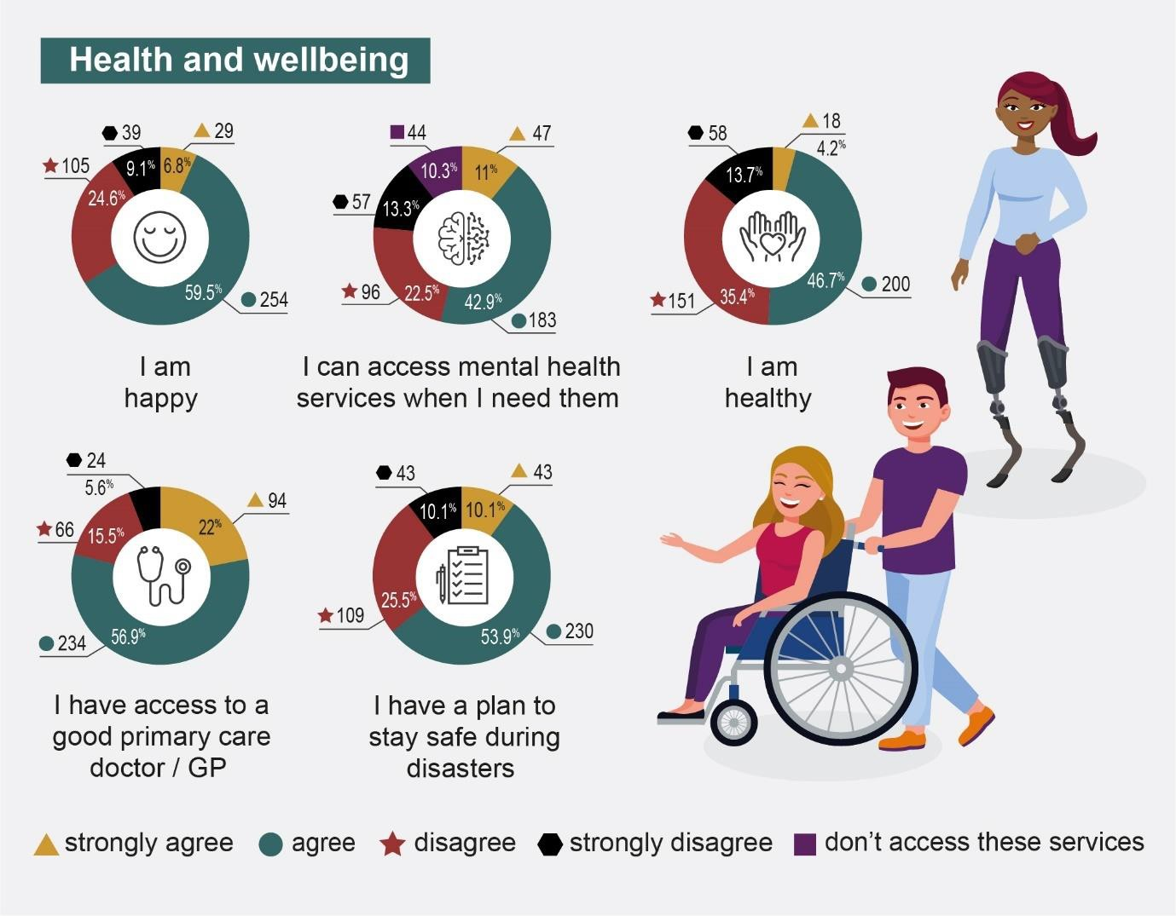
Figure 15: Health and Wellbeing Results from Participants with Disability

Health and wellbeing achievements
The health and wellbeing of participants with disability (policy priority 6.2) continued to be challenging. Positively, 66.3% of participants with disability stated that they were happy (slightly lower than 72% in 2023) and 50.9% were healthy (compared to 49% in 2023). These numbers were similar for people with sensory disability (50% across both years) and people with intellectual disability (60% in 2024 compared to 67% in 2023). However, it is worth noting is that 51% of people with chronic illness/pain reported being healthy in 2024, a large increase from the 25% who reported being healthy in 2023. More than half of the participants with disability (53.9%) were able to access mental health services when they needed them.

Access to primary care services and general practitioners (GPs) were positive (policy priority 6.1), with 78.9% of participants with disability stating they were able to access those services every time or most of the time they required them. Satisfaction with

primary care was also high, with 77.5% of participants with disability rating the service experiences and outcomes as good or very good. Nearly two-thirds (61.9%) of participants with disability were able to access health services most of the time or every time they needed to, and more than half (55.5%) rated the overall satisfaction with those services as good or very good. Participants noted that, generally, they had “[...] the supports I need and know where to access additional support and care should I need it” (PWD101). Participants, who experienced higher rates of good health and good access to health services, seemed to do so because they “[...] gathered together a team of health professionals who can help me” (PWD276) and had a “fantastic team” (PWD01).

More than two-thirds (64%) of participants with disability had a plan to stay safe during disasters, an important part of disability inclusion in Queensland (policy priority 6.4).

Health and wellbeing challenges

Many participants reported positive health and wellbeing, but the percentage of participants with disability who were unhealthy (49.1%) was similar to 2023 (51%), however that was not true for specific segments of the participant population. Those groups who were most likely to report being unhealthy were First Nations (4.2%), people with psychosocial disability (69%), cognitive disability (64%), neurodivergence (57%), physical disability (55%), and neurological disability (53%).

Although the majority of participants with disability were able to access health services when required (policy priority 6.1), 36.3% of participants were only sometimes or rarely able to access the health services they required and 37% had bad or very bad experiences with these same health services. There was an increase in the percentage of participants with disability who were unhappy (33.7%) when compared to 2023 (28%). However, 35.8% of people were not able to access mental health services when needed (policy priority 6.3), especially people living in rural areas. Living in a regional, rural, and remote location increased difficulty in accessing services (policy priority 6.1), as there was a lack of “reliable health providers – particularly specialists” (PWD25) and a lack of transport (PWD139).

Other barriers to accessing health services included “[...] long wait times for specialist consultations and surgery” (PWD101), “affordability” (PWD90, PWD139, PWD264), “lack of choice” specifically within regional/rural/remote areas (PWD62), and the lack of neuroaffirming services (PWD87). Access to health services was described as “fragmented” (PWD261) and the lack of telehealth options in some areas was problematic. In the context of COVID-19, participants expressed concern about inconsistent masking policies and adherence to masking and vaccination requirements, increasing the vulnerability of some participants to potentially life-threatening disease.

Although primary care was easy to access and rated positively, a worrying trend emerged for the future. As articulated by PWD262, “It is becoming increasingly difficult to get a timely GP appointment, it seems as if less screening is being done, access to necessary antibiotics (when required) is becoming more difficult and the overall level of rigour in care is less” (policy priority 6.1). Echoing sentiments explored in Section 5.1, Employment and financial security, financial implications of healthcare and health and wellbeing were major future challenges for participants with disability. PWD245 said, “The cost for medical appointments has sky-rocketed […] I have spent
$742 in 15 days to access 2 different doctors and get my daily medication”. PWD264 and many other participants stated that the “[...] price of health care services are crazy and unaffordable for anyone on the DSP”. The rising cost of accessing primary care, combined with the increasing cost of private health insurance caused extreme anxiety, with PWD44 stating “I am too afraid to cancel [private health] in case something happens […] my specialists are also getting more expensive because the gap between the charge and the Medicare Schedule Fee is increasing”. Expenditure on basic health services was increasingly impacting on physical and mental health, as expressed by PWD36 saying, “My mental health declines due to poor housing options and cost of living issues”.

The rising cost of living required many participants with disability to reprioritise health-related concerns, often foregoing essential therapies and/or medications, sometimes even going without healthy nutrition, to ensure that they maintained their home and paid bills. One participant described this balancing act, saying “I am in a situation if I give up work I could access better health services but it would increase

my cognitive decline and risk my housing” (PWD90). Other participants were weighing up expenses for today with their future, “I have to weigh up expenditure on health against further study and the cost benefit for employment” (PWD44). Despite the rising cost of living, cost of services, and overall financial insecurity for many people with disability, it was not the primary barrier for better health and wellbeing.

As in 2023, attitudinal barriers and stigma in healthcare settings continued to have the largest negative impact on health and wellbeing for participants with disability (policy priority 6.1). Although some participants with disability were able to access health services and even rated their experiences with health services as good or very good, there was an overwhelming amount of qualitative data shared through the survey about the presence of pervasive attitudinal barriers experienced in healthcare settings. Participants with disability shared experiences where clinicians did not have a strong understanding of disability, particularly certain stigmatised or lesser-known diagnoses. For example, PWD26 stated that “The hospital system has a profound lack of understanding of the requirements of a patient with coeliac disease”. Participants with endometriosis and ME/CFS (Myalgic Encephalomyelitis/Chronic Fatigue Syndrome) also echoed this sentiment, identifying that the guidelines for treatment have not been updated and/or that old information continued to be utilised by many specialists who were not adhering to best practice. PWD245 articulated that they needed to advocate for themselves, which could be difficult and draining: “I research my own illnesses and read journal articles because I can’t trust that the doctor I’m speaking to is actually aware of the intricacies [of my diagnoses]”. Some participants described a clinical one-size-fits-all type approach, without specific consideration of the inherent diversity of disability. Still others felt that their health concerns were ignored or minimised: “I’m in chronic pain and keep getting ignored when I seek help” (PWD208).

Ableism and limiting beliefs were reported as impacting on the type and quality of care that participants with disability received from their specialists (policy priority 6.1). PWD276 shared, “When I interact with health professionals (usually paediatric providers) as the parent of the patient (a minor), they are not able to accommodate requests for captions for telehealth and are often dismissive of mobility accessibility needs”. These sentiments were echoed by PWD141 who said, “I shouldn’t have to

constantly fight and argue just to get basic, non-judgemental and adequate healthcare. I should not be treated like a nuisance or hypochondriac because I ask for help”.

The lack of neuroaffirming care was mentioned repeatedly by participants, who identified as neurodivergent (policy priorities 6.1 and 6.3). Participants identified the overall lack of mental health services, private and public services, and specialist services that were appropriate, neuroaffirming, and/or run by a person who identified as neurodivergent. Many participants who identified as neurodivergent also had children who were neurodivergent, which contributed to “[...] lack of access and availability” (FC115). Family/carer participants were frustrated with the lack of belief in their own implicit knowledge about the person they were supporting, as stated by FC115, “[...] when a parent has done extensive testing and has their own exhaustive list of examples and observed behaviours [and possibly lived experience themselves], stop making up pay to tell us something we already know”. PWD161 mentioned that “the amount of paperwork for NDIS and Centrelink is ridiculous and very stressful for a neurodivergent person […] Medicare doesn’t really cover the cost of my [mental health] appointments well, even though I have a mental health plan. I don’t know where to get help locally as a neurodivergent person”. Participants who sought neuroaffirming care often travelled great distances and paid increasingly expensive specialists fees to get the care that would most benefit them.

Participants identified a number of strategic actions and recommendations to improve healthcare access, support, and equity (strategic area for action 3.4). Participants wanted to be taken seriously and better understood by healthcare professionals. They noted that enhanced training and support was required for healthcare professionals in order for them to build their capacity and awareness of the diversity of disability (strategic area for action 3.4.2). Financial considerations were critically important to improve equitable access, specifically increasing incentives to bulk bill, increase coverage by Medicare, and cap specialist fees (strategic area for action 3.4.1). Addressing the urban and regional/rural/remote divide in equity and access to healthcare services was also critical (strategic areas for action 3.2, 3.2.2 and 3.2.5).

Family and carer perspectives on health and wellbeing
Family/carer participants shared a nuanced range of experiences and challenges in relation to health and wellbeing. Although some participants observed improvements in the health of the person they supported, others grappled with significant challenges. Most family/carer participants greatly enjoyed their caring responsibilities and noted that “We enjoy every day […] there is much to be grateful for” (FC197), and “My child bring[s] a lot of joy” (FC196), and caring brought them “[...] joy, love and acceptance” (FC27). Most felt that the systemic challenges and barriers were the source of ongoing overwhelm, strain, and feelings of burnout.

Family and carer participants mentioned nearly all of the achievements and challenges mentioned by participants with disability. They specifically highlighted the administrative burden created by mainstream systems and services and by the NDIS created relentless demands and an ongoing physical and emotional strain, with participants noting, “I am stressed and I feel overwhelmed all the time” (FC124) and another participant saying “I have developed numerous chronic health conditions and chronic pain conditions from the nature of stress of what I do” (FC89). Some family/carer participants did mention loneliness and the struggle to maintain social connections amidst their caregiver responsibilities and obligations, with FC60 saying, “Life is a struggle and emotionally, I’m depressed, anxious, trapped and lack of lustre”.

Access to quality healthcare services (policy priority 6.1) was also mentioned as a critical challenge, with some participants reporting positive experiences with clinicians and service providers, while others noted the scarcity of skilled professionals and lengthy waitlists. Financial strain compounded the challenges, as family/carer participants grappled with the increasingly high costs of medical care and support services. The lack of financial support was ongoing, with some families noting disparities between children within the household who had funding versus children without funding and the lack of equity and caring challenges that presented.

Community attitudes

Goal^{2,3} | Community attitudes support equality, inclusion and participation in society for  people with disability.
Policy priorities^{2,3} | - Employers value the contribution people with disability make to the workforce and recognise the benefits of employing people with disability.  - Key professional workforces are able to confidently and positively respond to people with disability.  - Increase representation of people with disability in leadership roles.  - Improving community attitudes to positively impact on policy priorities under the strategy.

Community attitudes refer to the collective beliefs, perceptions, and opinions held by people within a society. These attitudes significantly influence the extent to which Queenslanders with disability are accepted, included, and supported in various aspects of community life. Community attitudes underpin the ways in which systems, services, built environments, and workplaces are designed and delivered, directly impacting the extent to which they cater to and accommodate the diverse needs of people with disability. Positive and inclusive community attitudes encourage the development of accessible infrastructure, adaptive technologies, and tailored support services, ultimately promoting equal opportunities in employment, education, and social participation. Thirty percent (30%) of participants with disability chose to share additional qualitative information about community attitudes.

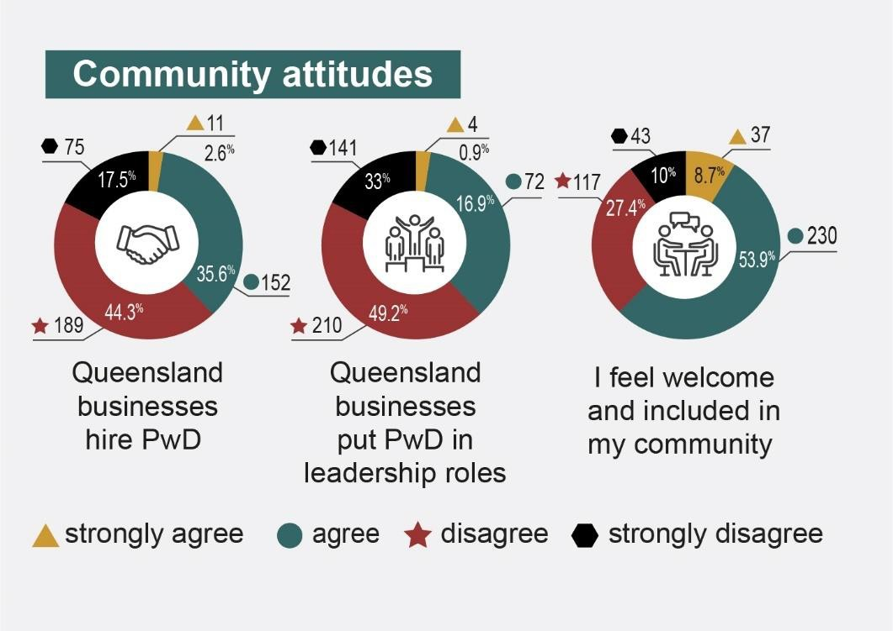
Figure 16: Community Attitudes Results from Survey Participants with Disability

Community attitudes achievements
Similar to the 2023 report, nearly two-thirds (62.6%) of participants with disability felt welcome and included in their community. Participants with disability noted that community attitudes were closely related to awareness, education, and perceptions of disability and inclusion within the community. Participants felt that, overall, disability awareness and inclusion were improving from year to year and that there was greater prioritisation of inclusion at the state and community levels. Participants with disability stated that “Everyone wants to do the right thing by me, including my workplace, my friends and my family” (PWD99) and that “I feel accepted and have a good relationship with my local community. My local area is like a village, we share outings, smiles and good humour” (PWD101).

Advocacy was a positive driver for improved disability awareness and inclusion. Participants with disability noted that organisations across the state were increasing their advocacy efforts and support, which was resulting in change. PWD203 said:

There are some improvements and good social justice advocacy and changes in behaviours, with initiatives to create opportunities for acceptance of diversity

for accessible and inclusive changes and have a voice for inclusive co-design to collaborate together as a community-minded group (PWD203).

Advocacy efforts by mainstream media were also recognised as a driver of positive change, with one participant sharing “Some media have taken my cause up and given it some public attention, some businesses also have adopted acceptance and been willing to learn directly from a more experienced assistance animal handler” (PWD136).

Awareness of assistance animals improved according to participants with disability who said “Most businesses are good about my service dog” (PWD33) and “They understand the legislation of assistance animal access and rights” (PWD280). Awareness increased not only the rights related to assistance animals, but also how to engage or not engage in respectful ways with animals that were working.

Community attitudes challenges

Although progress was noted across Queensland towards improving community attitudes, there were still many participants with disability who experienced negative attitudes and stigma. Nearly two-thirds (61.8%) of participants with disability believed that Queensland businesses do not hire people with disability (policy priority 7.1), a decrease from the report in 2023 by 5.2%. An overwhelming number (82.2%) of participants with disability said that Queensland businesses did not put people with disability in leadership roles (policy priority 7.3).

Community attitudes toward disability in Queensland continued to reflect a general lack of education and awareness (policy priority 7.4), contributing to negative stereotypes and stigma, and hindering the inclusion of people with disability in various life spaces, including in leadership roles. As PWD52 explained, “Some people are just not educated or listen to people with lived experiences”. Participants with disability felt that some professionals and community members were under-informed about the diversity of disability due to a lack of tailored education. PWD62 stated that they “[...] rarely see, hear or know of education programs being provided to individual communities”. Lack of awareness specifically extended to hidden disability, including

ADHD (Attention-deficit/hyperactivity disorder) and autism, which participants noted were often misunderstood or stigmatised, leading to invalidation and emotional distress. Participants with disability shared that there was a lack of understanding that “[...] not all disabilities are obvious” (PWD2) and that there needed to be a “[...] greater understanding that not all people with a disability use a wheelchair or have autism. There are many more impairments, which are invisible most of the time” (PWD39).

Misconceptions about inclusion (policy priority 7.4) were also described by a number of participants, especially the impact of environmental factors on people's health and wellbeing, such as lighting and fragrances. Some participants with less visible disability reported they were constantly navigating a world that failed to accommodate their needs, with “facilities not always well suited to cope” (PWD3) with their accessibility and inclusion requirements. The media’s portrayal of disability was also cited as contributing to misperceptions, with limited representation and a tendency to equate disability solely with physical representations, rather than the diversity of diagnoses and experiences. As PWD24 noted, there is a “[...] lack of representation of people with disability (and diversity of disability) in the media”, further perpetuating stereotypes and reinforcing feelings of community exclusion. Participants with disability wanted to “[...] feel wanted and helped, I need to be heard and seen and ACCEPTED” (PWD89), sentiments that were repeated by many participants.

The language used to talk about disability contributed to participants with disability feeling that they were viewed as a burden rather than valuable contributors to society. FC197 said that disability is “[...] framed as a cost burden rather than an investment in people, families, and a better society”. Negative rhetoric and language were especially troubling for some participants in light of the COVID-19 pandemic, which exposed negative societal perceptions in relation to disability. The unequal distribution of resources and the prioritisation of certain lives over others during the management of COVID-19 was described by some participants with disability as a key example of the systemic injustices experienced by people with disability.

Participants noted a number of strategic actions that could improve inclusion and continue to raise awareness of disability (strategic area for action 3.1). Leveraging the momentum of the media to increase representation and awareness of people with

disability (strategic area for action 3.1.3) was mentioned by a number of participants. Advocating for ongoing policy reforms to address stigma and discrimination (strategic areas for action 3.5 and 3.5.2) was also mentioned as a mechanism for improving community attitudes.

Family and carer perspectives on community attitudes

Family/carer participants reflected on both positive achievements and persistent challenges of community attitudes towards people with disability. While some participants reported improvements in social inclusion and acceptance – “I feel that community attitudes have improved over time with representation on television and people are more accepting” (FC4) – others highlighted enduring lack of support and awareness within communities (policy priority 7.4) – “There is still a long way to go before the community is fully accepting of people with disability” (FC33).

Family/carer participants agreed with many of the challenges and achievements discussed by participants with disability, and highlighted additional concerns about achieving social inclusion in “a segregated community with no understanding of what inclusion means” (FC29).

Increased education and awareness campaigns were identified by many family/carer participants as a way to foster greater inclusion and acceptance (policy priority 7.4). This call for education extended to service providers, health professionals, educators, and law enforcement agencies to ensure equitable treatment and support for people with disability.

Finally, family/carer participants also mentioned the lack of recognition of unpaid support as a challenge that contributed to stigma and financial strain. For example, FC89 said, “I find that there is a lot of stigma relying on government payments […] I don’t have any superannuation and likely never will because I am an unpaid carer”. Although progress has been made towards creating more inclusive communities, family/carer participants continued to emphasise the same challenges as participants with disability and made many of the same recommendations for improvement.

Strategic areas for action
We asked people who participated in this survey to describe strategic actions and make recommendations that would improve their lives in future. The ideas were vast, including small changes that could help an individual with a specific need as well as larger changes that could help many people with a range of requirements. This section describes four strategic areas for action that aim to promote dignity, equity and belonging, taken directly from what participants shared in alignment with Queensland’s Disability Plan 2022-2027:Together, a Better Queensland, Australia’s Disability Strategy, the 2023 NDIS Review, DRC Recommendations, and the CRPD.1,2,3 They consider the complex and dynamic interaction between personal experiences, disability-specific requirements, built and virtual environments, interpersonal community interactions, system design and delivery, and accessibility and inclusion. The strategic actions are similar in intent or implication to the recommendations made in the 2023 report.

Strengthen economic security and increase financial supports

According to the ADS, financial security is “central to improving outcomes for people with disability”.3 Participants shared much more frequently than the report in 2023 that the ongoing rising cost of living across all aspects of their lives was negatively impacting not just their hip pockets, but their mental health and wellbeing. Although some participants reported more favourable circumstances, others identified that they were in hardship circumstances. Still others expressed concerns about their reasonable financial position becoming more precarious, feeling vulnerable to unforeseen circumstances and unpredictable changes. Improving economic security and financial supports are urgent priorities for achieving the policy priorities across all outcome areas of the Queensland Disability Plan: Together, a Better Queensland, as financial security provides people with more choice and control over their lives.2 Participants shared that key actions could include:
  - Advocate for increases in welfare payments, state-based subsidies, and state and local government rebates to meet increased cost of living and expenses (DRC recommendation 7.31).

  - Improve the delivery of State-based foundational supports (NDIS Review Recommendation 1), specifically for non-NDIS funded children and adults to access improved early intervention and home-based supports. Consider subsidising foundational supports and recognition for complex chronic conditions.
  - Tailor State-based crisis services and foundational supports for people with intersectional identities and backgrounds, including people with multiple disabilities, women with disability, parents with disability caring for children with disability, First Nations people with disability, and people from culturally and linguistically diverse backgrounds.

Develop comprehensive approaches to standard of living and inclusion
All participants shared diverse ranges of living experiences and economic circumstances. Some participants were in positive, stable circumstances, whereas others shared that they faced significant challenges related to income, housing, employment, health, and access to mainstream systems and services. Participants also identified how some mainstream services, specifically primary care, and local businesses were doing well. The importance of ensuring an equitable and stable standard of living aligns with Article 28 of the CRPD, which advocates for equal access to basic resources and services, including proper living conditions, food, clothing, housing and financial support.1 Recommendations across the NDIS Review (recommendation 8 and Actions 8.1-8.3) and the DRC (recommendations 7.33, 7.35) encourage states to take urgent and comprehensive action to address the ongoing cost-of-living crisis across all outcome areas of Queensland’s Disability Plan 2022-2027: Together, a Better Queensland.2

Increase access to accessible and affordable housing

Although the majority of participants identified that they were living in suitable housing, First Nations people with disability were more likely to say that they were not living in housing that met their needs. Regardless of whether or not housing was meeting basic needs, most participants spoke of the rising cost of housing – both mortgages and

rentals. Housing is a foundation for safety and security. Some participants reported living in unstable housing circumstances and were concerned about homelessness. However, many more were focused on cost and the ongoing need to reprioritise household finances to ensure that adequate housing was maintained. Some potential next steps to improve access to accessible and affordable housing include:
    - Develop housing and living supports and rebates that support people with disability to have choice, control, and affordable and accessible options for their living arrangements (NDIS Review recommendations 8 and 9.11).
    - Consider state-based regulation and compliance with minimum accessibility provisions for residential housing and apartments, including National Construction Code 2022 and Disability (Access to Premises-Building) Standards 2010 (DRC recommendation 7.35).
    - Collaborate with housing agencies and key stakeholders to develop innovative housing solutions that prioritise the housing requirements of people with disability (DRC recommendation 7.33).

Improve the accessibility and reliability of transportation

Continuing to improve accessibility and reliability of transportation is critical to ensuring improved economic circumstances for people with disability and their families and carers. It also supports increased freedom of movement and inclusion in alignment with the CRPD.1 Many participants were able to access transport and utilise it to effectively engage in employment, public spaces, and the community in ways that enhanced opportunity and independence. However, some participants continued to experience transport barriers, including those participants living in regional, rural, and remote areas who could not easily access transportation. Participants identified some potential next steps that could improve both access to and the reliability of transportation, including:
    - Invest in building evidence about transport usage by people with disability with diverse access requirements and mobility challenges to better understand existing barriers and inform the design appropriate responses.

    - Improve the reliability and availability of alternate transport options to public transport, including rideshare and taxis, ensuring that people with disability can access essential services and opportunities Statewide.
    - Continue to improve State-based regulation and compliance with Disability Standards for Accessible Public Transport Guidelines 2004 to make transportation infrastructure and services more inclusive and accessible for people with disability.
    - Collaborate with transportation authorities and advocacy groups to co-design and co-develop innovative solutions and/or policy that address the mobility priorities of diverse people with disability (NDIS Review recommendation 2.9).

Enhance inclusive employment practices and opportunities

Increasing the inclusiveness of employment practices and the availability of employment opportunities could improve the standard of living and economic empowerment of people with disability. Participants emphasised the need for flexible ways of working tailored to each individual, reasonable and supportive workplace adjustments, and processes, practices and procedures that were aimed at inclusion. These potential next steps to realise this strategic action include:
    - Develop initiatives that improve linkages between employers, Disability Employment Services, NDIS, and non-NDIS funded people with disability and inclusive employment initiatives to improve equitable opportunities for people with disability to engage in all aspects of workforce, including leadership positions (NDIS Review recommendation 1.7).
    - Advocate for anti-discrimination laws and/or the development of a Disability Rights Act in alignment with the DRC recommendations, to ensure that hiring, onboarding, and retention of people with disability is equitable and rights based.
    - Invest in state-based foundational supports for enhancing supportive and reasonable workplace adjustments, including subsidies for employers who prioritise hiring and supporting employees with disability (NDIS Review recommendation 1).

Enhance professional training and quality support services
Participants noted that having access to quality formal supports, with professionals who were adequately trained, was imperative for realising improved economic stability and inclusion. Improving quality formal supports would ensure that people receive the care they need in a quality and reliable manner, which in turn supports ongoing independence and engagement in community. This also relates to the provision formal and informal supports. Participants identified some potential actions that could support the realisation of this strategic action, including:
    - Develop and provide accredited professional training and continuous development opportunities for staff who provide disability supports and services, including but not limited to health clinicians, support workers, government employees delivering state services, and educators (NDIS Review recommendation 2.2).
    - Ensure adequate and timely access to informal and formal supports.
    - Increase safety measures that enforce mandatory skills requirements to ensure quality and competence in service provision and prohibit unqualified service providers.
    - Improve the collection of evidence and data that monitors State-based market factors and utilisation of foundational and NDIS supports across Queensland (NDIS Review recommendation 13.1, DRC recommendation 6.19).
    - Replicate the business models of successful primary care facilities and local businesses for increased quality of foundational supports.

Enhance dignity and equity

As with the 2023 report, participants continued to express the importance of improved dignity and equity across all aspects of their lives, particularly in regards to healthcare, education, inclusion, and urban/regional disparities. Dignity and equity for people with disability is embedded in the CRPD (specifically in the preamble, Articles 9 and 25) which ensures that people with disability have equitable access to the same services, experiences, rights and lifestyles as people without disability.1 In order to achieve this strategic area for action, it is critical that the perspectives of lived experience are prioritised, embedded into development of solutions and change management

processes. Co-design and citizen leadership is essential in order to centre the perspectives of lived experience and safeguard community voice. Representation of intersectional perspectives and knowledge, including people from First Nations communities, CALD, LGBTIQA+, and regional, rural and remote communities are imperative in order to continue to pursue equity agendas.

Continue to raise awareness and foster inclusion

Many participants mentioned the ongoing improvement to inclusive community attitudes and improved awareness of disability. However, continuing to improve and foster inclusion and respectful, aware attitudes and approaches are imperative to dismantle barriers, nurture diverse relationships, and improve equity and belonging for people with disability. Participants, while generally positive about the trajectory of improving sense of dignity and equity across community, still recognised that discrimination and stigma influence the way in which they are included in all aspects of society. Participants identified some recommendations to realise this strategic action, including:
    - Develop Queensland-specific disability awareness training and initiatives for broad inclusion, but also key topics, including diverse disability, assistance animals, communication and language.
    - Develop and support enhanced training and education for specific professional groups (teachers, doctors, executives, support staff), including funding incentives to enhance their training and education to better support people with disability.
    - Invest in building evidence-based research to better understand the poor engagement of people with diverse disabilities in mainstream educational settings to inform the design of suitable responses.
    - Increase and evaluate the pace and impact of change management for community inclusion and accessibility and improve the connection between mainstream services and NDIS (NDIS Review recommendation 2, DRC recommendation 4.12).

Address the urban and regional/rural/remote divide in equity and access

Across all outcome areas, participants living outside of urban areas identified ongoing disparities in equity and access to mainstream systems and services. Participants discussed multifaceted approaches to improve equity and access outside of urban areas, many of which were related to reducing barriers and increasing incentives for service providers. Increasing service offerings and choice within regional, rural and remote locations is imperative in order to work towards equity and access. Participants identified the following actions that could be taken to achieve this strategic area:
    - Implement measures and develop innovations to improve access to healthcare services and specialists in regional, rural, and remote areas (NDIS Review recommendation 13.1).
    - State departments, across their relevant portfolios, should collaborate to identify and fund quality foundational supports and mainstream services in regional, rural and remote areas of Queensland to support improved health and wellbeing for people with disability (NDIS Review recommendations 1 and 13).
    - Develop Queensland specific policies and incentives (financial or other) to increase the number of formal support workers in regional, rural, and remote areas.
    - Collaborate with primary care providers and Queensland Health providers to improve integration of care and service delivery efficiency.

Promote inclusive education and learning

Improving inclusion within education and lifelong learning opportunities for people with disability is imperative for achieving equity and dignity across all outcome areas. Participants with disability and family and carers noted that, while inclusion was a focus of formal education, there was still a long way to go towards improving processes, policies, and practices for inclusive education. Participants mentioned that traditional school settings could greatly support inclusion but also could be a space of great barriers, including lack of responsiveness to diverse learning styles. Participants identified potential solutions for increasing equity and dignity within education, including:

    - Increase the use of inclusive and neuroaffirming practices in education to ensure inclusion and equitable education opportunities for all students (NDIS Review recommendation 2.5, DRC recommendation 7.1).
    - Increase state-based supports and funding for State Schools to build educator capacity on inclusive teaching strategies for diverse learners (NDIS Review recommendation 2.5).
    - Invest in lifelong learning and professional development opportunities for people with disability to improve their transition from school to employment and employability more generally.
    - Develop, recognise and support flexible education pathways while reducing segregation and exclusions (DRC recommendation 7.2).

Improve healthcare access, support, and equity

Improving healthcare access and equity promotes dignity by ensuring that people with disability receive cost effective, appropriate, person-centred care. Participants described barriers to health equity and access, many of which were related to increasing costs and decreasing financial support from Medicare and other government funding schemes. Cost was a key driver in equity and access as was ongoing stigma and lack of knowledge amongst health staff to support informed and aware provision of care. One positive finding revealed a marked increase in participants with chronic illness/pain being healthy. Participants identified actions that could support equity and dignity, including:
    - Improve equitable access to healthcare services by investing in state-based foundational supports (NDIS Review recommendation 1) and increasing rebates or subsidies to reduce financial barriers to healthcare.
    - Fund building an evidence base of the lifestyles of people with chronic illness/pain feeling healthy to establish best practice.
    - Enhance support and training for healthcare professionals to build capacity and awareness of the diversity of disability, specifically for lesser-known or stigmatised diagnoses. Develop and monitor policies and practices that support equitable access to health services (DRC recommendation 6.31).

Advocate for policy reform

Strengthening advocacy efforts for policy reform is critical for safeguarding and increasing the dignity and equity of Queenslanders with disability. Supporting rights-based responses to ongoing disability policy reform supports and upholds the inclusion and dignity of all people with disability. Participants expressed that the Queensland Government can continue to play a critical role in partnering with other government, industry and service providers to continue to improve processes and mechanisms for change, including:
    - Lobby the Commonwealth Government to introduce a streamlined process for Healthcare Cards for people with disability who require regular medication and medical treatment.
    - Consider policy reform at state level and advocate for federal policy reform to address systemic barriers and inequities for standard of living protections, equal rights and opportunities for people with disability (NDIS Review recommendation 5, DRC recommendation 5.1).
    - Collaborate with other government agencies, advocacy groups, and people with lived experience to continue to invest in research and policy that promote dignity and equity (DRC recommendation 5.1).

Improve and increase support for family and carers

Family and carers play vital roles in all aspects of support and inclusion for people with disability. Participants with disability recognised the role that family and carers played in their lives, in both formal and informal support roles. Family and carer participants, similarly to the 2023 report, acknowledged that, despite loving their support roles, they often felt overwhelmed with balancing providing support with their own health and wellbeing, employment, and engagement in community life. The increasing cost of living crisis negatively impacted family and carer participants, who were often required to increase their support role to fill gaps in funded supports, particularly as NDIA and mainstream systems and services realign their funding. Participants identified some potential change mechanisms that could improve support and recognition of families and carers, including:

  - Invest in funding and resources for respite care services and facilities.
  - Explore new and innovative funding models and rebates to better recognise and support the unpaid or underpaid contributions made by informal carers (NDIS Review recommendation 15.1).
  - Undertake an audit to ascertain existing long-term supports available to people with disability and their informal support networks, to co-produce an appropriate state response that meets their needs, including monitoring of measures of success (NDIS Review recommendations 8 and 8.3).
  - Improve access to mental health support services for families and carers, including counselling, therapy, and peer support programs.
  - Develop ongoing reviews to identify state-based systems navigation issues, informed by lived experience, to ensure an effective, timely and user-friendly approach to accessing foundational supports, NDIS supports, and integrated supports (DRC recommendation 5.4).
  - Explore additional state-based foundational supports for parents/guardians with disability caring for other people with disability, including purpose-built activity centres, respite houses and carer gateways especially in regional areas.
  - Co-design age appropriate and culturally sensitive support programs for younger families and carers.

6.5 Summary of strategic areas for action

Strategic areas | Priorities | We asked, you said
1. Strengthen economic security and increase financial supports | 1.1 Advocate for increases in welfare payments, state-based subsidies, and state and local government rebates to meet increased cost of living and  expenses. | - “More money to the pension”.  - “DSP to meet the basic cost of living”.  - “Funding not covering where the actual costs of disability lay”.  - “Higher rate of pension would greatly help”.  - “Cost of living relief for bills and groceries”.  - “Support for cost of living”.
 | 1.2 Improve the delivery of state-based foundational supports, specifically for non-NDIS funded children and adults. Consider subsidising foundational supports and recognition for | - “The provision of allied health services for children and adults who do not qualify for the NDIS”.  - “Currently we often fall between the cracks with health and disability services catering for only certain kinds of health conditions and disabilities. Those with complex chronic conditions are lacking in appropriate healthcare and support, especially in the public sector”.  - “I would like to see the early intervention [...] become easier to access, or to create subsidised (not fully paid for, but discounted) access to supports like home help (cleaning, laundry, shopping, appointment setting etc.), as I  believe this would support a large number of people who don’t meet

Strategic areas | Priorities | We asked, you said
 | complex chronic conditions. | traditional NDIS criteria in the short-term, and stop them from spiralling into a place where they can no longer keep up with full/part time work”.  - “Better cost on prescriptions – more on PBS [pharmaceutical benefits scheme], better access to specialists, far better access to bulk billing doctors”.  - “Restore Medicare support (…) More funding for regional hospitals so people do not have to be taken away to Brisbane”.  - “A more person-oriented and streamlined Centrelink process”.  - “Accessibility to affordable transport to medical appointments when you can’t drive”.  - “Disability support in the workplace”.
 | 1.4 Tailor State crisis services and foundational supports for people with intersectional identities and backgrounds, including people with  multiple disabilities, | - “INTERSECTIONALITY [original emphasis] must be a thing! I’m also First Nations, and the way we treat our brothers and sisters is horrific”.  - “They are migrants with limited English and they lack the knowledge and understanding of all the bureaucratic processes. They also do not understand the condition (Autism Level 2) and [...] I have been their main support for the last 2 years and have navigated the NDIS and Qld Health systems for them”.

Strategic areas | Priorities | We asked, you said
women with disability, parents with disability caring for children with disability, First Nations people with disability, and people from CALD
backgrounds.
2. Comprehensive approach to economic empowerment and inclusion | 2.1 Increase access to accessible and affordable housing. | - “Right to live in safe, stable accommodation where I am not at risk of injuring myself or having my lease terminated”.  - “More support from all levels of government to make residents homes, selves safe at home and personally”.  - “Living in a new house that is suitable for his wheelchair”.
 | 2.2 Improve the accessibility and reliability of transportation. | - “More effort to [accommodate] PwD [people with disability] in regards to affordability, accessibility and transport”.  - “Ramps with handrails on public transport”.  - “Sensory allowances, recognition of invisible disabilities”.  - “Access to accessible vehicles (taxis, buses)”.

Strategic areas | Priorities | We asked, you said
- “Brisbane city council buses to implement a hoist to safely allow a wheelchair or mobility scooter to be placed on a bus trip without the fear of ‘tipping’ over
due to the ‘laws of gravity’”.
 | 2.3 Enhance inclusive employment practices and opportunities. | - “Growth in a new job where I am hoping people understand he is a neurodivergent thinker and better management of his everyday stuff such as cooking more nutritious meals, cleaner clothes washing and better money management”.  - “Employers not be afraid to employ a person with a physical disability and hesitate in allowing employment due to liability concerns”.  - “Employment support services available to everyone with a disability, regardless of whether they are on a benefit or not would be more equitable  to all people with a disability”.
 | 2.4 Enhance professional training and quality support services. | - “A centralised point to be able to find medical professionals who have had training in chronic illnesses so it takes the guess work out”.  - “Funding from the federal government to train health workers, disability support workers and unpaid carers in how to perform dentally-led best-practice oral health care”.  - “Requirements in every single field for there to be mandatory education on people with disabilities e.g. Architecture courses should HAVE at least 1 unit  on universal design and disability in buildings, any and every hospitality

Strategic areas | Priorities | We asked, you said
course should have at least 1 subject on serving and communicating with people with disabilities”.
- “Education to health professionals regarding her conditions do and don’ts”.
3. Enhance dignity and equity | 3.1 Continue to raise awareness and foster inclusion. | - “Discourage disability specific activities and places as the default - support the community to include in everyday life and shift focus away from disability specific places”.  - “More awareness, compassion and accommodation for invisible conditions”.  - “Campaign on true diversity and inclusion”.  - “More education on assistance dogs”.
3. Enhance dignity and equity | 3.2 Address the urban and regional/rural/remote divide in equity and access. | - “Improvement is required in Qld in general but especially in Regional towns”.  - “More services in rural areas”.  - “Services to access in rural/remote areas for teenagers”.  - “Living regionally has its struggles – lack of experienced doctors, therapists and surgeons. Lack of hospitals. Lack of opportunities and lack of infrastructure for people with disability in a wheelchair”.

Strategic areas | Priorities | We asked, you said
 | 3.3 Promote inclusive education and learning. | - “Funding for State schools be increased. Funded/streamlined diagnosis and access to support. More clear guidelines for support of employees with disabilities. Universities more proactive in supporting students with disability”.  - “All educational professionals must be educated in inclusive and neuroaffirming practices. This should be the standard approach to educated it should not be dependent on parental advocacy to access this”.  - “More advocacy would really help make education more inclusive”.
 | 3.4 Improve healthcare access, support, and equity. | - “Make the public healthcare system more accessible and have it actually help people instead of making them worse”.  - “Shorter waiting times for specialist treatment. Easier access to mental health supports”.  - “All health care must be appropriately funded, staffed, and must be  individualised and neuroaffirming”.
 | 3.5 Advocate for policy reform. | - “Policy changes to make places safer for [immunocompromised people] to be able to access them regularly and equally again”.  - “There should be a way to obtain a health care card if you can show you have a disability and require medications that cost above $100 a month. I have friends with diabetes and they can barely afford insulin these days but they  aren’t eligible for a health care card”.

Strategic areas | Priorities | We asked, you said
4. Improve and increase support for family and carers | 4.1 Invest in funding and resources for respite care services and facilities. | - “More respite opportunities for caregivers because there just isn’t enough to fill the gaps”.  - “Accessibility to respite facilities”.  - “State funded Foundational Support for respite for families”.  - “A break knowing that he is able to be well cared for in my absence”.  - “Respite, someone skilled in home from time to time to help us all manage his condition, without having to sell the house to be able to afford it”.
4. Improve and increase support for family and carers | 4.2 Explore new and innovative funding models and rebates to better recognise and support the unpaid or underpaid contributions made  by informal carers. | - “More financial help from government”.  - “More funding from MyAgedCare to stay in her home”.  - “More part time and flexible employment options for carers, particularly experienced professionals”.  - “More support – financially and emotionally – for people caring for people with an illness and/or disability”.
4. Improve and increase support for family and carers | 4.3 Undertake an audit to ascertain existing long-term supports available to people with disability | - “[Better] coordination of health care for young adults”.  - “We desperately need purpose-built activity centres, short term respite houses and day centres”.  - “We just need more support, more help figuring out what would work for him,  more help figuring out how to work the NDIS portal”.

Strategic areas | Priorities | We asked, you said
 | and their informal support networks, to co-produce an appropriate state response that meets their needs, including monitoring of measures of  success. | - “I fear my decline and death because I want him to have a future that is in line with his potential”.
 | 4.4 Improve access to mental health support services for families and carers, including counselling, therapy, and peer support programs. | - “Emotional support services for carers”.  - “Actual support for carers so that they’re able to work harder for the people they care for and live a life worth living”.  - “More support for parents of kids with disabilities so they can cope and have a chance just to be parents sometimes”.  - “Work/life balance, getting enough support, keeping up with life, rest so that I can look after him well”.

Strategic areas | Priorities | We asked, you said
 | 4.5 Develop ongoing reviews to identify state-based systems navigations issues, informed by lived experience, to ensure an effective, timely and user-friendly approach to accessing foundational supports, NDIS supports, and  integrated supports. | - “Having someone/an organisation you could go to and tell them what it is you need support with, and they could guide you to possible options would be amazing”.  - “A more person-orientated and streamlined Centrelink process”.  - “Funded/streamlined diagnosis and access to support”.  - “NDIS bureaucracy is sorted out, less red tape in business”.
 | 4.6 Explore additional state-based foundational supports for parents/guardians  with disability caring | - “Support and understanding outside the home”.  - “Carers gateway. Getting help in a small country town”.  - “It would be really, really nice if someone actually noticed the carer sometime. Maybe noticed that it is hard. Maybe notice that we are trying. Maybe notice that we are stressed, struggling, exhausted”.

Strategic areas | Priorities | We asked, you said
 | for other people with disability, including purpose-built activity centres, respite houses and carer gateways especially  in regional areas. | - “Being a single parent and expected by NDIS to provide the responsibilities of two parents”.  - “Having to rely on a parent for every little and large thing is difficult for an adult”.
 | 4.7 Co-design age appropriate and culturally sensitive support programs for younger families and  carers. | - “Time and money poor [...]” (32-year-old carer of parent with disability).  - “Support for families where there are children who need this level of care” (35-year-old single parent carer of three children with disability).

References
- United Nations. (2006). Convention on the Rights of Persons with Disabilities. https://www.ohchr.org/en/instruments-mechanisms/instruments/convention-rights-persons-disabilities

- Queensland Government. (2022). Queensland's Disability Plan 2022-27. Together, a better Queensland. https://www.dsdsatsip.qld.gov.au/campaign/queenslands-disability-plan/about-plan/queenslands-disability-plan-2022-27

- Commonwealth of Australia (Department of Social Services) (2021). Australia’s Disability Strategy 2021-2031. Creating an inclusive community together. https://www.dss.gov.au/disability-and-carers/disability-strategy

- Chapman, K., Allen, C., and Kendall, E. (2023). The Voie of Queenslanders with Disability. Griffith University. https://qdn.org.au/wp-content/uploads/2023/06/Voice-of-Queenslanders-with-Disability-report.pdf

- Commonwealth Government. (2023). NDIS Review. Working together to deliver the NDIS. Our Final Report. A guide for people with disability and their families. https://www.ndisreview.gov.au/sites/default/files/resource/download/ndis-final-report-guide.pdf

- Commonwealth of Australia. (2023). Royal Commission in Violence, Abuse, Neglect and Exploitation of People with Disability. Final Report. https://disability.royalcommission.gov.au/publications/final-report-complete-volume-formats

- Australian Institute of Health and Welfare. (2022). People with disability in Australia. https://www.aihw.gov.au/reports/disability/people-with-disability-in-australia/contents/summary

- Australian Institute of Health and Welfare. (2023). Australia's Disability Strategy 2021-2031 outcomes framework. First annual report. https://www.aihw.gov.au/reports/australias-disability-strategy/australias-disability-strategy-outcomes-framework/contents/about

- Australian Bureau of Statistics. (2020). Disability, ageing and carers, Australia: Queensland, 2018. https://www.abs.gov.au/statistics/health/disability/disability-ageing-and-carers-australia-summary-findings/latest-release#data-downloads

- National Disability Insurance Agency. (2022). NDIS Quarterly Report: 2022-23 Q2. Queensland Dashboard as of 31 December 2022. https://www.ndis.gov.au/about-us/publications/quarterly-reports

- Australian Bureau of Statistics. (n.d.). Region summary: Queensland.
https://dbr.abs.gov.au/region.html?lyr=ste&rgn=3

- Chapman, K., Dixon, A., Cocks, K., Ehrlich, C., & Kendall, E. (2022). The Dignity Project Framework: An extreme citizen science framework in occupational therapy and rehabilitation research. Australian Occupational Therapy Journal. https://onlinelibrary.wiley.com/doi/full/10.1111/1440-1630.12847

- Bang the Table. (n.d.). Building community with our digital engagement platform and expert-led support. https://www.bangthetable.com/wp-content/uploads/2020/02/The-Bang-the-Table-Ecosystem.pdf

Appendix 1: Executive Summary Dashboard
This appendix contains a high-level overview of people with disability’s responses to some survey questions. It is the same information included in Figure 1 in the executive summary.

Who completed our ‘people with disability’ survey?
Number of participants with disability: 427 people Age range: 18-85 years old
First Australian participants with disability: 4% (18 participants) LGBTIQA+ participants: 22.9% (91 participants)
Gender
Female: 70.5% (297 participants)
Male: 24% (101 participants)
Non-Binary: 5% (21 participants)
Intersex: 0.5% (2 participants)

What did people with disability say it was like to live with disability in Queensland in 2024?

Queensland’s Disability Plan: Together, a Better Queensland  Priority areas | Question | Strongly Agree | Agree | Disagree | Strongly Disagree | Other
Employment and financial security | I have enough money to live well. | 7% (30  participants) | 39.9% (170  participants) | 26.2% (112  participants) | 26.9% (115  participants) | N/A
Employment and financial security | I have a good job. | 20.1% (86  participants) | 23.7% (101  participants) | 6.1% (26  participants) | 11.2% (48  participants) | I don’t have a job or don’t want one: 38.9% (166  participants)
Community attitudes | Queensland businesses hire  people with disability. | 2.6% (11  participants) | 35.6% (152  participants) | 44.3% (189  participants) | 17.5% (75  participants) | N/A
Community attitudes | Queensland businesses put people with disability in leadership roles. | 0.9% (4  participants) | 16.9% (72  participants) | 49.2% (210  participants) | 33% (141  participants) | N/A
Community attitudes | I feel welcome  and included in my community. | 8.7% (37  participants) | 53.9% (230  participants) | 27.4% (117  participants) | 10% (43  participants) | N/A
Inclusive homes and communities | I live in a home that meets my needs. | 13.8% (59  participants) | 55.3% (236  participants) | 20.4% (87  participants) | 10.5% (45  participants) | N/A

Queensland’s Disability Plan: Together, a Better Queensland  Priority areas | Question | Strongly Agree | Agree | Disagree | Strongly Disagree | Other
Inclusive homes and communities | I can go anywhere I want  to go in Queensland. | 8.2% (35  participants) | 35.8% (153  participants) | 31.6% (135  participants) | 24.4% (104  participants) | N/A
Safety, rights and justice | I am safe. | 12.6% (54  participants) | 64.9% (277  participants) | 15% (64  participants) | 7.5% (32  participants) | N/A
Safety, rights and justice | My human rights are protected. | 8.9% (38  participants) | 60.2% (257  participants) | 16.9% (72  participants) | 14% (60  participants) | N/A
Safety, rights and justice | Other people treat me well. | 8.9% (38  participants) | 62.8% (268  participants) | 24.4% (104  participants) | 3.9% (17  participants) | N/A
Personal and community supports | I have all the paid support I need. | 5.4% (23  participants) | 27.2% (116  participants) | 32.1% (137  participants) | 24% (102  participants) | I don’t access these services: 11.2% (48  participants)
Personal and community supports | I have all the unpaid support I need. | 6.8% (29  participants) | 40.8% (174  participants) | 30.2% (129  participants) | 13.8% (59  participants) | I don’t access these services: 13.8% (59  participants)
Personal and community supports | I can get extra support if I need it. | 3.7% (16  participants) | 37.4% (148  participants) | 35.83% (153  participants) | 19.9% (85  participants) | I don’t access these services: 5.9% (25  participants)
Education and learning | I can do courses and training if I want to. | 9.1% (39  participants) | 51.5% (220  participants) | 28.3% (121  participants) | 11.1% (47  participants) | N/A

Queensland’s Disability Plan: Together, a Better Queensland  Priority areas | Question | Strongly Agree | Agree | Disagree | Strongly Disagree | Other
Health and wellbeing | I am happy. | 6.8% (29  participants) | 59.5% (254  participants) | 24.6% (105  participants) | 9.1% (39  participants) | N/A
Health and wellbeing | I can access mental health services when I need them. | 11% (47  participants) | 42.9% (183  participants) | 22.5% (96  participants) | 13.3% (57  participants) | I don’t access these services: 10.3% (44  participants)
Health and wellbeing | I am healthy. | 4.2% (18  participants) | 46.7% (200  participants) | 35.4% (151  participants) | 13.7% (58  participants) | N/A
Health and wellbeing | I have access to a good primary  care doctor/GP. | 22% (94  participants) | 56.9% (234  participants) | 15.5% (66  participants) | 5.6% (24  participants) | N/A
Health and wellbeing | I have a plan to stay safe during disasters. | 10.1% (43  participants) | 53.9% (230  participants) | 25.5% (109  participants) | 10.1% (43  participants) | N/A

How did people with disability’s lives compare to 2023?

Question | It is better | It is the same | It is worse
How does your life compare to this time last year? | 24.7% (100 participants) | 43.5% (177 participants) | 31.9% (130 participants)
How do the lives of Queenslanders with disability compare to this time last year? | 6.8% (28 participants) | 56.1% (233 participants) | 37.1% (154 participants)

Appendix 2: Trends highlights from 2023 to 2024
This appendix includes a comparison of participants responses to survey questions in 2023 compared to 2024. It is the same information included in Figure 2.

Survey Questions and Demographics | 2023 responses | 2024 responses | Trend changes
Survey participants | 441 participants | 640 participants | Increased by 200 participants
People living in rural areas | 39.4% | 35% | Increased by 4.4%
Life is getting better | 30% | 24.7% | Decreased by 5.3%
Life is getting worse | 24% | 31.9% | Increased by 2.9%
Participants employed | 59% | 47.7% | Decreased by 11.3%
Incomes Under $25,000 Under $75,000 Above $75,000  Over $200,000 | 20%  52%  36%  5% | 19.2%  48.6%  37.1%  6.5% | Decreased by 0.8%  Decreased by 3.4%  Increased by 1.1%  Increased by 1.5%
I have enough money to live well. | 53% | 46.9% | Decreased by 6.1%
I have a good job. | 56% | 43.8% | Decreased by 12.2%
Queensland businesses hire people with disability. | 33% | 38.2% | Increased by 12.2%
Queensland businesses put  people with disability in leadership roles. | 14% | 17.8% | Increased by 3.8%
I feel welcome and included in my community. | 67% | 62.6% | Decreased by 4.4%
I live in a home that meets my needs. | 66% | 69.1% | Increased by 3.1%
I can go anywhere I want to go in Queensland. | 42% | 44% | Increased by 2%

Survey Questions and Demographics | 2023 responses | 2024 responses | Trend changes
I am safe. | 80.5% | 77.5% | Decreased by 2.5%
My human rights are protected. | 73% | 69.1% | Decreased by 3.9%
Other people treat me well. | 79% | 71.9% | Decreased by 7.3%
I have all the paid support I need. | 31% | 32.6% | Increased by 1.6%
I have all the unpaid support I need. | 45% | 47.6% | Increased by 2.6%
I can get extra support if I need it. | 43% | 41.1% | Decreased by 1.9%
I can do courses and training if I want to. | 68% | 60.9% | Decreased by 7.4%
Participants able to access courses and education. | 56% | 30% | Decreased by 26%
Participants having good education experiences. | 77% | 30.9% | Decreased by 46.1%
I am happy. | 72% | 66.3% | Decreased by 5.7%
I can access mental health services when I need them. | 52% | 53.9% | Increased by 1.9%
I am healthy. | 49% | 50.9% | Increased by 1.9%
I have access to a good primary care doctor/GP. | 77% | 78.9% | Increased by 5.7%
I am able to access public transport most of the time. |  |  | Decreased by 6.7%
I am having good public transport experiences. |  |  | Increased by 3.4%
I am experiencing difficulty accessing public facilities. |  |  | Increased by 6.9%

Appendix 3: Survey Participant Demographics
This appendix describes some of the characteristics and information about the people who participated in the Voice of Queenslanders with Disability surveys. It is the same information included in Figure 4.

Participant Information | People with Disability | Family/carers | Organisations
Number of participants | 427 people | 188 people | 25 people
Age range Average age | 18-85 years old  49 years old | 22-80 years old  58 years old | N/A
Gender Male Female Non-Binary Intersex | 24% (101 participants)  70.5% (297 participants)  5% (21 participants)  0.5% (2 participants) | 9.6% (18 participants)  90.4% (170 participants) N/A  N/A | N/A
First Australian Yes  No | 4% (18 participants)  96% (409 participants) | 3.7% (7 participants)  96.3% (181 participants) | N/A
LGBTIQA+  Yes No | 22.9% (91 participants)  77.1% (306 participants) | 4.4% (8 participants)  95.6% (174 participants) | N/A
Speak English at home Yes  No | 98.6% (421 participants)  1.4% (6 participants) | 99.5% (187 participants)  0.5% (1 participant) | N/A
Location City Regional Rural Remote | 60.7% (259 participants)  30.9% (132 participants)  7.3% (31 participants)  1.2% (5 participants) | 65.4% (123 participants)  26.1% (49 participants)  5.9% (11 participants)  2.7% (5 participants) | N/A

Appendix 4: Disability Identity
This appendix describes the disability identity of participants with disability and the people that family/carers support. It is the same information in Figure 5.

Disability identity | Participants with disability | Family/carer participants
Chronic illness/ pain | 20.2% (211 participants) | 7% (36 participants)
Cognitive | 6.2% (65 participants) | 11.4% (59 participants)
Intellectual | 3% (31 participants) | 13% (67 participants)
Psychosocial | 12.3% (128 participants) | 9% (46 participants)
Neurodivergent | 12.8% (133 participants) | 18.8% (97 participants)
Neurological | 12.1% (126 participants) | 9% (46 participants)
Physical | 20% (208 participants) | 13.2% (68 participants)
Sensory | 10.3% (107 participants) | 15.1% (78 participants)
Other | 3.2% (33 participants) | 3.7% (19 participants)

Appendix 5: State Disability Plan Outcome Areas and Policy Priorities
This appendix describes the outcome areas, goals and policy priorities in Queensland’s Disability Plan and Australia’s Disability Strategy. 2,3

Outcome area | Goals and policy priorities
1. Employment and financial security | People with disability have economic security, enabling them to plan for the future and exercise choice and control over their lives.  - Increase employment of people with disability.  - Improve the transition of young people with disability from education to employment.  - Strengthen the financial independence of people with disability.
2. Inclusive homes and communities | People with disability live in inclusive, accessible and well-designed homes and communities.  - Increase the availability of affordable housing.  - Housing is accessible and people with disability have choice and control about where they live, who they live with, and who comes into their home.  - People with disability are able to fully participate in social, recreational, sporting, religious and cultural life.  - The built and natural environment is accessible.  - Transport systems are accessible for the whole community.  - Information and communication systems are accessible, reliable and responsive.
3. Safety, rights  and justice | The rights of people with disability are promoted, upheld and protected, and people with disability feel safe  and enjoy equality before the law.

Outcome area | Goals and policy priorities
  - People with disability are safe and feel safe from violence, abuse, neglect and exploitation.
  - Policies, processes and programs provide better responses to people with disability who have experienced trauma.
  - Policies, processes and programs for people with disability promote gender equality and prevent violence against groups at heightened risk, including women and their children.
  - The rights of people with disability are promoted, upheld and protected.
  - People with disability have equal access to justice.
  - The criminal justice system responds effectively to the complex needs and vulnerabilities of people with disability.
4. Personal and community support | People with disability have access to a range of supports to assist them to live independently and engage in their local communities.  - People with disability are able to access supports that meet their needs.  - The NDIS provides eligible people with permanent and significant disability with access to reasonable and necessary disability supports.  - The role of informal support is acknowledged and supported.  - People with disability are supported to access assistive technology.
5. Education and learning | People with disability achieve their full potential through education and learning.  - Children with disability can access and participate in high-quality early childhood education and care.  - Build capability in the delivery of inclusive education to improve educational outcomes for school students with disability.

Outcome area | Goals and policy priorities
  - Improve pathways and accessibility to further education and training for people with disability.
  - People with disability have increased opportunities to participate in accessible and inclusive lifelong learning.
6. Health and wellbeing | People with disability attain the highest possible health and wellbeing outcomes throughout their lives.  - All health service providers have the capabilities to meet the needs of people with disability.  - Prevention and early intervention health services are timely, comprehensive, appropriate and effective to support better overall health and wellbeing.  - Mental health supports and services are appropriate, effective and accessible for people with disability.  - Disaster preparedness, risk management plans and public emergency responses are inclusive of people with disability, and support their physical and mental health, and wellbeing.
7. Community attitudes | Community attitudes support equality, inclusion, and participation in society for people with disability.  - Employers value the contribution people with disability make to the workforce and recognise the benefits of employing people with disability.  - Key professional workforces are able to confidently and positively respond to people with disability.  - Increase representation of people with disability in leadership roles.  - Improving community attitudes to positively impact on policy priorities under the strategy.

Appendix 6: Services and support utilised by participants with disability
This appendix includes information about what services and supports participants with disability can access every time, most of the time, sometimes, or rarely. It includes information from Figure 8.

Services and supports | Every time | Most of the time | Sometimes | Rarely | I don’t access these services
Income support (e.g. Centrelink, pension) | 21.8% (93  participants) | 18.5% (79  participants) | 8.4% (36  participants) | 10.1% (43  participants) | 41.2% (176  participants)
Disability support funding (e.g. NDIS) | 16.6% (71  participants) | 17.1% (73  participants) | 9.8% (42  participants) | 9.1% (39  participants) | 47.3% (202  participants)
Employment services (e.g. help to get a job) | 1.9% (8  participants) | 4.2% (18  participants) | 4.9% (21  participants) | 8.9% (38  participants) | 80.1% (342  participants)
Local businesses (e.g. shops) | 23.2% (99  participants) | 38.9% (166  participants) | 24.8% (106  participants) | 7.7% (33  participants) | 5.4% (23  participants)
Public transport (e.g. trains, buses) | 13.6% (58  participants) | 19.7% (84  participants) | 16.6% (71  participants) | 20.1% (86  participants) | 29.976% (128  participants)
Disability Services (e.g. support workers) | 10.1% (43  participants) | 23.2% (99  participants) | 13.1% (56  participants) | 9.1% (39  participants) | 44.5% (190  participants)
Education services  (e.g. training, universities) | 6.6% (28  participants) | 13.8% (59  participants) | 16.2% (69  participants) | 11.2% (48  participants) | 52.2% (223  participants)
Health Services (e.g. GPs, hospitals | 16.4% (70  participants) | 45.4% (194  participants) | 25.1% (107  participants) | 11.2% (48  participants) | 1.9% (8  participants)

Appendix 7: Experiences and outcomes with services and supports
This appendix includes information about the experiences and outcomes of interactions that participants with disability had with some services and supports. It includes information from Figure 9.

Experiences and outcomes | Very good | Good | Bad | Very Bad | I don’t access these services
Income support (e.g. Centrelink, pension) | 7% (30  participants) | 33.5% (143  participants) | 8.9% (38  participants) | 11% (47  participants) | 39.6% (169  participants)
Disability support funding (e.g. NDIS) | 9.1% (39  participants) | 20.1% (86  participants) | 11.5% (49  participants) | 14.5% (62  participants) | 44.7% (191  participants)
Employment services (e.g. help to get a job) | 1.9% (8  participants) | 7% (30  participants) | 5.6% (24  participants) | 9.4% (40  participants) | 76.1% (325  participants)
Local businesses (e.g. shops) | 14.5% (62  participants) | 64.2% (274  participants) | 12.9% (55  participants) | 4.2% (18  participants) | 4.2% (18  participants)
Public transport (e.g. trains, buses) | 8.7% (37  participants) | 33.7% (144  participants) | 14.1% (60  participants) | 12.9% (55  participants) | 30.7% (131  participants)
Disability Services (e.g. support workers) | 12.9% (55  participants) | 28.3% (121  participants) | 7.7% (33  participants) | 5.4% (23  participants) | 45.7% (195  participants)
Education services (e.g. training,  universities) | 6.8% (29  participants) | 24.1% (103  participants) | 12.4% (53  participants) | 6.6% (28  participants) | 50.1% (214  participants)
Primary health care (e.g. GPs) | 28.3% (121  participants) | 49.2% (210  participants) | 15.5% (66  participants) | 4.9% (21  participants) | 2.1% (9  participants)
Health services (e.g. hospitals) | 14.5% (62  participants) | 41% (175  participants) | 22% (94  participants) | 15% (64  participants) | 7.5% (32  participants)

Appendix 8: Some key recommendations from the 2023 NDIS Review
Recommendation | Recommended actions
1. A connected system of support | 1.1 Two types of foundational supports:  - General supports including information, advice and capacity building, systemic advocacy, peer support, and disability employment services.  - Targeted supports for people with lower-level support needs who are not eligible for NDIS and include home and community care, aids and equipment, psychosocial supports, early intervention for children with developmental delays, and support for young people navigating key life transitions.  1.2 Improved pathway:  - Access and eligibility – consistent methods for making eligibility decisions and measuring functional capacity and creating a new access form and guidance materials.  - Assessments – a new process to better evaluate a person’s support needs by a Needs Assessor who will be a trained allied health professional, social worker, or has similar disability expertise.  - Budgets and planning – setting budgets that consider whole-of-person needs, rather than line-by-line.  1.3 Navigating the system:  Streamlining by replacing existing Support Coordination, Local Area Coordinator and Psychosocial Recovery Coordinators with a new ‘Navigator’. There are two types of Navigators:  - General navigators who connect NDIS participants to mainstream and foundational supports and help them find and coordinate services.  - Specialist navigators who help NDIS participants with complex needs and some groups of participants  who need more support.

Recommendation | Recommended actions
2. Better support for children and their families | 2.1 More supports for children in their own environments, including:  - Increasing investment in mainstream systems and foundational supports for children with disability and developmental concerns or delays.  - Earlier checks and screening to pick up developmental concerns and provide early intervention support.
3. Better support for people with psychosocial disability and mental  health concerns | 3.1 Focus on personal recovery and independence by creating a continuum of supports through:  - Early intervention and transition to lifetime supports if and when appropriate.  - Increasing the supply of registered services with psychosocial expertise.  - Better coordination with public mental health care services.
4. Home and living supports | 4.1 Fair, consistent and more flexible housing and living supports:  - Shared Support Coordinator for shared living arrangements.  - New rule to be introduced that separates housing and tenancy.  - The NDIA and states and territories should commission Specialist Disability Accommodation (SDA) when needs are not being met by the private market.  - Governments should develop a strategy for upgrading or repurposing ageing SDA stock owned by states  and territories.

Recommendation | Recommended actions
5. Markets that empower people with disability and support systems | 5.1 Multiple recommendations relating to technological improvements for the NDIS, including:  - A centralised platform for finding supports.  - A fully electronic payment system that would allow people to pay all providers, regardless of their registration status.  - A new pricing and payments framework that takes less of a ‘one size fits all’ approach to better reflect the costs associated with factors like supporting people with more complex needs, locational  differences, in group-based settings, liability insurances and other indirect labour costs.

Appendix 9: Some key recommendations from the 2023 Disability Royal Commission
Finding | Recommendations
1. Barriers to access and inclusion across various sectors such as healthcare, employment, education and  housing | 1.1 Key reforms:  - Promote supported decision-making and reduce restrictive practices.  - Ensure disability advocacy is accessible, culturally safe, and well-resourced.  - Improve access to skilled interpreters for people with disabilities.  - Enhance access to quality healthcare for people with cognitive disabilities.
2. Barriers to inclusive education, employment and housing | 2.1 Reforms needed in mainstream services include:  - Significantly reform mainstream systems to remove barriers for people with disabilities in accessing quality education, employment, and housing.  - Increase housing accessibility and security.  - Improve responses to chronic homelessness for people with disabilities.
3. Unique challenges experienced by First Nations people with  disability | 3.1 Key reforms needed to remove barriers:  - Address the lack of culturally safe disability services and supports for First Nations people with disabilities.  - Remove barriers to accessing the NDIS in remote areas.  - Address the over-representation of First Nations people with disabilities in the child protection and criminal justice systems.

Finding | Recommendations
4. Prevalence of violence, abuse, neglect, and exploitation in disability services, particularly supported  accommodation | 4.1 Improvements in quality and safeguards in Disability Services include:  - Implement robust and transparent policies and procedures for disability service providers to detect and respond to violence, abuse, neglect, and exploitation.  - Enhance screening and recruitment processes for disability support workers.  - Strengthen the regulation and oversight of NDIS-funded disability services by the NDIS Quality and Safeguards Commission.

Appendix 10: Griffith Inclusive Futures
Griffith University was created to be a different kind of university – challenging conventions, responding to trends and pioneering solutions through innovative teaching and research. Since its beginning, Griffith has been deeply connected to the Asia-Pacific region, environmentally aware, open to the community and industry focused. Always ahead of its time, Griffith introduced Australia’s first degrees in a range of important areas, including modern Asian studies and environmental science.
Ranking in the top 2% of universities worldwide, Griffith has come to be regarded as one of Australia's most innovative tertiary institutions and one of the most influential universities in the Asia-Pacific region. Everything we do – from education to research and community engagement – is designed to meet the new world in which everything interconnects and is focused on improving people’s lives.

Inclusive Futures: Reimagining Disability

More than one billion people worldwide—including 40% of Australians—live with a disabling impairment or chronic condition. Of all the modern challenges facing humankind, creating a just, inclusive and equitable future for those living with disability is arguably one of the greatest.
To tackle this challenge, Griffith University has established Inclusive Futures: Reimagining Disability, an interdisciplinary alliance of people with disability, researchers, designers and educators, as well as health and social services providers, industry and government bodies. Griffith was ranked #1 university in the country for research and innovation on disability and rehabilitation.
Inclusive Futures seeks to deliver innovative solutions and shape policy to improve quality of life—through sport and recreation, education and work, and communities that promote health, wellbeing and social connection. We aim to work with people with disability to create products, services and places focused on reducing impairment and increasing participation in a reimagined, inclusive society.

Our values:

- A collective and creative vision for the future built by uniting experts from diverse sectors and disciplines in a collaborative solution-focused community.
- Sustainable solutions designed with stakeholders, through genuine and authentic relationships among individuals with disability, world-class industry leaders, and the community.
- Ambitious, innovative, and ethical solutions to the most important and long-standing challenges faced by people with disability.
- Equitable and transparent access to life-changing innovations, knowledge, and evidence.

Our focus:

We focus on disability across the lifespan, taking a “cell to community” approach to health and wellbeing. We unite efforts from all sectors and fields of research to reach new ways of reducing impairment, increasing participation and building better responses to disability.
Our work is underpinned by the core United Nations' principle of ‘leave no-one behind’ and guided by the UN Sustainable Development Goals. We give special focus to promoting healthy people in healthy places, by improving the places where people with disability:
- LIVE (a home for life)—supporting healthy, safe, affordable and accessible urban environments, housing and transport systems.
- WORK (pathways to employment)—creating sustainable employment, leadership opportunities and access to education.
- PLAY (active and engaged citizens)—promoting inclusive sport and recreation, including participation and performance in competitive sport in the leadup to the Brisbane 2032 Paralympic Game

