

The Voice of Queenslanders with Disability: Final Report 2023
Authors: Kelsey Chapman, Connie Allen and Elizabeth Kendall
May 2023



DRAFT – V8, 19 October 2022

DRAFT – V8, 19 October 2022

DRAFT – V8, 19 October 2022

DRAFT – V8, 19 October 2022

DRAFT – V8, 19 October 2022

DRAFT – V8, 19 October 2022

DRAFT – V8, 19 October 2022

DRAFT – V8, 19 October 2022

DRAFT – V8, 19 October 2022

DRAFT – V8, 19 October 2022

DRAFT – V8, 19 October 2022

DRAFT – V8, 19 October 2022

DRAFT – V8, 19 October 2022

DRAFT – V8, 19 October 2022

DRAFT – V8, 19 October 2022

DRAFT – V8, 19 October 2022

Suggested Citation
Chapman, K., Allen, C., and Kendall, E. (2023). The Voice of Queenslanders with Disability. Griffith University.

Published by
Inclusive Futures: Reimagining Disability, Griffith University
1 University Drive, Southport, QLD 4215
www.griffith.edu.au/research/inclusive-futures-reimagining-disability
© Griffith University 2023

A Note on Terminology
Inclusive Futures and the Dignity Project recognises that everyday language plays an influential part in forming people’s perceptions and identities. We use person first language, focusing on the individual first and then, if at all, disability or impairment. We recognise and uphold every individual’s right to self-identify the terms, pronouns, and language that is best for them, and we respect individual use of language and terminology. Where a person does not state their preferred language, person first language is used. Disability, in the context of this report, is grounded in the United Nations’ Convention on the rights of Persons with Disabilities and is conceptualised as resulting “from the interaction between persons with impairments and attitudinal and environmental barriers that hinders full and effective participation in society on an equal basis with others”.¹

General Acknowledgements
The authors of this report gratefully acknowledge the many people with disability, families and carers, and organisation representatives who contributed to this research. We would like to acknowledge the citizen scientists with lived experience of disability who worked with us on this research - Alisa Rayner, Geoff Cooper, Sharon Thorndike, Ilan Ivory, Hettie Rowan, and those who do not wish to be named. Thank you for sharing honestly and authentically about your experiences and for encouraging others in the community to do the same. Thank you to the members of our governance group – Alison Bennett-Roberts, Sharon Boyce, Stephen Coulter, Michael Guymer, Michelle Moss, Andrew Pope, Peter Tully, Troy Wolski - for guiding, informing and supporting this project, including our partners and funders, Queenslanders with Disability Network (QDN) for engaging us in this research and supporting us through the process. Special thank you to graphic designer Joe-Anne Kek-Pamenter for her exceptional contribution and designs.
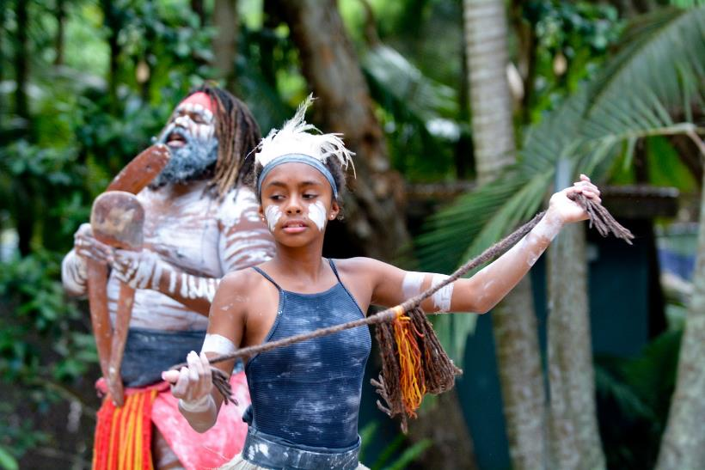

Acknowledgement
We acknowledge the Traditional Owners of the lands throughout Queensland. We pay our respects to Elders – past, present, and emerging – and acknowledge the important role Aboriginal and Torres Strait Islander people continue to play within the community. We also acknowledge people with disability who have come before us and died in institutional settings, as well as those who are still trapped in institutions or silenced by institutional practices. We take on the responsibilities of being clear about the rights of all people with disability and, where necessary, speak in an informed and considered manner, for those who cannot speak for themselves.

Contents
Suggested Citation 2
Published by 2
A Note on Terminology 2
General Acknowledgements 2
Acknowledgement 3
Contents 4
List of Figures 6
List of Abbreviations 7
Foreword 8
1. Key Messages 10
2. Executive summary 12
3. Context 16
4. Approach 19
4.1 Survey sample 20
5. Results 25
5.1 Employment and financial security 30
5.2 Inclusive homes and communities 36
5.3 Safety, rights, and justice 43
5.4 Personal and community support 48
5.5 Education and learning 53
5.6 Health and wellbeing 57
5.7 Community attitudes 64
6. Strategic areas for action 69
1. Safeguard community voice 69
2. Improve standard of living and social protection 71
3. Enhance dignity and equity 73
4. Strengthen belonging 76
Summary of strategic areas for action 78
References 88
Appendix 1 executive summary dashboard 91
Appendix 2: State Disability Plan Outcome Areas and Policy Priorities 97
Appendix 3: Griffith Inclusive Futures 101
Appendix 4: Sample demographics 103
Appendix 5: Queenslanders with disability case studies 105
Appendix 6: Accessing services. 110
Appendix 7: Service quality and outcomes 112

List of Figures
Figure 1 Executive summary dashboard part 1 13
Figure 2 Executive summary dashboard part 2 14
Figure 3 Number of people with disability and primary carers in Queensland 15
Figure 4 Participant demographics overview 20
Figure 5 Location of survey participants with disability 21
Figure 6 Types of disabilities reported by survey participants (number and order) 22
Figure 7 Origin of disabilities reported by survey participants (number and percent) 22
Figure 8: Number of survey participants with disability who believe life is getting better 25
Figure 9: How often participants with disability can access different services. 26
Figure 10 Participants with disability’s assessment of service quality and outcomes 27
Figure 11: Employment and financial security results from participants with disability 28
Figure 12: Inclusive homes and community results from participants with disability 34
Figure 13: Safety, rights, and justice results from participants with disability 41
Figure 14: Personal and community support results from participants with disability 45
Figure 15: Education and learning results from participants with disability. 51
Figure 16: Health and wellbeing results from participants with disability 55
Figure 17: Community attitude results from survey participants with disability 62

List of Abbreviations
CALD = Culturally and Linguistically Diverse
DCSSDS = Department of Child Safety, Seniors and Disability Services
DSP = Disability Support Pension
FC = Families/carers of people with disability (participant code for quotes)
GP = General Practitioners
LGBTIQA+ = Lesbian, gay, bisexual, transgender, intersex, queer/questioning, asexual, and other sexual identities
ME/CFS = Myalgic Encephalomyelitis/Chronic Fatigue Syndrome
NDIS = National Disability Insurance Scheme
OAM = Order of Australia medal for outstanding achievement and service
ORG = Organisational participants (participant code for quotes)
PBS = Pharmaceutical Benefits Scheme
PWD = People with disability (participant code for quotes)
QDN = Queenslanders with Disability Network

Foreword
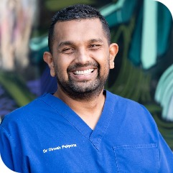
Dr Dinesh Palipana OAM
A message from Dr Dinesh Palipana OAM, 2021 Queensland Australian of the Year, Griffith University researcher, and Queenslanders with Disability Network (QDN) member.
They say that good work is good health. Work that is individually meaningful for each of us, therefore, is important. However, the employment challenge for people with disability is significant. While we have antidiscrimination laws and treaties that speak to the right of people with disability to work, employing people with disability just makes good business sense. Organisations that are diverse employers are more profitable, innovative and happy.
Although good work contributes to good health, people with disability still experience health gaps. Access to healthcare is routinely difficult. This community experiences a high rate of complications and mortality, especially during emergencies like pandemics. Health and employment are fundamental rights, but so is housing. Appropriate housing, quite literally, provides a homebase to build these things out of. Yet again, housing access is not easy for a person with disability.
In an economic powerhouse like Australia, where we invest so much in the well-being of our citizens, there is little reason not to improve these basics for people with disability. Apart from them being our obligations under various treaties, they make economic sense.
It is imperative that we pursue a good humane society where all people can be healthy, employed, live comfortably, access the community, have good supports, and have protection for safety and rights.
The Voice of Queenslanders with Disability Report
Powered by the Dignity Project. Funded by the Queensland Government.


1. Key Messages
The Voice of Queenslanders with Disability report provides insights gathered from a sample of 291 Queenslanders with disability, 117 family/carers and 34 organisational representatives who engaged with the research survey. Queenslanders shared authentically and transparently with us about what is going well and what is challenging across many aspects of their lives. As the first survey to collect stories across all seven outcome areas of Queensland’s Disability Plan 2022-2027: Together, a Better Queensland² and Australia’s Disability Strategy 2021-2031,³ diverse and sometimes divergent perspectives were shared. There was strong support and representation from members of the LGBTIQA+ community (24%) and from those who live in regional and remote areas of the state (35%). While hundreds of people shared their perspectives, there is no single ‘voice of disability’ in Queensland and it is important to recognise that while this report presents key findings, it does not represent all disability experiences throughout the state.
Queenslanders told us that for some, life was getting better, with more stable income, employment, and secure housing. Conversely, Queenslanders also told us that for some, life was getting worse, with challenges to health, income, and supports. There were also a group of Queenslanders who were doing relatively well, despite challenges, but who were concerned about what the future might hold, particularly if they supported children with disability. What the findings of this report highlight is that Queenslanders are experiencing a range of successes and achievements and it is important to consider multiple viewpoints when designing policies, support services, and implementing change.
We asked Queenslanders to share not only about their individual experiences, but also the ways in which government (across all levels), organisations, community groups, and key systems and services could continue to implement improvements in the daily lives of people with disability. They told us that strategic action should be examined and considered in four critical areas. First, participants told us that the voice of the community should be promoted and safeguarded through citizen leadership and monitoring mechanisms for the design, delivery, and implementation of any action. Second, participants called for improved standard of living and social protection for Queenslanders with disability, to improve economic security, accessible housing, increased employment opportunities, and support lifelong learning. Third, enhancing dignity and equity was mentioned to promote an inclusive society where everyone can participate fully. Finally, participants told us that we need to strengthen belonging across the state, fostering a sense of community and connection.

2. Executive summary
Hundreds of Queenslanders (442 participants) voiced their needs and experiences across the three ‘Voice of Queenslanders with Disability’ surveys: 291 people with disability, 117 family/carers and 34 organisational representatives. These voices were complex and multi-faceted, reflecting a wide range of experiences and communication styles. This report reflects a spectrum of lived experiences. However, this information may not be representative of all people with disability, family/carers, and organisations across the state. Strategic areas for action, priorities and potential next steps have been provided.
Fortunately, Queensland seems well placed to collaboratively address these issues across all levels of government, business, and community; underpinned by research and engagement with people with disability, their families/carers, and organisational representatives. Queensland’s Disability Plan 2022-2027: Together, a Better Queensland² provides a strong mandate to improve the lives of people with disability across a wide range of areas, in line with Australia’s Disability Strategy 2021-2031³ and the Convention on the Rights of Persons with Disabilities.¹ The Voice of Queenslanders with Disability provides a 2023 baseline, enabling Queenslanders to ask for what they need:
‘This survey is giving us a voice, finally. […] It’s not about governments saying what we need, it’s about us telling them what we need. Finally, someone is listening.’ (PWD268)
Queenslanders who engaged in the survey shared clear achievements. Life is improving for some Queenslanders with disability (30% of our sample). Participants told us that they were safe (80.5%), that they felt welcomed and included in the community (67%), and that they had plans to stay safe during disasters (64%). For these people, positive experiences were improved by financial security and stability. However, many participants also told us that they continue to experience challenges. Almost half of the participants told us that they did not feel they had enough money to live well (47%) and/or could not access paid (49%) and unpaid (41%) support they needed. For these people, challenges affected every aspect of their lives, including their human rights, safety, housing, employment, health, and wellbeing. Many family/carer participants and organisational representatives shared frustrations with the lack of integrated response options in the broader disability support systems. People with disability who were exposed to overlapping forms of discrimination and marginalisation (e.g., disability type, location, age, sexuality, and marital status) felt particularly disadvantaged, and often excluded from funding, services, and support. People with disability and their families and carers expressed cost-of-living and housing affordability issues, similar to those that many Queenslanders are experiencing in 2023. Many participants shared that they were experiencing or nearing crisis.
Queenslanders with disability, their families and carers, and the organisations were hopeful for the future and identified key strategic areas for action that could build on the existing activity in Queensland to support accessibility and inclusion in Queensland. These areas for action were derived from participant insights in line with Queensland’s Disability Plan 2022-2027: Together, a Better Queensland,² Australia’s Disability Strategy 2021- 2031,³ and the United Nation’s Convention on the Rights of Persons with Disabilities.¹
Figure 1 and Figure 2 on the next two pages detail a high-level overview of the views and responses of people with disability who participated in this study. A table containing the same information is included in Appendix 1.
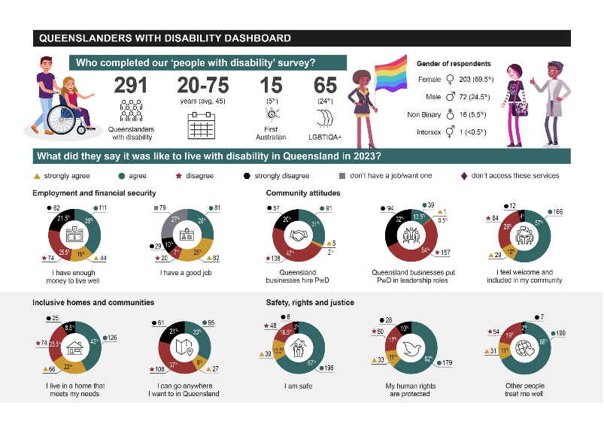
Figure 1 Executive summary dashboard part 1
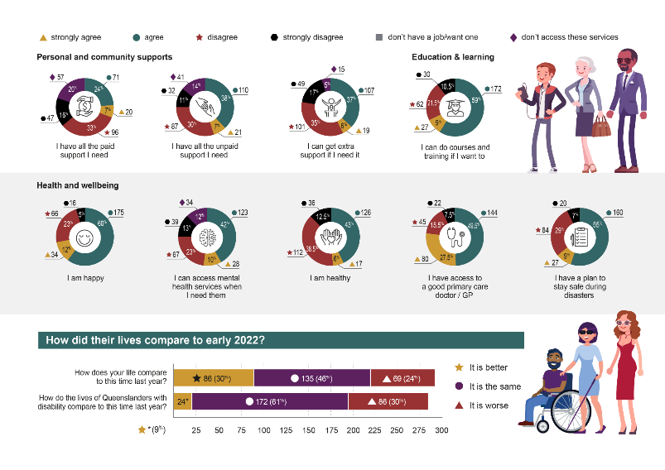
Figure 2 Executive summary dashboard part 2

3. Context
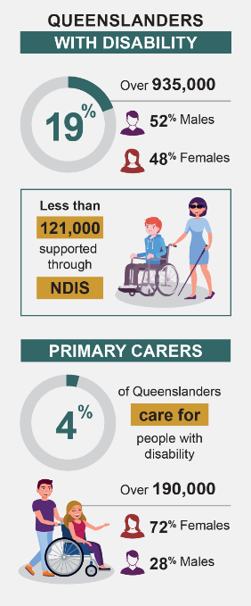
Figure 3 Number of people with disability and primary carers in Queensland
Around 4.4 million Australians (18%) are estimated to have disability.⁴ Australia’s Disability Strategy 2021-2031 aims to help them fulfil their potential, as equal members of an inclusive society.³ This strategy outlines improvements across seven outcome areas:
- employment and financial security
- inclusive homes and communities
- safety, rights, and justice
- personal and community support
- education and learning
- health and wellbeing
- community attitudes.³
The first strategy report was released in February 2023, providing ‘baseline’ information for each outcome area across Australia.⁵
Over 935,000 Queenslanders (19%) have disability: 488,100 males (52%) and 449,500 females (48%).⁶ Less than 121,000 of these people receive support from the National Disability Insurance Scheme (NDIS).⁷ Around 191,000 Queenslanders (4%) support people with disability as their primary carer: 137,200 females (72%) and 54,500 males (28%).⁸ Primary carers tend to be partners (40%), parents (25%) or children (24%) of people with disability.⁶ This is shown in Figure 3.
Queensland’s Disability Plan 2022-2027: Together, a better Queensland, affirms our state’s commitment to becoming more welcoming, accessible and inclusive for people with disability.² It aligns with Australia’s Disability Strategy 2021-2031,³ and the United Nations’ Convention on the Human Rights of People with Disability.¹ Appendix 2 describes Queensland’s policy priorities for each outcome area.
This 'Voice of Queenslanders with Disability' report provides ‘baseline’ information for Queenslanders with disability, their families/carers and support organisations. It describes what is happening in each outcome area in early 2023, including achievements and challenges. It also provides strategic areas for action for various levels of government, service providers, industry and business and the broader community.


4. Approach
In late 2022, Queenslanders with Disability Network (QDN) commissioned Griffith University’s ‘Inclusive Futures: Reimagining Disability’ team (see Appendix 3) to produce a report representing ‘The Voice of Queenslanders with Disability’; funded by the Queensland Government’s Department of Child Safety, Seniors and Disability Services (DCSSDS). The report needed to provide information across the seven outcome areas in Queensland’s Disability Plan 2022-2027: Together, a Better Queensland,² including an in-depth understanding of inclusion and service experiences, achievements, challenges, and strategic areas for action.
Griffith University, QDN, and DCSSDS created a reference group to guide the development of the ‘Voice of Queenslanders with Disability’ report, including people with disability and family/carers from each organisation. This group informed survey development for three groups:
- Queenslanders with disability
- their family/carers
- disability support organisations.
Each survey included questions on demographics, disability types, and achievements and challenges across each outcome area in Queensland’s Disability Plan 2022-2027: Together, a Better Queensland.²
Griffith University and QDN partnered to identify, train, and support seven paid citizen scientists with disability in early 2023, building on the extreme citizen science approach developed by Griffith University’s ‘Dignity Project’ team.⁹ The citizen scientists played an important role once the survey was open (31 January to 13 March 2023), promoting the ‘Voice of Queenslanders with Disability’ surveys to their networks, and supporting people to complete them as required (online, in-person or over the phone). The survey was also promoted through Griffith University, QDN, and DCSSDS networks, including newsletters (e.g., QDN e-Bulletins), social media platforms (LinkedIn, Twitter and Facebook), and cross-organisational signature blocks.
In March 2023, the Griffith University research team analysed the data from the three surveys to inform this interim report. Most of the quantitative (numerical) data was automatically tallied into response totals (counts and percentages) through ‘Bang the Table’ survey software.¹⁰ Three participants were manually removed from the data set (two withdrew consent and one did not reside in Queensland), and extra descriptive insights were provided as appropriate (e.g., age range and average). The qualitative data (e.g., descriptions of what was going well, what was not going well, and what could be improved) were thematically analysed by two research fellows in NVivo. This information was incorporated into the results section of this report.

4.1 Survey sample
There were 442 participants across the three surveys, including 291 people with disability, 117 family/carers, and 34 organisational representatives. This provided a useful ‘snapshot’ of what is happening for those people, but this sample size is not necessarily reflective of all Queenslanders with disability, family/carers, and support organisations.
Details on the age, gender, location, and culture of each group of survey participants are provided in Figure 4 and in Appendix 4. There was a wide spread of ages for each group: people with disability were aged between 20 to 75 (45 years on average), family/carers were aged between 18 to 85 (average of 58 years), and organisational representatives were aged between 30 and 62 (48-year average). Each group had a large percentage of female participants, ranging from 88% for family/carers, 69.5% for people with disability, and 64% for organisational representatives.
The locations of non-organisational participants were distributed in a similar manner, with 65% of people with disability living in cities (66.5% for family/carers), 31.5% in regions (25% for family/carers), 3% in rural areas (7% for family/carers), and less than 0.5% in remote areas (1.5% for family/carers). The geographic locations of the people with disability who participated in this study are shown in Figure 5, with participants clustered around Mount Isa, Cairns, Townsville, Barcaldine, Emerald, Rockhampton, Bundaberg, Hervey Bay, Toowoomba, and South-East Queensland (including Brisbane, Gold Coast and Sunshine Coast). There was a high proportion (24%) of participants with disability who identified as being lesbian, gay, bisexual, transgender, intersex, queer/questioning, and asexual (LGBTIQA+), and 5% of the family/carers identified in this way. The percentage of First Australians was quite small in each group: 5% for people with disability, 2% for family/carers, and 0% for organisational representatives. The proportion of people who did not speak English at home was also low: 2.5% for people with disability and 1% for family/carers.
Many types of disability were represented in this survey, as shown in Figure 6 (disability types) and Figure 7 (disability origin). Participants with disability most frequently reported physical, chronic illness/pain, and psychosocial disabilities, whereas family/carers were most likely to support people who were neurodivergent and/or lived with intellectual, physical, or sensory disabilities. Almost two-thirds of participants with disability (62%) obtained some (24%) or all (38%) of their conditions from non-genetic causes (e.g., accidents and illnesses), while 23% reported that their disabilities were all genetic in origin. Just over half of family/carer participants (53%) supported people with genetic disabilities, while 35% cared for people who had obtained some (12%) or all (23%) of their disabilities from non-genetic causes.
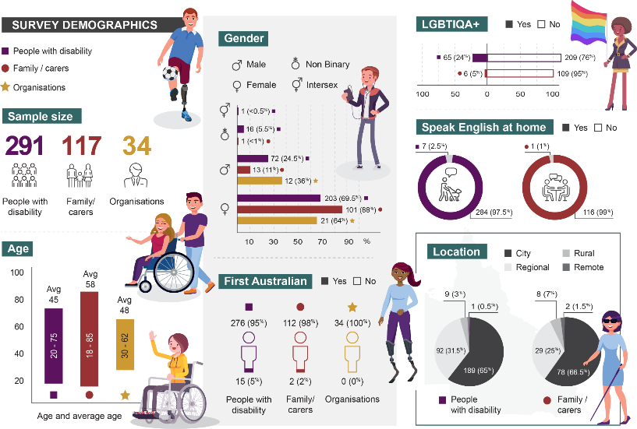
Figure 4 Participant demographics overview

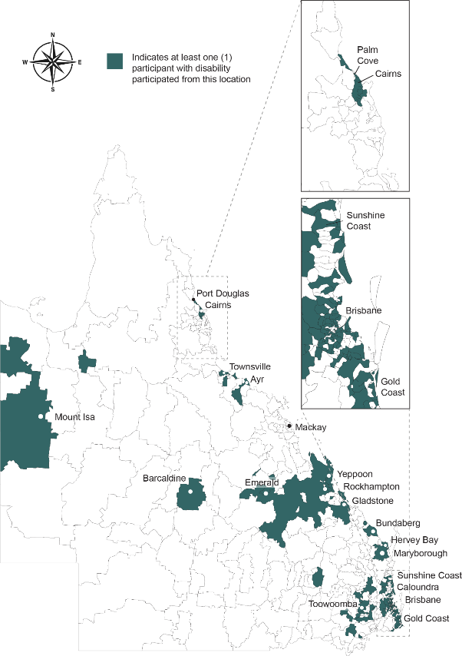
Figure 5 Location of survey participants with disability
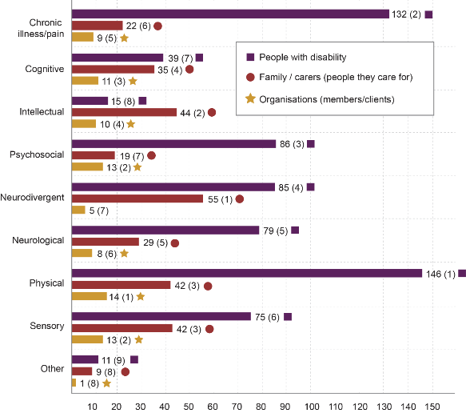
Figure 6 Types of disabilities reported by survey participants (number and order)
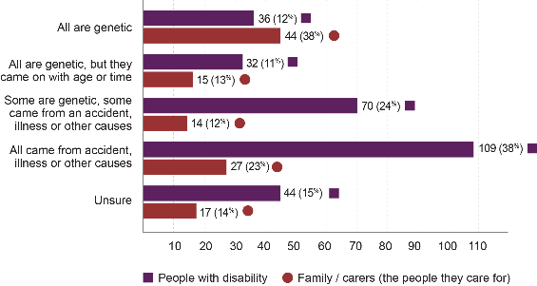
Figure 7 Origin of disabilities reported by survey participants (number and percent)

5. Results
The Voice of Queenslanders with disability collected stories and diverse perspectives from people with disability, family/carers, and organisations. Rather than a single ‘voice’, the results reflected a range of experiences. Appendix 5 details four case studies, combinations of data and experiences, that demonstrate some of the range of experiences represented by Queenslanders with disability who participated in this research. About one-third of people who participated in the study (30%) said that life had improved in the last year. These people agreed that they had enough money (53%), had a good job (56%), and accessible, safe housing (66%). People who felt that life was improving also said they were safe (80.5%), happy (72%), and healthy (49%), with access to the paid (31%) and unpaid (45%) support they needed.
Conversely, one-fourth of people who participated in the study said that life had worsened in the last year (24%) and that they did not have enough money (47%), did not have a good job (17%), and their home did not meet their needs (34%). These people tended to feel unsafe (19.5%), unhappy (28%) and unhealthy (51%), with difficulty accessing enough paid (49%) and unpaid (41%) support. The remaining participants shared that they fell somewhere in between - life was fairly similar to this time last year and that they were managing well. However, some participants, even those who were doing quite well, reported that difficulty accessing government assistance left them worried that they may not be able to manage so well for much longer. It was clear that the cost-of-living and housing affordability challenges experienced by Queenslanders in 2023 were also negatively impacting people with disability and their families/carers. Family and carers, as well as organisation representatives, identified the impacts of distress on people with disability, particularly where systems are not working in an integrated way to support people with disability.
Participants with disability who had intersectional identities (e.g., disability type, sexuality, location, age, and marital status) were particularly disadvantaged, and reported increased challenges with accessing funding, services, and support. Participants with invisible disabilities such as chronic pain and fatigue, neurodiversity and psychosocial disabilities often struggled to access funding and support and were more likely to experience attitudinal barriers from health professionals and community members. LGBTIQA+ participants said they often felt unsafe in formal and informal settings and had few places to meet and socialise. Non-urban participants found it difficult to access affordable, reliable, and quality health and support services, due to service gaps, staff shortages and turnover. Meanwhile, participants over 65 were excluded from NDIS-funded supports, and participants requiring welfare funding and subsidies sometimes felt forced to remain single in order to keep essential supports. Other forms of intersectional adversity (e.g., ethnicity) were not as evident in the data, due to the small number of First Peoples and Culturally and Linguistically Diverse (CALD) community members participating in this study. Future surveys could improve and increase intersectional perspectives with focused engagement of these groups.
This section of this report describes the ‘Voice of Queenslanders with Disability’ survey results, in a way that highlight the complex, multi-faceted, and sometimes divergent voices of participants with disability. These have been presented within the seven outcome areas in Queensland’s Disability Plan 2022-2027: Together, a Better Queensland² and Australia’s Disability Strategy 2021-2031³: (1) employment and financial security, (2) inclusive homes and communities, (3) safety, rights, and justice, (4) personal and community support, (5) education and learning, (6) health and wellbeing, and (7) community attitudes. Each set of findings includes relevant goals and policy priorities, participant demographics, and achievements and challenges.
There are also images depicting whether people with disability feel that life has changed since last year (Figure 8), their ability to access various services (Figure 9 and Appendix 6), their assessments of the quality and outcomes of these services
(Figure 10 and Appendix 7), and level of agreement with various statements (e.g., ‘I am happy’) (Figure 11-Figure 17). Participant quotes are used to highlight participant experiences in their own words. The examination of experiences across the seven outcome areas made it easier to see that all areas are connected and impact on the other areas. An achievement in one area may contribute to increased achievements in others and vice versa regarding challenges, which shows the cumulative complexity of change or action in any one of the outcome areas.
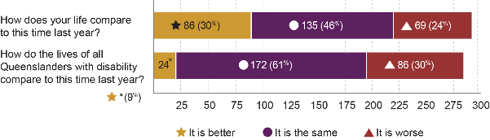
Figure 8: Number of survey participants with disability who believe life is getting better

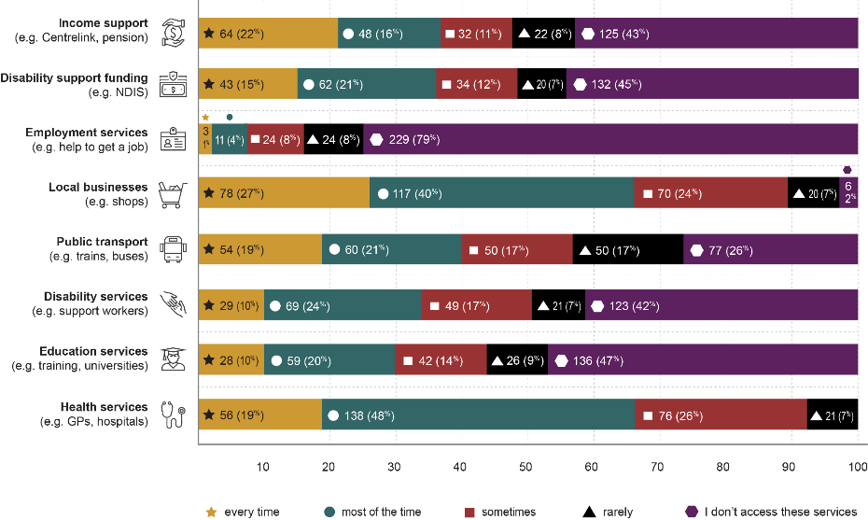
Figure 9: How often participants with disability can access different services.
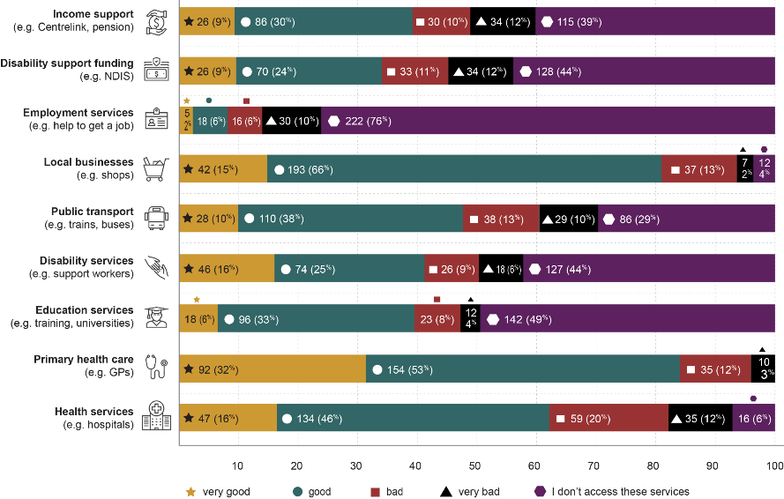
Figure 10 Participants with disability assessment of service quality and outcomes

5.1 Employment and financial security
Goal^{2,3} - People with disability have economic security, enabling them to plan for the future and exercise choice and control over their lives.
Policy priorities^{2,3}
1.1 Strengthen the financial independence of people with disability.
1.2 Increase employment of people with disability.
1.3 Improve the transition of young people with disability from education to employment.
Source
- Queensland’s Disability Plan 2022-2027: Together, a Better Queensland²
- Australia’s Disability Strategy 2021-2031³
Employment and financial security are important determinants of health and wellbeing, enabling people to experience a sense of meaning, connection and belonging, and obtain essential goods and services such as food, housing, and healthcare. The ‘employment and financial security’ outcome area in Queensland’s Disability Plan 2022-2027: Together, a Better Queensland² aspires towards economic security, so all Queenslanders with disability can “plan for the future and exercise choice and control over their lives”.² Its three policy priorities aim to strengthen the financial independence of people with disability, increase their employment, and improve the transition of young people with disability from education to employment. More participants (31.6%) provided additional information on ‘financial security and employment’ than any other outcome area.
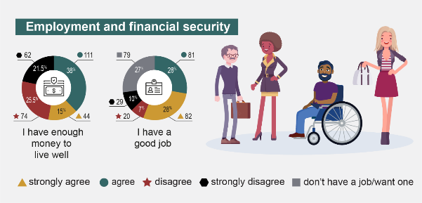
Figure 11: Employment and financial security results from participants with disability

5.1.1 Employment and financial security achievements
Just over half (53%) of participants with disability had enough money to live well (policy priority 1.3). They received this money from several sources, including jobs, self-employment (businesses), family, and government services. A third (36%) of the participants with disability had annual household incomes above $75,000, but few (15%) were above $150,000, including 5% above $200,000. Over a third (39%) received the Disability Support Pension (DSP), with slightly less (38%) accessing these services every time or most of the time. People’s satisfaction with the quality and results of these services seemed to reflect their ability to access them on a regular basis: 39% of participants rated Centrelink services as very good or good.
Almost two-thirds (59%) of participants with disability had employment (policy priority 1.1). Many were employed full-time (52%), while others worked part-time (23%), casual (9%), across multiple roles (6%), within the ‘gig economy’ (1%), or were self-employed (9%). Most participants worked in professional (37%) or management and administration positions (35%). Five factors seemed to support good jobs and businesses: (1) good pay and tenure, (2) flexibility, (3) enjoyment, (4) connection, and (5) help with career progression. Good pay and tenure enabled people to support themselves and their families, while reducing uncertainty and stress. Flexibility allowed participants to work in a way that reflected their needs, which could mean working less hours, from home and/or at their own pace; accessing workplace accommodations and adjustments as required. For example, PWD209 fulfilled their management position from home four days a week and accessed a free car park the day they attended in-person. When participants expressed a positive work experience, it was often when their interests and skills provided a sense of meaning, purpose and contribution. Connection referred to supportive supervisors, colleagues, peer or advocates working together in ways that were accessible and diverse. Help with career progression included mentors, graduate programs, and advancement opportunities.

5.1.2 Employment and financial security challenges
A large percentage (47%) of the participants with disability reported that they did not have enough money to live well (policy priority 1.3). This was reflected in their household incomes: 52% earned under $75,000, including 20% that earned under the poverty line for single people ($25,000 or less).¹² One-fifth of the participants with disability were dissatisfied with Centrelink and NDIS services: 19% could only access them sometimes or rarely. Once again, satisfaction seemed linked to access, with around one-fifth reporting that their experiences with these services were bad or very bad: 22% for Centrelink and 23% for NDIS. Many participants shared difficulty with accessing Centrelink (39%) or NDIS (44%) at all, but it is not clear if this was because these services were not needed. Future surveys could illuminate this issue, by providing more nuanced response options.
Many participants with disability said they were struggling to survive financially (policy priority 1.3), which adversely affected several aspects of their lives. Poverty compounded some peoples’ disabilities; affecting their ability to access support, food, housing, medication, and further limiting their ability to work. The detrimental impact poverty has on these cross-outcome areas was illustrated by PWD18:
[The] disability pension is below the poverty line, and I have now exhausted all my savings and struggle to make ends meet. And I do not have any alternates to supplement my cost of living— forget any extras like needed medications, holidays, gifts for my sons etc— these are simply too far out of reach. (PWD18)
PWD64 put it like this: “[The] disability pension is just surviving poverty. I can’t afford all my medication as it is, so I can’t adequately medicate. You can’t afford the drs you need to help you. I can’t get healthy enough to work”. Some participants said they are living off “two-minute noodles” to save for health services (PWD154), while others had to forgo these services completely. PWD129’s inability to access medical treatments resulted in “years of underemployment and ongoing health issues that could have been mitigated if treated in a timely fashion”, preventing 10 extra years on DSP. Not being able to work or earn enough money to live well made it hard to secure appropriate housing, meaning some participants had to live in insecure and/or unsafe conditions. Others had to work beyond their reported physical/mental capacity, to support themselves (and often others), leading them to worry how they would cope in the future when they burned out or were no longer able to work. Some participants mentioned discriminatory welfare policies that blocked “disabled peoples’ […ability] to be partnered without being financially reliant on the other person”, and how this leaves people without options and may keep them stuck in harmful situations, including domestic violence. Family and carer participants also worried how the person(s) they supported would manage financially. These challenges took a toll on people’s physical and mental wellbeing, increasing vulnerabilities and exacerbating disadvantage.
Participants recommended some solutions to strengthen financial support and economic security (see section 6. Strategic areas for action, 2.1). Participants mentioned the opportunity to review and increase welfare payments and subsidies to reduce cost of living, particularly in line with rising inflation (strategic area for action 2.1.1). The application processes for accessing welfare supports were mentioned by some participants, particularly in the context of improving accessibility and expanding eligibility (strategic area for action 2.1.2).
Over one-third (41%) of participants with disability were not employed (policy priority 1.1), but employment services rarely helped (policy priority 1.2). Most participants never (79%), rarely (8%) or sometimes (8%) accessed employment services. Twice as many participants reported bad or very bad quality and outcomes (16%) when accessing employment services, compared to those who found them good or very good (8%). Participants with disability reported a wide range of employment barriers. Many had encountered a “culture of bullying” (PWD21), “ableism” (PWD67), “hiring stigma due to [employers] not fully understanding the employee and their strengths and needs” (PWD124), and discrimination, even “within the disability community” (PWD98). They often found it difficult to obtain or maintain disability accommodations, including the ability to work from home.
Some participants felt pressured to take low-paid and/or insecure work that did not align with their interests, qualifications, or levels of experience, while others struggled to get work at all. Several said their employers and colleagues did not understand the impacts that working with disability had on their wellbeing, including overwhelm, exhaustion, ongoing stress and difficulties fitting disability-related appointments around work commitments. Other participants said their employers did not recognise their limitations, especially if their disabilities had “no physical/outward facing signs” (PWD198). Many participants expressed a need for more part-time positions (including professional and leadership roles), although some acknowledged that while they were unable to work full-time work hours, they were unable to live on the salaries of part-time positions. They also discussed the need to access professional development, opportunities to advance in their careers, and support to create their own businesses. Family and carer participants also discussed employment challenges, including concerns about their own employment and financial situation, and worries that the person(s) they cared for might not be able to obtain a job and support themselves.
Participants identified some potential areas for improvement and change in addressing and increasing the availability of employment opportunities (strategic area for action 2.3). Improving and increasing disability awareness and training for employers and employees was top of mind for many participants (strategic area for action 2.3.2) as this could assist in promoting inclusive hiring practices and inclusive work environments (strategic area for action 2.3.1). Participants mentioned the need for flexible work environments and approaches to employment, particularly around new opportunities like entrepreneurship (strategic area for action 2.3.3, 2.3.4).

5.2 Inclusive homes and communities
Goal^{2,3-} People with disability live in inclusive, accessible and well-designed homes and communities.
Policy priorities^{2,3}
2.1 Increase the availability of affordable housing.
2.2 Housing is accessible and people with disability have choice and control about where they live, who they live with, and who comes into their home.
2.3 People with disability are able to fully participate in social, recreational, sporting, religious and cultural life.
2.4 The built and natural environment is accessible.
2.5 Transport systems are accessible for the whole community.
2.6 Information/communication systems are accessible, reliable and responsive.
Inclusive homes and communities help people with disability live, work, play, and socialise.³ Queensland’s ‘inclusive homes and communities’ outcome area aims to ensure that “people with disability live in inclusive, accessible, and well-designed homes and communities”.² Two policy priorities focus on housing affordability, choice, and control; the others concentrate on accessible built and natural environments (including public transport), quality information and communication systems, and participation in recreational, social, sporting, cultural, and religious life. Over a quarter (28%) of the participants with disability provided extra information on homes and communities. Most lived alone (33%) or with one (31%) or two (19%) others.
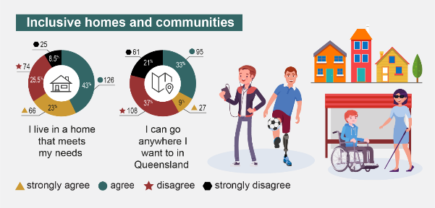Figure 12: Inclusive homes and community results from participants with disability

5.2.1 Inclusive homes and community achievements
Two-thirds (66%) lived in homes that met their needs. Positive home environments were affordable, safe, and accessible, with social support and an ability to work from home when required (policy priorities 2.1-2.2). These factors helped some participants manage expenses and avoid hazards. PWD107 said, “I am now in affordable, fit for purpose housing, this alone assists with managing expenses. […] I can work from home, which assists with my safety”. PWD164’s sense of safety, inclusion, and accessibility extended into other peoples’ homes, as their peers understood their invisible disability symptoms and adjusted sensory stressors to make them more comfortable (e.g., lowering noise volumes). Many family / carer participants supported the person(s) they cared for within their own homes.
Many participants with disability said community accessibility and inclusion were improving (policy priorities 2.3-2.6), with 42% reporting that they could go anywhere they wanted in Queensland. Participants discussed three non-residential areas: (1) shops, businesses, and community places, (2) travel and transport, and (3) online spaces. PWD45 concluded that “On the whole, building and infrastructure accessibility is improving”.
Local shops, businesses and communities were supportive for most people with disability (policy priority 2.3-2.4). Two-thirds (67%) of the participants with disability could access local businesses and shops every time or most of the time, with most (81%) rating their quality and outcomes as good or very good. Participants said, “new buildings and shops are getting better” (PWD10), “most places / spaces are easy to manage a wheelchair in” (PWD19), and that they “can get into and use most places [they] need” (PWD37). PWD209 was “happy […] most public places now have disability parking and toilets”, while PWD226 was also grateful for air conditioning. Local businesses seemed more conscious of disability supports, including companion cards that enabled participants to go to events with their carers attending free of charge, and greater acceptance of assistance animals. Genuine community inclusion was also improving and had started “to be a community conversation and focus” (PWD68). PWD83 reported that “most people within the community are respectful and helpful [and …] ask if [they] require help”, which was reflected by PWD201’s assertion that “help [was] available when required [as] the general public are generally kind and helpful”.
Travel and transport experiences were also positive for many participants with disability (policy priority 2.5). PWD201 found “braille signage, tactile ground surface indicators and audible lights” particularly helpful, while PWD271 benefitted from “floor markings for [people with] visual disabilities”. Some participants found their local councils to be responsive when notified of any issues with streetscapes and footpaths. Others appreciated public transport options such as quiet carriages and disability supports provided by Queensland Rail, as well as wheelchair accessible buses and ferries. Over a third (40%) of participants with disability were able to access public transport every time or most of the time, with the same proportion (39%) rating its quality and outcomes as good or very good.
Some participants also discussed the advantages of online spaces (policy priority 2.6). This included connecting to online meetings, shopping and community groups, and websites, including the accessible accommodation website. It also included the ability to seek assistance via email and social media. PWD65 said “online spaces are more accessible and equitable”. They rated their ability to connect to the “autistic community online” as “lifesaving” (PWD65).

5.2.2 Inclusive homes and community challenges
One-third (34%) of participants with disability lived in homes that did not meet their needs (policy priority 2.1-2.2). Residential challenges included: (1) not being able to find or afford a home at all, (2) not being able to access or use their homes, (3) violence, bullying and discrimination, and (4) unresponsive systems. These issues caused considerable distress to many participants with disability, adversely affecting health, safety, and wellbeing.
Queensland’s housing affordability crisis had caused some participants with disability to become homeless (policy priority 2.1), forcing PWD234 to live in a “homeless persons […] hostel”. The threat of homelessness weighed heavily on many participants’ minds. PWD74 constantly worried that their “rent will increase and [they] will become homeless because the DSP isn’t enough to live on”. Even those with jobs “fear[ed] losing [their] house sometimes”, due to chronic health issues, declining abilities, and organisational restructures and redundancies (PWD268). The lack of housing availability made PWD82 “feel out of control [across many life] circumstances”; continually “at threat of losing stability”. Family and carer participants also worried whether the person(s) they cared for would be able to live independently in the future.
Several participants reporting living in unsafe accommodation (policy priority 2.2). Some safety hazards were due to an absence of affordable, accessible disability housing and problematic home modification funding processes. Participants shared about enduring dangerous living conditions for several years while awaiting the results of NDIS applications and appeals, or funding initial home modifications themselves while preparing for less urgent modifications to be processed by relevant funding bodies. Some peoples’ disabilities made it difficult to leave their homes in emergencies, particularly wheelchair users living in multi-level apartments with lifts. Some participants reporting living with violent family members or being surrounded by abusive, discriminatory neighbours. A few had reported these types of issues to the police and housing providers but felt that they were ignored. Other housing issues (e.g., faulty locks and unnumbered carparks that made it difficult for support workers to find a park) have not received attention by property managers and housing providers, including government. Some participants who lived on their own also felt unsafe, from being “forced home prematurely” from hospital even though they were not able to cope by themselves (PWD256), or not being able to get help if they “fall, passed out or worse”, partly because they couldn’t afford a phone to call for help due to budget restrictions (PWD230). These challenges related to insufficient affordable, accessible housing stock; long and stressful home modification funding and appeal processes; and agencies that struggled to follow up on complaints and mitigate risks.
Participants identified a number of potential actions and improvements that could be taken to improve access to affordable and accessible housing (strategic area for action 2.2). Increasing the number of options for Queenslanders with disability was mentioned by many participants (strategic area for action 2.2.1). Increasing availability was complimented by some participants suggestion to develop incentives for builders and developers to adhere to universal design principles (strategic area for action 2.2.2). Increasing regulation of rentals (strategic area for action 2.2.4) and investment in community-based support services, particularly in regional and remote areas (strategic area for action 2.2.5), were discussed as potential solutions for the challenges facing Queenslanders with disability in regard to housing.
While accessibility and inclusion were improving for many Queenslanders with disability, a significant proportion still reported barriers, particularly in relation to physical and sensory accessibility and community attitudes. Over half (58%) of participants with disability could not go anywhere they wanted in Queensland). Just under one-third (31%) of participants could only access local businesses and shops sometimes or rarely), with 15% rating their quality and outcomes as bad or very bad. One-third (34%) could only access public transport sometimes or rarely), with 23% rating their public transport experiences as bad or very bad. Where participants lived may or may not have impacted on these experiences, with participants from regional and remote areas noting increased challenges with access and inclusion.
Several accessibility challenges were described in relation to shops, businesses, and communities (policy priorities 2.2-2.3). Public toilets were one of the biggest reported problems. Some places did not have disability toilets at all, while others were not accessible for wheelchair users due to poor fitout, obstacles (e.g., stored cleaning products), or because “some buffoon has locked it to keep it clean” (PWD39). One participant had got “stuck in toilets people insist are disabled but are more ambulant” (PWD213). Another chose to “pee in a bottle using a she-wee tube in the car” due to the inaccessible sensory nature of “auto-deodorisers in public toilets” (PWD189). PWD19’s ability to navigate “stores, restaurants and coffee shops” in a wheelchair was often impeded by excessive numbers of tables forced into small spaces and aisles that were “too crowded with stuff”. Some people were forced to sit outside to eat their meals because they couldn’t get inside or were deterred by an inability to reach the service counter and menus or use mobility devices.
Access to disability parking was often a challenge. Participants reported that public parks could also be problematic, with one participant saying that they had been “attacked by dogs and dog owners in public places on multiple occasions and sought help but not received it” (PWD40). Accessibility was also difficult for people with sensory challenges (e.g., sound, light, fragrance, and temperature), and intersectional identities (e.g., LGBTIQA+ people with disability, particularly those who were trans and/or gender-non-conforming). Some participants reported that public places were unpleasant due to “ignorance” (PWD18), people not understanding “hidden disabilities” (PWD12), and “being patronised, treated like a child” (PWD9). Family / carer participants also recognised these types of barriers in relation to the person(s) they support, including limited access and negative community attitudes.
Travel and transport can also be challenging (policy priority 2.5). Streets do not always have appropriate footpaths, lighting and marking. “Traffic lights don’t stay green long enough for [people] to feel safe getting across the road” (PWD72) and vehicle drivers can’t always see wheelchair users crossing roads. Some people do not feel safe on public transport, are not able to access disability seating (as others are using them), and/or don’t have access to buses or trains that go near their destinations. Taxi and Uber presented barriers for some participants and some people have had to pay a lot of their NDIS funds to carers to take them to and from places. Wheelchair users reported some trouble travelling on planes, due to an absence of aisle chairs, a reluctance to take manual wheelchairs, and multiple cancellations due to no longer being able to accommodate a wheelchair. PWD45 was told to “catheterise” on an overseas flight as there was no aisle chair and ended up needing to shuffle to the toilet on their “bottom”. Participants also struggled to enjoy “the Great Outdoors […] in a wheelchair” (PWD133), due to inaccessible beaches and bushwalks, and hotels without accessible, affordable family rooms.
Some participants with disability also mentioned problems with online spaces (policy priority 2.6). “Many websites do not support Web Accessibility Guidelines – and the Guidelines do not include the needs of light sensitivity/photophobia” (PWD164). PWD249 lamented the lack of “digital accessibility” and how frustrating this made bill paying. Meanwhile PWD251 noticed that the online interface of major grocery shops incorrectly reported items as being out of stock, forcing them “to rely on others to go to the store and buy them” and how that was a form of discrimination. It was clear there was still more to do to make online spaces accessible.
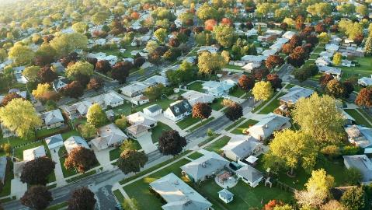
Participants identified a few potential areas for solutions to continue improvement of accessibility of physical and virtual environments (strategic area for action 3.1). Participants highlighted the importance of universal and inclusive design principles in building and construction as well as of online environments (strategic area for action 3.1.1). Some mentioned the need for bespoke accessibility audits around critical infrastructure, to better highlight the barriers and pathways for change and improvement (strategic area for action 3.1.2). Enhancing local community footpaths, wayfinding supports, and transport availability was mentioned by quite a few participants, as this could contribute to safer navigation (strategic area for action 3.1.3).

5.3 Safety, rights, and justice
Goal^{2,3 -} The rights of people with disability are promoted, upheld and protected, and people with disability feel safe and enjoy equality before the law.
Policy priorities^{2,3}
3.1 People with disability are safe and feel safe from violence, abuse, neglect and exploitation.
3.2 Policies, processes and programs provide better responses to people with disability who have experienced trauma.
3.3 Policies, processes and programs for people with disability promote gender equality and prevent violence against groups at heightened risk, including women and their children.
3.4 The rights of people with disability are promoted, upheld and protected.
3.5 People with disability have equal access to justice.
3.6 The criminal justice system responds effectively to the complex needs and vulnerabilities of people with disability.
Safety, rights, and justice are protected by the United Nations’ Convention on the Rights of People with Disabilities,¹ including rights to safety, justice, accessibility, inclusion, an adequate standard of living and the highest attainable standard of health. The ‘safety, rights, and justice’ outcome area in Queensland’s Disability Plan 2022-2027: Together, a Better Queensland ² focuses on upholding these rights. Its policy priorities aim to ensure that people with disability have their rights promoted and protected; are safe and free of harm; are supported by trauma-
informed policies, programs and processes that prioritise vulnerable groups; and have equal access to a responsive criminal justice system that understands complex needs. A quarter (25%) of the Queenslanders with disability who completed our survey provided more information on this outcome area. Many were positive, but the lengthiest responses focused on challenges.
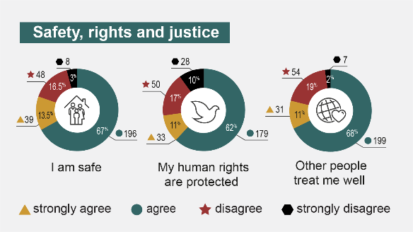
Figure 13: Safety, rights, and justice results from participants with disability

5.3.1 Safety, rights, and justice achievements
Around four-fifths of the participants with disability reported positive safety experiences (policy priority 3.1): 80.5% were safe and 79% were treated well. These participants felt safe in their families and homes, with their support workers, and in their communities. For example, PWD12 was “safe at home and with [their] husband”, while PWD76 had “no problem ventur[ing] to most areas of the city”. PWD45 mentioned that their safety had improved over time, “On the streets, I feel safer than I used to, and less people are abusive to me for being in a wheelchair”. People’s sense of safety often seemed linked to their experience of access and inclusion, including an absence of stigma and violence. Safety was improved through home modifications, support workers, and the ability to shop online; workplace design (e.g., tables at the right height for wheelchair users); accessible shops, change rooms and public transport (PWD268); and groups that “want to be inclusive” (PWD213). A few participants provided safety caveats. PWD15 felt safe now they had an “anti-burglar front door”. PWD14 was safe because they did not go out much and PWD11 felt safe “except in extremely busy locations or at night”. These provisos suggested that some people’s sense of safety relied on living within limits; not going out, or not going to certain places at certain times.
Three-quarters (73%) of participants with disability had their human rights protected (policy priority 3.4). Some spoke about knowing their rights and having access to people, organisations or platforms that could help when required. PWD140 said they “have a right to feel safe and respected”, whereas PWD101 knew their rights and people they could contact about them. Participants mentioned being able to obtain rights-based support from family, support workers, local councils, and social media platforms such as LinkedIn.

5.3.2 Safety, rights, and justice challenges
Around a fifth of participants with disability reported challenges in this outcome area: 19.5% were not safe, 27% did not have their human rights protected, and 21% were not treated well. The underlying causes crossed into every outcome area.
Physical environments impeded safety in several ways (policy priority 3.1). Some people (particularly wheelchair users) were not able to enter their homes, use fire escapes in emergencies, or leave their apartment when lifts were not working. Others reported experiences in and around the home that they felt threatened their safety, including domestic violence situations, violent neighbours, high crime rates in their neighbourhood, or faulty locks. Public areas could also be unsafe, including roads, footpaths, parks, shops, toilets, public transport, and airlines. The inaccessibility of physical environments also affected online spaces.
Health and support services were considered problematic when people could not access the supports required for their conditions or could not receive emergency healthcare that met their needs (policy priority 3.2 and 3.3). This included people who could not access support due their age, nationality, or marital status (e.g., being ‘too old’ to access NDIS, not having Australian citizenship and therefore not being able to access subsidised health services, or not being able to access the DSP or subsidised health and social services due to having a partner). Some participants felt unsafe when health professionals were not aware of their condition or needs, rushed appointments without listening to them, prescribed medications that made them worse, or put them on long waitlists. Others were afraid of their rights being removed, coercive control, and involuntary treatment orders due to previous experiences relating to their psychosocial conditions.
Community knowledge and attitude issues were mentioned by a few participants. For example, PWD65 said “Autistic people are not safe in society. We are vulnerable to ignorance and misconceptions, predators, […] stigma and discrimination, […] abuse, [… as well as a] lack of inclusion and connection to community”. PWD87 felt vulnerable to society’s stereotypes, biases, and discrimination, while PWD100 said they could never be safe as a disabled LGBTIQA+ Australian, as they encountered harm on a daily basis.
Justice was not accessible for some participants (policy priority 3.6), with one saying, “You need to go to court to exercise your rights and justice is only for those who can afford it” (PWD39). PWD3 said that the “legal system uses disability against people to demonstrate lack of competence”, forcing people to lose custody of their children. Some participants also encountered challenges with government agencies, police, and health professionals (e.g., not following up on complaints or mitigating risks).
The multifaceted harms experienced by some people with disability led to a sense of overwhelm, hopelessness and thoughts of self-harm; with one person saying they were “just trying to survive” (PWD159). These challenges were often compounded by cost-of-living pressures, which impacted on many other factors. PWD219 highlighted the complexity:
It is indescribably challenging to manage a full-time, high intensity, professional role, run a household, care for my neurodiverse partner and children and manage medical appointments, sick days, and feeling unwell. I live in terror of losing my job and being unable to provide for my family. I don't understand workplace politics so every time I make it to management level and away from the intensity of a frontline role, I feel bullied, or people think I'm odd or there's some social problem and I feel I can't cope. (PWD219)
Many family and carer participants were concerned about the mental and physical safety of the person(s) they supported. They were scared about them going out in public without formal support, and worried that they might be vulnerable to abuse and injustice, and/or have their human rights violated. These participants advocated strongly on behalf of the person(s) they cared for to ensure that this did not happen.
Participants identified that strategic action within all the other outcome areas would greatly impact on the rights and safety of Queenslanders with disability. Developing targeted initiatives to address the unique barriers faced by people with disability, and more specifically with intersecting identities (like lesser-known and stigmatised diagnoses), was mentioned by many participants (strategic area for action 3.2.6). Continuing to support and increase the policy and advocacy mechanisms to address stigma and discrimination was also emphasised by participants as a way to increase rights and safety throughout Queensland.

5.4 Personal and community support
Goal^{2,3 -} People with disability have access to a range of supports to assist them to live independently and engage in their local communities.
People with disability have access to a range of supports to assist them to live independently and engage in their local communities.
Policy priorities^{2,}
4.1 People with disability are able to access supports that meet their needs.
4.2 The NDIS provides eligible people with permanent and significant disability with access to reasonable and necessary disability supports.
4.3 The role of informal support is acknowledged and supported.
4.4 People with disability are supported to access assistive technology.
Personal and community supports enable people with disability to live more interdependently and actively engage in their communities. These services and resources include the quality and availability of formal and informal care, NDIS funding, and assistive technology. Participants with disability received support to:
- get around their home and community (146 participants)
- look after themselves (115 participants)
- access healthcare and talk to health professionals (95 participants)
- undertake day-to-day tasks and make decisions and choices (75 participants)
- build and maintain relationships (72 participants)
- talk and communicate with others (61 participants)
- learn new things (59 participants).
Many participants accessed several types of support.
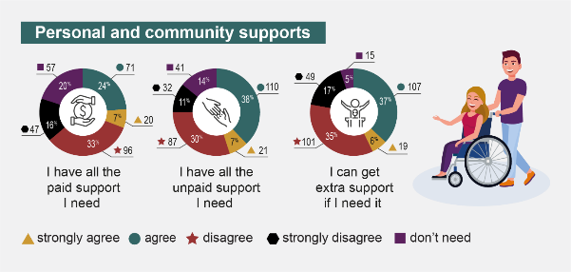
Figure 14: Personal and community support results from participants with disability

5.4.1 Personal and community support achievements
Many Queenslanders with disability accessed personal and community supports (policy priority 4.1), with nearly 40% obtaining NDIS-funded services. Participants with disability who received NDIS support and/or were employed had better access to, and choice and control of, services and service providers. One-third (34%) were able to access disability support funding and services most or every time they were needed (policy priority 4.2). Almost three-quarters (73%) of those that accessed these services rated their quality and results as good or very good. Participants with disability who were able to access the NDIS tended to appreciate this support. Family/carer and organisational participants acknowledged that the NDIS had transformed support systems and positively impacted on the finances, health, and wellbeing of many Queenslanders with disability. One family/carer participant asserted, “The NDIS has changed our lives completely and has ensured that our adult son will be helped as we age” (FC15).
Participants with disability suggested that good supports were flexible, reliable, and performed by highly qualified providers. Almost one-third (31%) agreed or strongly agreed that they had all the paid support they needed, which increased to 45% for those who had all the unpaid support required. Many said they were surrounded by great teams, “I’m lucky I have a really good team, everybody deserves that” (PWD28). Participants who did not have NDIS or other formal support funding relied heavily on informal support networks. For PWD149, this included their partner and friends, “I am fortunate enough to have an extremely supportive network including my partner and friends who just ‘get it’ when I might be feeling off or not able to do certain things”. Informal support networks played a crucial role in advocating for the person(s) they supported and helping them to access relevant supports.

5.4.2 Personal and community support challenges
People’s ability to access good quality formal supports (policy priority 4.1-4.2) seemed to be limited by service gaps, staff shortages and insufficient training, particularly outside Southeast Queensland. Half (49%) of the participants with disability did not have all the paid support they needed and 52% were unable to access extra support when required. Many participants struggled to find quality supports, particularly those in regional, rural, and remote locations. PWD18 said, “There is little choice in regional areas, meaning one has to settle for second best” (PWD18). Moreover, several participants with disability, families, and carers struggled with the reliability and stability of paid support workers, due to staff shortages, lack of quality and well-trained staff, and a general “lack of access and reliable support” (PWD235). One participant with disability expressed their frustration with the lack of support workers by recounting “high turn-over of support workers, especially for [their] personal care. Workers who lack basic training, are indifferent, and spend time on their phones rather than doing their job” (PWD83). The costs of formal supports were also problematic, as quality support from qualified professionals was often expensive and inconsistent. Some participants shared the negative impacts of a lack of quality supports, with one disclosing that they “have been locked up in the dark, isolated, had my NDIS plan slashed and been called a waste of time and money, repeatedly put at risk and traumatised, exhausting all limited capacity to have the support I need without success” (PWD23). Family/carers, organisations, and people with disability shared a sense of distrust with formal support systems, particularly regarding the management of their funding in relation to the NDIS.
Nearly all participants identified the need to improve access to quality formal supports (strategic area for action 3.1). Participants mentioned the need to increase the availability of paid support services, as well as ensuring that they are more easily accessible for people with disability (strategic area for action 3.1.1). Family and supporters of people with disability mentioned an increased need to invest in training and development, and people with disability called for a specific focus on quality, reliability, and stability as a mechanism to improve supports and services (strategic area for action 3.1.3). Participants in regional and remote areas identified the need to expand support options in those areas, such as incentives for support workers or other service providers (strategic area for action 3.1.2).
Many participants with disability found informal supports helpful, particularly those who could not access formal supports (policy priority 4.3), had insufficient or no funding, or could not find quality supports. Over one-third (41%) of participants did not have all the unpaid support they required. Some had been deemed ineligible for funding assistance due to their diagnosis or age, which forced them to rely on informal support networks or make do on their own. PWD159 lamented, “I have no supports, I am just doing what I can, and when I get home, I collapse”. While many participants with disability mentioned positive relationships and strong informal support networks, others felt like a burden on their loved ones. This tension was illustrated by PWD122, who said, “I don’t have any formal supports in place therefore heavily rely on my partner. It puts a large burden on him and makes me feel guilty. I struggle to function day to day due to the lack of supports I am able to access” (PWD122). Most family and carer participants were happy to provide a diverse range of supports to the person(s) they cared for, but many expressed a need for respite from their responsibilities. Several also worried about who would take over care and advocacy when they were no longer able to continue. This greatly impacted on the health and wellbeing of family and carers.
Participants identified some potential strategic actions that could be taken to increase support for family and carers (strategic area for action 3.3). Many participants, particularly those with disability, frequently mentioned the need to recognise the critical role that informal support networks play in providing resources and support (strategic area for action 3.3.1). According to participants, attention to the health and wellbeing of family and carers should be reviewed and improved, and policies should be developed to alleviate the administrative burden on people with disability, their family, and carers (strategic area for action 3.3.3, 3.3.4). Continuity of care was a critical concern for participants with disability as well as their family and carers, with participants identifying that better mechanisms for long-term care plans and respite should be developed (strategic area for action 3.3.2, 3.3.5).
NDIS system complexity and a lack of coordinating infrastructure were problematic for many participants. Organisational participants suggested that support systems were complex and siloed, with little integration. They struggled to access appropriate client supports and they were often forced to play a larger advocacy role than originally envisioned, due to the lack of coordinating infrastructure and wayfinding connectors. One reported that “It would be ideal if there were more established referral pathways intra-organisationally (e.g., between varying support organisations or government departments). Our members are exhausted by all the red tape and constant self-advocating for basic human rights and entitlements” (ORG20).

5.5 Education and learning
Goal^{2,3 -} People with disability achieve their full potential through education and learning.
Policy priorities^{2,3}
5.1 Children with disability can access and participate in high-quality early childhood education and care.
5.2 Build capability in the delivery of inclusive education to improve educational outcomes for school students with disability.
5.3 Improve pathways and accessibility to further education and training for people with disability.
5.4 People with disability have increased opportunities to participate in accessible and inclusive lifelong learning.
Inclusive and accessible educational environments are crucial for the development and success of all Queenslanders. Inclusive education fosters opportunities and pathways for people with disability to improve many aspects of their lives. Education and learning, in turn, are affected by many other outcome areas. For example, community attitudes influence the perspectives of education staff and the policies that inform how the education system is run. Funding and service availability, cost and quality also impact on accessibility and quality of education and learning. The highest levels of formal education completed by most participants with disability ranged from 24% with bachelor’s degrees, 17% with certificates (including trades), and 15% with master’s degrees. Fewer completed their formal education at Year 12 or equivalent (11%) or an earlier grade (9%). A fifth (20%) said that they required support when learning new things. Nearly 30% shared more information on this outcome area.
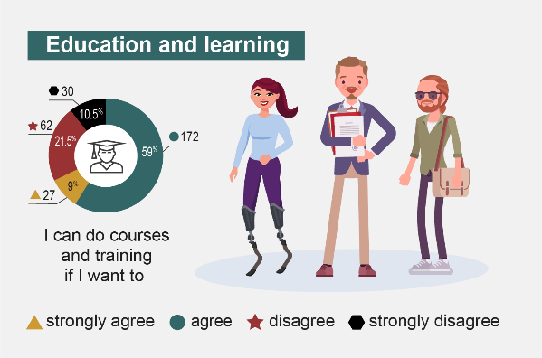
Figure 15: Education and learning results from participants with disability.

5.5.1 Education and learning achievements
Many participants with disability reported positive education and learning experiences. Two-thirds (68%) agreed or strongly agreed that they could participate in courses and training when required (policy priority 5.4). Over half (56%) of the participants with disability that were currently using education services were able to access them most or every time. Three-quarters (77%) of these participants rated the quality and outcomes of these services as good or very good, suggesting progress in accessible and inclusive lifelong learning experiences (policy priorities 5.3-5.4). Participants reported that flexible learning environments, including the transition to hybrid learning following COVID-19, had improved their ability to pursue learning opportunities. Survey participants included people with disability primarily focused on adult learning and revisiting their childhood learning experiences, as well as family and carers who were supporting both adults and children and sharing about their learning experiences.
Participants with disability and family and carer participants said supports were an important enabler of inclusive education, which were becoming more accessible to students with disability. Participants noted that it was becoming easier to access peer support and more individualised support within schools. Adaptable learning environments that catered for diverse needs were also becoming more prominent, as were more individualised approaches to learning. PWD32 stated that, “The university is very supportive and [their] disability plan is comprehensive. The inclusion of Zoom learning means I can continue to attend class even when my mobility is low”. Many family and carer participants felt that the person(s) they cared for were well supported and included in positive mainstream environments. However, despite the positive developments in supports for early childhood education and minors with disability (policy priorities 5.1-5.2), further efforts are required to in relation to lifelong learning.

5.5.2 Education and learning challenges
While the majority of participants with disability reported that they could do courses and training when required, 44% of those currently accessing these services could only do so sometimes or rarely, and a quarter (23%) rated these services as bad or very bad. A large percentage (42-49%) of participants with disability did not access education services at all, but it is unclear if this was their choice or the result of various education barriers. Some participants noted that the legacy of segregation continued to proliferate in education settings, as pointed out by PWD124, “there is still segregation areas that result in less information than most students get and can also cause there to be fewer skills for them to showcase”. Students continued to be taught in special schools and separate classrooms with modified curriculum, which could lead to ongoing struggles with education and employment after formal schooling. This situation had adversely affected PWD4:
I went to Year 12 at special school which means I didn’t receive a Year 12 certificate. I wanted to continue further education at TAFE and complete a Certificate III in [the] Music Industry as I am musically gifted with perfect pitch and it’s my passion. No TAFE would accept me… I felt discriminated against. (PWD4)
Some participants with disability said that educational segregation contributed to ongoing stigma and negative attitudes toward disability. Some family and carer participants echoed these sentiments, suggesting that schools could be exclusionary places of difficulty and stigma for the person(s) they support.
Educational supports may be improving, but there is still a long way to go. PWD33 reported that they “love learning but the learning environment I need is not available. When I explain what I need no one understands and speak to me like they do. I give up”. Participants across all three participant groups noted the desperate need for additional financial support for people with disability, families and carers, and support organisations to meet the demand for education supports. The need for financial support also extended to TAFE and university education, as participants with disability were often unable to access captions, interpreters, and/or one-on-one peer support on a consistent basis, requiring ongoing advocacy from people with disability and their support networks. Family and carers noted that school supports were largely dependent on the knowledge and awareness of teaching staff, rather than policy and procedure (policy priority 5.2). In the absence of support, some family and carer participants had started home-schooling to meet their child’s educational needs.
Participants identified some potential actions that could be taken to improve education and support. Developing and recognising alternative education pathways that are not segregated was important for participants (strategic area for action 2.4). Participants identified that expanding specialised education programs, particularly in collaboration with industry partners, schools and disability organisations could improve the life-long learning and employment opportunities for Queenslanders with disability (strategic area for action 2.4.2). Some participants suggested quality improvements for existing vocational training programs and pathways (strategic area for action 2.4.1) while others mentioned the need for increased recognition of flexible learning opportunities like short-courses, micro-credentials, and other certificates (strategic area for action 2.4.3).

5.6 Health and wellbeing
Goal^{2,3} - People with disability attain the highest possible health and wellbeing outcomes throughout their lives.
Policy priorities^{2,3}
6.1 All health service providers have the capabilities to meet the needs of people with disability.
6.2 Prevention and early intervention health services are timely, comprehensive, appropriate, and effective to support better overall health and wellbeing.
6.3 Mental health supports and services are appropriate, effective, and accessible for people with disability.
6.4 Disaster preparedness, risk management plans and public emergency responses are inclusive of people with disability, and support their physical and mental health, and wellbeing.
Health and wellbeing help to determine peoples’ quality of life. They are influenced by a wide range of physical, mental, social, cultural, and economic determinants, including the design and implementation of health services and support systems, and efforts to address and mitigate health disparities. Queensland’s Disability Plan aims to help people with disability attain the best possible health and wellbeing outcomes throughout their lives.² A comprehensive and inclusive health and wellbeing approach is crucial, to ensure that prevention and early intervention services, mental health supports, and emergency response plans are tailored to the specific needs of people with disability. Nearly 30% of participants opted to share additional information about health and wellbeing.
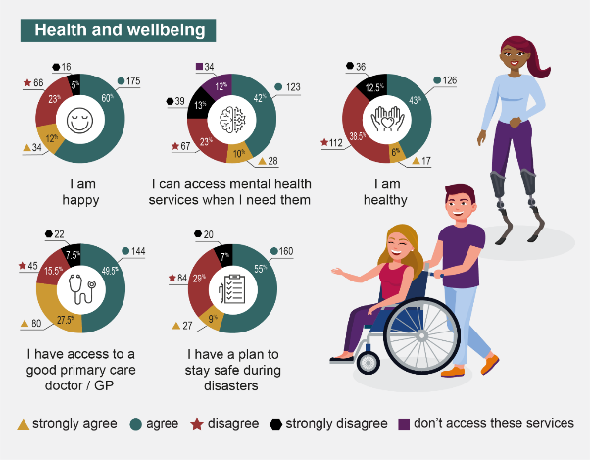Figure 16: Health and wellbeing results from participants with disability
5.6.1 Health and wellbeing achievements
Many participants with disability were happy and/or healthy. Almost three-quarters (72%) were happy. Half (49%) were healthy, particularly those with intellectual (67%), sensory (50%) and physical (46%) disabilities.
Health service access, quality and outcomes were rated positively by many participants with disability. Two-thirds (67%) could access health services such as General Practitioners (GPs) and hospitals every time or most of the time) and half (52%) could access mental health services when required, (policy priority 6.3). Participants were particularly satisfied with their GPs, with 85% rating primary care services as good or very good (policy priority 6.1 and 6.2). Health services such as hospitals were rated slightly lower, with 62% deeming them to be good or very good (policy priority 6.1). Almost two-thirds (64%) had a plan to stay safe during disasters, (policy priority 6.4)

5.6.2 Health and wellbeing challenges
While many participants with disability experienced relatively good health and wellbeing, many reported struggles. Over one-quarter (28%) were unhappy, and half (51%) were unhealthy. Participants with some types of disabilities were more likely to report being unhealthy, particularly those with chronic illness and/or pain (75%), cognitive disabilities (67%), psychosocial disabilities (65%) and neurodivergence (62%).
Some participants with disability struggled to access health services, including 36% who could not access mental health services and 23% who could not access a good GP. A third (33%) could only access health services sometimes or rarely. When asked to assess the quality and outcomes of health services, 32% rated hospital-related services as bad or very bad, with 15% rating GPs and other primary health care services as bad or very bad. Many participants provided information on what this all meant in practice.
Financial implications relating to disability and physical and mental health conditions were frequently discussed by two groups of participants: those with disability and family/carers. Many struggled to cover the cost of medications, and felt they had to choose between necessities, “Most of my medication is off label use and doesn’t qualify for the PBS [Pharmaceutical Benefits Scheme]. I worry that I will have to choose between food for my family and my medication” (PWD77). Participants said that “due to the cost of treatment, I can only treat one condition at a time” (PWD185) and that “getting access to meaningful healthcare is expensive, time consuming and a huge drain on energy” (PWD129). PWD132 noted that even with NDIS support, they still hit the Medicare safety net in mid-February each year. Moreover, while some participants were able to access private health services and supports, many could not afford private health insurance or services. The financial barriers created by healthcare systems became even more unmanageable when people reported experiencing long wait times for public health services and specialists.
Accessing health services and specialists (particularly those in the public health system) was a challenge for many participants with disability and family/carer participants, which was also noted by organisational participants. Lengthy wait lists and siloed health systems contributed to the reported poor and worsening health and wellbeing of many participants. For example, PWD101 ended up in the intensive care unit after months on a waitlist, leaving them to conclude that “Prevention is better than cure”. Access to health services was impacted by a number of other intersecting barriers, including physical barriers (PWD56 said “many medical centres […] do not provide reasonable physical access”) and financial barriers (PWD72 reported that “waiting lists for hospitals and dental services are way too long and [they] can’t afford private health insurance”). Moreover, the high cost of diagnosis for conditions like autism limited some participants ability to access necessary supports. Participants with diverse disability also noted that accessing mental health support was incredibly difficult. PWD56 said:
Accessing mental help support is a joke. I recently have not been able to access the help I need in a timeframe that would have been helpful. A referral from my GP to a specialist and the soonest anyone can see me is three months. Three months when you are thinking about ending your life is not helpful in any way. (PWD56)
While many participants with diverse disability noted difficulty in accessing health services, increased barriers and disparities emerged for certain segments of the sample.
Disparities in accessing health services were experienced by some specific groups, including participants in regional, rural and remote areas of Queensland, and participants with certain stigmatised or lesser-known diagnoses. One-third (31.5%) of participants in regional, rural and remote areas expressed frustration over the lack of resources and support in those areas, with some describing the basic availability of health services as “pathetic” (PWD190). Lengthy wait times to see GPs and specialists, along with non-existent or inadequate services, exacerbated physical and mental health concerns of those living in regional and remote areas. Participants noted that “it takes months to see a GP regionally and my condition is deteriorating while I was to see someone (sic)” (PWD106) and that the “ratios of health providers to population is inferior compared to metro areas” (PWD190). Beyond geography, other participants also shared that they experienced disparity in comparison to other people with disability in accessing health services and working towards optimal health and wellbeing. Participants with Myalgic Encephalomyelitis/Chronic Fatigue Syndrome (ME/CFS) shared that “less than 50% of clinicians are knowledgeable about ME/CFS and receive no training on it [which contributes to] few of the recommended symptom management treatments e.g., supplements, medications [being] on the PBS” (PWD164). Participants with multiple disabilities also experienced barriers when trying to access health services and optimise health and wellbeing.
Attitudinal barriers seemed to play a significant role in the challenges faced by participants with disability in Queensland, especially in healthcare settings. Participants reported frequent encounters with healthcare professionals who lacked education and understanding of their unique needs, leading to feelings of marginalisation. Ableism, low expectations, and dismissive attitudes were reported as increasing health and wellbeing challenges, with some participants feeling unheard or disrespected at all levels of healthcare. Participants with disability shared that “healthcare professionals are not given the time or education to deal with people in my situation” (PWD164) and that “lived experience needs to be respected and heard at all levels of health care and health/hospital management” (PWD132). The lack of education and awareness of health clinicians, combined with attitudinal barriers, result in Queenslanders with disability receiving inappropriate treatment plans and interventions that do not fully consider the unique experiences and preferences of the individual. The impact of stigma and attitudinal barriers on health and wellbeing of people with disability can be far-reaching. It may deter individuals from seeking timely medical care or engaging in open conversations with their healthcare providers. Additionally, it can perpetuate a cycle of discrimination and exclusion, hindering efforts to create more inclusive and supportive healthcare environments.
Choice of health clinicians was also a challenge, which was echoed by participants with intersectional identities and diagnoses that are stigmatised or neglected. Stigma, attitudes of health clinicians, and health service policies compounded health disparities with participants who identified as LGBTIQA+. Those participants shared that they felt unsafe and that there are no practitioners who “know about transgender people” (PWD113). PWD100 said, “I can never be safe as I have no credibility as a disabled LGBTIQA+ Australian”. Similar experiences were mentioned by participants with stigmatised diagnoses, “hospital staff, including doctors, are mostly oblivious to disabilities and neurodivergence and how this changes how patients communicate” (PWD132) and “I am excluded and will remain excluded due to the type and severity of disability…acceptance of this disability would allow me to safely access health needs” (PWD189). Exclusionary attitudes and lack of understanding among healthcare professionals about intersectional identities hindered people’s health and wellbeing.
Family and carer health and wellbeing was impacted by various challenges arising from their role within formal and informal support networks. A critical issue was the “overwhelming number of administrative tasks” (FC110) associated with coordinating support services, managing appointments and schedules, and balancing these duties with other home and work responsibilities. These feelings of stress and overwhelm were also mentioned by participants with disability. The extensive and reported intrusive administration requirements for obtaining and maintaining supports for Queenslanders with disability (particularly for minors) led many family and carer participants to share feelings of emotional exhaustion and burnout. One carer highlighted the difficulty in planning for their child’s developmental trajectory, record-keeping, and annual reporting to various organisations and government departments; a responsibility not shared to the same extent by parents of children without disability. Furthermore, immense administrative workload associated with service coordination could exacerbate stress and tension within family units. This stress ultimately impacted health and wellbeing, particularly mental health, for all family members, including siblings. The financial strain and time constraints faced by family and carer participants, juggling work and caregiving duties, often resulted in inadequate support and limited opportunities for their own respite, further impacting the wellbeing of both family and carers and the person(s) they support.
Participants identified a range of potential strategic action that could be taken to improve health and wellbeing, with a particular emphasis on health access and equity (strategic area for action 3.2). Taking specific action to reduce wait times for appointments with specialists, GPs and mental health services was identified by many participants, especially around increasing workforce capacity and quality (strategic area for action 3.2.1). Increasing mental health funding and service capacity was particularly important to participants (strategic area for action 3.2.5) as was increasing the availability of health services and support in regional and remote areas (strategic area for action 3.2.3). Some participants called for continuing investment in telehealth and technological innovations, although that was not widespread (strategic area for action 3.2.4). Finally, organisation representatives identified the need for integrated care pathways across all elements of healthcare (strategic area for action 3.2.2).

5.7 Community attitudes
Goal^{2,3 -} Community attitudes support equality, inclusion and participation in society for people with disability.
Policy priorities^{2,3}
7.1 Employers value the contribution people with disability make to the workforce and recognise the benefits of employing people with disability.
7.2 Key professional workforces are able to confidently and positively respond to people with disability.
7.3 Increase representation of people with disability in leadership roles.
7.4 Improving community attitudes to positively impact on policy priorities under the strategy.
Community attitudes refer to the collective beliefs, perceptions, and opinions held by individuals within a society. These attitudes significantly influence the extent to which Queenslanders with disability are accepted, included, and supported in various aspects of community life. Community attitudes underpin the ways in which systems, services, built environments, and workplaces are designed and delivered, directly impacting the extent to which they cater to and accommodate the diverse needs of people with disability. Positive and inclusive community attitudes encourage the development of accessible infrastructure, adaptive technologies, and tailored support services, ultimately promoting equal opportunities in employment, education, and social participation.
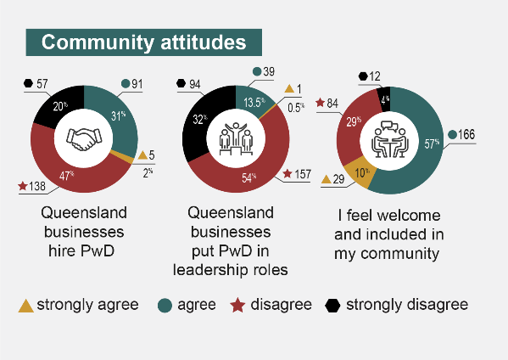
Figure 17: Community attitude results from survey participants with disability

5.7.1 Community attitude achievements
Participants with disability acknowledged that there had been improvements in community access and inclusion, both physically and virtually, although this change was occurring “slowly over time” (PWD8). Two-thirds (67%) of participants felt welcome and included in their communities. Participants noted that “most places I go to in community have reasonable access” (PWD29) and that “genuine inclusion is starting to be a community conversation and focus” (PWD67). Acceptance, respect, and positive attitudes were contributing to these changes, particularly public spaces.
Community attitudes over the last few years have changed dramatically. I credit this with the number of high-profile people in Australia and the world who have made their voices heard, through advocacy. I also credit this to the wonderful researchers and academics, and Peak Bodies who have the opportunity to shape Government policy and laws that make life for people with disability more inclusive. They have highlighted our struggles, and needs, and changed our lives for the better. (PWD278)
Improved community access and inclusion was directly linked to the overall increased awareness of disability within Queensland, creating a foundation for further improvements in overall community attitudes. Participants mentioned that public figures, such as Australian of the Year Dylan Alcott, had helped to increase community awareness about disability, which in turn improved community attitudes. Increased media presence and representation of people with disability, both in traditional and social media, had also challenging misconceptions about disability, and improved community attitudes. Although these aspects were working well, they need further reinforcement and expansion to ensure that the positive changes become deeply ingrained in the community.

5.7.2 Community attitude challenges
While some participants with disability felt positive about community attitude improvements, others did not. Two-thirds (67%) did not believe that Queensland employers hire people with disability (policy priority 7.1). Even more (86%) did not believe that Queensland businesses put people with disability in leadership roles (policy priority 7.3). These baseline figures indicate significant room for improvement in shifting community attitudes.
Negative community attitudes and lack of disability awareness were discussed by most participants with disability, as well as family and carers. Negative interpersonal community interactions and experiences were impacted by insufficient disability education, particularly in relation to hidden or invisible disability. Participants reported being “patronised” and confronted with “attitudes that display paternalism and ableism” (PWD9). They frequently discussed situations in which “people talk to my support worker instead of talking to me when I go out and about” (PWD200). Family and carer participants were concerned about the impact that negative community attitudes had on social inclusion. Particularly for family and carer participants who were supporting minor(s) with disability, social inclusion was spoken about at length as both an aspiration for the person(s) they support as well as a fear that it would be difficult to achieve. Concerns about bullying, lack of respect for dignity, and fear for safety in public spaces were common in family and carer discussions of community attitudes.
Participants with disability, family and carers, and organisation representatives all expressed concern that the lack of disability awareness and education negatively impacted on the ability of formal support workers and health services to provide relevant, safe, and inclusive care. Stigmatising attitudes were particularly prevalent in interactions with health services and health clinicians. Current education and training practices for health clinicians, support workers, and to a more limited extent teachers, were viewed as insufficient in addressing the misconceptions and negative attitudes that impact on Queenslanders with disability. There was an overall “lack of awareness, insight, and inclusion planning” (PWD23) which contributed to participants with disability feeling like an “afterthought in the general community, particularly with regard to public policy” (PWD16). Negative attitudes, misconceptions, and lack of awareness about disability hindered progress towards a more inclusive society (policy priority 7.4).
The importance of increasing awareness and education about hidden disability was discussed by participants with disability and family and carers. Participants with hidden disability discussed interpersonal experiences that increased their sense of social isolation. Misunderstanding and stigma were felt in many of the interactions participants recounted, particularly in regard to neurodivergence and lesser-known disability like ME/CFS. Masking or not disclosing disability, either from wanting to “fit in” or fear of negative attitudes and stigmatisation, manifested in increased marginalisation, exclusion, and in some extreme cases, harm. Disclosure was an important element of community attitudes impacting on employment and workplace support. Participants said that widespread stigma towards disability made it unsafe to disclose hidden disability. PWD40 disclosed that they “have been sacked in the past after disclosing as a person with disability. It is not safe to disclose in most contexts”. Another participant concluded that “disclosure is a tricky thing. There’s a lot of unconscious bias out there towards people with disability” (PWD85).
Workplace support and training were directly related to issues of disclosure and negative community attitudes. Participants with disability felt that workplace training was not yet widespread or effective enough to enhance understanding and support for employees with disability. Consistently inclusive workplace environments were still elusive for many marginalised participants with disability, particularly those with intersectional identities (e.g., LGBTIQA+ and/or culturally and linguistically diverse).
Participants called for targeted action regarding fostering inclusion and respectful attitudes across Queensland (strategic area for action 4.1). Implementing and using co-design to develop context specific disability education and awareness campaigns were mentioned by nearly all participants in relation to all outcome areas (strategic area for action 4.1.1). There was a particular need to emphasise hidden disability and intersectional identities in education for many participants, as well as ensuring that critical professional groups can access enhanced co-design education and training (strategic area for action 4.1.2, 4.2.13).

6. Strategic areas for action
We asked Queenslanders who engaged with this study to describe strategic actions and make recommendations to improve disability support and inclusion in Queensland. The ideas were vast, including small changes that could help an individual with a specific need as well as larger changes that could help many people with a range of requirements. This section describes four strategic areas for action that aim to promote dignity, equity and belonging, taken directly from what participants shared and aligned with Queensland’s Disability Plan 2022-2027: Together, a Better Queensland,² Australia’s Disability Strategy³ and the United Nations’ Convention on the Rights of Persons with Disabilities.¹ They consider the complex and dynamic interaction between personal experiences, disability-specific requirements, built and virtual environments, interpersonal community interactions, system design and delivery, and accessibility and inclusion.

1. Safeguard community voice
Participants expressed a strong desire to be heard, respected, and included in the development of initiatives that addressed their unique needs. Safeguarding community voice by ensuring that Queenslanders with disability can actively participate in decision-making processes is also a core principle of Article 4 of the Convention on the Rights of Persons with Disabilities.¹ Participants and the CRPD emphasise the importance of co-design and collaboration; enabling people with disability to help shape the policies, programs and services that directly impact their lives¹. One participant emphatically expressed this point saying,
This survey is giving us a voice […]. An Australia-wide survey would help a lot of people with disability have a voice. It’s not about governments saying what we need, it’s about us telling them what we need. Finally, someone is listening to what we need (PWD268).
Participants did not just need to be heard, they wanted their perspectives to be valued, shared, and acted upon. Fostering a culture of open, ongoing communication and collaboration across all sectors and levels of government, business and the broader community was thought to be a way to enable this to occur.

1.1 Embed citizen leadership in design, delivery, and implementation.
Embedding co-design and citizen leadership in the design, delivery, and implementation of the areas that impact on Queenslanders with disability is essential to safeguard community voice. Study participants and citizen scientists appreciated the opportunity this research provided to highlight their achievements and challenges — and saw this as an important step to drive change. Participants affirmed that they wanted this process to be conducted annually. Participants and a review of contemporaneous literature identified some potential next steps to inform strategic action, including:
1.1.1 Ensure that the disability rights movement principle of “nothing about us without us” informs research, decision-making, development, and prioritisation.
1.1.2 Increase representation of marginalised perspectives, particularly people from First Nations, CALD, LGBTIQA+ and regional, rural, and remote communities.
1.1.3 Explore opportunities to expand studies like the one described in this report Australia-wide on an annual basis.

1.2 Strengthen monitoring and accountability mechanisms.
Strengthening monitoring and accountability mechanisms safeguards community voice by supporting transparent, responsive decision-making that prioritises diverse perspectives. It also upholds the rights and interests of all people with disability. Some participants expressed their distrust of government systems and were unsure initially about sharing their stories as part of this study. However, many more participants expressed a desire for the promotion of continuous improvement processes and noted that their experiences could be mechanisms for change. Participants and a review of contemporaneous literature identified some potential next steps to inform strategic action, including:
1.2.1 Increase transparency of monitoring and accountability mechanisms, how they are designed and what the outcomes are.
1.2.2 Consistent, stable funding pathways and frameworks for ongoing research and monitoring to ensure progress is tracked, feedback is incorporated, and adjustments are made.
1.2.3 Communicate with stakeholders about the outcomes of monitoring regularly and in accessible formats.

2. Improve standard of living and social protection
Participants expressed diverse living experiences and quality of life, with some participants struggling with inadequate incomes, housing, jobs, and access to services. Other participants had the opposite experience. Some participants were maintaining employment and housing with limited support but felt that they were one illness or crisis away from no longer managing well. The right to an adequate standard of living and social protection for people with disability is enshrined in Article 28 of the Convention on the Rights of Persons with Disabilities.¹ The article highlights the importance of ensuring that people with disability have equal access to basic resources and services, including proper living conditions, food, clothing, housing, and financial support, which was echoed by many participants. Addressing the cost-of-living crisis requires an urgent, multi-pronged approach across all outcome areas in Queensland’s Disability Plan 2022-2027: Together, a Better Queensland. ²

2.1 Strengthen financial support and economic security.
Strengthening financial support and economic security can be achieved by examining intersecting opportunities to improve access to money, jobs, housing, education, and essentials such as food, health care and medication. Participants said welfare benefits (including DSP) are often not adequate to cover their expenses, particularly in the context of a broader cost-of-living and housing crises. Participants and a review of contemporaneous literature identified some potential next steps to inform strategic action, including:
2.1.1 Advocate for an increase in the rate of welfare payments, while also reviewing and implementing subsidies to reduce the cost of living.
2.1.2 Streamline application processes for a wide range of welfare supports (e.g., welfare payments and health care cards) and expand who is eligible to access benefits.¹³

2.2 Accelerate access to affordable and accessible housing.
Accelerating access to affordable and accessible housing was urgent for some participants, especially given Queensland’s rental crisis. Housing is a foundation for safety and security. Some participants reported living in unsafe housing circumstances, and many more were concerned about the loss of stable housing, shortages, and homelessness. Participants and a review of contemporaneous literature identified some potential next steps to inform strategic action, including:
2.2.1 Continue to increase affordable, accessible housing options through partnerships with public and private stakeholders.
2.2.2 Implement financial incentives for developers to adhere to principles of universal design when building homes and infrastructure.¹⁴
2.2.3 Streamline existing home modification funding applications and approval processes.
2.2.4 Increase rental regulation e.g., limiting frequency of rental increases.
2.2.5 Invest in community-based support services in regional and remote areas, such as in-home care and transportation assistance.
  - Increase availability of tailored employment opportunities.
Increasing the availability of tailored employment opportunities could improve the standard of living, economic empowerment, and availability of jobs for people with disability. Flexible jobs that are tailored to individual ways of working, diverse needs, and disability-specific factors, were mentioned by many participants. For participants who had jobs, adjusting hours (up or down) and job security were needed. Participants and a review of contemporaneous literature identified some potential next steps to inform strategic action, including:
2.3.1 Promote and monitor inclusive hiring practices and provide incentives for employers to develop accessible and inclusive work environments.
2.3.2 Increase disability awareness and training for employers and employees.
2.3.3 Trial more flexible approaches to employment, like the 4-day week.
2.3.4 Foster an inclusive entrepreneurial ecosystem and remove financial barriers to business ownership through grants, low interest loans and mentorship programs.^{15,16}
  - Develop, recognise and support alternative education pathways.
Developing, recognising, and supporting alternative education pathways can support people with disability to obtain specific skills and knowledge to further their employment opportunities and financial security. Participants mentioned that traditional school settings could be places of great enablement but also great barriers, including environments that were not inclusive of diverse styles of learning. The cost for education beyond secondary school prevented many from pursuing continuing education. Participants and a review of contemporaneous literature identified some potential next steps to inform strategic action, including:
2.4.1 Review and improve vocational training program and pathways.
2.4.2 Invest in, expand, and develop specialised alternative education programs in collaboration with industry partners, schools, and disability organisations.
2.4.3 Increase recognition of the value of flexible life-long learning opportunities like short-courses, micro-credentials and certificates.¹⁷

3. Enhance dignity and equity
Participants expressed the importance of equitable access to quality healthcare, spaces and places as a critical priority for change, particularly as they shared the ways in which accessibility and inclusion impacted on their health and well-being, safety, and community engagement. Promoting dignity and equity for people with disability, as emphasised in Articles 9, 25 and the preamble of the Convention on the Rights of Persons with Disabilities ensures that people with disability have access to the same services, experiences, rights, and lifestyle as people without disability.¹ Dignity is a powerful framing device, which serves as an important reminder that impairment should not prevent consideration, access, and inclusion. Participants emphasised dignity and equity throughout their recommendations and identified several priority areas in which strategic action could produce positive change for their lives.

3.1 Continue to improve accessibility of physical and virtual environments.
Continuing to improve accessibility of physical and virtual environments is integral to ensure dignified experiences for people with disability in public places and spaces. Some participants were able to access transport, shops and businesses, and public spaces in ways that enhanced independence. However, some could not. Participants and a review of contemporaneous literature identified some potential next steps to inform strategic action, including:
3.1.1 Promote the principles of Universal Design in new construction and development of online spaces, while retrofitting existing physical and digital infrastructure.^{18,19}
3.1.2 Identify initiatives that can be used to audit public accessibility, particularly around location and accessibility of public toilets and businesses to identify areas for improvement.
3.1.3 Continue to enhance local communities (e.g., footpaths and wayfinding supports) for safer navigation.
  - Improve access to quality formal supports.
Improving access to quality formal supports improves dignity and equity by ensuring that people with disability receive the care they need, when they need it, in a reliable manner. Participants noticed the impact of the ongoing disability support worker crisis, often struggling to access reliable support workers who provided quality care. Participants and a review of contemporaneous literature identified some potential next steps to inform strategic action, including:
3.2.1 Increase the availability of paid support services and ensure they are more accessible, through targeted strategic initiatives.
3.2.2 Expand support options in regional and remote areas through incentives for support workers and service providers.
3.2.3 Invest in training and development for support workers, focusing specifically on quality, reliability, and stability.

3.3 Improve health access and equity.
Improving health access and equity promotes dignity by ensuring that people with disability receive appropriate, non-discriminatory, and high-quality person-centred healthcare. Participants described many barriers to accessing health services, including long wait times, limited availability of appointments and cost. Participants were also concerned about increasing health disparities for people with intersectional identities, specifically LGBTIQA+ people and those with stigmatised or lesser-known diagnoses. Participants and a review of contemporaneous literature identified some potential next steps to inform strategic action, including:
3.3.1 Implement measures to reduce wait times for appointments with specialists, GPs, and mental health services by increasing workforce capacity.
3.3.3 Develop integrated care pathways across different elements of healthcare.
3.3.4 Increase the availability of health services and support in regional and remote areas, through incentivising healthcare professionals to practice in underserved regions.²⁰
3.3.5 Continue investing in telehealth and technological innovations.²¹
3.3.6 Review opportunities to increase funding and expand mental health service capacity.
3.3.7 Develop targeted initiatives to address the unique barriers faced by people with intersecting identities, stigmatised or lesser-known diagnoses.²²

3.4 Increase support for family and carers.
Increasing support for family and carers will improve dignity by acknowledging the vital role they play in all aspects of care and support for people with disability. Many family and carer participants felt overwhelmed with balancing care responsibilities with jobs, health, socialising, and all other life spaces. Participants with disability acknowledged the critical role that informal support plays in their life. Participants and a review of contemporaneous literature identified some potential next steps to inform strategic action, including:
3.4.1 Recognise the critical role of informal support networks by providing increased resources and support to enhance their capacity and health and wellbeing.
3.4.2 Develop long-term care plans for people with disability, ensuring that care transitions are smoother, and that advocacy support is in place if and when the primary support person can no longer continue their role.
3.4.3 Review and improve current resources and services to support mental health and wellbeing for family and carers.
3.4.4 Implement policies and programs that alleviate the administrative burden on people with disability, their family, and carers.
3.4.5 Develop targeted, subsidised respite care options and facilities.

4. Strengthen belonging
Most participants in this study mentioned the importance of continuing to improve community attitudes and the sense of genuine belonging, which can be facilitated by addressing attitudinal barriers and promoting disability awareness. Fostering belonging and inclusion for people with disability through positive community attitudes, as highlighted in Article 8 of the Convention on the Rights of Persons with Disabilities and as discussed by participants, is essential for reducing the barriers to participation and engagement in all aspects of life for people with disability.¹ To achieve this, participants discussed multifaceted approaches involving educational initiatives, public awareness campaigns, and collaborations between various stakeholders is needed.

4.1 Continue to foster inclusion and respectful attitudes.
Continuing to foster inclusion and respectful attitudes amplifies belonging for people with disability by dismantling barriers, nurturing diverse relationships, and cultivating a community that embraces and values the unique perspectives and contributions of all people. Participants were generally positive about the trajectory of improving community attitudes and sense of belonging. However, it was recognised that stigma, discrimination, and misrecognition continue to influence the way in which people with disability are welcomed and included in all aspects of society. Participants and a review of contemporaneous literature identified some potential next steps to inform strategic action, including:
Co-design context-specific disability education and awareness initiatives or campaigns with targeted implementation plans.
4.1.1 Emphasise hidden disability and intersectional identities in disability awareness and education initiatives.
4.1.2 Support specific professional groups (teachers, doctors, business executives) to access enhanced training and education to better support people with disability.
4.1.3 Embed empathy within systems and services by examining and reducing organisational pressures (resources, skills) on staff and providers.^{23, 24}
4.1.4 Leverage the momentum of media and social media to increase authentic representation of people with disability.
4.1.5 Continue addressing stigma and discrimination through policy and advocacy mechanisms.
A summary of these strategic areas for action, priorities and supporting participant quotes are provided on the following pages.

Summary of strategic areas for action
Strategic areas | Priorities | We asked, you said
1. Safeguard community voice | 1.1 Embed citizen leadership in design, delivery, and implementation. | - “Greater community consultation in the design phase of projects and spaces.”  - “Consultation! How are business owners going to know what is best if they don’t truly include a wide variety of people who experience disability?”  - “Wide consultation in early design phases- NOT reactive, you complain, we fix it.”  - “Having people in positions of power to change these and actually care or listen to what is being said by those with lived experience.”  - “Co-design solutions.”
1. Safeguard community voice | 1.2 Strengthen monitoring and accountability mechanisms. | - “Better policy, better understanding, ongoing measures to ensure inclusion happens at all levels.”  - “Physical access to all public spaces and buildings should be mandatory with an immediate strategy to implement and monitor this.”  - “I would like to see it made law, that businesses need to operate inclusively. An example would be captioning at all cinemas… universal design adopted for all new buildings, co-design- the inclusion of people with disability in paid consulting roles to develop programs and ideas.”
2. Improve standard of living and social protection | 2.1 Strengthen financial support and economic security. | - “A raise in the disability support pension.”  - “Increase the DSP by at least $100/ week. Increase rental allowance for DSP recipients. Provide more and lower cost accessible housing options.”  - “Centrelink could give more of a raise. When people work they get a raise, people on disability pension had to wait 12 years to get an extra $14/ fortnight in their pension.”  - Increase in Medicare rebates and Medicare bulk billing returns to all types of medication. Reduction in the Medicare rebate threshold.”  - “More financial support for my disability.”
2. Improve standard of living and social protection | 2.2 Accelerate access to affordable and accessible housing. | - “Stronger protections and support for people with disability who live in and own apartments in strata especially where there are building management agreements, mandatory changes to common property to make more disability safe and accessible.”  - “Building standards must be made contemporary in keeping with the National Disability Strategy.”  - “They need to make more inclusive homes now. Because eventually people that are ‘normal’ are going to get old and they’re going to need help like people with disabilities.”  - “Universal design and low sensory and light and heat protected public and private built spaces and public transport.”  - “More inclusive design.”  - “Simplify the bureaucracy. Get rid of reassessments.”
2. Improve standard of living and social protection | 2.3 Increase availability of tailored employment opportunities. | - “There needs to be education and support given to employers to encourage them to give the disabled individuals a chance. Greater public awareness of the difficulties people with disability face in obtaining meaningful employment.”  - “Having an opportunity to ask for adjustments at work without being sacked. Job security.”  - “More remote and flexible work opportunities without judgement and with long term security. Understanding from employers of different types of thinking, learning and working, and not penalising people who are different even when they are doing a good job.”  - “Agencies and businesses say they want to be inclusive, but I really don’t think they know what that means. Unless people with disabilities are genuinely and authentically included in the process of developing inclusivity then nothing is ever going to change. How can an able-bodied world understand the world of disability if they don’t ask those who experience it?”  - “Opportunity to improve my skills and knowledge and get better opportunities.”  - “More flexibility with work, better equipment at work, an office where I have control over the environment.”  - “Better support for employers to understand that people with disability bring both benefits and challenges to the workplace and that, properly supported, reasonable adjustments are easy to implement and do not add to the overall expense of an employee.”  - “Being able to access secure, meaningful employment.”  - “I need support to start and maintain my own businesses.”  - “DES providers need to offer support in career progression and self-employment opportunities for people with disability.”
2. Improve standard of living and social protection | 2.4 Develop, recognise and support alternative education pathways. | - “Opportunities for professional development, where I can learn and practice new skills and become confident with them, will help me grow.”  - “I love learning but the learning environment I need is not available….I cannot learn from reading the course material. I need alternatives.”  - “More exposure to options and flexible ways to participate.”  - “Having the ability in your NDIS plan to assist you to achieve your goal of accessing an education.”  - “Education providers are not always great at consistently providing simple requested accommodations (e.g., captions for deaf/hoh students and auditory descriptions of images for blind/low vision students).”  - “More content about people with disability in employment roles and in life.”  - “There needs to be a massive overhaul of the way education and schooling is done.”  - “More options to access educational needs outside of the school environment. And within the school environment, more awareness raising, more acceptance of lots of different approaches, more commitment to equity.”  - “Freedom to self-assess my ability to enrol in a course of my choice for which I have industry experience.”
3. Enhance dignity and equity | 3.1 Continue to improve accessibility of physical and virtual environments. | - “More inclusive design, especially in leisure areas like swimming pools, restaurants, pedestrian walkways.”  - “Suitable wayfinding measures. Clear signage. Accessible ramps/ doorways. Clear pathways through shops. Advertised sensory shopping hours.”  - “For community environments to be designed with consideration for neurodivergent people and those with sensory issues. Also design spaces with more consideration for those of us with mobility or chronic pain issues.”  - “Inclusive spaces for those with sensory needs.”  - “Ensure that all lifts in public buildings are accessible with braille and speech. Access to tactile maps. Descriptions of public buildings and other spaces available online to help with planning visits.”  - “Accessible toilets. If a building really is short of space, then there is no reasons why they just can’t have one toilet that is for all.”  - “More toilet facilities.”  - “If all places where completely wheelchair accessible and not just meeting the basic Australian building code.”  - “Access to transport to and from hospital appointments (in regional area).”  - “Digital accessibility.”
3. Enhance dignity and equity | 3.2 Improve access to quality formal supports. | - “Training, oversight, experienced support to manage and coordinate.”  - “Increased access, including financial support, to be able to access services would be helpful.”  - “Industry should pay workers more and require better training.”  - “Being able to rely on supports to arrive for shifts. Being able to find supports who are trained/skilled (or interested in learning) how to support neurological conditions.”  - “More choice of providers.”  - “Widening eligibility for support so people are able to access supports no matter the severity of their disability.”  - “More screening and background checks on the support workers under NDIS scheme.”
3. Enhance dignity and equity | 3.3 Improve health access and equity. | - “Better access including timely access to public health care.”  - “Better hospital services and rights.”  - “More Medicare coverage on VITAL services (psychiatry, psychology, dentistry).”  - “All hospital staff to be trained in disability awareness by people with disabilities as a mandatory part of their studies.”  - “Information on how I need to be treated and supported should be made available on admission and during all handover times.”  - “An ability to feel safe and supported in the healthcare system.”  - “Access to qualified, caring and understanding health professionals.”  - “More resources and support in regional areas.”  - “Cheaper medication, shorter wait times to see specialists. Shorter wait times in Emergency. Access to good healthcare closer to me.”
3. Enhance dignity and equity | 3.4 Increase support for family and carers. | - “Decrease the enormous amount of intrusive admin required to get and maintain supports for a person with disability.”  - “Better support for me as a parent and carer.”  - “Connecting with a support group or other carers.”  - “Better access to day services and therapy supports.”  - “Further assistance and respite care.”  - “I want a comprehensive vision in place, with clear goals, so that others who become involved in supporting him as he ages will appreciate our vision and continue to carry it forward.”  - “Who will look out for her when we are gone? We need access to long term plans and support.”  - “Continuity of support.”
4. Strengthen belonging | 4.1 Continue to foster inclusion and respectful attitudes. | - “More community education and awareness about invisible disabilities.”  - “Disability awareness for major public services (police, ambulance, transport). I’ve had a bus driver ask me WHY I had a white cane (which is the internationally recognised symbol for the blind), should not be driving a bus until this has been taught.”  - “Better education of communities, normalise accessibility measures, normalised disabled experiences, normalise aid devices/ systems.”  - “To feel that inclusion was something that was just a natural occurrence rather than a special provision.”  - “Removal of the medical model of dealing with people living with disabilities. Ableism, like racism and other discriminatory isms isn’t taught by our educators, politicians, leaders, community and culture. The removal of all segregated settings.”  - “To have more open and inclusive honest discussion about the issues and conditions with barriers which people with a disability have to navigate and overcome each day.”  - “Hospital staff and doctors need education on how to interact with patients with a disability and what to expect in their community. Plus, to treat the patient as the expert of themselves. Lived experience needs to be respected and heard at all levels of healthcare and health/hospital management.”  - “Medical professionals need more education around disability, especially non-verbal disability.”  - “Having access to a GP who will bulk bill and is understanding of my needs and won’t stigmatise me due to the medications I am on.”  - “More public awareness campaigns. Children being taught about disabilities at school.”

References
United Nations. (2006). Convention on the Rights of Persons with Disabilities. https://www.ohchr.org/en/instruments-mechanisms/instruments/convention-rights-persons-disabilities
Queensland Government (2022). Queensland's Disability Plan 2022-27. Together, a better Queensland. https://www.dsdsatsip.qld.gov.au/campaign/queenslands-disability-plan/about-plan/queenslands-disability-plan-2022-27
Commonwealth of Australia (Department of Social Services) (2021). Australia's Disability Strategy 2021-2031. Creating an inclusive community together. https://www.dss.gov.au/disability-and-carers/disability-strategy
Australian Institute of Health and Welfare. (2022). People with disability in Australia. https://www.aihw.gov.au/reports/disability/people-with-disability-in-australia/contents/summary
Australian Institute of Health and Welfare. (2023). Australia's Disability Strategy 2021-2031 outcomes framework. First annual report. https://www.aihw.gov.au/reports/australias-disability-strategy/australias-disability-strategy-outcomes-framework/contents/about
Australian Bureau of Statistics. (2020). Disability, ageing and carers, Australia: Queensland, 2018. https://www.abs.gov.au/statistics/health/disability/disability-ageing-and-carers-australia-summary-findings/latest-release#data-downloads
National Disability Insurance Agency. (2022). NDIS Quarterly Report: 2022-23 Q2. Queensland Dashboard as of 31 December 2022. https://www.ndis.gov.au/about-us/publications/quarterly-reports
Australian Bureau of Statistics. (n.d.). Region summary: Queensland. https://dbr.abs.gov.au/region.html?lyr=ste&rgn=3
Chapman, K., Dixon, A., Cocks, K., Ehrlich, C., & Kendall, E. (2022). The Dignity Project Framework: An extreme citizen science framework in occupational therapy and rehabilitation research. Australian Occupational Therapy Journal. https://onlinelibrary.wiley.com/doi/full/10.1111/1440-1630.12847
Bang the Table. (n.d.). Building community with our digital engagement platform and expert-led support. https://www.bangthetable.com/wp-content/uploads/2020/02/The-Bang-the-Table-Ecosystem.pdf
Gillet, C., Allen, C., & Ownsworth, T. (2022, October 13). Surviving or thriving? Client perspectives of valuable home-modification outcomes [paper presentation]. Hopkins Hour Symposium, Brisbane, QLD, Australia. https://www.hopkinscentre.edu.au/news-view/hopkins-hour-surviving-or-thriving-client-373
Davidson, P., Bradbury, B., & Wong., M. (2023). Poverty in Australia in 2023: Who is affected. Poverty and Inequality Partnership Report Number 20. Australian Council of Social Service and UNSW Sydney. https://povertyandinequality.acoss.org.au/wp-content/uploads/2023/03/Poverty-in-Australia-2023_Who-is-affected.pdf
Collie, A., Sheehan, L.R., & Lane, T. J. (2022). Changes in access to Australian disability support benefits during a period of social welfare reform. Journal of Social Policy, 51(1), 132-154.
Watchorn, V., Hitch, D., Grant, C., Tucker, R., Aedy, K., Ang, S., & Frawley, P. (2021). An integrated literature review of the current discourse around universal design in the built environment–is occupation the missing link? Disability and rehabilitation, 43(1), 1-12.
Halabisky, D. (2014). Entrepreneurial activities in Europe- Entrepreneurship for people with disabilities. OECD Publishing.
Renko, M., Parker Harris, S., & Caldwell, K. (2015). Entrepreneurial entry by people with disabilities. International Small business Journal, 34(5), 555-578.
Kauppila, A., Kinnari, H., & Niemi, Neim (2020) Governmentality of disability in the context of lifelong learning in European Union policy, Critical Studies in Education, 61(5), 529-544.
Aarhaug, J., & Elvebakk, B. (2015). The impact of universally accessible public transport—a before and after study. Transport Policy, 44, 143-150.
Hwangbo, H., Kim, J., Kim, S., & Gu Ji, Y. (2012). Toward universal design in public transportation systems: An analysis of low-floor bus passenger behaviour with video observations. Human Factors and Ergonomics in Manufacturing and Service Industries, 25(2), 183-197.
Bohanna, I., Harriss, L., McDonald, M., Cullen, J., Strivens, E., Bird, K., ... & Barker, R. (2022). A systematic review of disability, rehabilitation and lifestyle services in rural and remote Australia through the lens of the people-centred health care. Disability and Rehabilitation, 44(20), 6107-6118
Dew, A., Veitch, C., Lincoln, M., Brentnall, J., Bulkeley, K., Gallego, G., Bundy, A., & Griffiths, S. (2012). The need for new models for delivery of therapy intervention to people with a disability in rural and remote areas of Australia. Journal of Intellectual & Developmental Disability, 37(1), 50–53.
Harari, L., & Lee, C. (2021). Intersectionality in quantitative health disparities research: a systematic review of challenges and limitations in empirical studies. Social Science & Medicine, 277, 113876. 1-11.
Derksen, F., J. Bensing, and A. Lagro-Janssen. 2013. Effectiveness of Empathy in General Practice: A Systematic Review. British Journal of General Practice 63(606): e76-e84.
Zimmer, M. J. (2002). Systemic Empathy. Columbia Human Rights Law Review, 34, 575.

Appendix 1 executive summary dashboard
This appendix contains a high-level overview of people with disability’s responses to quantitative questions in Voice of Queenslanders with Disability. It provides a table that correlates to Figure 1 in the executive summary.

Who completed our ‘people with disability’ survey?
Demographics
Queenslanders with disability | 291 people
Age | 20-75 years.  Average age was 45 years old.
First Australian Participants | 15 people (5% of participants)
LGBTIQA+ participants | 65 people (24% of participants)
Gender  Female  Male  Non-Binary  Intersex | 203 people (69.5%)  72 people (24.5%)  16 people (5.5%)  1 person (<0.5%)

What did people with disability say it was like to live with disability in Queensland in 2023?
Queensland’s Disability Plan 2022-2027: Together, a Better Queensland Priority areas | Question | Strongly Agree | Agree | Disagree | Strongly disagree | Other
Employment and financial security | I have enough money to live well. | 15% (44 people) | 38% (111 people) | 25.5% (75 people) | 21.5% (62 people) | None
Employment and financial security | I have a good job | 28% (82 people) | 28% (81 people) | 7% (20 people) | 10% (29 people) | I don’t have a job/ want one: 27% (79 people)
Community attitudes | Queensland businesses hire people with disability | 2% (5 people) | 31% (91 people) | 47% (138 people) | 20% (57 people) | None
Community attitudes | Queensland businesses put people with disability in leadership roles | 0.5% (1 person) | 13.5% (39 people) | 54% (157 people) | 32% (94 people) | None
Community attitudes | I feel welcome and included in my community | 10% (29 people) | 57% (166 people) | 29% (84 people) | 4% (12 people) | None
Inclusive homes and communities | I live in a home that meets my needs. | 23% (66 people) | 43% (126 people) | 25.5% (74 people) | 8.5% (25 people) | None
Inclusive homes and communities | I can go anywhere I want to in Queensland. | 9% (27 people) | 33% (95 people) | 37% (108 people) | 21% (61 people) | None
Safety, rights and justice | I am safe. | 13.5% (39 people) | 67% (196 people) | 16.5% (48 people) | 3% (people) | None
Safety, rights and justice | My human rights are protected. | 11% (33 people) | 62% (179 people) | 17% (50 people) | 10% (28 people) | None
Safety, rights and justice | Other people treat me well. | 11% (31 people) | 68% (199 people) | 19% (54 people) | 2% (7 people) | None
Personal and community supports | I have all the paid support I need. | 7% (20 people) | 24% (71 people) | 33% (96 people) | 16% (47 people) | I don’t access these services: 20% (57 people)
Personal and community supports | I have all the unpaid support I need. | 7% (21 people) | 38% (110 people) | 30% (87 people) | 11% (32 people) | I don’t access these services: 14% (41 people)
Personal and community supports | I can get extra support if I need it. | 6% (19 people) | 37% (107 people) | 35% (101 people) | 17% (49 people) | I don’t access these services: 5% (15 people)
Education and learning | I can do courses and training if I want to. | 9% (27 people) | 59% (172 people) | 21.5% (62 people) | 10.5% (30 people) | None
Health and wellbeing | I am happy. | 12% (34 people) | 60% (175 people) | 23% (66 people) | 5% (16 people) | None
Health and wellbeing | I can access mental health services when I need them. | 10% (28 people) | 42% (123 people) | 23% (67 people) | 13% (39 people) | I don’t access these services: 12% (34 people)
Health and wellbeing | I am healthy. | 6% (17 people) | 43% (126 people) | 38.5% (112 people) | 12.5% (36 people) | None
Health and wellbeing | I have access to a good primary care doctor/ GP. | 27.5% (80 people) | 49.5% (144 people) | 15.5% (45 people) | 7.5% (22 people) | None
Health and wellbeing | I have a plan to stay safe during disasters | 9% (27 people) | 55% (160 people) | 29% (84 people) | 7% (20 people) | None

How did people with disability’s lives compare to early 2022?
Question | It is better | It is the same | It is worse
How does your life compare to this time last year? | 30% (86 people) | 46% (135 people) | 24% (69 people)
How do the lives of Queenslanders with disability compare to this time last year? | 9% (24 people) | 61% (172 people) | 30% (86 people)

Appendix 2: State Disability Plan Outcome Areas and Policy Priorities
This appendix describes the outcome areas, goals and policy priorities in Queensland’s Disability Plan² and Australia’s Disability Strategy³.
Outcome area | Goals and policy priorities
1. Employment and financial security | People with disability have economic security, enabling them to plan for the future and exercise choice and control over their lives.  1.1 Increase employment of people with disability.  1.2 Improve the transition of young people with disability from education to employment.  1.3 Strengthen the financial independence of people with disability.
2. Inclusive homes and communities | People with disability live in inclusive, accessible and well-designed homes and communities.  2.1 Increase the availability of affordable housing.  2.3 Housing is accessible and people with disability have choice and control about where they live, who they live with, and who comes into their home.  2.4 People with disability are able to fully participate in social, recreational, sporting, religious and cultural life.  2.5 The built and natural environment is accessible.  2.6 Transport systems are accessible for the whole community.  2.7 Information and communication systems are accessible, reliable and responsive.
3. Safety, rights and justice | The rights of people with disability are promoted, upheld and protected, and people with disability feel safe and enjoy equality before the law.  3.1 People with disability are safe and feel safe from violence, abuse, neglect and exploitation.  3.2 Policies, processes and programs provide better responses to people with disability who have experienced trauma.  3.3 Policies, processes and programs for people with disability promote gender equality and prevent violence against groups at heightened risk, including women and their children.  3.4 The rights of people with disability are promoted, upheld and protected.  3.5 People with disability have equal access to justice.  3.6 The criminal justice system responds effectively to the complex needs and vulnerabilities of people with disability.
4. Personal and community support | People with disability have access to a range of supports to assist them to live independently and engage in their local communities.  4.1 People with disability are able to access supports that meet their needs.  4.2 The NDIS provides eligible people with permanent and significant disability with access to reasonable and necessary disability supports.  4.3 The role of informal support is acknowledged and supported.  4.4 People with disability are supported to access assistive technology.
5. Education and learning | People with disability achieve their full potential through education and learning.  5.1 Children with disability can access and participate in high-quality early childhood education and care.  5.2 Build capability in the delivery of inclusive education to improve educational outcomes for school students with disability.  5.3 Improve pathways and accessibility to further education and training for people with disability.  5.4 People with disability have increased opportunities to participate in accessible and inclusive lifelong learning.
6. Health and wellbeing | People with disability attain the highest possible health and wellbeing outcomes throughout their lives.  6.1 All health service providers have the capabilities to meet the needs of people with disability.  6.2 Prevention and early intervention health services are timely, comprehensive, appropriate and effective to support better overall health and wellbeing.  6.3 Mental health supports and services are appropriate, effective and accessible for people with disability.  6.4 Disaster preparedness, risk management plans and public emergency responses are inclusive of people with disability, and support their physical and mental health, and wellbeing.
7. Community attitudes | Community attitudes support equality, inclusion and participation in society for people with disability.  7.1 Employers value the contribution people with disability make to the workforce and recognise the benefits of employing people with disability.  7.2 Key professional workforces are able to confidently and positively respond to people with disability.  7.3 Increase representation of people with disability in leadership roles.  7.4 Improving community attitudes to positively impact on policy priorities under the strategy.

Appendix 3: Griffith Inclusive Futures
Griffith University was created to be a different kind of university – challenging conventions, responding to trends and pioneering solutions through innovative teaching and research. Since its beginning, Griffith has been deeply connected to the Asia-Pacific region, environmentally aware, open to the community and industry focused. Always ahead of its time, Griffith introduced Australia’s first degrees in a range of important areas, including modern Asian studies and environmental science.
Ranking in the top 2% of universities worldwide, Griffith has come to be regarded as one of Australia's most innovative tertiary institutions and one of the most influential universities in the Asia-Pacific region. Everything we do – from education to research and community engagement – is designed to meet the new world in which everything interconnects and is focused on improving people’s lives.
Inclusive Futures: Reimagining Disability
More than one billion people worldwide—including 40% of Australians—live with a disabling impairment or chronic condition. Of all the modern challenges facing humankind, creating a just, inclusive and equitable future for those living with disability is arguably one of the greatest.
To tackle this challenge, Griffith University has established Inclusive Futures: Reimagining Disability, an interdisciplinary alliance of people with disability, researchers, designers and educators, as well as health and social services providers, industry and government bodies. Griffith was ranked #1 university in the country for research and innovation on disability and rehabilitation.
Inclusive Futures seeks to deliver innovative solutions and shape policy to improve quality of life—through sport and recreation, education and work, and communities that promote health, wellbeing and social connection. We aim to work with people with disability to create products, services and places focused on reducing impairment and increasing participation in a reimagined, inclusive society.
Our values:
- A collective and creative vision for the future built by uniting experts from diverse sectors and disciplines in a collaborative solution-focused community.
- Sustainable solutions designed with stakeholders, through genuine and authentic relationships among individuals with disability, world-class industry leaders, and the community.
- Ambitious, innovative, and ethical solutions to the most important and long-standing challenges faced by people with disability.
- Equitable and transparent access to life-changing innovations, knowledge, and evidence.
Our focus:
We focus on disability across the lifespan, taking a “cell to community” approach to health and wellbeing. We unite efforts from all sectors and fields of research to reach new ways of reducing impairment, increasing participation and building better responses to disability.
Our work is underpinned by the core United Nations principle of ‘leave no-one behind’ and guided by the UN Sustainable Development Goals. We give special focus to promoting healthy people in healthy places, by improving the places where people with disability:
- LIVE (a home for life)—supporting healthy, safe, affordable and accessible urban environments, housing and transport systems.
- WORK (pathways to employment)—creating sustainable employment, leadership opportunities and access to education.
- PLAY (active and engaged citizens)—promoting inclusive sport and recreation, including participation and performance in competitive sport in the leadup to the Brisbane 2032 Paralympic Games.

Appendix 4: Sample demographics
This appendix contains the high-level demographics information of all people who participated in the Voice of Queenslanders. It corresponds with the data contained in Figure 4.
Demographic | People with disability | Family/ Carers | Organisations
Participants | 291 people | 117 people | 34 people
Average Age | 45 years | 58 years | 48 years
Gender  Female  Male  Non-Binary  Intersex | 203 people (69.5%)  72 people (24.5%)  15 people (5.5%)  1 person (<0.5%) | 101 people (88%)  13 people (11%)  1 person (<1%)  0 people | 21 people (64%)  12 people (36%)  0 people  0 people
First Australian | 15 people (5%) | 2 people (2%) | 0 people
LGBTIQA+ | 65 people (24%) | 6 people (5%) | 0 people
Speak English at home | 284 people (97.5%) | 116 people (99%) | 0 people
Location  City  Regional  Rural  Remote | 189 people (65%)  92 people (31.5%)  9 people (3%)  1 person (0.5%) | 78 people (66.5%)  29 people (25%)  8 people (7%)  2 people (1.5%) | n/a

Appendix 5: Queenslanders with disability case studies
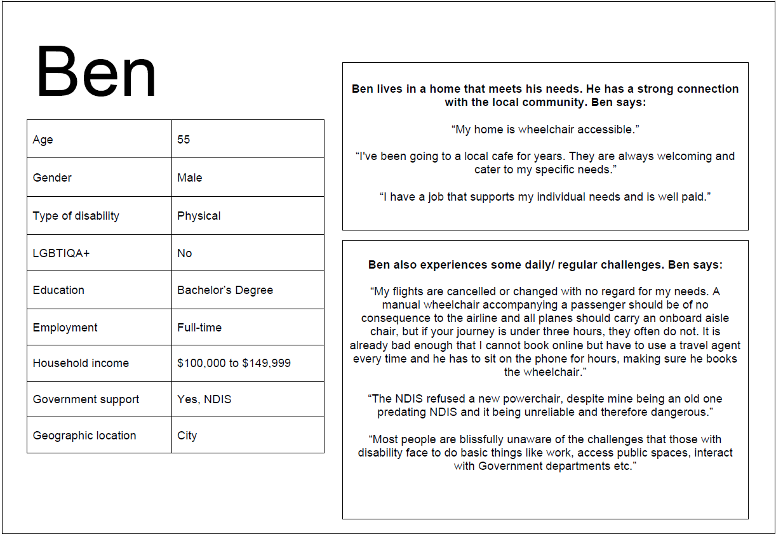
This appendix contains an amalgamation and combination of experiences shared by Queenslanders with disability who participated in this research. It does not represent the range of diverse, individual experiences, but does represent a general overview of similar stories shared across many participants.
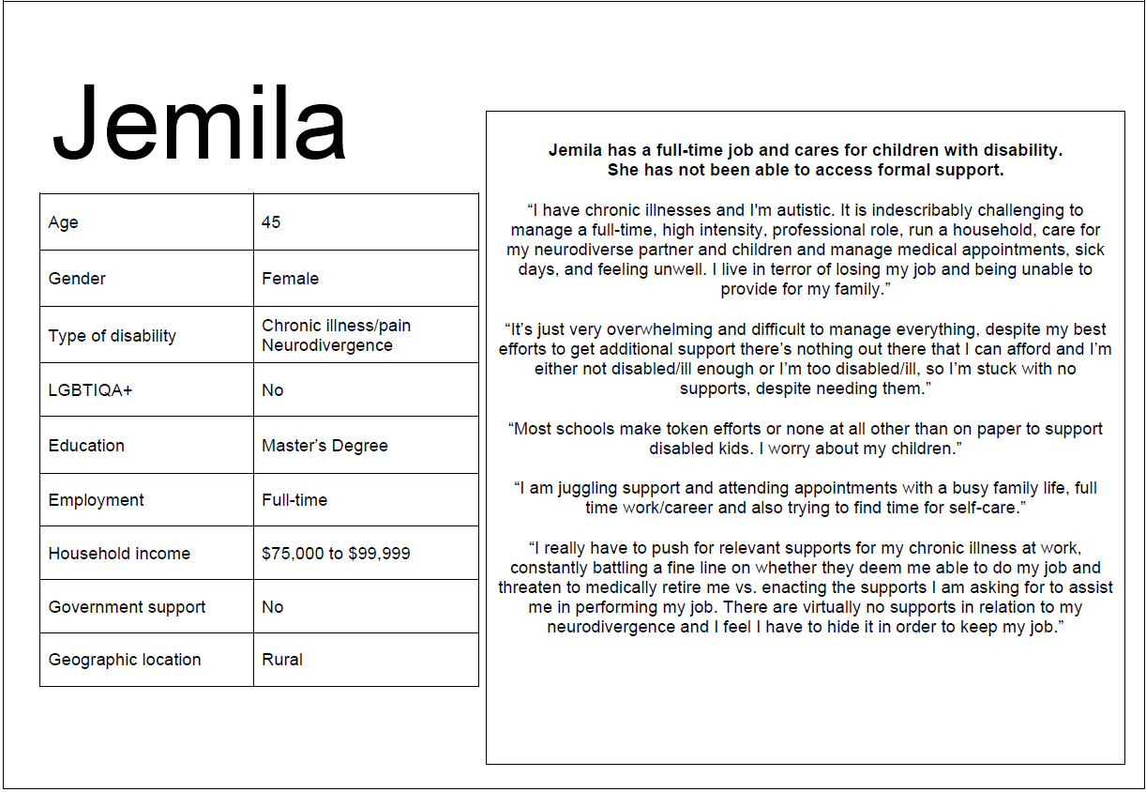
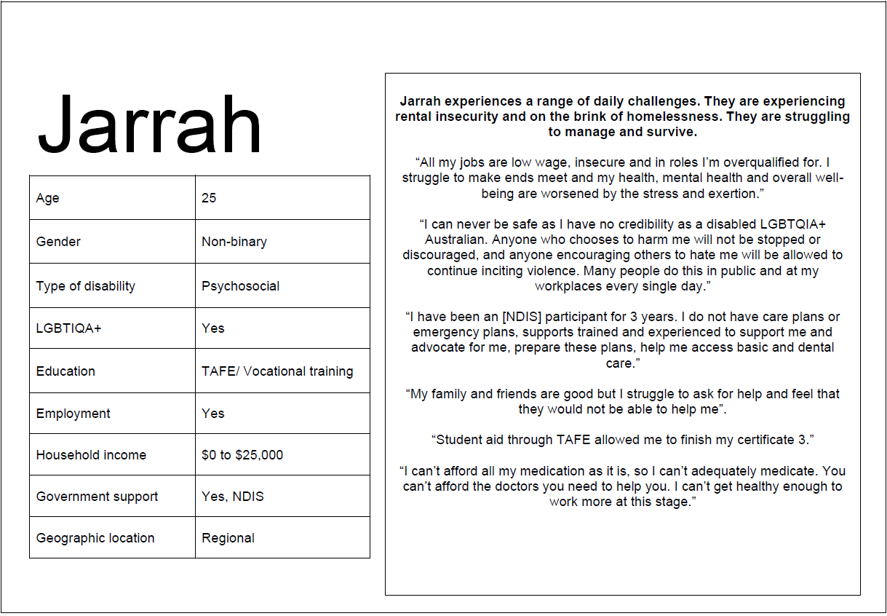
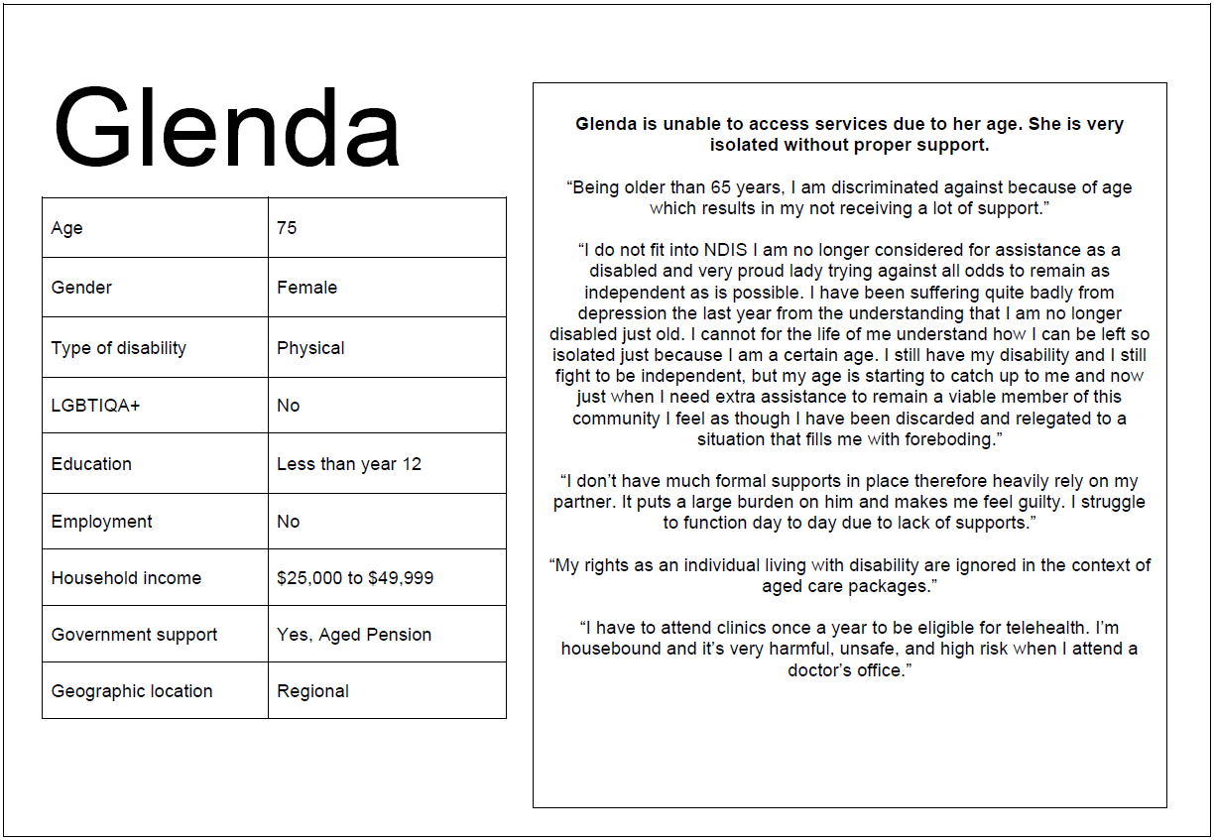

Appendix 6: Accessing services.
This appendix shows how often participants with disability can access different services, as shared in this research. The data in this table is also presented in Figure 9.
Service type | Every time | Most of the time | Sometimes | Rarely | I don’t access these services
Income support (e.g., Centrelink, pension) | 22% (64 people) | 16% (48 people) | 11% (32 people) | 8% (22 people) | 43% (125 people)
Disability support funding (e.g., NDIS) | 15% (43 people) | 21% (62 people) | 12% (34 people) | 7% (20 people) | 45% (132 people)
Employment services (e.g., help to get a job) | 1% (3 people) | 4% (11 people) | 8% (24 people) | 8% (24 people) | 79% (229 people)
Local businesses (e.g., shops) | 27% (78 people) | 40% (117 people) | 24% (70 people) | 7% (20 people) | 2% (6 people)
Public transport (e.g., trains, buses) | 19% (54 people) | 21% (60 people) | 17% (50 people) | 17% (50 people) | 26% (77 people)
Disability services (e.g., support workers) | 10% (29 people) | 24% (69 people) | 17% (49 people) | 7% (21 people) | 42% (123 people)
Education services (e.g., training universities) | 10% (28 people) | 20% (59 people) | 14% (42 people) | 9% (26 people) | 47% (136 people)
Health services (e.g., GPs, hospitals) | 19% (56 people) | 48% (138 people) | 26% (76 people) | 7% (21 people) | n/a

Appendix 7: Service quality and outcomes
This appendix shows participants with disability’s assessment of service quality and outcomes. The data in this table is also presented in Figure 10.
Service type | Very good | Good | Bad | Very bad | I don’t access these services
Income support (e.g., Centrelink, pension) | 9% (26 people) | 30% (86 people) | 10% (30 people) | 12% (34 people) | 39% (115 people)
Disability support funding (e.g., NDIS) | 9% (26 people) | 24% (70 people) | 11% (33 people) | 12% (34 people) | 44% (128 people)
Employment services (e.g., help to get a job) | 2% (5 people) | 6% (18 people) | 6% (16 people) | 10% (30 people) | 76% (222 people)
Local businesses (e.g., shops) | 15% (42 people) | 66% (193 people) | 13% (37 people) | 2% (7 people) | 4% (12 people)
Public transport (e.g., trains, buses) | 10% (28 people) | 38% (110 people) | 13% (38 people) | 10% (29 people) | 29% (86 people)
Disability services (e.g., support workers) | 16% (46 people) | 25% (74 people) | 9% (26 people) | 6% (18 people) | 44% (127 people)
Education services (e.g., training universities) | 6% (18 people) | 33% (96 people) | 8% (23 people) | 4% (12 people) | 49% (142 people)
Primary healthcare (e.g., GPS) | 32% (92 people) | 53% (154 people) | 12% (35 people) | 3% (10 people) | n/a
Health services (e.g., hospitals) | 16% (47 people) | 46% (134 people) | 20% (59 people) | 12% (35 people) | 6% (16 people)

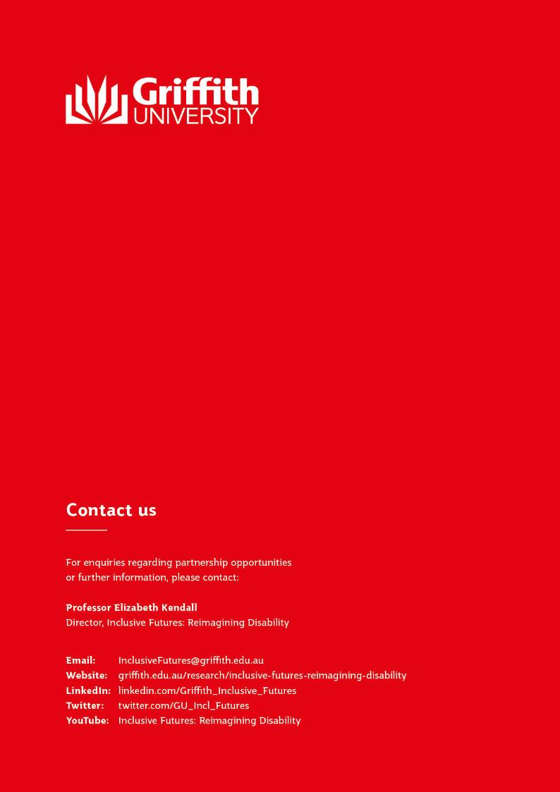

Ethical duty of care protocols were followed to check on the safety and wellbeing of this participant.

