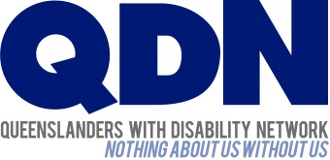

QDN Photographic/Digital Image/Recording General Consent Form

Why am I filling out this form?
QDN values your privacy, and we are asking for your consent before we use your personal information, including your photograph, as part of our commitment to the Information Privacy Principles set out in the Information Privacy Act (2009).
Can I say what/where my photograph/digital image or recording is used for?
The Consent Form is for general consent which means that QDN can use your image for promotion using our communication channels or third party such as media.
What if I give my consent and later change my mind?
You can change your mind or withdraw your consent at any time. QDN will make the changes as soon as possible. Any existing material that is already in use will not be withdrawn from use.
It is easy to change or withdraw your consent by simply contacting QDN and telling us about the change you want to make. Please do this via writing at the contact details below.

Contact QDN
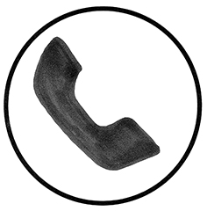 | 1300 363 783 | 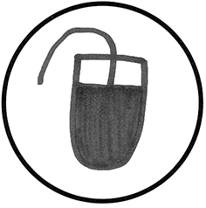 | qdn.org.au
 | qdn@qdn.org.au | 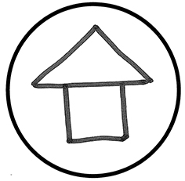 | 338 Turbot Street,  Spring Hill, QLD 4000



Photographic/Digital Image/Recording Consent Form

I, ______________________________________________________________
(Print full name)

Give consent to Queenslanders with Disability Network (QDN) to take photographs digital images or recordings of me for the purpose of use in QDN’s publications and promotion of QDN’s values.
I understand that:.
by giving consent, QDN can use my photograph/digital image or recording for:
- Promoting and advertising QDN in publications (ebulletin, brochure, website)
- Reporting and planning (reports to our funding bodies, grant submissions)
- Media release (stories where people with disabilities can be heard and have a say)
- Media (TV, radio, newspapers, online)
- Public Relations (conferences, forums)
QDN will only use my photograph/digital image/recording in activities that show me in a positive way.
Participants Details:
Name:________________________________ Phone number: ____________________
Address: ________________________________________________________________
Email: ________________________________Signature:_____________________Date:_______
Legal Guardian details: (Participants who have an appointed Guardian by the Office of Public Guardian or is under the age of 18 must seek permission before agreeing to consent.)
Guardian/Parent Name:______________________________Phone number:____________
Address: _________________________________________________________________
Email: ________________________________Signature_________________________________
For QDN staff to complete:
Name: | Contact Details:
Guardian/Support (where applicable) | Contact Details:

