Transport and Other Legislation (Managing E-mobility Use and Protecting Our Communities) Amendment Bill 2026
Submission No: 1948
Submission By: Queenslanders with Disability Network
Publication: Making the submission and your name public

Inquiry into Transport and Other Legislation
(Managing E-Mobility Use and Protecting Our Communities) Amendment Bill 2026

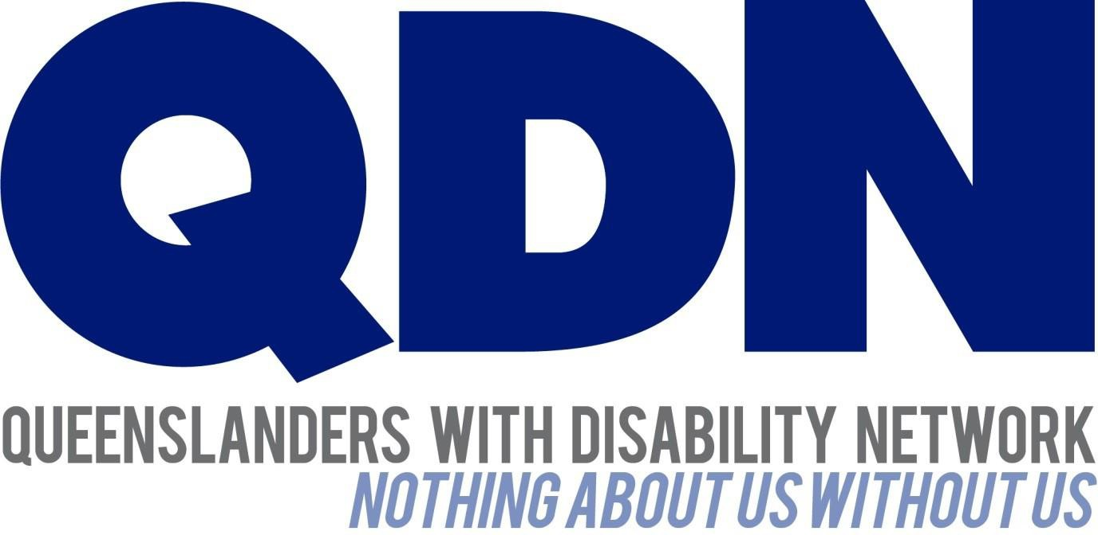

The State Development, Infrastructure and Works Committee April 2026

Contents
About Queenslanders with Disability Network (QDN) 3
Introduction and Acknowledgements 3
- Licensing and Qualified Riders 5
- Footpaths 6
- Legal Classification for Speeds of Personal Mobility Devices (PMDs) 7
Recommendations 8
Conclusion 9

About Queenslanders with Disability Network (QDN)
Queenslanders with Disability Network (QDN) is a state-wide, not-for-profit organisation led by and for people with diverse disability. We are dedicated to advancing disability rights and advocacy in Queensland. QDN is the Executive Peak Body for people with disability in Queensland, providing overarching leadership and coordination across funded peak bodies around the state. QDN operates a state-wide network of over 3,000 members and supporters all over Queensland. Guided by our motto “nothing about us without us,”
QDN ensures that people with lived experience of disability are central to shaping policies, services and supports. Our vibrant and dynamic membership is made up of people with diverse disability who are at the centre of everything we do. QDN as an organisation is in a unique position of representing people with a diverse range of disability.
QDN’s work is underpinned by a commitment to inclusion, co-design, collaboration, and innovation and is guided by the pillars of inform, connect, lead and influence. By partnering with communities, service providers, businesses, and government, QDN fosters systemic solutions that empower individuals, amplify the voices of people with disability, and create sustainable, inclusive systems of support, working toward a more equitable and inclusive Queensland.
Through a powerful and engaged network of individuals and 32 Peer Support Groups, QDN informs, leads and influences change on issues impacting the disability community. QDN’s extensive body of work includes connecting people through peer support groups, supporting future leaders through the Emerging Leaders Program, and influencing government policies and programs through targeted advocacy.
QDN’s initiatives are co-designed and co-delivered with people with disability. QDN engages with diverse communities, including Aboriginal and Torres Strait Islander peoples, Culturally and Linguistically Diverse groups, and rural and remote populations across Queensland. We believe that Queenslanders with disability need to be empowered active and valued citizens, and fully included in the economic, social, civic and cultural life of Queensland.

Introduction and Acknowledgements
Queensland Disability Network (QDN) acknowledges the work of the State Development, Infrastructure and Works Committee and this inquiry. The inquiry into

e-mobility use and their safe use highlighted the need to increase protection for people who use e-mobility devices as well as people who share roads and pathways with e-mobility users.
QDN acknowledges the efforts to incorporate the 28 amendments of the inquiry into e-mobility safety and use in Queensland. The legislation aligns with QDNs call to strengthen regulation and enforcement of e-mobility devices, however the Bill in its current form has the potential to impact people with disability and their ability to use e-mobility devices.
Proposed changes to licensing requirements, the speed limits of devices on footpaths and the legal classification of speed limits for personal mobility devices (PMDs) are areas of concern for QDN in Bill as it is currently drafted.
QDN acknowledges that the proposed s6 and s15 of the Bill exempt motorised mobility devices (MMDs) and that members and stakeholders noted that some changes needed to be made concerning the regulation of different e-mobility devices being used across Queensland.
However there remains concerns about the proposed changes and their impact on people with disability across Queensland.
QDN has previously commented on inquiries concerning the regulation of mobility scooters and motorised wheelchairs and highlighted concerns about enforcement of strict regulations that impinge on the mobility, freedom of movement and human rights of people with disability who use motorised scooters and wheelchair users. As noted previously, QDN does not wish to see limitations on people with disability’s ability to purchase the mobility device of their choice.
As part of this submission, QDN has consulted with stakeholders and our members who have taken the time to provide their concerns over these changes and the impact they may have on people with disability who use e-mobility devices as part of their daily life. This strong engagement by the disability community, despite the short time frame for consultation, is indicative of how important this issue is to our members and stakeholders.
For many Queenslanders with disability, e-scooters, e-bikes and e-trikes are not simply a convenience—they are critical mobility tools. These devices enable people to access employment, education, essential services, and community life, particularly where other transport options are limited or inaccessible. For some individuals, they

represent a viable alternative to holding a driver’s licence and are central to maintaining independence. This includes pedal assisted e-bikes and e-trikes. Additionally, e-mobility supports low-income earners by providing a cost-effective transport solution particularly where public transport does not provide end to end journey and there are financial barriers to mobility.

Licensing and Qualified Riders
QDN members and stakeholders have highlighted the proposed changes to licensing and qualifications for riders as a major concern in the new legislation. As noted, QDN acknowledges that this does not include MMDs, and in the case of s15, registered vehicles.
There are a range of people with disability including people with intellectual and cognitive disability who experience barriers to be able to gain a learners permit. This is because of inaccessible tests for people with learning, intellectual and cognitive disability and the requirements of a learners test are not proportionate to the competency and knowledge required to safely operate e-mobility devices. Additionally, there are people who may not be medically fit to operate a motor vehicle but can safely operate an e-mobility device.
QDN members have a specific focus on ss 78B – 78D in the Bill in regards to licencing requirements for people to be over the age of 16 and hold a valid driver’s licence.
This risks making it harder for people with disability to be able to use PMDs that enable their equal access to the transport that suit their needs and supports their independence, participation and involvement in moving around their community for work, study, leisure or social connection. This concern is further compounded by the requirement, as outlined in the explanatory notes on the Bill, that PMD users remain medically fit to drive.
There are significant numbers of people with disability who are able to safely ride and administer the requirements of an e-bike, e-trike or scooter that would otherwise be excluded by this requirement and the subsequent discrimination that people with disability will experience as a result of this. The explanatory notes to the Bill highlight that people with disability will be at risk of being unable to obtain a licence but there is no consideration for people with disability who are acknowledged as potentially being unable to obtain a licence but have ridden e-mobility devices for years.

It was noted by stakeholders that the people who often use e-mobility bikes and trikes are those who have a disability, particularly children with disability, and seniors who have let their licence expire because they no longer feel ok to operate a motor vehicle which is very different to the requirements of an e-mobility bike or trike that people may use for their mobility needs.
QDN members have also highlighted an additional consequence of this that would require people with disability will face the burden of having to prove they can administer the mobility device even if they have been in a position where they have used e-mobility devices for years without any problems or need for a licence. Asking people with disability to now prove their ability to drive e-mobility devices they have safely driven for many years will impact accessibility for people with disability and limit their options for equal access to transport options as citizens of Queensland.
QDN received significant feedback from members from across the state in regards to this issue, and overall feedback highlighted concerns that people with disability will be excluded from using e-mobility devices and will be disadvantaged and experience potential discrimination in relation to these proposed changes which will limit their ability to access transport and risk limit participation in public and social activities.
It is important that any licensing framework must include equivalent access pathways for people unable to hold a drivers licence, requirement for reasonable adjustments and that no additional financial or administrative burden is imposed on people with disability as a consequence of this legislation.

Footpaths
QDN acknowledges that the proposal to reduce the speed limit for devices operating on footpaths to 10km/h is designed to improve safety on footpaths across Queensland. People with disability are also pedestrians and are disproportionately impacted by unsafe environments. We support practical, proportionate measures that improve safety outcomes and ensure that all Queenslanders, including people with disability, can move safely through their communities.
However, decision to reduce footpath speed limits to 10km/h has also raised concerns across the disability sector, with stakeholders and members raising concerns about the proposed change.
Previous consideration of speed limits by the Queensland Walks Alliance had suggested that the speed limit be reduced to 12km/h to help ensure consistent flow

between different path users. Reducing the limit to 10km/h was seen as adding risk to traffic flow as it may hinder the speed of foot traffic instead of being consistent with it.
It was noted that 10km/h would lead to issues around maintaining balance and lead to the loss of safe and functional travel for anyone who uses an e-bike on a pathway. This is a risk for people with disability, many of whom use pathways due to the risk of not being seen on the road, and the fact that other vehicles on the road are travelling at 60km/h which is significantly different to the current or proposed speed limit for
e-bikes, e-trikes or e-scooters.
QDN acknowledges that members and stakeholders have called for improved safety on footpaths and other areas with high foot traffic and accepts that these areas need to be safe for use by all people including people with disability. Members described feeling unsafe due to the speed of e-scooters and other devices, not just in Brisbane but across towns in Queensland. It is important that consideration is given to previous work, submissions, and inquiries that have examined speed limits on footpaths.
In terms of parking and obstructing footpaths with e-mobility devices QDN agrees with the proposed changes to parking offences in the Bill. These changes will help protect people with disability from the hazards that can come from poorly parked e-mobility devices. Many members and stakeholders highlighted the hazards that e-scooters in particular can cause in terms of trip hazards when they are not properly parked.
Introducing enforcement officers is welcome, but consideration also needs to be given to improving infrastructure, such as more parking bays that can provide people who use e-mobility devices places they can park their devices without risk of committing an offence under the proposed Bill.

Legal Classification for Speeds of Personal Mobility Devices (PMDs)
Speed limits for e-mobility devices is also an issue that has been raised by QDN members and stakeholders. Some members noted that the speed limits should be set for certain devices and that focus should be on vehicles that have been modified for speed rather than assist in the use for the person with the device.
Many people with disability will not be using high-powered devices. Based on feedback from members, high-powered devices are a risk to people with disability

who share these pathways, but they are not used by people with disability as part of their travel.
People with disability have noted that they have felt insecure sharing space with these devices on footpaths and roads. Particularly as they surprise other road and path users.
QDN members in regional and rural areas noted that in many cases they are required to use the road rather than paths so the risk of being impacted by these devices is higher than it otherwise would be for people with disability who live in areas with accessible pathways. QDN commends the Bill for having a speed limit in place for these devices as called for in our original submission, but notes that having the speed limit at 60km/h is still high, and consideration should be given to reducing the speed further to avoid the risk to people with disability who share the road with e-mobility devices that are capable of reaching these speeds.

Modifications
The proposed legislative changes to e-mobility devices raise specific accessibility concerns for people with disability, particularly those who rely on modified or custom-built devices to achieve independent mobility. Many individuals use adapted e-bikes or similar devices that do not neatly align with standard definitions of
“EPACs” or mobility aids, creating uncertainty regarding compliance, classification, and potential requirements for exemption or re-engineering. This lack of clarity presents a disproportionate regulatory burden for people with disability, whose devices are often individually engineered to meet functional needs.

Recommendations
  - Introduce an inclusive access framework to ensure that people with disability, including young people under 16 who have access needs can continue to have equal access to e-mobility devices without additional burden or discrimination.
  - Review shared-path speed limits using a risk-based approach and reconsideration of a fixed 10km/h limit where it compromises stability or safe operation of the device. Reconsider the 60km/h speed limit with a possible reduction due to the risk to people with disability who share the road with these devices. Particularly those in regional, rural and remote areas who often share the road with these devices capable of higher speeds.

  - Identify a measures and exemption framework for modified or adaptive e-mobility devices for people with disability to meet access and functional needs within a proportionate risk-based approach.
  - Embed co-design with people with disability in the development of education, compliance, and communication materials, and establish consistent data collection on incidents involving e-mobility devices and disability. This should include ongoing collaboration through a formal advisory mechanism involving government, industry, and disability stakeholders.
  - Undertake targeted consultation and disability impact assessment prior to implementation of regulatory changes to ensure measures are proportionate, inclusive, and do not result in indirect discrimination. Engagement should include people with disability, families, and supporters to test real-world impacts.

Conclusion
QDN commends the government for its review on e-mobility and its commitment to reviewing the 28 recommendations of the final report. However, the Bill in its current form risks potential overreach in a number of areas that could end up having an impact on the lives of people with disability and the transport options that they can use.
Not all disabilities are the same, while some people with disability may be able to adapt and find new devices if their current device is no longer considered usable under the Bill, many will have their options for travel greatly reduced by what is proposed in the Bill. This can lead to lost social and public engagement and reduced connection to their local communities.
Members and stakeholders have agreed that there needs to be more done to protect users from e-mobility devices that go beyond regulations. There is broad agreement that these devices are dangerous and risk the safety of all users including people with disability.
However, the current Bill is broad in its design and risks creating a disadvantage for people with disability in their attempts to be part of social and public life. Removing these risks must be a consideration of this committee otherwise this Bill risks negatively impacting many people with disability who currently use these devices and use them safely.

