

Bright Sparks

Ways to lower energy use and save money
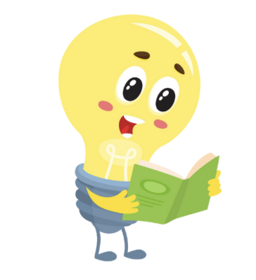

User Friendly Version
About QDN
QDN stands for – Queenslanders with Disability Network.
We will say QDN for the rest of this document. QDN is an organisation made up of people with disability.

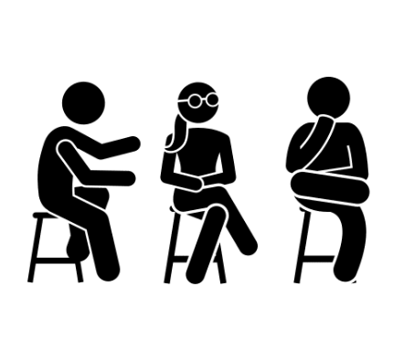

QDN is a group of members and supporters.
Our members share their ideas and experiences.
We believe that decisions should never be made about us without us.

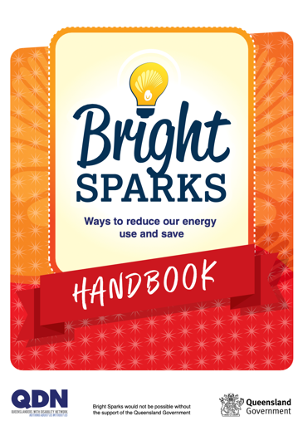

This Bright Sparks Handbook was created by and for people with disability.


You can get help with this handbook
You can get someone to help you
- read this book
- know what this book is about and find more information

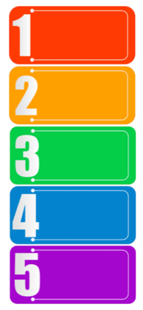
It has easy steps to help you:
- use less energy
- save money
Each step gives you useful tips and advice.

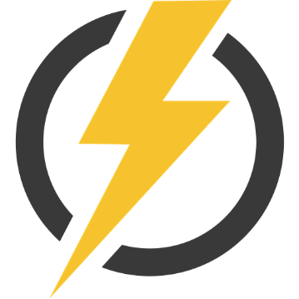
Energy can be electricity or gas.
Our homes use electricity.
For example:
- to turn on our lights
- or power our appliances.
Some homes use gas for stoves or hot water.
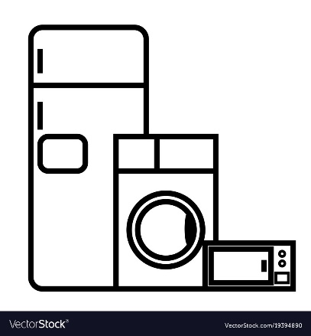
Appliances can use a lot of energy.
For example:
- fridges
- televisions
- or washing machines.

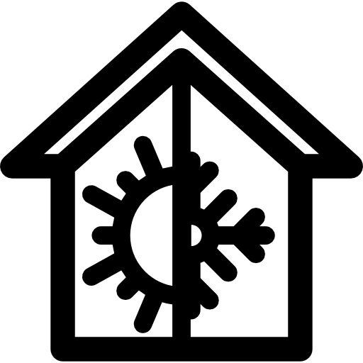
Most homes use half of their energy on heating and cooling.
This means heaters and air conditioners use a lot of energy.

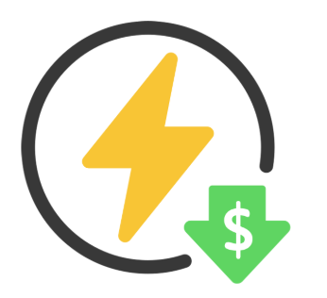
There are easy ways to save money and use less energy at home.
This is a step in Bright Sparks that we call “reduce your juice”.
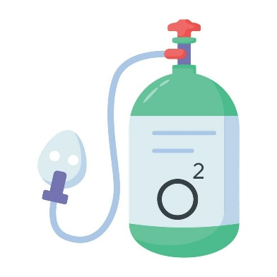
Everyone is different. People with disability may have important powered equipment or do things in a certain way.
It is very important to look after your health and wellbeing, while also saving energy.
You can save energy without having to stop using the equipment or doing the things that help you stay well.
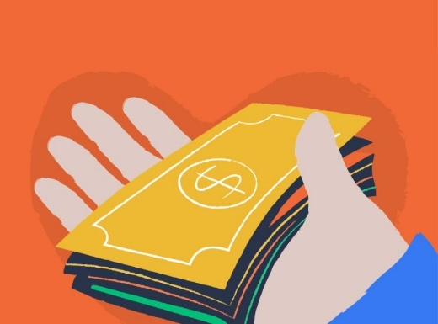
If you have a concession, pensioner or seniors card, or a specific medical condition, you may get help from the government with a rebate.
Electricity companies can also offer payment plans to make it easier for you to pay bills.

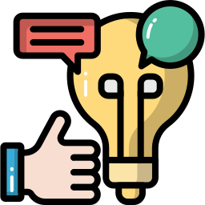
To get more information, you can use the Bright Sparks Handbook. You can also call the Queensland Government concession services on (07) 3247 5907.
Remember, everyone is different. But you can use the tips that work for you.

Now, let’s think about ways we can lower our energy use and save money at home.

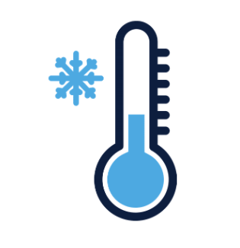
What are some ways to “reduce your juice” and stay cool in summer on a budget?
Close windows, doors, curtains, and blinds in rooms you want to cool. This helps keep the cool air inside.

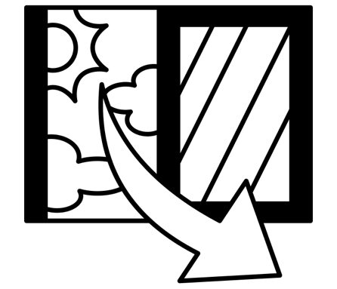
In tropical areas of Queensland, you can open windows to let the breeze flow.
But only if the outside air is cooler than inside.

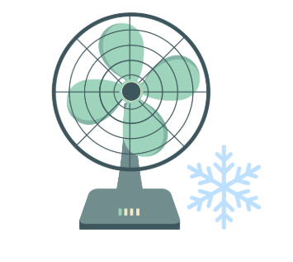
Use fans instead of air conditioners.
If you put a bowl of ice in front of a fan, it can cool the air like an air conditioner.

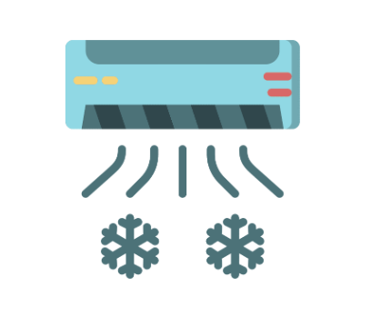
If you need to use an air conditioner:
Set the temperature to 26°C or as close to it as possible.
Clean the air conditioner filters to keep it working well.
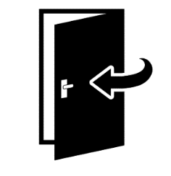
Close doors to rooms you don’t use often (like bathrooms)
This means, less rooms to cool down.

What are some ways to “reduce your juice” and stay warm in winter on a budget?
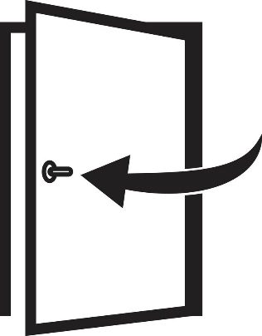
Block drafts by closing windows and doors. Use draft stoppers or old towels to block drafts under doors.


Wear extra clothes or use blankets instead of turning on the heater. It’s cheaper and cosier!

What are some ways to save power in the bathroom and laundry?

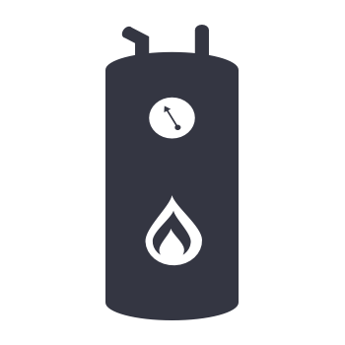
Set your hot water tank to 50°C.
You don’t need it higher.

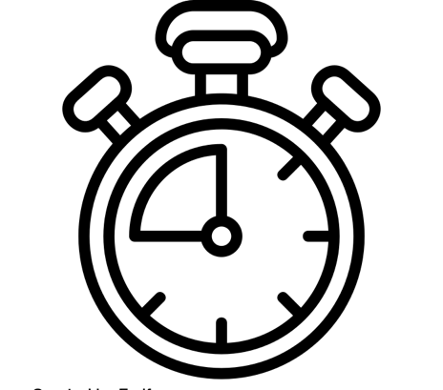
Take shorter showers – no more than 4 minutes – to use less hot water.
You can have a low flow shower head to save water and power. This means the shower head uses less water than other shower heads.

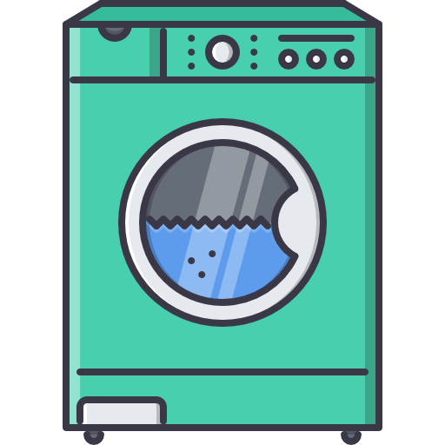

Wait until the washing machine is full of clothes before starting it.

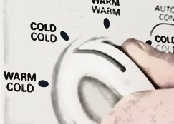
Use cold water to wash your clothes when possible.

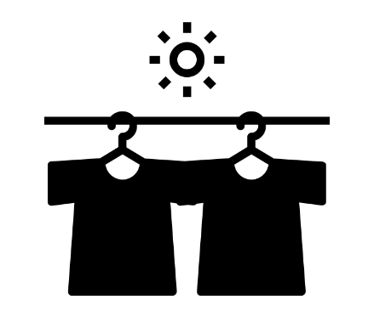

Try to use a clothesline instead of a dryer.
Dryers use a lot of power.

What are some ways to save power in the kitchen?
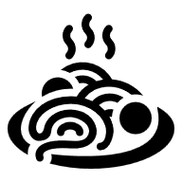

Defrost food in the fridge before cooking.
It will reduce cooking time.

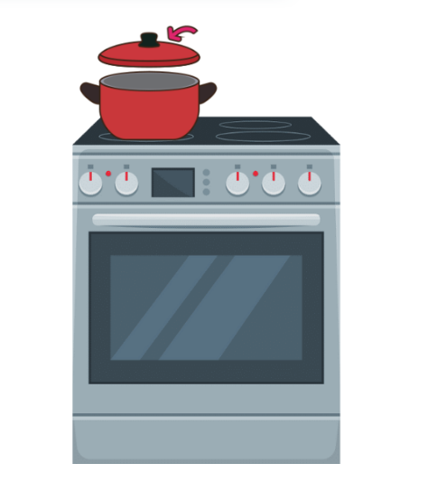
Check oven seals to make sure they are not worn out.
Turn off the oven about 5 minutes before food is fully cooked.
The oven stays warm for a while after you turn it off.

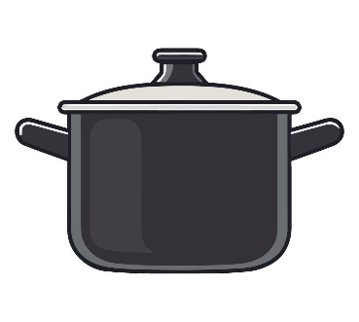
Keep lids on pots when cooking. This helps food cook faster and saves energy.

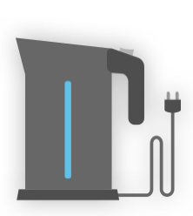
Use an electric kettle instead of a stove to boil water. It’s more efficient. Only fill the kettle with the water you need.

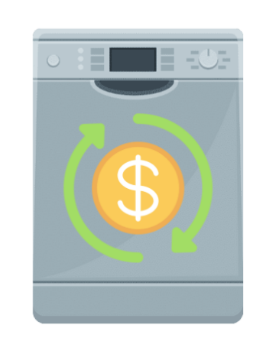

If you have a dishwasher, only use it when it’s full and choose the economy cycle.
This saves water too.

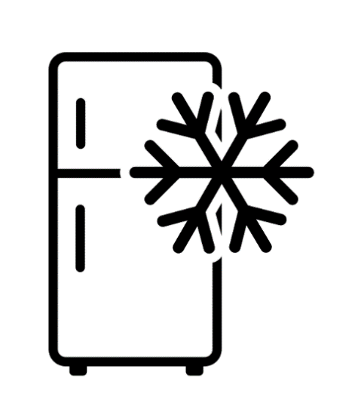
Keep fridges and freezers in a cool, breezy area, away from the oven or sun.
Leave a small gap around your fridge for air to circulate.
Fix or replace faulty door seals on fridges and freezers. Don’t leave the door open for too long.

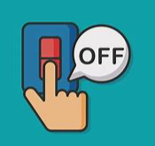
What are some other ways to save power around my home?

- Turn off lights when you don’t need them.
- Use a lamp instead of overhead lights when you can.
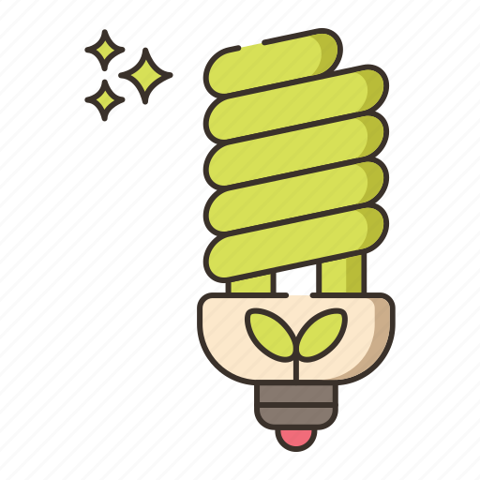

Use energy efficient bulbs or LED bulbs.
Energy efficient means they use less power than normal bulbs.

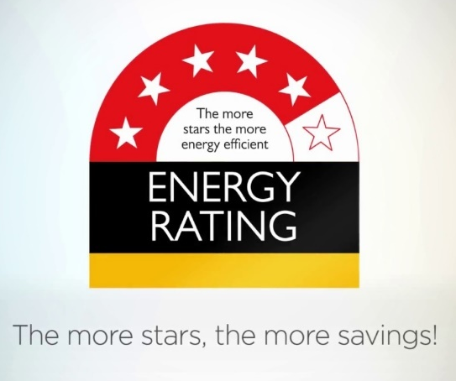
Appliances have an energy star rating label.

This can help you choose what appliances you buy.

The more stars means the less energy the product will use and the more money you will save on your energy bills.

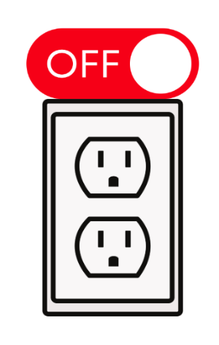
Switch off appliances at the wall when you are not using them.
TVs, game consoles, microwaves, and computers still use power even when turned off.


If you find it hard to reach plugs, consider getting an Eco-switch.
This lets you turn off everything on a power board with one switch.

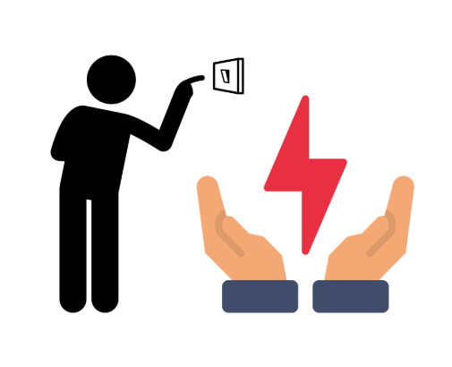
Bonus tip:
If you are going away for a while, turn everything off – even the hot water system.
This saves power while you’re away.

More information

This is a summary of the Bright Sparks Handbook.

You can find the full Bright Sparks Handbook on the QDN website.

Contact us

Call 1300 363 783

Email: qdn@qdn.org.au

Website: qdn.org.au

