2025 Queensland Disability Conference

Online Registration Instructions

- Click the link below to enter the Virtual venue: - Queensland Disability Conference 2025

- What you will need:

- Computer – Mac or PC (computers preferred, tablets are also supported)
- Browser – Chrome (preferred), Safari, Edge or Firefox
- Internet connection – the faster the better, but a minimum bandwidth of 5mb/5mb is required.
- Camera – webcam so we can see your face!
- Microphone – so you can be clearly heard.
- Headphones – this will help to minimise possible audio echo for other attendees.

- Once you have accessed the link, you will find the ‘Landing Page’. Prior to the event opening time, there will be a button that says, ‘Register for event’. Although this is not required it might be a good idea to get registered and set up prior to the day.

- Once the Virtual Event doors are open (1 hour prior to the start of the event) the ‘Landing Page’ will state ‘Join Event’. Click on this button to join!
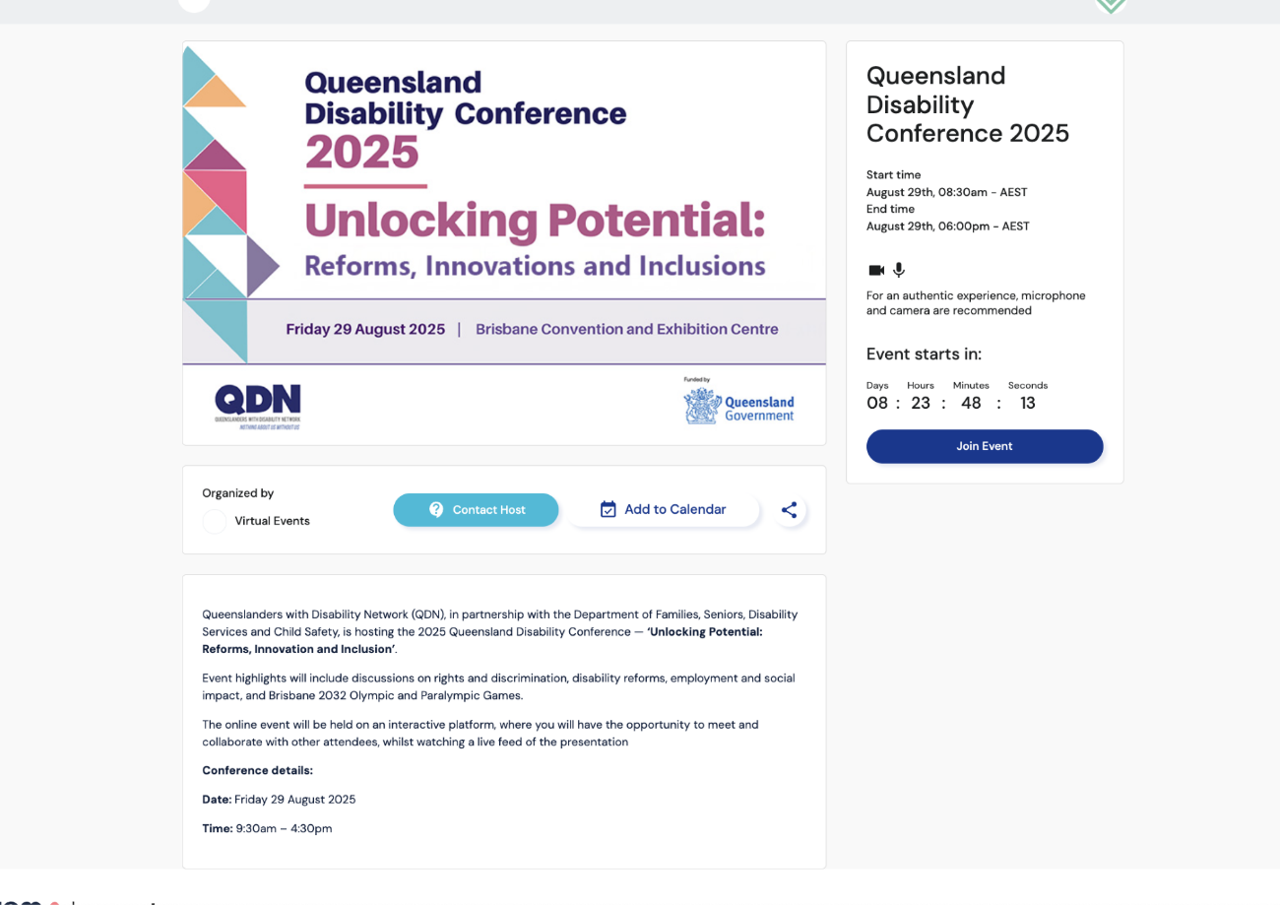

- You will be asked to provide your name and email address, create your own unique password to log in to future sessions, or request a “magic link” which will be sent to your email address (click the magic link to continue). Once this is complete, you will proceed to a quick test page for your camera and mic – at this point, your browser may ask you to ‘allow your camera and mic to be used’ – it is important to ‘allow’ that functionality.

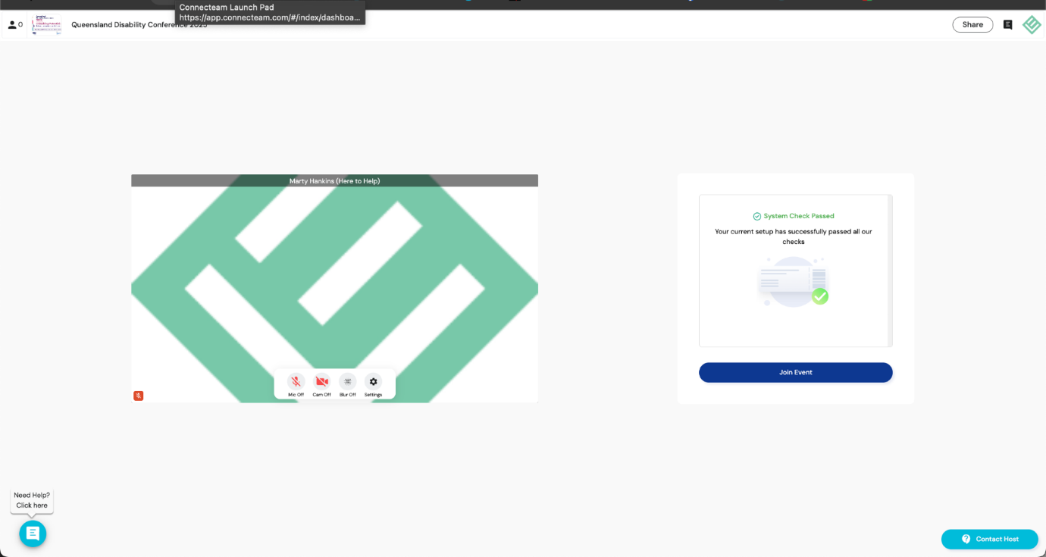

- Once complete, you will then proceed to the virtual venue. Once you arrive at the virtual venue you will be placed at the next available table. From there you are free to move and join another table by simply double clicking on a free chair at another table which will move you to that location.

- There will be help staff on hand to guide you, and if you have any issues, you can also contact the ‘Help Lounge’ at the bottom right of the screen in the virtual venue. There will be a real human there to assist you!

