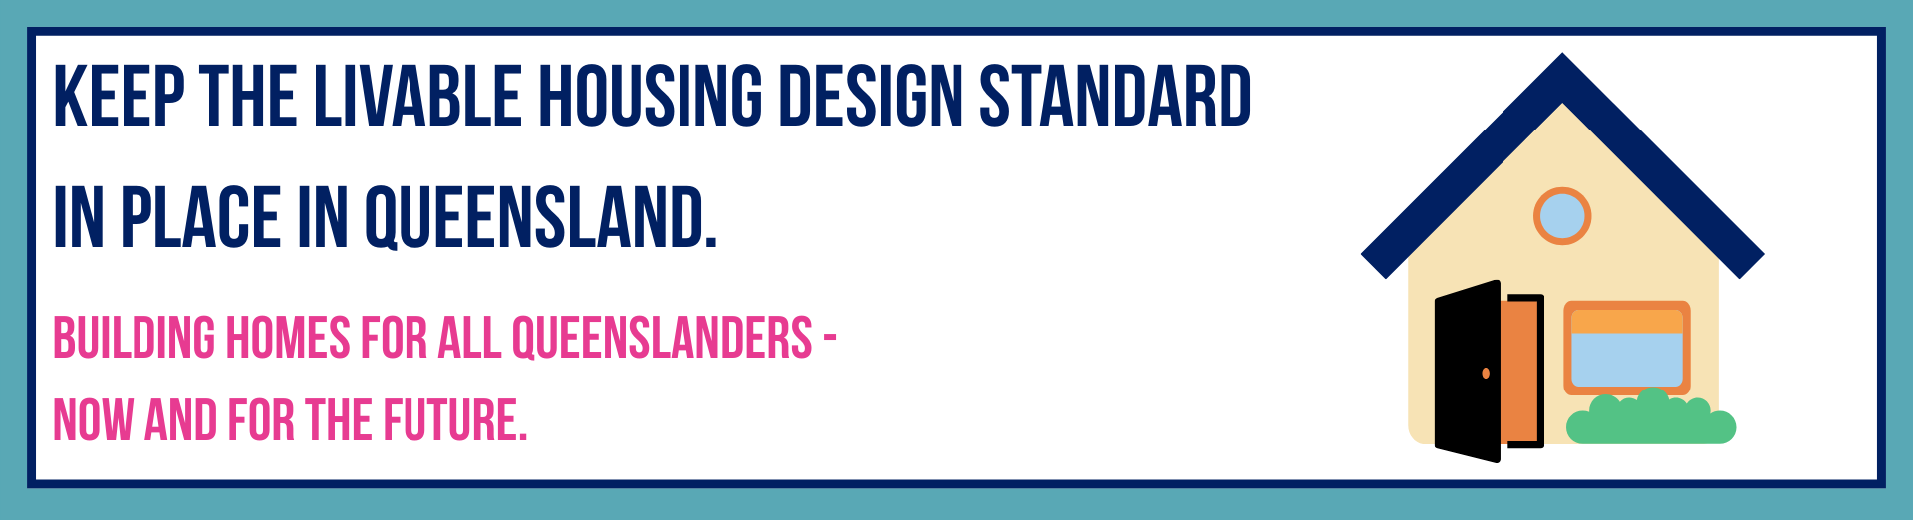

**Building homes for all Queenslanders - Now and for the future**

**As fifty-two (52) organisations representing people with disability, older people, families/carers and the disability, housing and community sectors,** we strongly support Queensland’s continued implementation of the Livable Housing Design Standard (LHDS) under the National Construction Code.

Everyone needs a place to call home that meets their needs. Accessible housing is not a luxury; it’s a basic human right for all people. We are an ageing population and also with disability mobility needs. It is critical that the homes we build today must meet the needs of both today and tomorrow’s Queenslanders.

The *Queensland Productivity Commission’s Interim Report* - *Opportunities to Improve Productivity in the Queensland Construction Industry* released on Thursday 31 July 2025 recommended that Queensland opt out of these Livable Housing Design Standards unless a net benefit to the State can be demonstrated. The Queensland Productivity Commission has argued that the new minimum accessibility standards in the National Construction Code fail to meet the required economic test, relying on analysis by the Centre for International Economics (CIE). However, the CIE’s findings have been contested across multiple reports, and it is important that we consider the social and societal outcomes and benefits of accessibility.[1]

Accessibility costs little up front (around 1% of build costs), but saves millions in health, aged care, and retrofit expenses. Building right the first time is cheaper than fixing later. This is confirmed by new research by the Melbourne Disability Institute, which shows that when the full benefits and full costs of LHDS are properly accounted for the benefit-cost ratio is at least 1.7.[2]

LHDS ensures the homes we build today are accessible, safe and future-proof.

Queenslanders deserve homes that are not only affordable, but livable and accessible - homes that let people live independently, age in place, leave hospital faster, and be part of their communities.

Rolling back the LHDS would:

* Deny people with disability and older people their right to safe, accessible housing and a place they can call home.
* Undo standards in place since October 2023 that have existing flexibility through exemptions that address industry concerns.
* Drive up long-term care in health, disability and aged care.
* Push expensive retrofit costs to State and Commonwealth administered schemes.
* Create national inconsistency and industry uncertainty.

Queensland cannot afford to reverse this progress.

We call on Queensland’s elected representatives to ensure we maintain mandatory implementation of the Livable Housing Design Standard and give everyone a place to call home that delivers accessibility, dignity, independence and safety for the Queenslanders of today, and for generations to come.

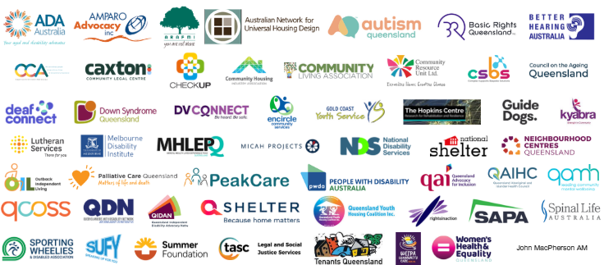V3

1. The Royal Commission into Violence, Abuse, Neglect and Exploitation of People with Disability, Final Report; Volume 7, Part C: Housing, pages 671-675, the Working Together to Deliver the NDIS: Independent Review into the National Disability Insurance Scheme Final Report – Supporting Analysis, pages 665-668, and the Melbourne Disability Institute, Submission on the productivity of the Queensland construction sector, June 2025.
2. Carter, R. & Bonyhady, B. Economic Advice Prepared To Assist Responses To The Queensland Productivity Commission On The “Net Benefit To The Community” Of The National Building Code Regulation To Achieve Accessible Housing”26/08/25