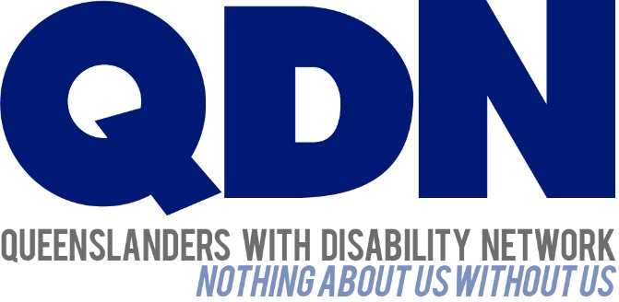

It’s time to act for…