# Apply to be on the Disability Reform Co-design Team

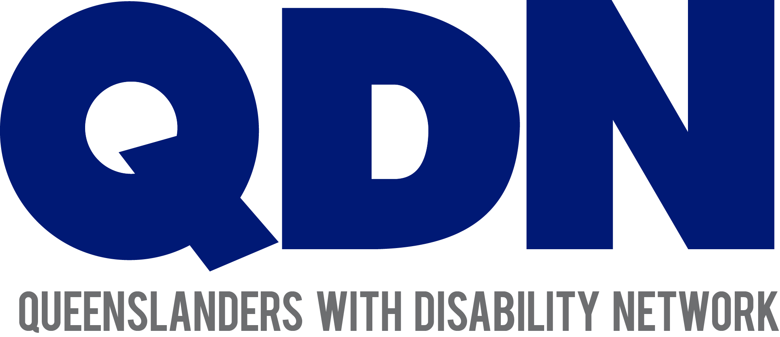

**About the Strategy**

The Disability Reform Co-design Team is part of the Queensland Disability Stakeholder Engagement and Co-design Strategy.

It is called the Strategy for short.

The Strategy is about how people with disability, their families, the government and the community can work together.



The Strategy is about working together to make things better for people with disability.

We call this ‘disability reform’.

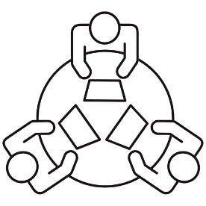

The Strategy is about making sure people with disability are very involved in disability reform through co-design.

Co-design is about working together and listening to people’s ideas.



Queenslanders with Disability Network (QDN) is leading the work to do with the Strategy.

**About the Hub**

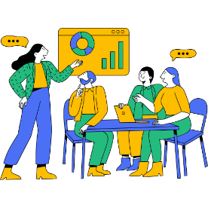

As part of the Strategy, a Co-Design Hub is being set up.



The Hub will bring people together to work together on disability reform.



The Hub will be a place for people to meet in-person or online.



The Hub will:

* host workshops
* teach people new skills
* share information.

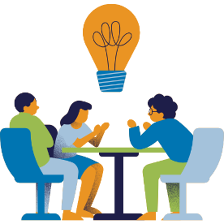**About the co-design team**

A team of people will do work in the Hub. This team is called the co-design team.

The co-design team will:

* come up with ideas
* A group of people sitting at a table

  Description automatically generatedhelp run workshops, focus groups, and discussions
* review feedback
* give advice
* make sure that people with disability have their say about disability reform.

They will listen and work with different groups to get their ideas about disability reform.

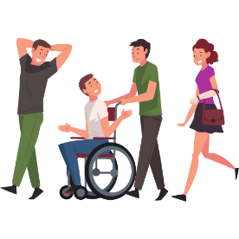

The co-design team will be made up of people with disability, their families and carers.

The co-design team will work with people who know about:

* co-design
* policy
* talking to people
* running meetings.

**Why should you apply?**



You should apply so you can:

* have your say on reforms for people with disability
* work with lots of different people
* learn about co-design, the disability sector, and new ways of working together.

**Details**



The co-design team will meet once a month, either online or in-person.



There might sometimes be more meetings when there is more work to do.



People who are part of the co-design team will be paid for the work they do.

**How to apply**

We want people with disability, their families, and carers to apply to be on the co-design team.



It is important that lots of different people are on the co-design team.

This includes:

* Aboriginal and Torres Strait Islander people with disability
* Culturally and Linguistically Diverse people with disability
* people with disability living in cities and the country
* young people and older people with disability
* family members and carers of people with disability.

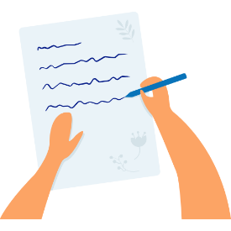

To apply you need to send 2 things to QDN:

* a short letter
* a resume.

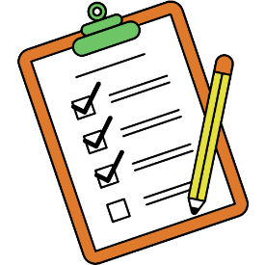The letter needs to talk about:

* why you want to join the co-design team
* your experience with disability
* what skills, ideas, and experience you have.



The letter needs to be 500 words or less.

Your resume should talk about your skills and experience.

You can also list the contact details for two referees if you want to.

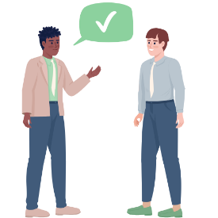

A referee is a person who knows about your skills and experience.



A referee could be:

* your manager
* someone you work or volunteer with
* someone you study with.

Applications close on 14 February 2025.



To apply, send your letter and resume to [admin@qdn.org.au](mailto:admin@qdn.org.au).

**What next?**



All the letters and resumes will be read.



They will choose some people to have a follow-up chat.

**More information**

For more information, please contact QDN.

Email QDN at [admin@qdn.org.au](mailto:admin@qdn.org.au).

Call QDN on 1300 363 783.