# Engagement and Co-design Hub

# Co-design Team

## Expression of Interest

QDN was engaged to develop the Queensland Disability Stakeholder Engagement and Co-Design Strategy (Strategy) as a priority action of the Queensland Disability Reform Framework. The Queensland Disability Reform Framework was designed as an initial framework for disability reform in Queensland, including a response to the Royal Commission into Violence, Abuse, Neglect and Exploitation of People with Disability (Disability Royal Commission) and as an initial response to the Independent Review of the National Disability Insurance Scheme (NDIS Review). The Strategy establishes structures to put people with disability and stakeholders at the heart of reform processes through co-design. QDN is leading the implementation of the Strategy which includes key governance mechanisms for the project at strategic advisory and project delivery implementation.

We are inviting people with disability, their families and carers with passion, creativity, and lived experience to join the QDN Engagement and Co-design Hub **Co-Design Team**. The Co-Design Hub is a central Hub that will host co-design labs, capacity building workshops, online communities of practice and a digital resource clearinghouse. Deep dive consultations and co-design activities will bring together diverse groups to identify and design solutions for policies, strategies and legislation. This is your chance to help design engagement processes and deliver key parts of the work that will generate and inform policy and program solutions.

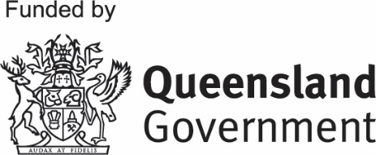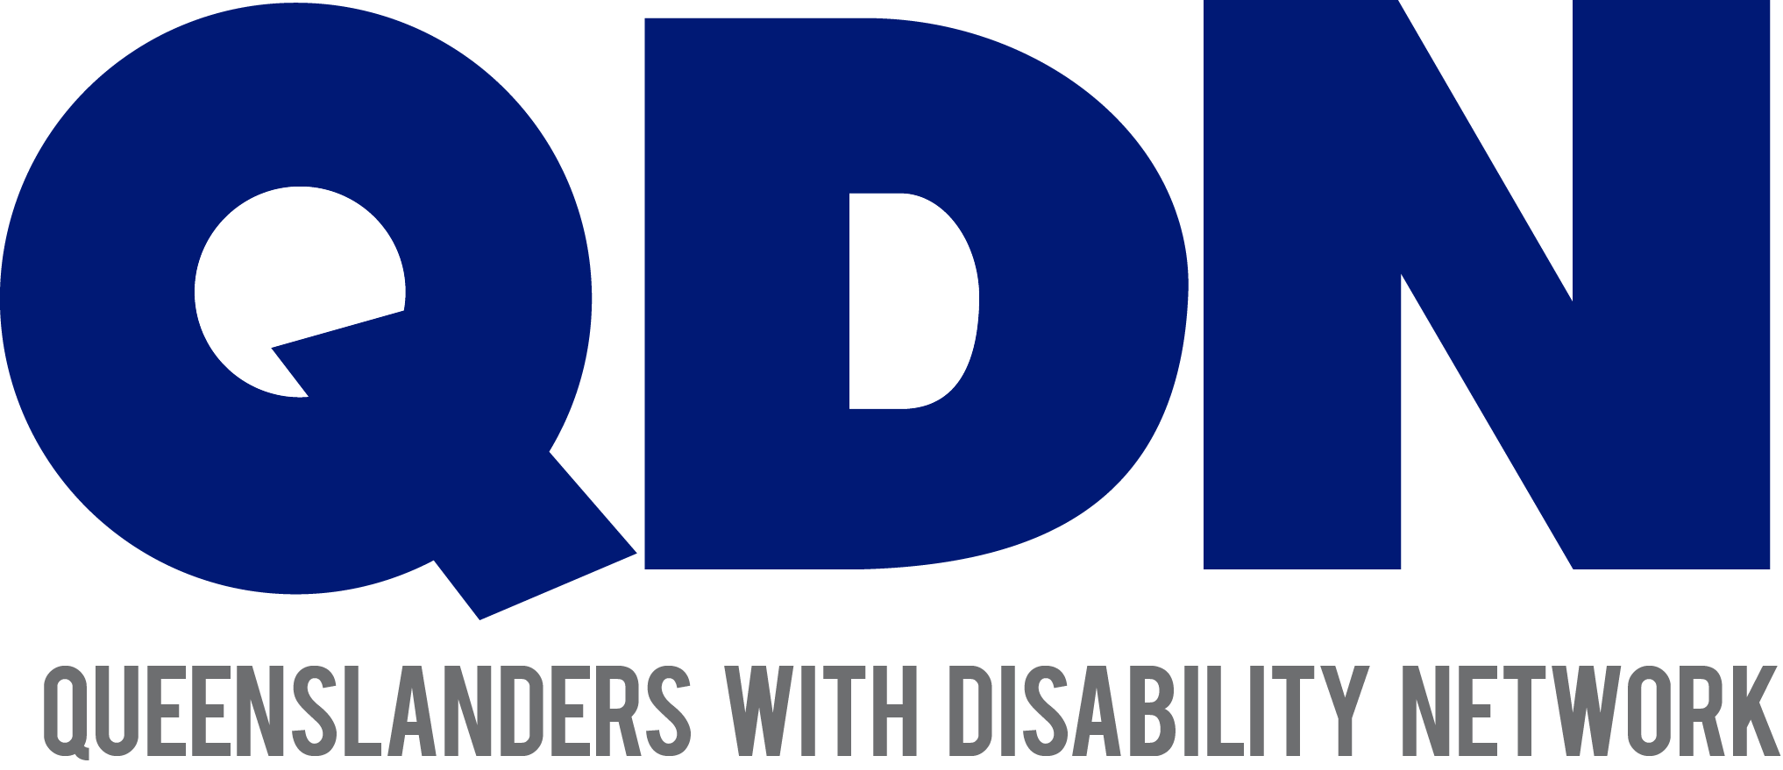

### What is the Co-Design Team?

The Co-Design Team will drive disability reform by creating and testing ideas that put people with disability at the centre of the process. You’ll work alongside specialists in facilitation, engagement design, and policy. The **Queensland Disability Stakeholder Engagement and Co-design Framework** establishes structures to put people with disability and stakeholders at the heart of reform processes through co-design.

### What Will You Do as a Member?

As part of the Co-Design Team, you will:

* **Create and Design**: Consider the issue, thoughtfully design the engagement, invite the participants and execute the plan.
* **Engagement**: Help facilitate workshops, focus groups, and discussions with people with disabilities, families, and other stakeholders state-wide.
* **Prototype and Test**: Take part in developing and testing new solutions, gathering feedback to make improvements.
* **Analyse and Recommend**: Review the feedback from testing and provide recommendations for improvement or scaling.
* **Ensure Inclusion**: Make sure all voices, particularly from underrepresented groups, are heard and included in the process.

### Who Can Apply?

We’re looking for:

People with lived experience of disability including people with disability from Aboriginal and Torres Strait Islander backgrounds and culturally and linguistically diverse backgrounds, people with disability living in metropolitan, regional, rural and remote communities, young people and older persons, and family members and carers.

### Remuneration

Members with lived experience of disability who are not attending as part of their working role will be remunerated for meeting attendance and meeting preparation in line with QDN sitting fees.

### Time Commitment

The Co-Design Team will meet monthly either online or in-person, with additional workshops or activities scheduled when needed. Members will be expected to contribute actively in discussions, workshops, and other co-design activities when available and within your field of interest.

### Why Join?

* **Make a Real Difference**: Be part of a team that’s shaping reforms for people with disabilities in Queensland
* **Collaborate with Experts and Community Leaders**: Work with a diverse group of people, including those with lived experience, sector professionals, and government representatives.
* **Develop and Learn**: Gain experience in co-design, service development, and testing real-world solutions.

### How to Apply

If you’re interested in joining the Co-Design Team, please submit:

1. A brief statement (maximum 500 words) telling us:
   * Why you’re interested in joining the Co-Design Team.
   * Your experience with disability.
   * What skills or insights you can bring to the team.
2. A current resume Contact details for two referees (optional).

Please submit your EOI to [admin@qdn.org.au](mailto:admin@qdn.org.au) by 14 February 2025.

### What Happens Next?

All EOIs will be reviewed by a selection panel, and shortlisted applicants may be invited for a follow-up discussion. We are committed to ensuring the Co-Design Team reflects the diversity of the community, and we welcome applications from a wide range of people and backgrounds.

For more information, please contact QDN at [admin@qdn.org.au](mailto:admin@qdn.org.au) or phone 1300 363 783.