|  |  |
| --- | --- |
| **2024 Annual General Meeting** | In blue, Q, D and N. In grey, Queenslanders with Disability Network. In pale blue, Nothing About Us Without Us. |

4 October 2024

**Dear QDN Members**

This cover letter has been prepared to help you understand the material you have been sent and guide you where to find any other information you may need.

Annual General Meeting

On Saturday, 9 November 2024, QDN will hold its Annual General Meeting (AGM). The 2024 AGM will be held at:

|  |  |
| --- | --- |
| **Location** | **Brisbane City Hall**, 64 Adelaide St, Brisbane, Queensland, in the Kedron Room |
| **Online via Zoom** | If you are unable to come to City Hall, you may join the meeting:   * by videoconference – please enter this link into your favourite web browser:   [**https://us06web.zoom.us/j/84175771392**](https://us06web.zoom.us/j/84175771392)   * or by teleconference (sound only) – please dial **07 3185 3730**, then enter **841 7577 1392 #** when you are asked for a Meeting ID. |
| **Time** | * Members Sign-in from 9:15 am to 10:00 am * Morning Tea from 9:15 am * AGM from 10:00 am |

The Notice of Annual General Meeting, annual financial report and minutes of the 2023 AGM accompany this letter.

*What’s in your pack*

Please find enclosed the following information for QDN members:

* Directions to the AGM venue (attached to this letter)
* Notice of Annual General Meeting and Agenda, including Annexures, Explanatory Notes and statements from the candidates for election (second in your pack on blue paper)
* Ballot form and voting instructions (third in your pack on green paper)
* Minutes of the 2023 AGM (fourth in your pack on yellow paper)
* Annual financial report (fifth in your pack on white paper)

You can find these additional resources online:

* VIDEO: Short video stories from the candidates for election
* An electronic copy of the Voting Form
* QDN Annual Report 2024 (after the 2024 AGM)
* Electronic copy of the annual financial report
* Member Code of Conduct

To access this material, go to the QDN website: <https://qdn.org.au/about-qdn/2024-AGM/>

You **MUST REGISTER YOUR ATTENDANCE BY FRIDAY 1 NOVEMBER**. When you register, please make sure you **PROVIDE YOUR EMAIL ADDRESS AND MOBILE NUMBER** in case we need to contact you urgently in the days leading up to the AGM or on the day itself.

You can register for the AGM one of three ways:

* **Go on-line** to [Home – Queenslanders with Disability Network (qdn.org.au)](https://qdn.org.au/)
* **Call us** on 1300 363 783, or
* **Email us** at [admin@qdn.org.au](mailto:admin@qdn.org.au)

You are welcome to bring your own support worker. QDN will provide support workers on the day. Please let us know if you have any access, personal care or other support needs.

QDN can provide limited transport assistance to members within south-east Queensland. If you would like to make use of this assistance, please contact the office.

If you wish to refer to the financial report at question time in the AGM, we request that you bring the hard copy of the financial report included in this pack to help QDN to be as cost efficient and environmentally friendly as possible. A small number of copies will be available on the day if required by members, however copies will be limited.

You are invited to contact us on **1300 363 783** or **07 3252 8566** or email [admin@qdn.org.au](mailto:admin@qdn.org.au) if you have further questions regarding your attendance at our AGM.

I look forward to seeing you there.

Kind regards

Michelle Moss

Chief Executive Officer

Queenslanders with Disability Network

In blue, Q, D and N. In grey, Queenslanders with Disability Network. In pale blue, Nothing About Us Without Us.

2024 Annual General Meeting

— Directions to the Venue

Map of location of Brisbane City Hall

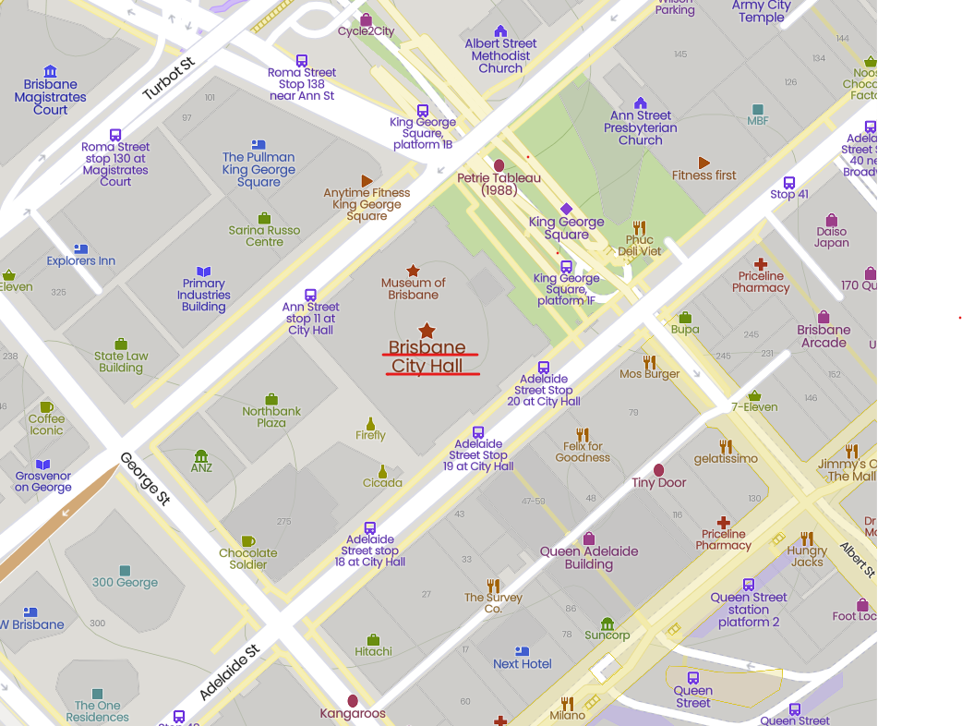

Brisbane City Hall is within easy distance of the bus stops, railway station and taxi stops. Please enter via the King George Square entrance: QDN will have staff members at this entrance to assist with directions.

Public Transport

You can catch a **bus** to Brisbane City Hall, and **trains** stop nearby at Central and Roma Street. Information about Brisbane public transport is available by calling Translink on 13 12 30 or visiting their website at [translink.com.au](https://translink.com.au).

Public Car Parking

There are a number of public car parking stations within the CBD (including one under King George Square) and metered street parking is also available.

V2 – 27/09/2024