|  |  |
| --- | --- |
| **2024 Annual General Meeting** | In blue, Q, D and N. In grey, Queenslanders with Disability Network. In pale blue, Nothing About Us Without Us. |

**Meet the Candidates**

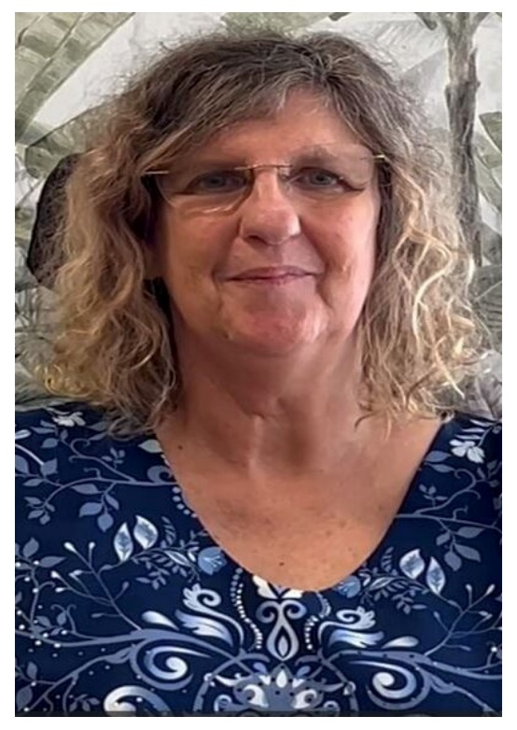

**Alison Barber**

My name is Alison Barber. I’m a mother of 3 young adult children and live with my husband of 37 years. Both of my sons live with multiple medical complexities and disabilities which, between them, has resulted in approximately 30 brain surgeries, living with hydrocephalus, acquired brain injury, both having gastronomies and being tube fed for the majority of their lives, in addition to being on different levels of the autistic spectrum.

Additionally, I personally acquired a C2 incomplete spinal cord injury in late 2019 and am now a permanent power wheelchair user. I believe the combination of my somewhat unique life experiences enables me to be able to represent multiple viewpoints with relation to the NDIS, and I pride myself in attempting to be the best advocate I can be, for those with both visible and invisible disabilities. As such, I am a convenor for the Caboolture Peer Support Group, a State Carer Representative for Carer’s Queensland, a member of the Statewide Spinal Cord Injury Delivery Service - Codesign Project, a founding member of University of the Sunshine Coast’s research Project into Technology Enabled Homes for People with Disability and am actively involved in numerous other disability and NDIS related projects.

I originally graduated university with a double degree in both primary and early childhood education. After working in this field for many years, I retired from teaching, when my husband and I established, owned and operated one of the first veterinary hospitals in Queensland. After a period of time, we made the decision to move to a very new business experience, owner operating an outdoor recreation school camp facility that was also open to the public for camping, in addition to running a variety of special events and weddings. Unfortunately, my sons’ medical complexities necessitated us relocating closer to the children’s hospital in Brisbane, and I spent many years homeschooling and raising our children.

I believe my combination of the above business and life experiences have combined to give me a unique skill set to bring to the Board of QDN. I am passionate about advocacy for all people living with disabilities, both visible and invisible. I have completed both state and national level media training through my work with Carer’s Queensland and have a wide range of experience in advocacy through my involvement with associations such as The Carer’s Foundation, Caring for Carers, my 20-year involvement with ABIQ and Autism Queensland and more recently, QDN. I feel experienced and comfortable with public speaking and in representing those who are unable to represent themselves.

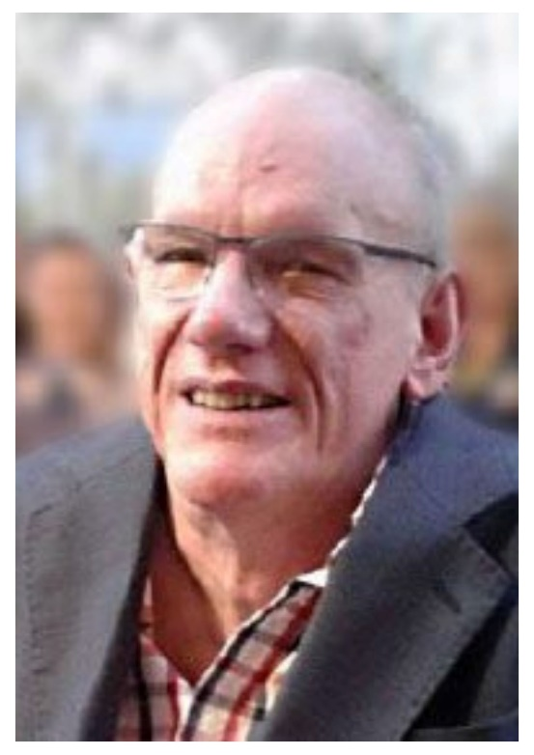

**Des Ryan**

Presently, I chair the Audit & Compliance Committee, previously chaired the QDN Board, and I was first elected to the Board of QDN in 2018. As well as QDN, I have been a board member of Spinal Life Australia since 1996 and President from 1999-2007, resigning in January 2018 and leading the transition from a community-based board to a mixed board with a diverse skill set from the business and corporate sector. I have a twenty-year history with not-for-profit boards in Central Queensland providing care services to people with disabilities or training.

My database development business, Abled Disabled, has been consulting throughout QLD since the early 1990s and has been in continuing employment for the same period with Community Solutions, supporting people with disabilities, and now as a Community Relations Ambassador. I hold an Associate Diploma in both Information Technology and Community Services Work. I was a recipient of the Rotary Paul Harris Fellow in 2000 and 2012, a Companion of Central Queensland University and a recipient of the Order of Australia Medal in 2013 for service to people with disabilities.

Personal highlights occurred in:

* 2001, supporting 23 Aboriginal and Torres Strait Legal Services across Queensland (every ATSICS Service in QLD) in the process of my part-time job
* 2008, honoured with a local landmark named after me – the Des Ryan Pier at Rockhampton’s Riverbank.

**What do I bring to the board?**

My experience of 50 years with a disability, surviving, still working, and enjoying life. I’ve luckily fitted within the constraints of the NDIS parameters so that I have a package of support. I have been able to build on my own experience of work so that I can self-manage my complete package.

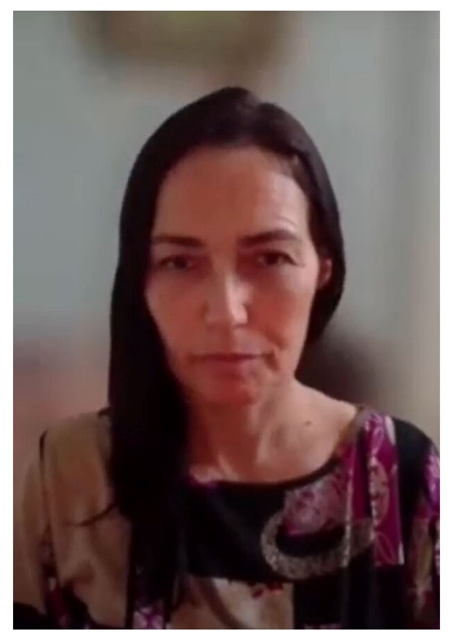

**Harmonie Downes**

I am applying to the board of QDN for the following reasons:

1. Personally, I have lived experience of disability, I have had low vision since birth and am a parent of a young adult with disability. I have been a carer of my sibling with a psycho-social disability in and out of the psychiatric system. I have direct experience in what has worked and what could be done better within the education, healthcare systems and in the employment sphere as an advocate and service user.

2. Professionally, I have worked in the disability sector for the past 15 years including as a sole trader supporting my community to grow their skills for socioeconomically benefit. I have done amazing things in my career including working on the national arts and disability strategy in November with Arts Access Victoria, I have piloted the first accessible public art tour with Arts ACT precovid, I have supported writing submissions to funders on what gaps they need to fill, I have co-designed programs too. I have delivered massive street festivals working from a ‘burn’ framework (accountability for self and others), have recently been a board secretary for 5 years including managing their finances writing treasurer reports, training volunteers, managing all sorts of events and projects (a very operationally driven board with no employees only contractors).

I currently work with Vision Australia to drive better employment outcomes for people who are blind and have low vision. I work in employment services. I have written millions of dollars of grant apps across numerous orgs for projects I have wanted to get going and can drive things from start to finish and then reevaluate and re-deliver.

3. Why QDN? I love the work seeing the community become fierce leaders, I have seen the work QDN in growing member capacity over many years. It is very intentional to see this process in all the QDN Engage work I have done to date. I can contribute knowledge on funders, networks, governance, marketing and grants. I like change so if you want someone to innovate / shift and help support this. I am comfortable to do this as well as consolidate and ground current work. I also will assist in elevating others who want support to do this work also. I have benefited from various consults and the Art of Hosting, which was held today, so perhaps it’s time to give back.

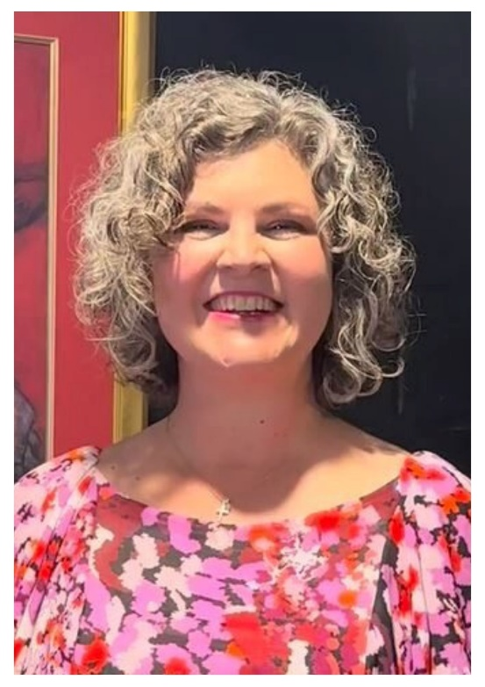

**Karen McCarthy**

I'm Karen McCarthy, a former lawyer, business graduate and keynote speaker on change and resilience, wife, and mother of two teenagers. I have lived experience of legal blindness and acquired brain injury, having incurred these disabilities in my mid-30s.

Over my career, I have demonstrated many of the professional skills the Board has identified, especially:

* expertise in governance, performance, and compliance;
* strategic thinking and policy shaping based on collective experience and evidence; and
* marketing, advertising, grant writing, and fundraising.

I also have also gained some experience in risk management and a basic understanding of auditing, accounting, and financial management.

If elected to the Board, I will bring strong analytical and critical thinking skills, as well as the commitment to sound governance, integrity and accountability that I've cultivated over a 20-year legal career.

Career highlights include 15 years at the Commonwealth Director of Public Prosecutions, where, as well as assessing briefs of evidence and prosecuting cases in court:

* I led a small team of lawyers - including practitioners who've gone on to hold judicial office - and had overall responsibility for their performance and professional development;
* Compiled a practice manual for an emerging area of law that was adopted by other jurisdictions; and
* Conducted liaison with police and investigative agencies who expressed a high level of satisfaction in client surveys.

After losing my sight, I continued my legal career with the Queensland Crime and Corruption Commission. My responsibilities were both outward-facing, in assessing complaints from the public and making recommendations for findings against police and public officers, and inward-facing, in giving advice to internal stakeholders concerning the operations of the Commission itself.

I know about the optimal safeguards for integrity and accountability, including how to manage actual and perceived conflicts of interest and the steps to minimise corruption risks.

I offer strong written and oral communication skills and a deep reserve of compassion, empathy and genuine admiration for the creativity and resilience of people with disability and their supporters. While I no longer practice law, I would welcome the opportunity to use my advocacy skills in a broader sense for the benefit of QDN and its members.

In the past, I have written successful grant applications for a community kindergarten and led fundraising activities for local schools, charities and community organisations. Since starting my speaker business in 2022, I have gained practical skills in marketing and advertising, including appreciating the value of a strong brand and the effectiveness of speaking to the clients' needs, rather than the solution you offer.

I'm endlessly curious, an excellent listener, a confident speaker, and an eager learner with a basic knowledge of the Art of Hosting and Harvesting Conversations That Matter. Through my own vision loss and ABI, I gained insight into the unique challenges faced by those whose life is affected by disability.

I would be honoured to serve as a director of QDN and commit to applying my skills to further the rights and interests of people with disability and the vision of QDN that there be nothing about us without us.

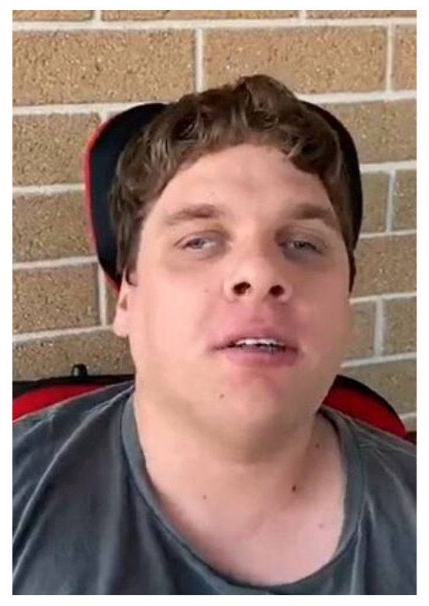

**Nathan Slachter**

Let me tell you a little about myself. I am a 31 year old male who has Cerebral Palsy. I live with wife Kerryanne and three cats in the garden city of Toowoomba. I was born and bred in Cranbourne, Victoria. Since May 2014 I have been a volunteer public speaker with Annecto Public Speakers Bank which is a disability advocacy organization. I have done a couple of years as a volunteer radio announcer on SYN Media. Throughout the years I have been involved in various podcasts and interviewed numerous people. I have also conducted speaking gigs through speakers bank with a number of school groups, universities and community groups.

I have lived experience with a disability having Cerebral Palsy from birth which gives me a unique perspective and extensive knowledge of what it is like navigating day to day life with a disability. I am a big advocate for people with disabilities having the same human rights as every other non-disabled person. For example, I believe that if someone with a disability wishes to lead normal life and get married and have children it is their right to do so. As a public speaker and former radio presenter I consider myself to be an honest, truthful and conﬁdent communicator and have no concerns expressing my point of view if needed in the role. These roles have also given me a can-do attitude and I consider myself to be a highly motivated and driven individual that just wants to get in and get the job done to the best of my ability.

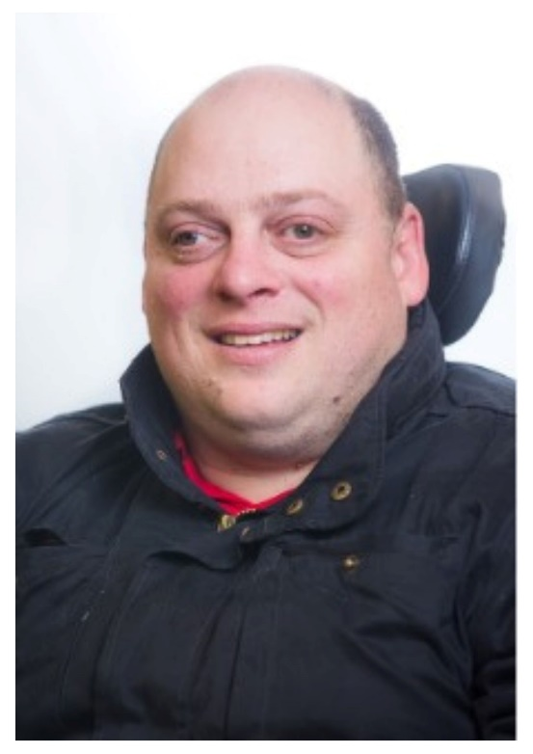

**Nigel Webb**

As you may know, I have been privileged to have been a past Director of QDN – June 2009 – October 2020. I was elected annually as Chair of the Board by its Directors between February 2010 until the AGM of October 2020.

I have been busy over the 4 years since leaving the Board role. I was again appointed to the Queensland Disability Advisory Council (QDAC) in September 2022. Subsequently, I was appointed as a Queensland Delegate of The Australian Disability Strategy Advisory Council (ADSAC) in June 2023/24 by the Minister/s.

I am employed by Choice, Passion Life as a Client Liaison Officer supporting 14000 clients throughout Qld & NSW.

With the final reports for the Disability Royal Commission and the NDIS review released with their respective recommendations, the NDIS Amendments Bill working through the respective Parliaments now, is the time that the voices of people with disability must be elevated more than ever and for QDN members and non-members to be actively involved.

I have been an active QDeNgage Consultant, a Housing Champion and a Peer Leader co-convening the NDIS Self-Management Peer group in recent years.

I am delighted to see the success of the Emerging Leaders program and the Leadership Bursary that QDN supports each year. The Peer Leaders and each group situated within their communities must be encouraged and must flourish.

I have good governance knowledge and diverse experiences to support QDN Directors and senior leadership personnel. I am humbled to have been awarded Life Membership by QDN Directors’ in October 2022.

I welcome the opportunity to be considered for a Directorship. I see a few challenges ahead with NDIS Needs Assessments, NDIS rules, Foundational Supports and State and Federal elections all to be revealed during the upcoming twelve months.

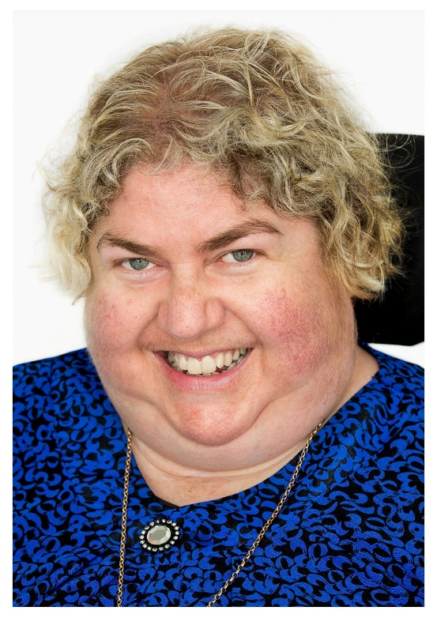

**Sharon Boyce**

My name is Sharon Boyce and I am currently the Chairperson of the board at QDN and I need your vote to continue in this role. Just to let you know a little bit about me and why it would be good for you to vote for me to continue on the board of QDN. I am experienced in working and understanding personal, Board and organisational performance. I am qualified as a graduate of the Institute of Company Directors and understand and practice good governance in everything that I and we do on the board. I have always demonstrated effective decision making processes across many areas and always operate with real transparency. I believe that our members should have good leadership and I love working across all the areas that we participate in as members of the board and as the leader of that board.

In my current position, together with the CEO, Michelle Moss, we have managed to successfully apply for a number of grants to enable us to continue as a strength-based organisation and I am proud to say we are now operating a $6 million budget. But what really matters to me is that we can do a good job in making people with disabilities lives better. I want to find out as much information as I can about what is currently happening and then share it to everyone who makes up QDN.

I am an author, educator and disability advocate. I work across a number of areas and perform many different roles. I aim to promote a true understanding of disability and diversity. Recent experiences with septic shock and intensive care stays have also led to a strong commitment to exploring issues of complex health needs and disability. I founded [**Discovering Disability and Diversity**](http://www.discoveringdisability.com.au/) and helped design the [**Discovering Disability and Diversity**](http://www.discoveringdisability.com.au/) experiential hands on Disability Awareness program which helps students and teachers and care, community and doctors and health workers experience and explore a wide range of disabilities, instead of just talking about them. I am skilled in planning and research.

My awards and recognition include:

* Received the Human Rights Award for Individuals 2008 for her contribution to creating inclusion across the Australian community,
* Honoured with the Queensland Regional Achiever Regional Service Award 2012, Regional Achievement and Community Awards.
* Awarded the Australia Day Regional Citizen of the year for work in awareness raising and creating inclusive communities (2013)
* YWCA – Top 125 Queensland Women Leaders (2013)
* Dept of Communities Local Hero Award (2015)
* University of Southern Queensland's Community Services Alumnus Award for (2016)
* USQ Alumnus of the Year Award (2016)
* Toowoomba Business Disability Award for Social Inclusion (2017)

I have experience and networks that will link with QDN to make our organization better and stronger. All members will be listened to and will have a voice and the opportunity to share their concern or ideas with me at any time. I am open and honest and believe in creating a fully inclusive world. I am the current chair of the Queensland disability advisory council and the independent advisory council for the NDIS. I can link all these areas and networks together and share ideas and communications across the sectors. We need to listen to people with disability and encourage them to have a strong voice and great ideas. I will do my best to ensure this always happens. I will advocate strongly and share ideas and ask for opinions of all members.

QDN is a great organisation and I hope you will give me your support to continue working as a director and with government and other disability organizations to make it even better. I understand disability policy and the processes behind governance and how to engage in best practice. I understand the legal obligations for the organization. We need rights and to have real choice and control of our lives. As a group we can make this happen. Please give me your vote and I will not disappoint you. Vote for Sharon Boyce the voice of Boyce! I will make sure that the members and QDN remain very strong in our current disability landscape.

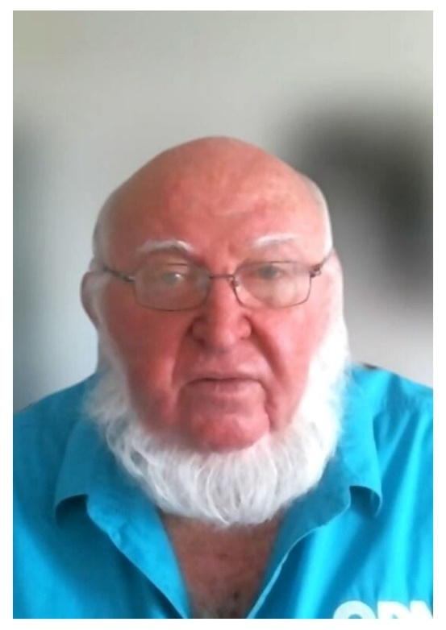

**Wayne Maitland**

My name is Wayne Maitland, I am 71-year-old Caucasian man, with a right leg above knee amputation and use an electric wheelchair for mobility. I am married to Marjorie and on 2 October this year it will be our 53rd Anniversary. We have two children (one deceased), 8 grandchildren and 2 great-grandchildren. I am the Cairns Convenor for QDN and have been for 8 years.

I commenced employment at Mulgrave Sugar Mill in 1971 and whilst in that employment, I worked impartially in a team environment as my employment consisted of me being a site Foreman and the Cairns Area Union representative. I continued in this role until 1992 in conjunction with starting my own business in 1984 (Convenience store} and expanding to a second business in 1996 (Steel Fabrication).

I had a fall in 2005, which resulted in my right leg, above-knee amputation and in 2010, I was diagnosed with advanced degenerative joint disease that meant I would be permanently in a wheelchair. At a meeting in 2011 in Cairns, about the introduction of the NDIS, my interest in the predicament of all people living with a disability began. After living most of my life as an active, independent, able-bodied man and suddenly experiencing the social and environmental injustices that people with disabilities experience every day, this meeting  
really struck a chord. In 2018 I completed a Diploma of Counselling, at Estrata College (AUST). During this time, I also participated in 12 months Lifeline Crises Support, manning a shift once a week. I also gained experience in Applied Suicide Intervention Skills Training.

I realised early in life, that I thrive on trying to drive positive changes in this chaotic world, using my personal skill set of team development, problem solving with team-oriented leadership, the ability to listen and learn from others, genuine connection, and most of all accountability and creditability.

I bring to the QDN board a comprehensive understanding of business (30 years Director / Partner), interpersonal skills and the shared experience of living with a disability (19 years). Having experienced both worlds, as an able-bodied and disabled person, I can use my work and life experience, of learning and training, to help others have a voice and make a difference.

V2 – 27/09/2024