# Submission – Disability Services (Restrictive Practices) and Other Legislation Amendment Bill 2024

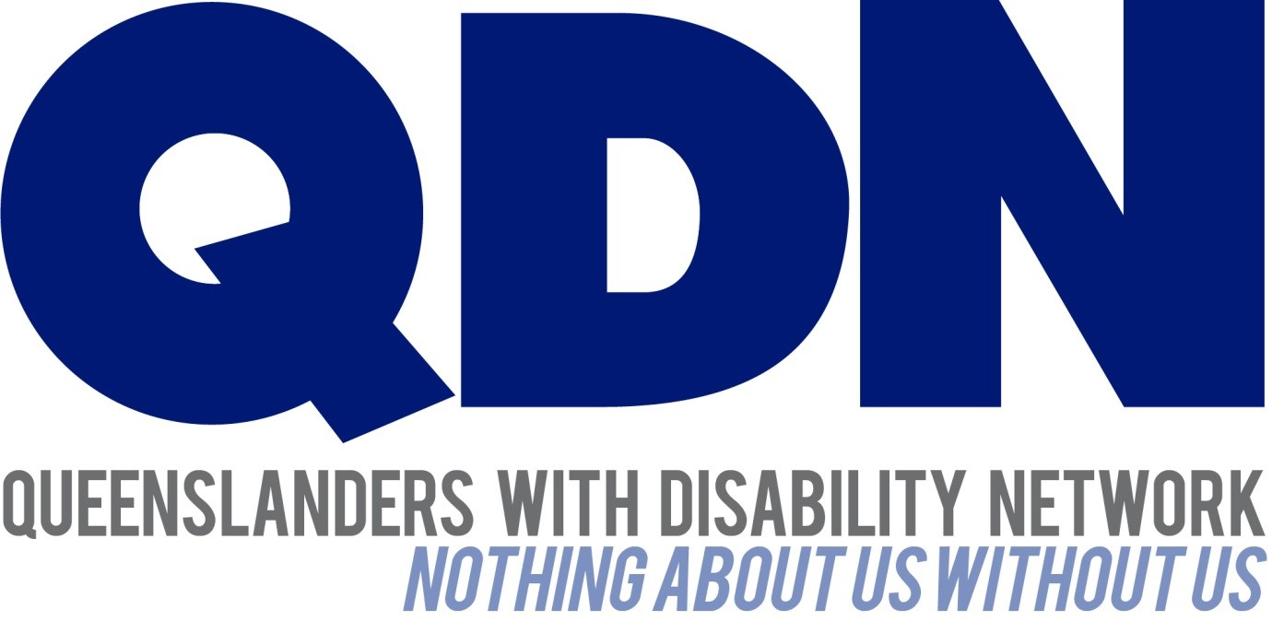

Submitted to the Community Support and Services Committee

July 2024

# About Queenslanders with Disability Network (QDN)

Queenslanders with Disability Network (QDN) is an organisation of, for, and with people with disability. QDN operates a state-wide network of 2,000+ members and supporters who provide information, feedback and views based on their lived experience, which inform the organisation’s systemic advocacy activities. QDN’s work is focused on the rights and full social and economic inclusion of people with disability, along with areas of key importance identified by Queenslanders with disability – the NDIS and mainstream services that people with disability rely on every day, including health, housing, employment and transport.

QDN members have actively engaged to provide feedback, input and their lived experience at the Commonwealth level including the Royal Commission into Violence, Abuse, Neglect and Exploitation of People with Disability (DRC), the National Disability Insurance Scheme (NDIS) Review and improving housing and support options for vulnerable people with disability. QDN commends reform to the use of restrictive practices. Fundamental to this is the authentic consultation and meaningful engagement of people with disability, their families, providers and the broader sector. We believe people with disability should always be at the table when decisions are made that directly impact their lives.

# Introduction

QDN commends reform to the use of restrictive practices and provided a submission to the 2022 consultation paper *Reforming Queensland’s authorisation framework for the use of restrictive practices in NDIS and particular disability services settings – Options for reshaping part 6 of the Disability Services Act 2006.* QDN was also engaged to conduct focus groups as part of the consultation process and is pleased to see the Disability Services (Restrictive Practices) and Other Legislation Amendment Bill 2024 (the Bill) aligns with feedback from these consultations.

QDN acknowledges the importance of quality and safeguarding and of getting the right balance to afford people the choice and control they need to live a good and ordinary life, alongside the measures and regulations to ensure the system is accountable and operates in a way that upholds the rights and well-being of the individual.

QDN believes that any reform and change process needs to include people with disability, families/carers from the outset in the planning, design, implementation, and evaluation process. Given the complex and changing nature of the NDIS and other systems, it will be critical that clear, accessible, practical information, and a co-designed communications strategy is developed to ensure people with disability and their families/carers are able to understand the changes, what they will mean for people with disability, and how they are going to be implemented.

Best practice approaches to delivering quality and safe services for people with disability also requires formal safeguards to have a person-centred organisational culture that reflects the voice of the people with disability. This is done by including people with disability in all aspects of the design, delivery, monitoring, and evaluation of services. Co-design supports continuous improvement and focuses on understanding and improving people’s experiences of services, as well as the quality of the services themselves.

People with disability need strong legislative frameworks to protect and uphold their rights regarding restrictive practices in a way that recognises that people are individuals with specific needs and life circumstances.

# Policy and reform context

QDN supports the underpinning of this reform by a human rights framework, including:

* Australia’s obligations to the *United Nations Convention on the Rights of People with Disabilities* (CRPD) to protect the rights, freedoms, and inherent dignity of people with disability and Queensland’s *Human Rights Act 2019*, and
* Australia’s *Disability Strategy 2021-2031*. QDN strongly believes this Strategy continues to have a sharp focus on building safeguards and quality services across the community.

QDN commends the Queensland Government for alignment with the *NDIS (Restrictive Practices and Behaviour Support) Rules 2018* and timely response to both the DRC and NDIS Review recommendations regarding restrictive practices through the tabling of the Bill including moves towards achieving the following:

* Key recommendations from The Final Report of the Royal Commission into Violence, Abuse, Neglect and Exploitation of People with Disability (DRC) on reduction of the use of restrictive practices. In particular the following as they relate to Queensland Government responsibilities:
* Recommendations 6.35 and 6.36 including State and Territory responsibilities for updating legal frameworks for the authorisation, review and oversights of restrictive practices and immediate action to provide that certain restrictive practices are not used across a range of settings.
* Recommendation 6.39 to support the Australian Institute of Health and Welfare collect and report on restrictive practices data and for definitions and collection methods to be finalised by the end of 2024.
* Recommendation 6.40 to establish sector-specific targets and performance indicators to drive the reduction of restrictive practices.
* Recommendation 6.41 to amend or enact legislation prohibiting non-therapeutic sterilisation of people with disability expect under certain circumstances by the end of 2024.
* The Independent Review of the National Disability Insurance Scheme (NDIS Review) final report’s three actions under Recommendation 18 including a joint action plan to reduce and eliminate restrictive practices, corrective actions against providers and support for providers to deliver on their role in reducing and eliminating restrictive practices.

# Authorisation Framework

QDN supports measures to prohibit certain forms of restrictive practices within service settings and that they be implemented only as a last resort after other least restrictive alternatives have been fully explored, and with appropriate authorisation and approvals.

QDN believes that people with disability and their families should always be actively involved and informed from the beginning in the assessment, plan development, and plan implementation and is pleased to see this reflected in the Bill.

QDN supports the Pure Clinical Model outlined in the Bill to provide a more streamlined authorisation process for restrictive practices and the establishment of a system that has a Senior Practitioner to carry out the functions of authorisation.

It is important that adequate mechanisms and safeguards are in place to ensure people with disability and their families are informed and are part of the planning process where restrictive practices are in place. This needs to be evidenced in some way through authorisation process that it has occurred.

This needs to be delivered in a way that ensures:

* all parts of the system work responsively together including timely responses of the NDIA to change of circumstances and processing of payments for providers
* skilled and experienced workforce in the positions to be making decisions and authorisations including operation from a person-centred human rights framework
* system of checks and balances to monitor quality and the decisions are being made in the best interests of the person and upholds their rights
* hierarchy of authorisations based upon the restrictive practice to be established, and levels of accountability and authority that have two-stage authorisation and decision making that means one person is not totally responsible for making a determination and authorisation
* a clear strategy to increase workforce capability and capacity to deliver on this including positive behaviour support, least restrictive alternatives, cultural competency, and trauma informed practice
* evidence informed practice and research is part of the role
* a clear communication strategy for people with disability and their families and community education strategy that is co-designed with people with disability and their families
* a specific communication and education strategy for disability service providers that is co-designed with people with disability and their families
* mechanisms to support State/Territories Practitioners/Officers to share knowledge, practice, and research
* clear and well-articulated pathways for people with disability and their families to raise reviews where plans are no longer adequate due to behaviour change (either increase or decrease in needs), to make complaints, and report issues
* Adequate resourcing that delivers timely responses and authorisations and does not leave people with disability and their families in a more disadvantaged position ‘waiting for Government’ to get back to them especially where time critical responses are required
* Notices and any relating communications to be provided to people with disability in a format they can easily access and understand.

QDN supports in principle the phased approach over a 24-month period for the development of positive behaviour support plans which are inclusive of containment and/or seclusion to be developed by specialist behaviour support practitioners in the open market. However, this needs to be reviewed at twelve and six months out to determine market capability to take on this role and Government needs to have a contingency plan around this. QDN also acknowledges the removal of the Chief Executive, Disability Services, to decide whether a multidisciplinary assessment will be conducted in the circumstances of containment or seclusion. QDN supports the need for multidisciplinary assessments where required, when conducting the functional behavioural assessment, to ensure a holistic approach to meeting individual need.

As people’s needs change there also need to be mechanisms in place to ensure timely responses to plan reviews where a person is an NDIS participant, and that these are adequately resourced. An effective, quality workforce and model of complex supports coordination continues to be needed. This could include clear escalation points from the Senior Practitioner to the NDIA to ensure integration and smooth and timely pathways.

QDN supports that the Senior Practitioner publish data on the performance of their functions, and that people with disability and families be involved from the outset in the planning, design, implementation, and evaluation of this. It is critical that this information be accessible to people with disability and families, with data collection and reporting reflecting the requirements utilised to inform continuous improvement.

# The role of the Queensland Civil and Administrative Tribunal (QCAT)

QDN supports the establishment of a mechanism that affords people a right of review of decisions around authorisation, and that the Bill stipulates QCAT have responsibility for this function as a review body. This is key to accountability. QDN members and supporters have raised a range of issues around decision making and authorisations and believe that the reform process and system that is developed needs to ensure independence and adequate skills, monitoring and oversight that is transparent and easy to navigate, and adequately resourced to ensure responsiveness.

# Reportable deaths in care framework

QDN supports all legislative reform regarding reportable deaths in care including the Bill’s policy objective to reinstate coverage for persons who received disability supports under the Commonwealth Government’s Disability Support for Older Australian (DSOA) program.

A Safeguarding Framework must be in place that includes an enquiry process when a safeguarding concern is raised for a person in care who has died to identify and protect other people who may be experiencing or at risk of abuse or neglect. The Safeguarding Framework must ensure learning and improvement in practice and be reviewed regularly.

# Implementation and transition

Formal safeguards have an important responsibility to ensure their communication resources support people with disability to better understand the practical application of their rights and what to expect from service providers. Without the foundational understanding of their rights, people with disability and their families are unable to make informed decisions on when and how to make a complaint or raise an issue.

QDN supports the safeguarding and expansion of the legislative framework to include authorisation for the use of restrictive practices to include children with disability while they receive NDIS supports, services or disability services from a relevant service provider. It is essential that providers are given adequate resourcing to ensure they meet the requirements of the Bill and that the NDIA fund individual plans in a timely manner to ensure the development of Positive Behaviour Support Plans as per the legislative requirements.

QDN recommends the implementation and transition team working across the Department of Child Safety, Seniors and Disability Services (DCSSDS), the Office of the Public Guardian (OPG) and QCAT consider investment in practical tools, resources, and information to build the capacity of people with disability, their carers and families. A specific sector implementation strategy will also be required to be developed. This will be integral to address some of the barriers preventing people with disability from understanding their rights and exercising their rights and enactment of the principles within the reformed framework.

# Conclusion

QDN supports the Bill to deliver a high-quality system that includes a nationally consistent user-friendly approach, underpinned by a human rights framework safeguarding people with disability. There are a range of issues that accompany this reform to be considered in the implementation and transition process, including critical workforce shortage and workforce development. Integration and application with other service systems is also critical to ensure smooth, streamlined and consistent support. Core to achieving this is the involvement of people with disability, families, and providers in the next stage of the reform to co-design implementation and transition.