# Submission – NDIS Provider and Worker Registration Taskforce

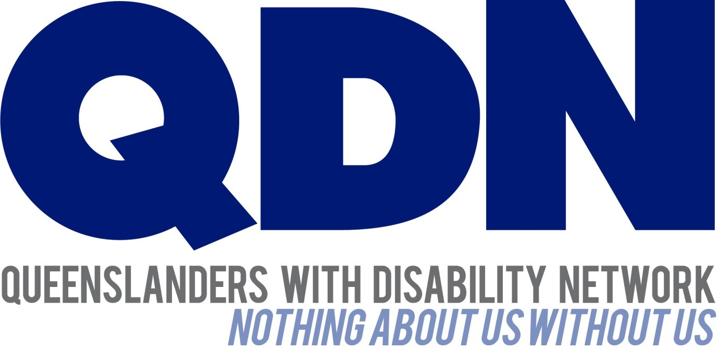

Submitted to NDIS Provider and Worker Registration Taskforce, Department of Social Services

May 2024

## Introduction

Queenslanders with Disability Network (QDN) welcomes the opportunity to make a submission to the National Disability Insurance Scheme (NDIS) Worker and Provider Registration Taskforce.

QDN’s work is focused on the rights and full social and economic inclusion of people with disability, along with areas of key importance identified by Queenslanders with disability – the NDIS and mainstream services that people with disability rely on every day, including health, housing, employment and transport.

QDN commends systemic reform to the NDIS. While Queenslanders with disability acknowledge the positive impacts of the NDIS, they also acknowledge that there is a need to improve the processes and outcomes for people with disability as end users. Fundamental is the authentic consultation and meaningful engagement of people with disability, their families, providers and the broader sector.

## QDN members and the NDIS

QDN is an organisation of, for, and with people with disability. QDN operates a state-wide network of 2,000+ members and supporters who provide information, feedback and views based on their lived experience, which inform the organisation’s systemic advocacy activities. QDN members have been informing the design of the NDIS since its inception over 15 years ago.

To date, the NDIS in Queensland has had a significant impact on the lives of over 138,000 Queenslanders with disability. For many people it is the first time in their life they have accessed disability support. However, many Queenslanders with disability including QDN members continue to experience challenges with not only access to the Scheme, but also as participants across varying aspects of the Scheme resulting in poorer outcomes.

While QDN acknowledges the positive impacts the NDIS has brought for many people, there has been a lack of investment in consumer rights capacity building for people with disability as end users of the scheme. Building the skills of people with disability to be informed and confident participants, to ensure that people with disability are able to successfully navigate the NDIS and are empowered to do so is crucial to success. Along with ensuring that people with disability managing their own plans are supported to self-manage and have accessible information and guidelines to empower them to continue with self-management.

Many people with disability have limited access to natural safeguards such as family relationships, peer support and community connections, particularly for those living in closed environments, regional and remote areas or without a strong network of support. Greater investment is needed in peer support, community access, community visitor programs and advocacy to reduce risk and support people to navigate systems.

QDN commends the work of the NDIS Review Panel and recommendations around addressing the gaps in oversight of providers, particularly when delivering high-risk supports.

QDN has undertaken engagement with our members to ensure the following feedback on the proposed model for worker and provider registration is informed by lived experience. This submission is also informed by Queensland’s current human services policy and legislative environment, the Disability Royal Commission and NDIS Review recommendations.

QDN acknowledges the diversity of people’s disability, people’s life experiences, decision making skills, abilities, formal and informal supports in people’s lives and the need for safeguards.

## NDIS participants who self-manage

QDN members who self-manage are service users, employers and service providers who have created innovative systems and solutions to meet their needs, goals and aspirations. These members have expressed concern about the provider obligation including for people with high-risk supports to enrol with the NDIS under Advanced Registration and go through an in-depth audit process.

Co-design with participants who self-manage to develop an enrolment model that is fit for purpose and proportionate is critical to uphold their rights, choice and control. The model needs to be adaptive to capture the innovative services and systems self-managed participants with high support needs have developed and use.

QDN recommends capacity building and supported safeguarding to build the skills of people with disability to be informed and confident participants who understand how to assess risk, what to ask for if at risk and have access to supported decision-making as required when deciding on providers.

## NDIS participants living in regional and remote Queensland

NDIS participants in very remote regions have limited access to support as the ratio of providers to participants is lower. In areas with thin markets participants are not able to choose a provider or change from one provider to another if they are unsatisfied with their current service provision.  The impact of the proposed model in regional and remote areas must be gauged and place-based approaches taken to registration requirements and what strengthening regulation looks like in those regions.

A one-size fits all approach is not appropriate for remote areas and smaller regional towns where a health provider or Aboriginal Community Controlled Health Organisation may be the only provider to deliver health, aged care, community and disability support services. There is a reluctance for these organisations to add further compliance burden. QDN is concerned unregistered providers in regional and remote areas will leave the market if they are unwilling to step into the NDIS registration process or the process is too onerous. Recognising compliance in similar regulatory systems such as aged care would reduce the risk of providers leaving the NDIS.

Where the market has failed completely to deliver support to people with disability there needs to be a provider of last resort, which ensures there is a safety net of service provision and support for those who need it. A provider of last resort will also provide safeguards against people being at risk of abuse, neglect and exploitation (both physical and financial) and contribute to eliminating any twin pricing regime, exacerbated by limited provider choice in regional, rural and remote areas. This issue has failed to be resolved and people continue to fall through the cracks.

Many Aboriginal and Torres Strait Islander peoples in regional and remote communities provide support for relatives and community members. There are systemic barriers for Aboriginal and Torres Strait Islander peoples in registering as support workers or service providers such as lack of trust in Government systems including the disability worker screening process. This ongoing issue has not been resolved despite efforts at respectful engagement in communities to raise awareness, build capability and address workforce supply.

There is a need for continued place-based workforce strategies where thin markets exist to prioritise disability awareness training, quality standards in service delivery, cultural awareness training, and skills development and strategies.

## Unregistered providers

In response to the proposed levels of registration and enrolment, QDN members have expressed concern they will lose trusted providers who are currently unregistered sole traders or smaller organisations in the transition to registration or enrolment. The option to choose providers that best suit budget and goals regardless of registration is crucial and life changing.

QDN has heard reports of the many benefits of using unregistered providers including:

* Quality supports from trusted providers
* More consistency in support staff, choice of workers and greater flexibility of shifts compared to experiences with registered agencies where different workers are sent to provide support
* Supporting local businesses for cleaning and gardening services and having greater choice in these services
* Cost savings in purchasing the same brand equipment and medical supplies, faster delivery and better service
* Better quality and cost savings in general across many service types.

QDN members are concerned costs associated with registering as a provider will be passed on to participants.

The design of Provider and Worker Registration will need to examine data on why participants use unregistered providers and the benefits to people who self-manage to inform the design. The voices of NDIS participants are crucial to conversations around preferences for unregistered providers and quality and safety of both registered and unregistered providers.

Concerns around the need for registration also stems from unregistered providers stating they do not want to go through a registration process and are now seeking other market opportunities. QDN sees that the importance of strategic communication about the proposed model will be critical to maintain and grow the care and support workforce particularly in regional areas where there are already less service provider options in thin markets.

Whilst there are benefits to the proposed levels of registration in terms of risk reduction and increased training of support workers, greater clarity and communication is urgently needed for the unregistered provider market about where they sit in the model and the benefit of registration to their business and to the clients they work with.

QDN members are also concerned regulation will drown out the few tailored supports for people with intersecting experiences of discrimination or violence. This could include, specialised counselling services by providers not currently NDIS registered, advocacy and peer support groups that address the unique needs of women, LGBTQIA+ and people from other marginalised gender identities.

Provider registration has not resulted in greater quality supports or prevented the abuse of people with disability. As recommended in the Disability Royal Commission Final Report (Recommendations 10.11, 10.25) stronger monitoring mechanisms need to be implemented including stronger compliance and enforcement activities for NDIS providers and increased face-to-face engagement with participants at greater risk of violence and abuse. Introducing independent reporting and monitoring mechanisms will also play a role in better outcomes for people with disability. Community Visitor Schemes should also be improved and nationally consistent (Recommendation 11.12).

## Worker Screening and Training

QDN is pleased to see a focus on training for the NDIS workforce in the proposed model. QDN members have raised the need for the NDIS workforce at all levels to have greater access to training and for ongoing professional development to be a requirement of their role. Training should include an understanding of the social model of disability, disability rights and the barriers and discrimination still faced by people with disability. The right training would reinforce quality service delivery.

The disability workforce shortage has meant that people who self-manage or are plan-managed have had to hire people who have never worked in the disability care sector before and have no qualifications. Many members who self-manage have developed their own training for support workers with no subsidy. QDN members suggest it would benefit both support workers and NDIS participants to have access to free training – in the style of a short course – that would cover off on the basics of disability support work.

Additionally, many members would like to be able to offer their support workers professional development but find it difficult to understand what training is practical, reputable and affordable. Offering quality training and professional development is an attraction and retention strategy to address the current national workforce shortage.

Training must be co-designed and facilitated by people with disability. Training and worker screening must be subsidised to reduce the cost for services providers and the risk those costs will be passed on to participants. People who self-manage should also be subsidised for the training they develop and facilitate for their support staff.

## Recommendations

QDN makes the following recommendations to ensure the proposed model upholds the rights of people with disabilities, including the right to live independently and be included in the community, be free from violence, abuse, neglect and exploitation, have an adequate standard of living and economic and social participation.

**Co-design an approach to enrolment for NDIS participants who self-manage** that is fit for purpose and proportionate particularly for participants with high-risk supports so that they can feel confident in continuing to self-manage.

**Supported safeguarding to build the skills of people with disability to be informed and confident participants** who understand how to assess risk, what to ask for if at risk and have access to supported decision-making when deciding on providers. Transparency and information sharing is a critical part of skilling participants, particularly in the context of self-managed plans. 

**Invest in consumer rights capacity building and a central place to raise the issues and seek help as a consumer** (not related to safety and/or service provision) for participants so that they better understand their rights in relation to purchasing services and products under the NDIS. This capacity building and awareness raising needs to include a range of inclusive information channels.

**Consultation and engagement in regional and remote Queensland** to assess the impact of the proposed model and co-design place-based approaches to addressing thin markets and local area safeguarding mechanisms.

**Targeted alternative commissioning models** in thin markets co-designed with people with disability and include community-based supports. Any commissioning approaches should include participant involvement in the commissioning process and elements of choice and control as much as possible.

**Recognise compliance and reduce duplication in similar regulatory systems** for providers working across disability, aged care and other service provision particularly in regional and remote areas.

**Implementation of Disability Royal Commission Final Report Recommendations** 10.11, 10.25 and 11.12 to ensure stronger compliance and monitoring mechanisms in the NDIS and improvement of Community Visitor Programs.

**Set up a provider of last resort scheme** recommended in the Disability Royal Commission to ensure there is a safety net of service provision and support where markets have failed in regional and remote areas to safeguard against abuse, neglect and exploitation.

**Continue to support place-based workforce strategies in regional, remote and rural areas** and where thin markets exist, but where this is not working, review impact and outcomes to identify different models of service delivery that ensure equity of access to supports.

**Undertake data collection and comparative analysis on the use of registered and unregistered providers from NDIS participants** to gain further understanding of the market from a user point of view. In particular, tailored NDIS supports for people with intersecting experiences of discrimination or violence.

**Develop and implement a communication strategy** targeted at unregistered providers and people with disability to communicate the benefits of registration to both providers and participants. The strategy should be co-designed with people with disability who use unregistered providers and their providers.

**Co-design worker training** with people with disability and engage people with disability to facilitate training.

**Subsidise people who self-manage for training** they develop and facilitate for their support staff.

## Conclusion

QDN thanks the NDIS Provider and Worker Registration Taskforce for the opportunity to provide this submission. QDN looks forward to working with the Taskforce on a model that upholds the rights of people with disability and maintains choice and control for NDIS participants.