Queensland Disability Stakeholder Engagement and Co-Design Strategy

User friendly version

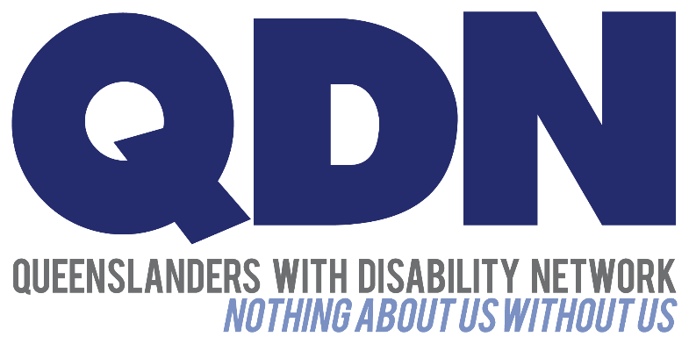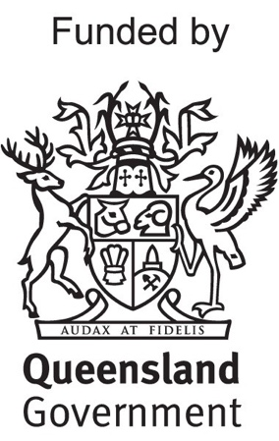

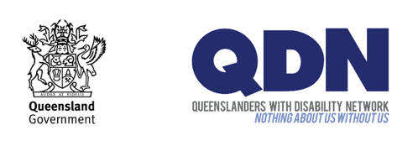The Queensland Government and Queenslanders with Disability Network (QDN) are working together.

They are working on the Queensland Disability Stakeholder Engagement and **Co-Design** **Strategy**. We call this document the Strategy.

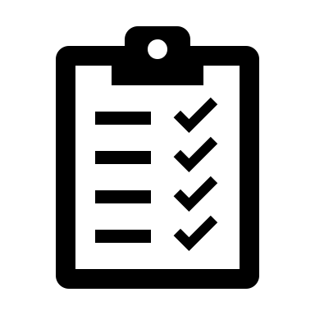

A strategy is a plan to help complete a goal.



This Strategy is the plan to deliver on the **Queensland Disability Reform Framework** in partnership with people with disability.



The Queensland Disability Reform Framework (the Framework) is a plan by the Queensland Government.

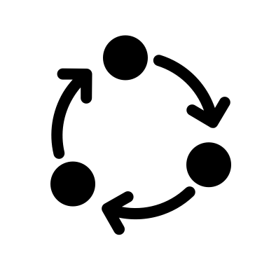

The Framework shows how the Government will put the ideas from the Disability Royal Commission and NDIS Review into action.

We call these actions **disability reforms**. These are the changes that will happen to make better services and systems for people with disability.

***Reform***

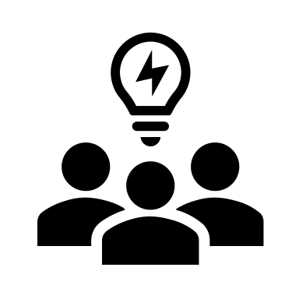

This Strategy is about how people with disability will **co-design** the disability reforms.



**Co-design** is a process of people working together.

The Strategy has 5 key areas:

* Governance
* Disability Engagement and **Co-Design** Hub
* Collaboration and **co-design**
* Capacity building
* Data collection and assessment



This document will help you understand the Strategy.



In this document we are going to explain each key area.

# 1 - Governance



**Governance** is the rules people make about how they work together.

The governance of the Strategy is about:

* how people will work together
* how reports will be written
* how people will make decisions



As part of the Strategy, a Disability Reform Implementation Stakeholder Committee will be formed. We will call this **DRISC** for short.



**DRISC** is a group of people that will come together to do a job.

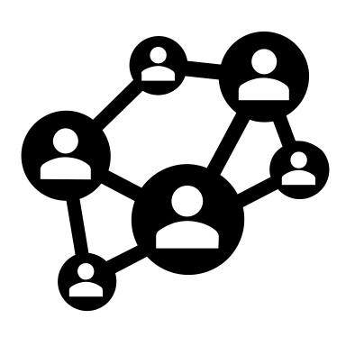

**DRISC** will include:

* people with disability
* disability advocacy organisations
* service providers
* peak bodies
* community organisations
* Government



Hearing from all these groups will help bring together different points of view.

DRISC will:

* give advice to the Government
* oversee **co-design** work
* support disability reform in Queensland.

# 2 - Disability Engagement and Co-Design Hub



The **Hub** is a place where people come together to meet and work together online and in person.

The **Hub** is for people to:

* design and test disability reforms
* have their say about disability reform activities
* give feedback about disability reforms

The **Hub** will help people to work together to do good **co-design**.



The **Hub** is for:

* people with disability
* families and carers
* disability advocacy organisations
* service providers
* Government



Lots of different people with disability will be involved:

* Aboriginal and Torres Strait Islander peoples
* women
* children and young people
* LGBTIQIA+ people
* people from culturally and linguistically diverse backgrounds
* people living in regional, rural and remote places

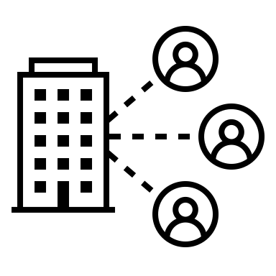

The **Hub** will work with important groups in the disability community.



The skills and knowledge of disability advocacy organisations will be an important part of work we do together.

The **Hub** will do lots of different things.

This will include

* bring people together to **co-design** and share ideas and solutions.
* sharing information about reforms.
* helping people learn about **co-design**.

# 3 - Collaboration and co-design approaches



**Collaboration** is people working together.

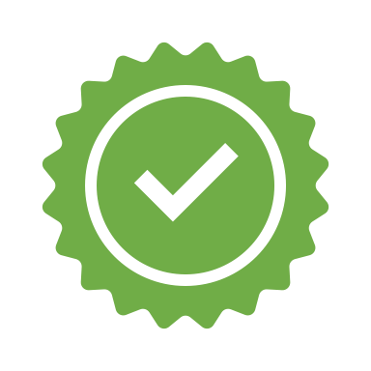

The Strategy focuses on the best way of working together.

**Co-design** is inclusive and brings together:

* Government
* industry
* business
* community organisations
* people with disability and their families and carers

# 4 - Capacity building



**Capacity building** is about teaching you and making your skills better.



The Strategy is focused on the skills of:

* people with disability and their families and carers
* Government
* disability advocacy organisations



The **Hub** will teach about co-design to help build on people’s skills.

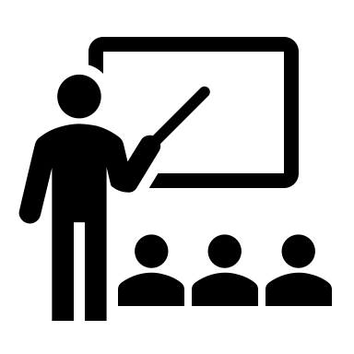The activities will be:

* workshops
* community engagement forums
* online Community of Practice
* online information with research and stories, case studies and resources.

# 5 - Data collection and assessment



**Data** is facts and statistics that help people understand if something is working.



We will work to gather good data.



This will help us to know the Strategy is working.

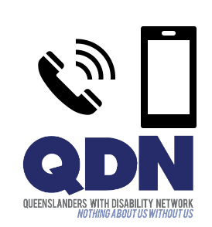

If you have any questions, contact QDN:

* Call 1300 363 783
* Email [qdn@qdn.org.au](mailto:qdn@qdn.org.au)