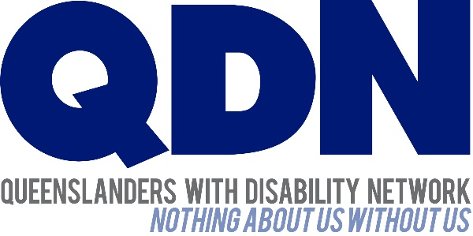

Committee Secretary

Senate Standing Committees on Community Affairs

PO Box 6100

Parliament House

Canberra ACT 2600

17 May 2024

Dear Committee Secretary,

Queenslanders with Disability Network (QDN) is pleased to provide this response to the National Disability Insurance Scheme Amendment (Getting the NDIS Back on Track No 1) Bill (the Bill). QDN is an organisation of, for, and with people with disability. The organisation’s motto is “nothing about us without us”. QDN operates a state-wide network of over 2,000 members and supporters who provide information, feedback and views from a consumer perspective to inform systemic disability policy and disability advocacy.

To date, the NDIS in Queensland has had a significant impact on the lives of over 120,000 Queenslanders with disability. For many people it is the first time in their life they have accessed disability support. The NDIS is key to enabling people with disability to participate fully as citizens within Australian society, increase social and economic participation and ensure people with disability can exercise their human rights and we anticipate these reforms will address many of the systemic issues faced by people with disability.

As indicated in the NDIS Review Final Report, the NDIS is part of a complex ecosystem of supports for Australians with disability, and it is critical that we improve the NDIS for the 10% who directly access individual supports through the scheme, and concurrently, the gaps in services and support for all Australians with disability through mainstream and foundational services and support.

This consultation has been initiated at a time when significant changes and reforms are impacting all areas of the disability sector, including outcomes of the Royal Commission into Violence, Abuse, Neglect and Exploitation of People with Disability (DRC) and National Disability Insurance Scheme (NDIS) Review. QDN acknowledges the need for NDIS reform and subsequent legislative changes to support this. Engagement and consultation with people with disability, their families and carers along with the disability sector is key to getting good policy and legislative frameworks.

It is disappointing that this did not occur with Queenslanders with disability prior to the introduction of this Bill. QDN thanks the Committee for this inquiry and the opportunity to provide input and feedback from the perspective of Queenslanders with disability and looks forward to further opportunities to engage with the Commonwealth Government on the Bill.

Yours sincerely,

Michelle Moss   
Chief Executive Officer   
Queenslanders with Disability Network

# Submission - The NDIS Amendment (Getting the NDIS Back on Track No. 1) Bill 2024

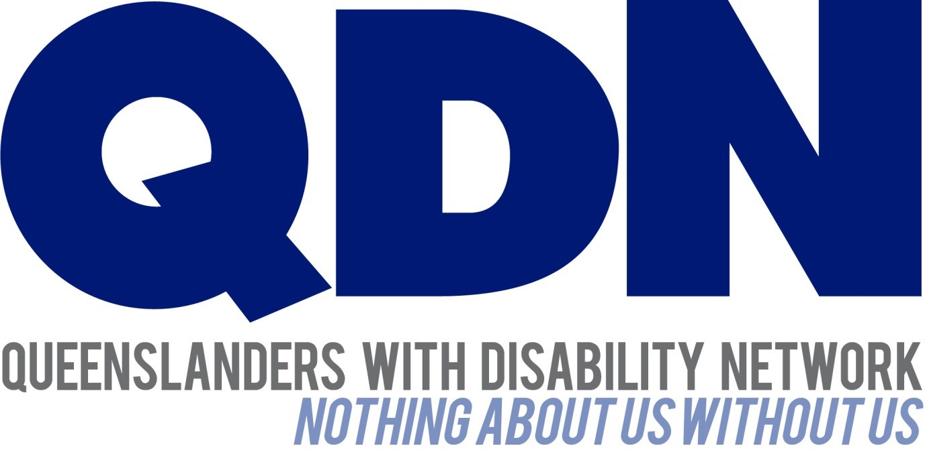

Submitted to the Community Affairs Legislation Committee May 2024

Contents

About Queenslanders with Disability Network (QDN) 2

Introduction 2

Key concerns 3

1. Lack of co-design and consultation 3

2. Lack of clarity and support for NDIS participants 4

3. Determining budgets 4

4. New definition of NDIS Supports 5

5. Foundational supports 6

6. Early interventions 6

7. The NDIA will have too much power 6

Recommendations 7

Conclusion 8

## About Queenslanders with Disability Network (QDN)

Queenslanders with Disability Network (QDN) is an organisation of, for, and with people with disability. QDN operates a state-wide network of 2,000+ members and supporters who provide information, feedback and views based on their lived experience, which inform the organisation’s systemic advocacy activities. QDN has worked with members around the NDIS for over 10 years since its introduction and has been actively involved in the design and formation prior. QDN’s work is focused on the rights and full social and economic inclusion of people with disability, along with areas of key importance identified by Queenslanders with disability – the NDIS and mainstream services that people with disability rely on every day, including health, housing, employment and transport.

QDN members have actively engaged to provide feedback, input and their lived experience at the Commonwealth level including the Royal Commission into Violence, Abuse, Neglect and Exploitation of People with Disability (DRC), the National Disability Insurance Scheme (NDIS) Review and improving housing and support options for vulnerable people with disability. QDN commends systemic reform to the NDIS. While Queenslanders with disability acknowledge the positive impacts of the NDIS, they also acknowledge that there is a need to improve the processes and outcomes for people with disability as end users. Fundamental is the authentic consultation and meaningful engagement of people with disability, their families, providers and the broader sector. We believe people with disability should always be at the table when decisions are made that directly impact their lives.

## Introduction

QDN welcomes consultation to the National Disability Insurance Scheme Amendment (Getting the NDIS Back on Track No. 1) Bill 2024. The Bill proposes the most significant changes to the NDIS since it started more than a decade ago. QDN acknowledges the need to reform NDIS processes and amend the legislative framework to support these changes. However, QDN does not support the Bill proceeding in its current form and QDN members have expressed concerns with the Bill which are outlined in this submission.

QDN members have raised concerns around the timeframe for implementation of this Bill, which relies heavily on a strong and robust foundational support service system, and equitable, inclusive and accessible mainstream services that meet the needs of people with disability, no matter where they live or their life experiences. Unfortunately, these assumptions are not met in the current environment, with the legacy of a pre-NDIS foundational support system that was essentially cashed out and has relied on short-term competitive grant funding processes through Information, Linkages and Capacity Building. There has been no strategic nor consistent approach to how this program as tier 2 of the broader functions of the NDIS has been implemented over the last decade, which leaves a disjointed and non-existent foundational support service system that needs to be designed and developed.

QDN acknowledges the importance of this foundational support service system and the impact it will have on the hundreds of thousand Queenslanders with disability who currently are not able to access basic disability supports to meet their fundamental needs. This means that there is no safety net in place and therefore no safeguards if this legislation is implemented without clear timeframes, guidelines and implementation plans with States and Territories to ensure people with disability will not be worse off and will not fall through the cracks and gaps.

QDN members believe it is important that the Bill has a clear focus on improving participant outcomes and experiences and understands the need for scheme sustainability, but this should not be at the expense of the human rights of Australians with disability to access essential disability supports.

Queenslanders with disability have experienced fatigue and impacts of a decade of change and reform and have expended energy and hard work to become informed customers of the NDIS system and ensure they effectively operate within its boundaries. Despite this, they are willing and committed to continuing to work and co-design the reforms needed to deliver a world-class disability service system in Australia that achieves the original goals and outcomes of the scheme.

## Key concerns

### Lack of co-design and consultation

The changes proposed in the Bill will affect fundamental aspects of the NDIS. Despite this, the Bill was tabled in Parliament without sufficient consultation or co-design with the disability community nor specifically the Queensland disability community. The current process has not allowed adequate time for consultation and is missing significant details and accompanying materials to enable appropriate review or understanding of the Bill by the disability community*.* QDN acknowledges there was some engagement with National Representative Organisations, however, co-design with current participants, disability advocates, activists and lawyers may have resulted in a broader understanding and socialisation of the Bill given its complexity and complicated accompanying explanatory notes, which has required individual organisations to try to break this down into more user-friendly and understandable language to enable people with diverse disability the opportunity to engage with it. Conducting consultation with the disability sector after introducing legislation can and has led to mistrust by some members of the disability community and contradicts the foundations of the NDIS to uphold, promote and centre people with disability. The NDIS Review and DRC Final Reports recommended that policy changes must be made by and with people with disability. In addition to this, the Bill was tabled without consulting with state and territory governments which concerns QDN. State and Territory Governments have a clear role and responsibility as financial contributors to the scheme alongside the responsibility they have to their constituents with disability. QDN believes it is critical for good governance and good government that State and Territory governments have an important role as decision makers and processes need to afford them the opportunity to fulfil this function.

### Lack of clarity and support for NDIS participants

The Bill currently does not provide any supports to transition new NDIS participants to the new pathways, understand and undertake assessments and reassessment processes, access funding and manage new plans*.* QDN is also concerned that existing NDIS participants will be required to undergo an assessment to determine disability status and support need requirements, and that this assessment could happen at any time following the commencement of the Bill. QDN members have expressed their anxiety about the uncertainty they feel. QDN members continue to raise the current operational and policy issues that impact upon their ability to engage effectively as NDIS participants and get their needs met. It is critical that these are resolved.

### Determining budgets

#### Lack of clarity and details about the needs assessment tool and method used to determine budgets

QDN members have expressed concern over the lack of detail for the needs assessment tool and how it will function as the current available information does not say what evidence will be required or what this tool will look like. Of particular concern to QDN members is what re-assessment of a 5-year plan will look like, particularly if people’s needs or circumstances change, which can happen unexpectedly, and whether NDIS participants will have a choice of medical professional to undertake their needs assessment or if this will be a decision made by the NDIA. Neither the Bill nor Explanatory Memorandum provide information about what the re-assessment process will look like. Greater clarity is needed around NDIS participants choosing a medical professional to undertake their needs assessment. QDN members have also expressed concern over the lack of available information about the method proposed to determine NDIS participant budgets. Of particular concern to QDN members is how this method will address the current gap for people with disability experiencing homelessness or people with disability who do not have an address, and how the needs assessment tool will work for people who are neurodivergent or have psychosocial disability. It is unclear what opportunity people with disability will have to have input into this. Whilst QDN acknowledges the Bill needs to be legislated for these functions, there is a need for further clarity around these functions and co-design processes to understand the impact of the Bill.

#### Failure to achieve a ‘whole of person’ approach

QDN members are concerned the proposed needs assessment tool and method may fail to achieve a ‘whole of person’ approach by implementing distinctions in how people with multiple and interrelated disability access the support they need. The Bill proposes amendments which will require NDIS participants to separate their impairments against the access criteria to get NDIS supports for their whole disability. QDN members are concerned the new needs assessment tool will be similar to independent assessments, which were inappropriate. Additionally, the changes in the Bill do not connect the needs assessment only to impairments tested against the access criteria. Meeting the criteria means relying on extensive medical evidence for each diagnosis. This will significantly disadvantage many people with disability who have multiple diagnoses or complex disability and NDIS participants who transitioned from the State systems or entered the NDIS based on one impairment.

#### Concern needs assessments will not be a reviewable decision

It is not clear in the Bill what an NDIS participant can do if they wish to seek a review of the outcome of a needs assessment, however, the DSS website states “where a participant identifies that the assessment report does not accurately reflect their needs and circumstances, they can request that a new needs assessment be conducted as part of the review application”[1]. QDN members are concerned they will not be able to challenge an inappropriate needs assessment. QDN recommends this is added to the Bill. QDN members have highlighted that this is a disproportionate level of power given to the Agency to be able to request alternative assessments, and it is not clear if a review is afforded to NDIS participants if there is something that is incongruent with their needs, disability and diagnosis due to ineffective or inaccurate assessments.

### New definition of NDIS Supports

#### Lack of clarity over NDIS Supports

QDN members are concerned about the lack of clarity and details about the definitions of NDIS supports, and how the new definitionof NDIS supports will impact them. Of concern to QDN is that the NDIS supports are not benchmarked against all elements of the United Nations Convention on the Rights of Persons with Disability (UNCRPD). Additionally, QDN members have expressed concern that the eight new categories of supports outlined in the Bill will be too restrictive, and people who need alternative support including behavioural support, will be unsupported. The Bill clarifies what disability-related supports participants can use their NDIS funding for, as set out in the current NDIS Rules and the Applied Principles and Tables of Support (APTOS).

#### Concern that APTOS is not fit-for-purpose

The Bill states that until the new Rules are written, the NDIS will use the APTOS to decide what will be funded by the NDIS and what will be funded by state and territory governments. The APTOS principles were initially written as broad policy guidance for governments and QDN is of the view that they were never intended to be inserted into legislation, and in some places are very unclear and difficult to apply. The NDIS Review found that APTOS has failed and recommends replacing APTOS with a new multilateral schedule (see Action 2.6) under the new Disability Intergovernmental Agreement (see Action 20.1). Using APTOS could result in a situation where NDIS participants are not receiving a type of support they need, because it is either not clear or not stated if the NDIA nor the state and territory governments are responsible for providing that type of support. QDN does not consider the APTOS principles fit-for-purpose and does not support APTOS being used as an interim measure. QDN recommends further consultation with the disability sector to co-design an alternative interim measure.

### Foundational supports

QDN is concerned that the Bill proposes NDIS participants receive supports outside of the NDIS from service systems that have not been developed yet. QDN does not support the introduction of ‘early intervention’ or ‘disability’ access pathways without a service system that is co-designed with the disability sector and governments. Additionally, the foundational supports system requires resourcing and priority of all governments, before legislation creates pathways of referral. QDN members have expressed particular concern over how the government will address gaps for people with psychosocial disability and chronic conditions, and what the introduction of Foundational Supports would mean for them. Critical to foundational supports is peer support, peer mentoring and peer education. As a member-led and member-driven organisation, the role of peers and leadership of people with disability is paramount to effectively implementing the reforms of the NDIS and the DRC as we move forward. This needs to be adequately resourced and supported within a foundational support service system alongside capacity building for people with disability and families and carers. This is long term developmental work that has had to rely on short-term competitive grants. People with disability are key to leading and influencing change in our communities to deliver a more inclusive and accessible Australia.

### Early interventions

QDN members are concerned early interventions will impact the ability of children with disability, people with Autism, and people with psychosocial disability to access life-changing support they need through the NDIS, and that the early intervention pathway will not deliver supports that meet their needs. It is critical that there are no unintended consequences and implications of this policy and any potential legislative change that changes the trajectory for these cohorts and means that their access to essential services is diminished or removed.

### The NDIA will have too much power

#### Too much control exerted by one party to a joint Scheme

The Bill proposes provisions that give considerable decision-making power to the Commonwealth Government. QDN does not agree with the inclusion of heads of power in the Bill that create a foundational supports system, without the system first being developed.

Under the new provisions, the Commonwealth Minister for the NDIS would have unilateral decision-making powers over several critical aspects of the NDIS. These include determining the criteria for new framework plan assessment, specifying which classes of participants will require new framework plans, setting the duration of these plans, deciding on the total funding amounts, and overseeing state support and transitional arrangements. These decisions are fundamental to the operation of the NDIS, directly impacting current and future participants' ability to access services and supports, secure appropriate funding, manage expenditure, and ensure accountability. Given the NDIS is a collaborative initiative between the Commonwealth, state, and territory governments, it is concerning to QDN that the Bill delegates considerable policy and operational decision-making authority to the Commonwealth diminishing the role and influence of states and territories. Similar to other Rules and regulation-making requirements, there should be mandatory obligation for the Commonwealth to consult with states and territories when making legislative instruments.

#### Concern about particularly vulnerable people with disability

QDN members have raised that the NDIS Bill diminishes the choice and control of NDIS participants. In its current state, the Bill gives significant power to the NDIA, which if applied without a human rights framework could be hugely detrimental to people with disability. QDN holds concerns these powers will particularly impact people with disability who are least able to navigate the system including people who are homeless, people fleeing domestic and family violence, and those with limited access to health care.

#### Concern over 28-day timeframe to provide information or documents to the NDIA

The Bill proposes giving the NDIA new powers to request information or documents from NDIS participants and suspend or revoke their plans when the participant does not provide this information. The Bill states that participants will only have 28 days to provide evidence to the NDIA if requested. QDN does not believe this is an acceptable timeframe. QDN members have long reported extremely long wait times to see their healthcare providers, inaccessible healthcare facilities, no available public transport or other way of travelling to appointments, unaffordable healthcare providers, or lack of healthcare services where they live. These issues are compounded in regional, rural and remote Queensland. Whilst QDN acknowledges that participants can request more time, many do not know or have the capacity to navigate the system and QDN believes this might leave some people with disability, particularly vulnerable cohorts, at risk of having their plans suspended unfairly.

## Recommendations

The following recommendations are based on the work QDN has undertaken on the NDIS over the past 10 plus years, QDN members insights and current disability reforms and are underpinned by a human Rights based approach and framework, co-design principles, person-centred principles, and the UNCRPD:

1. Extend the Bill’s consultation period in order to engage in genuine co-design and consultation with the disability community.
2. Develop the NDIS Rules and determinations in close consultation with the disability sector.
3. Co-design the needs assessment tool with the disability sector.
4. Work in partnership with all the states and territories, particularly around design of Foundational Supports.
5. Co-design with the disability community around the operation of Foundational Supports.
6. Introduce additional requirements before the Minister can make determinations.
7. Amend the Bill where necessary to ensure unilateral decision-making powers are not enabled.
8. Ensure significant changes to the Bill are phased in slowly with appropriate commencement and transitional supports.
9. Ensure the NDIS Rules are accessible, user-friendly and provide the appropriate guidance.
10. Ensure NDIS budgets enable participants to access assistive technology, repairs, and updates and are included in participant plans.
11. Amend the Bill to ensure it is clear that NDIS participants are able to review the outcome of needs assessments.

## Conclusion

QDN thanks the Community Affairs Legislation Committee for the opportunity to provide this submission to the National Disability Insurance Scheme Amendment (Getting the NDIS Back on Track No. 1) Bill 2024 [Provisions]. QDN and its members look forward to further consultation and engagement regarding the Bill.

1. The NDIS Amendment Bill – questions and answers, Australian Government Department of Social Services, [The NDIS Amendment Bill - questions and answers | Department of Social Services, Australian Government (dss.gov.au)](https://www.dss.gov.au/disability-and-carers-programs-services-ndis-reforms/the-ndis-amendment-bill-questions-and-answers#:~:text=The%20NDIS%20Amendment%20Bill%20-%20questions%20and%20answers,to%20review%20rights%20under%20the%20new%20planning%20framework%3F) Accessed 17 May 2024.