
Australia’s Disability Strategy
2021–2031

State and Territory Forum

Queensland

19 June 2023
ISBN: 978-1-920851-54-5 (online)

This document, Queensland State Forum Report 19 June 2023, Australia’s Disability Strategy, licensed under the Creative Commons Attribution 4.0 International Licence, with the exception of:
- Australia’s Disability Strategy 2021-2031 logo and branding
- Any third-party material
- All images and/or photographs.
More information on this CC By license is set out at the Creative Commons website: https://creativecommons.org/licenses/by/4.0/legalcode

Attribution
Use of all or part of this document must include the following attribution:
© Commonwealth of Australia (Department of Social Services) 2023
Enquiries about copyright arrangements and any use of this information can be sent to the Department of Social Services:
By email: copyright@dss.gov.au
By post: Communications and Media
Department of Social Services
GPO Box 9820, Canberra ACT 2601
If you are deaf or have a hearing or speech impairment, you can use the National Relay Service to contact any of the Department of Social Services listed phone numbers.
TTY users — phone 133 677 and ask for the phone number you wish to contact.
Speak and Listen users — phone 1300 555 727 and ask for the phone number you wish to contact.
Internet relay users — visit the National Relay Service at https://www.communications.gov.au/what-we[1]do/phone/services-people-disability/accesshub/national-relay-service
Aboriginal and Torres Strait Islander people are advised this publication may contain images or names of deceased people.
Web links, telephone numbers, and titles correct at the time of publication. They may have changed after publication.
DSS Product Number - DSS3117.12.23

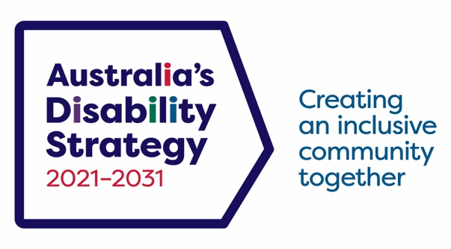
Table of contents
Executive Summary 4
Introduction 8
Panel 1: Employment and Financial Security 10
Panel 2: Inclusion in action 15
Panel 3: We all have a role to play 18
Appendix 21

Executive Summary
The Department of Child Safety, Seniors and Disability Services in collaboration with the Department of Social Services and Queenslanders with Disability Network (QDN) hosted the first Australia’s Disability Strategy 2021-2031 (ADS) state and territory Forum (the Forum) on 19 June 2023 at the Brisbane Convention Centre. These Forums provide an opportunity for people with disability to play an active role in shaping the implementation of ADS. At least one public forum or consultation will be held to support the implementation of the ADS every year from 2022 to 2031.
The Forum included 3 panel sessions and celebrated Queensland’s achievements and ambitions across each of the 7 Outcome Areas of ADS and Queensland’s Disability Plan 2022-27: Together, a better Queensland (Queensland’s Disability Plan).
The day began with an Acknowledgment of Country from Uncle Willie Prince and Cody Skinner.
The Queensland Minister for Child Safety and Minister for Seniors and Disability Services,
the Hon Craig Crawford MP, opened and closed the Forum. The Commonwealth Minister for Social Services, the Hon Amanda Rishworth MP, addressed the forum via a pre-recorded video message.
The Forum featured keynote presentations from Professor Bruce Bonyhady AM (Co-Chair, NDIS Review) and Dr Sharon Boyce (Chair, Queensland Disability Advisory Council). Both Professor Bonyhady and Dr Boyce emphasised the motto ‘nothing about us without us’ and the years of driving inclusion for people with disability undertaken by the Queensland Disability Advisory Council, QDN and the broader disability community.
The Forum facilitators and speakers provided diverse insights from leaders in the disability community, government, business, healthcare, and education. This approach reflects the Forum’s key theme that we all have a role to play in successfully delivering ADS and Queensland’s Disability Plan.
In addition to the formal policy presentations and discussions, the Forum reflected Brisbane’s reputation as a creative hub by showcasing performances by Queenslanders with disability. This included a film screening, comedy sketches, and music recitals.

Overarching themes
Throughout the Forum we heard four key recurring themes from participants, raised across multiple sessions and table discussions:
- Co-design and co-production with people with disability is critical to achieving the vision of ADS and Queensland’s Disability Plan.
- We all have a role to play in making Queensland and Australia more inclusive for people with disability; many speakers emphasised the value of cross-sector partnerships and collaboration.
- Queensland has compelling case studies of inclusion that could be adopted by other jurisdictions (for example, in the areas of emergency management and criminal justice).
- The 2032 Olympics and Paralympics in Brisbane provide a focus point to help Queenslanders come together and showcase to the world what can be achieved in disability inclusion.

Panel 1: Employment
Key ideas expressed during this session included:
- Skills and labour shortages are severe and projected to get worse.
- Employers are using technology to create new employment opportunities for people with disability.
- Employers need more help to fully utilise the skills of people with disability.
- We need more creativity and ambition from government and employers in employment targets for people with disability.
- Pay people with disability award wages.
- The transition from university to employment needs more attention.
In his address to close the Forum, Minister Crawford returned to these themes and outlined conversations he has had with departmental staff about what could be done to bring down barriers for people with disability in applying for roles in Child Safety.

Panel 2: Inclusion in Action
This session focused on success stories of inclusion in action. Queensland has already delivered some impressive innovations and programs.
The Forum heard how disability inclusive disaster risk reduction can save lives. In Queensland, people with disability, government, police, emergency services, and academic experts have collaborated to ensure the diverse needs and vulnerabilities of the disability community have been considered at all stages of the planning and preparation process for disasters.
The Forum also heard how new approaches to justice are keeping young First Nations people with disability out of detention and prison. Synapse has an innovative pilot in Far North Queensland which has identified that nearly all young First Nations people appearing before Magistrates have unsupported disability needs (especially for those with acquired brain injury). The pilot pairs young people with a community elder who shares the responsibility for ensuring they comply with any Orders made by the Court.

Panel 3: We all have a role to play
This session focused on the roles different sectors are playing to achieve the vision of ADS and Queensland’s Disability Plan.
QDN Chief Executive Officer Michelle Moss reinforced a theme from the Forum that engaging people with disability in co-design and co-production is the most efficient and effective way to achieve the vision of Queensland’s Disability Plan and ADS:
“I can tell you that there's thousands and thousands, maybe even over 1 million people with disability in this state who are ready and willing to be engaged in those conversations and take their place at the table to help and support and deliver on inclusion for Queensland. So I encourage you all to think about how that looks and what that could be in your workplaces, in your working, in your communities and look at what that role is to play.”

Next steps, monitoring and timelines
The next Forum will be held in 2024. The program will include recapping key themes from the National Forum held in November 2022 and the Queensland State Forum. It will review whether governments have implemented the many ideas and suggestions provided by participants at those Forums.
During 2023 and 2024, Australia’s Disability Strategy Advisory Council will consider the key themes and suggested actions from the National Forum and Queensland State Forum in more detail and make recommendations on policy priorities, implementation options and timelines to the Disability Reform Ministerial Council.

Introduction

Australia’s Disability Strategy 2021-2031
At the heart of Australia’s Disability Strategy (ADS) is a commitment to create inclusive communities that call on all Australians to ensure that people with disability can participate as equal members of society. Consistent with the United Nations Convention of the Rights of Persons with Disabilities, it commits all Australians to realising the fundamental freedoms and human rights of people with disability.
ADS was developed in collaboration with people with disability, their families, carers and representatives and all levels of governments through more than 2 years of consultations and engagements. Further information on ADS is available on the Disability Gateway.
The seven Outcome Areas in ADS set out where governments, working with people with disability, communities and business, will focus on driving improvements for people with disability. The Outcome Areas are the areas people with disability have said need to improve to achieve an inclusive Australian society.
Queensland’s Disability Plan is consistent with the vision and outcomes of ADS. It provides a blueprint for action tailored to Queensland’s unique strengths and context.

The Queensland State and Territory Forum
At least one public forum or consultation will be held to support the implementation of the ADS every year from 2022 to 2031. The Australian Government and state and territory governments will alternate hosting duties of the forums.
The first State and Territory Forum was held in Brisbane on 19 June 2023, bringing together people with disability to discuss the implementation of ADS and Queensland’s Disability Plan. The Forum included people with disability, business and education leaders, service providers and community representatives, with 224 people attending in-person and 150 people attending virtually.
The Queensland Minister for Child Safety and Minister for Seniors and Disability Services, the Hon Craig Crawford MP, opened and closed the Forum. The Commonwealth Minister for Social Services, the Hon Amanda Rishworth MP, addressed the forum via a pre-recorded video message. There were also keynote presentations by Professor Bruce Bonyhady AM (Co-Chair, NDIS Review) and Dr Sharon Boyce (Chair, Queensland Disability Advisory Council).
There were three panel sessions that covered Queensland’s achievements and ambitions across each of the seven Outcome Areas of ADS and Queensland’s Disability Plan.
The event was designed and delivered by the Queenslanders with Disability Network (QDN) on behalf of the Queensland and Australian Governments.
Consistent with the Forum’s theme – that we all have a role to play in changing what it means to be a person with disability – the session facilitators and speakers comprised diverse leaders from the disability community, government, business and education.
In addition to the formal policy presentations and discussions, the Forum showcased Brisbane’s reputation as a creative hub with performances by Queenslanders with disability. This included a film screening, comedy sketches, and musical interludes.

Purpose of this Report
This report summarises the discussions at the Forum across the three panel sessions. It aims to provide readers with an understanding of the key topics discussed by the panel at each session. The report also provides key actions raised in the employment session, for governments to consider and focus their implementation efforts.

Panel 1: Employment and Financial Security
This session highlighted case studies of employers increasing employment and financial security for people with disability – one of the ADS Outcome Areas. It also identified actions that would help reproduce these successes on a larger scale.

With severe skills and labour shortages there is an opportunity to lift the employment of people with disability, benefiting workplaces and communities
Leaders representing diverse sectors of the Queensland economy highlighted that the state is experiencing severe skills and labour shortages. These shortages are in cities and regional areas. They also explained that factors such as the ageing population mean these shortages are projected to worsen.
As a result, many sectors and employers in Queensland are looking to identify fresh talent pools. Employers are thinking not just about how they fill shortages, but who they employ to fill them – including people with disability. Sharing best practice case studies can help businesses learn how to employ people with disability, how to become employers of choice for people with disability, and how to future-proof their workforce.
Workforce diversity brings broader opinions, experience and inputs which can lead to increased productivity. The Australian Industry Group noted inclusive teams make better decisions 87% of the time. And they make those decisions faster.

Employers are utilising technology to create new employment opportunities for people with disability
Several speakers presented case studies explaining how new and emerging technology is eliminating barriers to employment in sectors where people with disability have been under-represented and under-utilised.
For example, one industry leader from the manufacturing sector described how robotics and automation is enabling people with disability to work offsite and operate machinery remotely. This innovation removes real and perceived risks around occupational health and safety.

Employers need more help to fully utilise the skills of people with disability
Several industry leaders called for greater support to help employers remove unintended barriers and create more employment for people with disability. This applies especially to eliminating barriers from recruitment and role description, for example writing job ads that identify pragmatic characteristics for the role. It is also essential to make recruitment accessible using forums such as webinars or expressions of interest through social media platforms.
Organisations also need leaders with lived experience of disability. Pathways to leadership require investment in the capacity and leadership potential of people with disability. Ensuring workplaces are inclusive will also allow people with disability to rise to leadership positions.
The panel highlighted that industries are changing. For example, there is a perception that working in manufacturing requires certain physical attributes. However, the future of manufacturing won’t necessarily rely on the ‘traditional roles’ of the past. It will be in the space of digital technology and automation. Many roles in the future will allow people to work from home.

We need more creativity and ambition from government and employers
The Chief Executive Officer of Deaf Connect highlighted the importance of inclusive cultures, including people with disability in leadership positions and explained how disabled people’s organisations are showing what can be achieved through focussing on cultural change.
About 45% of Deaf Connect’s workforce identify as people with disability. This increases to 60% at senior executive level.
Deaf Connect provides an example of how ambitious and creative culture change can help organisations maximise the benefits from diverse workforces. Its Chief Executive Officer described how all corporate communication is provided in bilingual formats (i.e. Auslan as well as print).

Pay people with disability award wages
A standout from the session was a case study presented by Woolworths Australia on a pilot that re-assessed the productivity of employees previously engaged under ‘supported employment’ (i.e. people with disability paid less than award wages because they were assessed to be less productive). Woolworths deployed a person-centred reasonable adjustment process to redesign work roles and ensure that its employees had all the support needed to perform their work as well as possible. It then determined that 85% of the employees participating in the pilot were capable of earning full award wages.

The transition from university to employment needs more attention
Policy Priority 2 for this Outcome Area is an improved transition from education to employment for young people with disability. One university leader focussed attention on the under-representation of people with moderate or severe disability in higher education and called on universities, TAFEs, employers and disability service providers to work together to close the gap in employment outcomes between graduates with disability and other people.
Less than 5% of people with disability get into university, and that decreases to only 1.5% for people who have severe disability. Partnerships with industry and the education sector will help to improve these numbers.
More funding is required to support students with disability complete their degrees. There has been 160% growth in students with disability at university but only 22% growth in funding to support those students. Health (both physical and mental) issues are reported as the main reason for students dropping out.
Employment outcomes are 10% lower for graduates with a disability than they are for graduates without a disability. Better programs are required to improve career readiness. Universities would benefit from input from industry and alumni with disability on how to reform and co-design a career readiness system for students with disability.

Actions discussed to focus on during ADS implementation

General
- Take full advantage of the skills and labour shortages in the economy to increase employment and financial security for people with disability.
- Utilise new and emerging technology and reasonable adjustment to overcome real and perceived barriers to people with disability working in manufacturing and other non-traditional sectors.

Policy Priority 1: Increase employment of people with disability
- Invest in more supports enabling employers to dismantle unintended barriers created by recruitment practices and job design.
- Increase opportunities for people with disability to take on leadership positions, as they have the ability to inspire opportunities for other people with disability.
- Demand that public sector employers be more creative in their approach to employing people with disability, as illustrated in Minister Crawford’s closing address where he discussed taking recruitment of people with disability to the next level, going beyond a job ad that says "people with disability may apply".

Policy Priority 2: Improve the transition of young people with disability from education to employment
- Create new partnerships between higher education providers, employers and disability service providers to close the gap in employment outcomes between graduates with disability and other people.

Panel 2: Inclusion in action
This session provided case studies of how Queensland is empowering people with disability to make systems and services more inclusive and effective.

Disability inclusive disaster risk reduction will save lives
The Forum heard that people with disability have historically been at much greater risk from natural disasters, but this is changing through Queensland’s application of disability inclusive disaster risk reduction.
“It's about making sure that people and their support needs are at the centre of emergency management planning, response and recovery. If we want to make sure that people with disability are safe, well and alive in emergency situations, we need to make sure that they are included from the very beginning. And we need to change our policies and our practices to align with that inclusion goal and safety and wellbeing outcomes.”
Queensland has undertaken this work through a co-production process which involves people with disability, emergency services, government and service providers “of all types and stripes” who provide services and supports in the community. Critical to its success has been the role of QDN, government leadership and community engagement and support so people are aware, capable and prepared for emergencies.
Through peer support and mentoring, QDN led a co-design process to develop a suite of resources for person-centred emergency preparedness.
It can be difficult to think about how to create preparedness plans. The peer support model helps people to feel welcome and have a sense of belonging in the group. This is important because people need to feel safe when they are having conversations that can be quite confronting. People with disability might need to navigate disaster preparedness in the context of multiple service providers, different types of equipment, and different contingencies that need to be put in place.

New approaches to justice are keeping young First Nations people with disability out of criminal justice and should be built on
The Forum learned about a restorative justice initiative in Far North Queensland, operated by Synapse, that is helping to deliver a key Safety, Rights and Justice Outcome, under ADS and Queensland’s Disability Plan:
“We've been operating in Cairns on this particular project for a couple of months and this is what we found. Every person that has appeared before the court either has a brain injury, cognitive impairment or an undiagnosed disability. So far none of those participants before the court with a disability has ended up with custodial sentence. That's equality before the law. That's about ensuring that people who actually present who have difficulty following those Court-ordered obligations are encouraged and supported in how to do that. So how do we do that? The cultural authority of our old people. Matching people up… We go to old people. If we have a young member before Cairns magistrate, let's say he's 25, he comes from a particular community, we will do that peer to peer matching, find someone a little bit older or an Uncle who will go with him. Our mob, our people will pick that boy up and take him to do his work, what he has to do [as ordered by the Magistrate to avoid imprisonment].”

Actions discussed to focus on during ADS implementation
- Co-design is a critical success factor to inclusion in action and works best when people with disabilities are involved from the beginning to the end.
- There is an opportunity to build on Queensland’s successes in emergency management and new approaches in safety, justice and rights, both in Queensland and other jurisdictions.

Panel 3: We all have a role to play
This session provided perspectives from leaders in diverse sectors about how we can all help to deliver the outcomes articulated in ADS and Queensland’s Disability Plan.

Health providers are developing Disability Action Plans and linking more effectively with other service providers
Queensland is building on lessons learned from the COVID-19 pandemic – especially with respect to delivery of health services in the home – and is undertaking co-design with the disability community to ensure needs are met.
The five pillars of this work are:
- Equity of access – the right care at the right time at the right place (including in the home).
- Helping health professionals to better understand what people with disability need (including by increasing employment of people with disability at Queensland health services).
- Ensuring healthcare is well coordinated and that people with disability can exercise choice and control over care.
- Empowering people with disability to integrate family and other supports into the care they receive in the health system.
- Ensuring that health services are safe and welcoming for people with disability (e.g. limiting restrictive practices, ensuring there are quiet spaces).
The theme of employment continued in this session, noting that employing people with disability in the health sector will make health workers (and workers in general) more confident in how to deal with different situations so they can cater for people with diverse needs.

The real estate sector is becoming more disability-confident
Emphasising the value of partnership and co-production, the Real Estate Institute of Queensland (REIQ) showcased how they are reducing barriers for people with disability wanting to purchase or rent a home:
- Education – REIQ has developed products to help property managers, landlords and tenants better understand the protections applying to people with disability. For example, REIQ is proud of its work educating the community on the difference between a pet and an assistance animal.
- Service redesign – REIQ also presented information about its efforts to adjust processes so they are easier for people with disability. For example, it has worked to replace requirements for in-person signing of print documents with an option for accessible electronic execution.
- Innovation – REIQ is investigating adding functionality to property portals that would enable people with disability to filter dwellings by selected accessibility features.

Local government recognises its important role in creating inclusive communities
The Mayor of Moreton Bay Council highlighted efforts in his municipality to be the sector leader in implementing the vision of ADS and Queensland’s Disability Plan:
“I think from Local Government's perspective, it's an area that we are behind the 8 ball on. We've probably been slow to react. I think a lot of governments are slow to act on disability and accessibility issues. From our perspective, as a Local Government we are trying to step into that space now and become leaders in that space. We don't want to talk the talk, we want to walk the walk as well and actually do things.”
The Mayor provided specific examples of how Moreton Bay Council is doing just that:
- Building the infrastructure needed to enable more people with disability to get to the beach and water (including a $3 million Changing Places investment at Woorim Beach).
- Ensuring that playgrounds are safe and accessible for children with disability.
- Offering ‘quiet’ times at libraries to make the service more welcoming for people with disability.
The Mayor noted it makes financial sense to improve accessibility, “every dollar you invest in accessibility through your business can generate you $13 in return.” In developing their recent tourism strategy, the Council identified a gap in the market for accessible tourism. Accessible tourism boosts the economy by providing infrastructure and facilities that all visitors can enjoy.
The Mayor highlighted the positive impacts these efforts can have on the lives of people with disability:
“On Friday we had Dylan Alcott share the experience of going to the beach. He went to Noosa recently and put his feet in the water, touched the sand and felt it. He was crying. He said it was so emotional to be able to do that. It's little things like that that a lot of able people take for granted that we don't know the impacts. If you put those pieces of infrastructure in… it changes people's lives.”

People with disability are ready and waiting to help all sectors become more inclusive
QDN Chief Executive Michelle Moss concluded the session by reiterating that engaging people with disability in co-design and co-production is the most efficient and effective way to ensure that we achieve the vision of Queensland’s Disability Plan and ADS:
“I can tell you that there's thousands and thousands, maybe even over 1 million people with disability in this state who are ready and willing to be engaged in those conversations and take their place at the table to help and support and deliver on inclusion for Queensland. So I encourage you all to think about how that looks and what that could be in your workplaces, in your working, in your communities and look at what that role is to play.”

Appendix

Speaker Biographies and Images

Acknowledgement of Country and Keynote Addresses
Name | Bio | Headshot
Uncle Willie Prince | Wilfred Prince, known as Uncle Willie, was born on Wakka Wakka country in Cherbourg and has cultural and spiritual connection to the Kalkadoon clan group in Mt Isa. Uncle Willie experienced multiple hospital admissions in his early life and was removed from family and culture at age two and placed in the Royal Children’s Hospital. He was later transferred to Xavier Home for Crippled Children and he left there when he was 16. Uncle Willie worked for the State Library for 33 years and had a distinguished career in disability sport, representing Queensland 16 times. He carried the Paralympic torch in 2000 and in 2018 carried the Queen’s baton for the Commonwealth Games. Uncle Willie is a voice and advocate for people with disability, particularly Aboriginal people with a disability. | 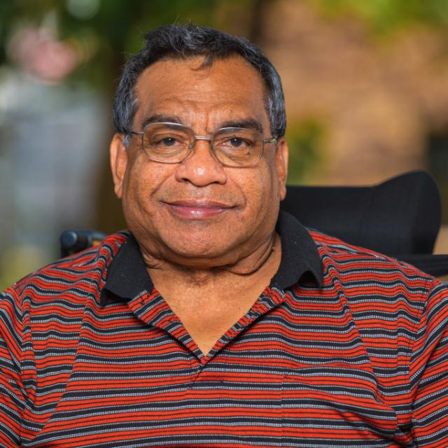
Cody Skinner | Cody Skinner is a First Nations gay man who is passionate about human rights for all. He gave evidence at the Disability Royal Commission in 2020 about his experience in employment. Cody now runs his own business in disability advocacy and teaches Auslan sign language to the community. | 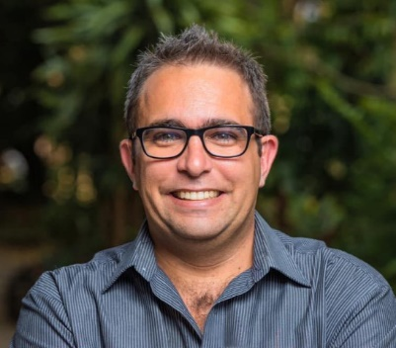
The Hon Craig  Crawford MP  Minister for Seniors and Disability Services | Born and raised on a dairy farm in the Western District of Victoria, Craig Crawford relocated to Far North Queensland (FNQ) with his wife Rosalie in 2008. Prior to entering politics in 2015, Craig worked as an Ambulance Paramedic for 15 years. He has also owned and operated small businesses and volunteered as a firefighter. Craig was the regional representative for the United Voice union whilst working as a paramedic in Cairns where he represented paramedics and emergency helicopter flight crews from Cardwell to Thursday Island. A keen gardener and handy-man, Craig often has several home renos on the go. Craig can also be found caravanning and exploring FNQ with his wife Rosalie and beloved King Charles Cavaliers, Flik and Sulley. | 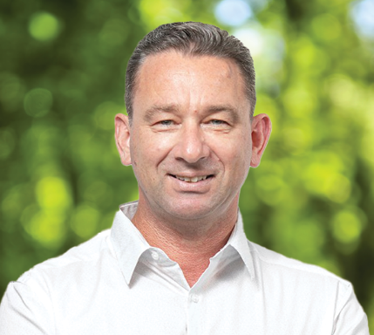
The Hon Amanda Rishworth MP  Minister for Social Services | Amanda Rishworth is the federal Minister for Social Services, and was elected as the Member for Kingston in 2007. During her university studies, Amanda worked as a sales assistant and developed a strong interest in workplace fairness. Amanda followed this passion to work in the trade union movement, both as a union representative and an occupational health and safety trainer. Amanda graduated with a Bachelor of Psychology Honours from Flinders University and a Masters Degree in Psychology from Adelaide University. She has practised as a psychologist, working with General Practitioners in the delivery of mental health care to the community. Amanda lives in Hallett Cove with her husband Tim and their two young sons, Percy and Oscar. | 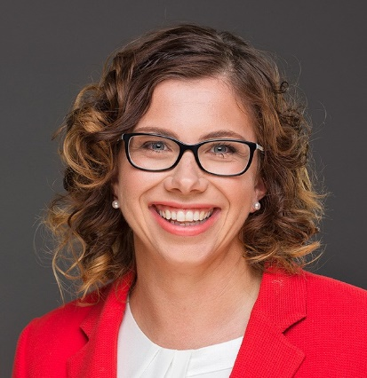
Professor Bruce Bonyhady AM  Melbourne Disability Institute | Bruce Bonyhady is Co-Chair of the NDIS Review and the Executive Chair and Director of the Melbourne Disability Institute at the University of Melbourne. He is one of the key architects of the NDIS and is widely regarded as the “father” of the NDIS. From 2013 to 2016, he was the Inaugural Chair of the National Disability Insurance Agency. Bruce is also the father of three adult sons, two of whom have disabilities. In 2010 he became a Member of the Order of Australia for services to people with disability, their families and carers and to the community, as a contributor to a range of charitable organisations. | 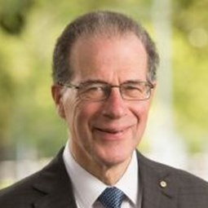
Dr Sharon Boyce  Queensland Disability Advisory Council | Sharon Boyce is an educator, author, speaker and disability advocate from Toowoomba. Sharon has dedicated her life to promoting a true understanding of disability, diversity and complex health issues. She is passionate and committed to social justice, empowering people with disability and supporting real independence. Sharon is the Chair of the Queensland Disability Advisory Council and Chairperson of the Queenslanders with Disability Network Board. Sharon is Director of the Australian Institute of Inclusive Education and Research, Director of the Disability Training Institute and Chief Executive Officer and Director of Aus Inclusion Pty Ltd. In 2020 she was awarded a Doctor of Letters for her research in education inclusion and dyslexia, and is currently completing a Doctor of Philosophy. | 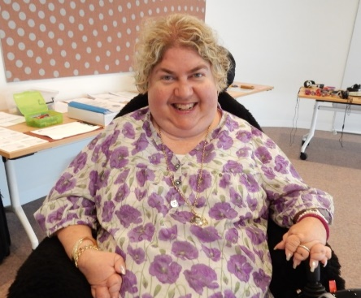

Panel 1 – Employment
Name | Bio | Headshot
Brett Kapernick  Manufacturing Skills Qld | Prior to his appointment to establish the operations of Manufacturing Skills Queensland, Brett Kapernick held the role of Deputy CEO for the Queensland Tourism Industry Council. During COVID Brett was appointed onto the Department’s Economic Recovery Working Group, Business Liaison Unit of Federal Treasury for Economic Recovery and Austrade’s Workforce and Skills Technical Working Group. He sits on the National Careers Institute reference committee on people in everyday careers, is a member of the National Roundtable on Skills and Workforce, and the Department of Agriculture and Fisheries’ Agribusiness diversification reference panel. He held a fellowship of the Australian Institute of Management and holds qualifications in business with post graduate qualifications in business administration and leadership. | 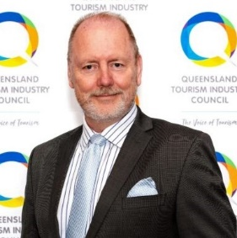
Rebecca Andrews  Australian Industry Group | With more than 25 years of professional experience in both private and public organisations, and a background in economic and community development, Rebecca Andrews has a strong understanding of challenges and opportunities facing business and industry. As the State-Head for Ai Group, Rebecca is responsible for government and stakeholder engagement, and business and industry development. She is passionate about helping business and industry to succeed. Rebecca has previously held senior roles within the Queensland Government and has worked in economic and community development and tourism in the Whitsundays, New Zealand and South Australia. | 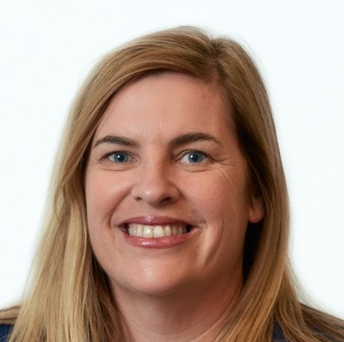
Brett Casey  Deaf Connect | Brett Casey has been the Chief Executive Officer of Deaf Connect since 2010. Prior to this appointment, Brett worked as General Manager overseeing the operational management of the organisation. Brett has been integral to the strategic and operational direction of the organisation. From 2011- 2014 Brett was appointed as the Independent Chair for the Queensland Disability Advisory Council providing strategic and policy advice to the Minister for Disabilities in Queensland. In 2013, Brett travelled to Geneva as part of the group to represent people with disabilities from Australia at the United Nations. Brett holds a Bachelor of Laws LLB and a Bachelor of Arts. | 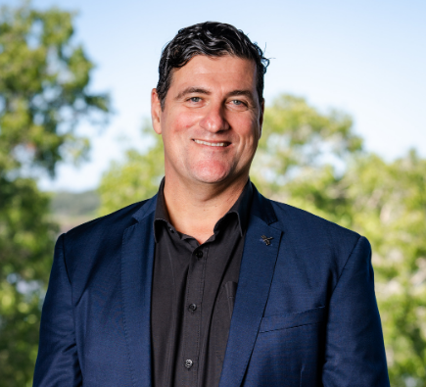
Professor Elizabeth Kendall  Griffith University | Elizabeth Kendall is a rehabilitation psychologist and Director of the Inclusive Futures: Reimagining Disability research alliance. Elizabeth has run collaborative research programs for over 30 years, has published more than 200 papers, attracted over $70 million in research grants and consultancies, and has designed and managed major projects focused on disability, chronic disease, and rehabilitation with a range of populations and communities. Elizabeth is focused on bringing together researchers, people with disability, practitioners, and industry to improve the lives of people with disability. The research she drives aims to improve the precision, personalisation, and innovation that underpins rehabilitation, education, and disability services. | 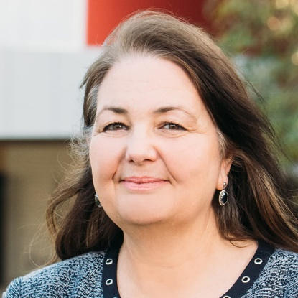
Geoff Trappett OAM  Woolworths Group | Geoff Trappett is a Paralympian who has competed in the Sydney and Athens Paralympics. Winning Gold in Sydney, he was the first person under 14 seconds for the 100m wheelchair sprint. He held this world record through to his retirement in 2005. Accolades include receiving an Order of Australia medal and being named Queensland Paralympian of the Year. Geoff has transitioned to working in multiple senior executive roles within the disability sector, spanning human service providers and disabled person run advocacy organisations. He has been a board member of several disability peak bodies and now devotes his passion and expertise to speaking out on human rights and disability inclusion related issues. | 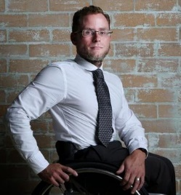

Panel 2 – Inclusion in Action
Name | Bio | Headshot
Associate Professor Michelle Villeneuve  University of Sydney | Michelle Villeneuve is Deputy Director at the University of Sydney Impact Centre for Disability Research and Policy. Michelle leads an international program of research that addresses inequities that people with disability experience in everyday living and situations of natural hazard disaster and other emergencies. Michelle is leading the development of Disability Inclusive Disaster Risk Reduction (DIDRR) in Australia - bringing together health, community, disability and emergency services sectors to establish cross-sector DIDRR policy and practice. Michelle has over 20 years of experience working in regions of conflict and natural hazard disaster to develop community-led services and re-build opportunities for people with disability. Her partnership research keeps people with disability and their support needs at the centre of development and change. | 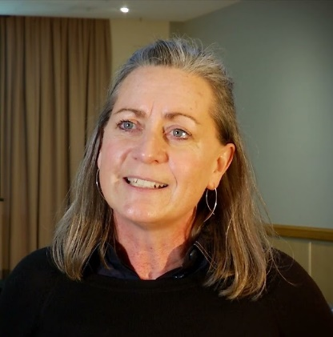
Jennifer Cullen  Synapse | Jennifer Cullen has been the Chief Executive Officer of Synapse Australia Limited for 17 years. Jennifer was awarded an honorary doctorate by Griffith University and has more than 28 years’ experience working in disability and aged care services. Jennifer is a member of the NDIS Independent Advisory Council and was previously a member of the National Disability and Carers Advisory Council. Jennifer also holds Director and Board Executive positions with MJD Foundation, the Independent Advisory Council - Equity and Inclusion Reference Group, and the Queensland Board of the Community Services Industry Authority. Jennifer is a descendant of the Bidjara and Wakka Wakka people and has extensive networks with Indigenous people and communities across Queensland and Australia. She is committed to Aboriginal and Torres Strait Islander issues, rural and remote disability service delivery, and strategies for service innovation and delivery for people with disability and their families. | 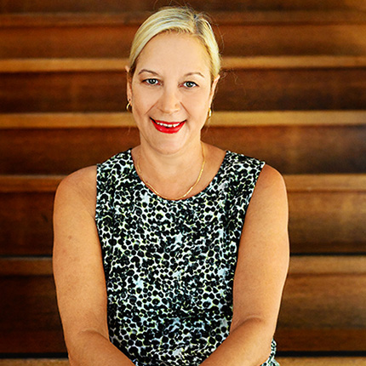
Kevin Cocks AM  Accessible Transport Network | Kevin Cocks is a recognised leader in the human rights and disability field. He has dedicated himself to pushing for an inclusive, accessible, and diverse Queensland through legislative and policy reform and advocacy. Kevin is currently the Executive General Manager of Accessible Transport Network, developing an Accessibility and Inclusion Strategy - a framework for cultural change over the next ten years. Previously, Kevin was Queensland’s Ant-Discrimination Commissioner and realigned the Commission to focus on a vision for a fair and inclusive Queensland, through generative conversation, deep engagement and internal and external capacity building. Kevin has been awarded Doctor of the University from Griffith University and Honorary Doctor of the University of Southern Queensland, made a member of the Order of Australia, and awarded the Australian Human Rights medal. These awards reflect and recognise Kevin’s lifelong commitment and contributions to advocacy and human rights. | 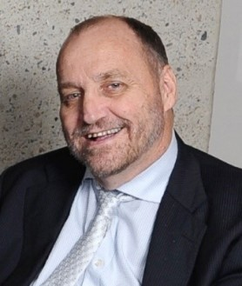
Katie Kelly OAM  Sports Access Foundation | Katie Kelly is a Disability and Inclusion advocate and Paralympian. She was the first Australian to win the Gold medal in Para-triathlon. Katie also won two World Championships (2015 and 2017) and retired after the Tokyo 2020 Paralympics. In 2017, Katie established Sport Access Foundation, providing grants for young Australians living with disability to improve their access to sport. The Foundation has provided over $70,000 in grants. Katie is a Non-Executive Director for Achieve Australia, an Industry Fellow with Griffith University’s Disability Inclusive Council, a co-Patron of the Australian Deaf Games, and is a Facilitator for a Victoria University Sport Inclusion Project. Katie works as the Disability Engagement Manager for MEGT, a not-for-profit providing apprenticeship and employment services. | 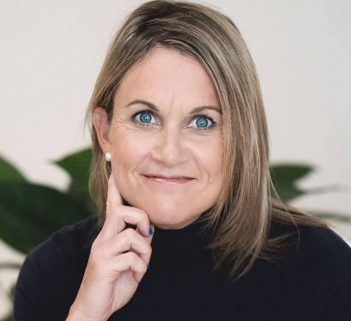

Panel 3 – We All Have a Role to Play
Name | Bio | Headshot
Matthew Ames  Board Director and Consumer Advocate | After spending almost 20 years in the energy and resources industry and following the loss of all four of his limbs in 2012, Matthew Ames has applied his unique mix of professional and personal experience across several governance and advocacy roles. His roles have included board positions in the health and disability sectors, including as a board member of Metro South Hospital and Health Service, Hear and Say and Centacare. Matthew is a passionate advocate for improving outcomes for consumers, working with agencies such as Queensland Health, Commonwealth Government, and peer support programs, such as the “Quad Squad”. | 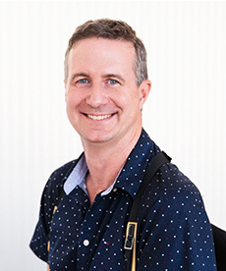
Antonia Mercorella  Real Estate Institute of Qld | Antonia Mercorella is the Chief Executive Officer of the Real Estate Institute of Queensland’s (REIQ). As the organisation’s first female CEO, and its youngest, Antonia has transformed the 105-year-old institute into one of most progressive and high-profile industry associations in Australia. With a 20-year plus legal and executive management career, Antonia has led and shaped some of the most significant real estate legislative reforms across multiple jurisdictions. Under Antonia’s leadership, the REIQ has attracted national and international attention for its advocacy and educational programs. | 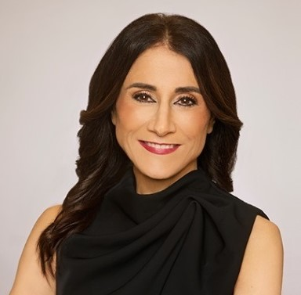
Cr Peter Flannery  Moreton Bay Regional Council Mayor | As a former Australian Army soldier and long-serving local Councillor, Moreton Bay Regional Council Mayor Peter Flannery has devoted his career to serving his country and community. Peter is known for his collaborative leadership style and is committed to being a leader for the entire region. As Mayor, Peter has led the charge to put Moreton Bay on the map as a city distinct from the others in South East Queensland (SEQ). Peter is committed to making Council more open and transparent with the community, especially in relation to planning and development. He is passionate about technology, innovation, and medical research and is especially excited by the potential for the Olympics and Paralympics to transform Moreton Bay. Peter is also chair of the Council of Mayor’s SEQ 2032 Legacy Group, as well as a representative on the Policy Executive of the Local Government Association of Queensland. | 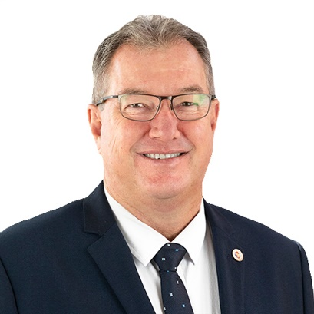
Michelle Moss  Queenslanders with Disability Network | Michelle Moss is Chief Executive Officer at Queenslanders with Disability Network and has almost 30 years’ experience in the human services sectors across disability, health, and sexual assault and domestic violence services. An expert in the human services sector, she has worked in direct support work, complex behaviour support, training and education, consumer and community engagement, project management, and policy. Michelle is a strong advocate and is committed to the voice of people with disability. Her work is founded on a strong commitment to ensuring the voice of people is part of public policy and the design, planning and evaluation of services and systems. | 