2024 QDN Emerging Leaders Information pack

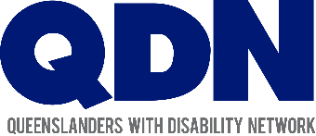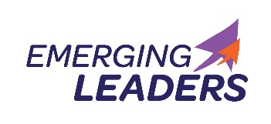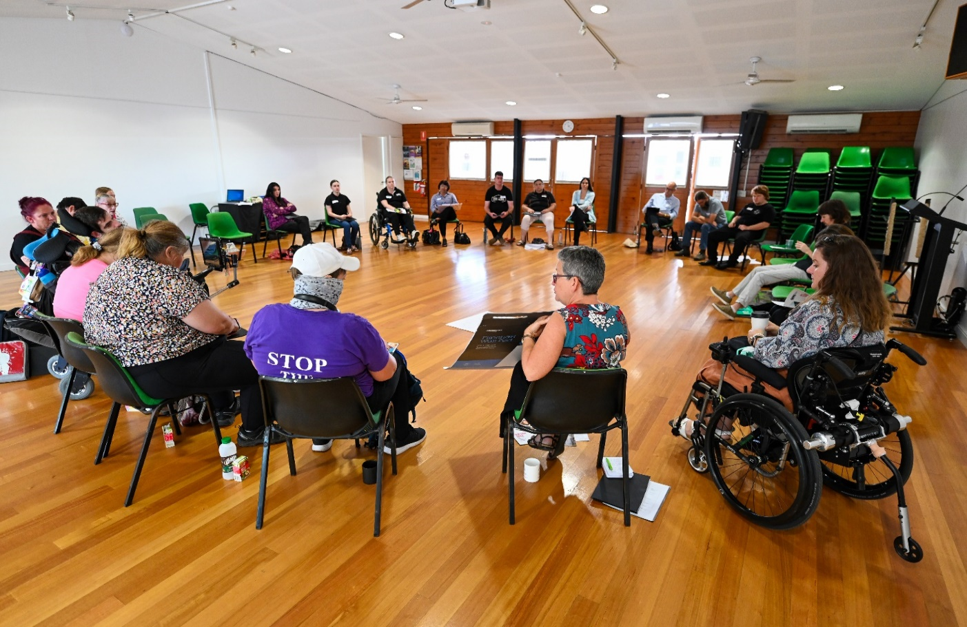

What is the QDN Emerging Leaders program?
QDN’s Emerging Leaders program is a program focused on building the leadership of people with disability to lead and influence change in their own lives and in their communities.
Each year up to 25 people with disability complete the program which develops skills and builds capacity of leaders at individual, community and systems levels.
The program includes learning opportunities ranging from face-to-face workshops, online interactive sessions, mentorship, and community activities. It provides a safe and inclusive environment to develop critical thinking, explore leadership theory, systems thinking and systems change, practice techniques, have inquiring conversations, build relationships, and connect with established leaders.
The underlying framework for the program is QDN’s pillars of inform, connect, lead and influence, and key elements of participatory leadership. This framework provides a safe and inspiring environment for your leadership journey to unfold.
Previous participants have reported sometimes life-changing benefits in confidence and connection with others, new skills, and a renewed sense of purpose and direction. Everyone has the ability to inform, connect, lead and influence.
QDN’s key four pillars of Inform, Connect, Lead and Influence are at the centre of everything that we do, and are central to the Emerging Leaders program. Leadership by people with disability is key to driving and influencing change that delivers equality, rights and inclusion.

When will the program run?
Now in its fourth year, the program will run from March 2024 to November 2024. Participants will need to commit to being part of the whole program over 9 months which includes two workshops in Brisbane as well as monthly online sessions. Travel and accommodation for success applicants outside the south east corner will be covered by the program.

Who should apply?
People with disability who live in Queensland, who want an opportunity to develop leadership skills. We welcome diversity and encourage people with disability of all ages, from culturally and linguistically diverse backgrounds, who are LGBTQIA+ and gender-diverse, live in rural, regional and remote areas, or are First Nations to apply. It is important for applicants to have a willingness to work on their own development and to support others in theirs. If not already a QDN member, successful applicants will become QDN members through the program.

How to apply?
To apply please complete the online application form via this link: https://forms.office.com/Pages/ResponsePage.aspx?id=pN22SPKKGkecMSBHox1OyK8T1pTBKOBMlkxpq9iv9p1UQlI1NUhGT0RBTlpOOEtJWFZDS1NWMUNHUi4u.
Applications close on 9 February 2024. Please get contact us if you need assistance completing the form.

What happens after applying?
A selection panel will review all the applications to determine the successful candidates. The program will commence with a workshop on 13 – 14 March 2024 in Brisbane. For participants who live in regional areas, travel to and from Brisbane and accommodation will be provided for to enable participation in the workshop.

For more information?
If you would like more information about the QDN Emerging Leaders program, please contact us at peersupport@qdn.org.au or phone 1300 363 783.
Funded by the Australian Government Department of Social Services. For more information visit https://www.dss.gov.au/.

