Australia’s Disability Strategy

Queensland Forum

Program
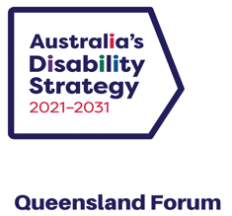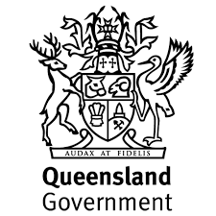

Acknowledgment of Country
We would like to respectfully acknowledge the Traditional Owners and Custodians of the land on which this event is taking place. We would also like to pay respects to Elders past, present and emerging.

Introduction
Australia’s Disability Strategy 2021–2031 (the Strategy) is a national plan to improve the lives of people with disability. Queensland’s Disability Plan - Together a Better Queensland - 2022-2027 (the Plan) builds on the Strategy, and previous achievements in Queensland, towards a more inclusive Queensland.
The Strategy has been co-designed with people with disability to provide a framework and outline of the outcomes we need to achieve to advance the human rights of people with disability. It calls on all Australians to create an inclusive Australian society that ensures people with disability can fulfil their potential, as equal members of the community.
The Queensland Government is committed to celebrating the value people with disability bring to our community and ensuring people with disability can live their best lives in our state. This commitment is demonstrated by, along with all other states and territories, becoming a signatory to the Strategy, developing the Plan with people with disability, and by being the first state or territory to convene an event.
The purpose of the Plan is to be the primary mechanism to drive implementation of the Strategy in Queensland. Queensland Government departments are required to develop, publish, and deliver key actions under Queensland Government disability service plans that align with this plan. The Queensland Government will also invite and encourage all levels of government, businesses, industries, and communities to make the same commitment – to work collectively and with people with disability towards a common objective of access and inclusion.
This forum is a milestone in that invitation to engagement and commitment. The agenda supports collective thinking about how we can all contribute to great outcomes from the Strategy and Plan. It also models and showcases the work already being done in inclusion in Queensland and the gifts, skills, capacities, and leadership of people with disability.
Your hosts today are the Department of Child Safety, Seniors and Disability Services (DCSSDS) and Queenslanders with Disability Network (QDN), whose members play a key part in hosting activities throughout the day as MCs, speakers, panellists, table hosts and performers. We hope you enjoy the conversations, connections, and opportunities to contribute your ideas and energy towards a more accessible and inclusive Queensland.

Event Overview
At this forum, people with lived experience of disability and other leaders across government, community, and business are invited to contribute their ideas about how we can each play our part in bringing the Strategy and the Plan to life in Queensland.
There are two keynote speakers and three panel sessions that highlight key areas of the Strategy for Queensland.
Each panel session will begin by hearing from leaders working towards inclusion in Queensland, moderated by people with disability, and conclude with table conversations hosted by people with disability.
In between sessions and during lunch and the networking event, guest performers will highlight the inclusion of people with disability in the arts in Queensland, and their skills, gifts, and talents.

Keynote Speakers
Participants will hear from the Minister for Child Safety and Minister for Seniors and Disability Services, the Hon Craig Crawford MP and two keynote speakers, Professor Bruce Bonyhady AM and Dr Sharon Boyce, who will speak about the national and Queensland landscapes. These addresses will be followed by a moderated conversation between the speakers.

Panel 1: Employment
Exploring progress in inclusion in employment with:
- Brett Kapernick, CEO, Manufacturing Skills Queensland
- Rebecca Andrews, State Head, Queensland, Australian Industry Group
- Brett Casey, CEO, Deaf Connect
- Professor Elizabeth Kendall, Director, Inclusive Futures: Reimagining Disability, Griffith University
- Geoff Trappett, Disability Inclusion Lead Australia and New Zealand, Woolworths Group
- Panel Moderator: Jane Britt, Board Director, Queenslanders with Disability Network

Panel 2: Inclusion in Action
Exploring disaster readiness, inclusion of Aboriginal and Torres Strait Islander peoples, remote and regional issues, and accessible transport and sport with:
- Associate Professor Michelle Villeneuve, Deputy Director, Centre for Disability Research and Policy, UniSyd
- Jennifer Cullen, CEO, Synapse
- Kevin Cocks, Executive General Manager, Accessible Transport Network
- Katie Kelly, Founder, Sports Access Foundation
- Panel Moderator: Peter Tully, Board Director, Queenslanders with Disability Network

Panel 3: Everyone has a Role to Play
Exploring how we can all contribute to inclusion in health, local government, housing and advocacy with:
- Matthew Ames, Board Director and Consumer Advocate
- Antonia Mercorella, CEO, Real Estate Institute of Queensland
- Cr Peter Flannery, Mayor, Moreton Bay Regional Council
- Michelle Moss, CEO, Queenslanders with Disability Network
- Panel Moderator: Dr Talitha Kingsmill, Board Director, Queenslanders with Disability Network

Forum Agenda 2023, 9:30am - 4:30pm
9:30am - Acknowledgement of Country: Uncle Willie Prince & Cody Skinner
9:40am - Forum opening: MCs Alison Maclean & Allycia Staples
9:45am - Minister’s address: Minister for Child Safety and Minister for Seniors and Disability Services, the Hon Craig Crawford MP
10:00am - Video Address: Federal Minister for Social Services, the Hon Amanda Rishworth, MP
10:05am – Keynote 1: Professor Bruce Bonyhady AM, Director, Melbourne Disability Institute and Co-Chair, NDIS Independent Review Panel
10:25am - Keynote 2: Dr Sharon Boyce, Chair, Queensland Disability Advisory Council
10.45am - In conversation with Professor Bruce Bonyhady and Dr Sharon Boyce; Moderator: Michelle Moss, CEO, Queenslanders with Disability Network
11:05am - Morning tea
11:30am - Performance: Blue Roo Theatre
11:35am - Panel 1 – Employment: Brett Kapernick, CEO, Manufacturing Skills Queensland; Rebecca Andrews, State Head – Queensland, Australian Industry Group; Brett Casey, CEO, Deaf Connect; Professor Elizabeth Kendall, Director, Inclusive Futures: Reimagining Disability, Griffith University; Geoff Trappett, Disability Inclusion Lead Australia and New Zealand, Woolworths Group; Moderator: Jane Britt, Deputy Chair & Board Director, Queenslanders with Disability Network
12:15pm - Table conversation
12:40pm - Lunch: Includes two screenings of “Sunshine”, a film by Bus Stop Films, introduced by lead actor Olivia Hargroder
1:30pm - Panel 2 - Inclusion in Action: Associate Professor Michelle Villeneuve, Deputy Director, University of Sydney Centre for Disability Research and Policy; Jennifer Cullen, CEO, Synapse; Kevin Cocks, Executive General Manager, Accessible Transport Network; Katie Kelly, Founder, Sports Access Foundation; Moderator: Peter Tully, Board Director, Queenslanders with Disability Network
2:00pm - Table conversation
2:25pm - Performance: Sunshine Troupe
2:30pm - Break
2:40pm - Panel 3 - We all Have a Role to Play: Matthew Ames, Board Director and Consumer Advocate; Antonia Mercorella, CEO, Real Estate Institute of Queensland; Cr Peter Flannery, Mayor, Moreton Bay Regional Council; Michelle Moss, CEO, Queenslanders with Disability Network; Moderator Dr Talitha Kingsmill, Board Director, Queenslanders with Disability Network
3:10pm - Table conversation
3:35pm - Afternoon tea
4:00pm - Summary remarks: Dr Sharon Boyce, Chair, Queensland Disability Advisory Council
4:05pm - Close: The Minister for Child Safety and Minister for Seniors and Disability Services, the Hon Craig Crawford MP
4:15pm - Thanks, and close: MCs Alison Maclean & Allycia Staples
4:30pm - Networking event: Jazz duo Dr Jeff Usher and Ella Doneman
5:30pm – Finish

Forum Presenters

Acknowledgement of Country

Uncle Willie Prince
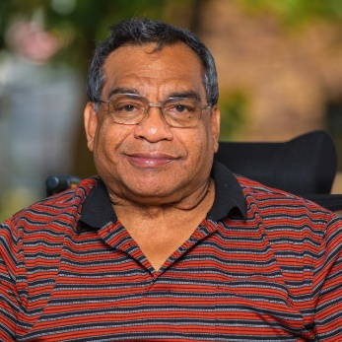
Image description: A man in a red and black striped polo shirt, with a glimpse of a wheelchair back behind his shoulders. He is wearing square shaped glasses and smiling slightly and warmly.
Wilfred Prince, known as Uncle Willie, was born on Wakka Wakka country in Cherbourg and has cultural and spiritual connection to the Kalkadoon clan group in Mt Isa. Uncle Willie experienced multiple hospital admissions in his early life and was removed from family and culture at age two and placed in the Royal Children’s Hospital. He was later transferred to Xavier Home for Crippled Children and he left there when he was 16. Uncle Willie worked for the State Library for 33 years and had a distinguished career in disability sport, representing Queensland 16 times. He carried the Paralympic torch in 2000 and in 2018 carried the Queen’s baton for the Commonwealth Games. Uncle Willie is a voice and advocate for people with disability, particularly Aboriginal people with a disability.

Cody Skinner
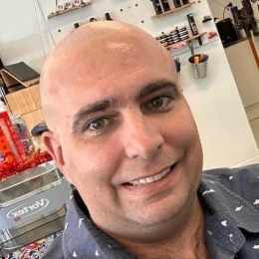
Image description: A young man with a bald head and brown eyes, wearing a grey shirt with a white design on it. He is standing in a kitchen or office with open shelves behind him. He has a friendly smile.
Cody Skinner is a First Nations gay man who is passionate about human rights for all. He gave evidence at the Disability Royal Commission in 2020 about his experience in employment. Cody now runs his own business in disability advocacy and teaches Auslan sign language to the community.

Masters of Ceremonies

Alison Maclean
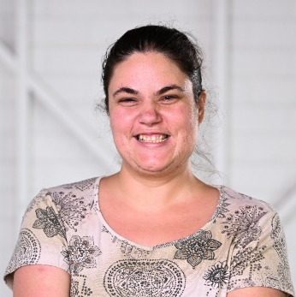
Image description: A young woman with dark hair tied back, with a smiling, friendly face. She is wearing a white and black patterned t-shirt. The background is blurred, she appears to be standing in front of a white wall.
Alison is a 34-year-old disability advocate and peer educator. Alison works in the domestic violence field for the Listen Up project and is the Vice Chairperson of Speaking Up For You. She has facilitated, co-designed and hosted many events and programs for QDN, WWILD and other organisations. Alison was a QDN Emerging Leader in 2022 and is now studying a Diploma in Event Management. She lives on her own and has a dog called Banjo. Alison is passionate about helping others understand what it is like to have a disability and how to make things better.

Allycia Staples
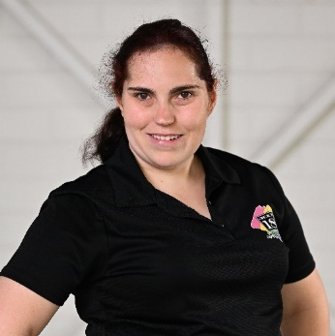
Image description: A young woman with dark hair ties back in a ponytail. She is wearing a black, short sleeved polo shirt with a colourful logo on the left-hand side. She is smiling and has a determined look on her face, looking directly at the camera.
Allycia is a passionate creative, disability advocate, and a founding member of Loud & Clear Advocacy group. Allycia served on Inclusion Australia's Our Voice Committee, was a QDN Emerging Leader in 2022 and served on the organising committee for the National Youth Summit hosted by Children and Young People with Disability Australia. Allycia is a performing artist and founding member of the Sunshine Troupe and the Aha Ensemble, and has performed in numerous productions locally, interstate and overseas. She has participated in prestigious residencies and was a finalist with Queensland Young Achievers. Her creative practice is steeped in her advocacy - she sees the stage and screen as important vehicles for bringing messages of inclusion and diversity.

Speakers

The Hon Craig Crawford MP
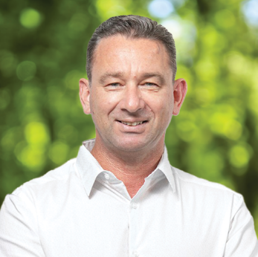
Image description: A man with brown hair, wearing a white, long sleeved, open neck shirt. He is looking directly at the camera, with a kind smile on his face. He is standing in front of a green shrub; the background is blurred.
Born and raised on a dairy farm in the Western District of Victoria, Craig relocated to Far North Queensland with his wife Rosalie in 2008 for the warmer tropical climate and spectacular landscape. Prior to entering politics, Craig worked as an Ambulance Paramedic for 15 years. He has owned and operated small businesses and volunteered as a firefighter from the age of 17. Craig was the regional representative for United Voice union whilst working as a paramedic in Cairns where he represented paramedics and emergency helicopter flight crews from Cardwell to Thursday Island. A keen gardener and handy-man, Craig often has several home renos on the go. Craig can also be found caravanning and exploring FNQ with his wife Rosalie and beloved King Charles Cavalier, Flik and Sulley. Craig was elected to the Queensland Parliament in 2015 and is the Minister for Child Safety and Minister for Seniors and Disability Services.

The Hon Amanda Rishworth MP
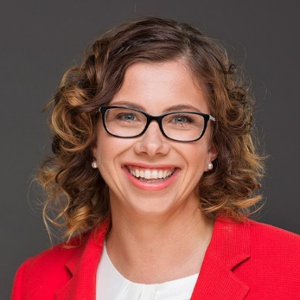
Image description: A woman with dark blonde curly hair, which is out and sitting just above her shoulders. She is wearing a bright red blazer over a white blouse, and dark squarish glasses. She is smiling broadly and looking directly at the camera.
Amanda is a member of Federal Labor’s Cabinet as Minister for Social Services, and was elected as the Member for Kingston at 29 years of age in 2007. Amanda was educated at state schools in Adelaide and was a volunteer swimming instructor and surf life saver. During her university studies, Amanda worked as a sales assistant and developed a strong interest in workplace fairness. Amanda followed this passion to work in the trade union movement, both as a union representative and an occupational health and safety trainer. Amanda graduated with a Bachelor of Psychology Honours from Flinders University and a Masters Degree in Psychology from Adelaide University. She has practised as a psychologist working with General Practitioners in the delivery of mental health care to the community. Amanda lives in Hallett Cove with her husband Tim and their two young sons, Percy and Oscar.

Professor Bruce Bonyhady AM
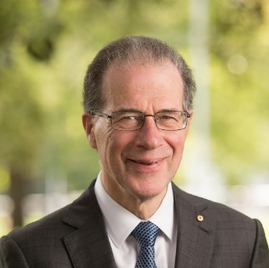
Image description: A man wearing a dark suit, white shirt, blue tie and lapel pin. His hair is brown and grey. He is wearing squarish glasses and smiling. Behind him is a blurred background of trees and grass.
Professor Bruce Bonyhady AM is Co-Chair of the NDIS Review and the Executive Chair and Director of the Melbourne Disability Institute at the University of Melbourne. He is one of the key architects of the National Disability Insurance Scheme (NDIS) and is widely regarded as the “father” of the NDIS. From 2013 to 2016, he was the Inaugural Chair of the National Disability Insurance Agency. Professor Bonyhady is also the father of three adult sons, two of whom have disabilities. In 2010 he became a Member of the Order of Australia for services to people with disability, their families and carers and to the community, as a contributor to a range of charitable organisations.

Dr Sharon Boyce
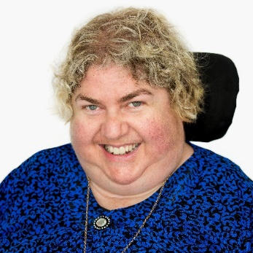
Image description: A woman with short blonde curly hair. She is wearing a blue top or dress and a metal necklace and round brooch. A wheelchair headrest can be seen behind her head. She is smiling warmly.
Dr Sharon Boyce is an education academic and consultant, focused on disability awareness across Queensland. She is passionate and committed to social justice, empowering people with disability and supporting real living independence. Dr Boyce is the Chair of the Queensland Disability Advisory Council, Regional Chair of the South-West Regional Disability Advisory Council, and Chairperson of the Queenslanders with Disability Network QDN) Board. Among the awards Dr Boyce has received are the Queensland Regional Achiever Award in 2012 for her work in awareness raising and creating inclusive communities across Australia, a Human Rights Award in 2008 for her contribution to creating inclusion across the community, and a Disability Action Week Award in 2003 for her work writing an accessible children’s story book.

Panellists

Brett Kapernick
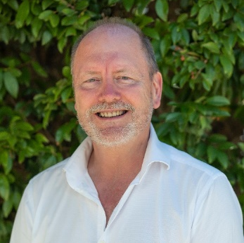
Image description: A man with some balding, grey and brown hair and a grey beard. He is wearing a white open necked shirt and smiling broadly. He is standing in front of a green shrub.
Brett Kapernick is the Chief Executive Officer of Manufacturing Skills Queensland. Prior to his appointment to establish the operations of Manufacturing Skills Queensland, he held the role of Deputy CEO for the Queensland Tourism Industry Council (QTIC). During COVID Brett was appointed onto the Department’s Economic Recovery Working Group, Business Liaison Unit of Federal Treasury for Economic Recovery and Austrade’s Workforce and Skills Technical Working Group. He sits on the National Careers Institute reference committee on people in everyday careers, is a member of the National Roundtable on Skills and Workforce, and the Department of Agriculture and Fisheries’ Agribusiness diversification reference panel. He held a fellowship of the Australian Institute of Management and holds qualifications in business with post graduate qualifications in business administration and leadership.

Rebecca Andrews
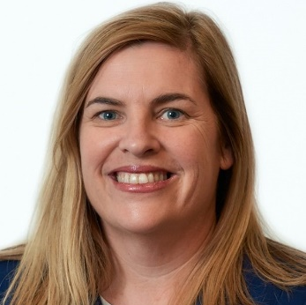
Inage description: A woman with dark blonde, straight hair that sits on her shoulders. She is wearing a collarless blue jacket over a white top. She has blue eyes and is smiling warmly.
With more than 25 years of professional experience in both private and public organisations, and a background in economic and community development, Rebecca Andrews has a strong understanding of challenges and opportunities facing business and industry. As the State-Head for Ai Group, Rebecca is responsible for government and stakeholder engagement, and business and industry development. She is passionate about helping business and industry to succeed. Rebecca has previously held senior roles withing the Queensland Government and has worked in economic and community development and tourism in the Whitsundays, New Zealand and South Australia.

Brett Casey
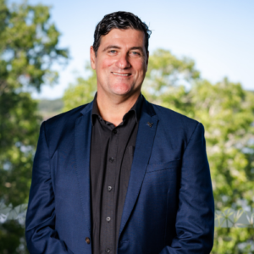
Image description: A man with short dark hair wearing a dark navy suit and a black shirt. He has an open expression and is smiling slightly. Behind him is a blurred background of green trees and blue sky.
Brett Casey has been the Chief Executive Officer of Deaf Connect since 2010. Prior to this appointment, Brett worked as General Manager overseeing the operational management of the organisation. Brett has been integral to the strategic and operational direction of the organisation. From 2011-2014 Brett was appointed as the Independent Chair for the Queensland Disability Advisory Council providing strategic and policy advice to the Minister of Disabilities in Queensland. In 2013, Brett travelled to Geneva as part of the NGO parallel group to represent people with disabilities from Australia at the United Nations. Brett holds a Bachelor of Laws LLB, a Bachelor of Arts and is admitted to the Supreme Court of Queensland as a lawyer.

Professor Elizabeth Kendall
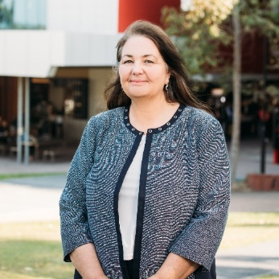
Image description: A woman with shoulder length brown hair, wearing a collarless grey jacket with black trim and a white shirt. She is smiling and has her hands clasped in front of her. Behind her is a university building, some trees and a path.
Professor Elizabeth Kendall is a rehabilitation psychologist and Director of the Inclusive Futures: Reimagining Disability research alliance. Elizabeth has run collaborative research programs for over 30 years, has published more than 200 papers, attracted over $70 million in research grants and consultancies, and has designed and managed major projects focused on disability, chronic disease, and rehabilitation with a range of populations and communities. Elizabeth is focused on bringing together researchers, people with disability, practitioners, and industry to improve the lives of people with disability. The research she drives aims to improve the precision, personalisation, and innovation that underpins rehabilitation, education, and disability services.

Geoff Trappett OAM PLY
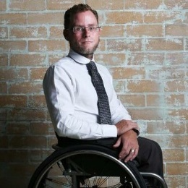
Image description: A man with wavy brown hair and a beard, sitting in a wheelchair. He is wearing glasses, a white shirt and dark coloured tie and pants. His wheelchair is facing to his left and his upper body is angled towards the camera, arms crossed over his lap, and smiling slightly. He is sitting in front of a brick wall.
Geoff is a Paralympian who has competed in the Sydney and Athens Paralympics. Winning Gold in Sydney, he was the first person under 14 seconds for the 100m wheelchair sprint. He held this world record through to his retirement in 2005. Accolades include receiving an Order of Australia medal and being named Queensland Paralympian of the Year. Geoff has transitioned to working professionally in multiple senior executive roles within the disability sector, spanning human service providers and disabled person run advocacy organisations. He has been a board member of several disability peak bodies and now devotes his passion and expertise to speaking out on human rights and disability inclusion related issues.

Jane Britt
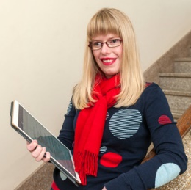
Image description: A young woman with long, straight, fringed blonde hair. She is wearing red lipstick and roundish glasses. Her jumper is blue with a graphic design of circles in red, white and stripes. She is wearing a knotted red scarf. She is holding a large rectangular device and leaning against a banister with a set of stairs behind her.
Jane Britt is a QDN Board Director and Deputy Chairperson. She is a passionate advocate and human rights expert who brings considerable experience from across the disability sector to the Board. She is an active QDN member and a member of the Expert Advisory and Quality Review Panel for Women with Disabilities Australia (WWDA). Jane is Senior Policy Officer at People with Disability Australia (PWDA) and previously held role national policy roles at Blind Citizens Australia and a graduate of Vision Australia’s Graduate Start program in Service Innovation and Design. She has worked with the Disability Leadership Institute as an Engagement Guru, and as a freelance writer for the Australian Disability Clearinghouse on Education and Training (ADCET) and Eureka Street. She has been a member of the Reference Group for Deafblind Australia and is a Founder of Achilles Brisbane, a not-for-profit organisation assisting people with disabilities to lead an active lifestyle. Jane was recently awarded a 2020 Vision Australia Award for her commitment to advocacy

Associate Professor Michelle Villeneuve
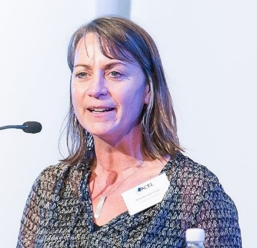
Image description: A woman with straight shoulder length brown hair. She is wearing a patterned black and white blouse with a white coloured pendant necklace and a white nametag. She is speaking into a microphone and is addressing a crowd and has a determined look on her fact.
Associate Professor Michelle Villeneuve is Deputy Director at The University of Sydney Impact Centre for Disability Research and Policy. Michelle leads an international program of research that addresses inequities that people with disability experience in everyday living and situations of natural hazard disaster and other emergencies. Michelle is leading the development of Disability Inclusive Disaster Risk Reduction (DIDRR) in Australia - bringing together health, community, disability and emergency services sectors to establish cross-sector DIDRR policy and practice. Michelle has over 20 years of experience working in regions of conflict and natural hazard disaster to develop community-led services and re-build opportunities for people with disability. Her partnership research keeps people with disability and their support needs at the centre of development and change.

Jennifer Cullen
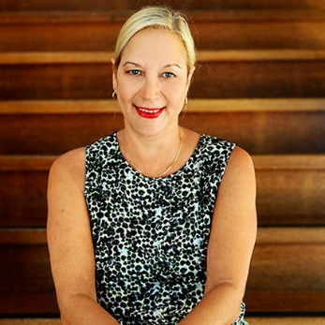
Image description: A woman with blonde hair pulled back from her face. She is wearing a sleeveless black, blue and white patterned blouse, a gold necklace and earrings, and bright red lipstick. She appears to be sitting on timber stairs, the rest of the stairs can be seen behind her. She is smiling warmly and looking into the camera.
Adjunct Associate Professor Jennifer Cullen has been the Chief Executive Officer of Synapse Australia Limited for 17 years. Jennifer was awarded an honorary doctorate by Griffith University and has more than 28 years’ experience working in disability and aged care services. Jennifer is a member of the National Disability Insurance Scheme (NDIS) Independent Advisory Council and was previously a member of the National Disability and Carers Advisory Council. Jennifer also holds Director and Board Executive positions with MJD Foundation, the Independent Advisory Council - Equity & Inclusion Reference Group, and the Queensland Board of the Community Services Industry (Portable Long Service Leave) Authority. Jennifer is a descendant of the Bidjara and Wakka Wakka people and has extensive networks with Indigenous people and communities across Queensland and Australia. She is committed to Aboriginal and Torres Strait Islander issues, rural and remote disability service delivery, and strategies for service innovation and delivery for people with disability and their families.

Kevin Cocks AM
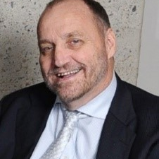
Image description: A man wearing a dark suit, a silvery chequered tie and a white shirt. He is balding, his hair is dark, and he has a beard. Behind him is an aggregate wall. He has an open, warm smile.
Kevin Cocks is a recognised leader in the human rights and disability field. He has dedicated himself to pushing for an inclusive, accessible, and diverse Queensland through legislative and policy reform and advocacy. Kevin is currently the Executive General Manager of Accessible Transport Network (ATN), developing an Accessibility and Inclusion Strategy - a framework for cultural change over the next ten years. Previously, Kevin was Queensland's Ant-Discrimination Commissioner and realigned the Commission to focus on a vision for a fair and inclusive Queensland, through generative conversation, deep engagement and internal and external capacity building. Kevin has been awarded Doctor of the University (DUniv) from Griffith University and Honorary Doctor of the University of Southern Queensland, made a member of the Order of Australia, and awarded the Australian Human Rights medal. These awards reflect and recognise Kevin's lifelong commitment and contributions to advocacy and human rights.

Katie Kelly OAM PLY
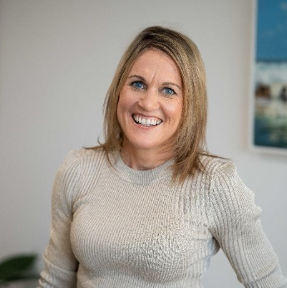
Image description: A woman with blonde, shoulder length hair and blue eyes. She is wearing a grey round neck ribbed jumper. The background behind her is blurred, and shows the corners of two paintings and a plant against a white wall. She has an open, wide smile.
Katie Kelly is a Disability and Inclusion advocate and a two-time Paralympian. She was the first Australian to win the Gold medal in Para-triathlon. Katie also won two World Championships (2015 and 2017) and retired after the Tokyo 2020 Paralympics. In 2017, Katie established Sport Access Foundation, providing grants for young Australians living with disability to improve their access to sport. The Foundation has provided over $70,000 in grants. Katie is a Non-Executive Director for Achieve Australia, an Industry Fellow with Griffith University’s Disability Inclusive Council, a co-Patron of the Australian Deaf Games, and is a Facilitator for a Victoria University Sport Inclusion Project. Katie works as the Disability Engagement Manager for MEGT, an NFP providing apprenticeship and employment services. Katie's journey of living with Usher Syndrome is one of tenacity and grit.

Peter Tully
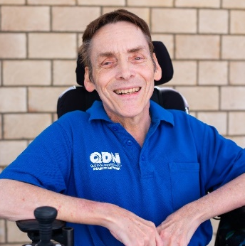
Image description: A man with dark hair wearing a blue short sleeved polo shirt with the words ‘QDN Queenslanders with Disability Network’ on the upper left of the shirt. He is sitting in a wheelchair. He has a friendly, open smile.
Peter Tully is a member of QDN’s Board of Directors, and brings a range of skills, expertise and connections to his role. He has a strong commitment to community engagement, advocacy and empowering individuals and communities to be the leaders in their own lives. Peter is a Life Member of QDN. His roles at QDN have included Regional Facilitator, Ready to Go Peer Facilitator, Housing Champion, Getting on the NDIS Grid, Peer to Peer advocacy, Bright Sparks, Changing Lives Changing Communities and currently in Disability Inclusive Disaster Risk Reduction and Digital Inclusion. Peter played a leadership role with the Every Australian Counts Campaign and is a member of the Intellectual Disability Reference Group – Home and Living to the Independent Advisory Council NDIA. Peter was a Baton bearer for the 2018 Commonwealth Games Queen’s Baton Relay. He is a leader in his local community of Ipswich and works collaboratively with governments, Members of Parliament and service providers to ensure Ipswich is an inclusive and welcoming city for all.

Matthew Ames
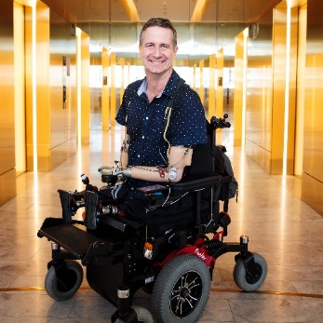
Image description: A man with brown hair wearing a collared, short sleeved blue shirt with white spots. He is sitting in a power wheelchair which is angled to the right, facing away from the camera. He has full length prosthetic arms and short prosthetic legs with a plate on the end. His left arm is leaning on the wheelchair armrest angling him towards the camera. He is pictured in a corridor with a stone floor and gold-hued lighting that bounces off the walls and doors along the corridor behind him. He has a friendly smile and is looking at the camera.
After spending almost 20 years in the energy and resources industry and following the loss of all four of his limbs in 2012, Matthew has applied his unique mix of professional and personal experience across several governance and advocacy roles. His roles have included board positions in the health and disability sectors, including as a board member of Metro South Hospital and Health Service, Hear and Say and Centacare. Matthew is a passionate advocate for improving outcomes for consumers, working with agencies such as Queensland Health, Commonwealth Government, and peer support programs, such as the “Quad Squad”.

Antonia Mercorella
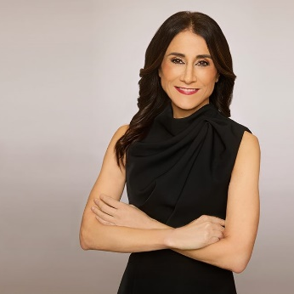
Image description: A woman with long dark slightly wavy hair and dark eyes. She is wearing a dark sleeveless dress and red lipstick. She is standing and her arms are crossed in front of her in a relaxed way. Behind her is a light-coloured blank wall. She is smiling.
Antonia Mercorella is the Chief Executive Officer of the Real Estate Institute of Queensland’s (REIQ). As the organisation’s first female CEO, and its youngest, Antonia has transformed the 105-year-old institute into one of most progressive and high-profile industry associations in Australia. With a 20-year plus legal and executive management career, Antonia has led and shaped some of the most significant real estate legislative reforms across multiple jurisdictions. Under Antonia’s leadership, the REIQ has attracted national and international attention for its advocacy and educational programs.

Cr Peter Flannery – Moreton Bay Regional Council Mayor
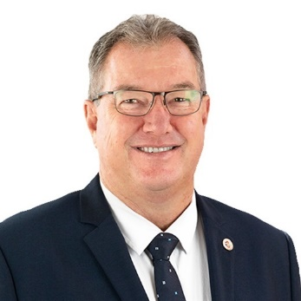
Image description: A man with brown and grey hair wearing a dark blue suit, blue and white spotted tie and a white shirt. He is also wearing a lapel pin and squarish glasses. He is smiling.
As a former Australian Army soldier and long-serving local Councillor, Moreton Bay Regional Council Mayor Peter Flannery has devoted his career to serving his country and community. Peter is known for his collaborative leadership style and is committed to being a leader for the entire region. As Mayor, Peter has led the charge to put Moreton Bay on the map as a city distinct from the others in SEQ. Peter is committed to making Council more open and transparent with the community, especially in relation to planning and development. He is passionate about technology, innovation, and medical research and is especially excited by the potential for the Olympics and Paralympics to transform Moreton Bay. Peter is also chair of the Council of Mayor’s SEQ 2032 Legacy Group, as well as a representative on the Policy Executive of the Local Government Association of Queensland (LGAQ).

Michelle Moss
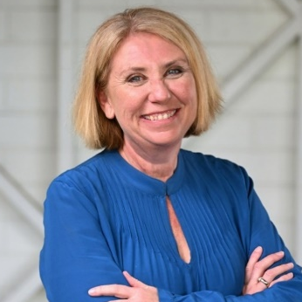
Image description: A woman with short straight blonde hair and blue eyes. She is standing and has her arms crossed. Her dress is bright blue and has long sleeves, pin tucking and a button at the collar. Behind her is a white brick wall. She has an open bright smile.
Michelle Moss is Chief Executive Officer at Queenslanders with Disability Network (QDN) and has almost 30 years’ experience in the human services sectors across disability, health, and sexual assault and domestic violence services. An expert in the human services sector, she has worked in direct support work, complex behaviour support, training and education, consumer and community engagement, project management, and policy. Michelle is a strong advocate and is committed to the voice of people with disability. Her work is founded on a strong commitment to ensuring the voice of people is part of public policy and the design, planning and evaluation of services and systems.

Dr Talitha Kingsmill
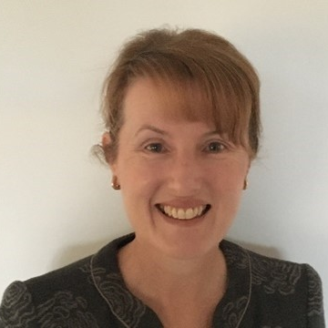
Image description: A woman with light golden coloured hair, gold earrings, wearing a dark collared shirt with a white geometric pattern. She is smiling warmly and looking directly at the camera.
Dr Talitha Kingsmill is a Queenslanders with Disability Network Board Director. Talitha has 25 years’ experience across the private and public sectors in education, educational leadership, consultancy, research, law, regulatory compliance and policy development. She is a passionate advocate for equitable, accessible opportunities for all. Talitha’s lived and professional experience provides rich insights to the confronting and very real challenges and obstacles for people living with impairment and disability. Talitha has received an Australian Council for Educational Leaders Research in Educational Leadership and Management Award (2017), an Australian Catholic University Higher Degree Research Award (2012) and ACU Top Graduate Award – Graduate Diploma in Education (Secondary) & Graduate Certificate (RE).

Performers and artists

NuunaRon Art Group
NuunaRon is a group for Aboriginal and Torres Strait Islander artists and emerging artists living with disability, working from the NuunaRon Hub on the Sunshine Coast, a welcoming, safe space for people to share stories of resilience and keeping strong via yarning, painting and creating art. The name NuunaRon is in memory of and out of respect for two of our Elders. Aunty Nuuna was a saltwater Noonuccal woman from Stradbroke and Uncle Ron was a Kamilaroi man. Both were beautiful artists who lived with disability and made a valuable contribution supporting others living with disability. Both have crossed over to the Dreaming and they are sadly missed by family and friends.
A display of thirteen artworks by the Group will be displayed onscreen throughout the forum. The artworks are from the exhibition ‘Culture is Inclusion’ at United Nations Headquarters in Geneva in 2019, coinciding with the Committee meetings of the UN Convention on the Rights of Persons with Disability (UNCRPD). It was an opportune time for First Peoples with disability to share their voices and stories with delegates from around the world. The artworks promoted how connecting people with disability to their culture and expression through art and storytelling plays a huge part in healing and building individual resilience.

Blue Roo Theatre Company
Blue Roo Theatre Company Inc. is a not-for-profit independent production company, founded in 2009. They are an essential link between the disability community, the performing arts and the broader community. All performers have a range of abilities, and all people are welcome.
Chased by Rainbows: A Snippet
A small troupe performs a snippet of mayhem from the current production touring regional schools. Chasing Rainbows is a high melodrama with original narration, drama and music, devised by the Ensemble members, today performed by the Narrator, the Wizard and the Witch (the villains), the Tooth Fairy (a confused hero) and a wandering musician.
Cast: Narrator - Matt Southgate; Warlock - James Loakes; The Tooth Fairy - Ben Halpin; Witch - Oriel Halpin; Wandering musician - Luke Scott.

Bus Stop Films
Bus Stops Films has been in operation since 2009, teaching adults with disability and others from marginalised communities film studies. They use filmmaking and the film industry to change community attitudes globally around the rights and contribution to society of and by people with disability. The film screening today is of “Sunshine” - 10 minutes of moving story with an unexpected ending – introduced by lead actor Olivia Hargroder.

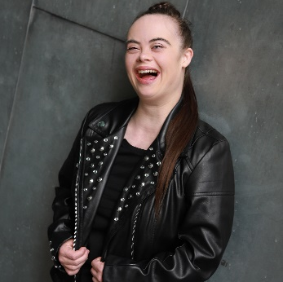

Olivia Hargroder
Image description: A young woman with long dark hair pulled back in a ponytail which sits over her left shoulder. She is wearing a leather biker jacket with silver metal rivet detail on the full-length lapels. She is leaning against a mottled grey background. She is laughing.
Olivia Hargroder is an actor, dancer, activist and public speaker. She studied with NIDA Young Actors Studio and has a Cert IV in stage and screen. She became a LaBoite Theatre Emerging Artist in 2020 with her acclaimed monologue Quick Fixes. She played the lead in films Sunshine (screening today at the forum) and We’ll Always Have Dance. Olivia also stars in ABC’s Better Date Than Never. Olivia’s campaign to have Down Syndrome included in the Paralympics has taken her across the world, including addressing the United Nations in New York.

Sunshine Troupe
Sunshine Troupe is a group of performing artists who identify as living with a disability. They create unique theatre and performances to build inclusive communities on the Sunshine Coast and beyond. The Troupe embraces Disability Led Practice where members' stories, talent and dreams are the driving force of all that they do. Authenticity of voice, story and performance, where the sharing of collective lived experience creates awareness and conversation about who the performers are, are the mechanisms to inspire inclusion in community and beyond.
Cast: Sophie Bolton; Timothy Orton; Mitchell Page; Renee Ruming; Mitchell Runcie; Elli Scanlan; Phoebe Skulthorpe; Tricia Smith (Forum MC Allycia Staples is Assistant Choreographer for the piece).
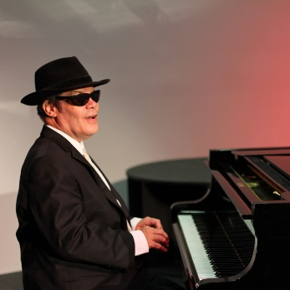

Jeff Usher
Image description: A man sitting at a grand piano with the key lid open. He is wearing a dark suit, a white shirt and a dark fedora hat and dark glasses. There is a pinkish light and a light grey-coloured wall behind him and the piano. He is oriented towards the right of the image and his head is slightly angled towards the camera. His hands are slightly raised away from the keys. He is smiling slightly or perhaps saying or singing something.
Jeff Usher, composer, pianist, singer/songwriter, arranger and music educator, is in many ways Australian music’s best kept secret. He was once described by Australian jazz legend, Paul Grabovsky, as “one of Brisbane’s living treasures". Blind since birth, Jeff stands in a long line of blind pianists. A jazz specialist, Jeff also excels in a wide variety of other genres. He has performed across Australia and the world during a career spanning over forty years. Jeff has performed with notable American jazz musicians, released seven albums, has been a tutor at Queensland Conservatorium Griffith University since 1998, and received his PhD in music composition from University of Queensland in 2019.
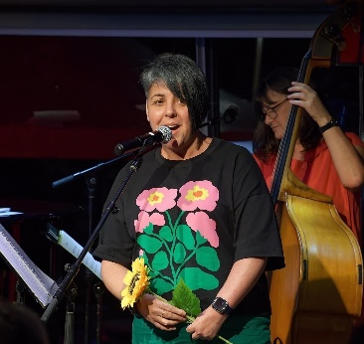

Ella Doneman
Image description: A woman with short dark asymmetrical hair. She is standing and singing into a microphone on a stand. She is wearing green pants, a watch, a black T shirt with pink, yellow and green flowers, and is holding a yellow sunflower. Behind her is a woman wearing an orange t-shirt playing a double bass and a music stand with sheet music on it.
Ella is a musician and educator who has had a love for singing from her youngest years. The love of music enabled her to connect with her family in Europe through traditional Czechoslovakian folk songs. She and her Czech family may not have spoken the same language but they all shared their love of music, song and story. In school, Ella sang in choirs and played the euphonium and later was part of a cappella singing group, the “Deep C Divas” for over 10 years. In 2015 Ella began her own education and teaching business working with people with disability, called Practical Life Skills. Right now Ella is at the beginning of a new project entitled “Blossoming Ella - Blossom Dearie, Ella Fitzgerald and Me!”.

Monte Lupo
Speakers' gifts are made by talented ceramicists with disability at Monte Lupo Arts. Monte Lupo offers beautiful handmade ceramic and textile artworks and homewares, and provides employment opportunities for people living with disability.
Monte Lupo’s employee artists manage each step of the production process, preparing the clay, glazing and painting. Each detail is unique to the finished product and a testament to the hard work of their team members. Many of the artists have received national and international recognition for their work, and Monte Lupo is regularly featured in exhibitions across Australia, in addition to holding their own exhibitions. Monte Lupo is operated by disability support provider Multicap.
Gifts are accompanied by cards from Jan-Al Cards, the creative business of a person with disability.

