Brisbane 2032 Olympic and Paralympic Games
Legacy Games Consultation Survey

To help shape the Brisbane 2032 Legacy Plan we want your feedback on the:

- Legacy themes and focus areas – are these the areas where we should concentrate our efforts?
- Legacy vision – does this accurately describe what we want to achieve by 2042?

To provide your comments please read the following pages about the draft legacy themes and some of the ideas we have heard so far and then answer the questions related to the themes you are most interested in.

Please note that because “Celebrating the world’s oldest living cultures” and “Creating a barrier free society for people with disability” run across all themes, these do not have a separate page or focus areas included.

For more information you can also read the Elevate 2042: The Brisbane 2032 Olympic and Paralympic Games Legacy Consultation Paper.

Theme: Sport, Health and Social Inclusion

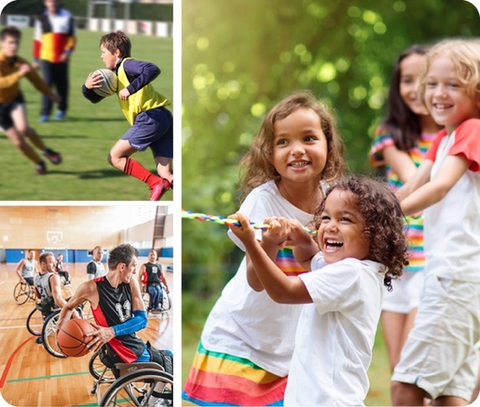

Desired Outcomes
- A more physically active, and healthy community.
- Enhanced pathways for elite athletes, including First Nations and people with disability.
- Improved equity within and between our regions.
- Increased inclusion and accessibility for vulnerable or marginalised communities.
- Stronger gender equity, increasing the attraction, enablement and retention of women in sport.

Some of the ideas we have heard so far through the community engagement process:

Sport for Every Child
School and community sport funded to allow every child to participate at least once a week.

Oceania of Sport
Building pathways for community and elite athlete participation across the Oceania region - including coaching, mentoring, scholarship and inspiration.

Paralympic Centre of Excellence
A training, athlete development and accreditation facility to enhance research and participation for all athletes with disability.

Volunteer Passport
Build the volunteering culture, skills and capacity to deliver a great games and grow volunteers in sport and community activities.

Indigenous Excellence in Sport
An innovative program that attracts and develops First Nations athletes across Queensland, Australia and Oceania.

Sporting Futures Fund + Regional Sporting Hubs
Enable community clubs to access the training and resources they need for athletes to remain in their home regions - for the benefit of both the athlete and their community.

Olympic and Paralympic Housing Trust
Explore potential for using the athletes’ villages across the region to help address affordable housing supply.

Elite Athlete Pathway Program
Support for high performance athletes at every stage of their career.

Sport, Health and Social Inclusion questions
- Please select the below focus areas for the Sport, Health and Social Inclusion theme that are most important to concentrate our efforts on?
An Active and Healthy Lifestyle (Example ideas: Sport for Every Child, Sporting Futures Fund and Regional Sporting Hubs)
Strengthening our Volunteer Network (Example idea: Volunteer Passport)
Elite Sporting Pathways (Example ideas: Oceania of Sport, Paralympic Centre of Excellence, Indigenous Excellence in Sport, Elite Athlete Pathway Program)
Equity in Sport Participation (Example ideas: Paralympic Centre of Excellence, Indigenous Excellence in Sport, Sporting Futures Fund and Regional Sporting Hubs)
Inclusive, Affordable Housing (Example idea: Olympic and Paralympic Housing Trust)

- Do you have any comments on how we could deliver this theme and these focus areas?
For example, let us know what practical steps or ideas can we do to deliver this theme and focus areas and who could benefit from these ideas?

Theme: A better future for our environment

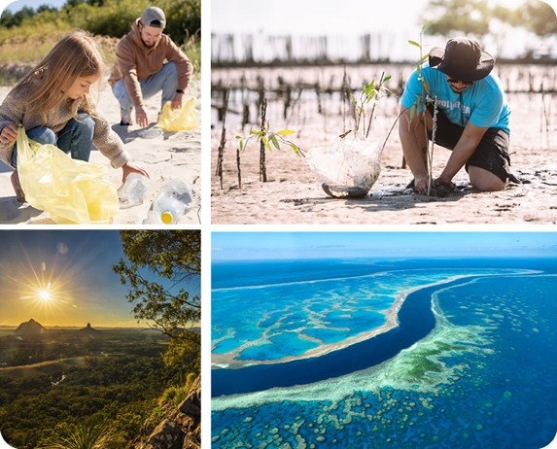

Desired Outcomes
- Climate Positive Games leads to a climate positive Queensland.
- Regenerating and caring for Country.
- Combining ancient wisdom with emerging science and technology.
- Changing behaviour to improve environmental outcomes.
- Accelerating renewable energy.

Some of the ideas we have heard so far through the community engagement process:

Legacy Forests
Enhance biodiversity, reduce carbon and cool the Earth by investing in an Olympic forest or planting a tree for every ticket sold.

Zero Waste to Landfill by 2032
Support a low carbon, circular economy through the introduction of enhanced waste management and material passports for all new venues and infrastructures.

Biodiversity Credits
Develop a state wide trading scheme to allow corporates to invest in the protection and regeneration of our most special natural places.

Water Sensitive Regions
Protect and restore water bodies across our cities and regions to enhance our blue ecosystem.

Most Sustainable Venues
Our Olympic and Paralympic venues have the smallest environmental footprint possible, and sustainable economic and social legacies.

2042 Living Environment “Museum”
A natural history museum without walls - created by packaging the most iconic natural places in Queensland into a singular online and lived experience.

Introduce Environmental Science to School Curriculum
Mandatory education for all children in Queensland to enable a culture of environmental responsibility.

A Better Future For Our Environment questions
- Please select the below focus areas for A Better Future For Our Environment theme that are most important to concentrate our efforts on?
Protecting Habitat, Increasing Biodiversity (Example ideas: Legacy Forests, Biodiversity Credits, Water Sensitive Regions)
Minimising Our Environmental Footprints (Example idea: Most Sustainable Venues)
Progressing to a Circular Region (Example ideas: Zero Waste to Landfill by 2032)
Advancing Renewable Energy (Example idea: Introduce Environmental Science to School Curriculum)
A Culture of Environmental Stewardship (Example ideas: Introduce Environmental, Science to School Curriculum, 2042 Living Environment “Museum”)
- Do you have any comments on how we could deliver this theme and these focus areas?
For example, let us know what practical steps or ideas can we do to deliver this theme and focus areas and who could benefit from these ideas?

Theme: Connecting Regionally and Globally

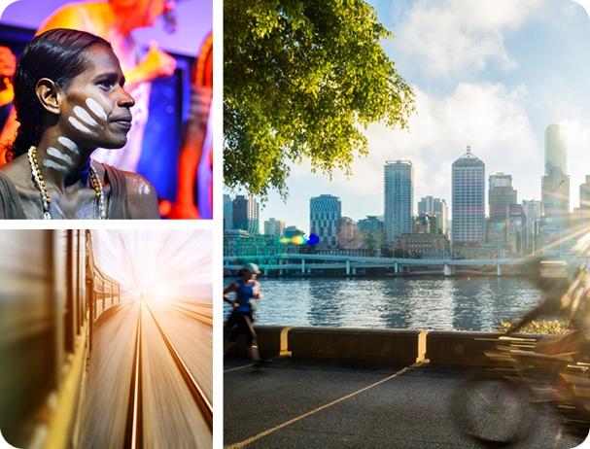

Desired Outcomes
- A region that is connected culturally, linguistically and environmentally.
- Improved transport and digital connectivity.
- Urban renewal delivers more great precincts and places that support future liveability, community spirit and connectedness.
- A stronger global identity.

Some of the ideas we have heard so far through the community engagement process:

Oceania “Song Line”
A digital storytelling collection and tourism initiative to connect the story and cultures of First Nations peoples across Oceania.

Make Walking or Wheeling Easy and Enjoyable
Develop dedicated, safe and engaging pedestrian networks connecting venues and precincts locally and region-wide.

Deliver Great Local Places and Precincts that Connect Communities
Invest in creating vibrant places and precincts in our cities, towns and regional areas.

First Nations Cultural “Experience”
An iconic building that tells the stories of the world’s oldest living cultures, in their own way. A place for truth-telling, truth-hearing, creativity and cultural expression.

A Future-Fit Transport System for South East Queensland
Enhanced and inclusive mass transit solution that unlocks other legacy benefits
for South East Queensland.

First Nations Language and Culture
Celebrate the local languages through signage, naming conventions, stories, school curriculum and the Opening Ceremony.

Develop Digital Solutions that Create Regional Opportunities
Invest in digital infrastructure and partnerships to enhance equity and accelerate economic outcomes.

Universal Access
All Olympic and Paralympic venues, precincts, live sites and infrastructure are accessible to everyone.

Connecting Regionally and Globally questions
- Please select the below focus areas for the Connecting Regionally and Globally theme that are most important to concentrate our efforts on?
A More Connected South East Queensland Region (Example idea: A Future-Fit Transport System For South East Queensland)
Advancing Universal Accessibility (Example ideas: Make Walking or Wheeling Easy and Enjoyable, Universal Access)
Urban Renewal, Places and Precincts (Example idea: Deliver Great Local Places and Precincts that Connect Communities)
One Oceania (Example idea: Oceania “Song Line”)
Celebrating First Nations’ Cultures and Languages (Example ideas: First Nations Cultural “Experience”, First Nations Language and Culture)
Develop Digital Solutions to Enable Regional Development (Example idea: Digital Solutions Creating Regional Opportunities)
- Do you have any comments on how we could deliver this theme and these focus areas?
For example, let us know what practical steps or ideas can we do to deliver this theme and focus areas and who could benefit from these ideas?

Theme: Economy, Jobs and Innovation

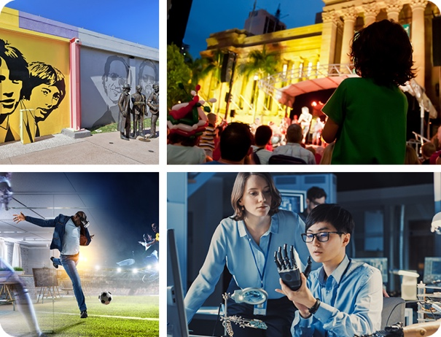

Desired Outcomes
- Develop the business of sport.
- An inclusive future economy.
- Build a next generation talent pipeline.
- A more resilient business community with enhanced ability to participate in procurement pathways.
- Develop the capacity of our cultural and creative arts sector.

Some of the ideas we have heard so far through the community engagement process:

Three World Class Innovation Clusters
Building new economic opportunity in key future sectors, including augmented and virtual reality, bio-medical and environmental technology.

Sports City
Establish Brisbane as the sports high performance and technology capital of the Southern Hemisphere, supported by hubs across the South East Queensland region.

2042 Talent Strategy
Attract, upskill, retain, and transition talent to make us ready for the jobs of the future.

Build the Queensland, Australia and Oceania Tourism Brand
Make sure the world knows all the things we are famous for, leveraging long-term tourism outcomes.

Inclusive Supply Chains and Workplaces
Support small businesses, First Nations and people with disability through procurement quotas for Games related contracts, and create a barrier-free and inclusive workplaces.

South East Queensland is the World’s First Inclusive Tourism Destination
Making it even easier for people with a disability, their family and friends, to enjoy all the attractions we have to offer.

Grow our Major Event Capability
Further develop our major cultural and business tourism capability and visitor experience.

South East Queensland Music Plan
Our live music scene is flourishing and expresses our identity to the world.

Made in Queensland
Support and reinforce local manufacturers, producers and creatives.

Economy, Jobs And Innovation questions
- Please select the below focus areas for the Economy, Jobs And Innovation theme that are most important to concentrate our efforts on?
Building the Business of Sport (Example idea: Sports City)
Encouraging Innovation, Jobs and Sectors of the Future (Example ideas: Three World Class Innovation Clusters, Sports City)
Made in Queensland, Growing Local Business (Example idea: Support and Reinforce Local Manufacturers, Producers and Creatives)
An Inclusive Next Generation Visitor Economy (Example ideas: South East Queensland is the World’s First Inclusive Tourism Destination, Build the Queensland, Australia and Oceania Tourism Brand, Grow our Major Event Capability)
Advancing Equitable Economic Participation (Example ideas: Inclusive Supply Chains and Workplaces, 2042 Talent Strategy)
Fostering Arts, Culture and Creativity (Example idea: South East Queensland Music Plan)

- Do you have any comments on how we could deliver this theme and these focus areas?
For example, let us know what practical steps or ideas can we do to deliver this theme and focus areas and who could benefit from these ideas?

Other themes or focus areas
- Are there any other themes, focus areas or ideas we should include?

For example, are there programs and/or initiatives that can be run, policies and targets that can be set or things that can be built before 2032 and up to 2042. And who could benefit from these ideas?

Draft legacy vision
- Do you have any comments on the below draft Legacy vision?

"By 2042, a child born today has more opportunities in life, in an inclusive society and a connected region."

Your details - individuals
If you are answering as an individual please provide the following details.

- Where do you live?

  - Inside Queensland (please identify which town or region?)

  - Outside Queensland (please identify which state?)

  - Outside Australia (please identify which country?)

- Your age:
Under 18
18 – 29
30 – 39
40 – 49
50 – 59
60 – 69
70 – 79
80+
- Do you identify as any of the below?
Aboriginal
Torres Strait Islander
Traditional owner
Other cultural background
Person with disability
None of the above

- Please provide an email contact (required):

(The Department of Tourism, Innovation and Sport will only use your information to communicate with you in relation to Brisbane 2032 Legacy planning. Your personal information will otherwise not be used or disclosed unless authorised or required by law. Your personal information will be handled in accordance with the Information Privacy Act 2009.)

Your details – organisations
Please answer if you are answering on behalf of an organisation.

- What is your organisation’s name?

- Where is your organisation based?

  - Inside Queensland (please identify which town or region?)

  - Outside Queensland (please identify which state?)

  - Outside Australia (please identify which country?)

- Please provide an email contact (required):

(The Department of Tourism, Innovation and Sport will only use your information to communicate with you in relation to Brisbane 2032 Legacy planning. Your personal information will otherwise not be used or disclosed unless authorised or required by law. Your personal information will be handled in accordance with the Information Privacy Act 2009.)

