ANNUAL REPORT
2021-2022

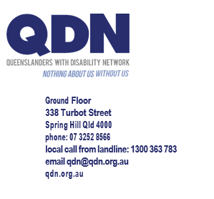

ACKNOWLEDGMENT OF COUNTRY

We acknowledge the people who are the Traditional Owners and Custodians of the Land on which we gather. We thank the peoples of the land past and present for their custodianship and for the opportunity to meet in this place. QDN also acknowledges people with disability who have come before us and died in institutional settings, as well as those who are still trapped in institutions or silenced by institutional practices. We take on the responsibilities of being clear about the rights of ALL people with disability and, where necessary, speak in an informed and considered manner, for
those who cannot speak for themselves.

QDN Annual Report 2021-2022

VISION:

People with disability are active and valued citizens

Leadership

- 28 Group Convenors
- 14 Local NDIS Champions
- 20 Emerging Leaders
- 8 Peer Mentors
- 69 QDeNgage Consultants
- 25 Disability Inclusive Disaster Resilient (DIDR) Peer Leaders
Policy contributions
- 55 Committee and consultations
- 33 policy submissions
Community and stakeholder education
- 7 QDN lead and partnered events
- 28 conferences or fourms
- 17 policy areas
Targeted Outreach
- 1193 enquiries
- 623 referrals
- 229 met NDIS access
- 196 plans approved
Social Media
- 519 posts
- 2631 followers of QDN page
Media Engagement
- 11 media releases
- 28 press and radio interviews

Communication

- 85 blogs
- 6 e-bulletins
- 12 fortnightly news

ATSIDNQ
- 97 new members
- 1313 total members
- 9 Yarning Circles
- 7 Champions
- 4645 contacts via face to face, emails, yarning circles, consultations
- 110 community service organisations engaged
- 47 social media posts

Governance and operations
- Board governance and renewal strategic planning
- Quality Management System recertification to ISO 9001:2015
Power of Peers
- 27 groups
- 157 meetings
- 28 group convenors
- 1414 contacts at meetings
- 1969 members on closed Facebook groups

QDENGAGE

- 38 engagements
- 13 Queensland locations
- 17 customers
- 369 opportunities for people with disability to engage
Disability Inclusive and Disaster Resilient Queensland
- Queensland and National Awards - Resilent Australia
- 2857 contacts with people with disability, community,
disability and emergency sectors
- 25 Peer Leaders with disability trained in PCEP
- 281 people with disability introduced to PCEP through peer support
- 22 people with disability individually mentored in PCEP
- 47 people with disability made PCEP plans
- DIDRR framwork and toolkit resources
- Person-Centred Emergency Prep
Membership
- 1240 Ordinary Members
- 54 Support Organisations
- 767 Supporters
- 1313 Aboriginal and Torres Strait Islander Disability Network
Awards
- 2020 Resilient Australia Award Community Category - Queensland
- 2020 Suncorp Resilient Australia National Community Award (National)
- IGEM 2020 International Women’s Day Champion of Change Award
QDN lead and partnered events
- Covid Conversations
- Stand With Us advocacy campaign
- My Disability Matters
- Make Disability Count
- NDIS Reforms
- DIDRR

PART 1: INTRODUCTION

WHO WE ARE

Our motto is NOTHING ABOUT US, WITHOUT US

We’re an organisation of, by and for people with disability, a company limited by guarantee and governed by a Board of Directors, including elected directors, all people with disability, and up to two appointed directors. As we go into
our 20th year, our reach and influence are growing, and we are proudly working towards our vision of people with disability as active and valued citizens
of Queensland.

QDN believes that:

People with disability have a right to belong and contribute as empowered, free citizens who are valued, present, participating and welcomed.
The place of people with disability in community is welcomed where they are genuinely given opportunities to contribute and participate.
People with disability need to be in communities where their individuality, talents, and lived experiences are recognised. People with disability are not afforded the same value, opportunities or access to community life, and inclusion is conditional and easily withdrawn.

Many people with disability are excluded from the most basic experiences.
Current exclusionary practices are unacceptable, must be challenged and affect the whole community.
Responsibility to ensure that people with disability have a place and are resourced to belong in community is shared.

QDN receives funding from Governments for activities engaging people with disability across the state-wide network, systemic advocacy, peer support, disability inclusive disaster risk reduction activities around person-centred emergency preparedness, targeted outreach to assist people with disability to access the NDIS, developing responses to policy, and driving social and economic changes on issues that align with our values.

QDN acknowledges the following Government Departments for funding received by QDN in 2021-22 delivery of work during this financial year.

Commonwealth Government Departments

- Department of Social services
- Queensland Government Departments
- Senior, Disability Services, and Aboriginal and Torres Strait Islander Partnerships
- Communities, Housing, and Digital Economy
- Queensland Health
- Two projects were funded through collaborations between the Queensland and Commonwealth Governments
- Targeted Outreach project
- Get Ready Plan ahead through Queensland Bushfire – Category C – Flexible Funding
- We are grateful for the opportunities for ‘nothing about us, without us’ that funding brings.
- QDN also generates income from consultancy activities under the QDeNgage banner.

QDN’s work includes
- informing people about important issues and collaborating for change
- referring people onto groups of peers to lad a good life
- helping people with disability to have a voice in disability policy.
- projects that help improve the lives of people with disability.

QDN is a member led organisation.
It has three membership categories
. Ordinary Members (people with disability)
. Supporter and Support Organization Members
. Corporate Members

OUR DIRECTION

Our strategic direction and goals are shaped by four pillars

INFORM
CONNECT
LEAD
INFLUENCE

Our Vision
People with disability are active and valued citizens of Queensland

Our Mission
We lead, inform, connect, and influence to empower people with disability to be fully included as citizens in the social and economic life of the community as per the rights recognised in the United Nations Convention on the Rights of Persons with Disabilities.

Our Values
AUTHENTIC VOICE
We are with, and for, all people with disability and ensure those with limited or no voice are heard and valued.

RIGHTS
We believe in and model a human rights approach that recognises disability as a social issue.

COLLABORATIVE ACTION

We work together to learn from the collective experiences, values,
and wisdom of people with disability.

RESPECT

We value human difference and diversity and build mutual respect through openness and fellowship.

RESILIENCE

We are hopeful, even about the most complex challenges, and are here for the long term.
We have grown in member numbers, continually adding to the strength of our voice. From the QDN Emerging Leaders program, where we are working with leaders to grow.

CHAIRPERSON’S REPORT
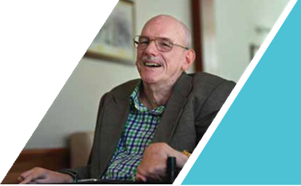

Reflecting on the year past, I am filled with a sense of pride, respect and admiration for the commitment shown by my fellow QDN board members, CEO Paige Armstrong, staff, and of course members, who are at the centre of all that we do.

For me, the theme of the year has been ‘Voice’. Our members’ voice speaking the message of ‘nothing about us, without us’ has never been louder or more united.

We are a member led organisation and committed and engaged members are QDN’s most important resource. their individual and collective voice, to the launch of our Co-design Principles and Leadership Framework which gives shape to our voice, we can see the harvest of our strategic intentions to build the leadership capacity of our members to inform, connect, lead, and influence. To give ‘Voice’ to what matters.

In April 2022, we hosted more than 70 Peer Leaders from all over Queensland in a one-day forum - an opportunity to connect and discuss how we can lead and influence change. It was clear to me, as I participated in that forum and listened to the many perspectives that make up QDN’s Voice, that growth of that combined voice’s reach is assured.

While all our leadership and work in policy, campaigns and advocacy is informed
by our members, two particular issues where members have led the work have stood out this year. Firstly, the COVID-19 response, in which the issues impacting members changed rapidly and had a great deal of urgency attached to them. Our members were wonderfully responsive and united in their voice, being heard loud and clear by Government, which responded with significant adaptation to meet the needs of people with disabilities during
the pandemic. In addition, members led the work of rolling out Disability Inclusive Disaster Preparedness to two other states. This kind of peer-to-peer support is becoming more and more important due to the frequency of natural disasters, and I commend members for their leadership in this space.

We are a member led organisation, and
committed and engaged members are QDN’s most important resource
Through the work, QDN has been involved in in Disability Inclusive Disaster Risk Reduction, we have influenced Commonwealth policy and legislation through the inclusion of Person Centred Emergency Planning in the Australian Disability Strategy and the NDIS Quality and Safeguards Commission Practice Standards. These are key pieces of aspirational work for people with disabilities that give us hope for a better future. I thank you for your contribution.

The launch of the Australian Disability Strategy is one of the highlights of the year for me. The Strategy’s vision is for an inclusive Australian society that ensures people with disability can fulfil their potential, as equal members of the community. The Strategy sets out practical changes that will assist people with disability. It is once in lifetime opportunity for profound change, and I am proud of QDN’s contributions towards it. As we look forward to a new year, we hold the intention of ensuring people with disability are involved in implementation of the Strategy, and that there is continued action and good progress made.

Other key campaign and advocacy areas have included the 2032 Brisbane Games, the NDIS, e-scooters, taxi and passenger issues and the Federal Election, where we connected and heard from every major party in Queensland, allowing us to have an informed vote on disability issues.

In line with our strategic vision, and with the aim of amplifying the voice of people with disability on the issues that matter, we have increased our focus on informing and influencing through the media. QDN’s advocacy on 13 separate issues important to our members has featured 57 times in media across Australia during the last 12 months. Your voice, and the QDN brand, has been heard and seen by over 13 million people across Australia, on radio, TV, newspaper and online – an astonishing 50% of our population!

The Board reviewed our strategic plan in November 2021, further developing and refining our mission statement and strategic goals to reflect our emphasis on developing leadership, increasing capacity based on the lived experience of people with disability. and embedding principles of co-design. Our work has also focused on broadening our depth and reach of our work and membership, including diverse cultural backgrounds reflective of the diversity of our people and our state.

I am looking forward to QDN’s continued excellence in leadership and governance - supporting people with disability to inform, connect, lead, and influence change, and ensuring there is truly nothing about us without us as our shared voice continues to rise

Des Ryan
Chairperson
QDN Board of Director

CHIEF EXECUTIVE OFFICER’S REPORT
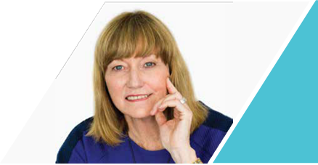

Looking back over 2021-22, I feel a sense of wonder at QDN’s capacity to adapt, grow and make change amidst continually challenging circumstances.

The last year has certainly been a hard time for many. In particular, people with disability have experienced additional impacts from social isolation, lack of access to rapid antigen tests, and the growing housing crisis and cost of living amongst other issues. I have spoken
to many of you about these issues and I acknowledge the difficulty and challenge our members, their families and supporters have experienced.

I am proud of the work done by the QDN team in these challenging times. A highlight for me is our continuing advocacy work in housing. We have worked closely with the Department of Communities, Housing and Digital Economy (DCHE) and other key
stakeholders to support the development and delivery of policies, programs, and services that better meet the housing and homelessness needs of Queenslanders with disability. In times of acute housing stress, this work is even more important.

In 2021-22, QDeNgage continued to expand its influence and ensure its sustainability as a consultancy service that informs businesses, organisations, and Government on how to provide policy, services, and infrastructure in a more inclusive way. QdeNgage connects the lived expertise of QDeNgage consultants to a growing customer base. Consultants have had influence in the transport, health, disaster preparedness, domestic and family violence, NDIS, adult safeguarding, volunteering, eSafety, and tourism sectors.

Our Power of Peers work continued to flourish with established and new local groups doing fantastic work informing others about issues that matter and leading change and influencing issues locally. Groups have had particular influence around local accessibility issues and have connected and strengthened relationships with stakeholders including local representatives, emergency services and other organisations, exchanging information about issues that matter. This work, funded by Information Linkages and Capacity Building (ILC) program, is fundamental to QDN’s success. Power of Peers work is at the core of who we are as an organisation, building the capacity of peers to inform, connect, lead and influence change that benefits all Australians with disability, their carers, and families.

Our Targeted Outreach project finished on 30 June 2022. This work was significant in enabling many Queenslanders who may have otherwise missed out to access the NDIS and its potential benefits, including the resulting $56 million in NDIS plans. In the words of one of our members:

“The NDIS has been life changing in lots of ways for me. It has enabled me to take control of my life, in ways I didn’t think was possible”.

The ending of this program has created a concerning gap for a segment of our
population whose opportunities to access and be supported by the NDIS are now very limited.

Our Digital Inclusion project launched during the year and has now been rolled out to four locations in SouthEast Queensland. This project has been extremely successful in bridging the digital gap for people with disability and providing people with disability the reassurance and confidence to be ready for emergency situations such as natural disasters, emergencies, or COVID-19.

We continued to deliver co-designed and peer-led Person Centred Emergency Preparedness (P-CEP) and leadership online workshops to people with disability in South Australia, New South Wales, and ACT. We brought together P-CEP Peer Leaders in Queensland, Victoria, NSW, SA and ACT to form a community of practice so people with disability can share information, strategies and learnings with each other to continue to build their emergency preparedness knowledge
and skills.

We also worked with the University of Sydney and City of Gold Coast Council to run workshops for people with disability to be more prepared for an emergency or disaster. The success of our work in this area has led to new projects in 2022-23.

I wish to note also the loss of two disability advocates and members of QDN, Wendy Lovelace and Matt McCracken, both of whom died in 2022. Both Matt and Wendy were long-term, passionate, influential, committed advocates and campaigners and made enormous contributions to QDN, their communities and to leading and influencing change at state and national levels. We all feel the loss of both of these wonderful people and will honour their memory during our 20th birthday celebrations.

I sincerely thank the dedicated QDN members, peer leaders and QDeNgage consultants for your commitment, engagement, and willingness to provide support and connection to others, and to engage in policy issues to inform and influence. To our staff at QDN, I thank you for your hard work, your dedication, and for helping to make a difference every day. I also thank QDN’s Board of Directors for your leadership and governance, ensuring QDN is of, by and for people with disability and delivers on our mission, vision and goals.

Paige Armstrong
Chief Executive Officer

GOVERNANCE

Board of Directors
Meet your QDN Board of Directors. A passionate and dedicated group of leaders.

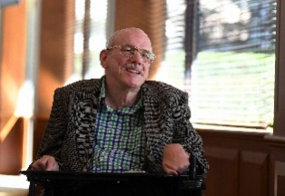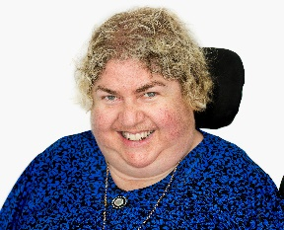
Des Ryan Sharon Boyce Jane Britt
Chairperson Deputy Chair Director (Chair Nominations and Performance)

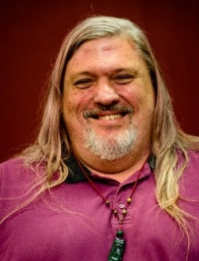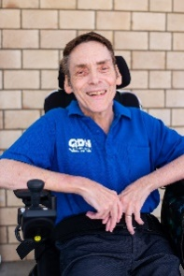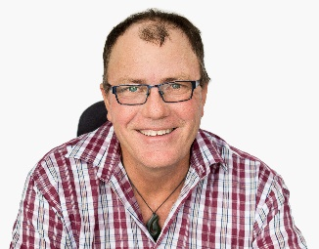

Gary Matthews Peter Tully Peter Gurr
Director (Chair Audit and Compliance) Director Director

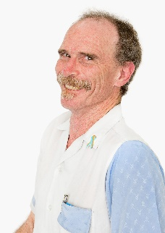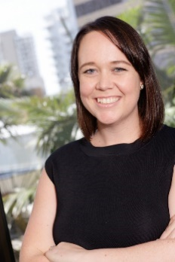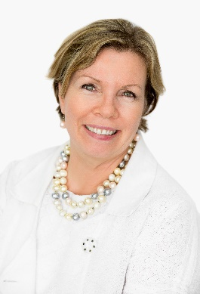

John MacPherson Stacey Miller Colleen Papadopolous
Director Appointed Director Company Secretary

PART 2: AN OVERVIEW OF OUR YEAR

A HIGHLIGHT – LAUNCH OF OUR LEADERSHIP

OUR LEADERSHIP FRAMEWORK AND CO-DESIGN PRINCIPLES

In our 20 years as an organisation, QDN’s motto ‘nothing about us without us’ has been central to who we are and the work we do.

Co-design is an important element of how we do our work and of our leadership in the sector. When done well and effectively, people with disability are engaged in a meaningful, equal, and authentic way to co-design solutions that deliver quality outcomes for the end–user.

Co-design is increasingly considered as the most effective way forward in complex issues, and Governments and business are starting to understand this. QDN’s leadership in bringing people together is bearing fruit.

We see that effective and quality co- design includes these key elements for all participants to:

- have a shared understanding of the issue being addressed
- are able to engage meaningfully in processes for identifying and making sense of issues, identifying options, prioritising, and crafting solutions have time to reflect before responding have reasonable opportunity to be heard and have their contribution acknowledged
- have their contributions carry relatively equal weight
- see their contributions may be included in the final policy, program, product, or service
- be acknowledged for their contribution or have transparency around why their ideas were or were not taken on board.

As part of our QDN Leadership Framework, we have expanded on our core values to outline our principles and processes that underpin this work.
Co-design is a meaningful process when there is genuine intention to work together, with a belief that the process will add value and be a positive experience for those involved. Co-design contributes to positive change, and it is important that people involved get feedback about how their information will be used, what has changed, and the end outcome.

Our five values of Authentic Voice, Collaborative Action, Rights, Respect, and Resilience have been used to inform QDN’s principles for co-design and the actions and indicators that demonstrate in practice, quality, and effective codesign that values, empowers, and respects the role and voice of Queenslanders with disability.
Our co-design processes
The starting place
Craft the question that reflects intent/purpose and invites inquiry.

Build the team
Get diversity and support inclusion.

Discovery Phase
See the issue from lots of different viewpoints, perspectives, and ways. Hear from others including those who aren’t connected or disagree.

Generate options
Stage where sense- making starts to yield conclusions, ideas and possibilities, and people get in the creative zone.

Sense-making
Look at the data, story, research, and evidence in their raw form and work together to make sense and meaning
of what has been gathered.

Pause and Reflect Take time to pause and reflect on what you have learnt in the discovery phase and what you still don’t know before jumping to solutions.

Developing Prototypes Generate as many ideas as possible and develop a working example of the policy, service, program, product, or scenario- based solution.

Learning, reworking, and refining
Part of the learning cycle and reworks can produce ‘prototype’
– the solution for testing, piloting, or putting into action.

Imbed what works Turn it into action and make it real.
Keep people engaged and stay accountable.

OUR STRATEGIC GOALS

QDN’s strategy is deeply informed by the foundations of INFORM, CONNECT, LEAD, INFLUENCE. Out of this foundation comes our five strategic goals. We hope you enjoy reading about QDN’s work under these five goals in 2021-22.

GOAL 1 – INFORM
promote and maintain active, vibrant local networks that inform our work and build local capacity

GOAL 2 – CONNECT
To let people, know about the lives of people with disability and have their experience and expertise valued and recognised.

GOAL 3 – LEAD
To enhance the leadership and influencing capability of people with a disability

GOAL 4 – INFLUENCE
To influence governments and others to bring about full and equal participation, citizenship, and protection of rights for all
GOAL 5 – GROW OUR NETWORK
To grow an independently sustainable, effective, accountable and rights-based organisation that reflects our vision, mission, values, and principles

GOAL 1: INFORM

INFORM speaks to QDN’s strategic goal of informing members and the wider world through policy papers, research activities, QDeNgage consultant activities and Peer to Peer support

Policy

Wherever QDN can meaningfully inform and contribute to policy review and development across the myriad policy areas impacting people with disabilities, we do. We do this through member engagement forum reports, membership on multiple advisory groups and committees, appearances before enquires and hearings, and formal submissions and letters. In 2022, QDN formally contributed to policy at state and national levels on topics including:

- National Disability Employment Strategy

- NDIS Forum Report Pause, Reset, Co-design

- Register of Enduring Power of Attorney Consultation

- Rental Tenancy Legislation Inquiry

- Primary Health Care Strategy

- Coercive Control Domestic Violence Law Inquiry

- Disability Support Pension Inquiry Submission

- Voluntary Assisted Dying Brief and Public Hearing at Committee Appearance

- Federal Budget Analysis

- State Budget Analysis

- Queensland Making Rent Fair Campaign

- Housing and Homelessness Strategy Electric Scooter Consultation

- Brisbane City Council Metro Access Project

- Proposed Legislative Amendments for

- Motorised Mobility Aid Devices

- Anti-discrimination Act Review, Queensland Human Rights Commission
South-East Queensland Rainfall and Flooding Event February-March 2022
Review, Queensland Parliament

- Disability Royal Commission: The impact of, and responses to, the Omicron wave of the COVID-19 pandemic for people with disability

- Qld Police Service training: Domestic and Family Violence video recording of evidence

- Open Letter to all parties and candidates at Federal Election – Leave no Australian behind in disasters and emergencies

. Disability Standards for Accessible Public Transport – Stage 2 Cost Benefit Analysis

“ It’s good to be part of the Emerging Leaders Program because it gives you a greater sense of community and you give back”

Kamania Butler

- QDN response to Price Waterhouse Coopers Survey

- The Australian Commission on Safety and Quality in Health Care – Intellectual Disability Resources

- Letter to Premier re Olympics and Paralympics in Queensland in 2032

- Letter to Senator Linda Reynolds (NDIS Minister) and Minister Hunt (Health) re COVID-19 situation

- Letter to Ministers re current COVID-19 situation and improved healthcare for people with disability

- Letter to Senator Anthony Chisholm re COVID-19 situation and Federal Election national advocacy for Centre for Excellence for National Roadmap for Health and Intellectual Disability. - QDN has undertaken a range of work with Universities to inform the national research agenda including:

Policy spotlight: Housing

QDN has continued to be funded by and work in collaboration with Department of Communities, Housing and Digital Economy (DCHDE) to support the development and delivery of policies, programs, and services that better meet the housing and homelessness needs of Queenslanders with disability. A key event was a co-design workshop which brought together a diverse group of approximately 60 stakeholders including people with lived experience of disability and a range of government, private and community housing and disability sector representatives to contribute their ideas, perspectives, and expertise to co-design priorities and actions to inform a state-wide action plan; “Partnering for inclusive housing with people with disability in Queensland 2022–2025 (Partnering for Inclusive Housing)”.
The new plan will contribute towards Queensland’s implementation of the Australian Disability Strategy 2021-2031 and the State Disability Plan and will be underpinned by the Housing principles for inclusive communities which align with international, national and state disability legislation, strategies
and policies. The principles of rights, choice, control, and inclusion ensure that people with disability are empowered and supported to make informed decisions about their housing, living arrangements and supports.

Policy spotlight: COVID-19

QDN has been very active in the COVID-19 response. COVID-19 has disproportionately negatively impacted people with disabilities. Multiple concerns and issues have emerged throughout the pandemic and QDN has ensured that State and Federal Governments have heard these issues and made great gains in influencing responses and keeping people informed and engaged.

QDN staff attended a number of State and National meetings and were included on a range of committees, stand up strategic meetings with key allies, and QDN- initiated responses.

This included a strategic briefing twice a week with the Director-General of Queensland Health, Chief Health Officer, and Health Minister. QDN submitted key issues and potential solutions information to Federal and State Government
Ministers and senior Health and other Department personnel. QDN was also able to work with communications staff from the Health Department to shape the information and messages being given to people with disabilities.

QDN also initiated engagement and regular detailed communication with members and hosted a Peer Leaders online forum in January to give members a briefing and receive feedback.

Media engagement was strong, with QDN-initiated stories about the impact of COVID on people with disabilities reaching more than 1 million people in January.
Key outcomes of our influence in this space included:

- The Public Health Direction including disability workers in the critically essential workforce.

- Health Minister, Chief Health Officer and Director General all communicated their increased awareness of the issues for people with disability. Actions included mentioning people with disability when discussing vulnerable populations during media interviews, and not reporting COVID deaths in a way that minimises people with underlying health conditions and disability and acknowledges all deaths as significant.

- Funded fact sheets on Mandatory Vaccination for the Disability Workforce funded by Queensland Health which are available on QDN’s website and Queensland Health.

Queensland Health Deep Dive COVID-19 Safety Measures for Queenslanders with Disability Forum

QDN partnered with Health Consumers Queensland to release an Open Letter in relation to key COVID-19 health impacts in the disability community, especially the impacts of the Omicron variant, in January 2022. The Open Letter was co-signed by consumer, clinician and other peak bodies raising issues about the low priority given to people with disability and the sector, and the overall lack of timely, appropriate responses that were user-friendly to diverse disability cohorts.
The Director General of Queensland Health responded by requesting a deep dive forum be held to understand what worked well, what didn’t and what can be improved. 60 people across community, government and QDN were invited. The forum shaped Queensland Health’s plans for how disability is positioned going forward within Health and other agencies, and interface issues with Commonwealth disability agencies. 12 QDN members joined to inform the discussion and have input into the key outcomes.

Research

Evidence based responses to issues that impact people with disabilities are critical to ensure information and issues are discussed, understood, and responded to in ways that work. QDN actively seeks to support and partner in research activities that promote the wellbeing of people with disabilities. QDN has undertaken a range of work with Universities to inform the national research agenda including:

- Nationally leading research and projects with Associate Professor Michelle Villeneuve Centre for Disability Research and Policy, The University of Sydney through the work of Disability Inclusive Disaster Risk Reduction (DIDRR) and the new project for Homelessness Inclusive Disaster Risk Reduction (HIDRR).

- Griffith University partnerships around specific pieces of work for NDIS and Dignity Project.

- National Disability Research Partnership – QDN was part of the Consortium of over 30 organisations involving six university or academic centres, Disabled People’s Representative Organisations, services, and other non-government organisations involved in a range of different activities including advocacy, training, and service provision led by the University of Sydney to develop the national disability research agenda. National Disability Research Partnership has been funded by the Commonwealth Department of Social Services for two years, 2020-2022 to build the case for large-scale ongoing investment in a collaborative and inclusive disability research program that builds the evidence for successful innovation in policy and practice.

Mater EASY Health Project

- QDN is working with Mater Research on the EASY Health Program funded by the Independent Linkages in the Community (ILC) Mainstream Capacity Building in Health Grant round.

EASY-Health is a qualitative research pilot programme that works with people with intellectual or developmental disability, their carers, and health service staff to understand and enhance their experience in the healthcare setting.
The programme will use qualitative data to produce resources and education materials to improve experience and outcomes for people with intellectual
or developmental disability accessing mainstream healthcare, and then evaluate this health service innovation.
The intended outcomes of the activities are increased understanding of disability and inclusion by mainstream health service personnel; improved inclusive, relevant, high quality health services and; improved individual attitudes and service culture in the health service system.

“We need to Talk”: Social and ethical dialogue around genomics and disability”

“We need to Talk” is a project grant in relation to the ethical, legal, and social issues around genomics in health care. QDN sits on the reference group.
This University of Queensland funded project aims to:

Gain an understanding of how genomics is understood and perceived by people with disabilities and their families;

Gain an understanding how genomic researchers and clinicians perceive the ethical, legal and social impact of genomics for people with disabilities and their families;
Identify commonalities and incongruencies between researcher priorities and the lived experience, values and priorities of people with disabilities, carers and clinicians.

Co-design strategies for obtaining input from people with disabilities and their families for informed decision- making and engagement.
Inform and validate the Australian genomic research agenda in relation to disability related ethical, legal and social issues.
Identify policy-relevant recommendations that will address the translation of genomics research into practice using ways that consider the ethical, social and legal issues

Behaviour Support Plan Quality Assurance Reference Group

QDN is involved in the Enabling Behaviour Support Practitioners to meet Behaviour Support Practice Standards and Registration Obligations project. QDN is on the Reference Group. The project is developing resources to improve practice in the formulation and implementation of Behaviour Support Plans (BSPs). This will in turn establish a practice environment in which people with disability are supported in safe and dignified ways that promote their health, wellbeing and quality of life.
The key elements of this project are:

Providing evidence-informed education and training resources that will enable Behaviour Support Practitioners to meet behaviour support practice standards and registration obligations (Flinders University)
The development of quality assurance processes and tools to appraise the quality and compliance of the BSPs with evidence-informed standards that support practitioner development and participant outcomes (the University of Queensland)

The establishment of an IT software platform to both provide practitioners with supportive feedback during the development of BSPs and appraise the quality of BSPs for the purposes of assessing compliance with nationally agreed standards (the University of Melbourne)

Market Stewardship in the NDIS

QDN contributed via interview to a research project by the Centre for Social Impact, University of New South Wales, on market stewardship in the NDIS. The project has resulted in two published papers so far:

Advocacy as market stewardship in social care quasi-markets
Market shaping: Understanding the role of non-government actors in social care quasi-market stewardship

These papers are available through the Centre for Social Impact for anyone who is interested in this valuable contribution to shaping the NDIS.
In 2021-22, QDeNgage continued to expand its influence as a consultancy service that informs businesses, organisations, and Government on the provision of more inclusive policy, services and infrastructure. We do this through connecting the lived expertise of the QDeNgage consultants to our growing customer base.

QDeNgage consultants have participated in consumer experience consultations, user testing, research, policy development, infrastructure design, marketing and communication campaigns, and delivering training and development.
We have had influence in the transport, health, disaster preparedness, domestic and family violence, NDIS, adult safeguarding, volunteering, eSafety, and tourism sectors.

As part of our commitment to process improvement, we surveyed our customers and consultants at year’s end. Here’s what we learned:

From customers:

100% - customers felt the QDeNgage experience represented value for money.

Of respondents felt they would work with QDeNgage again

Respondents said they would refer QDeNgage to colleagues or friends

From consultants:

96% felt QDeNgage provided the right level of support for people to engage effectively.
90% felt the rates of pay offered were appropriate.
93% felt they were able to influence change through the engagement they conducted.
96% felt valued citizens because of being part of QDeNgage.

Peer to Peer support

QDN’s foundation is our state wide member network, and the connection and sharing of information, ideas, support and encouragement offered by people with disabilities to each other. These peer-
to-peer connections continue to grow and strengthen our members and our organisation. Many examples, including Peer Support Groups and Emerging Leaders, can be found throughout this report.

Media and Communications

QDN continues to inform and influence through the media, with the overall aim of people with disability leading on the issues that matter.

QDN member issues have featured 57 times in media across Australia during the last 12 months. The exposure of the QDN brand, the issues that we have been advocating, and the voice of our members has been received by over 13,148,500 people across Australia. Be it radio, TV, newspaper or online, 50% of the Australian public have heard the issues that we have talked about.

This approach has enabled us to grow as an organisation and in the spirit of our motto nothing about us without us, we are getting our issues heard by major stakeholders and Government departments. With more doors opening than ever before, this approach is now embedded, and QDN will continue to invest in this area.

We have discussed over 13 member issues and policy areas over the year, including COVID-19, taxi issues, e-scooters, digital inclusion, employment, Queensland budget, and worker shortages. We have also campaigned through the media on QDN campaigns that have included the federal election, Leave No Australian Behind and the Health Open Letter Campaigns.

Our voice using social media has also grown over the last 12 months we have grown by 69.5% with an extra 1624 people interacting with us online.

How we communicate with our members has changed - we have made our communication even more easily accessible and informative. We have largely moved our communication to video so we can get information out to our members quickly and so our members can connect with and know QDN staff.

- 57 QDN members issues have featured in the media during the last 12 months.
- 13.148.500 people have received the QDN brand, the issues we’ve been advocating, and the voice of our members.
- 50 % of the Australian public have heard the issued that we have talked about.

GOAL 2: CONNECT

CONNECT encompasses QDN’s goal of connecting through engagement with QDN’s state-wide network of members and supporters.

QDN supports connection with and between members and the broader community through peer support groups, issue-based engagement forums, leadership summits, local champions sharing their expertise, and the activities of a growing number of Peer Support Groups and communities of practice.

Peer Support Groups

QDN has 32 Peer Support groups during this financial year, some based on demographics or regional, and some interest or issue based. Support Groups are a very effective vehicle for enhancing leadership and influence.

Brisbane Peer Support Group
The Brisbane Peer Support Group has focused on building their knowledge and capacity around key topics including the National Disability Insurance Scheme, better understanding how elections work and how to vote, finding out being involved and having a say through QDeNgage, and understanding the role of Queensland Ambulance Service in an emergency and who to call when you need help.

Brisbane Hot Topics Peer Support Group
The Brisbane Hot Topics Peer Support Group has had another busy year bringing people with an intellectual disability together to influence change. This group has been meeting regularly with self- advocacy groups in Canada to plan and host an online event for International Day of People with Disability. The group has also have found out more about Centrelink and the disability support pension, and has presented at the Australasian Society for Intellectual Disability on how they worked as a group to become more prepared for an emergency or disaster.

Caboolture Peer Support Group
The Caboolture Peer Support Group Convenor Matt McCracken passed away in April 2022. Matt was an integral part of setting up the Caboolture Peer Support bringing people with disability in the area together to have a say and to find out information to make informed decisions about their lives. Matt had huge influence on the group and he is remembered with gratitude and fondness.

“It is great to be part of QDeNgage, I love the flexibility and variety of the work. it’s great to meet new people, connect and influence change for the community in which I live”

Bev Best
QDeNgage Consultant

The group this year had a strong focus on the NDIS and disability matters.
Guest speakers including Max Wise from Disability and Seniors Connect, who talked about state disability activities and listened to local disability issues and Jocelyn Wills and Lee-Anne Simpson from Carers Queensland and Mark Edmonds from the NDIA to share what was happening with the LACs and NDIA for the Caboolture community.

Deception Bay Peer Support Group

The Deception Bay Peer Support Group is a vibrant group of people with disability who meet monthly to share information and learn about topics of interest to them. This year, the group has welcomed several speakers including: ADA Australia to talk about disability advocacy, a guest who supported people to better use their computers, phones and other devices, the State Emergency Services sharing about what they do and how to call them during an emergency, and Queensland Advocacy Incorporated introducing the new Pathways disability advocacy service.

Brisbane North Peer Support Group

The Brisbane North Peer Support Group have been meeting online this year to ensure they can continue to meet during COVID outbreaks. The group have been learning about scams and practical tips to protect themselves with the Office of Fair Trading, NDIS and disability housing options and accessible activities for health and wellbeing in the community.

Gold Coast Peer Support Group

The Gold Coast Peer Support Group has been meeting both online and in person in 2022, supporting each other to explore topics including Specialist Disability Accommodation and Supported Independent Living in the NDIS and finding out more about the role of the NDIS Quality and Safeguard Commission.

Gold Coast Hot Topics Peer Support Group

The Gold Coast Hot Topics Peer Support Group is a place for people with an intellectual disability to find out information and share experiences with each other.
They have invited speakers including the Local Area Coordinator, Carers Queensland to find out more about how they support people with an intellectual disability, been part of a digital workshop to learn more about using their phones and computers and been out together for a social meal to get to know each other better.

Gympie Peer Support Group

The Gympie Peer Support Group have had a busy year supporting each other through natural disasters. To build the capacity of group members the Peer Support Group have been working on their own Person-Centred Emergency Preparedness (P-CEP) plan. After the last flood the group invited the Gympie Mayor Glen Hartwig, and Peter Harkin and Erin Grevell from Queensland Fire and Emergency Services to learn more about their roles and learnings from the flood event. The group have also been learning more about National Disability Insurance Scheme supports and services.

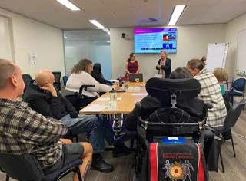

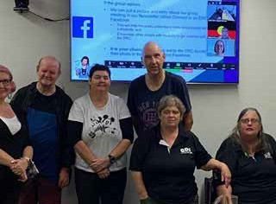

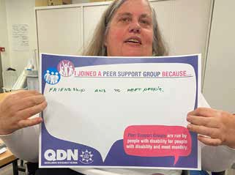

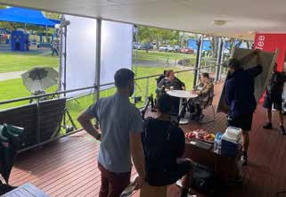

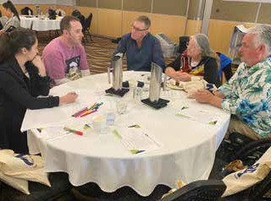

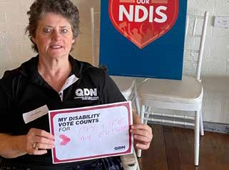
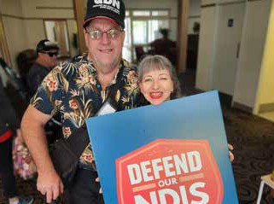

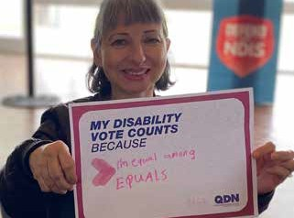

Sunshine Coast Peer Support Group

The Sunshine Coast Peer Support Group has been working on building their connections on the Coast and creating a welcoming environment for members. The group meetings have had a focus on better understanding of decision making, choice and control, and inclusive and accessible housing, as well as inviting Federal election candidates to share with the group what their parties offer people with disability on the Coast.

Positive Parenting Peer Support Group

In 2022, QDN welcomed a new peer support group. The Parenting Peer Support Group is a state-wide group for parents with intellectual disability which meet both in person and online. The group have been meeting monthly to talk about topics such as child safety services, emotional resilience, and supports under the NDIS.

Toowoomba Peer Support Group

The Toowoomba Peer Support Group moved their meetings online this year to ensure they all could meet safely during the COVID-19 outbreaks. The group had robust discussions about the Federal election and invited candidates to share their views on disability services and supports in the region. The group has also been exploring social participation and creative spaces for people with disability in the Toowoomba region.

Ipswich Peer Support Group PCEP

Ipswich Peer Support Group have been working together around preparing for emergencies and disasters. The group put their person-centred emergency plans to into action when the area flooded in early 2022. Group members have been using meetings to build their resilience while catching up over a coffee to make sure everyone is doing alright.

Brisbane South Peer Support Group

In 2022, the Sunnybank Peer Support Group changed their name to the Brisbane South Peer Support Group. This group have been meeting online and plan to move back to face to face meetings when COVID-19 outbreaks drop in the community. The group has heard from Queensland Fire and Rescue representatives about new smoke detector laws and what to do in case of an emergency, speakers on disability housing options, and Laura Freak from the NDIA about the NDIS and vaccinations.

Cairns Peer Support Group

The Cairns Peer Support Group partnered with ARC Disability Services, STRIDE, Rights in Action and Every Australian Counts to host a Disability Election Forum on 28 April 2022. This event had all 11 candidates running for the seat of Leichhardt join the debate, giving people with disability the opportunity to ask questions of the candidates. The group also had a continuing focus on disaster planning and person-centred emergency preparedness plans to help group members to be prepared for Far North Queensland weather events.

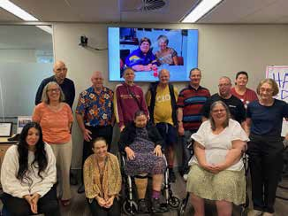

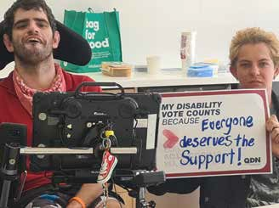

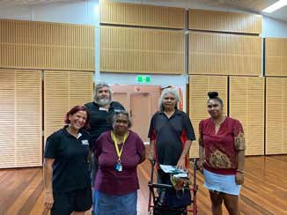
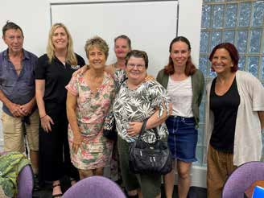

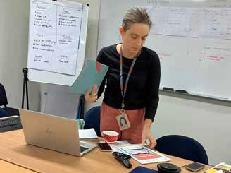

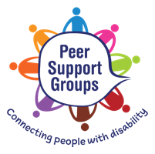

State-wide Online Peer Support Group

On 14 September 2021 QDN held the first meeting of the state-wide online peer support group for people with disability on Zoom. The group provides people with disability with another option to be part of a peer support group to connect with people with disability from all over the state. This group has welcomed members from all over Queensland from Mission Beach to Toowoomba.

Normanton Peer Support Group

The Normanton Peer Support Group is bringing together people with disability in this remote part of Queensland. The group have been finding out more about the Royal Commission into Violence, Abuse, Neglect and Exploitation of People with Disability, with speakers joining online to hear from this community directly. The group also welcomed in person the NDIS Community Engagement National Operations, Rural and Remote team who provided members with information about the National Disability Insurance Scheme

MAC Peer Support Group for over 65s

QDN’s MAC Peer Support group is for people with disability over the age of 65. The group has been discussing Wills, enduring power of attorney and public trustee with ADA Australia, age friendly communities with Queensland Human Rights Commission, and the Queensland Anti-discrimination Act review.

Griffith University Peer Support Group

QDN has been working with Griffith University to form a peer support group for people with disability at university. On 27 April 2022, QDN hosted the first Griffith University Peer Support Group with 10 people with disability attending. The group has continued to grow with more people with disability joining the group to provide support to each other around navigating systems like the NDIS and University life.

Redcliffe Peer Support Group

The Redcliffe Peer Support Group foundations for the group have been established through active engagement and development the community.

Rockhampton Peer Support Group

The Rockhampton Peer Support Group had a focus on inclusion this year. The group has been inviting speakers to discuss inclusion for people with disability in Rockhampton and exploring inclusive tourism and the benefits to the community and businesses. To build on this topic the group invited Councillor Drew Wickerson from Rockhampton Council to discuss access and inclusion in the local community.

Tablelands Peer Support Group

To provide more opportunities for people with disability to be part of the Tablelands Peer Support Group the group decided to hold meetings alternating between Mareeba and Atherton. The group has a strong focus on accessible and safe communities and has been talking with the Council about how they can work together on this important topic.

Self-management Peer Support Group

The Self-management Peer Support Group is an online space for people with disability to discuss self- and plan-managing their NDIS plans. The group meet monthly to talk about tools and strategies and has invited the NDIS to provide the group with up-to- date information about the scheme and any changes.

QDN Y Peer Support Group for young people with disability

QDN Y Peer Support Group for young people with disability. This group provides a space for younger people with disability to discuss the issues that are important to them. Topics the group have explored have included Disability Royal Commission, better understanding how and why to vote in elections, and maintaining mental health and wellbeing.

Yarning Circles for Aboriginal and Torres Strait Islander People with Disability

QDN has been partnering with First Nations people to establish and support peer support groups for Aboriginal and Torres Strait Islander people with disability. Group have been meeting in Cairns, Ipswich and Maryborough to explore the National Disability Insurance Scheme, as well as coming together for a yarn to talk about topics that are important to them and their community.

Supported Accommodation Peer Support Groups

As part of this project QDN has established Peer Support Groups in four supported accommodation places in Nambour, Ipswich, and Brisbane. These groups have been meeting monthly onsite to talk about learn more about topics including National Disability Insurance Scheme, getting connected, using digital technology, and social participation.

P-CEP Peer Leadership Project

QDN has been delivering co-designed and peer-led person-centred emergency preparedness and leadership online workshops to people with disability in South Australia, New South Wales, and ACT.
62 people with disability have completed all five workshops and are now building awareness of emergency preparedness in their local networks.
QDN has brough together P-CEP Peer Leaders in Queensland, Victoria, NSW, SA and ACT to form a community of practice so people with disability can share information, strategies and learnings with each other to continue to build their emergency preparedness knowledge and skills.

Gold Coast – Get Ready, Plan Ahead workshops

QDN has been working with the University of Sydney and City of Gold Coast Council to run workshops for people with disability to be more prepared for an emergency or disaster. 89 people with disability from across the Gold Coast have taken part in two workshops to learn more about inclusive disaster emergency planning. The codesigned workshops have been delivered by QDN’s peer leaders who have experience developing their own emergency and disaster plans as well as helping other people with disability to get prepared. The workshops had presentations from City of Gold Coast Council and State Emergency Services giving participants information on what do to do in an emergency and what are the local supports. The project used individual data from PCEP plans to inform local level disaster emergency planning to be enacted in time of emergency and worked collaborative with community and disability services sectors, emergency services, and local disaster management team to identify a process and framework for working together in disability inclusive disaster planning.

Group Convenors Community of Practice

Group Convenors continue to meet monthly to share ideas, information, support and access learning and development opportunities around their leadership in peer support.

Engagement forums

Brisbane 2032 Games

2032 Olympic and Paralympic Games: Visioning Forum

On 13 June 2021, QDN held the Brisbane 2032 Games Visioning Forum. With over 70 participants the Forum was opened by the Hon Stirling Hinchliffe MP, Minister for Tourism, Innovation and Sport and Minister Assisting the Premier on Olympics and Paralympics Sport and Engagement. Three speakers, including two former Paralympians, Geoff Trappett and Karni Liddell, and Dr Sharon Boyce, set the scene for how we can work together to create an inclusive, accessible games and ensure the legacy of the Games includes positive outcomes for Queenslanders with disability in terms of more accessible housing, transport and infrastructure.

The Brisbane 2032 Olympics and Paralympics Games provide a ‘once in a lifetime’ opportunity for Southeast Queensland and our state more broadly to be recognised on the world stage as the most inclusive and accessible city. The Games also provide an unprecedented opportunity to deliver an Olympics and Paralympics that showcases inclusion and accessibility and leaves a legacy for an inclusive Queensland for all including people with disability.

We have 10 years to go until the main event occurs with the Olympic games being held from 23 July to 8 August 2032 and the Paralympic Games from the 24 August to 5 September 2032. Whilst this is a momentous and important event, we acknowledge that the Games are a short moment in time. QDN and the disability community broadly aspires to a legacy left that encompasses people with disability living, playing, learning and working in inclusive and accessible communities across Queensland.

QDN and its broad network of people with disability want to ensure Queenslanders with disability benefit from the $8 billion economic and social revenue generated for Queensland by hosting the 2032 Olympic and Paralympic Games, including jobs.
QDN members are also excited about the opportunities for Queenslanders with disability to be included in the planning,design and delivery of the Games, even in these initial planning stages, to ensure a Games’ legacy that sees Brisbane and our surrounding communities emerge as one of the most accessible and inclusive cities in the world.

‘’ Disability leadership means to me that I am representing my community’’

Alycia Staples
Emerging Leader

QDN Online Forum: Taxis and passengers with disability

QDN held an online event with over 50 people on 2 June 2022 around taxis and passengers with disability. The aim of this forum was to give members a platform to make an impact in improving issues around taxis for people with disability.
QDN members noted that taxis are becoming increasingly unreliable, there are longer waiting times to order and wait for a cab to arrive, and many drivers are insufficiently trained to secure people

in wheelchairs or provide them with appropriate customer service. People are missing their medical appointments and have reported instances of having to wait in often unsuitable conditions for long periods for taxis to arrive. People are also experiencing insecurity about the continuation of the Taxi Subsidy Scheme (TSS) which, if discontinued, would mean accessing essential services and socially and economically participating in the community would become out of reach to many people.

QDN members identified that this forum was an important opportunity to discuss shared experiences of people with disability living in metropolitan, regional, rural, and remote communities. Alongside this, it was important to identify solutions focused on improving accessibility, affordability, timeliness, and quality for passengers with disability, along with broader issues around TSS and obtaining some certainty around a national solution to subsidies taxi travel.

Disability is an Election Issue

On 4 May 2022, nine state-wide organisations came together to host an online forum with over 200 participants, and representatives from a range of political parties. The purpose of the forum was to hear how the key political parties standing in this Federal Election will deliver a more inclusive Australia and raise the disability issues that matter to people with disability, families, and workers.

This event was convened by QDN, with the assistance of ADA Australia, Aboriginal and Torres Strait Islander Disability Network of Queensland, National Disability Services Queensland, Queensland Alliance for Mental Health, Queensland Advocacy Inc., Parent to Parent, QIDAN and the Queensland Collective for Inclusive Education

Election Forum - Cairns Event

On 28 April 2022 in Cairns, as part of the ‘Every Australian Counts’ Defend the NDIS
- Day of Action, several organisations came together to host a Disability Election Forum. All 11 candidates running in the seat of Leichhardt attended. The debate lasted for over 2 hours and provided
QDN members in the Cairns community an opportunity to ask questions around disability. The local organisations who co- hosted the event included ARC Disability Services, STRIDE, Rights in Action and Every Australian Counts, supported by the Cairns Peer Support Group.

The NDIS: 2021 in review and the way forward to improve in 2022

QDN members came together on 13 December 2021 for this event, reflecting on a year that was filled with a range of proposed legislative changes and issues impacting on the day to day lives of people with disability, and together working on ways forward.

A report was provided to the Hon Craig Crawford, Minister for Seniors and Disability Services and Minister for Aboriginal and Torres Strait Islander Partnerships, and the feedback from QDN members is also being used to inform QDN’s work to improve the NDIS for Queenslanders with disability. QDN members were clear that it is only through listening to the lived experiences of people with disability and involving people from the beginning in the planning, design, implementation and evaluation processes that the NDIS can deliver on its promises of greater choice and control.
This was also an important key message Queenslanders with disability put forward to candidates in the 2022 Federal election.

Transport Matters – Advocacy and Inclusion

On 6 December 2021 a workshop was held for QDN members who wanted to learn more about the legislation and standards that govern and guide our transport accessibility and inclusion. Geoff Trappett from Inclusion Moves delivered
a two-hour workshop for members interested in getting more information and growing their knowledge, skills and advocacy in this space.

Disability Action Week event
- Driving workforce diversity, inclusion, and innovation

QDN celebrated the end of #DisabilityActionWeek by hosting an on- line employment forum with up to 150 people with disability, family, community and government registrations.

The forum discussed employment opportunities for people with disability and the benefits of inclusive workforces. Dr Dinesh Palipana, the 2021 Queenslander of the year, Katie Brooker and Catrin Culla from Mater Health, and Cody Skinner, First Nations person from QDN’s Emerging Leaders program, were keynote speakers. The event was opened by Minister Craig Crawford, Minister for Disability Services.

Participants spoke about ways people with disability can be included and engaged in employment opportunities, why having a diverse and inclusive workforce is a good business model, and the different ways we need to rethink employment and business such as entrepreneurship and small businesses run by people with disability.

The breakout rooms were hosted by graduates from QDN’s 2021 Emerging Leaders program, show-casing their growing leadership skills.

The concurrent sessions explored different aspects of employment and inclusion
in relation to people with disability, from systemic change to self-employment innovation. While discussion explored the barriers and experience of people with disability, the intent was to lead to solution focussed actions to increase employment rates and experiences for people in the workplace.
COVID-19 Situation – What’s changed? – Managing my treatment and care in COVID-19

This online forum took place on 17 February, with Deputy Chief Health Officer, Dr Peter Aitken as key speaker. The free online information session was for people with disability and their families. It covered information about testing, what to do and who to call if you or your support worker/ family member test positive to COVID-19, and keeping safe with PPE, vaccination, boosters and your health and disability supports during this time.

Peer Leaders

QDN’s Peer Leaders are leading in their own lives and in their communities across Queensland and influencing a range of issues affecting their local communities. They are critical to QDN’s network of influence which ranges from this kind of local, grassroots activism, to national influence informed by these and other active members.

Targeted Outreach Project

Connecting people to the NDIS

The purpose of the Targeted Outreach project was to undertake targeted outreach with people with disability, community, and mainstream services across Queensland to identify, support and refer potentially eligible applicants to the Department’s Assessment and Referral Team (ART) for intensive case management support to apply for NDIS.
The project focussed on priority cohorts often deemed as ‘hard-to-reach’ including individuals and families at high risk of homelessness, domestic and family violence, and hospitalisation, and from rural, regional, remote communities.

The Targeted Outreach Project (TOP) was delivered by a consortium comprising QDN, the Queensland Council of Social Service (QCOSS), AMPARO Advocacy and the Aboriginal and Torres Strait Islander Disability Network Queensland as part of Aged and Disability Advocacy Australia (ADA Australia), working in partnership with hundreds of community organisations and voluntary groups across Queensland.

Top worked intensely with

2,243 people with disability regarding their NDIS eligibility.

1,284 individuals with disability making direct referrals ART.
This resulted in $56 million in NDIS plans across Queensland.
An additional 959 people were referred to other support systems.
Top coordinated
2,473 engagement/capacity activities.
Top worked with
8,608 individuals across the social service sector.
Top engaged with 4,500 organisation and hosted 14 local level Engagement Groups.
241 organisation participating and contributing to regular LLEG meetings held in each region.
21 Local Champion with disability and lived experience of the NDIS across the regions.
QDN have facilitated
1,294 items to be donated to people with disability
768 instance of capacity building support

AAA Digital Inclusion Project
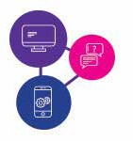
Connecting people to technology

Beginning in November 2021, Access, Affordability and Ability Digital Inclusion is a pilot project for Queenslanders with disability to get access to digital devices, data, and skills to help them stay connected to their communities and supports, particularly during emergencies including health and natural disasters.

Research shows that people with disability are up to four times more likely to die or be injured during disasters than others. The consequences of people not having a plan and access to warnings severely impacts what happens during an emergency and in the response phase.

This includes impacts on resources and safety of not only the individual, but also the other service systems involved, including community, disability, and emergency services.

To ensure people with disability have access to supports and services during emergent situations it is important they have digital connection. In recent natural disasters, the ability to access the digital world has been key to enabling people with disability to have the right and timely information, as well as access to essential goods and services to support their health, emotional wellbeing and continued social connection.
This project is a collaboration between Queenslanders with Disability Network (QDN), GIVIT and Volunteering Queensland (VQ).

To help ensure that people with disability are not left behind and that the digital divide in this sector is reduced, this project will assist people to:

ACESS: Get devices

AFFORDABILITY: Get information about

ABILITY: Get the skills knowledge to know how to use technology with a key focus on accessing information and services during an emergency or disaster.

GOAL 3: LEAD

LEAD expresses QDN’s goal of enhancing the leadership and influencing capability of people with a disability. This goal has been met this year through the activities of Peer Leaders and the Emerging Leaders programs and with 2 key leadership summits.

Peer Leaders

Peer Leaders came together in April for the Peer Leaders forum to work on the QDN leadership framework, co-design principles, leadership and relationship development, and team building, enhancing, and building on their leadership skills.

Emerging Leaders Program

In 2021 QDN held the first Emerging Leaders program, with 20 people with disability graduating in November 2021.

Graduation: 2021 Emerging Leaders

Due to the success of the first Emerging Leaders program, QDN received a large number of applications from people with disability for the 2022 program. Due to the high number of quality applications QDN increased the number of participants from 20 to 40 for 2022 and established 2 groups.

In March and April 2022, 33 program participants met in Brisbane for their first workshop. The Emerging Leaders also participate in a monthly online workshop where industry and disability leaders share their experiences, knowledge, and their own leadership journeys, and answer questions and participate in conversation with the group, to build the capacity of this new generation of leaders. Guest speakers have included Dr Stephen Duckett who held health sector leadership positions in Australia and Canada, Geoff Rowe, CEO of Aged and Disability Advocacy Australia, Anne Greer and Nigel Webb, disability and social justice advocates, Sharon Boyce, QDN Board Director and founder of Discovering Disability and Diversity, Kevin Stone, self-advocacy educator and Fran Vicary, Director of Engagement, NDIS Quality and Safeguards Commission.

Nigel Webb Emerging Leaders Bursary

Nigel Webb was elected to the QDN Board of Directors in 2010 and as Chairperson in 2011 and retired in 2021. In these 10 years, Nigel made a significant contribution to the organisation, to the Board, and more broadly to the disability sector.

“I got involved with QDN through Hot topics, before that there was no outlet for people with disability to discuss the topics that matter to us”
Donna Best

To acknowledge and recognise Nigel’s long-term role and dedicated work, QDN’s Board of Directors established a bursary to be offered to the Emerging Leaders called the Nigel Webb Emerging Leader Bursary.

Jeni Lewington was the successful recipient of the inaugural Bursary in 2021- 22, and due to COVID had to postpone her chosen trip to Melbourne until June 2022.
Jeni’s learnings from the trip:

The best leaders are kind, generous with their time and very good at listening.
They are also non-hierarchical, treat everyone with dignity and respect, and display a sense of confidence and empathy.

Each of the people I met welcomed me with kindness and openness, and a sense of really being interested in what I had to say. There was an equality inherent in their approach to others, with no obvious hierarchy. This approach has taught me not to be intimidated by people in power and to realise that I do have the confidence to speak to unfamiliar people. I love the sentiment ‘There are no strangers here, only friends you haven’t met yet’.

These are the qualities I saw in each of the people I met while in Melbourne, and I hope to treat everyone I meet with the same respect, dignity, generosity and kindness that I experienced on my trip to Melbourne.

Leadership Summits

Two summits were held this year to strengthen the connections, support and influence of QDN members.

Peer Leaders Forum
More than 70 QDN Peer Leaders from across Queensland gathered for a one- day forum and dinner on 27 April 2022 at Broncos Leagues Club. The Peer Leaders group are made up of the Group Convenors, Local Champions, DIDRR Peer Facilitators, Digital Inclusion leads and QDeNgage consultants and Board Directors. It was a great day and Minister Crawford opened the forum and spoke with members about leadership, the importance of people with disability as leaders, and how the Minister and Government intend to work with QDN now and into the future.

The day included activities and engagement around our leadership framework, co-design principles, leadership and relationship development and team building, and was followed by a dinner attended by key Government Department representatives.

International Day of People with Disability online summit

As part of the Power of Peers Project and building on the success of last year’s event, QDN’s Brisbane and Gold Coast Hot Topics Peer Support Groups for people with an intellectual disability have continued to work with self-advocacy groups in Canada to hold their second international online event.

Almost 100 people with intellectual disability from around Australia, Canada and USA, came together to talk about how they use their voices to lead in a post-COVID world. They talked about how they are leaders in their own lives and communities and what is needed from them as leaders now. This empowering event was a great success, and the shared work of growing the leadership of people with intellectual disabilities continues. Jeni Lewington and the VALID team

“ Through QDeNgage I have been connect to different projects and feedback sessions that I otherwise would not have known how to get involved with. Making these connections through QDN has meant so much to me as
I look forward to meeting new people with the same focus on outcome for those with disabilities.

I have also been able to connect with people who understand what life is like with a disability and there is an instant camaraderie of understanding. Because of this, I have met some really wonderful people and have made personal friendships. This has also opened up the opportunity to hear more about what is happening in other communities with the possibility of getting involved!
Because of QDeNgage and the connections I have made through them has given me a lot of purpose, focus and a renewed energy for positive outcomes!

Thank you so much to the QDeNgage team! “

Member Sarah Empey, QDeNgage

GOAL 4: INFLUENCE

INFLUENCE is key to QDN’s success and encompasses the strategic goal of Influencing through governance structures and practices that reflect QDN’s values, representation to key points of influence, State and National alliances, and membership of local, state and national committees.

Governance structure and practice that reflects QDN’s values

QDN’s motto of Nothing About Us Without Us, and its values, are expressed in QDN’s governance and structures in several ways:

- QDN is governed by people with disabilities
- QDN is an employer of people with disabilities
- QDN’s work supports capacity in people with disability to inform, lead, connect and influence.
- QDN has developed its position of influence in the sector and successfully sought funding for its peak body status

In 2021-22, QDN’s Board of Directors reviewed the strategic plan and goals, reinforcing the direction that QDN is growing in, led by members and focused on nothing about us, without us.

Representation to key points of influence

QDN continues to grow its leading position as an organisation of, by and for people with disability. QDN is a respected and sought-after voice for people with disability and is engaged in representation to key points of influence from the local to the national level.

This representation includes:

Meetings and briefings with Queensland Government Ministers and senior Government officials, particularly this year with the Departments of Seniors, Disability Services and Aboriginal and Torres Strait Islander Partnerships; Health; Communities, Housing and Digital Economy; and Justice and Attorney- General.

“ To me, Disability Leadershio means being authentic and proactive in driving and supporting change for people with disability, with empathy and integrity so that inherent value is recognised and voices heard”

Angie Keegan

Key Committee representation

In Queensland, QDN is represented on key committees, including

- QHealth COVID-19 Working Group – Disability
- QHealth COVID-19 Working Group – Residential Aged Care.
- QHealth COVID-19 Testing Implementation and Improvement Working Group
- Advisory Group: Implementing NDIS Worker Screening
- COVID-19 Disability Services Clinical Advisory Group
- Queensland Volunteering Partnership.
- Department of Housing Residential Services Reference Group
- Residential Tenancy Authority Stakeholder Working Group
- Queensland Human Rights Commissioner – Review of Anti- Discrimination Act Reference Group
- COVID-19 Vaccination Consumer Engagement Committee
- COVID-19 Residential Aged Care and Disability Services Clinical Advisory Group
- QCOSS and Department Communities, Housing and Digital Economy Human Rights and Housing and Homelessness Stakeholder Reference Group
- Queensland Women’s Strategy Advisory Group – Attorney General
- COVID-19 Testing Implementation and Improvement Working Group
- Queensland Health - QLD Hospital Discharge and Housing Project
- Youth Justice and Disability Working Group
- Queensland Health Long Stay Strategic Working Group
- Positive Behaviour Support and Restrictive Practices Review Reference Group
- Queensland Disability Advisory Council
- Positive Behaviour Support and Restrictive Practices Review Reference Group
- Voluntary Assisted Dying Communication and Engagement Committee
- Council to Homeless Person Queensland (CHPQ) Network
- Queensland Health Long Stay Strategic Working Group
- Queensland University of Technology Centre for Justice, Domestic and Family Violence Committee

QDN also engages at a national level, meeting with Commonwealth Government Senators, MPs, Ministers and senior government officials, particularly around COVID-19 issues, health, and the NDIS. QDN is represented on national committees including the Disability and Health Sector Consultation Committee (DHSCC)

Forums, briefings and consultations

QDN is frequently invited to bring our expertise and advocacy to a wide range of one-off or short-term policy and issue-
based forums, briefings and consultations. The list below illustrates the enormous range of QDN’s influence:

- NDIA – Independent Advisory Council Research and Evaluation Advisory Panel - NDIS Wellbeing Index Steering Group
- . Queensland Clinical Senate Meeting Reimagining healthcare: for the next phase and beyond

- Intellectual Disability Reference Group (IDRG) Sub-committee of the
Independent Advisory Council, National Disability Insurance Agency – several sessions

- Behaviour Support Formal Advice: Independent Advisory Council of the NDIS

- Attorney-General’s office – key election commitments in the justice and women’s portfolio areas

- Interviewed for Disability Royal Commission Research grant – young people with intellectual disability and criminal justice system

- Housing and Domestic and Family Violence Roundtable

- Queensland Public Advocate – Restrictive Practices Reform Options paper

- COVID System Response Planning Forum Queensland Health

- Roundtable on e-Scooters

- Critical Supply Chain CRC Healthcare Roundtable

- National Disability Data Asset Community Stakeholders Consultation – Office of Prime Minister and Cabinet

- Commonwealth Disability and Health Sector Consultation Committee (DHSCC) meeting

- Commonwealth Department of Health – National Roundtable on Roadmap for Health and Intellectual Disability

- Rental Law Reform Briefing

- Queensland Health COVID-19 Vaccination Rollout Forum

- Disability Advocacy Forum 2021 – NDIS Quality & Safeguards Commission

- Sustainable Built Environment National Research Centre – Liveable Social and Affordable Higher Density Housing.

- Women and Children Health and Safety Consultation – Coercive control.

- Queensland Alliance For Mental Health member forum

- Halwyn Centre Multi-Agency Meeting Council for Homeless People Queensland coalition

- QShelter CEO Housing Forum

- Meeting with Blind Citizens Australia Acting CEO, National Policy Officer and Policy Manager to discuss key policy issues

- New Zealand Assistant Director Fire and Emergency Services meeting – DIDRR

- E-safety Commission – Digital safety and digital inclusion for people with intellectual disability

- Health Consumers Queensland NGO COVID meetings

“The involuntary loss of function was difficult on so many ways but the consequent loss of choices in my life was actually the hardest thing to come to terms with. QEeNgage has reminded me of value and worth I provide to society. With their encouragement and support, I’ve had the confidence to pursue other business endeavors and seek opportunities to support my community.”

Nerine Williams
QDeNgage

- Queensland Health COVID Planning Forum

- Young People in Residential Aged Care QLD Industry Reference Group - Ability First Australia YPIRAC System Coordinator Program

- Volunteer Management Activity Reference Council - People with Disabilities

Speaking engagements
QDN members and staff have been speakers at a variety of events this year:

- Complex Interfaces Forum – key note speaker and forum partner with The Hopkins Centre

- Keynote presentation at Griffith University Reflecting on NDIS Reforms – Next steps for Rights and Justice workshop

- Keynote presentation to University of Sydney Disability Inclusion students with member Donna Best

Influence spotlight - NDIS reforms

In 2021, widespread member concern and distress around proposed NDIS Reforms, including Independent Assessments, underpinned a determined campaign by QDN on this important issue. QDN actively engaged with members, allies, partners, Governments and MPs, and statutory bodies including the NDIA, as well as the broader sector around the reforms. We also worked closely with the Every Australian Counts Campaign group as close interstate allies.
QDN also engaged directly with the NDIA and its advisory groups:

- Consultation with Independent Advisory Council, NDIA with regards to NDIS Reforms
- Intellectual Disability Reference Group (IDRG) Sub-committee of the
Independent Advisory Council, National Disability Insurance Agency – several sessions
- NDIA – Independent Advisory Council - Research and Evaluation Advisory Panel
- NDIS Wellbeing Index Steering Group

Influence spotlight - All Abilities Working Group

QDN worked closely with the Department of Seniors, Disability Services and Aboriginal and Torres Strait Islander Partnerships in providing subject matter expertise and establishing a Working Party to provide feedback on the All Abilities Queensland Plan.

QDN developed, in consultation with members, disability sector representatives and the department, a report which examined the extent to which Disability Service Plans achieved their purpose as required under the Disability Services Act 2006. The report considered the full suite of All Abilities Queensland: Opportunities for all State Disability Plan 2017–2020 reporting documents, including progress reporting on 2017-2020 DSPs, 2017-2020 DSPs and 2020-2021 interim DSPs. This report included:

- An analysis of how individual agency Disability Service Plans reflect the needs of people with disability. For example – for Queensland Health, this feedback would include issues for improving the healthcare of people with disability.
- An analysis of the extent to which actions identified in DSPs contributed to the achievement of All Abilities Queensland priority areas (Communities for all; Lifelong learning; Employment; Everyday Services; Leadership and Participation) – with a particular focus on employment opportunities for people with disability.
- Recommendations to strengthen issues identified in the above and areas for future action.

This report and the Working Party had strong influence in the key stages of the development of the new State Disability Plan under the Australian Disability Strategy.

State and National Alliances

QDN always works collaboratively to advocate for issues impacting people with disabilities, forming alliances for specific campaigns and issue-based engagement. Our alliances include:

- Queensland Volunteering Action Partnership

- Queensland Disability Advocacy Alliance

- Council to Homeless Persons Queensland homelessness alliance .Health/Disability Non-Government Organisation Partnership

- Disability Advocacy Network Australia

- QCOSS Community Services Network Queensland Peaks Network

- Making Rent Fair Alliance

QDN also actively supports organisations that share values and goals with
QDN, attending events and forums to demonstrate that support. Forums and meetings with allies included:

- QCOSS Budget Breakfast Q-Shelter AGM

- AMPARO Advocacy AGM SUFY AGM

- QCOSS AGM

- QAMH 6th Annual Alliance Members meeting

- Volunteering Queensland AGM

- Tenants Qld AGM

In addition, QDN has been a guest at a variety of public launches and events this year:

- Premier’s Christmas reception

- Aboriginal and Torres Strait Islander Housing Queensland launch

- State of Volunteering in Queensland Report launch

- Launch of the Strangulation Trauma Centre

- Second Action Plan for Housing 10 Year Plan launch

- State of Volunteering in Queensland policy position and advocacy plan launch.

Influence spotlight: Making Rent Fair Alliance and Rental Reforms

QDN is an alliance partner in the Making Rent Fair Queensland Campaign. A campaign re-launch was held on 7 July 2021 in Cathedral Place, across the road from QDN, and attracted strong media presence and coverage on TV, radio and print media across Queensland. Elisha Matthews, QDN member and peer leader, was interviewed by ABC and Channel 9 about her rental experience.

On the 13 July QDN provided a submission to the State Parliament’s Community Support and Services Committee about the State Government’s Housing Legislation Amendment Bill 2021. This submission highlighted the needs of people with disability in the housing rental market and improvements to the draft Bill to strengthen renters’ rights. QDN was consequently invited to appear before the Committee to present the issues.

GOAL 5: GROWING OUR NETWORK

Growing our network is critical to our continued success as a voice for people with disability in Queensland. This means not just reaching members and growing membership, but also growing our network of influence for change and getting our messages out to the community

This year we have had great success growing our network and amplifying the voice of members in disparate issues such as e-scooters, COVID-19 and Housing. Our voice on social and other media continues to grow, as more people and agencies become aware of what QDN does and the people and issues it represents.

Vale

In 2021-22, the disability community in Queensland lost a number of outstanding leaders, advocates, and dedicated QDN members. We pay tribute to them all, and will further recognise these irreplaceable leaders in our 20 year birthday celebrations in 2022-23.

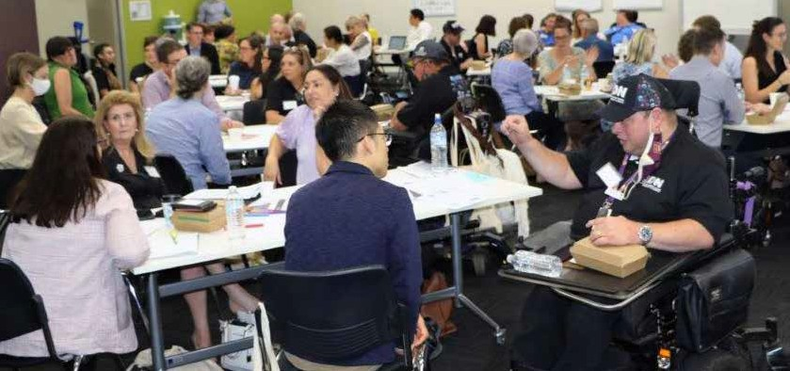

“Disability leadership to me is doing things that will make changes that help other people with disability in some way”

Richard McCarthy
QDN Emerging Leader

PART 3: FINANCIAL OVERVIEW

Income
QDN’s total income for the 2021-2022 financial year was $3,656,787
(2020-2021: $3,066,712).

This was primarily comprised of:

$482,914 QDN Core Business
$1,100,000 Targeted Outreach
$ 160,000 Queensland Department of Communities, Housing and Digital Economy Projects
$154,433 Queensland Health Projects
$909,650 Department of Social Services- Power of Peers and Community Inclusion Capacity Building. – Disaster Inclusive Risk Reduction Project
$5,000 Gambling Community Benefit Fund & others grants
$511,456 Other income from projects QDeNgage and investments
$333,334 Digital Inclusion Project

Expenditure
QDN’s total expenditure fro the 2021-2022 financial year was $3,654,247 (2020/21: $2,899,569).
Surplus
QDN generated an operating surplus of $2,540 for the 2021-2022 financial year.

PART 4: APPENDIX

QDN Organisational Chart
