QDN 2022 Annual General Meeting | 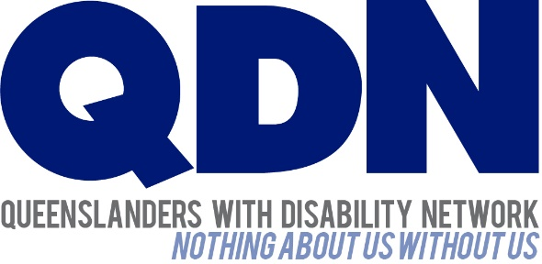
23 September 2022
Dear Queenslanders with Disability Network (QDN) Members,
This cover letter has been prepared to help you understand the material you have been sent and guide you where to find any other information you may need.

Annual General Meeting
On Saturday 29 October 2022, QDN will hold our Annual General Meeting (AGM).
The 2022 AGM will be a hybrid meeting both via Zoom and in person at:
Location | In person - Brisbane City Hall, ‘Kedron Room’, 64 Adelaide Street, Brisbane City  Online - ZOOM LINK - https://us06web.zoom.us/j/87930705454
Time | Members Sign-in from 9:15AM to 10:00 AM, Morning Tea from 9:15AM  AGM from 10:00 until 12:00

IMPORTANT INFORMATION
Votes MUST be cast in advance and sent to the Company Secretary 48 hours in advance.
The Notice of AGM audited financial statement and minutes from 2021 AGM accompany this letter.

What’s in your pack:
Please find enclosed the following information for QDN members:
- Notice of Annual General Meeting and Agenda (second in your pack on blue paper)
  - This includes:
    - The notice of Annual General Meeting
    - Nominations for Elected Directors of Board
- Voting instructions and voting form (third in your pack on green paper)
- Minutes of the previous AGM 2021(fourth in your pack on yellow paper).
- Audited financial statements (fifth in your pack on white paper)
- Directions to the AGM venue
To help you with your voting, you may also access the following online:
- Short video stories from nominees
- An electronic copy of the Voting Form
You can also find these resources online:
- QDN Annual Report 2022 (after the 2022 AGM)
- Electronic copy of the audited financial statements
- Member code of conduct
To access this material online go to the QDN website under the About QDN > Corporate Information or go to www.qdn.org.au/about-qdn/corporate-information.
You MUST REGISTER YOUR ATTENDANCE BY FRIDAY 21 OCTOBER. When you register, please make sure you PROVIDE YOUR EMAIL AND MOBILE NUMBER in case we need to contact you urgently in the days leading up to the AGM or on the day itself.
You can register for the AGM to attend either in person or online in one of three ways:
Go on-line: to www.qdn.org.au/about-qdn/corporate-information
Call us: on 1300 363 783, or
Email us: at qdn@qdn.org.au
You are welcome to bring your own support worker. QDN will provide support workers on the day. Please let us know if you have any access, personal care or other support needs, e.g., interpreters.
QDN can provide limited transport assistance to members within the south-east corner. If you would like to make use of this assistance, please contact the office.
If you wish to refer to the financial report at question time in the AGM, we request that you bring the hard copy of the financial report included in this pack to help QDN to be as cost efficient and environmentally friendly as possible. A small number of copies will be available on the day if required by members, however copies will be limited.
You are invited to contact us on 07 3252 8566 or email qdn@qdn.org.au if you have further questions regarding your attendance at our AGM.
I look forward to seeing you there.
Kind regards
Michelle Moss
Acting CEO Chief Executive Officer
Queenslanders with Disability Network

Directions to the Venue
- Entry to the Brisbane City Hall, which is via King George Square and is within easy distance of the bus stops, railway station and taxi stops.
- QDN will have a staff member at the entrance of the location to assist with directions.

Map of location of Brisbane City Hall
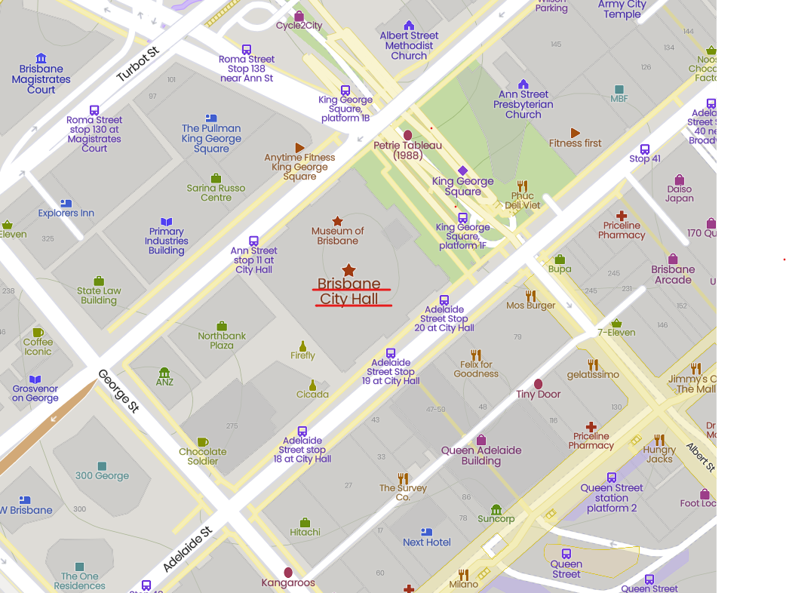
Map of Brisbane with Brisbane City Hall highlighted by a star. The surrounding bus stops are marked by a small purple bus symbol.

Public Transport
You can catch a bus or train to Brisbane City Hall.
Information about Brisbane public transport is available by calling Translink on 13 12 30 or visiting their website at www.translink.com.au/(opens in a new window).
- ramp access into the building via the main entrance on King George Square
- a nearby taxi rank on the corner of Ann Street and Roma Street.

Public Car Parking
There are a number of public car parking stations within the CBD and metered street parking is available in surrounding streets. Brisbane City Council operates two public car parks in the Brisbane Central Business District (CBD). There are also street parking meters throughout the city and surrounding inner-city areas. Find information on parking in the Brisbane CBD at Council's car parks.

