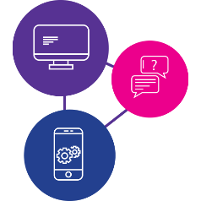
Need to learn the skills to access information online during a disaster?
Our digital inclusion program can help!
These workshops are for people with disability to:
- learn essential digital skills,
- get facts and information in times of emergency,
- have access to essential goods, services and support like food, medicine, healthcare, support
- stay connected to family, friends and workers.
Being online is really important during emergencies and disasters.
We will be running workshops on a Thursday so bring your phone, tablet or laptop with a full battery and any additional support you need!

Workshop #1 - Getting to know your device - How do I use my device? What do I need to know? – Thursday, 1 September 2022
Workshop #2 - Being online and staying informed - How do I access the internet and make a video call? – Thursday, 8 September 2022
Workshop #3 - Accessing essential goods and services - How do I use social media, apps and online services? – Thursday, 15 September 2022
Workshop #4 - Understanding data - What is data, how much does it cost and where do I start? – Thursday, 22 September 2022

Time: 1:00pm to 3:00pm (afternoon tea provided)
Where: 52 Palm Dr, Townsville Queensland 4818, North Townsville Community Hub (NOTCH)
Do you need a digital device? Please call 1300 363 783 and ask to speak to the digital inclusion team or scan the QR code below to learn more about the project.
www.qdn.org.au/our-work/access-affordability-ability-digital-inclusion/
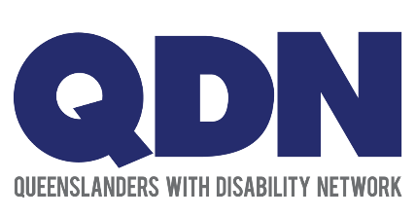

Do you need support with your phone, tablet or laptop?
Our digital drop-in sessions can help!
These digital support drop-in sessions are for people with disability to:
- learn essential digital skills,
- get facts and information in times of emergency,
- have access to essential goods, services and support like food, medicine, healthcare, support
- stay connected to family, friends and workers.
Bring your phone, tablet or laptop with a full battery and any additional support you need!
Time: Every Thursday from 1:00pm to 3:00pm
Where: 52 Palm Dr, Townsville Queensland 4818, North Townsville Community Hub (NOTCH)
RSVP: Please call QDN: 1300 363 783 to register your interest or (07) 4751 6511 to speak with NOTCH for venue enquiries.
Online or over the phone digital support may also be available please ring 1300 363 783 to enquire.
Do you need a digital device? Please call 1300 363 783 and ask to speak to the digital inclusion team or scan the QR code below to learn more about the project.
www.qdn.org.au/our-work/access-affordability-ability-digital-inclusion/

