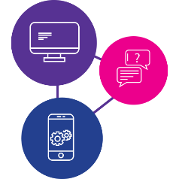

Need to learn the skills to access information online during a disaster?

Our digital inclusion program can help!

These workshops are for people with disability to:
- learn essential digital skills,
- get facts and information in times of emergency,
- have access to essential goods, services and support like food, medicine, healthcare, support
- stay connected to family, friends and workers.
Being online is really important during emergencies and disasters.
We will be running workshops on a Monday so bring your phone, tablet or laptop with a full battery and any additional support you need!

Workshop #1 - Getting to know your device - How do I use my device? What do I need to know? – Monday, 1 August 2022
Workshop #2 - Being online and staying informed - How do I access the internet and make a video call? – Monday, 8 August 2022
Workshop #3 - Accessing essential goods and services - How do I use social media, apps and online services? – Monday, 15 August 2022
Workshop #4 - Understanding data - What is data, how much does it cost and where do I start? – Monday, 22 August 2022

Time: 10:30am to 12:30pm (morning tea provided)
Where: Nerang Neighbourhood Centre, 29 Martin St, Nerang QLD 4211
Do you need a digital device? Please call 1300 363 783 and ask to speak to the digital inclusion team or scan the QR code below to learn more about the project.
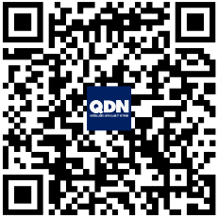
www.qdn.org.au/our-work/access-affordability-ability-digital-inclusion/
