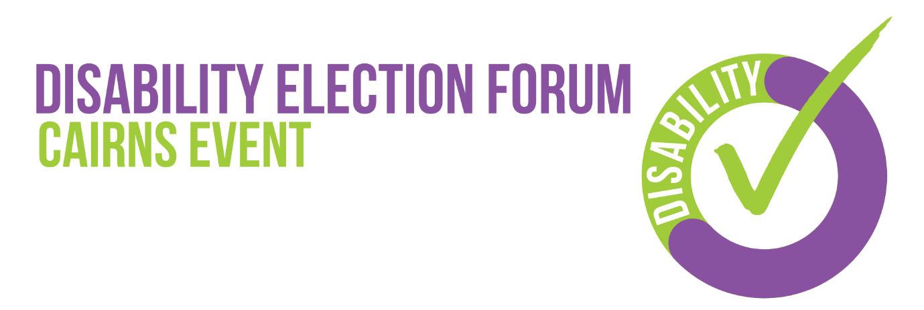

The Federal Election is on 21 May 2022, it is an important one, especially to people with disability, their families and workers. The past two years have demonstrated the need to elect a future Federal Government who will listen and to lead with vision to deliver full inclusion and participation of people with disability as citizens within our communities.
Come along to a local forum and hear how the key political parties standing in our electorate, will deliver a more inclusive Australia and raise the disability issues that matter to you!
When: Thursday, 28 April 2022
Time: 3:00pm to 5:00pm
Where: Cairns Colonial Club, Cannon Street, Manunda
RSVP: Register online at www.eventbrite.com.au/e/disability-election-forum-tickets-321122846077
For more information or if you need assistance in registering contact QDN by phone 1300 363 783 or email qdn@qdn.org.au

