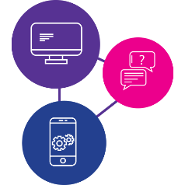

Need to learn the skills to access information online during a disaster?

Our digital inclusion program can help!

These workshops are for people with disability to:
- learn essential digital skills,
- get facts and information in times of emergency,
- have access to essential goods, services and support like food, medicine, healthcare, support
- stay connected to family, friends and workers.
Being online is really important during emergencies and disasters.
We will be running workshops on a Wednesday so bring your phone, tablet or laptop with a full battery and any additional support you need!

Workshop #1 - Getting to know your device - How do I use my device? What do I need to know? - 4 May 2022
Workshop #2 - Being online and staying informed - How do I access the internet and make a video call? - 11 May 2022
Workshop #3 - Accessing essential goods and services - How do I use social media, apps and online services? - 18 May 2022
Workshop #4 - Understanding data - What is data, how much does it cost and where do I start? - 25 May 2022
Time: 10:00am - 12:00pm (morning tea provided)
Where: Bardon Neighbourhood Centre, 180 Jubilee Terrace, Bardon
To register call 1300 363 783
Do you need a digital device? Please call 1300 363 783 and ask to speak to the digital inclusion team or scan the QR code below to learn more about the project.
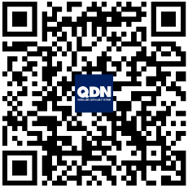
www.qdn.org.au/our-work/access-affordability-ability-digital-inclusion/

