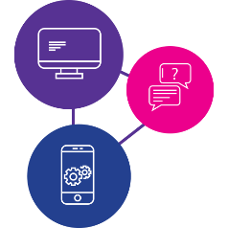

Need to learn the skills to access information online during a disaster?

Our digital inclusion program can help!

These workshops are for people with disability to:
- learn essential digital skills,
- get facts and information in times of emergency,
- have access to essential goods, services and support like food, medicine, healthcare, support
- stay connected to family, friends and workers.
Being online is really important during emergencies and disasters.
We will be running workshops on a Wednesday so bring your phone, tablet or laptop with a full battery and any additional support you need!

Workshop #1 - Getting to know your device - How do I use my device? What do I need to know? - 30th March 2022
Workshop #2 - Being online and staying informed - How do I access the internet and make a video call? - 6th April 2022
Workshop #3 - Accessing essential goods and services - How do I use social media, apps and online services? - 13th April 2022
Workshop #4 - Understanding data - What is data, how much does it cost and where do I start? - 20th April 2022

Time: 1:30pm to 3:30pm (afternoon tea provided)
Where: Gailes Community House - 30 Karina St, Gailes 4300
Do you need a digital device? Please call 1300 363 783 and ask to speak to the digital inclusion team or scan the QR code below to learn more about the project.
www.qdn.org.au/our-work/access-affordability-ability-digital-inclusion/

