QDN 2021 Annual General Meeting | 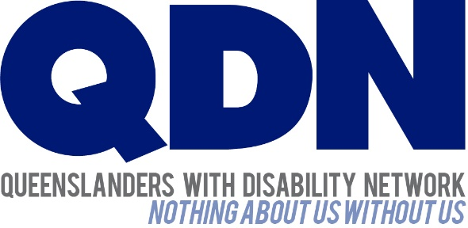
3 January 2022

Dear Queenslanders with Disability Network (QDN) Members

This cover letter has been prepared to help you understand the material you have been sent, and guide you where to find any other information you may need.

Annual General Meeting
On Saturday 19 February 2022, QDN will hold our 2021 Annual General Meeting (AGM). A COVID-19 safety plan is in place for the venue.
The 2021 AGM will be held as a hybrid event, both on Zoom and face to face at:

Join Zoom Meeting online
https://zoom.us/meeting/register/tZMkcOGvqD8vE9yfwDWDYmsi9yK_8BjXBUDi

Broncos Leagues Club
98 Fulcher Road Red Hill

Members Sign-in (Registration) from 9:30am to 10:15am
AGM from 10.15am until 12:30pm followed by a light lunch

What’s in your pack:
Please find enclosed the following information for QDN members:
- Notice of Annual General Meeting and Agenda (second in your pack on green paper)
- Minutes of the previous AGM 2020 (third in your pack on blue paper).
- Audited financial statements (fourth in your pack on white paper)
- Overview of QDN Annual Report 2020-21 (fifth in your pack on white paper)

You can also find these resources online:
- QDN Annual Report 2020-21 (full version)
- Electronic copy of the audited financial statements
- Member Code of Conduct

To access this material online go to the QDN website here
Broncos Leagues Club has a COVID-19 safe plan in place. You will need to check in either with the Check in Qld app or using a paper register, and be prepared to show evidence of your full COVID vaccination. This is a requirement for entry to the club.

Directions to the Venue if coming in person
The link to Google maps is here

Public Transport
You can plan how to get to the Broncos Club using this link here
Information about Brisbane public transport is available by calling TransLink on 13 12 30 or visiting their website here

Map of Broncos Leagues Club
There is a map available online here and below

Public Car Parking
Broncos Club offers free parking for visitors. There is some street parking available, and disability parking bays are located close to the entry pathway in the visitor’s carpark.
The COVID environment means arrangements are always subject to change. If QDN needs to move the meeting to online only we will let everyone know as soon as possible.

You can register for the AGM one of three ways:

Register on Zoom here You will need to have an established email address to register online and participate in the AGM on Zoom. If this is not possible you can call through on the phone or ask family or friends to assist you to create one. You can look up free email accounts on the internet to see how to set one up – Apple and Google are the most widely used.

Call us: on 1300 363 783
Email us: at qdn@qdn.org.au

You are welcome to bring your own support worker. QDN will also provide support workers on the day. Please let us know if you have any access, personal care, or other support needs. There will be an interpreter on the day, and captioning available on Zoom.

QDN can provide limited transport assistance to members within the south-east corner. If you would like to make use of this assistance, please contact the office.

If you wish to refer to the financial report at question time in the AGM, we request that you bring the hard copy of the financial report included in this pack to help QDN to be as cost efficient and environmentally friendly as possible. A small number of copies will be available on the day if required by members, however copies will be limited.

You are invited to contact us on 07 3252 8566 or email qdn@qdn.org.au if you have further questions regarding your attendance at our AGM.

I look forward to seeing you there.

Kind regards
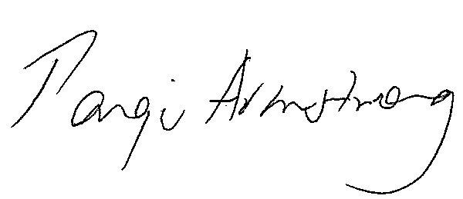
Paige Armstrong
Chief Executive Officer
Queenslanders with Disability Network

