Be Prepared for Disasters or Emergencies
QDN are looking for people with disability to learn more about making a plan an emergency.

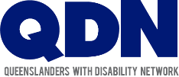
Queenslanders with Disability Network (QDN) is a state-wide organisation of, by, and for people with diverse disability.
What are we doing?
QDN has been working with the University of Sydney to help people with disability to prepare and make plans for an emergency or disaster.
Everyone should be prepared for an emergency.
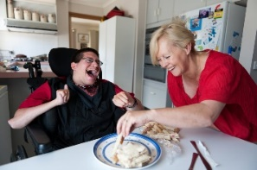
It helps if you have a plan for what to do before, during and after an emergency.
People with disability may need more time, support or information to make a plan.

QDN and the University of Sydney have co-designed this program by and for people with disability.
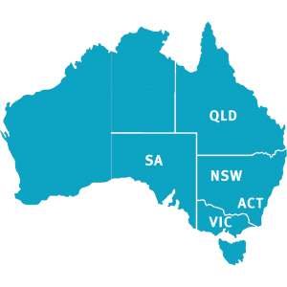
QDN is looking for people with disability in ACT, New South Wales and South Australian who want to make their own plan for an emergency or disaster and help other people find out more so more people can be prepared.
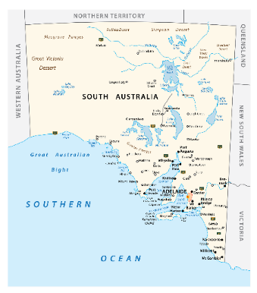
We’re looking for 20 people with disability in South Australia to become Peer Leader.

What would I have to do?
There are three things you’ll need to do:
Come to five online workshops to learn about making to make your own plan for an emergency or disaster

Tell others about how they can start to get ready and make a plan for an emergency or disaster.
Be part of online meetings with other people with disability from across Australia who have done the training called a community of practice. This is a place to share your ideas, learnings and tips.

Who Do I Contact for More Information?
Contact me, Lisa on 1300 363 783 or
email me at peersupport@qdn.org.au

Successful applicants will receive $250 contribution for their time being part of the five workshops.

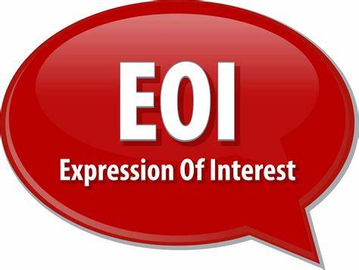
Please complete the Expression of Interest form by Sunday 19 December 2021

This project is Funded by the Australian Government Department of Social Services.

Expression of Interest form- P-CEP Peer Leadership Program

Ok, I’m Interested, How Can I Apply?

Great! There are many ways you can apply
you can complete the form below,

call us and we can complete the form with you,

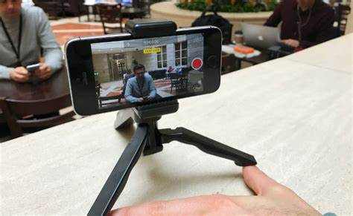
send us a video answering the questions

or
tell the answers to us in a way that you feel comfortable.

Questions

Name:

Contact Number:

Why would you like to be a part of this project?

How would you help others learn about being prepared for an emergency or disaster?

Tell us about your networks of people with disability:
Expression of interest close by Sunday 19th December 2021

please email completed forms or videos to
peersupport@qdn.org.au

