Person-Centered Emergency Preparedness Planning for COVID-19

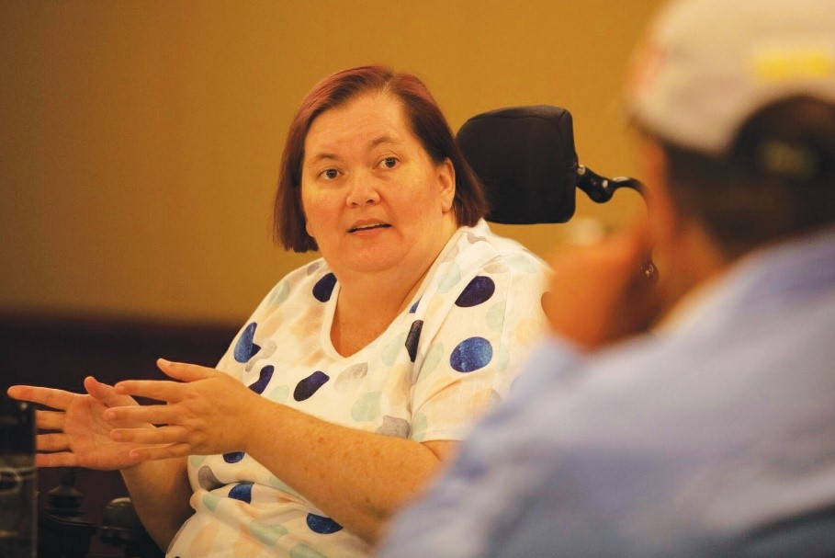

A GUIDE TO ASSIST YOU TO DEVELOP YOUR OWN EMERGENCY PREPAREDNESS PLAN FOR COVID-19

This is a guide to help people with disability to get the facts about Coronavirus (COVID-19) and make a plan for how they will manage the impact of this situation. People with disability need a plan that is tailored to their unique support needs.

Who developed this guide?
Queenslanders with Disability Network is working with a team at The University of Sydney who lead research on Disability Inclusive Disaster Risk Reduction. We work together to make sure people with disability are aware and prepared for all emergencies. This resource is funded with support from the Queensland Government Department of Communities, Disability Services and Seniors.
We work in partnership with people with disability to make sure they are included in all decisions about emergency management and disaster risk. We are working together during this public health emergency because we know that people with disability are at greater risk of contracting COVID-19 and may develop more severe symptoms.

What is in this guide?
This guide provides links to trusted sources of information about COVID-19 that have been made available in different formats to help people with disability get the information they need. It includes information about:
- Understanding COVID-19 and how to protect yourself;
- Making a plan for how you will manage during this public health emergency;
- Knowing what to do if you or someone who supports you experience symptoms of COVID-19.
In this guide, we are using the Person-Centered Emergency Preparedness (PCEP) Toolkit (Villeneuve et al., 2019). The PCEP helps people with disability to tailor emergency preparedness planning to their capabilities and function-based support needs. The PCEP was developed by researchers at The University of Sydney through a co-design process
involving people with disability and the services that support them.

Why is this guide important?
People with disability, their family and carers need the facts about COVID-19. Once they have the facts, they need to make a plan for how they will act together with their support network.
Some people with disability:
- have trouble getting the facts about emergencies and making a plan because information is not always accessible.
- need to adapt public health prevention strategies for COVID-19 to their abilities and living situation.
Until recently, there were no tools for people with disability to make emergency preparedness plans tailored to their support needs.
The PCEP (Villeneuve et al., 2019) is an Australian-designed toolkit that helps people with
disability to make a plan for how they will act together with their support network during emergencies.
The PCEP Toolkit has a series of three videos to show the PCEP in action. The PCEP Toolkit can be accessed here: www.collaborating4inclusion.org/prepare-nsw/

What should I do?

There are two things you can do now to keep yourself safe:

1. Get the facts about COVID-19 so you understand your risks and can take steps to protect yourself.
2. Make a plan for how you will manage the risks to your health and well-being during this period of uncertainty. This includes knowing what you will do if you or someone who supports you experience symptoms of COVID-19

We all need to be prepared and know what to do before, during, and after an emergency. People with disability may need additional support, resources, or advocacy during this health emergency.
Public health emergencies are unpredictable. Novel coronavirus (COVID-19) is a new virus that has no treatment at this time. This can make people feel worried or anxious.
Having a plan means knowing how you will:
- Manage your own needs;
- Stay in touch with family, friends and workers in different ways to help stop the spread of the virus;
- Know where to get help; and
- Support others during this period of uncertainty.

Having a plan helps
- People to manage their mental health and well-being;
- Build individual and community resilience.

Get COVID-19 Facts

You might catch novel coronavirus (COVID-19) if:
- Someone with the virus sneezes or coughs onto you
- Someone with the virus coughed or sneezed onto a surface (like a door handle) that you touched, and you get infected droplets on your hands and then transfer them to your mouth, nose, or eyes when you touch your face or eat.

There are 5 ways that we can all help stop the spread of viruses:
- Clean your hands regularly with soap and water or alcohol-based hand rubs.
- Cover your nose and mouth with a tissue or bent elbow when coughing or sneezing.
- Avoid touching your face, nose and mouth. Do not shake hands.
- Stay home if you are unwell.
- Practice social distancing, which includes staying 1.5 meters away from others as much as you can.

Household cleaning is also important:
Germs can live outside the body, on surfaces, after a person coughs or sneezes.

Regular cleaning is important for:
- Reducing the spread of germs and
- Minimizing the number of germs surviving on surfaces.

How do I get information about COVID-19?

Get the facts from trusted sites
Queensland Health https://www.health.qld.gov.au/
Australian Government Department of Health https://www.health.gov.au/
National Disability Insurance Agency (NDIA) https://www.ndis.gov.au/understanding/ndis-and-other-government-services/ndis-and-disaster-response
Health Direct Coronavirus Hub https://www.healthdirect.gov.au/coronavirus

We all need to be prepared and know what to do before, during, and after an emergency. People with disability may need additional support, resources, or advocacy during this health emergency.
Public health emergencies are unpredictable. Novel coronavirus (COVID-19) is a new virus that has no treatment at this time. This can make people feel worried or anxious.

Have a conversation
Find people who can help you to get started - this may be your house mates, family or friends. These are the people you should talk with.
You do not have to plan alone, and it is important to reach out to others for support.
Communication is key. Talk with the people who support you, including your paid staff about how you will keep each other safe from COVID-19.

Make a plan

What am I planning for?

- Plan to stay at home for a long period of time
- Plan what you will do if you or someone who supports you gets COVID-19 symptoms

How do I make a plan?

STEP 1: Identify your strengths and support needs
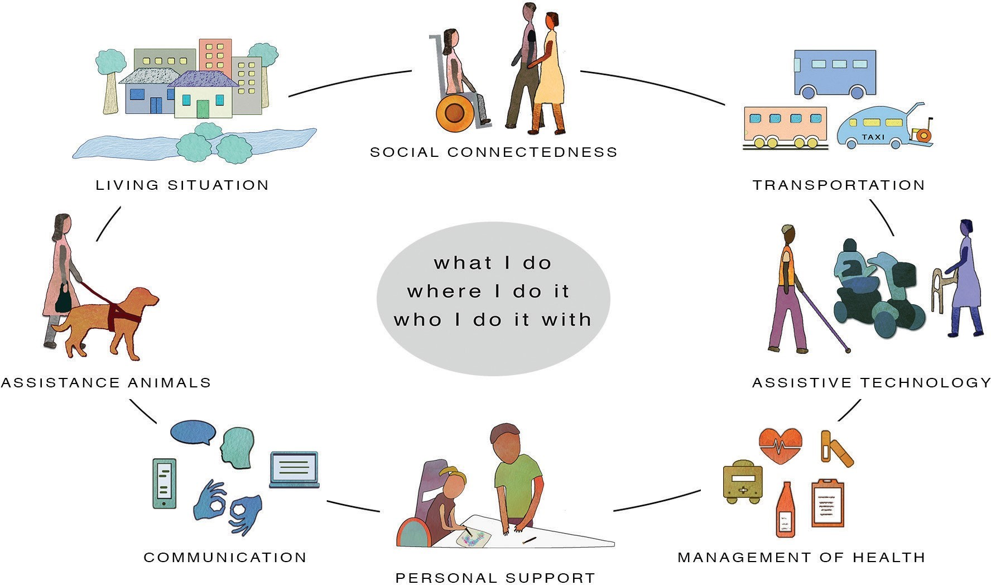

The PCEP helps you break down planning into eight areas:
Person-Centered Emergency Preparedness Capability Wheel (Re-printed with permission).

- Think about what you do, where you do it and who you do it with.
- Consider your roles and responsibilities to others (e.g., partner, children, parents) that you support
- Make a list of the things you need support for in each of the 8 areas.

My Support Needs

Communication: Getting, giving and understanding information.
Action: Write down things you need support for:

Management of Health: Taking care of your health.
Action: Write down things you need support for:

Assistive Technology: Help you get from equipment, but not people.
Action: Write down things you need support for:

Personal Support: Help you get from other people.
Action: Write down things you need support for:

Assistance Animals: Help from animals and how to care for them.
Action: Write down things you need support for:

Transportation: How you travel where you want or need to go (egg: Car, bus, train, taxi, walking).
Action: Write down things you need support for:

Living Situation: Where you live and who you live with.
Action: Write down things you need support for:

Social Connectedness: The people you do things with. Your relationships with friends, family, and other people.
Action: Write down things you need support for:
Published with permission ( www.collaborating4inclusion.org )

Make a Plan

What am I planning for?

1. Plan to stay at home for a long period.
2. Plan what you will do if you or someone who supports you gets COVID-19 symptoms.

Step 2: Use the following information starting from page 12 to plan now you will do things differently during COVID-19

The questions and tips help you to plan for

- How you will manage your supports needs while isolating at home
- Ways to reduce your risk of getting COVID-19
- What you will do if you or someone who supports you gets COVID-19

Share your plan with the people who support you - Family, friends and your support services and workers.

There are several resources that you can download, print and use to help to be safe. Links to resources are also provided.

Please be aware that some information and links provided in this workbook are specific to Queensland, Australia. If you reside in a different state, look for equivalent links and resources on COVID-19 in your state.

My PCEP Plan during COVID-19

Communication

Things to consider

- What devices do I use to keep in touch with people? (e.g., landline, mobile, computer, tablet etc.)
- How do I pay my bills?
- Do I have a pre-paid or post-paid plan?
- How will I keep in touch with others?

Tips

1. If you normally go to the shop to top up your phone, or the post-office to pay your bills, contact your provider to see how you could pay online or over the telephone.
2. Check that you have enough data and credit to keep in touch with people
3. Now is the time to ask for help around learning how to use technology. Think about what you might like to know (e.g., how to use Facetime; WhatsApp; Messenger; etc.) and who could help you learn.
4. Think about what back-up devices you could organize now and maybe if you only have a landline, is there a family member or friend who has a spare mobile phone they could loan to you?
5. Make a plan for how you will receive mail and packages to reduce the spread of germs.
6. Wipe packages and clean hands
7. Information on Australia Post and mail deliveries are here: https://auspost.com.au/about-us/news-media/important-updates/coronavirus#location

Management of Health

Things to consider
- What critical health information do I need to share in an emergency?
- What are the options in my area for having my prescriptions delivered?
- What supplies do I need? How will I get them?
- What other things will I need to maintain my health and wellbeing for two weeks?
- How will I take care of my mental health?
- How will I take care of my physical health?
- Do I have anyone who helps me with decisions around my health?

Tips
1. It is important you can continue to get the support you need and have your essential daily needs met.
2. The National Disability Insurance Agency (NDIA) has committed to prioritizing participants to ensure they can continue to get their disability-related supports, including additional supports or funding.
3. If you run out of essentials (food; medication) and you don’t have anyone to help you, call the Community Recovery Hotline on 1800 173 349
4. Do a stock take of what you currently have.
1. Check you have enough for 14 days or more of your prescription medication.
2. Non-prescription medication like aspirin, Panadol, ibuprofen continence aids, gloves, catheters, PEG feeding equipment and formulas, dressings, any other supplies relating to your disability.
3. Make a list of your important health information, current medication, essential supplies. Keep it somewhere that you can grab it or share with staff if you need to.
4. If you have someone who normally helps you with making decisions around your health, or is your statutory health attorney (SHA), make sure their name and contact number is written in your list.
5. If you have a health diary or way of sharing your important health information, make sure others who support you know where it is.
6. Check you have any special foods you might need on hand. Try to maintain healthy eating.
7. Make a plan for what you can do if the gym and normal exercises and classes are cancelled. Think about what you can do from home to keep up your exercise routine. Think outside the box and maybe link into an online class or get some dumbbells to use at home.
8. Talk to your service provider about different ways that can support you with your therapy or services to help you maintain your health and well-being. Some are starting to offer phone or video appointments so ask your provider.
9. Make sure you have the phone numbers written down somewhere handy to call if you start to feel sick with COVID-19 symptoms. Call your doctor or 13 HEALTH on 13 43 25 84.
10. Let your support workers know that you have COVID-19 symptoms.
11. Call 000 if you get very sick. If someone who supports you gets sick, call your service provider. If you are an NDIA participant, you can call the NDIA on 1800 800 110.

Assistive Technology (AT)

Things to consider
- What AT do I use?
- How will I clean my assistive technology to prevent the spread of germs?
- If my wheelchair or other AT breaks down, who do I call?
- What back up equipment do I need?

Tips
1. Have telephone or computer power cords or spare batteries/re-charging stations for your hearing aids.
2. Make a list of other items you would need to take with you if you needed to leave your home (e.g., specific utensils, shower chair.
3. Check your power sources and back-up power supplies.
4. Review your current AT maintenance schedule and check it is up to date.
5. If your AT breaks down and it is an emergency urgent repair, you can call the National Disability Insurance Agency (NDIA). For More information: https://www.ndis.gov.au/news/4142-urgent-assistive-technology-repairs
6. Think about if there is any everyday technology you could purchase that would help to manage by yourself. For example, Google home or other home technology could assist you with:
- voice commands for turning off lights
- listening to music
- getting news updates etc.

Personal Support

Things to consider
- What are my essential supports that I need each day?
- What supports must I have?
- What can I live without at this time?

Tips
1. Make a front door sign - This sign asks visitors to stop and consider whether their visit is essential.
2. You can leave instructions for visitors or mail deliveries.
3. A printable version is available at the end of this resource.
4. Have clear COVID-19 personal support instructions for your support staff: Including any new support staff.
5. Write COVID-19 care instructions down and post them in an accessible location at home.
6. Talk to your support staff about the 5 steps to keep you all safe from spreading the virus.
7. You can download and print this infographic to put up on the wall so your support workers can follow the 5 steps to stop the spread of COVID-19.
8. Link here: https://www.qld.gov.au/health/conditions/health-alerts/coronavirus-covid-19/take-action/coronavirus-prevention

If you are an NDIS participant
1. The NDIA has put a range of flexible things in place. If you need to, you can get your worker to do your shopping or get essential medications.

Frequent updates on NDIS disaster response and FAQs here
https://www.ndis.gov.au/understanding/ndis-and-other-government-services/ndis-and-disaster-response#faq
2. For older persons with disability - the Commonwealth Government has measures in place for older persons receiving aged care supports to continue to receive the essential services they need.
3. Have a back-up list of support workers. There are some agencies that may provide back-up staff like: Hireup, Mable, Careseekers.
4. Keep phone numbers of your service providers handy.
5. Know who you will call in an emergency and discuss your plan with your emergency contacts.
6. Have a printed or digital back up copy of:
A. My NDIS plan or My Aged Care plan
B. COVID-19 care instructions for support staff
C. Any information or materials that you may need to share so new staff know how to support you the best

Community Recovery Hotline

If it is not a medical emergency but you need urgent assistance or urgent supplies if you don’t have anyone to help you, you can call the Community Recovery Hotline on 1800 173 349.

Assistance Animals and Pets

Things to consider
- What care does my assistance animal or pet need?
- What will I do if my animal needs to see the veterinarian?
- Am I stocked up on supplies, food, medicines for my assistance animal or pet?

Tips
1. If your animal becomes unwell and needs to go to the veterinarian, call your regular vet first before visiting in person.
2. Check supplies and stock up on what you need for your animal or pet.
3. Don’t forget any medications your animal needs.
4. Find information on preparedness planning for your assistance animal or pet here: https://www.qld.gov.au/emergency/dealing-disasters/prepare-for-disasters/prepare-pets).

Transportation

Things to consider
- What are my options if I need to travel safely during COVID-19?
- If public transport service isn’t an option, how can I get to my essential services if I need to go to doctors or shopping?
- Can I call my doctor, family, friends instead of going in person?

Tips
1. Stop and think about whether you need to leave the house.
2. Can someone else go for you?
3. Can you call instead?
4. If you need to go, consider the safest way to travel where you need to go.
5. If you need to see the doctor or other medical health specialist telehealth may be available.
6. Telehealth happens by video or telephone attendance instead of face-to-face appointments and may be bulk-billed. Check with your doctor or health professional.
7. Ensure you have taxi subsidy card somewhere with your other health information if you need to travel in a taxi.
8. If you are using ride shares like uber, check that you have their booking apps on your phone if you need to book with them.

Living Situation

Things to consider
- Think about where you live and your home situation. Think about who you live with and arrangements you can make now to ensure your safety at home.
- Where do I spend most of my time?
- Who lives nearly that can help me wen needed?
- If public transport services isn’t an option, how can I get to my essential services if I need to go to doctors or shopping?
- Can I call my doctor, family, friends instead of going in person?

Tips
1. Make a plan if you have to stay in your home with people you live with and how you could keep safe distances from each other.
2. Plan now for how you can keep surfaces clean and how you will manage to support each other with meal preparation, laundry, house cleaning and other home maintenance.
3. Think about if someone you lived with had to self-isolate somewhere else, and how you can support each other during this period.
4. Read and print these three steps for household cleaning /PDF Format (Queensland Government).
5. Take time to review your fire safety at home. Information and preparedness tips can be found here.

Social Connectedness

Things to consider
- How can I maintain social connectedness while physically distancing from others?
- Who is in my circles of support both in person and virtually - who do I count on, and who counts on me?
- Who else is nearby that maybe that you could call on? think broadly about this, not only who you see in person, but who else do you have social connections with (e.g. online groups)
- What other ways could I feel connected to others?
- If you got sick, are there people who rely on you to contact them? Who else could they connect with?

Tips

1. Make a list of people who are important to notify of your whereabouts, including phone numbers, addresses and email addresses.
2. Make a plan for staying connected and in touch with people. Think about:
- speaking to someone you know at the same time each day (a check-in phone call)
- using facetime or other applications to speak with people
- starting a group with friends or family through social media (Facebook, Messenger, WhatsApp)
- speaking with friends or neighbors over the fence or balcony
- calling friends and family regularly
- Start an over the phone movie or book club
- Write letters to people that you haven’t seen in a while
- Make video calls and text friends and family
3. Find tips for looking after your health and well-being here.

4. Reach out and get help for social and emotional support when you need it. Contact numbers are below:
- Community Recovery Hotline
- Call 1800 173 349
- Lifeline
- Phone: 13 11 14 (24 hours/7 days)
- Text: 0477 131 114 (6pm – midnight AEDT 7 nights)
- Chat online: www.lifeline.org.au/crisischat (7pm - midnight AEDT 7 nights)
- Website: https://www.lifeline.org.au/
- Beyond Blue
- Phone: 1300 224 636 (24 hours/7 days)
- Chat online: https://online.beyondblue.org.au/#/chat/start (3pm - 12pm AEDT 7 days)
- Website: https://beyondblue.org.au

My COVID-19 Plan
Complete the following My COVID-19 Plan and put in a safe and easy to find place in your home:

Communication

1. I have my phone and computer or tablet to be able to stay in touch with people or call people in emergency?
Action: Write the name of your phone company here:

2. I have enough data and credit to keep in touch?
Action: Write the name of the company the data for your computer is with here:

3. Other things I need to do?
Action: Other important information about my communication:

Management of Health
    - I have my list of who to call?
Action: Write your list of emergency contacts here:

    - I know if medical emergency - call 000.

    - If I develop COVID-19 symptoms, I will call my doctor first or 13 HEALTH on 13 43 25 84.
Action: Write down the name of your support person for making health decisions:
4. Then call your service provider to let my support workers know that I have COVID-19 symptoms.

5. Have my important health information printed and accessible including my medications, blister packs, essential supplies and contact information if I have someone who helps me with my health decisions.
Action: Write down a list of your current medications:

6. I have a plan for looking after my mental and physical health and wellbeing if I have to stay home for a long time?

Action: Write down a list of essential supplies you need:

7. I know if I run out of essentials (food; medication) and there is nobody to help me, I can call the Community Recovery Hotline on 1800 173 349.
Action: Things I am going to do to look after my mental and physical health and wellbeing:

Assistive Technology
1. I have my power sources and back-up power supplies?
Action: Write down your current assistive technology maintenance schedule:

Action: Write down your current assistive technology maintenance people:

Notes
Repairs to AT in an emergency are considered by the National Disability Insurance Agency (NDIA) as urgent repairs. More information: https://www.ndis.gov.au/news/4142-urgent-assistive-technology-repairs

Personal Support
1. I have clear COVID-19 personal support instructions for my support staff, including any new support staff?
Action: Write down where copies of your important documents are kept:

2. I have communicated my COVID-19 care instructions to all of my support staff?
Action: Write down the names of your back-up list of support workers here:

3. I have written COVID-19 care instructions down and posted them in an accessible location at home?

4. I have discussed my play with my emergency contact?
Action: Write down the name and phone number of who you will call in an emergency:

5. I have a copy of my NDIS plan or My Aged Care support plan?
Action: Write down phone numbers of service providers, NDIA and other supports here:

Assistance animals and pets
1. I have a plan for who will look after my animal if I become unwell?
Action: Write down the name and phone number of your vet here:

2. I can develop a detailed preparedness plan for my assistance animal or pet using this information: https://www.qld.gov.au/emergency/dealing-disasters/prepare-for-disasters/prepare-pets).
Action: Write down the name of people who will help you with your animals if needed:

Action: Write down your animals needs here:

Transport
- I will call ahead to plan appointments?
2. I will make different plans to make sure I don’t have to leave home?
3. I have a plan for different ways to travel if I need to go out?
Action: Write down your transport options here
    - I have someone who can help me make decisions about transport?
    - Action: Write down the contact details of who can assist you with transport:

Living Situation
1. I have made or checked by home safety plan?
2. I have considered ways to protect me and others at home if we need to isolate from each other if someone gets sick?
3. I have a plan to increase household cleaning so that surfaces are wiped down regularly to decrease spread of germs?
Action: Write any notes here:

Social Connectedness
1. I have an emergency contact list?
Action: Write down your contact list of name and phone numbers here:
2. I have shared my emergency contact list with my support network?

3. I have a plan for staying connected and in touch with people?
Action: Write down your plan for staying connected and in touch with other people here:

Frequently Asked Questions

Question: I can’t isolate myself from other people because I need help with personal care including things like transfers, toileting, and bathing. What should I do to reduce my risk?
Answer: Be proactive. Keep lines of communication open with the people who support you. It is your right! Make sure that all the people who support you follow the 5 steps to stop the spread of viruses.
The 5 steps are:
1. Clean your hands regularly with soap and water or alcohol-based hand rubs.
2. Cover your nose and mouth with a tissue or bent elbow when coughing or sneezing.
3. Avoid touching your face, nose and mouth. And avoid shaking hands.
4. Stay home if you are unwell.
5. Practice social distancing, which includes staying 1.5 Meters away from others as much as you can.

Question: I rely on others to get my groceries, to prepare meals and to clean my house. How do I minimize my contact with germs?
Answer: Negotiate new routines to minimize your contact with germs to reduce their spread.
“I've changed some of my support worker routines - more hand washing and gloves for some things, wiping down surfaces with soapy water daily, they will open mail/parcels carefully and wash afterwards. We will keep re-evaluating if more changes are needed.”
“For my shopping person we've arranged he will leave the shopping on the front porch instead of bringing them in and putting things away - he brings it at a time there's already another support worker here. So, that support worker will bring things in, rinse them down, and put them away.”
Question: I have health/medical appointments and selfcare activities that require attendance in person (e.g. blood tests, scans, manual therapy sessions, hydrotherapy, home-based assessments for the NDIS). How do I weigh-up the risks versus benefits of appointments? What measures can I take if I need to attend things in the community?
Some people will need to attend medical or other specialist appointments in person.
Answer: Always call ahead to make a plan for your visit. Learn what to expect on arrival and follow the requested procedures.
Ask your provider if they can provide alternative formats such as telehealth or video conference as a substitute for face-to-face visits. Many service providers are increasing their capacity to deliver in novel formats that are helpful accommodations for people with disability. Check in with your provider about options they are developing for receiving services and supports.

Always take precautions to keep yourself safe before, during, and after appointments. This includes washing hands and cleaning surfaces (e.g. wheelchair).
Some providers may cancel services and this may impact your physical or mental health and well-being. Talk with your service provider about what alternatives you could put in place to maintain your health and well-being. For example, can your physiotherapist provide home exercises and check in with you by telephone? Will your counsellor provide online sessions?
Question: How do I look after my mental health and wellbeing during this time?
Answer: There are many ways we can support ourselves and others to look after our mental health at this time.
Some of these suggestions are to:
- Structure your day and keep routines where possible
- Do things that you enjoy and that are good for you
- Keep socially connected
- Keep things in perspective
- Find a healthy balance with media coverage
- Remind yourself that this is temporary
- Reach out to others
- Call support and help lines if you need to reach out. These are listed in the social connectedness section
On the next page is a printable sign which says stop, someone in this house is at higher risk of COVID-19. You could print it and put it on your front door.

Someone in this house is at higher risk of Coronavirus (COVID-19)

Please consider if your visit is essential
If you are showing any of these symptoms DO NOT VISIT! Cough: Sore throat: Runny nose: Fever: Shortness of breath. If your visit is essential, please wash your hands immediately for 20 seconds upon entering.

You can contact us on: Leave any packages at the door.

This is a sign that you can use to place on your front door to help people stop and think before they knock.
There is space at the bottom of the sign so that you can write any further instructions to visitors, or support workers.

Authors

A/Prof Michelle Villeneuve
Centre for Disability Research and Policy, The University of Sydney
E: michelle.villeneuve@sydney.edu.au, W: collaborating4inclusion.org

Michelle Moss
Business Development and Operations Manager, Queenslanders with Disability Network
E: mmoss@qdn.org.au W: qdn.org.au

Louise Abson, Project Officer, Queenslanders with Disability Network
E: labson@qdn.org.au
W: qdn.org.au

Ricky Buchanan
Bedridden Disability Advocate E: ricky@notdoneliving.net W: http://notdoneliving.net/

Suggested Citation

Villeneuve, M., Moss, M., Abson, L., & Buchanan, R. (2020). Person- Centred Emergency Preparedness Planning for COVID-19. A resource produced for the Queensland Government Department of Communities, Disability Services and Seniors.

Queenslanders with Disability Network and The University of Sydney.

This guide was funded by Queensland Department of Communities, Disability Services and Seniors and conducted in partnership with University of Sydney and Queenslanders with Disability Network.

