# Coronavirus (Covid-19) **Essential** Items Checklist

The Commonwealth Government has recently announced a one-off payment of $750 for people who hold Pension Cards. When thinking about spending this money, you might like to think about what essential items you might need to have in the cupboard if you have to stay at home for 14 days and can’t go out in the community. *You don’t need to go out and get everything on this list. It is a guide.*

**What are essential items?** Essential items are sometimes called staples. These are the things you need to live day to day. It can include food, personal, health and cleaning products you need that will last a long time in the cupboard and not go off. You can still get your fresh food, fruit and vegetables but these are some other things to think about having on hand.

## Important things to think about:

Check what you have already. You may have a range of things already stocked up in your cupboard and freezer.

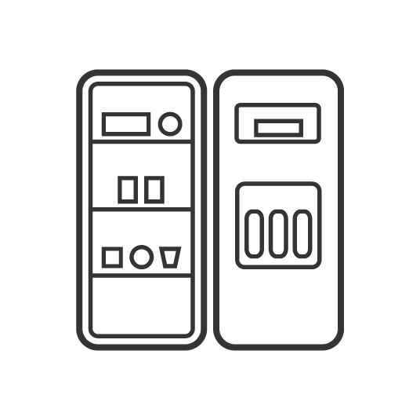 When you are buying items, look for canned, boxed and long-life items that can stay in the cupboard for a long period of time. Frozen foods are also good to have as well.

 It may be hard to find these some of these items at the moment. Governments are working with food chains to improve the supply of goods and food to our shop. It is important that you don’t over buy more than you need.

It is important you check what is happening at the place you usually shop. Different shops have different things in place like early morning shopping times for older persons and people with disability. Supermarkets and pharmacies may also have special arrangements for who can use home delivery services.

Drawing of computer and mobile phone You can call the shop, go online to their website, or you might ask your support service, family or friends to help you.

# Essential Items Checklist

## Drawing of an appleFood and water

## Long lasting fruit like apples and oranges

## Drawing of a carrotDrawing of a tomatoLong lasting vegetables like potatoes, sweet potatoes, carrots, onions, whole mushrooms

## Drawing of tinned fishTinned fruit and vegetables

## Tinned foods like baked beans, spaghetti, soups, lentils, tuna, chicken

## Drawing of a loaf of breadDrawing a roast chickenFrozen products like vegetables, fruit, meat, chicken, fish and frozen meals

Breads, pasta, rice, flour

Drawing of a box of cereal and bowl Cereals and packet foods like noodles, muesli, crackers, biscuits

 Eggs



Hard cheeses will last longer

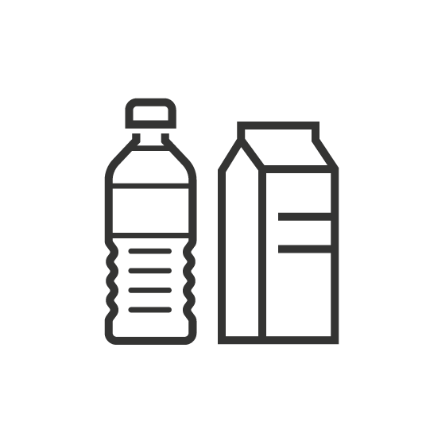

Water, juice, UHT long-life milk



Pet food and litter for your animals



Tea, coffee

Things you might like as a sometimes food treat 

## Toiletries & personal hygiene

 Toilet paper

 Toothbrush/ toothpaste

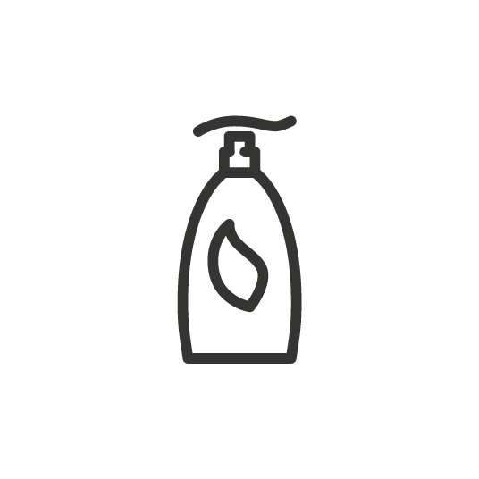 Soap/shampoo/conditioners

Personal hygiene/ Sanitary items (e.g. pads, hand sanitiser, deodorant, wipes, shaving products)

## Drawing of a bucket and broomCleaning and household products

Cleaning goods for floors and surfaces

Drawing of a washing machine

Washing detergent

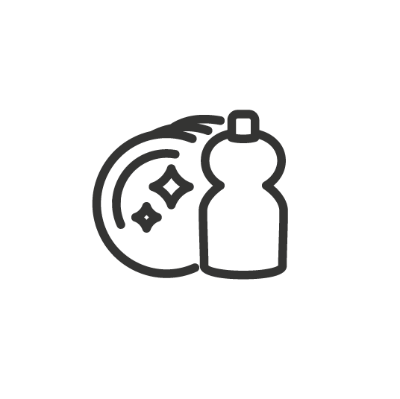

Dishwashing liquid



Bin liners

Plastic bags for food storage and used tissues



Batteries, chargers, candles

## 

## Medical and disability related health support

Over the counter medicines you usually have in the cupboard like asprin, paracetamol, ibuprofen, vitamins



Important medications and script medications (enough for 14 days)



First Aid Kit (optional)



Other essential consumable items related to your disability supports eg incontinence aids, catheters



Personal Protective Equipment (PPE)s like gloves and masks

## Communication & Entertainment

 Access to a home telephone or mobile phone, and if you do pay as you go, get your docket so you can recharge at home without needing to go to shops. Check on your phone coverage if you have switched to NBN recently

Books, games and things you like to do to relax



If you have it the internet and smart devices, check if you have enough data to access it during that time – you might think about downloading TV shows or movies during the night when lots of people are not using the internet

Drawing of a guitar Other