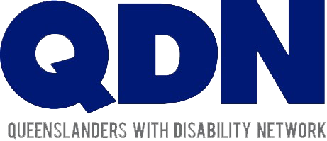
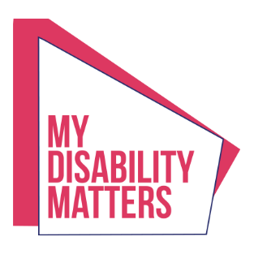

2020 State Election: Summary of key commitments from the political parties
Liberal National Party (LNP)
- "An LNP Government will continually work with the disability sector towards the best possible outcome for people with a disability."
- "A future LNP Government will continue to have a Minister for Disability Services."
- "A future LNP Government would welcome the opportunity to investigate solutions that
- deliver devices, data and build the digital skills of people with disability."
Queensland Labor Party
- The Palaszczuk Government has committed $500,000 for a new project to link people with disability with devices, data and digital skills.
- Labor will establish the Queensland Accessible Transport Advisory Council, providing "unprecedented opportunity for early and authentic consultation on all major transport projects."
- If re-elected Labor will "continue funding QDN as the state-wide peak organisation that provides an independent voice for Queenslanders with disability."
Queensland Greens
- The Greens "are committed to strengthening funding for independent individual and systemic disability advocacy services for people with disability."
- "The ​Queensland Greens recently announced our fully costed plan​ to build 100,000 public homes over the next 4 years."
- The Greens "support an investment in programs to build the digital skills of people with disability, and to provide support to deliver devices and data to people with disability."
One Nation Party
- "One Nation is committed to continued investment in independent individual and systemic advocacy across disability"
- "One Nation commits… to implement the outcomes and recommendations of the Disability Royal Commission."
- "One Nation commits... to a dedicated Minister for Disability Services and Inclusion."
To read the full responses from the political parties visit: https://bit.ly/2HEhb9R

