How to connect to a Zoom meeting

A guide for iPhones and iPads (iOS)

Topics include:
- What is Zoom?
- How do I install Zoom?
- How do I set up Zoom?
- How do I join a Zoom meeting?
- Muting and other Zoom meeting controls
- Troubleshooting and Frequently Asked Questions

What is Zoom?
Zoom is an online meeting space. People who are invited to a Zoom meeting can connect together.

Zoom is free to download. It will use your internet data.
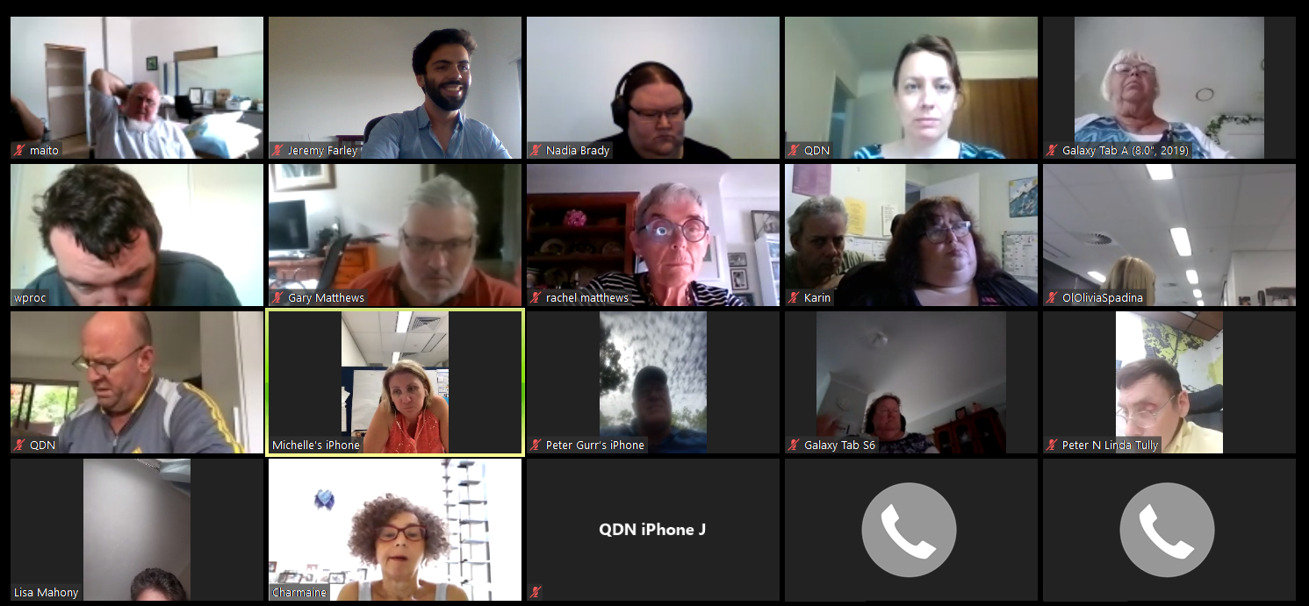

This is what a Zoom meeting looks like using a computer.

What device do I need to use Zoom?

To use Zoom, you need a device connected to the internet or to a phoneline.

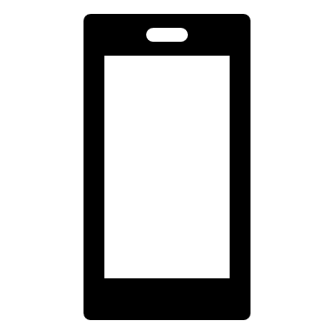
Your device might be a:
Smartphone
(like an iPhone or Samsung Galaxy);
Mobile phone or landline telephone.
Tablet (like an iPad or Samsung Galaxy Tab); or
Computer
(like a Windows or Apple laptop);

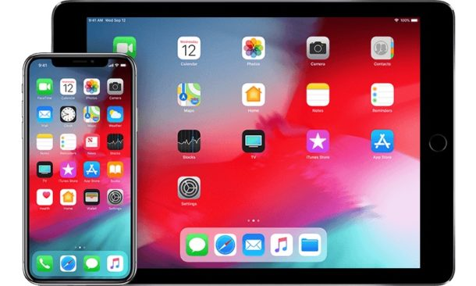
This is what the Zoom
app looks like.

How do I install Zoom?
You can install Zoom by getting the Zoom Cloud
Meetings app from the App Store.

To do this:
1.
This is what the App Store icon looks like.

While using your device, you can tap this link here to go to the App Store.
(Or you can open the App Store and search for ‘Zoom Cloud Meetings’.)

2.
3.
Tap the ‘Get’ button and follow any instructions. Look for the Zoom app on your device.
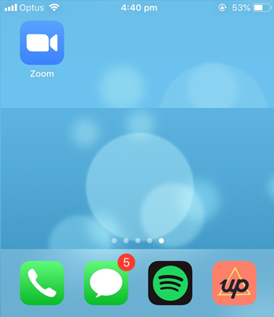

How do I set up Zoom?
Zoom needs to use your device’s microphone and camera.

To do this:
This is what the Settings app looks like.

1.
Open the Settings app on your device.

2.
3.
Scroll down to the bottom. Select Zoom. Make the microphone and camera buttons green.
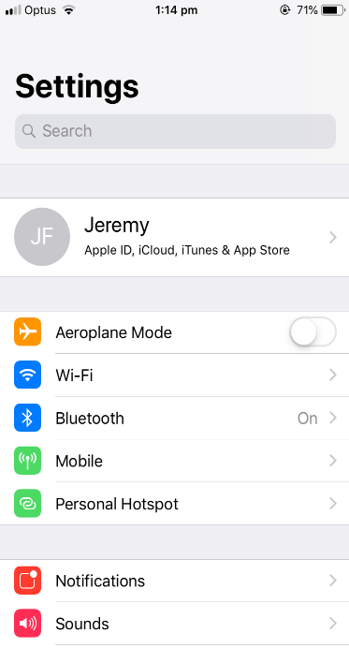
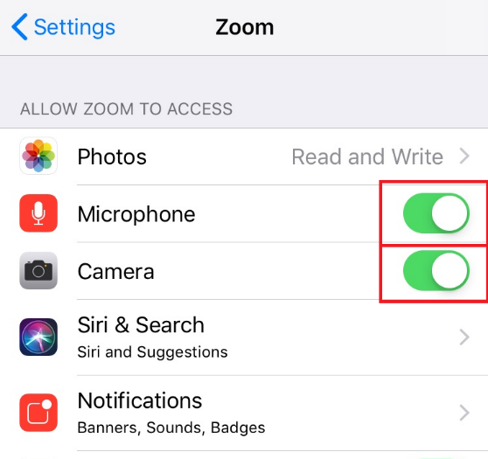

How do I join a Zoom meeting?
To join a Zoom meeting, you need to have the Meeting ID (and sometimes the Password).

These will be emailed to you. Use your device to open the email about the Zoom meeting.

Does this email have a Zoom website link that looks like this?

If you do have a Zoom website link…
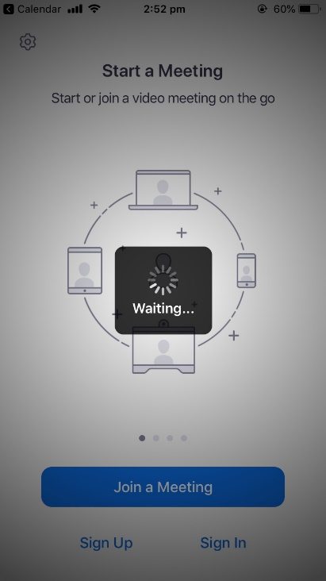
This link gives Zoom the Meeting ID and any Password.
1.
Tap the Zoom website link.

2.

The Zoom app will open.

Choose if you want to join the meeting with video. Choose ‘Call using Internet Audio.’
4.
3.
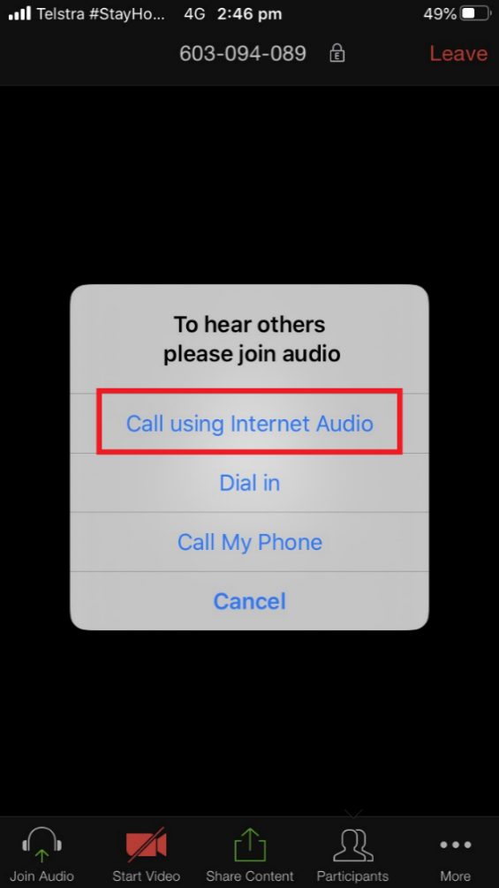
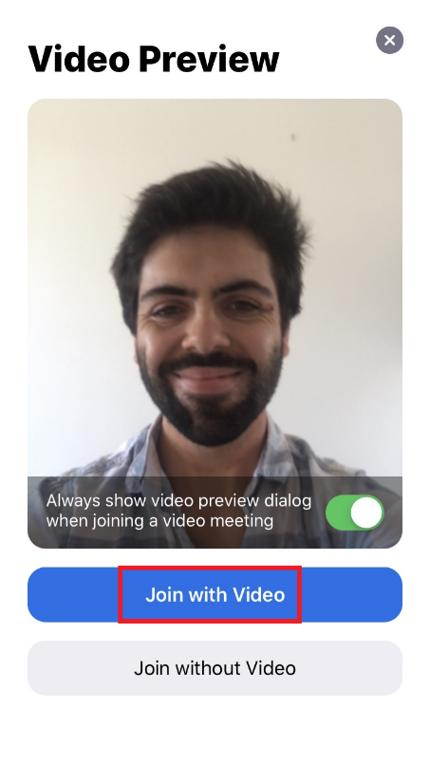

5.
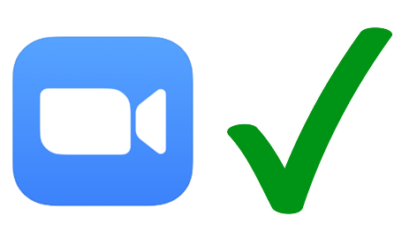
You’ve joined the Zoom meeting!
Check our Troubleshooting help sheet if things aren’t working.

If you do not have a Zoom website link…
You’ll need to give Zoom the Meeting ID and any Password yourself.
Open the Zoom app.
Note down the Meeting ID and any Password
from the email.
2.
1.

3.
5.
4.
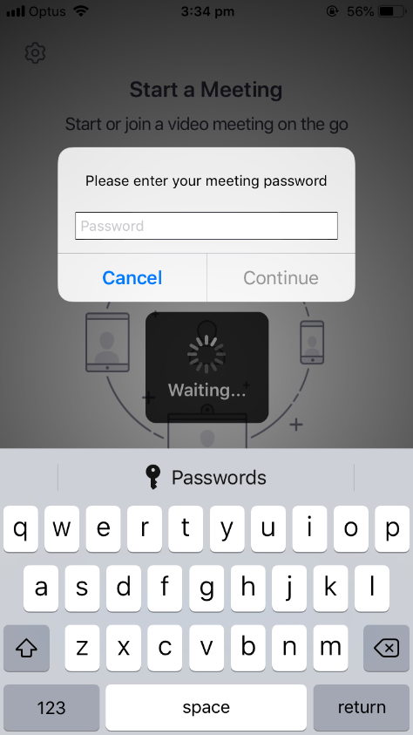
Tap ‘Join a Meeting.’ Type in the Meeting ID. Type in the Password for the meeting.
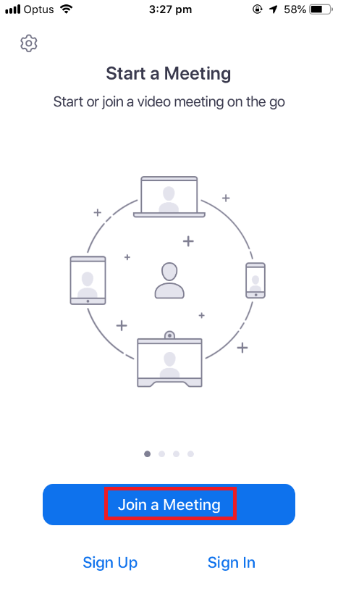
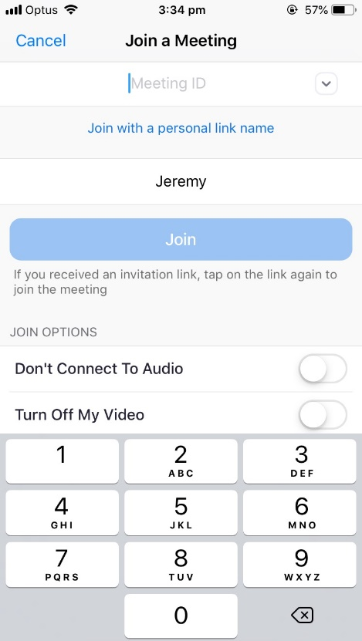

Choose if you want to join the meeting with video. Choose ‘Call using Internet Audio.’
7.
6.
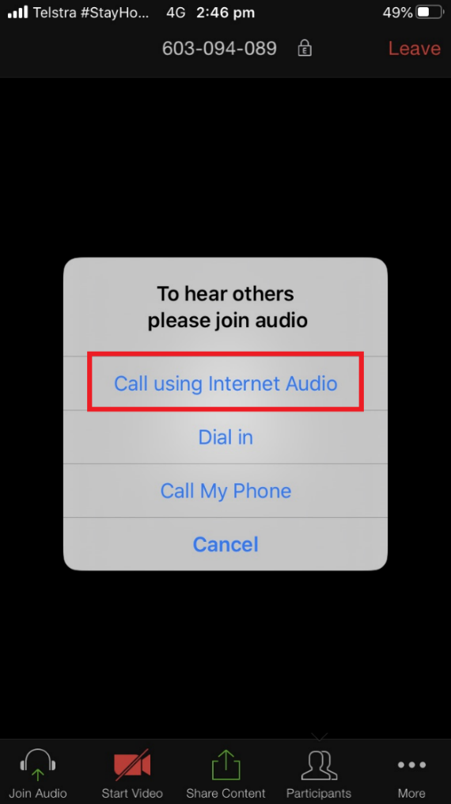

8.
You’ve joined the Zoom meeting!
Check our Troubleshooting help sheet if things aren’t working.

Muting and other Zoom controls
When using an iPhone or iPad, your Zoom meeting can look like this.
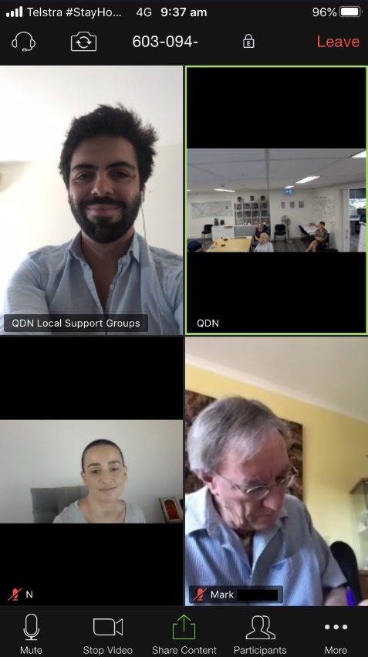
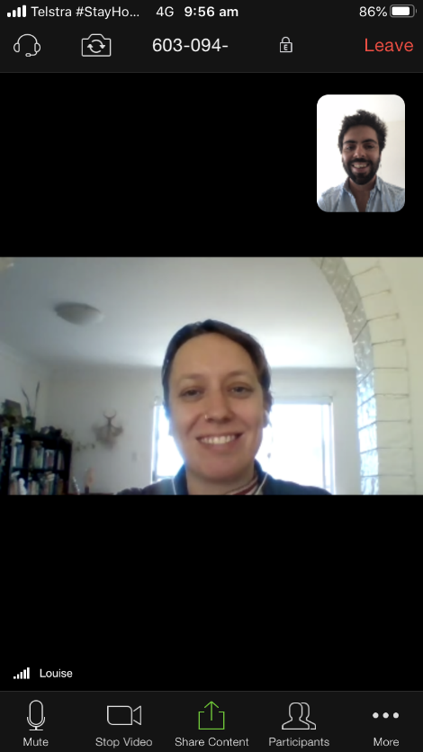

The person with the green outline is the person who is speaking.

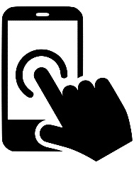
Your Zoom meeting has different controls.
If you cannot see these controls, tap your screen once.
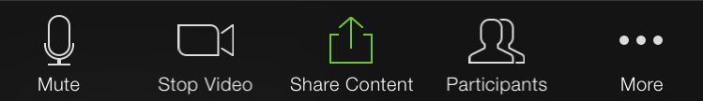

Muting your microphone
Extra noise is bad for the Zoom meeting. It makes it difficult to hear each other.
Mute turns your microphone off.
- Please mute your microphone when you are not speaking.
- Please unmute your microphone when you want to speak.
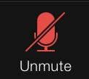
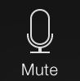
To unmute your microphone when you
want to speak, tap the ‘Unmute’ button.
To mute your microphone when you are
not speaking, tap the ‘Mute’ button.
1.
2.

Seeing other people

When everyone won’t fit on your screen, Zoom only shows you who is speaking.
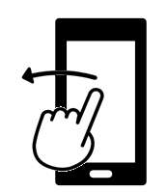
For iPhones:
To see other people, swipe your screen across.
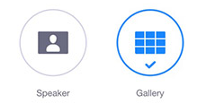
For iPads:
To see other people, tap the ‘Gallery’ or ‘Speaker’ button.
.

Screen sharing
When you want to show people something, you can share your screen to show them what’s on your device.

1.
Tap ‘Share Content.’
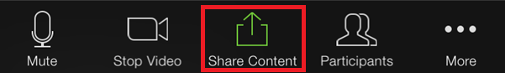

2.
4.
3.
Choose what you would like to share. Use your device to show others. Tap ‘Stop Share’ to stop.
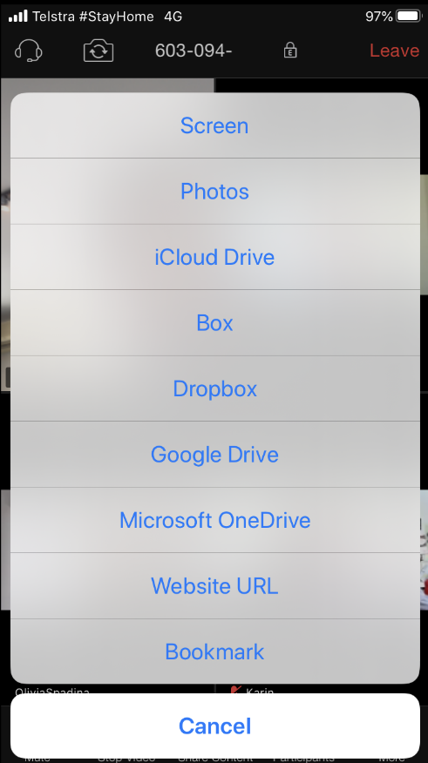
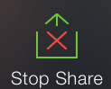

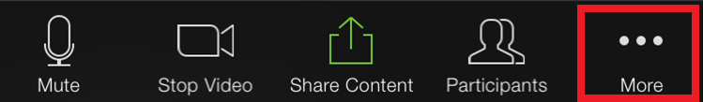
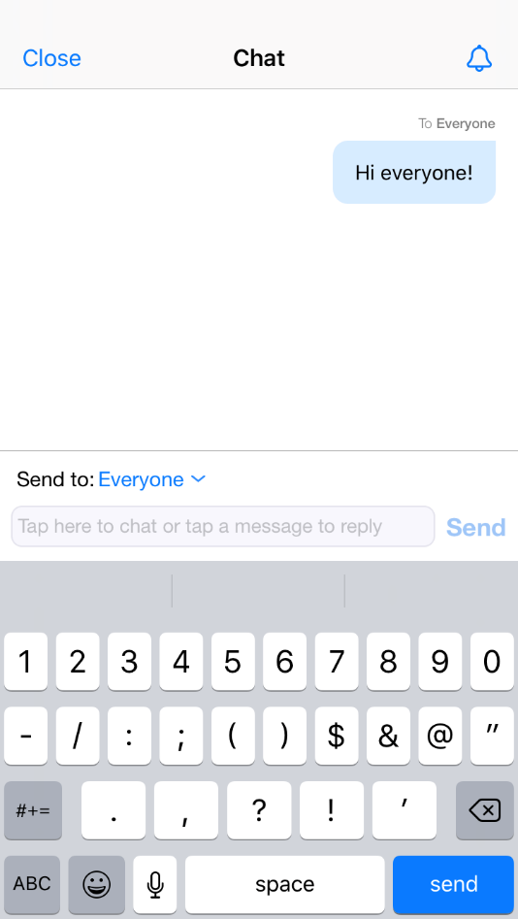
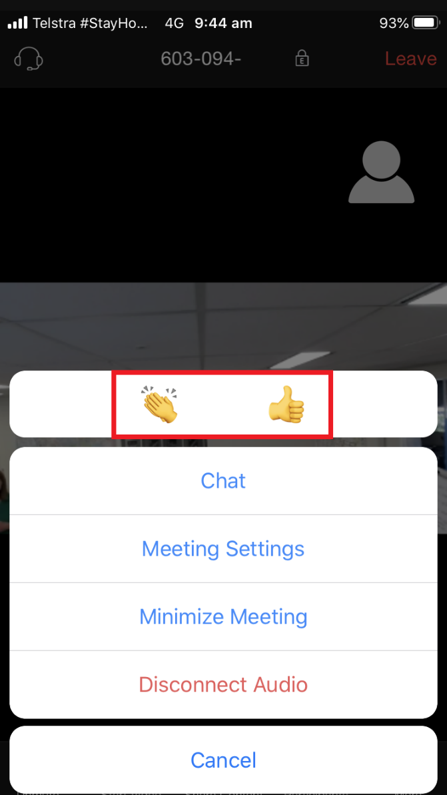
You can type a message to other people in a Zoom meeting.

These messages will show in a separate Chat window.

Tap the ‘More’ button.

Tap ‘Chat’. Type and send.

Sending a message in chat
When you agree with something, you can show an emoji to let others know.

Others will see your emoji in your video square.

Tap the ‘More’ button.

Choose which emoji you want to show.

Reactions

1.
1.

2.
3.
2.

A lot of help is available on the Zoom website at the following links.

Troubleshooting
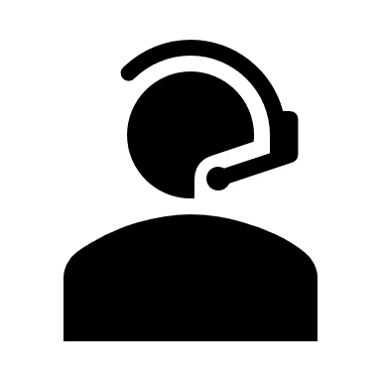
- The Zoom Help Centre is available by clicking this link here.

- Zoom Video Tutorials are available by clicking this link here.

- You can register for Live Training by clicking this link here.

No one can see me
Make sure you’ve told Zoom it can use your camera. In the meeting, click ’Start Video’ if the button is there.
Otherwise, try this article on the Zoom website.

No one can hear me
Make sure you’ve told Zoom it can use your microphone. In the meeting, click ‘Unmute’ or ‘Join Audio’ if the buttons are there.
Otherwise:
- For mobile devices, try this article on the Zoom website.
- For computers, try this article on the Zoom website.

I can’t hear anybody
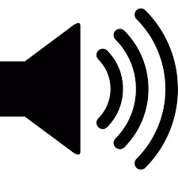
Check the volume or speakers on your device.
Try this article on the Zoom website.

The meeting audio and video is glitching a lot

The meeting audio is echoing a lot
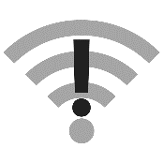
Try this article on the Zoom website about improving your Wi-fi connection.

Will Zoom cost me anything?

Frequently asked questions
The Zoom download is free. Meetings will use your own internet data.

There is no cost for phoning into a Zoom meeting using the toll-free telephone number.

Do I need to create a Zoom account?
No, not to join a Zoom meeting.
Zoom accounts allow you to host your own meetings. A Zoom account is not needed to join a Zoom meeting.

