Speakers
Michelle Moss - Director of Policy and Strategic Engagement, Queenslanders with Disability Network
Jo Smethurst - Senior Engagement Adviser, Health Consumers Queensland
Rajiv Bawa - Acting Clinical Nurse Consultant for Infection Control, Metro South Health
Anna Greig - Access and Capacity Building team, Metro South Health
Kath Harris – Branch Manager, Community and Engagement Services for the National Disability Insurance Agency
Kevin Stone – Chief Executive Officer, Victorian Advocacy League for Individuals with Disability (VALID)
Uli Kaplan – Self advocate, VALID

Testing and wearing masks – What do we need to know?

As the global pandemic COVID-19 continues throughout 2020, it is important to stay up to date with the latest and most accurate information. Reliable sources of information are key to good health, both physically and mentally. People with disability should take additional precaution in this regard as COVID affects every person differently and the outcome of contracting such a disease with any sort of pre-existing health condition is precarious. The main preventative method of transmission in community is with facial masks. Knowing when, how and, most importantly, why to use these masks is discussed in this conversation. Mental health impacts due to COVID and subsequent restrictions is a serious issue that has been identified by members of the disability sector. This conversation explores these impacts and potential social solutions on an interpersonal level.
Speaker #1: Jo Smethurst - Senior Engagement Adviser, Health Consumers Queensland
Presentation on Good Communication – What should you expect from your service providers - what does good communication look like? Based on the Residential Care Communication Checklist
Good communication is good practice and helps keep people with disability at the centre of all things. At the heart of good communication is respect, empathy and kindness.
HCQ, QDN with COTA Queensland, ADA Queensland, Palliative Care Queensland and Carers Queensland have developed a checklist for staff working in industry to help them think about how they communicate with people and their families, because communication is so important.
Good communication is open and transparent, which means staff are letting people in their workplaces know immediately if there is a COVID-19 positive case.
Knowing what is going on gives people an opportunity to think about what matters to them and what questions they would like answered.
Communication should be tailored to the people it is intended for, including their communication needs. People who are hearing impaired might need a support worker with them or a translator or closed captioning. The provider should be aware of the communication requirements and meet these needs. It is also two-way so there should be time not only for you to receive information, but to think it through, and ask questions that matter to you. This takes time.
It is the responsibility of providers to make sure people who live in their residences/homes can understand what is happening, what is going on, and what they need to do.
Most of us like to get information face to face. However there may come a time when this is not possible. If face-to-face meetings are not possible, what would be an alternative? Recorded video message from someone that you know and trust? Could you do it by phone? Can you use an iPad to setup a Zoom call?
There is lots of information people might want to know if someone tests positive to COVID-19 in a facility like:
- If it is a staff member, have they been out and about and seen lots of different people or do they work solely in the office?
- Will this change when, or if, visitors are able to come?
- What will happen with the care providers who normally come in and provide care?
Speaker #2: Rajiv Bawa - acting clinical nurse consultant of infection control at Metro south health.
Speaking on infection control and the use of masks as it relates to COVID-19, specialising in this area Rajiv demonstrates the best practices around mask use for both people with disability as well as workers in the industry.
Since COVID has started, hospital staff have been well educated on how to be well prepared to manage COVID cases. In Queensland (where opportunities to talk to the patients or people in the community hasn't been as successful), there has been a lot of information in the media, in particular social media, which has been inaccurate and inconsistent.
Thus far there has not been any unknown transmission cases within the Queensland community. All the work that the public health teams and members of the community are doing in terms of maintaining social distancing, washing hands and the other measures in place are working so far.
A statement was recently issued by the Chief Health Officer for the members of the public; if people are outside in areas like the supermarkets, where they cannot maintain social distancing, they should wear a mask. As a result, it's important to talk about how to do so effectively. A mask is two-way protection. It not only protects the person who is wearing the mask from other people who may be transmitting COVID, but it also protects other people from a person who could potentially be infected. the mask protects that person from not spreading the disease to others.
Talking about specifically COVID-19, it is important to understand how this disease transmits. The most common way we are seeing in most of the cases is direct transmission.
- If a person who is infected with the disease is talking to someone else for about 15 minutes face to face contact, they are putting the next person at a risk of getting the disease
- If you have spent up to two hours in the same room with someone who is potentially infected or currently transmitting the disease to others
- Indirect contact means surfaces which may be potentially contaminated. For example, someone touching a table. If the last person who was at the table was infected, it can be picked up on the hands and then gets into the body.
It's important that we perform hand hygiene by using alcohol-based hand rubs and not touch the eyes, nose and mouth. Wearing PPE protects but it's important to wear the PPE in the right way as well.
When you feel a mask, one edge will have a metal wire in it this part is fitted over our nose. The flexible part goes to our chin-side. The coloured part needs to be outside and the non-coloured part or the white part needs to be inside.
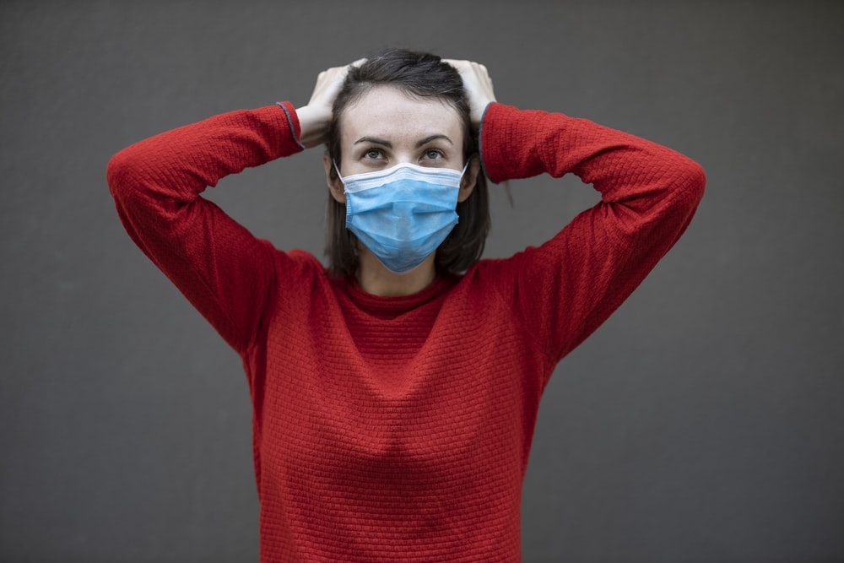
Photo by engin akyurt
The front of the mask is the most contaminated. When we remove the mask, never grab it from the front because this area is potentially contaminated. Always grab it from behind where the ear loops are, bringing it away from our body. Health care staff are recommending the masks for a single use only. Sometimes that is not possible in the community and especially with the disability sector, these are very expensive practices. If using a washable cloth mask the representations are that it needs to be three-ply or have at least three layers of cloth to have appropriate protection in the community.
Gloves are another area of contention. The reason for that is when a person has got gloves on, they're unlikely to clean their hands. You cannot clean the gloves with the alcohol-based hand rub and you cannot wash gloves. So, the best advice is not to wear gloves; perform hand hygiene as many times as possible and especially before touching the face.
Glasses fogging due to masks is a bit of an issue. There are a few different brands of masks available, some of them being anti-fog masks. There is a protective layer on the top of the inside. These are a little bit expensive when compared to a normal mask.
Speaker #3: Anna Greig is also from Metro South Health and Anna works in the access and capacity building team of the health and equity unit at Metro South Health.
Presenting on why it's important to get tested, when you need to get tested, where to go, and what the process and protocol is when you are actually tested.
There are three main reasons why you would get tested for COVID-19:
- Do you have symptoms? At the moment we're encouraging everyone with any symptoms to get tested
- Have been in close contact with someone with COVID-19?
- Have been in a location that has been advertised as somewhere where someone with COVID-19 has been and have started to get COVID-19 symptoms? You might see on the news they give information about places and usually they will say what time that is specifically and, in which case, they encourage to you get tested if you start getting symptoms.
Obviously, we want our families to be safe. You may think, “Oh I'm pretty sure this is just a cold, cough or flu”. But there's a little voice in the back of my head that thinks, "What if it's not? What if it is COVID-19?" The safe thing to do is go and get tested.
A Table of Symptoms of coronavirus (COVID-19) compared with common cold and flu (QLD Health) can be found at https://www.qld.gov.au/health/conditions/health-alerts/coronavirus-covid-19/stay-informed/symptoms-of-novel-coronavirus-covid-19-comparison
This link: (https://www.qld.gov.au/health/conditions/health-alerts/coronavirus-covid-19/stay-informed/testing-and-fever-clinics#testing-centre-map) shows you where your nearest testing centres are and also about what sort of service it is. It is worth checking this before you go as there are changes happening all the time. There are three main types of testing clinics:
- Hospital screening clinics or fever clinics are a free service to everyone that are offered at our hospital. In Metro South, all our hospitals apart from the PA Hospital are offering free screening
- Pathology clinics such as Sullivan Nicolaides will need a referral from your GP
- Respiratory clinics run by the federal government. Some of these are drive through or you can make appointments to go to.
- Children testing clinics. Not all locations test children. If you are going with a child, you might want to find out first that they do test children as well. If in doubt and you need information the best thing to do is call the 13HEALTH number.
Speaker #4: Kath Harris from the National Disability Insurance Agency
Presenting information about what the NDIA has put in place in terms of provisions in people's plans and particularly around PPE and workers providing support to affected participants.
The NDIA is closely monitoring the COVID-19 situation and trying to be as flexible as possible within people's plans and the arrangements we have in place with both participants and providers.
The Australian Government enacted the Coronavirus Emergency Response Plan very early on and the National Disability Insurance Agency (otherwise known as the NDIA) has taken necessary steps to make sure that the Coronavirus pandemic is part of a support package we have for participants and providers. We're working through all tiers of government, including state and territory on our response plan and recently some of you may have been involved or in this. We have reached out to over 70,000 of our participants across the states and territories to check in and make sure they are supported and accessing the supports and services that they need.
The measures we have introduced currently to date to support participants to continue to access the supports and services they need, include our planning meetings, are still occurring but moving to phone where possible. This is to comply with our social distancing arrangements but also to make sure that our participants are safe. Providing participants with the option to have their plan in place for 24 months. The NDIS is also introducing participants the opportunity to use $1,500 in their plan to purchase low-cost-effective assistive technology to help them continue to access the NDIS funded supports or services. These can include smart devices like Zoom.
It's important that you again talk to your LAC or your planner to ensure you are getting the information that's more relevant to you. If you are receiving funding for a support coordinator, they can also assist you through this process. Participants can also request an unscheduled plan review over the phone - they no longer have to request this in writing. The NDIS has established a team of specialised planners who can be contacted over the phone for urgent escalation. From 22 August to 30 September 2020, those in Queensland can claim the costs to purchase PPE, which includes face masks, facial shields and gloves, when receiving or providing face-to-face daily supports. PPE outside the home including hand sanitiser are still an everyday expense.
Speaker #5: Kevin Stone – VALID
Kevin presents on the COVID situation in Victoria presently and how it has impacted the disability community.
One of the roles that VALID quickly adopted was the development of plain English materials (https://www.valid.org.au/resources-and-media/resources/) and other ways of getting accurate information to people. In Victoria, the State Minister, acted very quickly and set up a COVID-19 Task Force. There are about 35 or so representatives of all the different bodies, including of course the NDIA itself. Initially infections weren't too high in Victoria and infections weren't occurring in group homes and amongst people with disability generally.
I think the good news is that firstly the numbers are coming down generally across Victoria as a result of the lockdown as a result of, from my perspective, a very well-handled intensive program of getting the community behind it, as well as the wearing of masks and the use of PPE.
People losing contact, not able to go to work, not able to participate in their day programs, not able to see their friends or indeed, in some cases, their partners because of the extent of Stage 4 lockdowns. The affect on mental health has been significant. We have had lots of online self-advocacy meetings, conduct all sorts of forums and provide people with iPads in order to stay connected if that's necessary. I would like to focus in particular on what this may mean for, you know, QDN and other advocacy organisations and I would like to share with you the sorts of issues we have seen arising. A critical factor is collaboration and coordination across the sector. Service providers and people with disability, community organisations, health agencies are all working collaboratively on this.
There was a survey in Victoria amongst health workers, not disability workers, that showed 43 per cent of health workers didn't know how to effectively or properly use masks and PPE.
The other critical issue there for us has been the need for a surge capacity work force. If you get multiple infections in a group setting and staff go down, where does the backfill come from? One of the measures that has been adopted here in Victoria is services for large services, these have been contracted to provide a latent surge capacity workforce to be able to hit if there is a crisis.
One of the issues we were confronted with was a number of people with severe disabilities who had dental surgery booked. They were in pain and needed to get surgery done. They couldn’t have that done because in order to have general anaesthetic, they need to be tested clear, negative and then go a week with the same staff.
Trying to get the balance right between the person's rights and the responsibilities as citizens. A lot of people with disability in particular people with autism and behaviours of concern, that can be a very difficult thing to be suddenly confined to a house when going out and being part of the community, often going on long walks as part of their routine. Finding safe alternatives to these activities is key.
Speaker #6: Uli Kaplan – VALID self-advocate
Uli is a Victorian living with disability who has experienced the impact of COVID firsthand and is presenting his thoughts on where to go from here.
Some of the key messages that Uli shared:
- One of Uli’s support workers had to sleep on a fold out mattress after a positive COVID case was identified in the building next door to his home.
- Organisations, government and the NDIA's role and responsibility is to give the information and provide clarity. “If you don't plan, it's a little bit too late. I'm a person with a disability so I'm vulnerable but I also have a lung condition… you have to do what you got to do to survive”.
- Uli used to be tired of going to supported employment and it used to be exhausting but he hasn’t been for two months. “I really want to go. I want to work”. Not being able to follow routine or feel productive can be stressful.
- Uli’s message to the listeners was: “Just keep it simple. Work together. No-one is better than the other. No-one is less than the other. Just all pitch in. It’s your responsibility to wear a face mask. It's your responsibility to keep your distance.”
- From studying a Certificate IV in Support, Uli knows that support workers aren't trained and their job description is not to control infectious diseases like this.
- Speaking to people with disability, Uli stresses the importance of patience and working collaboratively with support workers in these strange conditions.

