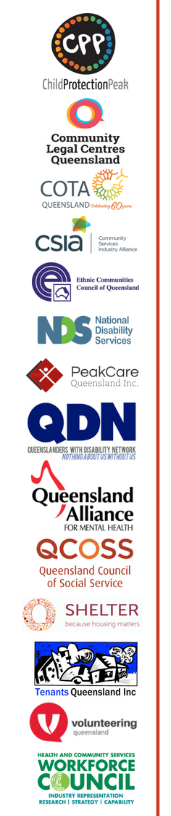
Queensland’s 14 community sector peaks support the introduction of a
Human Rights Act for Queensland
We strongly support laws that ensure fairness and equality for all Queenslanders. For the coalition of 14 peaks, a Human Rights Act for Queensland is priority issue for 2018, and we welcome the Government’s commitment to introduce legislation this year.
A Human Rights Act will mean all Queenslanders are treated fairly – particularly for people who experience vulnerability, with whom our members work.
The Palaszczuk Government has committed to legislation modeled on Victoria’s Charter of Human Rights and Responsibilities. We look forward to working constructively with Government to ensure Queensland’s Human Rights Act means that people who have been mistreated can hold authorities to account.
As well as enshrining human rights in law, a Human Rights Act would also provide important social, economic and cultural benefits. The key benefits are:
- improving law making and government policy
- improving public service delivery
- protecting marginalised Queenslanders by addressing disadvantage
- contributing to the development of a human rights culture
- creating and adding economic value
- assisting to fulfil Australia’s human rights obligations
- 'bringing rights home' by enabling human rights complaints to be heard and determined within the State of Queensland.
We support a Human Rights Act that:
- protects the rights of all people in Queensland
- protects the human rights contained in the international human rights treaties that Australia has signed up to
- recognises that many human rights are subject to 'reasonable limits' while other rights, such as the right to freedom from torture, cannot be limited
- binds the Queensland Government and organisations and businesses carrying out the functions of government
- requires all arms of government to have regard to, and respect for, human rights in making, applying and administering of laws and in their other activities
- allows people experiencing human rights abuses to bring legal proceedings against the offender for the full range of judicial remedies, including damages (more flexible and accessible remedies, such as mediation and complaints mechanisms, should complement this right).

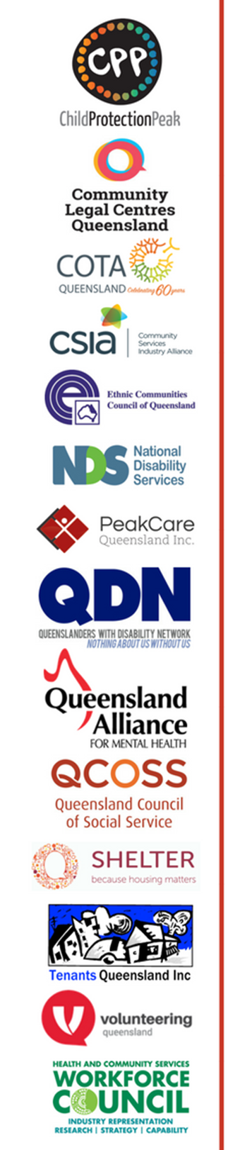
Benefits of a Human Rights Act
A Human Rights Act will help to create a fair, just and equal society for everyone.
When human rights are protected by law they help to ensure that we are all treated fairly, and with dignity, equality and respect.

To demonstrate how this might be applied a number of case studies have been prepared by the Human Rights Act for Queensland campaign. They look specifically at how different groups of people may benefit from this act. The case studies include looking at the applications for:
- Aboriginal and Torres Strait Islander peoples
- children and young people
- people with disability
- older people
- LGBTI people
- people from culturally and linguistically diverse backgrounds
- women experiencing domestic and family violence
- people experiencing homelessness
- people living in rural, regional and remote areas, and
- access to justice.

You can access these case studies at www.humanrights4qld.com.au

We still need your support
While the government has committed to a Human Rights Act for Queensland, we want to make sure Queensland’s Human Rights Act means that people who have been mistreated can hold authorities to account.
There is still time to act.
Lobby your MP

How do I explain what a Human Rights Act is and why it is important?
The Human Rights for Queensland campaign have developed a range of material you can use when having a conversation with you MP. You can find them here www.humanrights4qld.com.au

Find out more about this campaign at www.humanrights4qld.com.au

