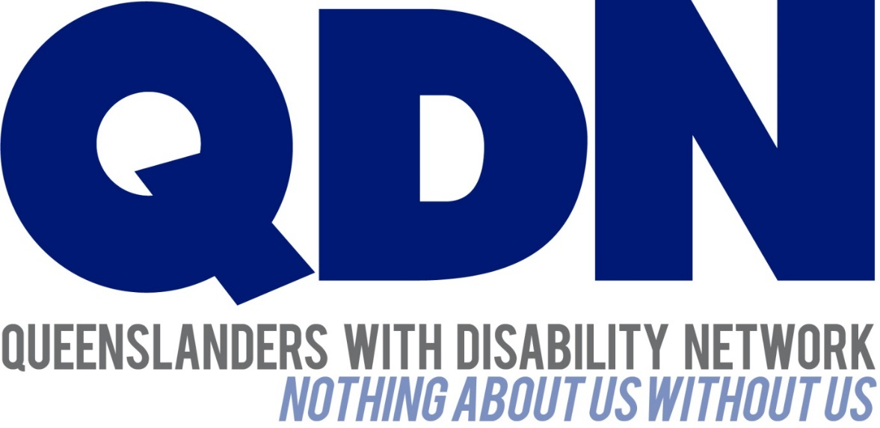

Response to
Queensland Competition Authority

Medical and Disability Aids and Equipment Pricing Investigation

Draft Report 2013

Table of Contents

About Queenslanders with Disability Network (QDN) 3
Value Statement on People with Disability 3
Introduction 4
8.1 The Department of Health and Department of Communities, Child Safety and Disability Services should investigate opportunities to make: (a) product and price information more readily available to consumers 4
9.1 The Queensland Government, in its reviews of government procurement and the MASS program, should give consideration to: (f) reducing and streamlining the application process for MASS equipment 4
9.2 Governments should consider the following features when designing programs for aids and equipment: (c) Choice. Choice is important. Consumer-orientataed programs tend to produce better outcomes for people with disability, and can increase competition and lower prices. However the limits faced by consumers from information assymetries must be considered. 5
9.3 The Department of Health and Department of Communities, Child Safety and Disability Services should give consideration to establishing a mechanism that would allow comsumers to report pricing disparities for medical aids and equipment. 5
10.3 The Queensland Government should investigate ways to increase the supply and thereby reduce the cost of taxi transportation. 5

Queensland Competition Authority

Medical and Disability Aids and Equipment Pricing Investigation

Draft Report Submission

About Queenslanders with Disability Network (QDN)
QDN has been established, as a network of, for, and with people with disability, for eleven years. The network regularly brings members together to campaign on issues that impact upon their lives. From such gatherings, and through input from Local Area Networks, the members determine the focus of the network and activities undertaken.

QDN has over 700 members across Queensland. All of QDN’s members are people with disability.

Value Statement on People with Disability
Since its inception, QDN has spent considerable energies clarifying the values that underpin its way of working and interacting with other agencies. The following statements articulate the values of QDN, in relation to the place of people with disability in an inclusive, Australian society.
QDN believes that:
- All people with disability have a right to a place in the community and contributions to make to community. This is as empowered, free citizens who are as valued, present, participating and welcomed as members of any dynamic and diverse society.
- The place of people with disability in the community is not just about people with disability having a house in the community. The crux of the issue is that they are welcomed in the community as ordinary citizens where they are genuinely given opportunities to contribute and actively participate. People with disability need to be in communities where their individuality, their talents, and their lived experiences of disability are recognised and acknowledged.
- Culturally and historically, people with disability are not afforded the same value, opportunities or access to community life.
- Any inclusion in community for people with disability is conditional and vulnerable to withdrawal.
An example of this is “forced co-tenancy”, where people with disability are forced to share public housing and supports with other people with disability or risk having both housing and supports withdrawn.
- Many people with disability in Queensland are excluded from the most basic experiences of ordinary lives.
- Current exclusionary practices are unacceptable and must be challenged.
- These issues affect not only people with disability but the whole community.
The responsibility is shared. It lies within government (federal, state and local) and the community at large, to ensure that people with disability have a place and are resourced to belong in community.

Introduction
Queenslanders with Disability Network (QDN) welcomes the Queensland Competition Authority’s Inquiry into the Pricing of Medical and Disability Aids and Equipment. This has been an issue of great concern for many people with disability for a number of years.
QDN supports many of the recommendations and key findings made in the Queensland Competition Authority (QCA) Medical and Disability Aids and Equipment Pricing Investigation 2013 Draft Report.
This brief submission makes comment on some of the recommendations made in the Draft Report.

8.1 The Department of Health and Department of Communities, Child Safety and Disability Services should investigate opportunities to make: (a) product and price information more readily available to consumers
QDN fully supports the recommendation to make consumer information and equipment prescribers more readily available. For many people with disability, the complexity of the task of acquiring the right piece of equipment through the correct channels, is enough to stop them from even starting the process. Consequently, many people with disability continue to use out-dated or inferior equipment to avoid the effort and time required to upgrade or update their aids or equipment.
Product and price information will be critical in ensuring the National Disability Insurance Scheme (NDIS) is effective for people acquiring the equipment that best suits their needs. The prospect of having greater choice and control of all aspects of an individual’s support is exciting and much anticipated. Information is the cornerstone of choice, and QDN believes that accessible information for all consumers is pivotal in the upcoming reform in the sector.
Providing accessible information involves an awareness of target markets. QDN believes that some equipment providers will have to tailor their marketing more towards the consumer, rather than prescribers and other stakeholders in the sector. As people with disability are provided greater power in the marketplace, this consumer centred service will hopefully increase.

9.1 The Queensland Government, in its reviews of government procurement and the MASS program, should give consideration to: (f) reducing and streamlining the application process for MASS equipment
QDN absolutely endorses the recommendation to streamline the MASS application process. This process has for too long been onerous and lengthy, and QDN looks forward to a more efficient system. The efficiency of this part of the equipment purchasing underpins the entire process. Without this element being improved, all other improvements will largely be in vain.

9.2 Governments should consider the following features when designing programs for aids and equipment: (c) Choice. Choice is important. Consumer-orientated programs tend to produce better outcomes for people with disability, and can increase competition and lower prices. However the limits faced by consumers from information asymmetries must be considered.

People with disability will benefit from specific consumer education programs to address the current information asymmetries that exist. With the rapid advancement in technology, it is likely that these asymmetries will broaden rather than narrow without the implementation of targeted consumer education.

9.3 The Department of Health and Department of Communities, Child Safety and Disability Services should give consideration to establishing a mechanism that would allow consumers to report pricing disparities for medical aids and equipment.
QDN fully supports this recommendation. This will empower people with disability to participate as active consumers in a manner that they have rarely experienced before.

10.3 The Queensland Government should investigate ways to increase the supply and thereby reduce the cost of taxi transportation.
Taxi costs (even with the use of the Taxi Subsidy Scheme) are prohibitive for many people with disability. While the NDIS will assist eligible participants with some taxi costs, many people with disability who rely on regular taxi use, will not be participants in the NDIS. These people with disability will be left to pay high transport costs, and are often limited in their capacity to access their community as a result.
QDN fully endorses all measures that will result in a more affordable and accessible taxi service.

