Response to the New Disability Employment Framework Consultation – Round Two

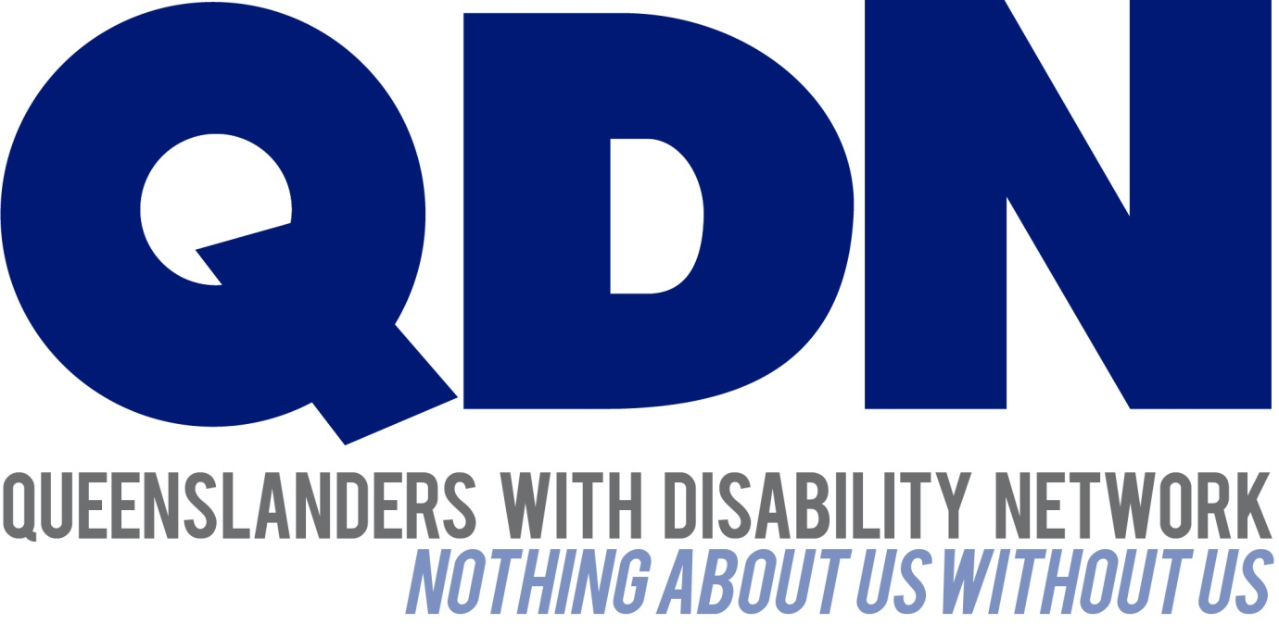

Contents
About Queenslanders with Disability Network (QDN) 3
Value Statement on People with Disability 3
QDN Consultation 4
Overview 4
Individualised Funding and Market Based Service Provision 5
Mutual Obligation and People with Disability 5
Advocacy Services 5
A More Open and Less Restricted Market 6
Engaging with Employers and Creating Jobs 6
Ongoing Support and Supported Employment 7
Australian Disability Enterprises (ADEs) 7
Subsidised Wages 7
Virtual Marketplace 7
Conclusion 8

About Queenslanders with Disability Network (QDN)
QDN is an organisation of, for, and with people with disability. The organisation’s motto is “nothing about us without us.” QDN operates a state-wide network of members who provide information, feedback and views from a consumer perspective to inform systemic policy feedback to Government and peak bodies. QDN also provides information and referral support to people with disability.
This submission is informed by feedback from members. QDN has over 700 members and 300 supporters across Queensland. All of QDN’s voting members are people with disability.

Value Statement on People with Disability
QDN’s work in providing feedback and input into systemic policy issues is based upon the organisation’s core values and the place of people with disability in an inclusive Australian society.
QDN believes that:
- all people with disability have a right to a place in the community and have contributions to make to community. This is as empowered, free citizens who are as valued, present, participating and welcomed as members of any dynamic and diverse society
- the place of people with disability in the community is not just about people with disability having a house in the community. Core to this is that they are welcomed in the community as ordinary citizens, where they are genuinely given opportunities to contribute and actively participate. People with disability need to be in communities where their individuality, their talents and their lived experiences of disability are recognised and acknowledged
- culturally and historically, people with disability are not afforded the same value, opportunities or access to community life
- any inclusion in community for people with disability is conditional and vulnerable to withdrawal
- many people with disability in Queensland are excluded from the most basic experiences of ordinary lives
- current exclusionary practices are unacceptable and must be challenged
- these issues affect not only people with disability but the whole community
- the responsibility is shared. It lies within government (federal, state and local) and the community at large, to ensure that people with disability have a place and are resourced to belong in community.

QDN Consultation
A consultation was undertaken by QDN with its members and key allies to inform our response to the New Disability Employment Framework.
Our submission is informed by the lived experience of members with disability and strategies for strengthening the new employment framework have grown out of the consultation feedback.

Overview
QDN welcomes the opportunity to respond to the second round of the New Disability Employment Framework Consultation which builds on our input into the first round.
QDN takes this opportunity to reiterate that employment remains one of the key issues for people with disability. The current range of employment programs and policy approaches has been unsuccessful in making a significant difference to generational levels of unemployment, underemployment and a low participation in the work force.
QDN acknowledges the legislative and policy environment that has been put into place to improve employment outcomes for people with disability. There is however a significant way to go in order to create a system that is effective in finding appropriate long term employment solutions for people with disability.
In ensuring people with disability can participate economically in their communities through employment, it is essential that they also have access to affordable, accessible and appropriate housing, health services, education, transport and specialist disability services.
QDN strongly endorses the approach of the New Disability Employment Framework which includes:
- an individualised and agreed career planning process based on people’s strengths and abilities;
- funding linked to the individual for activities and services necessary for achieving long-term sustainable outcomes, outlined in a career action plan; and
- consumer choice of service providers to deliver these services.
QDN believes these principles reflect the intent of the National Disability Strategy and contemporary disability social policy. Overall, this is an approach that reflects the principles underpinning the NDIS. This includes a focus on assisting people with their goals and dreams supported by a strengths-based approach to planning, building on a person's abilities and capabilities rather than their disability and deficits. Additionally, a thorough understanding of the daily challenges and complexities faced by people with disability is needed alongside strategies that support people to work, rather than creating punitive measures that inhibit people’s participation.
There are a number of areas we believe can be strengthened and built upon to ensure people with disability experience better outcomes in relation to employment. These are explored further below.

Individualised Funding and Market Based Service Provision

Mutual Obligation and People with Disability
Mutual obligation refers to an individual being required to undertake a variety of activities such as performing voluntary work, applying for jobs, undertaking study or training and participating in meetings in order to receive their Centrelink benefits. People with disability genuinely want to work and participate in labour market programs. However, imposing arbitrary mutual obligation on people with disability may result in unfair, discriminatory practices that can perpetuate poverty cycles.
People with disability experience a multitude of compounding challenges that make it difficult to meet mutual obligations. These include:
- reliance on formal or informal support structures (or no support at all) to assist people to get ready for the day
- inadequate accessible housing, health services, transport, specialist disability support and other infrastructure systems
- poorer health outcomes than those without disability
- unreliable assistive devices and equipment
- challenges keeping routines and appointments
- challenges understanding the full impact of mutual obligation
- potentially low self-worth and self-esteem, anxiety and depression, which can be further exacerbated when required to meet stringent mutual obligation requirements.
For these reasons, QDN strongly supports that any mutual obligations need to be negotiated in partnership with the individual. They need to be realistic and tailored to the person’s specific needs.

Advocacy Services
QDN supports people with disability having access to strong, independent and robust individual advocacy services to negotiate systems and services in their lives. There is however a huge unmet need for advocacy for vulnerable people with disability to advocate for their fundamental needs. Unless further resources are provided to the advocacy sector or additional advocacy organisations are created, QDN is concerned that people with disability will miss out on the advocacy support needed to gain employment.

A More Open and Less Restricted Market
QDN recognises that deregulation may open up the market so that a greater number of employment opportunities are available to people with disability. However, we caution that employment services will still need to have a thorough and effective knowledge of disability issues and the barriers that exist to people with disability in finding and maintaining employment. There is also a need to maintain a sense of safety and security for people with disability accessing employment services and to ensure the appropriate checks and balances are in place for safe service provision.

Engaging with Employers and Creating Jobs
One of the greatest challenges facing people with disability is the actual number of job placements available across Australia. Proactive strategies need to be implemented to grow a jobs market where people with disability can get meaningful work and be treated with respect for what they do.
Additional to the recommendations outlined in the discussion paper, QDN recommends the following strategies:
- multiple pathways to employment: employment services, graduate intake programs, companies linking with employment services and ADEs to give participants opportunities in open employment
- an individual capacity building and peer mentoring support service targeted at people with disability entering the workforce
- Local, State and Commonwealth Public Services being an example of best practice and having benchmark figures on the employment of people with disability
- targeted job creation opportunities – matching a job to a person’s skills and building upon the person’s disability i.e. giving a job of shredding confidential documents to a person who cannot read and thus, turning a potential deficit into a strength
- incentive schemes – imbed in government contracts targets for employing people with disabilities. This could be facilitated through public/ private/ community formalised partnership arrangements between government, peak bodies representing the business sector and community and disability employment agencies and peaks
- personal care and other disability support funding to be available in the work sphere for those who require it
- specific targeted measures are also needed for the intersectionality of disability and other factors of discrimination that exists for further marginalised groups such as women, people from Aboriginal and Torres Strait Islander background, people from cultural or linguistically diverse backgrounds, LGBTI people and older people
- accessible buildings and workplaces.

Ongoing Support and Supported Employment

Australian Disability Enterprises (ADEs)
QDN welcomes a shift which sees ADEs as an employer of people with disability in the market place rather than being solely a provider of specialist disability supported employment. However, we caution that this may result in some people becoming ‘stuck’ in this type of employment with no opportunity for individual capacity building or trialling open employment.
QDN also raises the following points in relation to ADEs :
- QDN supports the payment of full award wages to employees
- QDN would also like to see clear options for people in ADEs to be supported to move out of this type of employment if they choose and trial open employment or other options that more fully use their skills and abilities
- Member feedback has indicated that people with skills are potentially being underpaid in ADEs, for example, through our consultation, QDN became aware of the story of a fully qualified and skilled forklift driver being paid a subsidised wage in an ADE. Under the new framework, QDN would expect that this individual could be given the opportunity to trial open employment for a period of time with Award pay and conditions without losing their place in the ADE
- QDN members expressed concern that the term ‘pro-rata’ in the discussion paper is being used to talk about productivity-based wages
- QDN notes in the discussion paper that ADEs are transitioning to the NDIS. QDN expects that this would mean ADEs reflect community norms and standards of workplaces of similar industries with workforces that reflect the diversity and skills of Australian workers with and without disability.

Subsidised Wages
QDN members have fed back to us numerous stories of their lived experience where employers have taken the $1,700.00 wage subsidy to employ a person for 12 weeks and then finishing that person’s employment in order to move on to the next person and the next $1,700.00 subsidy. These loopholes need to be closed as they don’t lead to real employment outcomes for people with disabilities.

Virtual Marketplace
QDN is aware that many people with disability do not have access to the internet. For a virtual marketplace to be fully inclusive of all people with disability, QDN recommends that the National Employment Framework ensures:
- the Virtual Marketplace comprises an IT system and other devices and assistive technologies that are fully accessible to people with physical, intellectual, psychosocial, sensory and multiple disability.
- adequate training and ongoing support that is tailored to people with all types of disabilities so they can effectively use and participate in the Virtual Marketplace
- free, reliable internet access available in community spaces and employment services throughout Australia – this will require specific strategies for regional and remote areas of Australia where internet access is not reliable.
Additional to the options listed in the discussion paper, QDN also supports a Virtual Marketplace that has the capacity to make direct payments to individuals so that they can self-direct their employment supports (similar to the NDIS). People choosing this option would be required to adhere to regular accountability and reporting requirements.

Conclusion
QDN acknowledges the positive steps that the Commonwealth has taken in reviewing the current employment framework for people with disability. We strongly endorse a National Employment Framework which focuses on the strengths of the individual and attaches funding to the individual to meet their employment goals.
There are a broad number of legislative and policy frameworks that have been put into place for people with disability to support social and economic participation in the community. Through the National Disability Strategy, Australian Governments at all levels have identified the importance of ensuring people with disability experience greater economic security. The United Nations Convention on the Rights of Persons with Disabilities should also provide guidance in this process.
To realise these goals there are significant regulatory and policy frameworks that can be implemented to influence systemic change and ensure people with disability are able to navigate the sector and succeed in long term employment.

Queenslanders with Disability Network – 7 December 2015.

