26 July 2018

Dear QDN Member

**Member Hub and new look website**

We are pleased to let you know that we have updated our website and created the QDN Member Hub. The new website and the Member Hub will be active from 30 July. You will be able to access the Member Hub through the QDN website www.qdn.org.au.

**Why a Member Hub?**

QDN is a member driven organisation, and wants to be able to offer members more information, access to resources and tools that relate to people with disability. The Member Hub will share more opportunities to build skills, knowledge and capacity to be involved, to influence and speak at events, workshops, committees, policy forums, co-design activities and more.

QDN will continue to have our public information available on the website so everyone can find out information about our work, our projects, our policy positions, our submissions and our events. This will all remain the same. You will see the website has a new look and accessibility features and this will be our main communication channel.

However, QDN also wants to give members something more – access to information, resources and opportunities that enable Queenslanders with disability to be a strong voice influencing and leading change so that everyone can be active citizens. This is why we have created the Member Hub.

**What is the Member Hub?**

The Member Hub is a place where only Ordinary Members of QDN and informal and formal guardians of members can access information such as:

* Special edition member consultations
* Member surveys
* User friendly member policy updates and information about what is happening for people with disability across all the important areas like NDIS, Housing, Health, Transport, Employment, Inclusion, Advocacy and Human Rights
* Workshop opportunities
* Current sponsorship opportunities for members to attend events and workshops
* Volunteer opportunities
* Engagement opportunities for people with disability as speakers, consumer representatives and co-designers as they arise

We will continue to develop content for the Member Hub, and you may have some ideas too about what information you would like in the Member Hub. We plan to add the following information to the Member Hub in the coming months:

* Buy, sell and swap disability specific goods and services
* Library of resources
* Member tips for accessible and inclusive places, spaces and businesses

**What do I need to do to access the QDN Member Hub?**

Because the QDN website is a public place and the Member Hub is for members only, you will need to use a username and password to access member only content.

In the next few days, you will receive another email from QDN, which will tell you what username and password to use when first logging in. Once you have logged into the Member Hub for the first time we encourage you to change your password. We have included instructions below on how to find and access the Member Hub but we have also set up a Hub Helpdesk which you can call on 1300 363 783 for support.

**Member Hub log in steps**

Blue circle with white Q in the centre.  Below this are the words QDN member hub, an information hub for members only, sign into member hub here.  


Step 1: Look for this section on the homepage of the new QDN website and click LOG INTO MEMBER HUB HERE. You will then be taken to the screen shown in Step 2 below called Member Login.

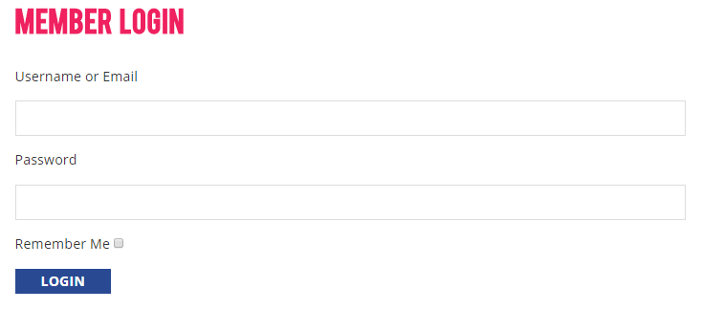

Step 2: Enter your username and password (with no spaces) that we email you and click **LOGIN.** You will now have access to the special information on our website for members only in the Member hub.

Please remember the Hub Helpdesk is there to take your call between 8:30am – 4:30pm Monday to Friday. The Hub Helpdesk phone number is 1300 363 783 or you can email [qdn@qdn.org.au](mailto:qdn@qdn.org.au).

Once again, welcome to the QDN Member Hub - an online hub for QDN members to inform, connect, influence and lead change to a more inclusive Queensland.

Yours sincerely

signature of Paige Armstrong

Paige Armstrong

Chief Executive Officer

Queenslanders with Disability Network