Written Submission on solutions to tackle cyberbullying

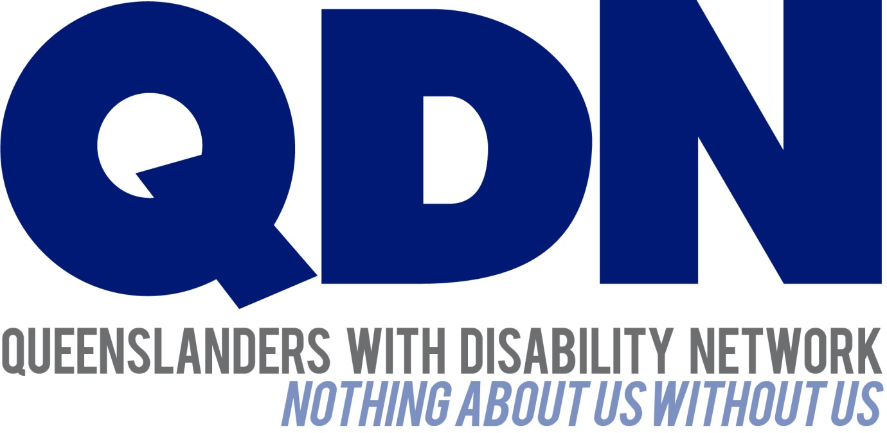

Submitted To:
Queensland Anti-Cyber Bullying Taskforce

Contents
About Queenslanders with Disability Network (QDN) 3
Value Statement on People with Disability 3
Introduction 4
QDN’s Position 4
Cyberbullying 4
Digital Inclusion 5
Conclusion and Recommendations 6

About Queenslanders with Disability Network (QDN)
QDN is an organisation of, for, and with people with disability and the organisation’s motto is “nothing about us without us.” QDN operates a state-wide network of members who provide information, feedback and views from a consumer perspective to inform systemic policy feedback to Government and peak bodies. QDN also provides information and referral support to people with disability.
QDN has over 900 members across Queensland who provide QDN with the perspectives of people with disability.

Value Statement on People with Disability
QDN’s work in providing feedback and input into systemic policy issues is based upon the organisation’s core values and the place of people with disability in an inclusive Australian society.
QDN believes that:
- All people with disability have a right to a place in the community and have contributions to make to community. This is as empowered, free citizens who are as valued, present, participating and welcomed as members of any dynamic and diverse society.
- The place of people with disability in the community is not just about people with disability having a house in the community. Core to this is that they are welcomed in the community as ordinary citizens where they are genuinely given opportunities to contribute and actively participate. People with disability need to be in communities where their individuality, their talents, and their lived experiences of disability are recognised and acknowledged.
- Culturally and historically, people with disability are not afforded the same value, opportunities or access to community life.
- Any inclusion in community for people with disability is conditional and vulnerable to withdrawal.
- Many people with disability in Queensland are excluded from the most basic experiences of ordinary lives.
- Current exclusionary practices are unacceptable and must be challenged.
- These issues affect not only people with disability but the whole community.
- The responsibility is shared. It lies within government (federal, state and local) and the community at large, to ensure that people with disability have a place and are resourced to belong in community.
- Above all, we believe in, and seek to model, a human rights approach that recognises disability as a social issue and recognises the rights of all Australians as equal citizens.

Introduction
QDN welcomes the opportunity to make a brief submission to the Queensland Anti-Cyber Bulling Taskforce to share our thoughts on cyber-bullying and digital inclusion and to present a disability perspective on this issue. While QDN members are adults, many use the internet and social media platforms as a form of communication and self-expression, to seek information and stay connected with peers and the outside world. QDN is aware that people with disability are often targets for online abuse, harassment, trolling, intimidation and scams.
Digital parenting blog uknowkids! reports that children with disability are especially at risk, particularly children with “invisible” disabilities such as Asperger's syndrome, autism spectrum disorder, learning disabilities, ADD and ADHD, and obsessive-compulsive disorder are more likely to be victims of cyber-bullying. Furthermore, these children may not even realise that they are being bullied or taken advantage of.

QDN’s Position
QDN strongly supports the right of people with disability to be engaged in their communities and online, fully participating in the educational, work, social and cultural pursuits on offer and a part of the fabric of our diverse society and culture.
QDN believes children, young people and adults with disability have a right to interact with the online world and be protected against cyber-bulling. Due to their increased vulnerability to online abuse and exploitation, any measures to tackle cyber-bullying among children and young people needs to be fully inclusive and accessible to children with disability, with specific targeted responses which cater for individual learning needs of children.
Furthermore, governments must address barriers to the digital inclusion of people with disability particularly in relation to access, affordability and digital ability.

Cyberbullying
Cyberbullying can be an extension of bullying behaviour that is already happening in school, work or the wider community – or it can be between people that rarely meet face to face – or have never met in person. Cyberbullying has some unique characteristics that make it particularly painful to experience, particularly for people with disability who have often been subjected to other forms of bullying throughout their lives. Cyberbullying can take a wide range of forms. It can be threats and intimidation, name-calling, harassment, exclusion, gaining access to unauthorised information online or ‘hacking’, impersonation, posting personal information, engaging in hate crimes, sexting/sexualised or manipulation. Cyberbullying is often relentless and pervasive in nature, with fewer opportunities to escape or seek solace from bullying at home. Social pressure to ‘fit in’ or have many friends or followers can mirror ‘real life’ challenges for people with disability to develop meaningful relationships. Additionally, people with disability may be increasingly vulnerable to incidents of fraud or being scammed or exploited through being too trusting and open in the relationships they develop online.
QDN is aware many people with disability avoid using the internet because they have no support to do so. People with disability are more vulnerable to abuse and can experience heightened isolation and emotions such as feeling frightened or not knowing what to expect in the ‘new’ digital world or what to do when they experience bullying or harassment online. QDN is also aware that people with disability experiencing cyberbullying find it is an extension of the bullying they experience face-to-face, it often goes unchallenged and they have limited support or capacity to deal with it.
QDN is aware many people with disability are seen as intermittent users of the internet and therefore often miss out on information on cyberbullying or internet safety as they are not the focus of strategies around this. This means they are not aware of how to stay safe online (often resulting in over-sharing information on social media platforms or online chat rooms), what to do about cyberbullying, or even identifying cyberbullying behaviour as wrong.
To begin to address some of these issues QDN has recently done some peer-based work on tips on using social media and produced a series of four videos. More work needs to be done in this space to enable people with disability to safely and confidently use the internet. For example, QDN has found people with disability need active support – more than just factsheets - on protective strategies on reviewing how they currently use the internet and exploring ways of improving their online safety, for example, being shown how to block people or increase their privacy settings.

Digital Inclusion
Digital inclusion is a significant issue for people with disability in being able to access mainstream services, and participate in community. QDN members have highlighted their experiences of being excluded from many of the everyday services and experiences that other members of our community take for granted such as accessing key government services like Centrelink, through to making doctors’ appointments or participating in social media. The effects of cyberbullying makes people less likely to engage in these online services and supports.
Many people with disability experience challenges with understanding social norms and communication, making them vulnerable to cyberbullying and recognising when it is happening. Many people with disability also experience challenges with the way information and skills development is provided by mainstream services as there is a lack of tailored responses.
Affordability and accessibility remain major barriers for people with disability in their use of information and communication technologies. Lack of access to ICT education and training, lack of digital literacy, incompatible devices and technologies and poorly designed websites are just some of the issues that exacerbate these common barriers. As people with disability are seen as intermittent users, they are not included in information on ICT education and training, including information on cyberbullying and how to stay safe. Some people may be vulnerable to abuse or exploitation via social media as they may have an intellectual impairment and are not aware how to ‘stay safe’ online.
Because of issues of access, affordability and digital inclusion, people with disability start from a place that is not equal to other children and citizens. QDN members have confirmed these are the key issues affecting their digital inclusion, and their heightened vulnerability to bullying in an online environment. Many people with disability have not had the access to a ‘safe learning’ environment to practice and learn as children to engage in social media and platforms often because of families wanting to protect their children. Because of this lack of learning experiences, people do not know how to behave.
Many QDN members have experienced limitations with their digital ability as they have not had the same opportunities as others to increase their IT knowledge and skills. Many people with disability live on the margins or completely “off the grid” and are either homeless or living in supported accommodation facilities (boarding houses) and have become disenfranchised from services and supports. They struggle to get their basic daily needs met and have very limited access to the internet.

Conclusion and Recommendations
QDN is pleased to provide this submission to the Queensland Anti-Cyber Bullying Taskforce. QDN believes children and adults with disability have a right to interact with the online world and be protected against cyber-bulling. Strategies to tackle cyber-bullying among children, young people and adults need to be fully inclusive of and accessible to people with disability, with specific targeted responses which cater for individual learning needs.
QDN makes the following recommendations to the Anti-Cyber Bullying taskforce in relation to cyber bullying and digital inclusion:
- Investing in the development of targeted and accessible peer lead e-safety education programs: focusing on learning about what cyberbullying is, how to spot it and what to do about it. Education programs could reinforce messages such as: think before you post, would I like to read this about myself?, respecting people’s thoughts and feelings online, becoming good digital citizens, taking care of yourself and your peers, and legal consequences of cyber bullying. For many people with disability, QDN supports that learning and skill development happens best when this happens in a face-to- face supported learning environment.

- Investing in the delivery of additional peer lead digital literacy projects for people with disability: to develop their digital literacy and confidence in engaging in the digital world. This would include specific strategies for people with disability who experience additional disadvantage including people with intellectual disability, people from culturally and linguistically diverse backgrounds, people from Aboriginal and Torres Strait Islander backgrounds.
- Investing in intervention services that meet the therapeutic and support needs of children, young people and adults with disability: ensuring people with disability have access to appropriate support services when experiencing cyberbullying, knowing who they can talk to and how.
- Ensuring mainstream programs and services have Digital Equity policies in place: recognising that certain groups are disadvantaged when it comes to digital technology and have strategies on how they will address digital exclusion, including cyberbullying issues, of consumers who access their services.

See: http://resources.uknowkids.com/blog/bid/159105/Kids-with-Disabilities-Especially-at-Risk-for-Cyberbullying for further information.
For more information on QDN Digital Champions project and link to video series, see: http://www.qdn.org.au/all-blog-posts/social-media-tips-from-nigel-webb-digital-champion.aspx

