Written Submission in response to the Draft Transport Plan for Brisbane – Strategic Directions

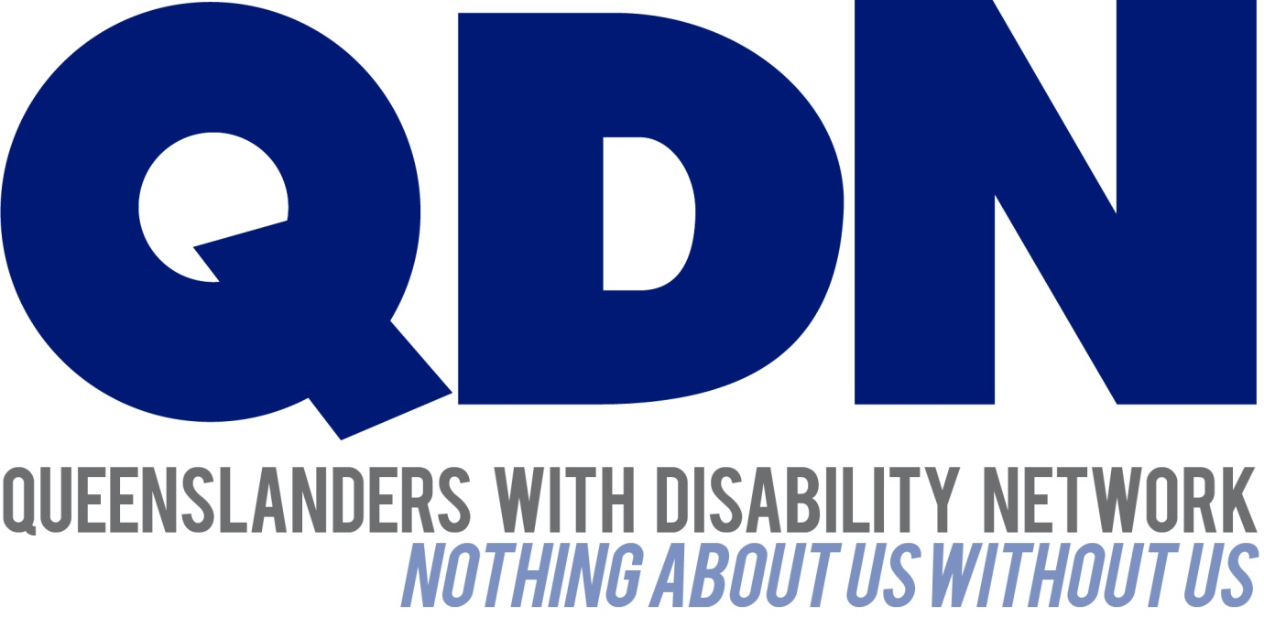

Submitted To:
Brisbane City Council

Contents
About Queenslanders with Disability Network (QDN) 3
Value Statement on People with Disability 3
Introduction 4
QDN’s Position 4
Queensland context 5
Conclusion 5

About Queenslanders with Disability Network (QDN)
QDN is an organisation of, for, and with people with disability and the organisation’s motto is “nothing about us without us.” QDN operates a state-wide network of members who provide information, feedback and views from a consumer perspective to inform systemic policy feedback to Government and peak bodies. QDN also provides information and referral support to people with disability.
QDN has over 900 members across Queensland who provide QDN with the perspectives of people with disability.

Value Statement on People with Disability
QDN’s work in providing feedback and input into systemic policy issues is based upon the organisation’s core values and the place of people with disability in an inclusive Australian society.
QDN believes that:
- All people with disability have a right to a place in the community and have contributions to make to community. This is as empowered, free citizens who are as valued, present, participating and welcomed as members of any dynamic and diverse society.
- The place of people with disability in the community is not just about people with disability having a house in the community. Core to this is that they are welcomed in the community as ordinary citizens where they are genuinely given opportunities to contribute and actively participate. People with disability need to be in communities where their individuality, their talents, and their lived experiences of disability are recognised and acknowledged.
- Culturally and historically, people with disability are not afforded the same value, opportunities or access to community life.
- Any inclusion in community for people with disability is conditional and vulnerable to withdrawal.
- Many people with disability in Queensland are excluded from the most basic experiences of ordinary lives.
- Current exclusionary practices are unacceptable and must be challenged.
- These issues affect not only people with disability but the whole community.
- The responsibility is shared. It lies within government (federal, state and local) and the community at large, to ensure that people with disability have a place and are resourced to belong in community.

Introduction
QDN welcomes the opportunity to make a submission to the Draft Transport Plan for Brisbane – Strategic Directions. For many QDN members safe, accessible, reliable and affordable public and private transport options remains a significant barrier to their full inclusion in the community and their full enjoyment of social, cultural, recreational and employment pursuits. QDN believes the Draft Transport Plan for Brisbane highlights key achievements of Brisbane City Council (BCC) in relation to accessible and integrated transport systems and congratulates BCC on their efforts to date, particularly their fully accessible bus fleet.
In going forward with this Plan QDN highlights the importance of effective and meaningful consultation in the planning, design, delivery and evaluation phases. In this submission QDN highlights a number of areas of the Plan that could be strengthened to ensure people with disability have equitable opportunities for safe, accessible and affordable transport. QDN strongly supports the right of people with disability to be engaged in their communities, fully participating in the work, social and cultural pursuits on offer and a part of the fabric of our diverse society and culture. QDN believes that effective, affordable and accessible transport systems are a vital step towards this.

QDN’s Position
QDN gives in principle support to the Draft Transport Plan for Brisbane. It is a robust document with references throughout on the importance of safe, accessible transport.

Although this is a local government transport plan QDN believes accessible public transport remains a Commonwealth, State and Local Government responsibility and a right of all people enshrined in international conventions, the National Disability Strategy, and legislative frameworks.

“Transport both public and taxis needs to be accessible, on time and have good routes” – QDN member.
Safe, accessible and affordable public and private transport options are essential for people with disability to be part of community and participate socially and economically. People with disability need access to a range of transport options, subsidies and programs which have the underlying intent of providing access to the same level of transport options the rest of the community experiences. There are a range of options for public and private transport available in Queensland, however, people with disability have continued to raise the impacts and challenges they face in accessing this transport.

The importance of effective engagement
Good policy and good decision making happens when the people who use the services or products are part of their planning, design, delivery and evaluation from the beginning. It is also critical that decision makers invest in their capacity to listen to, hear and respond to the input from people with disability to deliver good governance and implement a plan that will achieve safe, accessible and affordable transport options for everybody. This includes opportunities for people with disability to be involved in user testing and provide feedback on user experience. QDN has seen recent examples of how transport planning can lead to poor outcomes without effective prior engagement. Providing information to transport operators on the access needs of people with disability is essential to people being able to enjoy freedom of movement and liveability in their communities.

Specific feedback on the Draft Plan
QDN notes that page 37 of the plan states “provide a reasonable level of access for all”. QDN believes this could be strengthened if the statement made reference to Standards. QDN believes this needs to be cross-referenced with the Disability Standards for Accessible Public Transport 2002 (Transport Standards). QDN is aware this Standards are due to be reviewed shortly.
Technology has the potential to greatly assist people with disability in planning their transport. However, many people with disability experience barriers to digital technology and can feel “left behind’. Therefore, it is important that technology is inclusive and people with disability have the opportunity to be involved in user testing and user experience of any technology that is developed.
QDN applauds the recent development of Google maps to include accessible journeys as part of the menu of options. It is features such as these that make cities more liveable, inclusive and accessible. For more information, see: http://fortune.com/2018/03/15/google-maps-wheelchair-accessible-routes/.
“Some buses won’t stop for visually impaired people who can’t hail the bus so they miss out on meeting up with friends, important appointments etc” QDN member.
QDN sees potential for Global Positioning Satellite (GPS) technology currently used for trip planning to be enhanced to improve access to buses for people who are blind or vision impaired. There is also enormous potential for driverless vehicle technology to be of great benefit to people with disability in enhancing their independence and freedom of movement.
The transport plan states that over 21,000 Brisbane residents experience disability. Therefore it is important that:
- Transport service information and way-finding signage is easy to understand and accessible for people with disability;
- There are accessible interchange facilities with integrated services and timely transfers; and
- The proposed Brisbane metro is fully accessible. As stated above it is important to get this right from the beginning in terms of planning, design, delivery and evaluation to avoid costly retrofit and a product that is not useable by everyone.
QDN believes that many areas in the plan under Enhancing Liveability need targeted strategies to be inclusive of people with disability, such as:
- Community health and wellbeing – traditionally people with disability experience poorer health outcomes.
- Meeting people’s needs – if you make it accessible for people with disability, it is accessible for everybody
- Better journey experience – people with disability want seamless, easy-to-navigate travel options, with friendly, efficient service
- Convenient community – people with disability want communities that are easy to get to and engage with so they can access the services and supports they need, socialise with friends and family, work.
- Supporting the tourism and visitor industry – people with disability also go on holidays and visit Brisbane and need accessible travel information

Conclusion
Thank you for this opportunity to provide feedback on the Draft Brisbane Transport Plan. QDN sees the integration of technology, accessible transport hubs and facilities and the opportunity for people with disability to be involved in design, testing and evaluation processes from the beginning as essential to create transport systems that work for everybody.

