Written Submission on Draft DCDSS Stratgic Plan 2018-2022

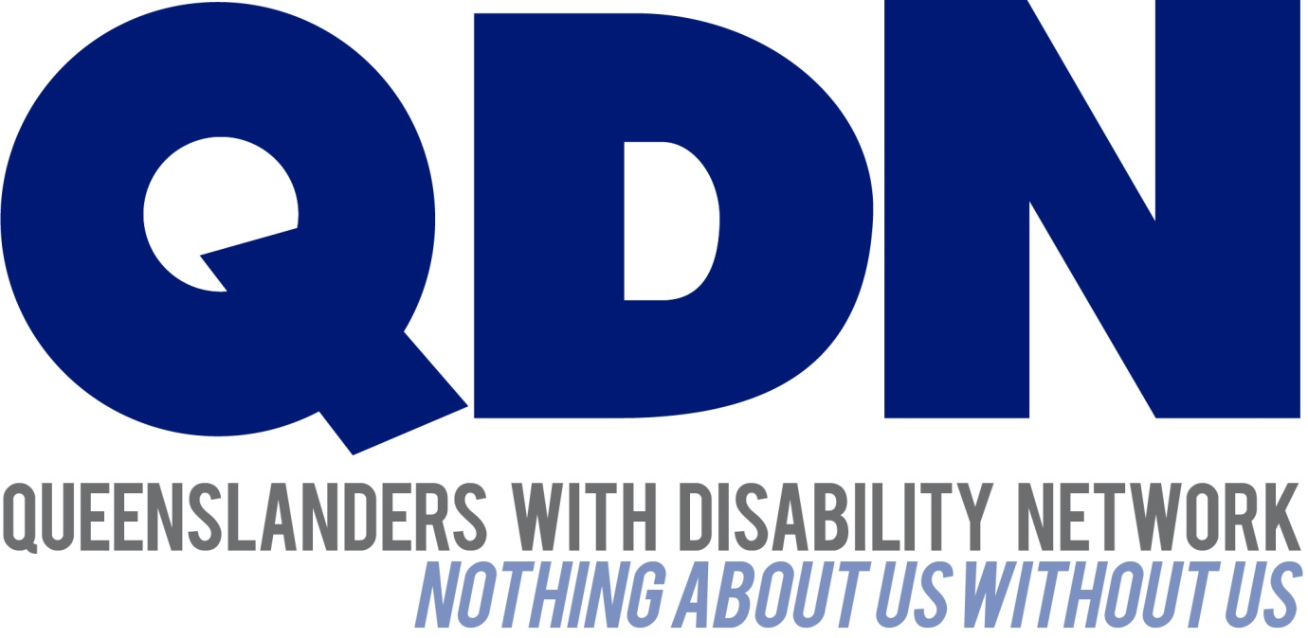

Submitted To:
Department of Communities, Disability Services and Seniors

Contents
About Queenslanders with Disability Network (QDN) 3
Value Statement on People with Disability 3
Introduction 4
QDN’s Position 4
Put people first 4
State government commitment to fund advocacy services for people with disability 4
Effective engagement with people with disability 5
Deliver the workforce development and workplace diversity strategies 5
Queensland Financial Inclusion Plan 5
Transition Queenslanders with disability to the NDIS including successful negotiation of the bilateral agreement and legislative amendments 6
Value Queensland Communities 6
Advance the community services industry 7
Support service providers to prepare for the NDIS 7
Lead public sector approaches 7

About Queenslanders with Disability Network (QDN)
QDN is an organisation of, for, and with people with disability and the organisation’s motto is “nothing about us without us.” QDN operates a state-wide network of members who provide information, feedback and views from a consumer perspective to inform systemic policy feedback to Government and peak bodies. QDN also provides information and referral support to people with disability.
QDN has over 900 members across Queensland who provide QDN with the perspectives of people with disability.

Value Statement on People with Disability
QDN’s work in providing feedback and input into systemic policy issues is based upon the organisation’s core values and the place of people with disability in an inclusive Australian society.
QDN believes that:
- All people with disability have a right to a place in the community and have contributions to make to community. This is as empowered, free citizens who are as valued, present, participating and welcomed as members of any dynamic and diverse society.
- The place of people with disability in the community is not just about people with disability having a house in the community. Core to this is that they are welcomed in the community as ordinary citizens where they are genuinely given opportunities to contribute and actively participate. People with disability need to be in communities where their individuality, their talents, and their lived experiences of disability are recognised and acknowledged.
- Culturally and historically, people with disability are not afforded the same value, opportunities or access to community life.
- Any inclusion in community for people with disability is conditional and vulnerable to withdrawal.
- Many people with disability in Queensland are excluded from the most basic experiences of ordinary lives.
- Current exclusionary practices are unacceptable and must be challenged.
- These issues affect not only people with disability but the whole community.
- The responsibility is shared. It lies within government (federal, state and local) and the community at large, to ensure that people with disability have a place and are resourced to belong in community.
- Above all, we believe in, and seek to model, a human rights approach that recognises disability as a social issue and recognises the rights of all Australians as equal citizens.

Introduction
QDN welcomes the opportunity to make a brief submission to the Draft Department of Communities, Disability Services and Seniors (DCDSS) Strategic Plan 2018-2022. The need for a clear strategic direction is important, particularly in this time of change for many people with disability and their families. People with disability who are not eligible for the NDIS need assurance that services and supports will continue for them in some capacity. QDN supports continuation of the rollout of the All Abilities Queensland Action Plan and sees this as fundamental a fully inclusive Queensland.
QDN’s response will focus on key points of feedback on the strategic priorities set out in the strategic plan: put people first, value Queensland communities, advance the community services industry and demonstrate leading approaches to public sector management and governance.

QDN’s Position
QDN strongly supports the right of people with disability to be engaged in their communities, fully participating in the educational, work, social and cultural pursuits on offer and a part of the fabric of our diverse society and culture. QDN supports the vision set out in the Draft Strategic Plan where “people of all ages, backgrounds and abilities can participate, are included and resilient and, enjoy high levels of social and economic wellbeing”. QDN believes that continuing to deliver on the Action Plan for All Abilities Queensland Opportunities for all is fundamental to this. QDN also calls for the Queensland Government to invest directly in the leadership and citizenship of skills of people with disability so they are better equipped to engage with, and contribute to, their local communities.
Ensuring there is a smooth transition for people into the NDIS as the State transitions to full roll out and that bilateral agreements are successfully negotiated is also important. Continuing to provide a service response to people who are NDIS ineligible is also fundamental. Providing robust independent advocacy for vulnerable people is an important safeguard for people, wherever they sit in the service system.

Put people first

State government commitment to fund advocacy services for people with disability
QDN welcomes the recent announcement by Minister O’Rourke to honour an election commitment and continue funding advocacy services in Queensland until 2021. It is fundamental to continue funding advocacy support to people during times of change. It is also important that people with disability, including those who are not NDIS eligible, are able to receive advocacy for issues outside the NDIS. It is important that these services maintain their independence to ensure effective advocacy. These services will protect the rights of people with disability and help them have a voice in the decisions that affect their lives, particularly as they continue to transition to the NDIS.

Effective engagement with people with disability
It is essential that the Queensland Government continue to directly engage people with disability to deliver citizen-led policy development and to ensure their procurement of services and products minimises risk.
Engagement with people with disability in the planning, design, delivery and evaluation of all State Government portfolio areas will deliver inclusive and accessible policy, services and systems, reduce the likelihood of making costly procurement and design errors and provide better outcomes for Government and Queenslanders.
To engage effectively with people with disability requires the Government to invest in the leadership and capacity of people with disability to be able to engage and represent as consumers of services.

Deliver the workforce development and workplace diversity strategies
QDN supports the workforce development and workplace diversity strategies developed by Queensland Government. QDN challenges DCDSS to meet and exceed the 10 percent target set out in the Inclusion and Diversity Commitment. QDN believes Queensland government has an opportunity to act as a lead employer of people with disability, adopting Australian best practise targets in relation to the percentage of people with disability to be employed across the Queensland Government and promoting a similar approach across Local Government.
Government also has a role in ensuring Queensland and Local Government workplaces are fully accessible and investing in individual capacity building and peer mentoring support services targeted to people with disability entering the workforce. Other strategies include: creating targeted job creation opportunities, matching a job to a person’s skills and building upon the person’s ability and contributing to targeted programs and strategies to employ people with disability.

Queensland Financial Inclusion Plan
QDN supports the inclusion of people with disability in the Queensland Financial Plan. QDN acknowledges there are often specific reasons relating to why people with disability and their supporters experience financial hardship. These include: paying for the extra costs associated with disability, balancing earning money with caring responsibilities, and saving for retirement. Many people with disability are on low incomes and may experience a greater incidence of financial exploitation due to their circumstances.
QDN asserts there should be specifically targeted strategies concerning people with disability in relation to:
- Improving financial literacy and increasing capabilities of people with disability
- Targeted access to financial hardship programs and services
- Reducing barriers to financial products and services to enable people with disability to generate income and asset build

Transition Queenslanders with disability to the NDIS including successful negotiation of the bilateral agreement and legislative amendments
The successful negotiation of bilateral agreements and legislative amendments is imperative to the successful transition of Queenslanders with disability to the NDIS. Of particular concern to QDN members is ensuring issues relating to cross-government portfolios of transport and health are clearly resolved.
NDIS participants will continue to need services that are not part of the reasonable and necessary services and support funded through the NDIS. Currently, there is confusion around a number of critical areas of the interface between NDIS and mainstream services that need resolution including the taxi subsidy scheme, wound care and the medical aids subsidy scheme. NDIS participants will need to access quality, affordable and integrated supports across mainstream, community and specialist services.
It is essential to re-negotiate components of the bilateral arrangements around the planning and implementation of the NDIS to deliver improved outcomes for Queenslanders with disability, in line with lessons learnt in the first year of roll out and the recommendations of the Productivity Commission’s Report – NDIS Costs October 2017.

Value Queensland Communities

Continue to operate high quality Accommodation Support and Respite Services.
QDN commends DCDSS for continuing to provide services to people living in Accommodation Support and Respite Services (AS&RS). QDN believes every effort should be made to ensure people receiving these services have the opportunity to develop and pursue their dreams and goals under the NDIS (through the development and implementation of NDIS plans). These plans should encompass a broad range of services and supports, including those outside the AS&RS system so that people receiving AS&RS services have the same opportunities as other people to achieve their goals through the NDIS. Targeted supports should be in place to ensure people with AS&RS supports have a voice in the NDIS planning process.
Continue to deliver, in partnership with non-government organisations, high quality disability services in the lead up to the full transition to the NDIS
This needs to include targeted strategies for people who are ineligible for the NDIS so they can continue to access the services and supports they need. It is imperative all non-government services are inclusive of people with disability and have understanding of their needs and aspirations.
Deliver the action plan for All abilities Queensland: Access for all
QDN supports the All abilities Queensland Action Plan. Our priorities under this include:
- Leadership: the capacity and development of people with disability as leaders, as well as leadership by all parts of our community to make this happen.

- Accessible quality mainstream services: are critical to meeting peoples’ basic human needs and rights, as well as key to being able to participate socially and economically in the community, including health, transport, digital inclusion, justice, and housing.

- Employment and educational opportunities: to enable people with disability to participate socially and economically in the community

- Personal and community relationships and having fun through recreation and tourism: accessible pubic and accommodation facilities are essential to this.

QDN believes that there needs to be targeted strategies in each of these five areas for specific groups, such as:
- Aboriginal and Torres Strait Islander (A&TSI) people with disability
- Culturally and Linguistically Diverse (CALD) people with disability
- Women with disability
- Children with disability
- People with intellectual and cognitive disability
- People with serious mental health issues

Advance the community services industry

Support service providers to prepare for the NDIS
NDIS participants will need to be able to access a viable and sustainable marketplace and a workforce that meets supply and demand and delivers quality staff. QDN notes that particular attention is needed to ensure adequate service provision in rural and remote areas.

Lead public sector approaches
Provide tailored and secured forensic disability services to people with disability with high and complex needs including review of the Forensic Disability Act 2011
QDN calls for the review of the use of restrictive practices welcoming a review of the Forensic Disability Act 2011. It is imperative that reviewing length of time of orders is undertaken so people languishing in these systems for years is eliminated.
A targeted strategy around people in these services is needed to ensure they have the supports they need to access the NDIS and consequently reduce the likelihood of their future incarceration.

Develop a strategy on the future arrangements for disability services, including community care services, forensic disability services and the government’s policy and intergovernmental role.
QDN supports targeted strategies for the ongoing continuity of services for people who are ineligible for the NDIS and for strategies that ensure the future arrangements for services ensure lead public sector approaches are well coordinated and able to meet their diverse needs of people with disability across the state.
QDN also requires the State Government to ensure a provider of last resort exists for people with disability to live within the community in community based options and to do this, uphold the intentions of the Carter report.

See: https://www.forgov.qld.gov.au/inclusion-and-diversity-commitment for further information.

