Written Submission on Brisbane Metro Bus Project

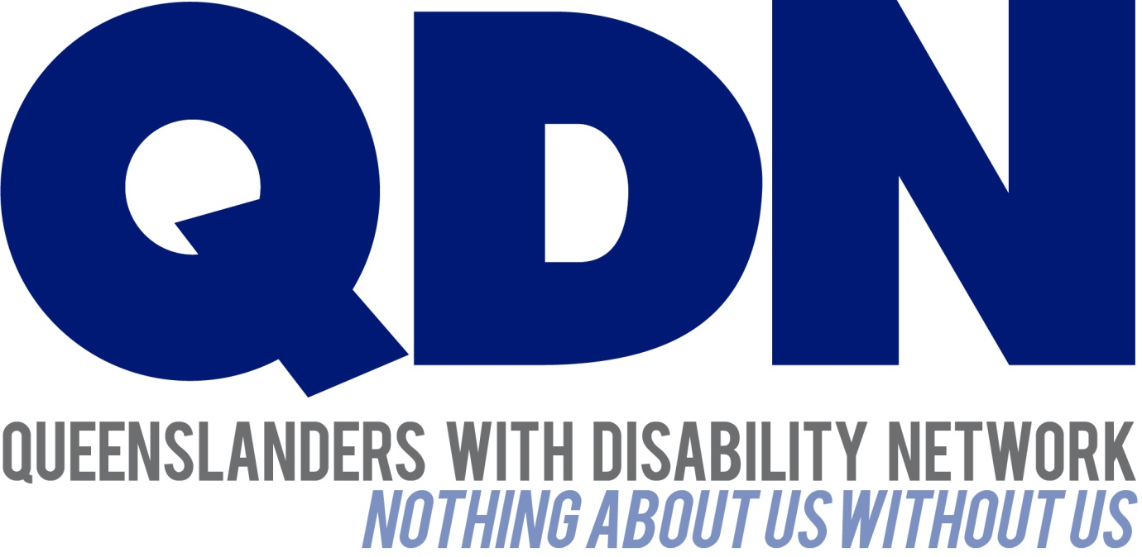

Submitted To:
Brisbane City Council

Contents
About Queenslanders with Disability Network (QDN) 3
Value Statement on People with Disability 3
QDN expectation of the Metro Bus 4
3 Objects 4
9.11 Movement of mobility aid in allocated space 4
27.4 Access to information about location 4
Infrastructure 6
Boarding 6
Metro Bus 6

About Queenslanders with Disability Network (QDN)
QDN is an organisation of, for, and with people with disability and the organisation’s motto is “nothing about us without us.” QDN operates a state-wide network of members who provide information, feedback and views from a consumer perspective to inform systemic policy feedback to Government and peak bodies. QDN also provides information and referral support to people with disability.
QDN has over 900 members across Queensland who provide QDN with the perspectives of people with disability.

Value Statement on People with Disability
QDN’s work in providing feedback and input into systemic policy issues is based upon the organisation’s core values and the place of people with disability in an inclusive Australian society.
QDN believes that:
- All people with disability have a right to a place in the community and have contributions to make to community. This is as empowered, free citizens who are as valued, present, participating and welcomed as members of any dynamic and diverse society.
- The place of people with disability in the community is not just about people with disability having a house in the community. Core to this is that they are welcomed in the community as ordinary citizens where they are genuinely given opportunities to contribute and actively participate. People with disability need to be in communities where their individuality, their talents, and their lived experiences of disability are recognised and acknowledged.
- Culturally and historically, people with disability are not afforded the same value, opportunities or access to community life.
- Any inclusion in community for people with disability is conditional and vulnerable to withdrawal.
- Many people with disability in Queensland are excluded from the most basic experiences of ordinary lives.
- Current exclusionary practices are unacceptable and must be challenged.
- These issues affect not only people with disability but the whole community.
- The responsibility is shared. It lies within government (federal, state and local) and the community at large, to ensure that people with disability have a place and are resourced to belong in community.
- Above all, we believe in, and seek to model, a human rights approach that recognises disability as a social issue and recognises the rights of all Australians as equal citizens.

QDN expectation of the Metro Bus
QDN believes that compliance with the Disability Standards for Accessible Public Transport 2002 (DSAPT) is the structure around which an accessible bus and associated infrastructure are built. The DSAPT is silent on many aspects of a public transport journey and so the broader Objects of the Disability Discrimination Act 1992 must be applied to the Metro Bus system. In this way a non-discriminatory service can be achieved.

3 Objects
The objects of this Act are:
- to eliminate, as far as possible, discrimination against persons on the ground of disability in the areas of:
  - work, accommodation, education, access to premises, clubs and sport; and
  - the provision of goods, facilities, services and land; and
  - existing laws; and
  - the administration of Commonwealth laws and programs; and
- to ensure, as far as practicable, that persons with disabilities have the same rights to equality before the law as the rest of the community; and
- to promote recognition and acceptance within the community of the principle that persons with disabilities have the same fundamental rights as the rest of the community.
Current Brisbane bus services have two DSAPT non-compliances:
- Next stop announcements are not given.
- No restraint system for wheelchairs is provided.
The absence of these required facilities dissuades many QDN members from travelling on buses. QDN expects that the Metro buses will enter service in full compliance with DSAPT Sections 9.11 and 27.4:

9.11 Movement of mobility aid in allocated space
An allocated space must contain movement of a mobility aid towards the front or sides of a conveyance.
Conveyances include:
    - Buses, except dedicated school buses
    - Trams
    - Light rail

27.4 Access to information about location
All passengers must be given the same level of access to information on their whereabouts during a public transport journey.

QDN’s further expectations are listed below.

Infrastructure
The new bus stations must be designed to provide:
- Wayfinding systems that permit ease of travel and navigation from street entry to platform boarding point and from boarding point to street exit.
- Boarding points that are easily identifiable for people with vision, intellectual or cognitive disabilities.
- Real-time information of incoming buses in audio and visual format.

Boarding
In order to board the Metro Bus safely and successfully systems must be designed that easily and conveniently allow:
- People with disability to know which platform bay their bus has pulled into.
- People who require boarding assistance to easily and conveniently contact staff and communicate the nature of assistance needed.
- People with vision, intellectual or cognitive disabilities to hail the metro bus successfully and consistently.
- People with mobility impairments to request that drivers or platform staff deploy boarding ramps.

Metro Bus
A successful journey on the Metro Bus will require systems that provide:
- Audio and visual next stop announcements consistently and reliably prior to each stop.
- Clearly signed and colour differentiated priority seating located immediately adjacent to the entry doors as per the QRail practice.
- Priority seating signs with Braille and raised text as per QRail practice rather than being a non-tactile decal.
- Allocated spaces that allow manoeuvring space in the aisle to permit easy positioning of mobility aids.
- A system that prevents wheelchairs from tipping or moving out of the allocated spaces during turns, acceleration or braking.
- Conveniently located, colour and luminance contrasted, call buttons that alert drivers that passengers wish to alight at the next stop.
- Conveniently located, colour and luminance contrasted, call buttons that alert drivers that passengers will need the boarding ramp deployed at the next stop.
- Emergency / Assistance intercoms located adjacent to allocated spaces and priority seating to permit passenger communication with drivers stationed in discrete cabs.

