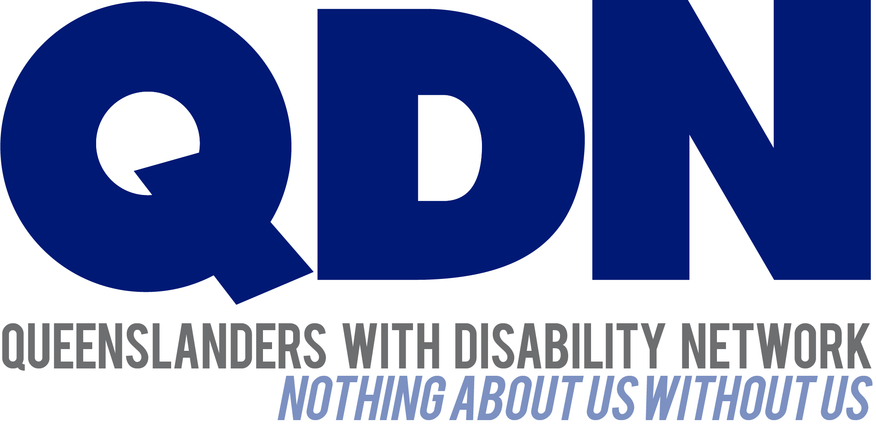

21 January 2016

Chairperson
Communities, Disability Services, and Domestic and Family Violence Prevention Committee
Parliament House
Brisbane Qld 4000
Email: cdsdfvpc@parliament.qld.gov.au

Dear Chairperson
Re: QDN Submission to the proposed Communities, Disability Services and Domestic and Family Violence Prevention Committee regarding the Disability Services and Other Legislation Amendments Bill 2015
Introduction
Queenslanders with Disability Network (QDN) welcomes the opportunity to make this submission regarding the Disability Services and Other Legislation Amendments Bill 2015.
QDN is an organisation of, for, and with people with disability. The organisation’s motto is “nothing about us without us.” QDN operates a state-wide network of members who provide information, feedback and views from a consumer perspective to inform systemic policy feedback to Government and peak bodies. QDN also provides information and referral support to people with disability.
This submission is informed by feedback from members. QDN has over 700 members and 300 supporters across Queensland. All of QDN’s voting members are people with disability.
QDN’s work in providing feedback and input into systemic policy issues is based upon the organisation’s core values and the place of people with disability in an inclusive Australian society.
QDN believes that:
- all people with disability have a right to a place in the community and have contributions to make to community. This is as empowered, free citizens who are as valued, present, participating and welcomed as members of any dynamic and diverse society

Unit 11 / 7, O’Connell Terrace, Bowen Hills Qld 4006
phone: 07 3252 8566 local call from landline: 1300 363 783
email: qdn@qdn.org.au web: qdn.org.au
- the place of people with disability in the community is not just about people with disability having a house in the community. Core to this is that they are welcomed in the community as ordinary citizens, where they are genuinely given opportunities to contribute and actively participate. People with disability need to be in communities where their individuality, their talents and their lived experiences of disability are recognised and acknowledged
- culturally and historically, people with disability are not afforded the same value, opportunities or access to community life
- any inclusion in community for people with disability is conditional and vulnerable to withdrawal
- many people with disability in Queensland are excluded from the most basic experiences of ordinary lives
- current exclusionary practices are unacceptable and must be challenged
- these issues affect not only people with disability but the whole community
- the responsibility is shared. It lies within government (federal, state and local) and the community at large, to ensure that people with disability have a place and are resourced to belong in community.
Background
QDN supports the intent of the Disability Services and Other Legislation Amendment Bill 2015. QDN believes that in this time of transition through the introduction and roll out of the National Disability Insurance Scheme (NDIS), it is important to ensure that the rights and safety all people with disability receiving funded disability services are protected by robust legislation.
QDN acknowledges that under the NDIS, people will receive services in a variety of settings that sit outside of these specific regulations, and it is important to have safeguards through other legislative functions and the work being undertaken by the National Disability Insurance Agency (NDIA).
Widening of visitable sites – Part 6 Amendment of Public Guardian Regulation 2014
QDN strongly supports the widening of visitable sites as outlined in Part 6 Amendment of Public Guardian Regulation 2014. This is an effective way to ensure more people with disability are afforded the same protection of independent, autonomous observation and accountability of service practices regardless of where they live.
QDN was particularly pleased to see the inclusion of level 3 Supported Accommodation facilities registered under the Residential Services (Accreditation) Act 2002 and sees this as a positive step towards eligible residents in these facilities having the same opportunity to access services under the NDIS as other people with disability.
QDN would like to raise that there are many people with disability living in Level 1 and 2 Residential Services who may be eligible to receive NDIS funded services either onsite or in the community and at this stage Level 1 and 2 Residential Services will not be covered by the widening of visitable sites.

Opportunity for evaluation of specific programs/ policy areas
QDN believes that the introduction of this Bill makes it timely to review and evaluate other programs, particularly in light of how they sit within an NDIS framework and philosophy. QDN believes reviews could occur in the areas of:
- Restrictive practices: it is relevant to review this policy and practice area in light of new service delivery frameworks provided under the NDIS.
- Decision-making: as Queensland transitions to the NDIS, QDN believes it is important to shift from a culture of substitute decision-making to supported decision-making so that people can truly exercise choice and control
- Complaints handling: as the culture of service delivery shifts from people being consumers to customers, the practice of complaints handling needs to be reviewed to ensure processes are robust and customers are both empowered to make complaints and satisfied with the outcomes of complaints handling processes and be placed in the position of customer throughout this process which may require shifts in operational practices and guidelines.
Advocacy

QDN recognises that the proposed NDIS Quality and Safeguards Framework will afford safeguards for all people with disability. QDN notes that a key recommendation from the recent Senate Committee Inquiry recognises that within a national system to protect people, that it is essential to have access to independent advocacy.

Access to independent individual advocacy is essential in any disability service system so that people can have assistance to negotiate service systems in a way that their human rights and best interests will be upheld.

Systemic advocacy will also continue to be important to influence the policies and procedures of agencies and government to change in response to the needs of people with disability and their families and carers as the NDIS rolls out.

QDN appreciates the opportunity to provide feedback to the Disability Services and Other Legislation Amendments Bill 2015 and believes the introduction of the Bill is timely so that people with disability receiving services are protected and safeguarded regardless of where these services sit within the system.

Yours faithfully

Paige Armstrong

CEO

Queenslanders with Disability Network

