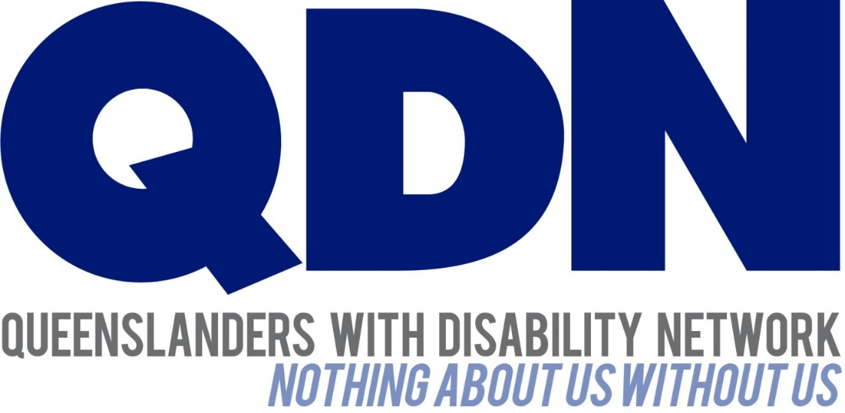

Response to the Framework for Information, Linkages and Capacity Building
National Disability Insurance Scheme

Contents
1
About Queenslanders with Disability Network (QDN) 3
Value Statement on People with Disability 3
Introduction 3
What are the most important elements of ILC? 3
What’s missing? 5
How will we know the ILC streams are meeting their objectives/vision? 6
What would be the implementation challenges? 6
Which aspects of a person’s life do you think ILC could have the greatest impact on? 7
What are some of the principles that should guide investment across ILC streams? 7
How do you see the interface between ILC functions and activities and the interaction with the mainstream service system? (housing, education, employment, health, family, accessibility and transport) 8

About Queenslanders with Disability Network (QDN)
QDN is an organisation of, for, and with people with disability and the organisation’s motto is “nothing about us without us.” QDN operates a state-wide network of members who provide information, feedback and views from a consumer perspective to inform systemic policy feedback to Government and peak bodies. QDN also provides information and referral support to people with disability.
QDN has over 700 members across Queensland. All of QDN’s members are people with disability.

Value Statement on People with Disability
QDN’s work in providing feedback and input into systemic policy issues is based upon the organisations core values and the place of people with disability in an inclusive, Australian society.
QDN believes that:
- All people with disability have a right to a place in the community and contributions to make to community. This is as empowered, free citizens who are as valued, present, participating and welcomed as members of any dynamic and diverse society.
- The place of people with disability in the community is not just about people with disability having a house in the community. The crux of the issue is that they are welcomed in the community as ordinary citizens where they are genuinely given opportunities to contribute and actively participate. People with disability need to be in communities where their individuality, their talents, and their lived experiences of disability are recognised and acknowledged.
- Culturally and historically, people with disability are not afforded the same value, opportunities or access to community life.
- Any inclusion in community for people with disability is conditional and vulnerable to withdrawal.
- Many people with disability in Queensland are excluded from the most basic experiences of ordinary lives.
- Current exclusionary practices are unacceptable and must be challenged.
- These issues affect not only people with disability but the whole community.
- The responsibility is shared. It lies within government (federal, state and local) and the community at large, to ensure that people with disability have a place and are resourced to belong in community.

Introduction
QDN welcomes the draft framework for Information, Linkages and Capacity Building (ILC) formerly known as Tier 2, in the National Disability Insurance Scheme (NDIS) and the opportunity to provide feedback.

What are the most important elements of ILC?
QDN believes in an inclusive society where people with disability live as valued members, fully participating socially and economically in their communities. The NDIS provides key strategic and operational frameworks that build the capacity of individuals and community to better include and support people with disability, and also deliver the required specialists individual supports to meet individual needs.
The societal change needed to build inclusive communities that enable and facilitate the social and economic participation of people with disability and their families and carers will be greatly linked with the core functions of ILC.
Consistent with the National Disability Strategy, the key functions of the ILC will support building inclusive and accessible communities, economic security, personal and community support, early intervention support which assist and develop learning and skills, integration with mainstream services including health system that will enhance the health and well-being of people with disability.
Safeguards and accountability are important functions of the NDIS, and QDN believes that it is essential that adequate safeguards are in place across all sections of the scheme to ensure the rights of individuals are protected, and that people do not fall through the gaps and experience greater disadvantage because of their disability.
Sustainability of the NDIS will be greatly reliant on integrated systems, across community, mainstream and specialist disability services. Central to this is successful implementation lies in the achievement of the outcomes of ILC in building:
- Well-informed knowledge networks within communities
- Individual capacity of people with disability and their families
- Peer communities of interest to facilitate knowledge sharing
- strong responsive community and mainstream services
- social capital within local communities.
QDN believes that this will require locally based and locally driven responses that are consumer led and look at what exists within each community, where its strengths lie, its social capital and build solutions that create accessible and inclusive communities. Key to this is the integration and collaboration across all parts of the community, including people with disability, industry, government and business.
QDN strongly support the role of independent and systems advocacy in the ILC framework. Ensuring that the individual and collective voice of people with disability is heard, listened to and acted upon in a productive and proactive way is vital to ensuring service providers and mainstream services are continually challenged to improve through constructive and independent feedback. QDN believes that there are many organisations that currently for fill this role and must be supported to do so into the future in order to ensure people with disability have a strong, thoughtful and informed voice to develop more inclusive communities, constructively influencing government and ensure people with disability are given a voice in decisions that effect their lives.

What’s missing?
QDN recognises that there are people with disability who members of our community who experience a double disadvantage and heightened vulnerability related to their cultural background, their gender, their cognitive abilities, mental illness, their age and where they live.
QDN therefore identifies that specific strategies that recognise the double disadvantage and marginalisation that different groups experience is essential to ensuring appropriate implementation of capacity building for individuals and communities that delivers on the goals of the NDIS and other policy frameworks and programs.
QDN supports the development of the following specific strategies within the framework of ILC focused on people with disability who identify as:
- from Aboriginal and Torres Strait Islander background
- from Culturally and linguistically diverse backgrounds
- Women
- Having cognitive, intellectual or learning disability
- Having lived experience of mental illness
- Lesbian, gay, bisexual and transgender
- Living in rural and remote areas especially in Queensland. These issues are similar in nature to those of the Northern Territory and Western Australia given the diversity and geographical challenges in these states,
- Older Australians,
- Living in institutional settings such as long stay health facilities.
It is essential that work undertaken recognises and maps the formal and informal support networks and values the role that they play in people’s lives in facilitating and supporting participation in community. Considerable knowledge and capacities exist already within communities, however, it is essential that the framework of ILC includes a strengths-based approach to community development.
QDN also believes that an essential element of the success of the NDIS will involve building the capacity of all parts of the system and market to become adaptive living systems that can innovate, iterate and respond quickly. People with disability play a pivotal role in shaping and driving innovation. The core functions of the ILC will provide an important capacity building mechanism to foster and support consumer led innovation that drives quality improvement and delivers better outcomes people with disability.
The provision of information is a service, and it not just about the distribution of written materials via print or online mechanisms. Sustainability of the scheme also relies on a considered and planned approach recognising the long term view and work that resources the activities of capacity building along a continuum.
It is also essential that there are formal mechanisms in place for engagement with people with disability at individual, service and systemic levels to provide feedback and input to government to inform the policy, systems and service reforms and improvements.
QDN also recognises a need to continue to provide ILC services to people as they age beyond 65 as the need for these services in no way diminishes as people move into this demographic.

How will we know the ILC streams are meeting their objectives/vision?
In measuring the objectives and vision of the ILC, QDN believes it is essential that a social impact measurement framework is developed which enables a consistent approach across jurisdictions in line with a national scheme. An outcomes and social impact measurement will ensure we are measuring the key functions and outcomes related to capacity building that see an increase in inclusiveness, accessibility, integration, and social and economic participation of people with disability in their communities.

What would be the implementation challenges?
QDN identifies a number of key potential challenges in the implementation of the 5 core streams of service under ILC. These include:
- Integration, coordination of services and collaboration across government portfolios, industry, cross sector services
- Building the capability of all parts of the community to work collaboratively to build and grow social capital and access the diversity of local communities.
- Being able to develop, implement and evaluate effective engagement with marginalised groups such as people in boarding houses, regional and remote communities, people with intellectual and learning disabilities.
- Ensuring consistency across jurisdictions
- Geographical challenges of Queensland
- Reducing opportunities and risk for duplication, and inefficient use of resources in different locations, while recognising the need for locally driven and locally responsive strategies.
- Creating and sustaining peer led networks and communities of interest that contribute to building inclusive communities.
- Allocation of adequate resources that build sustainable outcomes.
- Creating an interface that people can access and re-access in multiple formats – ie in person by visit or shop front, by phone, internet

Which aspects of a person’s life do you think ILC could have the greatest impact on?
ILC will have impact at an individual, community and system levels which will enable the achievement of the core aims of the increased social and economic participation of people with disability in their communities.
At an individual level, ILC will build the capacity of individuals, increase their experience and improve outcomes in the areas of:
- Inclusion
- Decision making
- Participation
- Navigation of services and systems
- Innovative ideas and responses to drive service redesign based around individual needs
At a community level, ILC will build the capacity of communities to be:
- Inclusive
- Accessible
- Collaborative
- Networks of people that demonstrate strong social capital
- Supportive of people with disability and their families and carers
At a system level, ILC will build the capacity of the system to be:
- Consumer focused
- Flexible
- Integrated
- Innovative
- Market driven
- Accessible
- Inclusive
- Quality.

What are some of the principles that should guide investment across ILC streams?
QDN believes that some of the important principles that should guide investment across ILC streams are:
- Sustainability
- Reduced duplication by multiple players
- Strategies which target marginalised groups
- Consumer and community engagement
- Collaboration
- Leadership development including emerging leaders in communities
- Adequate investment which is tailored to meet needs of specific communities

How do you see the interface between ILC functions and activities and the interaction with the mainstream service system? (housing, education, employment, health, family, accessibility and transport)

The complexity of the interface between the NDIS, mainstream service system and policy reforms is well recognised. It is essential that clear systems and outcomes are put in place to ensure that people with disability and their families and carers experience seamless and integrated services which are built around their needs. There is a significant risk to people with disability to experience challenges and disadvantages within multiple systems that do not communicate or integrate with each other. The functions of ILC and the outcomes of capacity building will enable individuals and community to build and grow their skills in navigation of the different service systems.
The system reforms which will enable improved integration will support people with disability to be able to experience seamless transitions from community, mainstream and specialised disability supports.
The NDIA is well positioned to manage and provide oversight of the interface between NDIS, mainstream service systems and other policy reforms such as National Disability Strategy.
QDN also believes that the successful interface between NDIS and mainstream service systems will be enhanced through effective engagement, operationalisation of National Disability Strategy, reforms such as universal access and a base provisioning of resources.

