Guide, Hearing and Assistance Dogs Amendment Bill 2015

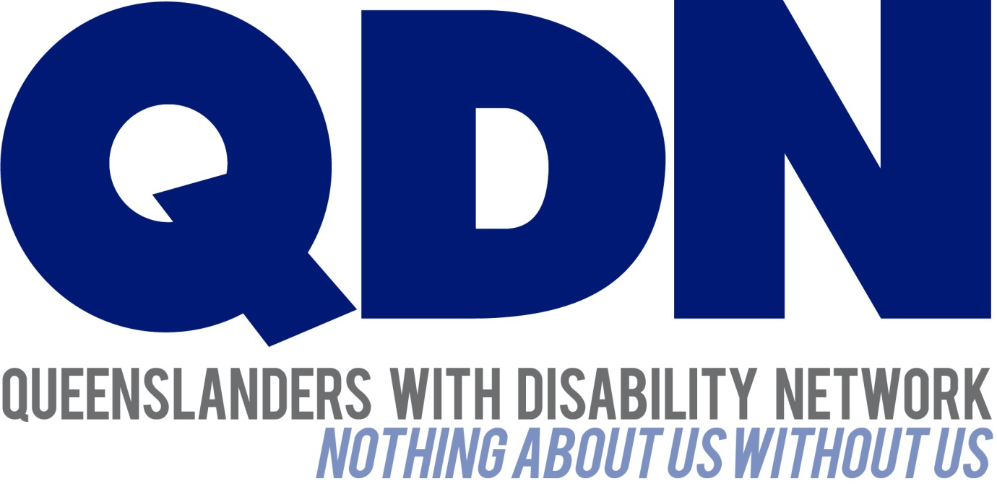

Contents
About Queenslanders with Disability Network (QDN) 3
Value Statement on People with Disability 3
About this Submission 4
QDN Consultation and this submission 4
Key Feedback 4
Recommendations 4
Conclusion 5

About Queenslanders with Disability Network (QDN)
QDN is an organisation of, for, and with people with disability and the organisation’s motto is “nothing about us without us.” QDN operates a state-wide network of members who provide information, feedback and views from a consumer perspective to inform systemic policy feedback to Government and peak bodies. QDN also provides information and referral support to people with disability.
QDN has over 700 members across Queensland. All of QDN’s voting members are people with disability.

Value Statement on People with Disability
QDN’s work in providing feedback and input into systemic policy issues is based upon the organisation’s core values and the place of people with disability in an inclusive, Australian society.
QDN believes that:
- All people with disability have a right to a place in the community and have contributions to make to community. This is as empowered, free citizens who are as valued, present, participating and welcomed as members of any dynamic and diverse society.
- The place of people with disability in the community is not just about people with disability having a house in the community. Core to this is that they are welcomed in the community as ordinary citizens where they are genuinely given opportunities to contribute and actively participate. People with disability need to be in communities where their individuality, their talents, and their lived experiences of disability are recognised and acknowledged.
- Culturally and historically, people with disability are not afforded the same value, opportunities or access to community life.
- Any inclusion in community for people with disability is conditional and vulnerable to withdrawal.
- Many people with disability in Queensland are excluded from the most basic experiences of ordinary lives.
- Current exclusionary practices are unacceptable and must be challenged.
- These issues affect not only people with disability but the whole community.
- The responsibility is shared. It lies within government (federal, state and local) and the community at large, to ensure that people with disability have a place and are resourced to belong in community.

About this Submission
QDN’s submission responds to the proposed amendments to the Guide, Hearing and Assistance Dogs Act 2009. These amendments are being made to give effect to recommendations made by the stakeholder review panel in 2013.
QDN has been involved in the review process for the Guide, Hearing and Assistance Dogs Act 2009 as a member of the stakeholder review panel.

QDN Consultation and this submission
QDN has undertaken consultation across its 700 strong state wide network of members and from key disability sector allies. As part of this, QDN sought and received targeted feedback on the review from members with lived experience of guide, hearing and assistance dogs, a teleconference with QDN’s Regional Facilitators and discussion with key disability sector organisations.

Key Feedback
QDN congratulates the Queensland Government on its adoption of the recommendations made by the stakeholder review panel following its review of the Guide, Hearing and Assistance Dogs Act 2009 and welcomes the opportunity to make this response.
QDN welcomes the changes to this legislation which strengthen and improve access rights of guide, hearing and assistance dog users, and reflects the intention of the recommendations of the panel.
QDN endorses the proposed amendments to the bill which simplify the processes to trainers and users of guide, hearing and assistance dogs, amendments to increasing the number of persons with disabilities to be granted access rights under the Act and the adoption of greater flexibility over current rigid legislative requirements.
The legislation needs to be an enabler for people with disability who use guide, hearing and assistance dogs to have their rights of access to public spaces is upheld within the community.
QDN supports ongoing engagement with people with disability who use guide, hearing and assistance dogs to inform the implementation of this legislation, including compliance standards and any regulations that sit alongside this.

Recommendations
QDN supports the amendments that expand the definition of handler to include alternative handler and the changes that enable the alternative handler to be the primary person responsible for the dog in particular circumstances. There are a number of different scenarios included in the notes on the provisions of the Act.
QDN believes it is important that the development of regulations and implementation of this area of legislation enables users and people responsible for the access to a particular public space to be clear about the different range of scenarios where it will apply. Alternative handlers, and consequently the primary handler should not be denied access, discriminated or disadvantaged because of misinterpretations of this provision. QDN members have raised for example, an instance whereby the handler of a guide, hearing or assistance dog is hospitalized, while accompanied by their dog, and the dog requires toileting or to leave the location for other purposes.
In the implementation of this legislation, it is essential that all people with disability who fall under the legislative definition of disability, including people with ongoing, persistent serious mental illness, be acknowledged and included. It will be important in the development of any regulations, communication strategies or awareness raising and education activities that people with disability, industry stakeholders, mainstream services and Government agencies are aware of the scope of who is included in this legislation. This will ensure that individuals are not experiencing discrimination and challenges in living their day to day life.
The practical outcomes of increased access to public spaces which changes to the bill bring rely heavily on the monitoring, investigative and enforcement requirements under the Act.
To be effective in improving the lives of people with disability these legislative changes need to be both proactively enforced and effectively communicated with relevant stakeholders, in particular the transport and hospitality industries.
Raising the awareness of the legislative requirements that allow access to guide, hearing and assistance dogs with all stakeholders is crucial to achieving the aims of the legislative amendments, and compliance.
Resources should also be directed to building the capacity of people with disability and the disability service system that supports them in interacting with mainstream services and understanding their rights within the legislative framework. Giving people information about their rights under the Act is a fundamental step to ensuring the aims of the Act are achieved.
QDN supports regulations around the accreditation of dog trainers and ongoing process of review and reaccreditation for this group to ensure high and consistent standards are maintained.
QDN acknowledges the shift away from an advisory committee mechanism to give authority to the Chief Executive to consult and call upon industry experts when assessing an application from a trainer or training institution seeking approval under the Act.
QDN supports any approach which brings about streamlined processes and less red tape, however also sees that it is essential that the definition of industry experts specifically includes people with disability who use guide, hearing and assistance dogs as part of their day to day life.
QDN would recommend that any definition of industry experts within regulations include people with disability as a key stakeholder. It is essential that they are called upon to share their views to inform decision-making and deliver good governance.
QDN also supports a consistent identification process across guide, hearing and assistance dogs. This will deliver great community awareness, and smoother implementation and adoption of new regulations which uphold the rights of all users of dogs to access their community and live their life with the support they need.
Appropriate resourcing also needs to be available to ensure enforcement officers are able to be both proactive and to respond in a timely an effective way when complaints are received.

Conclusion
QDN acknowledges the positive steps taken by the Queensland Government to ensure the legislation is relevant to the lived experience of people with disability and ensure that processes around guide, hearing or assistance dogs improve the access rights of these members of our community.
QDN acknowledges the Queensland Government for its engagement with people with lived experience of disability and other key stake holders in the review and development of legislation that has an impact upon people’s lives. We look forward to ongoing engagement with the Queensland Government around important issues for people with disability.
Queenslanders with Disability Network – 28 August 2015.

