Response to the Information, Linkages and Capacity Building Commissioning Framework – Consultation Draft

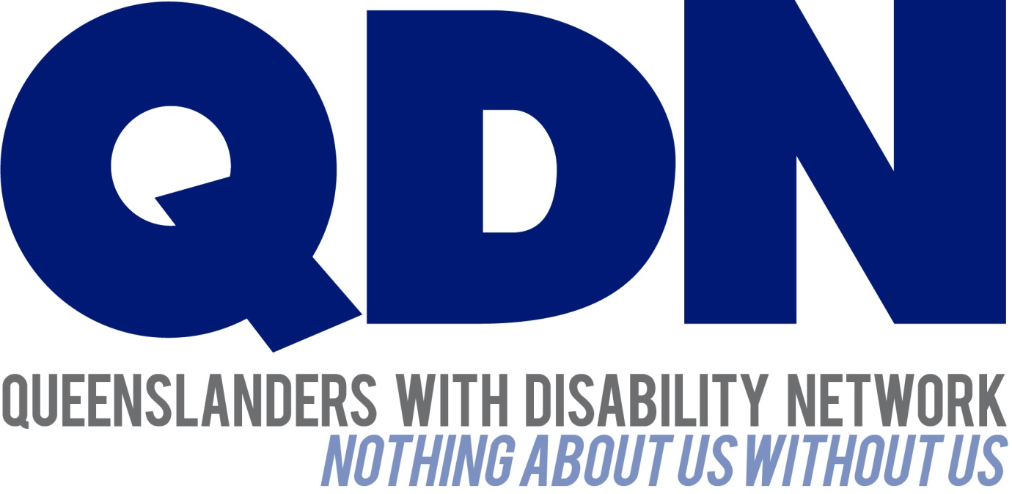

Contents
About Queenslanders with Disability Network (QDN) 3
Value Statement on People with Disability 3
Policy Overview 4
QDN Context 4
ILC Commissioning Framework Outcomes 5
Do you agree with the outcomes? 5
Is anything missing? 6
How should the outcomes be measured? 7
Getting everyone ready 7
What are the biggest challenges for people with disability and the sector created by the introduction of the ILC and outcome based measures? 7
How to grow social capital in the sector, particularly volunteering? 8
How to prepare the sector for the ILC sourcing process 8
How do we ensure that the needs of people with disability are at the centre of ILC supports? 9
How will people with disability, families and carers stay involved in ILC? 9
Rural and remote issues 9

About Queenslanders with Disability Network (QDN)
QDN is an organisation of, for, and with people with disability. The organisation’s motto is “nothing about us without us.” QDN operates a state-wide network of members who provide information, feedback and views from a consumer perspective to inform systemic policy feedback to Government and peak bodies. QDN also provides information and referral support to people with disability. All of QDN’s voting members are people with disability.
This submission is informed by feedback from QDN’s 700 plus members and 500 supporters.

Value Statement on People with Disability
QDN’s work in providing feedback and input into systemic policy issues is based upon the organisation’s core values and the place of people with disability in an inclusive Australian society.
QDN believes that:
- all people with disability have a right to a place in the community and have contributions to make to community. This is as empowered, free citizens who are as valued, present, participating and welcomed as members of any dynamic and diverse society
- the place of people with disability in the community is not just about people with disability having a house in the community. Core to this is that they are welcomed in the community as ordinary citizens, where they are genuinely given opportunities to contribute and actively participate. People with disability need to be in communities where their individuality, their talents and their lived experiences of disability are recognised and acknowledged
- culturally and historically, people with disability are not afforded the same value, opportunities or access to community life
- any inclusion in community for people with disability is conditional and vulnerable to withdrawal
- many people with disability in Queensland are excluded from the most basic experiences of ordinary lives
- current exclusionary practices are unacceptable and must be challenged
- these issues affect not only people with disability but the whole community
- the responsibility is shared. It lies within government (federal, state and local) and the community at large, to ensure that people with disability have a place and are sufficiently resourced to enable them to belong in community.

Policy Overview
The purpose of the Information, Linkages and Capacity (ILC) Building Commissioning Framework – Consultation Draft is to share information about what the ILC will look like and the National Disability Insurance Agency’s (NDIA) plan for the ILC. The purpose of the ILC Commissioning Framework is to translate the ILC Policy Framework into action. The ILC Commissioning Framework starts with the five activity streams outlined in the ILC Policy Framework, including:
- Information, linkages and referrals
- Capacity building for mainstream services
- Community awareness and capacity building
- Individual capacity building
- Local area co-ordination (LAC)

It also sets out what outcomes the NDIA expect from those activities, and how those activities will be funded and delivered.

QDN Context
QDN has made a previous submission to the ILC Framework in March 2015. This response builds on our original submission and highlights some key areas that QDN believes are important for the NDIA to consider before implementing the ILC Framework.
As an organisation of, by and for people with disability, QDN makes this submission both from the perspective and feedback of our 700+ members who are all people with disability and as a potential provider of ILC supports.
QDN is pleased that one of the five priority investment areas for ILC outlined in the ILC Policy Framework includes: Delivery (of ILC supports and activities) by people with disability for people with disability. QDN sees this as positive acknowledgement of the integral role people with disability have in the following aspects of self-determination and service design (which is inclusive of several of the outcomes of the ILC Commissioning Framework):
- Shaping the service system and providing high quality, efficient and effective services and supports (ILC Commissioning Framework Outcomes 5 and 7);
- Providing targeted and appropriate peer-driven information and support networks (ILC Commissioning Framework Outcome 7);
- Assisting peers to develop their capacity to exercise choice and control (ILC Commissioning Framework Outcome 1);
- Promoting the independence and social and economic participation of people with disability (ILC Commissioning Framework Outcome 2);
- Increasing the awareness of mainstream services and systems of how to support people with disability (ILC Commissioning Framework Outcome 8); and
- Ensuring that the interests of people with disability are represented in the design of policy and infrastructure (ILC Commissioning Framework Outcome 9).

ILC Commissioning Framework Outcomes

Do you agree with the outcomes?
The proposed outcomes of the ILC Commissioning Framework are as follows:
- People with disability have capacity to exercise choice and control in pursuit of goals.
- Independence and social and economic participation of all is promoted.
- Informal support and care arrangements are upheld and nurtured.
- Participants can access unfunded supports and individual funding is provided at the optimal time.
- High-quality, effective and efficient disability support, is available including ILC activities.
- People with disability have appropriate support during their lifetime, including early intervention.
- People with disability, their families and carers shape supports and services.
- Increased community/mainstream awareness of how to support people with disability.
- Interests of people with disability are faithfully represented in policy/infrastructure design.

QDN gives in principle support to each of these outcomes and acknowledges their intent and the important role people with disability have in leading this change as we transition to the NDIS.
QDN suggests that the wording of the second outcome be changed and strengthened to:
2. Independence and social and economic participation of all is realised and achieved.
QDN acknowledges the importance of informal supports in the lives of people with disability, however cautions against the over-reliance of informal support networks, recognising that for too long many people have been going without the formal supports they need to live valued, contributing lives in the community.
QDN suggests that the wording of the seventh outcome be changed and strengthened to:
7.People with disability, their families and carers take a lead role in shaping supports and services.
QDN believes it is important that people with disability are included at every level of an organisation and must be accorded influence, co-design opportunities, responsibilities and freedom to express innovation.
QDN believes our organisation (and other Disabled Persons Organisations) have a pivotal role in the achievement of the eighth and ninth outcomes. It is essential that people with disability take up the banner of educating mainstream services about how to support us, anything less could potentially be paternalistic or tokenistic. In keeping with our organisational slogan: “Nothing about us, without us”, QDN believes people with disability should also always have a place at the policy table. Organisations of by, for and with people with disability are best placed to facilitate opportunities for people with disability to contribute to policy.

Is anything missing?
QDN understands that the purpose of ILC supports and activities is to provide support to people with disability who may not be eligible for a direct NDIS support package. People who are most likely to self-refer to the NDIS may already be well-connected to service systems, may have good informal support networks and may have some awareness of their rights, at least at a service level. For these reasons QDN makes the following recommendations:
- Recommendation 1: Targeted strategies are developed to ensure that hard to reach populations (for example, homeless people with disability, residents of supported accommodation, hospitals or other institutions, people who are isolated because of their geographic or living situation, women who are isolated and dependent on informal caregivers and who may also be victims of violence, people from culturally or linguistically diverse backgrounds, people exiting prisons) receive information and support and are made aware of the NDIS and possibilities of support through ILC: QDN believes it is insufficient to leave the scope of ILC supports to the results an open tender process. Strategic and well thought out planning is required to ensure those who are most in need of ILC supports, receive them and that specific supports are created to meet individual needs.
- Recommendation 2: ILC supports are rolled out parallel with NDIS supports, or there are measures put in place to address the ensure that people who need a combination of an ILC and more individualised response have their needs met before full scheme.
QDN believes there is an imperative in the transition period to full scheme roll out that the State Departments and National Disability Insurance Agency work collaboratively to identify potential gaps throughout this period. Many people who have already been waiting many years to receive any support may not receive an NDIS package. Under the proposed plan, these people will need to wait even longer to get support as they will need to wait until NDIS packages have been rolled out in their region. This may create another two-tiered system of support, with potential for inequity and unfairness. Rolling out ILC supports parallel with NDIS supports also means that people with disability who may not be eligible for an NDIS package can learn about ILC supports as part of NDIS participant readiness activities.

How should the outcomes be measured?
In measuring the objectives and vision of the ILC, QDN believes it is essential that a social impact measurement framework is developed which enables a consistent approach across jurisdictions in line with a national scheme. An outcomes and social impact measurement will ensure we are measuring the key functions and outcomes related to capacity building that see an increase in inclusiveness, accessibility, integration, and social and economic participation of people with disability in their communities.
Other measures may include but are not limited to:
- Percentage of participants self-directing their funds
- Number of participants in paid employment, voluntary work, supported employment and those who are unemployed.
- How assistive technologies and provided equipment have escalated participants’ goals
- Number, frequency and type of community awareness activities
- Quantity of participant feedback about policy and infrastructure design and the positive/ negative impact of either

Getting everyone ready

What are the biggest challenges for people with disability and the sector created by the introduction of the ILC and outcome based measures?
QDN identifies a number of key potential challenges in the implementation of the 5 core streams of service under ILC. These include:
- Integration, coordination of services and collaboration across government portfolios, industry, cross sector services
- Building the capability of all parts of the community to work collaboratively to build and grow social capital and access the diversity of local communities.
- Being able to develop, implement and evaluate effective engagement with marginalised groups such as people in boarding houses, regional and remote communities, people with intellectual and learning disabilities.
- Ensuring consistency across jurisdictions
- Geographical challenges of Queensland
- Reducing opportunities and risk for duplication, and inefficient use of resources in different locations, while recognising the need for locally driven and locally responsive strategies.
- Creating and sustaining peer led networks and communities of interest that contribute to building inclusive communities.
- Allocation of adequate resources that build sustainable outcomes.
- Creating an interface that people can access and re-access in multiple formats – ie in person by visit or shop front, by phone, internet.
- Ensuring the sustainability of the service system as it transitions to the NDIS from region to region.
- Ensuring the service system and people with disability, their family members and supporters have access to quality training and information on the NDIS and ILC
- Ensuring that traditional service systems can transition to a customer focus
- Ensuring services have adequate product or service knowledge.
- Creating opportunities to regularly bring stakeholders together.

How to grow social capital in the sector, particularly volunteering?
Social capital is important to keep the sector sustainable. There are many examples of how volunteers have helped keep the sector viable because of inadequate funding of the service system. Volunteering can be positive as it provides opportunities for individuals to give back to their community and feel a sense of purpose.
Building upon the social capital that exists in a community is essential to achievement of the objectives of the National Disability Strategy and enabling people with disability to be active citizens of truly inclusive communities.
All roles within community, both paid and unpaid have responsibility to grow social capital, and volunteering plays a role in this, as do informal support networks and formal services and systems.
Feedback from QDN members indicates some people with disability have a fairly mixed experience of voluntarism, especially when they undertake it to provide good work experience to secure paid employment. QDN believes the roll out of the NDIS will provide the support and opportunity to enable many people with disability the opportunity to take up paid employment so they can contribute to building the social capital of their community.

How to prepare the sector for the ILC sourcing process
The sector will face many challenges as it transition to the ILC sourcing process. Issues for organisations moving to competitive grant funding include:
- Ongoing sustainability and service viability
- Inability to do long-term service planning based on uncertainty of funding
- Uncertainty for clients receiving supports from organisations with limited funding
- Financial uncertainty for employees working in these organisations
- Costs to the organisation in preparing grant applications (staff hours, loss of productivity, investing in grant writing processes with no certainty of outcome)
Agencies can help organisations meet those challenges by having:
- Clear funding guidelines and transparent assessment processes based on merit
- Opportunities for organisations to develop their skills through grant writing workshops
- Opportunities for smaller organisations to compete in the marketplace
- Targeted funding opportunities based specific needs and cohorts so that niche agencies providing specialist services have opportunities to compete
- Providing a mix or core and grant funding to address service sustainability issues

How do we ensure that the needs of people with disability are at the centre of ILC supports?
QDN believes that the success of the ILC is dependent on the needs of people with disability being at the centre. It is essential that there are formal mechanisms in place for engagement with people with disability at individual, service and systemic levels to provide feedback about what they need from ILC services and input to government to inform the policy, systems and service reforms and improvements.
QDN believes it is essential to have targeted strategies and measures in place to ensure the needs of people with disability are met. This needs to be combined with strategic planning processes to ensure the most effective supports are identified and funded under ILC supports. These processes will allow the NDIA to identify specific areas of need and target funding rounds accordingly. QDN believes this will be a more effective strategy than an open tender process to ensure the needs of people with disability are at the centre of ILC supports.

How will people with disability, families and carers stay involved in ILC?
People with disability, families and carers will stay involved in ILC through:
- Regular, meaningful engagement and feedback opportunities – including opportunities for people to shape supports and services;
- Accessible information delivered in a culturally sensitive manner – print, online, workshops;
- Opportunities to learn from and with experienced peers;

Rural and remote issues
The NDIA needs to consider the following issues when rolling out the ILC in rural and remote areas:
- Population
- Isolation
- Seasonal conditions
- Cultural appropriateness/language
- Linking with or away from community events
- Scarcity of resources, services and infrastructure impacting on choice and control
The NDIA can encourage the growth of ILC services in rural and remote communities through:
- Connectivity to technologies – ensuring reliable internet connection and telephone network coverage
- Access to fundamental needs and services as a priority
- Radio communications and print announcements
- Connecting with local governments, NGO’s and health providers
- Connecting with local leaders in the community
Queenslanders with Disability Network
April, 2016

For more information on social Impact measurement frameworks see: https://www.nds.org.au/resources/social-impact-measurement-toolkit-simt?_cldee=a3N3aWZ0QHFkbi5vcmcuYXU%3d

